CARIBE EWS Tsunami Signage Inventory and Report

Working Group IV
Preparedness, Readiness and Resilience
UNESCO-IOC CARIBE EWS Revised: December 2025

Contents
Summary...................................................................................................................................................... 4
Introduction….............................................................................................................................................. 4
Results.......................................................................................................................................................... 6
CARIBE EWS Signage Inventory.................................................................................................................... 7
Antigua y Barbuda .................................................................................................................................... 7 Barbados .................................................................................................................................................. 8 Colombia .................................................................................................................................................. 9 Costa Rica ............................................................................................................................................... 10 Dominica ................................................................................................................................................ 11 Dominican Republic ............................................................................................................................... 12 France..................................................................................................................................................... 13 Grenada.................................................................................................................................................. 14 Haiti ....................................................................................................................................................... 15 Honduras ............................................................................................................................................... 16 Jamaica .................................................................................................................................................. 17 Kingdom of the Netherlands (Aruba) ..................................................................................................... 18 Kingdom of the Netherlands (Curaçao) .................................................................................................. 19 Nicaragua ............................................................................................................................................... 20 Saint Kitts and Nevis................................................................................................................................ 21 Saint Lucia .............................................................................................................................................. 22 Saint Vincent and the Grenadines .......................................................................................................... 23 Trinidad and Tobago ............................................................................................................................... 24 United Kingdom Overseas Territories (Anguilla) ................................................................................... 25 United Kingdom Overseas Territories (Bermuda) ................................................................................... 26 United Kingdom Overseas Territories (British Virgin Islands) ................................................................ 27 United Kingdom Overseas Territories (Turks and Caicos Islands) .......................................................... 28 United States (Puerto Rico) .................................................................................................................... 29 United States (Virgin Islands) ................................................................................................................. 30
Venezuela ................................................................................................................................................ 31
Discussion .................................................................................................................................................. 32
Alternative Public Display of Tsunami Hazard Information ........................................................................ 33
Alternative Public Display from ICG/CARIBE-EWS Member States & Territories ................................ 33 Saint Kitts and Nevis - Murals ............................................................................................................. 33 Saint Vincent and the Grenadines - Billboards ................................................................................... 34 Puerto Rico – Road Marking and Murals ............................................................................................ 34
Nicaragua – Tsunami Wall-Color ......................................................................................................... 35
Blue Line Project .................................................................................................................................... 36 Previous Event Signs................................................................................................................................... 37 Recommendations ..................................................................................................................................... 37 Acknowledgements ................................................................................................................................... 38 Appendix .................................................................................................................................................... 39

Summary
During IOC’s ICG/CARIBE-EWS XIII session Working Group 4 together with Working Group 2 were tasked to conduct an inventory of tsunami evacuation signs and symbols used in the region as well as internationally and make corresponding recommendations to the ICG/CARIBEEWS XIV session. In 2019 the International Tsunami Information Caribbean Office prepared a report of the Working Group based on a survey sent to the Tsunami National Contacts of the CARIBE EWS Member States and Territories. 21 Member States/Territories responded to the survey. The report was presented at ICG/CARIBE EWS XIV Session. After considering the report, the ICG/CARIBE-EWS XIV instructed the Working Group 4 to annually update the database and expand information on the blue line concept for evacuation. Following the ICG/CAIBE-EWS XIV instruction, the report was updated in 2020 and presented at the ICG/CARIBE EWS XV session. Between 2022 and 2023 the report was updated to be presented at IOC’s ICG/CARIBE EWS-XVI.
The current report includes signage and contact information from 25 Member States and Territories and is based on a survey conducted in October 2020 by the International Tsunami Information Center Caribbean Office, Tsunami Ready project reports and communication with project team members, the NTWC, TNC, and TWFP for EWS Caribbean Member States and Territories, 27 January 2023 list, and review of literature and internet resources. In addition to the signage, the report includes information on alternative public display of tsunami hazard information, and signs on previous signs.

Introduction
The Intergovernmental Oceanographic Commission (IOC) Intergovernmental Coordination Group for the Tsunami and Other Coastal Hazards Warning System for the Caribbean and Adjacent Regions (ICG/CARIBE-EWS) held its XIII session in Curaçao in April 2018. At this session, Working Group 4 (WG-4) on Preparedness, Readiness, and Resilience was tasked to conduct the inventory of tsunami evacuation signs and symbols used in the region, as well as internationally (including the ISO 20712) and make recommendations to the ICG XIV on tsunami signage. Similarly, Working Group 2 (WG-2; Hazard Assessment) and Task Team (Evacuation Mapping) was also requested to conduct an inventory of tsunami inundation and evacuation mapping. The Chair of WG-2 and WG-4 and the Evacuation Mapping Task Team decided to join forces and prepared one survey on both signage and mapping. The International Tsunami Information Center Caribbean Office (ITIC-CAR), previously known as the Caribbean Tsunami Warning Program, developed in Google Forms a template that could accept both text and images. On February 5, 2019 the CARIBE-EWS Secretariat sent an email to the Tsunami National Contacts (TNC) of the CARIBE-EWS Member States and Territories requesting each of them to complete the survey. On October 2020 ITIC-CAR prepared a new survey that was sent to each CARIBE-EWS Member State and Territories requesting an update on their signage. Based on the survey results the 2019 CARIBE-EWS Tsunami Signage Inventory and Report was prepared and presented at the ICG/CARIBE-EWS XIV Session.
After considering the report, the ICG XIV instructed the WG-4 to annually update the database and expand information on the blue line concept for evacuation. In 2020 the report was updated and presented at the ICG/CARIBE-EWS XV session, where ICG/CARIBE-EWS stated in the session report:
“Notes the importance of having an updated inventory of Tsunami Signage and Public Displayed employed in the regions and its support to the implementation of the Tsunami Ready programme,
Further notes that 50 percent of the Member States have contributed examples of the signage used,
Reminds Member States in coordination with local authorities to respond to the annual call to provide updates, including the location metadata, artwork and photographs of installed signs for inclusion in the signage database,
Encourages Member States in coordination with local authorities to develop an inventory of the signage installed in the country,
Requests the WG4 to provide guidance on tools and resources used for inventory of installed signage,
Further requests the ITIC-CAR to continue updating and posting annually the Signage Inventory and include a section on best practices for national inventories as well as new best practices for public display of tsunami guidance information.”
The development and update of this report supports one of the 12 key indicators that must be met by communities seeking recognition under the UNESCO-IOC Tsunami Ready Recognition Programme. This key indicator is categorized under Preparedness (PREP) and states that “PREP-2. Tsunami information including signage is publicly displayed”. Signs such as entering and leaving tsunami hazard zones, evacuation routes, assembly/meeting area/points, tsunami response education (e.g. go to higher ground, alert levels), and tsunami evacuation maps are suggested for public display to provide information on tsunami risk and public education on how communities can respond in the event of a tsunami. Considering these suggestions, this inventory includes pictures for the following signage, if available, for the listed Member States and Territories: Tsunami Hazard Zone, Entering and/or Leaving Tsunami Hazard Zone, Tsunami Evacuation Route, Tsunami Assembly Point, Tsunami Evacuation Map, and Tsunami Ready Recognition.
In addition to the signage this inventory includes, if available, for the listed Member States and Territories, information on the installed signage measurements, materials, and total amount. This inventory also includes other tsunami best practices that have been implemented and ISO 207-12 – Beach Safety Flags and Water Safety Sign Standards (2008).
This report provides an update to the contents of the 2020 CARIBE-EWS Tsunami Signage Inventory and Report, including the addition of CARIBE-EWS Member States and Territories. The previous survey results were left in the report and the newly added and/or updated signage content were obtained from the UNESCO-IOC Tsunami Ready Recognition Programme documents, reports, deliverables, and communication with project team members, and the review of literature and internet resources.
Based on the findings and updates of this report, WG-4 will prepare a recommendation for the consideration of the ICG/CARIBE-EWS XIX session.

Results
A total of 25 CARIBE-EWS Member States/Territories are included in this report. ITIC-CAR updated the signage content and/or contact information, if available, for CARIBE-EWS Member States/Territories included in the 2020 report. The previous survey results for 11 Member States/Territories, also included in the 2020 report, were left in this one: Colombia, Costa Rica, France (French Lesser Antilles), Grenada, Kingdom of the Netherlands (Aruba, Curacao), United Kingdom Overseas Territories (Anguilla, Bermuda, British Virgin Islands, Turks and Caicos Islands), United States (Puerto Rico), and Venezuela.
Updates to the inventory include the addition of signage artwork/pictures and corresponding information previously not included in the 2020 report, replacement of some signage artwork/pictures for ones with a higher quality and visibility, updates to the Member State/Territory Contact Information, addition of hyperlinks to the UNESCO-IOC website for Member States/Territories and/or communities recognized under the UNESCO-IOC Tsunami Ready Programme, and more alternative public displays.
The newly added and/or updated content was obtained from the revision of UNESCO-IOC Tsunami Ready Recognition Programme Fulfilment of the Indicators forms (either New Recognition or Renewal Recognition), reports and deliverables from the communities available to ITIC-CAR, the review of the most recent and available national and regional Tsunami Warning Information Dissemination Protocol and Standard Operating Procedures (SOPs) available to ITIC-CAR, the revision of official CARIBE-EWS Member States/Territories agency websites, and the UNESCO-IOC website.

CARIBE EWS Signage Inventory
Antigua and Barbuda
Signage Art/Photo | Signage Type | General Information
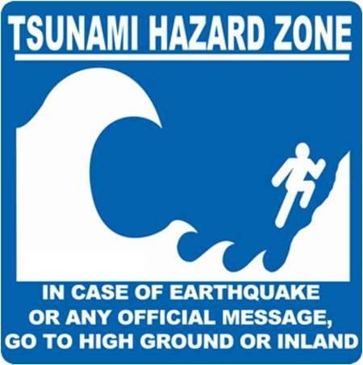 | Tsunami Hazard Zone | Width/Height (ft):
 | Tsunami Hazard Zone | Materials (e.g. aluminum, plastic, or fiber glass):
 | Tsunami Hazard Zone | Number of signs installed:
 | Entering/Leaving Tsunami Hazard Zone | Width/Height (ft):
 | Entering/Leaving Tsunami Hazard Zone | Materials (e.g. aluminum, plastic, or fiber glass):
 | Entering/Leaving Tsunami Hazard Zone | Number of signs installed:
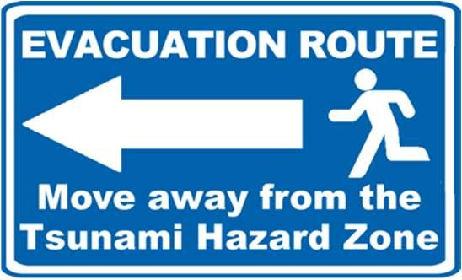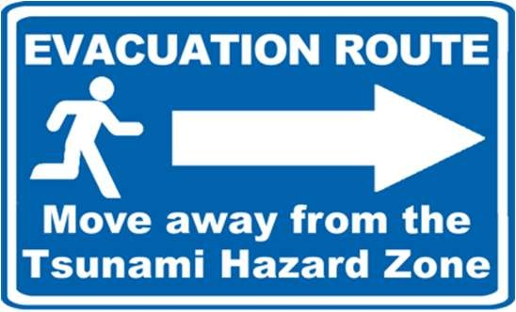 | Tsunami Evacuation Route | Width/Height (ft):
 | Tsunami Evacuation Route | Materials (e.g. aluminum, plastic, or fiber glass):
 | Tsunami Evacuation Route | Number of signs installed:
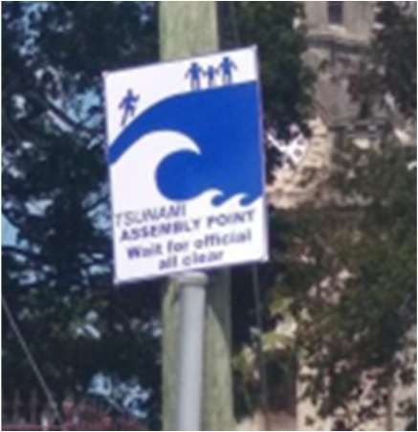 | Tsunami Assembly Point | Width/Height (ft):
 | Tsunami Assembly Point | Materials (e.g. aluminum, plastic, or fiber glass):
 | Tsunami Assembly Point | Number of signs installed:
Maps not publicly displayed | Tsunami Evacuation Map | Width/Height (ft):
Maps not publicly displayed | Tsunami Evacuation Map | Materials (e.g. aluminum, plastic, or fiber glass):
Maps not publicly displayed | Tsunami Evacuation Map | Number of signs installed:
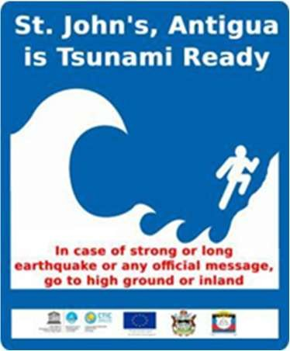 | Tsunami Ready Recognition | Width/Height (ft):
 | Tsunami Ready Recognition | Materials (e.g. aluminum, plastic, or fiber glass):
 | Tsunami Ready Recognition | Number of signs installed:
Member State/Territory Contact Information
TWFP: Meteorological Service of Antigua & Barbuda, Mr. Dale Destin (Director). Tel: +12684624606, email: dale_destin@yahoo.com, dale.desin@ab.gov.ag
TNC: National Office of Disaster Services, Mr. Sherrod James (Director). Tel: +12684624206, email: nodsanu@gmail.com,
nods.anu@ab.gov.ag, sherrod.james@ab.gov.ag
Notes/Comments:
- Corresponding documentation for St. John’s, Antigua and Barbuda available here.
- ITIC-CAR previously added all the signage art/photo, type, and information for this Member State/Territory.
- In 2022 ITIC-CAR made updates to the signage/art, type, and information.
- In 2025 ITIC-CAR made updates to the Member State/Territory Contact Information (based on the document ICG/CARIBE-EWS DATABASE for TNCs, TWFPs, and NTWCs, 12, December, 2025).).

Barbados
Signage Art/Photo | Signage Type | General Information
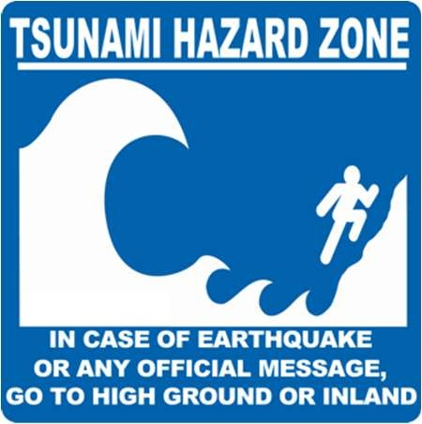 | Tsunami Hazard Zone | Width/Height (ft):
 | Tsunami Hazard Zone | Materials (e.g. aluminum, plastic, or fiber glass):
 | Tsunami Hazard Zone | Number of signs installed:
 | Entering/Leaving Tsunami Hazard Zone | Width/Height (ft):
 | Entering/Leaving Tsunami Hazard Zone | Materials (e.g. aluminum, plastic, or fiber glass):
 | Entering/Leaving Tsunami Hazard Zone | Number of signs installed:
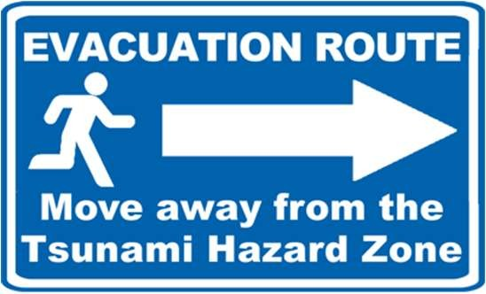 | Tsunami Evacuation Route | Width/Height (ft):
 | Tsunami Evacuation Route | Materials (e.g. aluminum, plastic, or fiber glass):
 | Tsunami Evacuation Route | Number of signs installed:
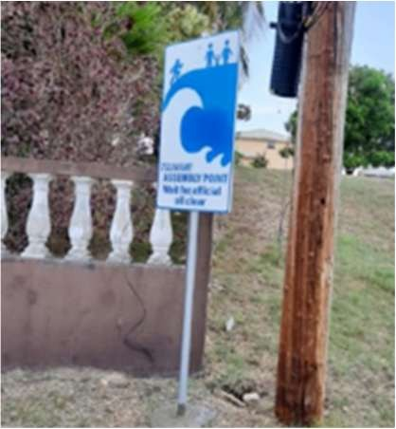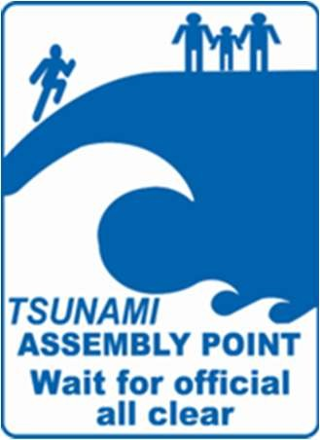 | Tsunami Assembly Point | Width/Height (ft):
 | Tsunami Assembly Point | Materials (e.g. aluminum, plastic, or fiber glass):
 | Tsunami Assembly Point | Number of signs installed:
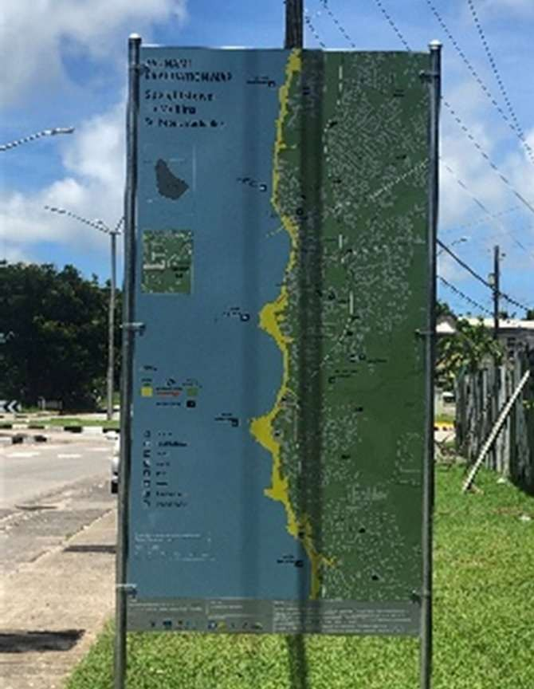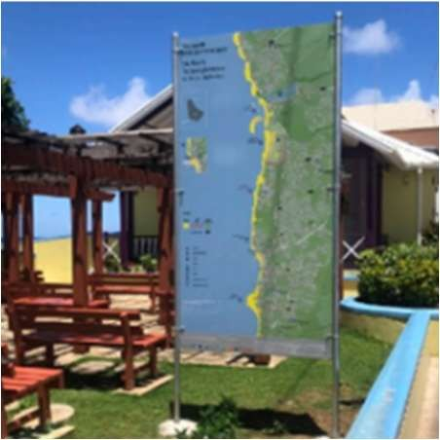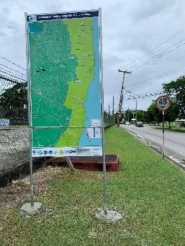 | Tsunami Evacuation Map | Width/Height (ft):
 | Tsunami Evacuation Map | Materials (e.g. aluminum, plastic, or fiber glass):
 | Tsunami Evacuation Map | Number of signs installed:
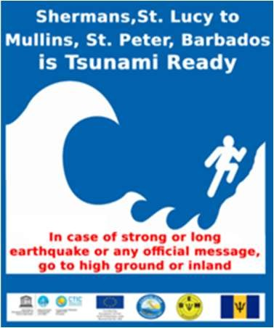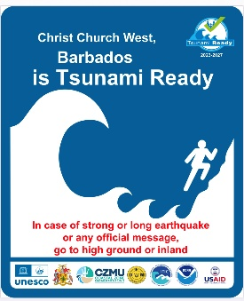 | Tsunami Ready Recognition | Width/Height (ft):
 | Tsunami Ready Recognition | Materials (e.g. aluminum, plastic, or fiber glass):
 | Tsunami Ready Recognition | Number of signs installed:
Member State/Territory Contact Information
NTWC & TWFP: Barbados Meteorological Services, Mr. Sabu Best (Director). Tel: +12465350017, email:
sabu.best@barbados.gov.bb, meteorological.services@barbados.gov.bb, barbadosmet@gmail.com
TNC: Coastal Zone Management Unit, Dr. Leo F. S. Brewster (Director). Tel: 12465255740, email: lbrewster@coastal.gov.bb, director@coastal.gov.bb
Notes/Comments:
- Corresponding documentation for Barbados available here.
- ITIC-CAR previously added all the signage art/photo, type, and information for this Member State/Territory.
- In 2022 ITIC-CAR made updates to the signage/art, type, and information.
- In 2023 ITIC-CAR made updates to signage/art (based on documents from http://itic.iocunesco.org/index.php?option=com_content&view=article&id=2266&Itemid=3387) (December 13, 2023)
- In 2025 ITIC-CAR made updates to the Member State/Territory Contact Information (based on the document ICG/CARIBE-EWS DATABASE for TNCs, TWFPs, and NTWCs, 12, December, 2025).

Colombia
Signage Art/Photo | Signage Type | General Information
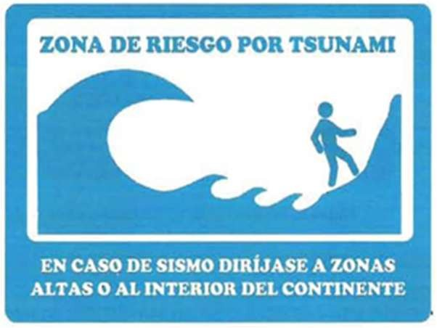 | Tsunami Hazard Zone | Width/Height (ft):
 | Tsunami Hazard Zone | Materials (e.g. aluminum, plastic, or fiber glass):  Reflective sheet of polyester reinforced with fiberglass, galvanized or aluminum, for roads  whose height above sea level is less than one  thousand meters (1000 m)
 | Tsunami Hazard Zone | Number of signs installed:  2
 | Entering/Leaving Tsunami Hazard Zone | Width/Height (ft):
 | Entering/Leaving Tsunami Hazard Zone | Materials (e.g. aluminum, plastic, or fiber glass):
 | Entering/Leaving Tsunami Hazard Zone | Number of signs installed:
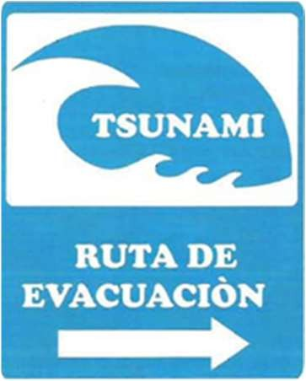 | Tsunami Evacuation Route | Width/Height (ft):
 | Tsunami Evacuation Route | Materials (e.g. aluminum, plastic, or fiber glass):  Reflective sheet of polyester reinforced with fiberglass, galvanized or aluminum, for roads  whose height above sea level is less than one  thousand meters (1000 m)
 | Tsunami Evacuation Route | Number of signs installed:
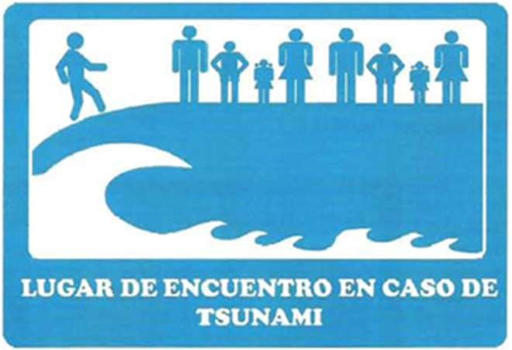 | Tsunami Assembly Point | Width/Height (ft):
 | Tsunami Assembly Point | Materials (e.g. aluminum, plastic, or fiber glass):  Reflective sheet of polyester reinforced with fiberglass, galvanized or aluminum, for roads  whose height above sea level is less than one  thousand meters (1000 m)
 | Tsunami Assembly Point | Number of signs installed:
Maps not publicly displayed | Tsunami Evacuation Map | Width/Height (ft):
Maps not publicly displayed | Tsunami Evacuation Map | Materials (e.g. aluminum, plastic, or fiber glass):
Maps not publicly displayed | Tsunami Evacuation Map | Number of signs installed:
 | Tsunami Ready Recognition | Width/Height (ft):
 | Tsunami Ready Recognition | Materials (e.g. aluminum, plastic, or fiber glass):
 | Tsunami Ready Recognition | Number of signs installed:
Member State/Territory Contact Information
NTWC & TWFP: Dirección General Maritima, Vicealmirante John Fabio Giraldo Gallo (Director). Tel: +573204515711, email:
director@dimar.mil.co
TNC: Captain Juan Camilo Forero Hauzeur (Secretario Ejecutivo, Comisión Colombiana del Océano). Tel: +57133158520, email:
oceano@cco.gov.co
Notes/Comments:
- mrengifo@dimar.mil.co was the initial survey respondent.
- ITIC-CAR previously added all the signage art/photo, type, and information for this Member State/Territory (based on the document “Especificación Normativa Disponible END 0068” of the Government of Colombia).
- In 2023 ITIC-CAR made updates to the Member State/Territory Contact Information (based on the document “NTWC, TNC, and TWFP for the EWS Caribbean Member States and Territories).

Costa Rica
Signage Art/Photo | Signage Type | General Information
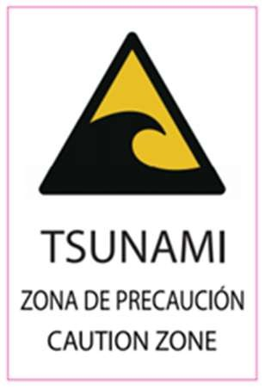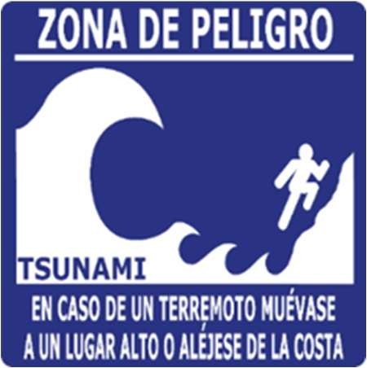 | Tsunami Hazard Zone | Width/Height (ft):  90 cm x 60 cm
 | Tsunami Hazard Zone | Materials (e.g. aluminum, plastic, or fiber glass):  Aluminum
 | Tsunami Hazard Zone | Number of signs installed:  Quepos 55, Ostional 5
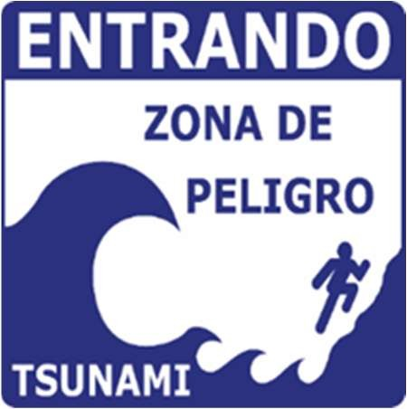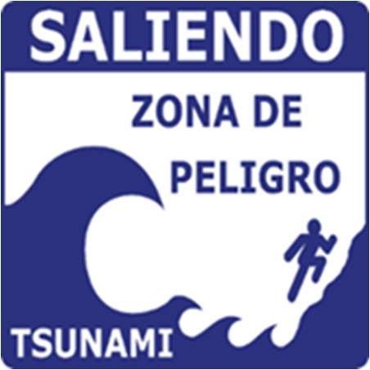 | Entering/Leaving Tsunami Hazard Zone | Width/Height (ft):
 | Entering/Leaving Tsunami Hazard Zone | Materials (e.g. aluminum, plastic, or fiber glass):
 | Entering/Leaving Tsunami Hazard Zone | Number of signs installed: Ostional 13
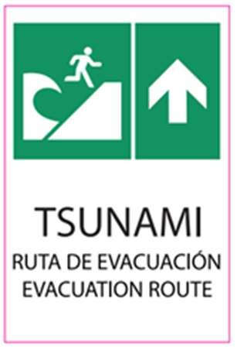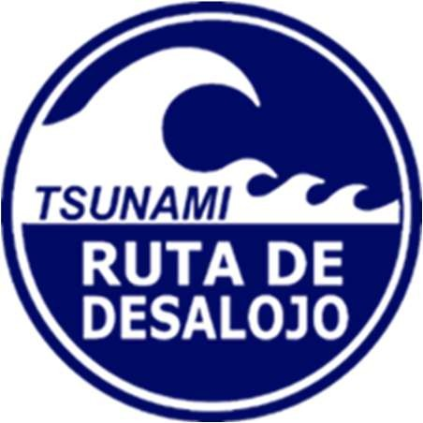 | Tsunami Evacuation Route | Width/Height (ft):  90 x 60 cm
 | Tsunami Evacuation Route | Materials (e.g. aluminum, plastic, or fiber glass):  Aluminum
 | Tsunami Evacuation Route | Number of signs installed:  Quepos 254, Ostional 1
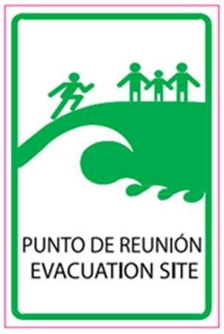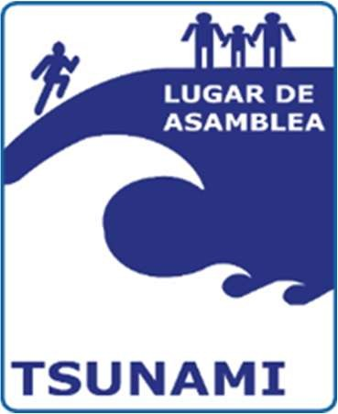 | Tsunami Assembly Point | Width/Height (ft):  90 cm x 60 cm
 | Tsunami Assembly Point | Materials (e.g. aluminum, plastic, or fiber glass):  Aluminum
 | Tsunami Assembly Point | Number of signs installed:  Quepos 77, Ostional 2
Maps not publicly displayed | Tsunami Evacuation Map | Width/Height (ft):  2.2 m x 2.1 m
Maps not publicly displayed | Tsunami Evacuation Map | Materials (e.g. aluminum, plastic, or fiber glass):  Aluminum
Maps not publicly displayed | Tsunami Evacuation Map | Number of signs installed: Quepos 13
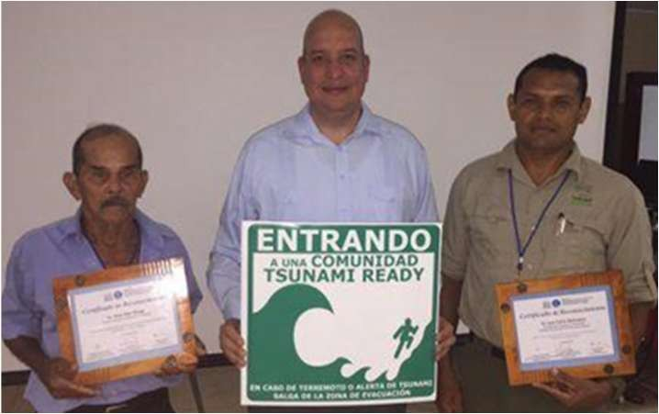 | Tsunami Ready Recognition | Width/Height (ft):
 | Tsunami Ready Recognition | Materials (e.g. aluminum, plastic, or fiber glass):
 | Tsunami Ready Recognition | Number of signs installed:
Member State/Territory Contact Information
NTWC: Sistema Nacional Monitoreo de Tsunami, Dr. Silvia Chacón Barrantes (Coordinator). Tel: +50683096690,+50688957412,+50622102872, +50622102873, email: sinamot@una.cr, silviach@una.ac.cr, sinamot.cr@gmail.com
TWFP: Comisión Nacional de Prevencion de Riesgos y Atencion de Emergencias, Mr. Sigifredo Párez Fernández (Operative Chief). Tel: +50622102731, +50622102732, email: sperez@cne.go.cr, telecomunicaciones@cne.go.cr
TNC: Sistema Nacional Monitoreo de Tsunami, Dr. Silvia Chacón Barrantes (Coordinator). Tel: +50622773929, email: silviach@una.ac.cr, silvia.chacon.barrantes@una.ac.cr
Notes/Comments:
- Corresponding documentation for Costa Rica available here.
- Silvia Chacón Berrantes (silviach@una.ac.cr) was the initial survey respondent.
- The 2020 response states: “There are two communities recognized as Tsunami Ready in Costa Rica: Quepos and Ostional. Both communities use two different types of tsunami signage. The signage of Quepos is mainly green and yellow, while the signage of Ostional is blue.”
- In 2025 ITIC-CAR made updates to the Member State/Territory Contact Information (based on the document ICG/CARIBE-EWS DATABASE for TNCs, TWFPs, and NTWCs, 12, December, 2025).

Dominica
Signage Art/Photo | Signage Type | General Information
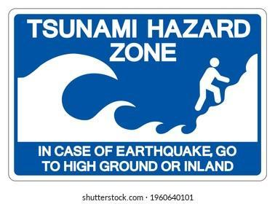 | Tsunami Hazard Zone | Width/Height (ft): Length: 24” Width: 36”/ total Height of signage on pole: 6ft
 | Tsunami Hazard Zone | Materials (e.g. aluminum, plastic, or fiber glass):
 | Tsunami Hazard Zone | Number of signs installed: 5
 | Entering/Leaving Tsunami Hazard Zone | Width/Height (ft):
 | Entering/Leaving Tsunami Hazard Zone | Materials (e.g. aluminum, plastic, or fiber glass):
 | Entering/Leaving Tsunami Hazard Zone | Number of signs installed:
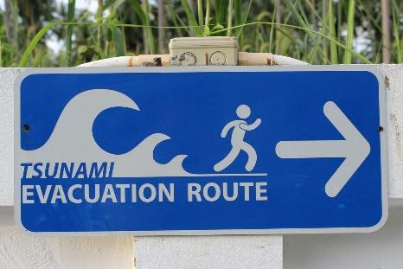 | Tsunami Evacuation Route | Width/Height (ft): Length: 24” Width: 36”
 | Tsunami Evacuation Route | Materials (e.g. aluminum, plastic, or fiber glass):
 | Tsunami Evacuation Route | Number of signs installed:5
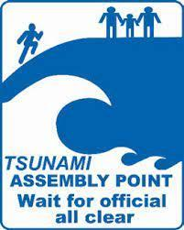 | Tsunami Assembly Point | Width/Height (ft): Length: 36” Width: 24”/ total Height of signage on pole: 6ft
 | Tsunami Assembly Point | Materials (e.g. aluminum, plastic, or fiber glass):
 | Tsunami Assembly Point | Number of signs installed: 5
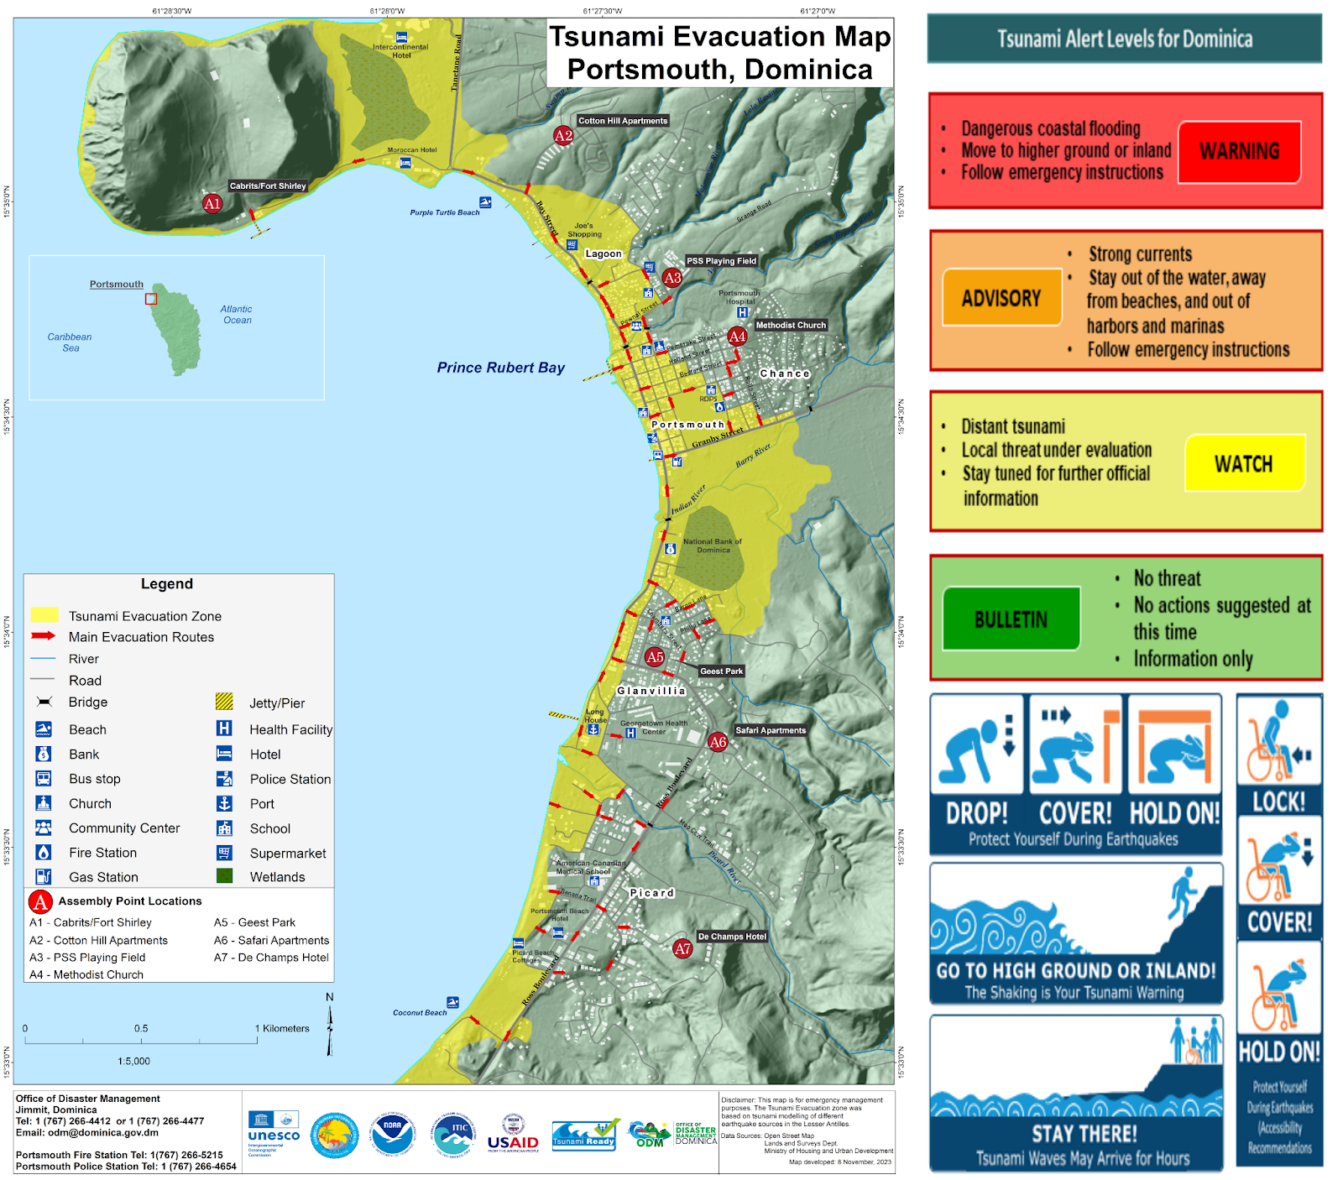 | Tsunami Evacuation Map | Width/Height (ft): Length: 36” Width: 48”/ total Height of signage on pole: 6ft
 | Tsunami Evacuation Map | Materials (e.g. aluminum, plastic, or fiber glass):
 | Tsunami Evacuation Map | Number of signs installed: 3
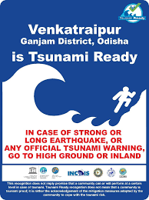  The top will read ‘Portsmouth, Dominica is Tsunami Ready’ | Tsunami Ready Recognition | Width/Height (ft): Length: 24” Width: 18”/ total Height of signage on pole: 6ft
 | Tsunami Ready Recognition | Materials (e.g. aluminum, plastic, or fiber glass):
 | Tsunami Ready Recognition | Number of signs installed: 2
Member State/Territory Contact Information
TWFP, and TNC: Office of Disaster Management Ministry of National Security, Mr. Pascal Fitzroy (National Disaster Coordinator). Tel: +17672664411,+17672664412,+17672664413,+17672664477, email: odm@dominica.gov.dm, odmdominica@gmail.com, odmsec@dominica.gov.dm
Notes/Comments:
- February 5, 2024 – added Signage Art/ photos for all except entering/leaving tsunami hazard zone with their respective width and heights and the number of signs installed.
- Corresponding documentation for Dominica is available here.
- In 2025 ITIC-CAR updated the Member State/Territory Contact Information (based on the document ICG/CARIBE-EWS DATABASE for TNCs, TWFPs, and NTWCs, 12, December, 2025).

Dominican Republic
Signage Art/Photo | Signage Type | General Information
 | Tsunami Hazard Zone | Width/Height (ft):
 | Tsunami Hazard Zone | Materials (e.g. aluminum, plastic, or fiber glass):
 | Tsunami Hazard Zone | Number of signs installed:
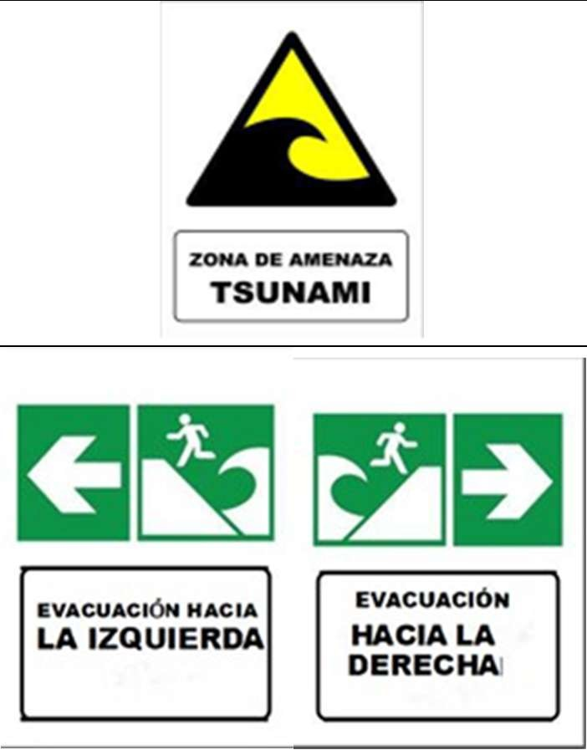 | Entering/Leaving Tsunami Hazard Zone | Width/Height (ft):
 | Entering/Leaving Tsunami Hazard Zone | Materials (e.g. aluminum, plastic, or fiber glass):
 | Entering/Leaving Tsunami Hazard Zone | Number of signs installed:
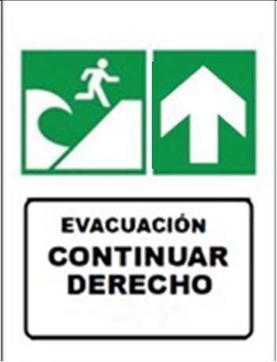 | Tsunami Evacuation Route | Width/Height (ft):
 | Tsunami Evacuation Route | Materials (e.g. aluminum, plastic, or fiber glass):
 | Tsunami Evacuation Route | Number of signs installed:
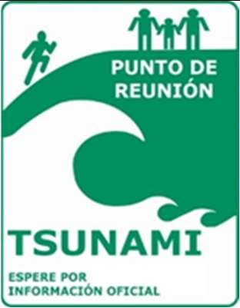 | Tsunami Assembly Point | Width/Height (ft):
 | Tsunami Assembly Point | Materials (e.g. aluminum, plastic, or fiber glass):
 | Tsunami Assembly Point | Number of signs installed:
 | Tsunami Evacuation Map | Width/Height (ft):
 | Tsunami Evacuation Map | Materials (e.g. aluminum, plastic, or fiber glass):
 | Tsunami Evacuation Map | Number of signs installed:
 | Tsunami Ready Recognition | Width/Height (ft):
 | Tsunami Ready Recognition | Materials (e.g. aluminum, plastic, or fiber glass):
 | Tsunami Ready Recognition | Number of signs installed:
Member State/Territory Contact Information
TNC: Ministerio de Medio Ambiente y Recursos Naturales, Viceministro de Recursos Costeros y Marinos. Tel: +18095674300 (Ext.: 7170), email: info@ambiente.gob.do
TWFP & NTWC: Ministerio de Medio Ambiente y Recursos Naturales – Centro de Pronóstico Oficina Nacional de Meteorología (ONAMET), Encargado División de Alerta de Tsunami. Tel: +18097881122 (Ext.201/202/228), email: sat.onamet@gmail.com, onamet40@gmail.com, onamet4@gmail.com, info@onamet.gob.do

Notes/Comments:
- In 2025 ITIC-CAR updated the Member State/Territory Contact Information (based on the document ICG/CARIBE-EWS DATABASE for TNCs, TWFPs, and NTWCs, 12, December, 2025).
- Documentation for Dominican Republic available here.

France
Signage Art/Photo | Signage Type | General Information
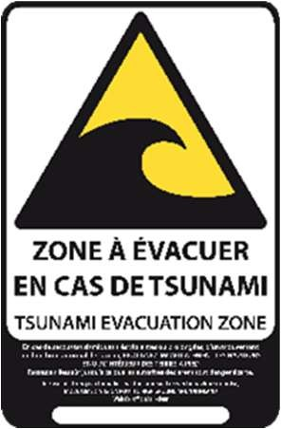 | Tsunami Hazard Zone | Width/Height (ft):  280 x 430 mm (without evacuation map)
 | Tsunami Hazard Zone | Materials (e.g. aluminum, plastic, or fiber glass):  Plastic and/or aluminum
 | Tsunami Hazard Zone | Number of signs installed:  Some installed in previous CaribeWave exercises
 | Entering/Leaving Tsunami Hazard Zone | Width/Height (ft):
 | Entering/Leaving Tsunami Hazard Zone | Materials (e.g. aluminum, plastic, or fiber glass):
 | Entering/Leaving Tsunami Hazard Zone | Number of signs installed:
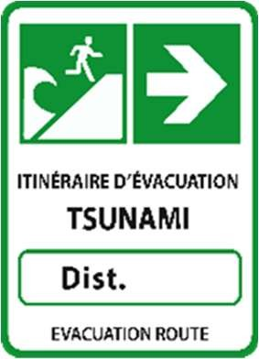  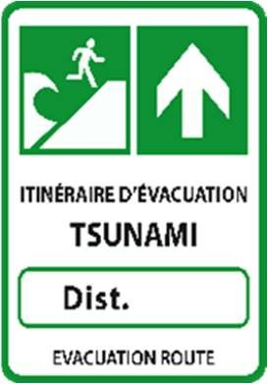  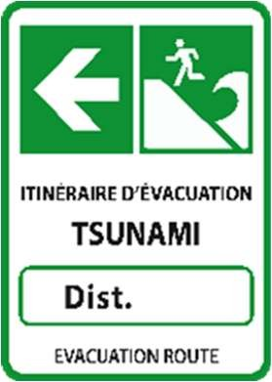  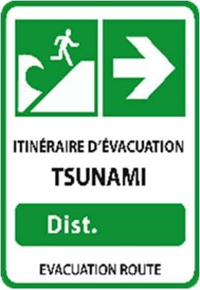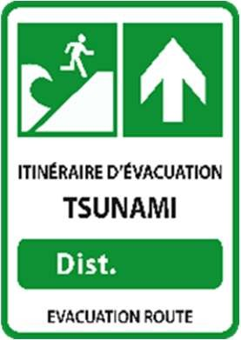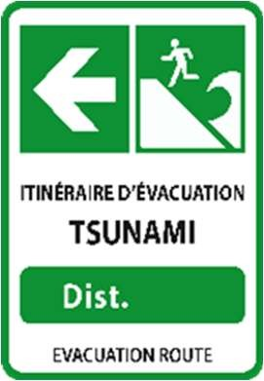 | Tsunami Evacuation Route | Width/Height (ft):  280 x 350 mm
 | Tsunami Evacuation Route | Materials (e.g. aluminum, plastic, or fiber glass):  Plastic and/or aluminum
 | Tsunami Evacuation Route | Number of signs installed:  Some installed in previous CaribeWave exercises
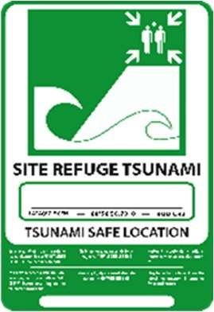 | Tsunami Assembly Point | Width/Height (ft):  280 x 350 mm
 | Tsunami Assembly Point | Materials (e.g. aluminum, plastic, or fiber glass):  Plastic and aluminum
 | Tsunami Assembly Point | Number of signs installed:  Some installed in previous CaribeWave exercises
Maps not publicly displayed? | Tsunami Evacuation Map | Width/Height (ft):  410 x 584 mm (with Tsunami Hazard zone sign)
Maps not publicly displayed? | Tsunami Evacuation Map | Materials (e.g. aluminum, plastic, or fiber glass):  Plastic and/or aluminum
Maps not publicly displayed? | Tsunami Evacuation Map | Number of signs installed:  Some installed in previous CaribeWave exercises
 | Tsunami Ready Recognition | Width/Height (ft):
 | Tsunami Ready Recognition | Materials (e.g. aluminum, plastic, or fiber glass):
 | Tsunami Ready Recognition | Number of signs installed:
Member State/Territory Contact Information
TNC: Geosciences Environnement Toulouse, Dr. Valérie Clouard. Tel: +33561332907, mobile: +33612816070, email: valerie.clouard@get.omp.eu Tsunami Advisor: LCL Patrick Tyburn (Service départamental d’Incendie et de Secours). E-mail: directeur@sdis972.fr
Notes/Comments:
- Corresponding documentation available here.
- mathieu.peroche@gmail.com was the initial survey respondent.
- The 2020 response states: “Answers written in this form only reflect the progress in terms of tsunami risk prevention at the French West Indies level (Martinique, Guadeloupe, Saint-Martin and Saint-Barthélemy). Discussions with the national level are frequent especially with the civil security and the CENALT (west Mediterranean tsunami alert center - http://www.info-tsunami.fr/). An official report from the
Ministry of the Interior (February 2019) mentions the above signage as the one to be installed in Metropolitan France.”
- In 2023 ITIC-CAR made updates to the Member State/Territory Contact Information (based on the document “NTWC, TNC, and TWFP for the EWS Caribbean Member States and Territories).

Grenada
Signage Art/Photo | Signage Type | General Information
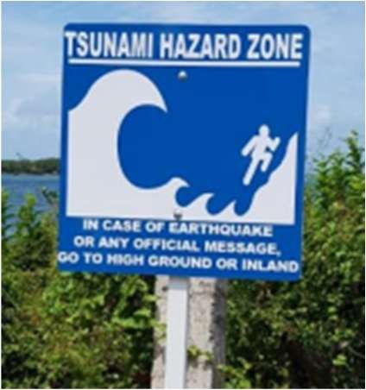 | Tsunami Hazard Zone | Width/Height (ft):  24” x 24”
 | Tsunami Hazard Zone | Materials (e.g. aluminum, plastic, or fiber glass):  PVC Foam Board
 | Tsunami Hazard Zone | Number of signs installed:  Carriacou & Petite Martinique 27, St. Patrick 16
 | Entering/Leaving Tsunami Hazard Zone | Width/Height (ft):
 | Entering/Leaving Tsunami Hazard Zone | Materials (e.g. aluminum, plastic, or fiber glass):
 | Entering/Leaving Tsunami Hazard Zone | Number of signs installed:
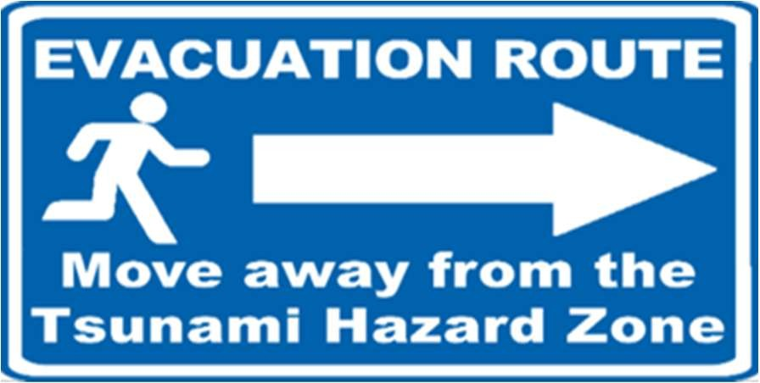 | Tsunami Evacuation Route | Width/Height (ft):  14.5"x 24"
 | Tsunami Evacuation Route | Materials (e.g. aluminum, plastic, or fiber glass):  PVC Foam Board
 | Tsunami Evacuation Route | Number of signs installed:  Carriacou & Petite Martinique 20, St. Patrick 12
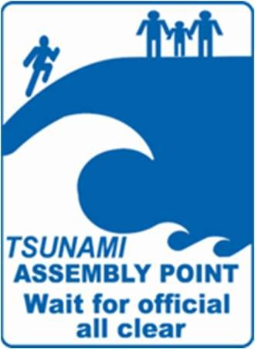 | Tsunami Assembly Point | Width/Height (ft):  36” x 24”
 | Tsunami Assembly Point | Materials (e.g. aluminum, plastic, or fiber glass):  PVC Foam Board
 | Tsunami Assembly Point | Number of signs installed:  Carriacou & Petite Martinique 7, St. Patrick 3
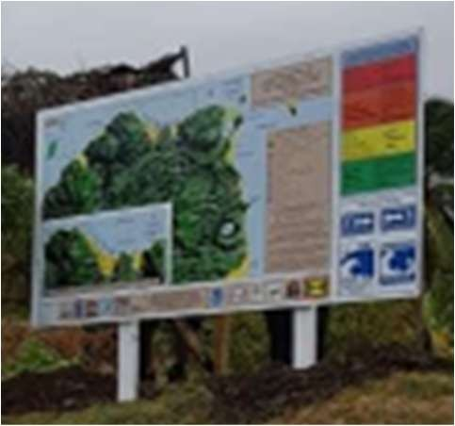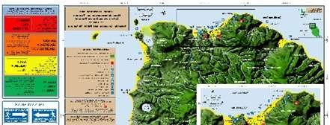 | Tsunami Evacuation Map | Width/Height (ft):  96” x 48”
 | Tsunami Evacuation Map | Materials (e.g. aluminum, plastic, or fiber glass):  PVC or Foam Board
 | Tsunami Evacuation Map | Number of signs installed: St. Patrick 2
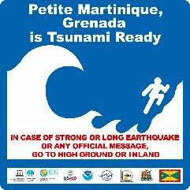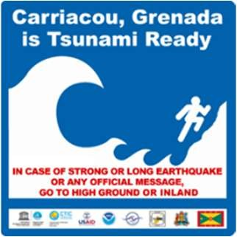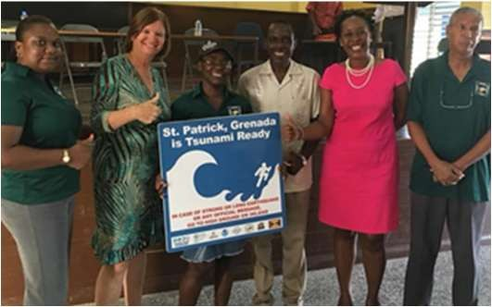 | Tsunami Ready Recognition | Width/Height (ft):
 | Tsunami Ready Recognition | Materials (e.g. aluminum, plastic, or fiber glass):
 | Tsunami Ready Recognition | Number of signs installed:
Member State/Territory Contact Information
TWFP: Grenada Meteorological Office, Ms. Kassia Johnson (Manager). Tel: +14734444142, +14734444150 ext. 2023, email: kjohnson@gaa.gd, meteorology@gaa.gd, forecaster@gaa.gd.
TNC: National Disaster Management Agency (NaDMA), Ms. Ruth Roberts (National Disaster Coordinator Ag.). Tel: +14734408390, email: pro@nadma.gd, rosejr71@gmail.com
Notes/Comments:
- Corresponding documentation for St. Patrick and Carriacou and Petite Martinique, Grenada available here.
- ITIC-CAR previously added all the signage art/photo, type, and information for this Member State/Territory.
- The 2020 response states: “There are two communities recognized as Tsunami Ready in Grenada: Carriacou & Petite Martinique and St.
Patrick.”
- In 2022 ITIC-CAR made updates to the signage/art, type, and information.
- ITIC-CAR Added Evacuation Map and Tsunami Ready Recognition for Petite Martinique
- In 2025 ITIC-CAR made updates to the Member State/Territory Contact Information (based on the document ICG/CARIBE-EWS DATABASE for TNCs, TWFPs, and NTWCs, 12, December, 2025).

Haiti
Signage Art/Photo | Signage Type | General Information
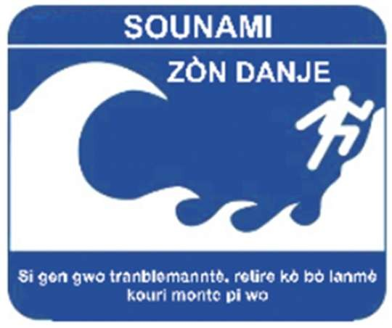 | Tsunami Hazard Zone | Width/Height (ft):
 | Tsunami Hazard Zone | Materials (e.g. aluminum, plastic, or fiber glass):  Aluminum
 | Tsunami Hazard Zone | Number of signs installed:
 | Entering/Leaving Tsunami Hazard Zone | Width/Height (ft):
 | Entering/Leaving Tsunami Hazard Zone | Materials (e.g. aluminum, plastic, or fiber glass):
 | Entering/Leaving Tsunami Hazard Zone | Number of signs installed:
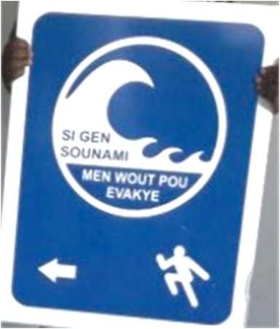 | Tsunami Evacuation Route | Width/Height (ft):
 | Tsunami Evacuation Route | Materials (e.g. aluminum, plastic, or fiber glass):  Aluminum
 | Tsunami Evacuation Route | Number of signs installed:
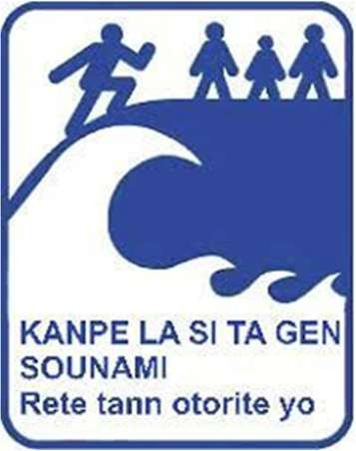 | Tsunami Assembly Point | Width/Height (ft):
 | Tsunami Assembly Point | Materials (e.g. aluminum, plastic, or fiber glass):  Aluminum
 | Tsunami Assembly Point | Number of signs installed:
Maps not publicly displayed | Tsunami Evacuation Map | Width/Height (ft):
Maps not publicly displayed | Tsunami Evacuation Map | Materials (e.g. aluminum, plastic, or fiber glass):
Maps not publicly displayed | Tsunami Evacuation Map | Number of signs installed:
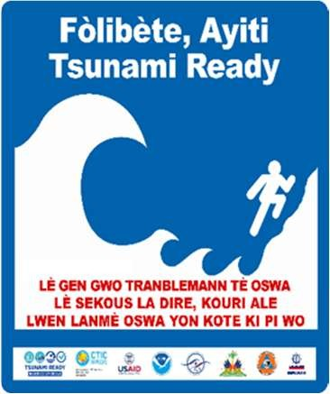 | Tsunami Ready Recognition | Width/Height (ft):
 | Tsunami Ready Recognition | Materials (e.g. aluminum, plastic, or fiber glass):
 | Tsunami Ready Recognition | Number of signs installed:
Member State/Territory Contact Information
TWFP: Unité Hydrométéorologique d’Haïti (UHM), Mr. Marcelin Esterlin (Coordinator). Tel: +50929111212, email: esterlinm@yahoo.fr
TNC: Service Maritime et de Navigation d’Haiti, Mr. Eric Prevost Jr (Directeur general). Tel: +50928161629, +50937706356+50948937805, email: juniorprevost@yahoo.com
Notes/Comments:
- Corresponding documentation for Fort-Liberté, Haiti available here.
- ITIC-CAR previously added all the signage art/photo, type, and information for this Member State/Territory.
- In 2025 ITIC-CAR made updates to the Member State/Territory Contact Information (based on the document ICG/CARIBE-EWS DATABASE for TNCs, TWFPs, and NTWCs, 12, December, 2025).

Honduras
Signage Art/Photo | Signage Type | General Information
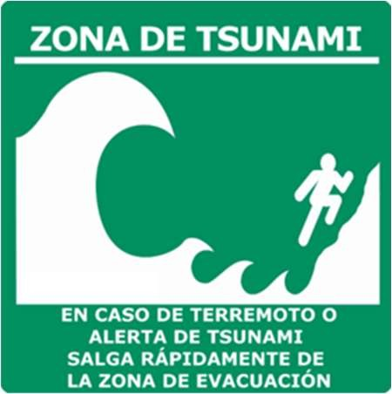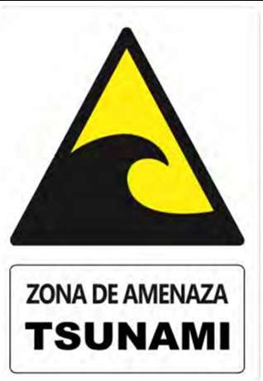 | Tsunami Hazard Zone | Width/Height (ft):
 | Tsunami Hazard Zone | Materials (e.g. aluminum, plastic, or fiber glass):
 | Tsunami Hazard Zone | Number of signs installed:
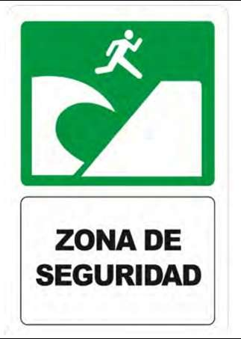 | Entering/Leaving Tsunami Hazard Zone | Width/Height (ft):
 | Entering/Leaving Tsunami Hazard Zone | Materials (e.g. aluminum, plastic, or fiber glass):
 | Entering/Leaving Tsunami Hazard Zone | Number of signs installed:
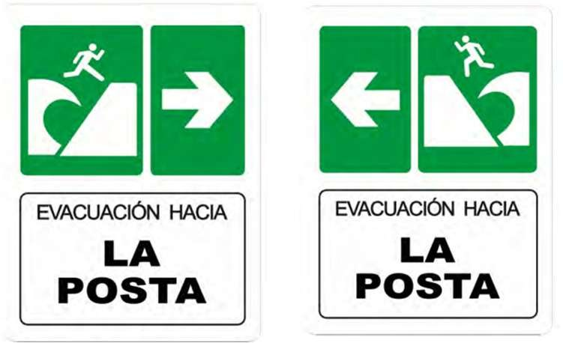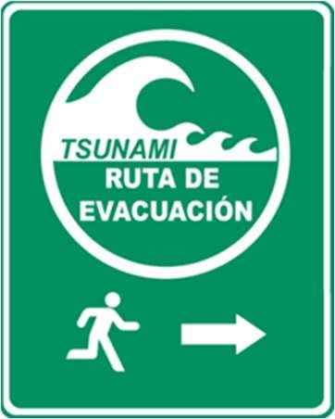 | Tsunami Evacuation Route | Width/Height (ft):
 | Tsunami Evacuation Route | Materials (e.g. aluminum, plastic, or fiber glass):
 | Tsunami Evacuation Route | Number of signs installed:
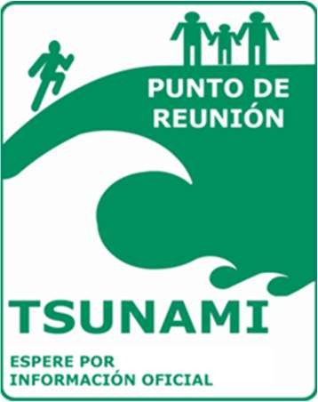 | Tsunami Assembly Point | Width/Height (ft):
 | Tsunami Assembly Point | Materials (e.g. aluminum, plastic, or fiber glass):
 | Tsunami Assembly Point | Number of signs installed:
Maps not publicly displayed | Tsunami Evacuation Map | Width/Height (ft):
Maps not publicly displayed | Tsunami Evacuation Map | Materials (e.g. aluminum, plastic, or fiber glass):
Maps not publicly displayed | Tsunami Evacuation Map | Number of signs installed:
 | Tsunami Ready Recognition | Width/Height (ft):
 | Tsunami Ready Recognition | Materials (e.g. aluminum, plastic, or fiber glass):
 | Tsunami Ready Recognition | Number of signs installed:
Member State/Territory Contact Information
TWFP: Secretaria de Estado en los Despachos de Gestión de Riesgos (COPECO), Ing. Jorge Aguilar (Jefe de Sismología). Tel:
+50433286958, email: twfp.ptws@copeco.gob.hn
NTWC: Secretaria de Estado en los Despachos de Gestión de Riesgos (COPECO), Mr. Victor Ortega (Alerta Temprana/COPECO). Tel: +50488436987, email: ntwc.copecohn@copeco.gob.hn
TNC: Secretaria de Estado en los Despachos de Gestión de Riesgos (COPECO), Ing. Iván Montalvo (Director de la Dirección de Gestión de Preparación y Respuesta). Tel: +50422290606 ext 410, email: ivan.montalvo@copeco.gob.hn
Notes/Comments:
- Corresponding documentation for Omoa and Tornabe/Tela available here.
- The 2020 response states: “The signage belongs to the Cedeño community, located in the Pacific coast of Honduras.”
- In 2023 ITIC-CAR made updates to signage art and photos (from the documents on (http://itic.iocunesco.org/index.php?option=com_content&view=category&layout=blog&id=2427&Itemid=3064)) (December 20, 2023)
- In 2025 ITIC-CAR made updates to the Member State/Territory Contact Information (based on the document ICG/CARIBE-EWS DATABASE for TNCs, TWFPs, and NTWCs, 12, December, 2025).

Jamaica
Signage Art/Photo | Signage Type | General Information
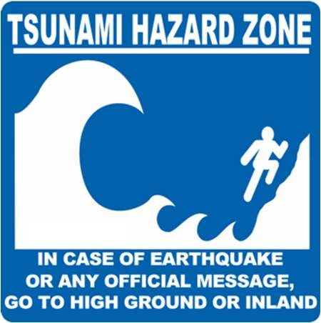 | Tsunami Hazard Zone | Width/Height (ft):
 | Tsunami Hazard Zone | Materials (e.g. aluminum, plastic, or fiber glass):
 | Tsunami Hazard Zone | Number of signs installed:
 | Entering/Leaving Tsunami Hazard Zone | Width/Height (ft):
 | Entering/Leaving Tsunami Hazard Zone | Materials (e.g. aluminum, plastic, or fiber glass):
 | Entering/Leaving Tsunami Hazard Zone | Number of signs installed:
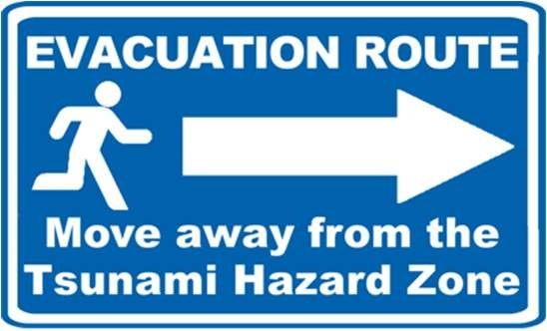  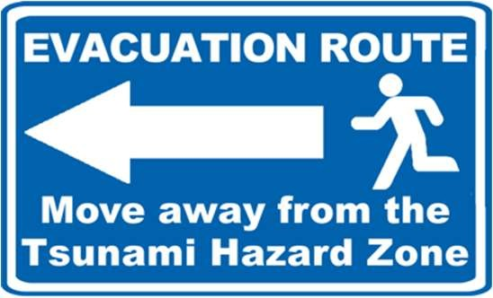 | Tsunami Evacuation Route | Width/Height (ft):
 | Tsunami Evacuation Route | Materials (e.g. aluminum, plastic, or fiber glass):
 | Tsunami Evacuation Route | Number of signs installed:
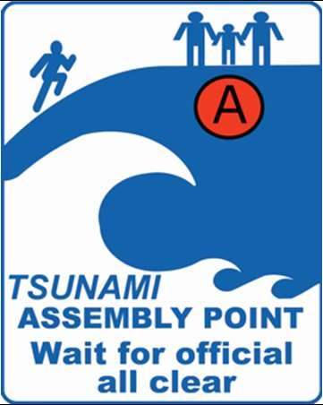 | Tsunami Assembly Point | Width/Height (ft):
 | Tsunami Assembly Point | Materials (e.g. aluminum, plastic, or fiber glass):
 | Tsunami Assembly Point | Number of signs installed:
Maps not publicly displayed | Tsunami Evacuation Map | Width/Height (ft):
Maps not publicly displayed | Tsunami Evacuation Map | Materials (e.g. aluminum, plastic, or fiber glass):
Maps not publicly displayed | Tsunami Evacuation Map | Number of signs installed:
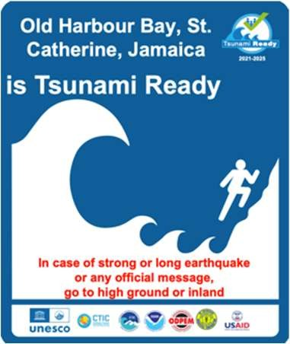 | Tsunami Ready Recognition | Width/Height (ft):
 | Tsunami Ready Recognition | Materials (e.g. aluminum, plastic, or fiber glass):
 | Tsunami Ready Recognition | Number of signs installed:
Member State/Territory Contact Information
NTWC: Office of Disaster Preparedness and Emergency Management (ODPEM), Senior Director, Preparedness & Emergency Operations Division or Senior Director, Mitigation Planning & Research Division. Tel: +18769069674-5, +18767549077-8, email: directorgeneralodpem@gmail.com, neocoperations@odpem.org.jm, ddgodpem@gmail.com.
TWFP: Meteorological Service Division, Head Weather Branch. Tel: +18769608990, email: nmcforecaster@metservice.gov.jm
TNC: Ministry of Local Government and Rural Development (MLGRD), Mr. Patrick Watson (Senior Director, Hazard Mitigation and Risk Management). Tel: + 18766187360-9 ext. 2068, email: pwatson@mlgcd.gov.jm
Notes/Comments:
- In 2022 ITIC-CAR added the signage/art, type and information.
- In 2025 ITIC-CAR updated the Member State/Territory Contact Information (based on the document ICG/CARIBE-EWS DATABASE for TNCs, TWFPs, and NTWCs, 12, December, 2025).

Kingdom of the Netherlands (Aruba)
Signage Art/Photo | Signage Type | General Information
 | Tsunami Hazard Zone | Width/Height (ft):
 | Tsunami Hazard Zone | Materials (e.g. aluminum, plastic, or fiber glass):
 | Tsunami Hazard Zone | Number of signs installed:
 | Entering/Leaving Tsunami Hazard Zone | Width/Height (ft):
 | Entering/Leaving Tsunami Hazard Zone | Materials (e.g. aluminum, plastic, or fiber glass):
 | Entering/Leaving Tsunami Hazard Zone | Number of signs installed:
 | Tsunami Evacuation Route | Width/Height (ft):
 | Tsunami Evacuation Route | Materials (e.g. aluminum, plastic, or fiber glass):
 | Tsunami Evacuation Route | Number of signs installed:
 | Tsunami Assembly Point | Width/Height (ft):
 | Tsunami Assembly Point | Materials (e.g. aluminum, plastic, or fiber glass):
 | Tsunami Assembly Point | Number of signs installed:
 | Tsunami Evacuation Map | Width/Height (ft):
 | Tsunami Evacuation Map | Materials (e.g. aluminum, plastic, or fiber glass):
 | Tsunami Evacuation Map | Number of signs installed:
 | Tsunami Ready Recognition | Width/Height (ft):
 | Tsunami Ready Recognition | Materials (e.g. aluminum, plastic, or fiber glass):
 | Tsunami Ready Recognition | Number of signs installed:
Member State/Territory Contact Information
NTWC, TWFP, and TNC: Meteorological Department Aruba, Mr. David Barkmeyer (Director). Tel: +2975826497, email: david.barkmeyer@meteo.aw, tsunami@meteo.aw.
Notes/Comments:
- Marck Oduber was the initial survey respondent.
- The 2020 response states: “Survey was together with disaster management office of Aruba (Marck Oduber/TNC). Survey section Tsunami Evacuation Maps and Signage was filled but there were no responses for the Tsunami Signage section.”
- In 2023 ITIC-CAR made updates to the Member State/Territory Contact Information (based on the document “NTWC, TNC, and TWFP for the EWS Caribbean Member States and Territories).

Kingdom of the Netherlands (Curaçao)
Signage Art/Photo | Signage Type | General Information
 | Tsunami Hazard Zone | Width/Height (ft):
 | Tsunami Hazard Zone | Materials (e.g. aluminum, plastic, or fiber glass):
 | Tsunami Hazard Zone | Number of signs installed:
 | Entering/Leaving Tsunami Hazard Zone | Width/Height (ft):
 | Entering/Leaving Tsunami Hazard Zone | Materials (e.g. aluminum, plastic, or fiber glass):
 | Entering/Leaving Tsunami Hazard Zone | Number of signs installed:
 | Tsunami Evacuation Route | Width/Height (ft):
 | Tsunami Evacuation Route | Materials (e.g. aluminum, plastic, or fiber glass):
 | Tsunami Evacuation Route | Number of signs installed:
 | Tsunami Assembly Point | Width/Height (ft):
 | Tsunami Assembly Point | Materials (e.g. aluminum, plastic, or fiber glass):
 | Tsunami Assembly Point | Number of signs installed:
 | Tsunami Evacuation Map | Width/Height (ft):
 | Tsunami Evacuation Map | Materials (e.g. aluminum, plastic, or fiber glass):
 | Tsunami Evacuation Map | Number of signs installed:
 | Tsunami Ready Recognition | Width/Height (ft):
 | Tsunami Ready Recognition | Materials (e.g. aluminum, plastic, or fiber glass):
 | Tsunami Ready Recognition | Number of signs installed:
Member State/Territory Contact Information
TWFP & TNC: Meteorological Department Curaçao, Dr. Albert E. Martis (Director). Tel: +59998393366, email: info@meteo.cw, forecaster@meteo.cw, albert.martis@meteo.cw, albert.martis@gobiernu.cw
Notes/Comments:
- Corinne Leysner (corinne.leysner@gmail.com) was the initial survey respondent.
- The 2020 response states: “Now that Curaçao has a Directorate of Risk Management we will pick up Tsunami risk management.”
- In 2022 ITIC-CAR made updates to the Member State/Territory Contact Information (based on the document “NTWC, TNC, and TWFP for the EWS Caribbean Member States and Territories).

Nicaragua
Signage Art/Photo | Signage Type | General Information
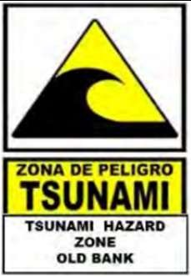 | Tsunami Hazard Zone | Width/Height (ft):
 | Tsunami Hazard Zone | Materials (e.g. aluminum, plastic, or fiber glass):
 | Tsunami Hazard Zone | Number of signs installed:
 | Entering/Leaving Tsunami Hazard Zone | Width/Height (ft):
 | Entering/Leaving Tsunami Hazard Zone | Materials (e.g. aluminum, plastic, or fiber glass):
 | Entering/Leaving Tsunami Hazard Zone | Number of signs installed:
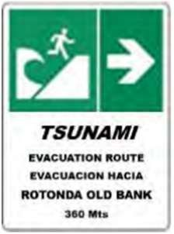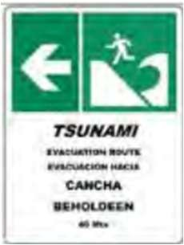 | Tsunami Evacuation Route | Width/Height (ft):
 | Tsunami Evacuation Route | Materials (e.g. aluminum, plastic, or fiber glass):
 | Tsunami Evacuation Route | Number of signs installed:
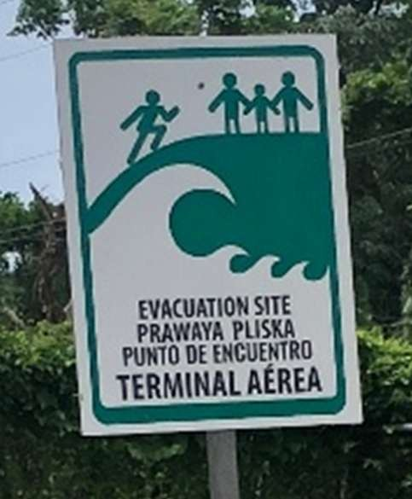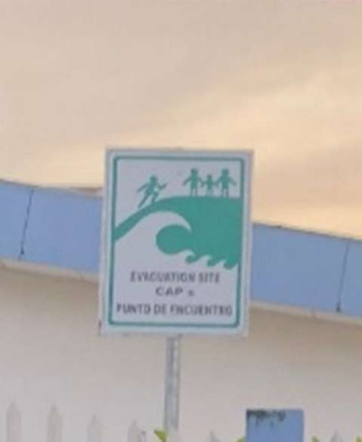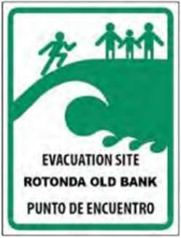 | Tsunami Assembly Point | Width/Height (ft):
 | Tsunami Assembly Point | Materials (e.g. aluminum, plastic, or fiber glass):
 | Tsunami Assembly Point | Number of signs installed:
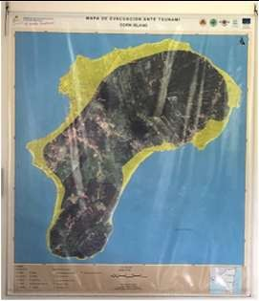  Maps not publicly displayed | Tsunami Evacuation Map | Width/Height (ft):
 | Tsunami Evacuation Map | Materials (e.g. aluminum, plastic, or fiber glass):
 | Tsunami Evacuation Map | Number of signs installed:
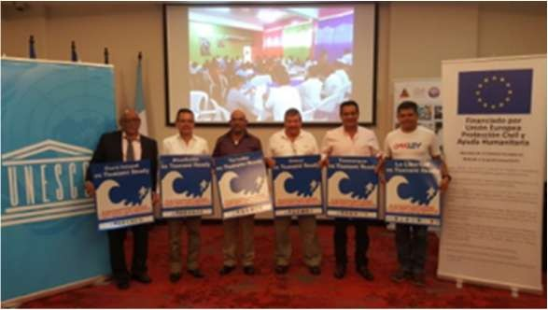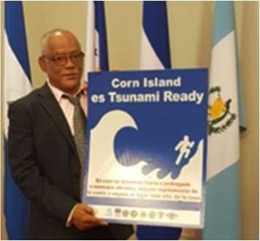 | Tsunami Ready Recognition | Width/Height (ft):
 | Tsunami Ready Recognition | Materials (e.g. aluminum, plastic, or fiber glass):
 | Tsunami Ready Recognition | Number of signs installed:
Member State/Territory Contact Information
TNC Alternate & TWFP: Instituto Nicaragüense de Estudios Territoriales (INETER), Dr. William Martinez (Director of Geological and Geophysics Division). Tel: +50522492761 ext 122, email: sismologia@ineter.gob.ni, ineter.tsunami@ineter.gob.ni
TWFP Alternate: Instituto Nicaragüense de Estudios Territoriales (INETER), Mr. Emilio Talavera (Director of Seismology). Tel: +50522492761 ext 102, email: sismologia@ineter.gob.ni, ineter.tsunami@ineter.gob.ni
Notes/Comments:
- ITIC-CAR previously added all the signage art/photo, type, and information for this Member State/Territory.
- The 2020 response states: “There are two communities recognized as Tsunami Ready in Nicaragua: Bluefields and Corn Islands. The signage pictures correspond to the community of Corn Island.”
- In 2022 ITIC-CAR made updates to the signage/art, type, and information.
- In 2023 ITIC-CAR made updates to the Member State/Territory Contact Information (based on the document “NTWC, TNC, and TWFP for the EWS Caribbean Member States and Territories, 27 January 2023”).
- In 2023 ITIC-CAR added Tsunami evacuation map picture from (http://itic.iocunesco.org/index.php?option=com_content&view=article&id=2107&Itemid=3051).

Saint Kitts and Nevis
Signage Art/Photo | Signage Type | General Information
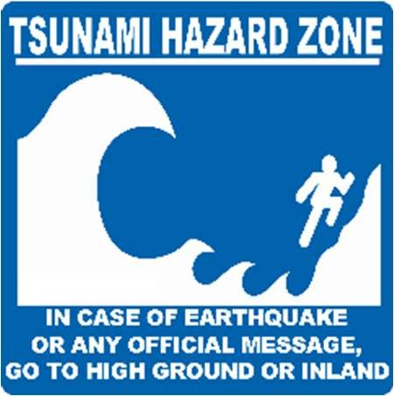 | Tsunami Hazard Zone | Width/Height (ft):  24” x 18”
 | Tsunami Hazard Zone | Materials (e.g. aluminum, plastic, or fiber glass):  High intensity grade prismatic reflective sheeting. Top laminated with Oraguard 2ml gloss. Mounted on aluminum blank
 | Tsunami Hazard Zone | Number of signs installed:  40
 | Entering/Leaving Tsunami Hazard Zone | Width/Height (ft):
 | Entering/Leaving Tsunami Hazard Zone | Materials (e.g. aluminum, plastic, or fiber glass):
 | Entering/Leaving Tsunami Hazard Zone | Number of signs installed:
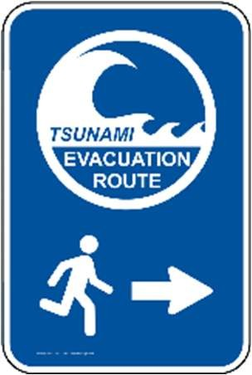 | Tsunami Evacuation Route | Width/Height (ft):  24” x 18”
 | Tsunami Evacuation Route | Materials (e.g. aluminum, plastic, or fiber glass):  High intensity grade prismatic reflective sheeting top laminated with Oraguard 2ml gloss
 | Tsunami Evacuation Route | Number of signs installed:  18
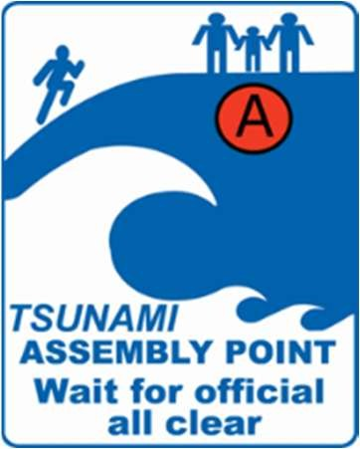 | Tsunami Assembly Point | Width/Height (ft):  24” x 18”
 | Tsunami Assembly Point | Materials (e.g. aluminum, plastic, or fiber glass):  High intensity grade prismatic reflective sheeting. Top laminated with Oraguard 2ml gloss. Mounted on aluminum blank.
 | Tsunami Assembly Point | Number of signs installed:  20
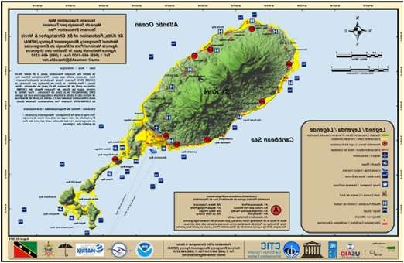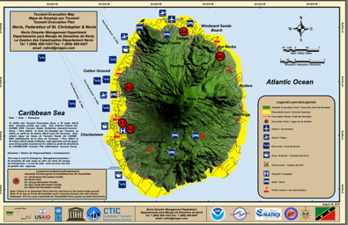 | Tsunami Evacuation Map | Width/Height (ft):  28” x 20”; 26” x 24”
 | Tsunami Evacuation Map | Materials (e.g. aluminum, plastic, or fiber glass):  Laminated poster
 | Tsunami Evacuation Map | Number of signs installed:  4; 4
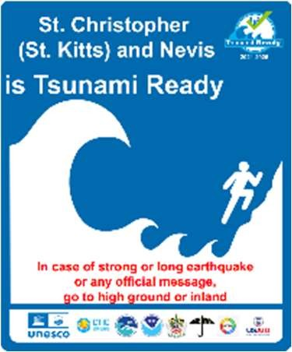 | Tsunami Ready Recognition | Width/Height (ft): 24” x 18”
 | Tsunami Ready Recognition | Materials (e.g. aluminum, plastic, or fiber glass): High intensity grade prismatic reflective sheeting. Top laminated with Oraguard 2ml gloss. Mounted on aluminum blank
 | Tsunami Ready Recognition | Number of signs installed:  2
TNC: National Emergency Member State/Territory Contact Information
TWFP: Royal St. Christopher Nevis Police Force, Mr. James Sutton (Commissioner of Police ). Tel: +18694652241, mobile: +869 662-8480, fax:
+18694657078, email: james.sutton@police.kn . Lyndon David Tel: +18694652241, mobile: +869 662-0302, email: lyndon.david@police.kn
fax: +18694657078.
Focal point email: skn.twfp@police.kn.

TNC: Management Agency (NEMA), Mr. Livingston Pemberton (National Disaster Coordinator ). Mobile: +18697621967, email: livingston.pemberton@gov.kn
Notes/Comments:
- Corresponding documentation for Saint Kitts and Nevis available here.
- ITIC-CAR previously added all the signage art/photo, type, and information for this Member State/Territory.
- In 2022 ITIC-CAR made updates to the signage/art, type, and information.
- 200 vinyl laminated with Oraguard 2 ml gloss property stickers were prepared.
- 2023 ITIC CAR added the Tsunami evacuation map (December 20, 2023)
The Chair for EWS Working Group 4 directly contacted superintendent Lydon David from the St Kitts Nevis Royal Police to update the contact information in 12, December, 2025.

Saint Lucia
Signage Art/Photo | Signage Type | General Information
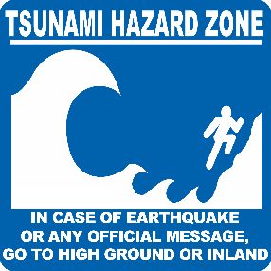 | Tsunami Hazard Zone | Width/Height (ft): 24” x 24”
 | Tsunami Hazard Zone | Materials (e.g. aluminum, plastic, or fiber glass): Plastic and pole, plastic and wall
 | Tsunami Hazard Zone | Number of signs installed: 7
 | Entering/Leaving Tsunami Hazard Zone | Width/Height (ft):
 | Entering/Leaving Tsunami Hazard Zone | Materials (e.g. aluminum, plastic, or fiber glass):
 | Entering/Leaving Tsunami Hazard Zone | Number of signs installed:
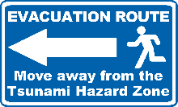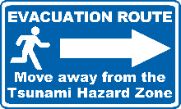 | Tsunami Evacuation Route | Width/Height (ft):14.5” x 24”
 | Tsunami Evacuation Route | Materials (e.g. aluminum, plastic, or fiber glass): Metal and pole, Metal
 | Tsunami Evacuation Route | Number of signs installed: 11
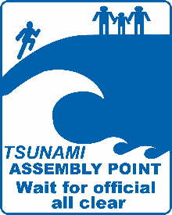 | Tsunami Assembly Point | Width/Height (ft): 36” x 24”
 | Tsunami Assembly Point | Materials (e.g. aluminum, plastic, or fiber glass): Metal and pole, metal and fence, plastic and wall
 | Tsunami Assembly Point | Number of signs installed: 7
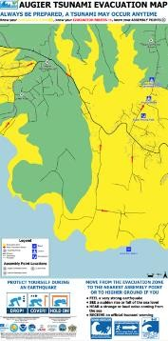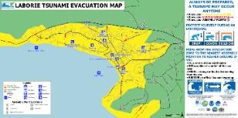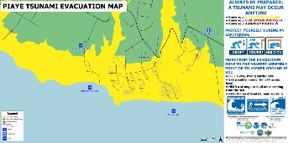 | Tsunami Evacuation Map | Width/Height (ft): 48” x 96”
 | Tsunami Evacuation Map | Materials (e.g. aluminum, plastic, or fiber glass): Metal and pole, Plastic and wall
 | Tsunami Evacuation Map | Number of signs installed: 3
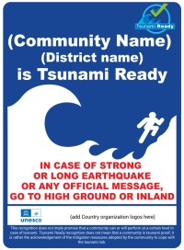 | Tsunami Ready Recognition | Width/Height (ft): 30” x 30”
 | Tsunami Ready Recognition | Materials (e.g. aluminum, plastic, or fiber glass): Metal and pole, plastic and wall
 | Tsunami Ready Recognition | Number of signs installed: 1
Member State/Territory Contact Information
TWFP: Saint Lucia Meteorological Services, Ms. Vigil Saltibus (Director). Tel: +17584546550, +17587292490, email: slumet@yahoo.com
TNC: National Emergency Management Organization (NEMO). Mrs. Kenisha Jeffrey-Isembert (Director). Tel: +17584523802, email: kenisha.jeffrey@govt.lc
Notes/Comments:
- In 2023 ITIC-CAR added signage general information (December 18, 2023)
- In 2025 ITIC-CAR updated the Member State/Territory Contact Information (based on the document ICG/CARIBE-EWS DATABASE for TNCs, TWFPs, and NTWCs, 12, December, 2025).

Saint Vincent and the Grenadines
Signage Art/Photo | Signage Type | General Information
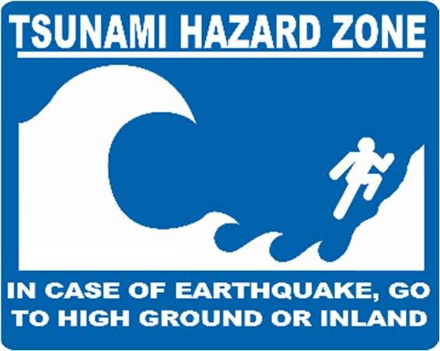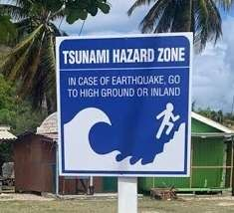 | Tsunami Hazard Zone | Width/Height (ft):  24’’ x 24’’/ 6ft
 | Tsunami Hazard Zone | Materials (e.g. aluminum, plastic, or fiber glass):  Aluminum and 2’’ galvanized tubing
 | Tsunami Hazard Zone | Number of signs installed:  St. George 10, Union Island 5
 | Entering/Leaving Tsunami Hazard Zone | Width/Height (ft):
 | Entering/Leaving Tsunami Hazard Zone | Materials (e.g. aluminum, plastic, or fiber glass):
 | Entering/Leaving Tsunami Hazard Zone | Number of signs installed:
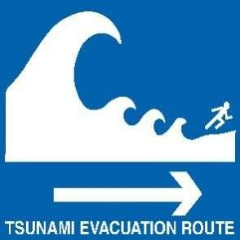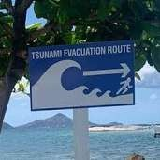 | Tsunami Evacuation Route | Width/Height (ft):  14.5’’ x 24’’/6ft
 | Tsunami Evacuation Route | Materials (e.g. aluminum, plastic, or fiber glass):  Aluminum and 2’’ galvanized tubing
 | Tsunami Evacuation Route | Number of signs installed:  St: George 11, Union Island 8
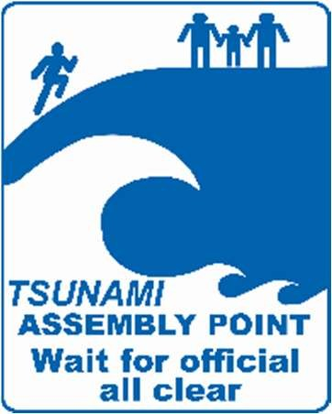 | Tsunami Assembly Point | Width/Height (ft):  24’’ x 30’’/ 6ft
 | Tsunami Assembly Point | Materials (e.g. aluminum, plastic, or fiber glass):  Aluminum and 2’’ galvanized tubing
 | Tsunami Assembly Point | Number of signs installed:  St. George 11, Union Island 8
Maps not publicly displayed 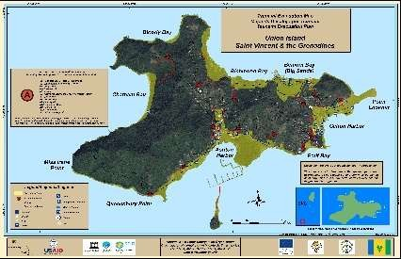 | Tsunami Evacuation Map | Width/Height (ft):  4’x 8’/6 ft
 | Tsunami Evacuation Map | Materials (e.g. aluminum, plastic, or fiber glass):  Aluminum and 2’’ galvanized tubing
 | Tsunami Evacuation Map | Number of signs installed:  St. George 7, Union Island 2
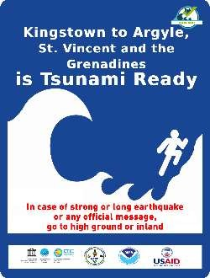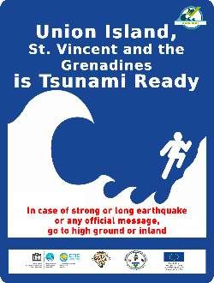 | Tsunami Ready Recognition | Width/Height (ft):
 | Tsunami Ready Recognition | Materials (e.g. aluminum, plastic, or fiber glass):
 | Tsunami Ready Recognition | Number of signs installed:
Member State/Territory Contact Information
NTWC: National Emergency Management Organization (NEMO). Tel: +17844562975, email: nemosvg@gov.vc
TNC & TWFP: National Emergency Management Organization (NEMO), Michelle Forbes (Acting Director). Tel: +17844512381, +17844562975. Email: nemosvg@gmail.com, nemosvg@gov.vc, michivic@hotmail.com
Notes/Comments:
- Corresponding documentation for Union Island, St. Vincent and the Grenadines available here.
- ITIC-CAR previously added all the signage art/photo, type, and information for this Member State/Territory.
- The 2020 response states: “There are two communities recognized as Tsunami Ready in Saint Vincent and The Grenadines: St. George
Parish and Union Island.”
- In 2022 ITIC-CAR made updates to the signage/art, type, information.
- In 2023 ITIC-CAR made updates to the Member State/Territory Contact Information (based on the document “NTWC, TNC, and TWFP for the EWS Caribbean Member States and Territories).
- ?? EVACUATION MAP

Trinidad and Tobago
Signage Art/Photo | Signage Type | General Information
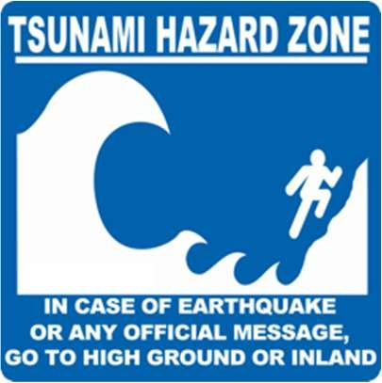 | Tsunami Hazard Zone | Width/Height (ft):  24” x 24”
 | Tsunami Hazard Zone | Materials (e.g. aluminum, plastic, or fiber glass):  Aluminum
 | Tsunami Hazard Zone | Number of signs installed:  7
 | Entering/Leaving Tsunami Hazard Zone | Width/Height (ft):
 | Entering/Leaving Tsunami Hazard Zone | Materials (e.g. aluminum, plastic, or fiber glass):
 | Entering/Leaving Tsunami Hazard Zone | Number of signs installed:
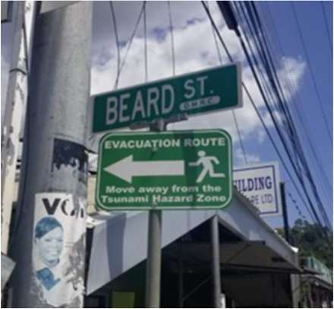 | Tsunami Evacuation Route | Width/Height (ft):  36” x 36”
 | Tsunami Evacuation Route | Materials (e.g. aluminum, plastic, or fiber glass):  Aluminum
 | Tsunami Evacuation Route | Number of signs installed:  7
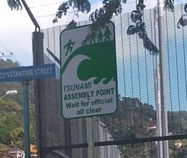 | Tsunami Assembly Point | Width/Height (ft):  36” x 24”
 | Tsunami Assembly Point | Materials (e.g. aluminum, plastic, or fiber glass):
 | Tsunami Assembly Point | Number of signs installed:  2
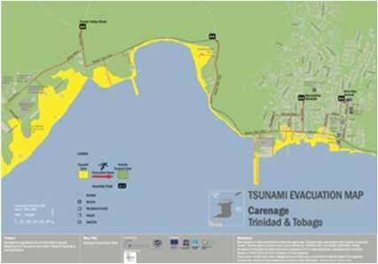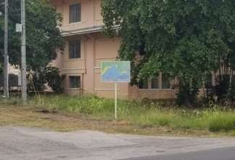 | Tsunami Evacuation Map | Width/Height (ft):
 | Tsunami Evacuation Map | Materials (e.g. aluminum, plastic, or fiber glass):
 | Tsunami Evacuation Map | Number of signs installed:
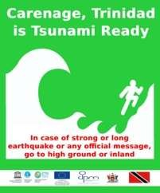 | Tsunami Ready Recognition | Width/Height (ft):  36” x 24”
 | Tsunami Ready Recognition | Materials (e.g. aluminum, plastic, or fiber glass):  Aluminum
 | Tsunami Ready Recognition | Number of signs installed:  1
Member State/Territory Contact Information
NTWC & TNC: Office of Disaster Preparedness and Management (ODPM), Major General (Retired) Rodney Smart (Chief Executive Officer). Tel:
+18686401285, email: rsmart@mns.gov.tt , odpmalerts@mns.gov.tt
TWFP: Trinidad and Tobago Meteorological Services, Mr. Ezekiel Sampson (Director Ag). Tel: +18686694392, +18686695465, email:
synop@metoffice.gov.tt, dirmet@metoffice.gov.tt
Notes/Comments:
- Corresponding documentation for Carenage, Trinidad available here.
- Muhammad Anwar Baksh was the initial survey respondent.
- The 2020 response states: “The signage corresponds to the community of Carenage.” - In 2022 ITIC-CAR made updates to the signage/art, type, information.
- In 2023 ITIC-CAR made updates to the Member State/Territory Contact Information (based on the document “NTWC, TNC, and TWFP for the EWS Caribbean Member States and Territories).

United Kingdom Overseas Territories (Anguilla)
Signage Art/Photo | Signage Type | General Information
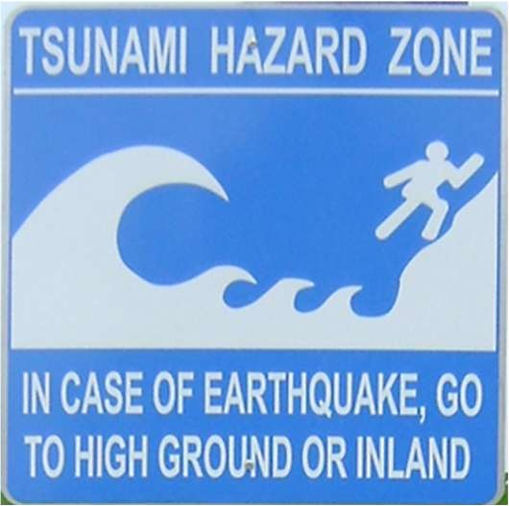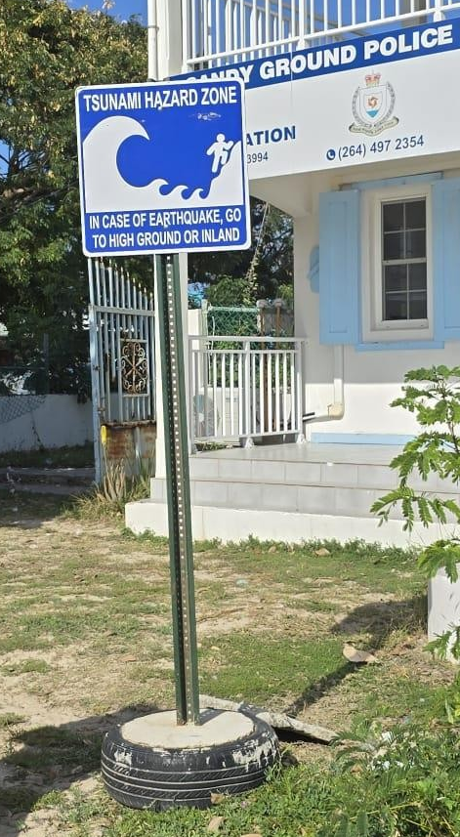 | Tsunami Hazard Zone | Width/Height (ft):  24” x 24”
 | Tsunami Hazard Zone | Materials (e.g. aluminum, plastic, or fiber glass):  Aluminum, Print on Laminated Adhesive Vinyl on ACM Board with U-channel Post Mounted  and Stainless Steel Hardware
 | Tsunami Hazard Zone | Number of signs installed:  17
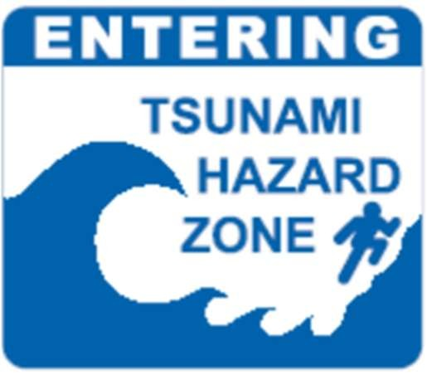 | Entering/Leaving Tsunami Hazard Zone | Width/Height (ft):  24” x 24”
 | Entering/Leaving Tsunami Hazard Zone | Materials (e.g. aluminum, plastic, or fiber glass):  Aluminum
 | Entering/Leaving Tsunami Hazard Zone | Number of signs installed:  A few (unknown how many)
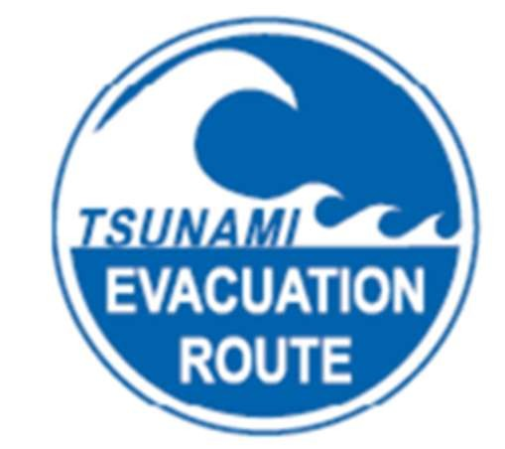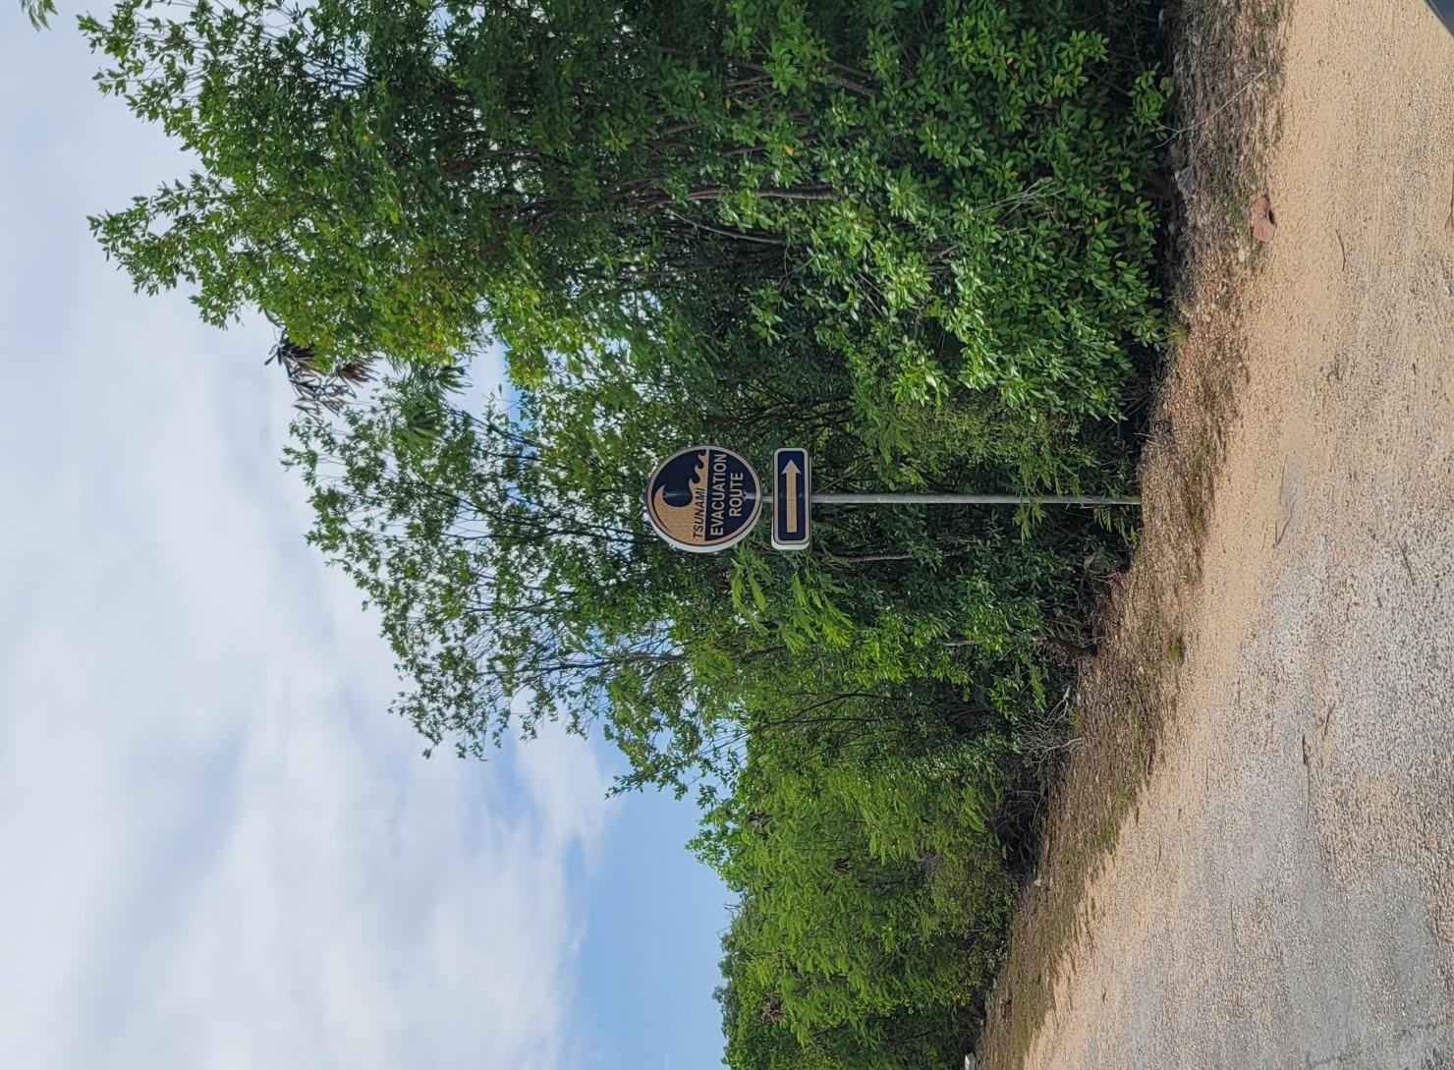 | Tsunami Evacuation Route | Width/Height (ft): 24in w x 30in h
 | Tsunami Evacuation Route | Materials (e.g. aluminum, plastic, or fiber glass):  Aluminum, Print on Laminated Adhesive Vinyl on ACM Board with U-channel Post Mounted  and Stainless Steel Hardware
 | Tsunami Evacuation Route | Number of signs installed: 28
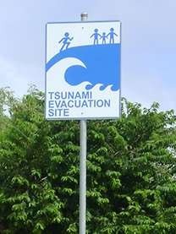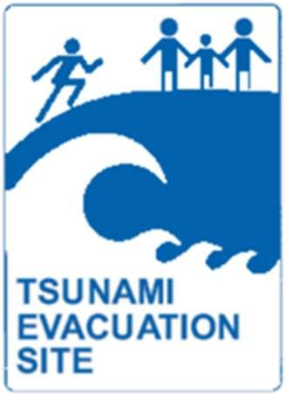 | Tsunami Assembly Point | Width/Height (ft):  24” x 36”
 | Tsunami Assembly Point | Materials (e.g. aluminum, plastic, or fiber glass):  Aluminum, Print on Laminated Adhesive Vinyl on ACM Board with U-channel Post Mounted  and Stainless Steel Hardware
 | Tsunami Assembly Point | Number of signs installed:  15
Maps not publicly displayed | Tsunami Evacuation Map | Width/Height (ft):
Maps not publicly displayed | Tsunami Evacuation Map | Materials (e.g. aluminum, plastic, or fiber glass):
Maps not publicly displayed | Tsunami Evacuation Map | Number of signs installed:
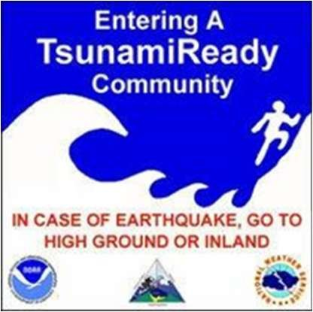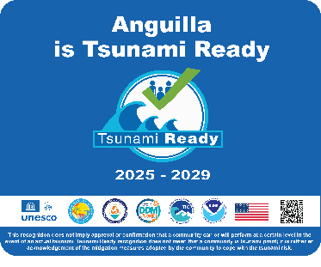 | Tsunami Ready Recognition | Width/Height (ft):  24” x 36”
 | Tsunami Ready Recognition | Materials (e.g. aluminum, plastic, or fiber glass): Full Colour Print on Laminated Adhesive Vinyl Mounted on PVC Board
 | Tsunami Ready Recognition | Number of signs installed: 3
Member State/Territory Contact Information
TWFP: Royal Anguilla Police Force Dispatch, Mr. David Lynch (Commissioner of Police). Tel: +12644972333, email: david.lynch@gov.ai,
TWFP@gov.ai
TNC & TWFP Alternate: Department of Disaster Management (DDM), Mr. Trevor Queeley (Deputy Direction). Mobile: + 12644763623. e-mail:
Trevor.Queeley@gov.ai
United Kingdom TNC: Dr. Angela Hibbert (Head of Sea Level and Ocean Climate). Tel: +441517954824, email: anhi@noc.ac.uk
Notes/Comments:
- Corresponding documentation for Anguilla available here.
- ddm@gov.ai was the initial survey respondent.
- ITIC-CAR previously added all the signage art/photo, type, and information for this Member State/Territory.
- In 2022 ITIC-CAR made updates to the signage/art, type, and information.
- In 2025 ITIC-CAR updated the Member State/Territory Contact Information (based on the document ICG/CARIBE-EWS DATABASE for TNCs, TWFPs, and NTWCs, 12 December 2025).

United Kingdom Overseas Territories (Bermuda)
Signage Art/Photo | Signage Type | General Information
 | Tsunami Hazard Zone | Width/Height (ft):
 | Tsunami Hazard Zone | Materials (e.g. aluminum, plastic, or fiber glass):
 | Tsunami Hazard Zone | Number of signs installed:
 | Entering/Leaving Tsunami Hazard Zone | Width/Height (ft):
 | Entering/Leaving Tsunami Hazard Zone | Materials (e.g. aluminum, plastic, or fiber glass):
 | Entering/Leaving Tsunami Hazard Zone | Number of signs installed:
 | Tsunami Evacuation Route | Width/Height (ft):
 | Tsunami Evacuation Route | Materials (e.g. aluminum, plastic, or fiber glass):
 | Tsunami Evacuation Route | Number of signs installed:
 | Tsunami Assembly Point | Width/Height (ft):
 | Tsunami Assembly Point | Materials (e.g. aluminum, plastic, or fiber glass):
 | Tsunami Assembly Point | Number of signs installed:
 | Tsunami Evacuation Map | Width/Height (ft):
 | Tsunami Evacuation Map | Materials (e.g. aluminum, plastic, or fiber glass):
 | Tsunami Evacuation Map | Number of signs installed:
 | Tsunami Ready Recognition | Width/Height (ft):
 | Tsunami Ready Recognition | Materials (e.g. aluminum, plastic, or fiber glass):
 | Tsunami Ready Recognition | Number of signs installed:
Member State/Territory Contact Information
TWFP: Bermuda Weather Service, Duty Forecaster. Tel: +14412935067 ext. 402, 452, or 403, email: contact@weather.bm, observers@weather.bm
TNC: Bermuda Weather Service, Alex Young (Deputy Director). Tel: + 4412935067, email: alex@weather.bm
United Kingdom TNC: Dr. Angela Hibbert (Head of Sea Level and Ocean Climate). Tel: +441517954824, email: anhi@noc.ac.uk
Notes/Comments:
- scosham2@gov.bm
- In 2023 ITIC-CAR made updates to the Member State/Territory Contact Information (based on the document “NTWC, TNC, and TWFP for the EWS Caribbean Member States and Territories, 27 January 2023”).
- In 2025 ITIC-CAR updated the Member State/Territory Contact Information (based on the document ICG/CARIBE-EWS DATABASE for TNCs, TWFPs, and NTWCs, , 12, December, 2025).

United Kingdom Overseas Territories (British Virgin Islands)
Signage Art/Photo | Signage Type | General Information
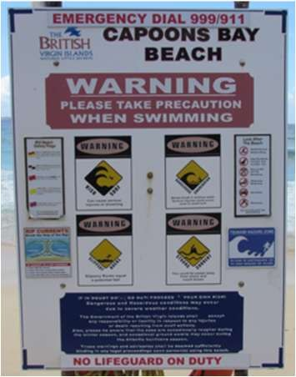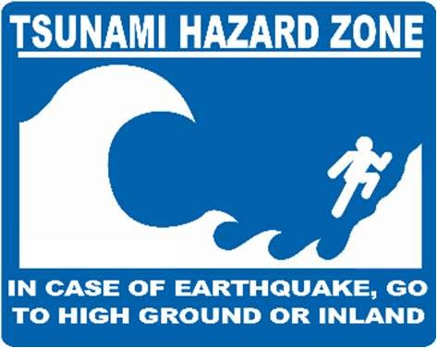 | Tsunami Hazard Zone | Width/Height (ft):
 | Tsunami Hazard Zone | Materials (e.g. aluminum, plastic, or fiber glass):
 | Tsunami Hazard Zone | Number of signs installed:
 | Entering/Leaving Tsunami Hazard Zone | Width/Height (ft):
 | Entering/Leaving Tsunami Hazard Zone | Materials (e.g. aluminum, plastic, or fiber glass):
 | Entering/Leaving Tsunami Hazard Zone | Number of signs installed:
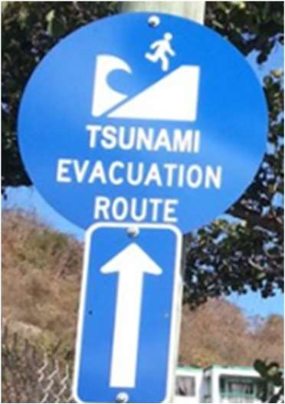 | Tsunami Evacuation Route | Width/Height (ft): 12”
 | Tsunami Evacuation Route | Materials (e.g. aluminum, plastic, or fiber glass):  Aluminum (circular)
 | Tsunami Evacuation Route | Number of signs installed:  60
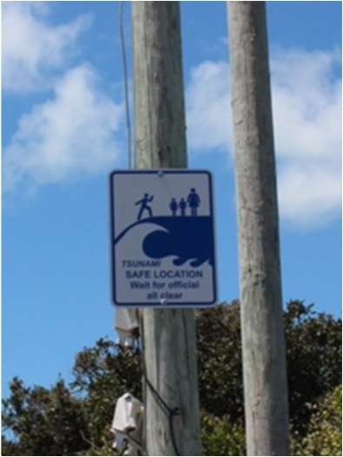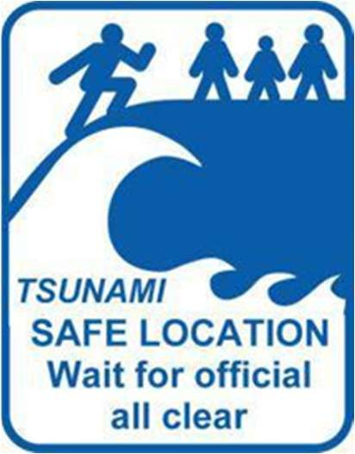 | Tsunami Assembly Point | Width/Height (ft):
 | Tsunami Assembly Point | Materials (e.g. aluminum, plastic, or fiber glass):  Aluminum
 | Tsunami Assembly Point | Number of signs installed:  12
Maps not publicly displayed | Tsunami Evacuation Map | Width/Height (ft):
Maps not publicly displayed | Tsunami Evacuation Map | Materials (e.g. aluminum, plastic, or fiber glass):
Maps not publicly displayed | Tsunami Evacuation Map | Number of signs installed:
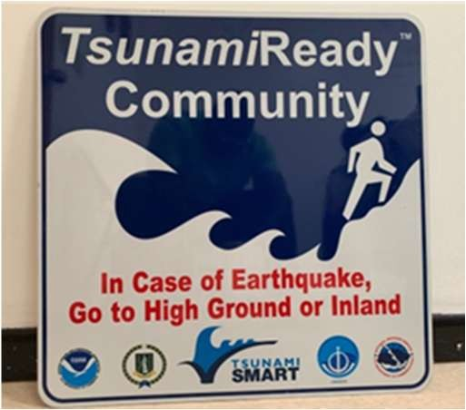 | Tsunami Ready Recognition | Width/Height (ft):
 | Tsunami Ready Recognition | Materials (e.g. aluminum, plastic, or fiber glass):
 | Tsunami Ready Recognition | Number of signs installed:  6
Member State/Territory Contact Information
TWFP: Royal Virgin Islands Police Force, Mr. Mark Collins (Commissioner of Police). Tel: +12843685371, email: mcollins@rvipolice.vg, control@rvipolice.vg
TNC: Department of Disaster Management, Mr. Jasen Penn (Director Ag). Tel: +12844684200, email: bviddm@surfbvi.com, japenn@gov.vg, jasen.penn@gmail.com
United Kingdom TNC: Dr. Angela Hibbert (Head of Sea Level and Ocean Climate). Tel: +441517954824, email: anhi@noc.ac.uk
Notes/Comments:
- bviddm@surfbvi.com and chicks@gov.vg were the initial survey respondents.
- ITIC-CAR previously added all the signage art/photo, type, and information for this Member State/Territory.
- In 2022 ITIC-CAR updated signage art/photo, type, and information for this Member State/Territory.
- In 2025 ITIC-CAR updated the Member State/Territory Contact Information (based on the document ICG/CARIBE-EWS DATABASE for TNCs, TWFPs, and NTWCs, , 12, December, 2025).

United Kingdom Overseas Territories (Turks and Caicos Islands)
Signage Art/Photo | Signage Type | General Information
 | Tsunami Hazard Zone | Width/Height (ft):
 | Tsunami Hazard Zone | Materials (e.g. aluminum, plastic, or fiber glass):
 | Tsunami Hazard Zone | Number of signs installed:
 | Entering/Leaving Tsunami Hazard Zone | Width/Height (ft):
 | Entering/Leaving Tsunami Hazard Zone | Materials (e.g. aluminum, plastic, or fiber glass):
 | Entering/Leaving Tsunami Hazard Zone | Number of signs installed:
 | Tsunami Evacuation Route | Width/Height (ft):
 | Tsunami Evacuation Route | Materials (e.g. aluminum, plastic, or fiber glass):
 | Tsunami Evacuation Route | Number of signs installed:
 | Tsunami Assembly Point | Width/Height (ft):
 | Tsunami Assembly Point | Materials (e.g. aluminum, plastic, or fiber glass):
 | Tsunami Assembly Point | Number of signs installed:
 | Tsunami Evacuation Map | Width/Height (ft):
 | Tsunami Evacuation Map | Materials (e.g. aluminum, plastic, or fiber glass):
 | Tsunami Evacuation Map | Number of signs installed:
 | Tsunami Ready Recognition | Width/Height (ft):
 | Tsunami Ready Recognition | Materials (e.g. aluminum, plastic, or fiber glass):
 | Tsunami Ready Recognition | Number of signs installed:
Member State/Territory Contact Information
NTWC, & TNC: Department of Disaster Management and Emergencies TCIG, Mrs. Allison Gordon (Director). Mobile: +16493468542, email: agordon@gov.tc
TWFP: 911 Emergency Call Centre, Tel: +16499465255, email: 911ECC@tcipolice.tc
United Kingdom TNC: Dr. Angela Hibbert (Head of Sea Level and Ocean Climate). Tel: +441517954824, email: anhi@noc.ac.uk
Notes/Comments:
- mclerveaux@gov.tc was the initial survey respondent.
- The 2020 response states: “The Department have completed a tsunami model so far. The Tsunami Plan is still in draft stage. We will begin mapping the evacuation routes for each island based on the results of the tsunami model”.
- In 2022 ITIC-CAR did not find any signage in the documentation and online sources review.
- In 2025 ITIC-CAR updated the Member State/Territory Contact Information (based on the document ICG/CARIBE-EWS DATABASE for TNCs, TWFPs, and NTWCs, , 12, December, 2025).

United States (Puerto Rico)
Signage Art/Photo | Signage Type | General Information
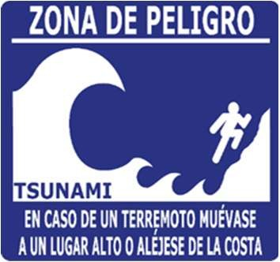 | Tsunami Hazard Zone | Width/Height (ft):
 | Tsunami Hazard Zone | Materials (e.g. aluminum, plastic, or fiber glass):  Fiberglass
 | Tsunami Hazard Zone | Number of signs installed:  >100
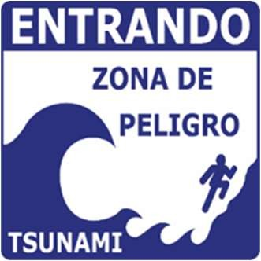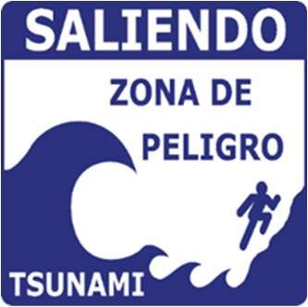 | Entering/Leaving Tsunami Hazard Zone | Width/Height (ft):
 | Entering/Leaving Tsunami Hazard Zone | Materials (e.g. aluminum, plastic, or fiber glass):  Fiberglass
 | Entering/Leaving Tsunami Hazard Zone | Number of signs installed:  >100
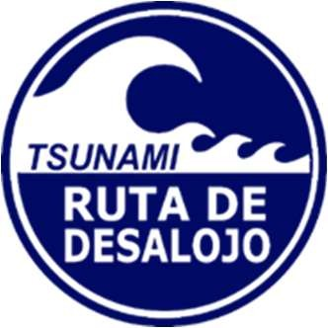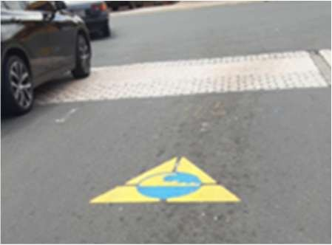 | Tsunami Evacuation Route | Width/Height (ft):
 | Tsunami Evacuation Route | Materials (e.g. aluminum, plastic, or fiber glass):  Fiberglass
 | Tsunami Evacuation Route | Number of signs installed:  >100
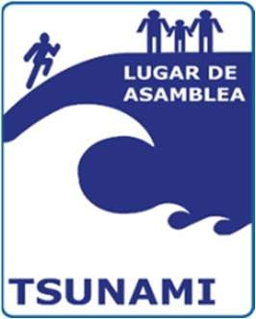 | Tsunami Assembly Point | Width/Height (ft):
 | Tsunami Assembly Point | Materials (e.g. aluminum, plastic, or fiber glass):
 | Tsunami Assembly Point | Number of signs installed:
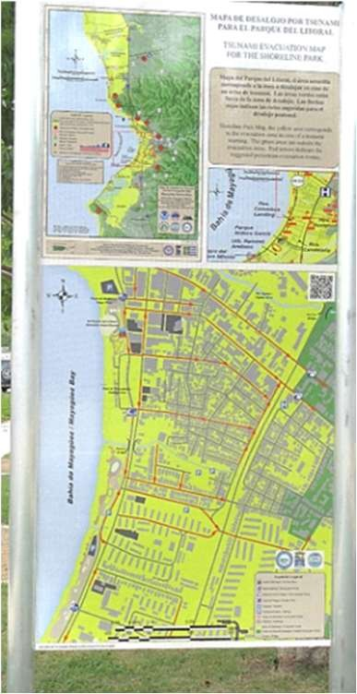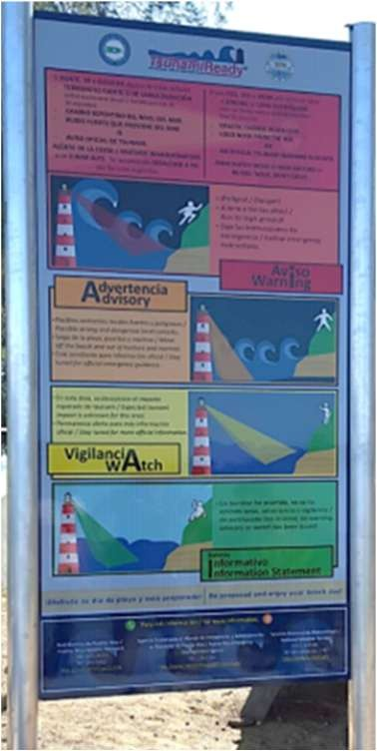 | Tsunami Evacuation Map  (Example of evacuation signage map of Mayagüez Bay) | Width/Height (ft):
Materials (e.g. aluminum, plastic, or fiber glass):
Aluminum
Number of signs installed:
12
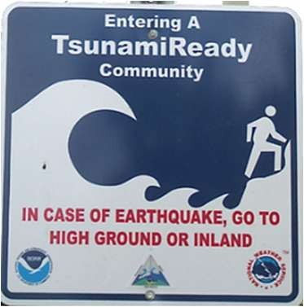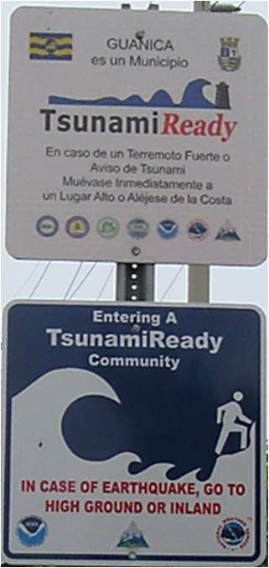 | Tsunami Ready Recognition | Width/Height (ft):
 | Tsunami Ready Recognition | Materials (e.g. aluminum, plastic, or fiber glass):
 | Tsunami Ready Recognition | Number of signs installed:
Member State/Territory Contact Information
United States NTWC: US Pacific Tsunami Warning Center (PTWC), Charles McCreery (Director). Tel: +18087256300, email: charles.mccreery@noaa.gov
TWFP: Puerto Rico Bureau for Emergency Management, Mr. Nino Correa Filomeno (Commissioner). Tel: +17877240124 ext 20001, ncorrea@dsp.pr.gov
United States TNC: NOAA/NWS, Analyze, Forecast, & Support Office, Ms. Corina Allen (Tsunami Program Manager). Tel: +14252761489, email:
corina.allen@noaa.gov
United States Tsunami Advisor: International Tsunami Information Center Caribbean Office, Mrs. Christa Von Hillebrandt-Andrade (Deputy Director). Mobile: +178772498307, email: christa.vonh@noaa.gov
Notes/Comments:
- Victor A. Huerfano (victor@prsnmail.uprm.edu) was the initial survey respondent.
- ITIC-CAR previously added all the signage art/photo, type, and information for this Member State/Territory.
- In 2022 ITIC-CAR made updates to the Member State/Territory contact Information (based on the document “NTWC, TNC, and TWFP for the EWS Caribbean Member States and Territories, 20 April 2021”).
- In 2025 ITIC-CAR updated the Member State/Territory Contact Information (based on the document ICG/CARIBE-EWS DATABASE for TNCs, TWFPs, and NTWCs, , 12, December, 2025).

United States (Virgin Islands)
Signage Art/Photo | Signage Type | General Information
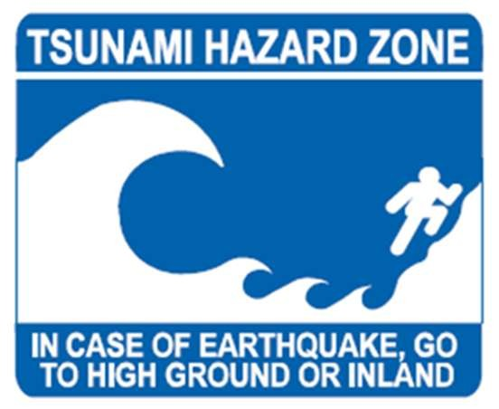 | Tsunami Hazard Zone | Width/Height (ft):
 | Tsunami Hazard Zone | Materials (e.g. aluminum, plastic, or fiber glass):
 | Tsunami Hazard Zone | Number of signs installed:
 | Entering/Leaving Tsunami Hazard Zone | Width/Height (ft):
 | Entering/Leaving Tsunami Hazard Zone | Materials (e.g. aluminum, plastic, or fiber glass):
 | Entering/Leaving Tsunami Hazard Zone | Number of signs installed:
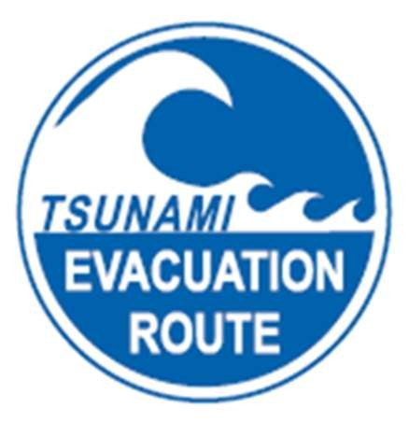 | Tsunami Evacuation Route | Width/Height (ft):
 | Tsunami Evacuation Route | Materials (e.g. aluminum, plastic, or fiber glass):
 | Tsunami Evacuation Route | Number of signs installed:
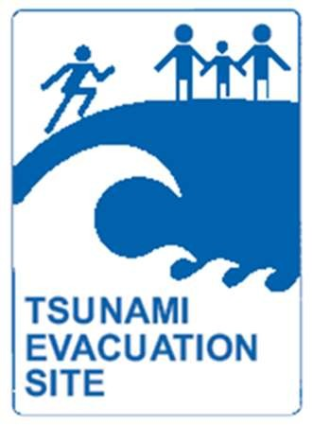 | Tsunami Assembly Point | Width/Height (ft):
 | Tsunami Assembly Point | Materials (e.g. aluminum, plastic, or fiber glass):
 | Tsunami Assembly Point | Number of signs installed:
 | Tsunami Evacuation Map | Width/Height (ft):
 | Tsunami Evacuation Map | Materials (e.g. aluminum, plastic, or fiber glass):
 | Tsunami Evacuation Map | Number of signs installed:
 | Tsunami Ready Recognition | Width/Height (ft):
 | Tsunami Ready Recognition | Materials (e.g. aluminum, plastic, or fiber glass):
 | Tsunami Ready Recognition | Number of signs installed:
Member State/Territory Contact Information
NTWC: US Pacific Tsunami Warning Center (PTWC), Charles McCreery (Director). Tel: +18087256300, email: charles.mccreery@noaa.gov
TWFP: Virgin Islands Territorial Emergency Management Agency/911, Mr. Daryl D. Jaschen (Director). Tel: +13407732244 (St. Croix), +13407156700 (St. Thomas), email: Daryl.Jaschen@vitema.vi.gov
United States TNC: NOAA/NWS, Analyze, Forecast, & Support Office, Ms. Corina Allen (Tsunami Program Manager). Tel: +14252761489, email:
corina.allen@noaa.gov
United States Tsunami Advisor: International Tsunami Information Center Caribbean Office, Mrs. Christa Von Hillebrandt-Andrade (Deputy Director). Mobile: +178772498307, email: christa.vonh@noaa.gov
Notes/Comments:
- bviddm@surfbvi.com and chicks@gov.vg were the initial survey respondents.
- ITIC-CAR previously added all the signage art/photo, type, and information for this Member State/Territory.
- In 2025 ITIC-CAR updated the Member State/Territory Contact Information (based on the document ICG/CARIBE-EWS DATABASE for TNCs, TWFPs, and NTWCs, , 12, December, 2025).

Venezuela
Signage Art/Photo | Signage Type | General Information
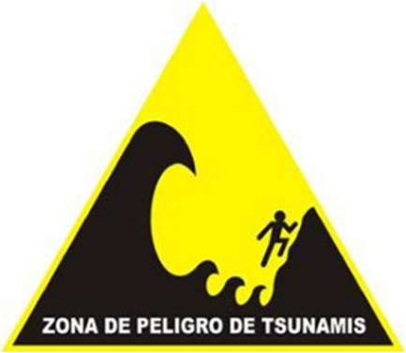 | Tsunami Hazard Zone | Width/Height (ft):
 | Tsunami Hazard Zone | Materials (e.g. aluminum, plastic, or fiber glass):
 | Tsunami Hazard Zone | Number of signs installed:
 | Entering/Leaving Tsunami Hazard Zone | Width/Height (ft):
 | Entering/Leaving Tsunami Hazard Zone | Materials (e.g. aluminum, plastic, or fiber glass):
 | Entering/Leaving Tsunami Hazard Zone | Number of signs installed:
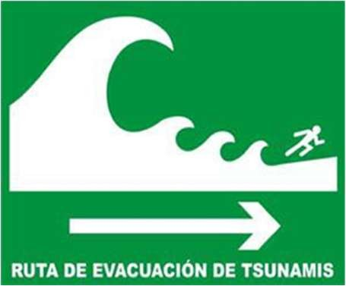 | Tsunami Evacuation Route | Width/Height (ft):
 | Tsunami Evacuation Route | Materials (e.g. aluminum, plastic, or fiber glass):
 | Tsunami Evacuation Route | Number of signs installed:
 | Tsunami Assembly Point | Width/Height (ft):
 | Tsunami Assembly Point | Materials (e.g. aluminum, plastic, or fiber glass):
 | Tsunami Assembly Point | Number of signs installed:
 | Tsunami Evacuation Map | Width/Height (ft):
 | Tsunami Evacuation Map | Materials (e.g. aluminum, plastic, or fiber glass):
 | Tsunami Evacuation Map | Number of signs installed:
 | Tsunami Ready Recognition | Width/Height (ft):
 | Tsunami Ready Recognition | Materials (e.g. aluminum, plastic, or fiber glass):
 | Tsunami Ready Recognition | Number of signs installed:
Member State/Territory Contact Information
TNC: Venezuelan Foundation For Seismological Research FUNVISIS, Mr. Roberto Betancourt (Presidente). Tel: +582122575153 ext 243, email: roberto.a.betancourt@gmail.com
TWFP: Venezuelan Foundation For Seismological Research FUNVISIS. Tel: +582122575153 ext 241, email: tsunami.funvisis@gmail.com, sismologia@funvisis.gob.ve
Notes/Comments:
- antoniodesastres@gmail.com was the initial survey respondent.
- The 2020 response states: “There will be an implementation of The International Organization for Standardization (ISO) proposed signage for Venezuela in the near future”.
- In 2023 ITIC-CAR made updates to the Member State/Territory Contact Information (based on the document “NTWC, TNC, and TWFP for the EWS Caribbean Member States and Territories, 27 January 2023”).
- In 2025 ITIC-CAR updated the Member State/Territory Contact Information (based on the document ICG/CARIBE-EWS DATABASE for TNCs, TWFPs, and NTWCs, , 12, December, 2025).

Discussion
The inventory revealed that although there is commonality in some of the designs and types of signage, there is a wide variety of artwork, materials, and placement and installation practices.
Signage artwork/color can be divided in three main categories: Blue, Green and ISO standard. Most of the artwork of the blue and green signs includes pictographs of waves approaching shorelines and stick figures, while the ISO standards include yellow and green signs, with waves, buildings, and arrows. The blue signs are used more broadly in the eastern Caribbean, with the exception of France which has adopted/adapted the ISO signage. In Central America, some countries have used the art of the blue signs but have green as a background color. Most of the countries approach on Tsunami signage was applying the same colors and similar designs to each type of signage irrespective of its purpose (Tsunami Hazard Zones, Entering and/or Leaving Tsunami Hazard Zone, Tsunami Evacuation Route, Tsunami Assembly Point, Tsunami Evacuation map, and Tsunami Ready Recognition signage). Venezuela and the French Lesser Antilles have applied variation in design and colors to some of these signage, which could be a more effective approach. In some countries the signage varies between communities. Further investigation may be needed to determine the difficulty of citizens to differentiate signage categories during events when comparing these two different approaches. Nevertheless, many times the choice made by the countries have to do with national signage guidelines.
Materials used for signage include Foam Boards, Fiber Glass, Aluminum, Aluzinc, Plastic and Polyvinyl chloride (PVC), with most of the countries using Aluminum. Not much information on signage size was provided, it can be determined that signage size ranges in variation on all countries.
Not much information was provided on signage placement either which could be an important piece of information in determining the longevity of signage once installed, each country should consider how placement may contribute to deterioration of signage by weather and/or human vandalism. Through examination of pictures provided and on file and on the web, most countries utilized street poles, trees, existing street poles (tsunami signage was an add on), building walls, to place signage, while a few construct their own signage frames and poles of different materials for installation.

Alternative Public Display of Tsunami Hazard Information
Alternative Public Display from ICG/CARIBE-EWS Member States & Territories Saint Kitts and Nevis - Murals
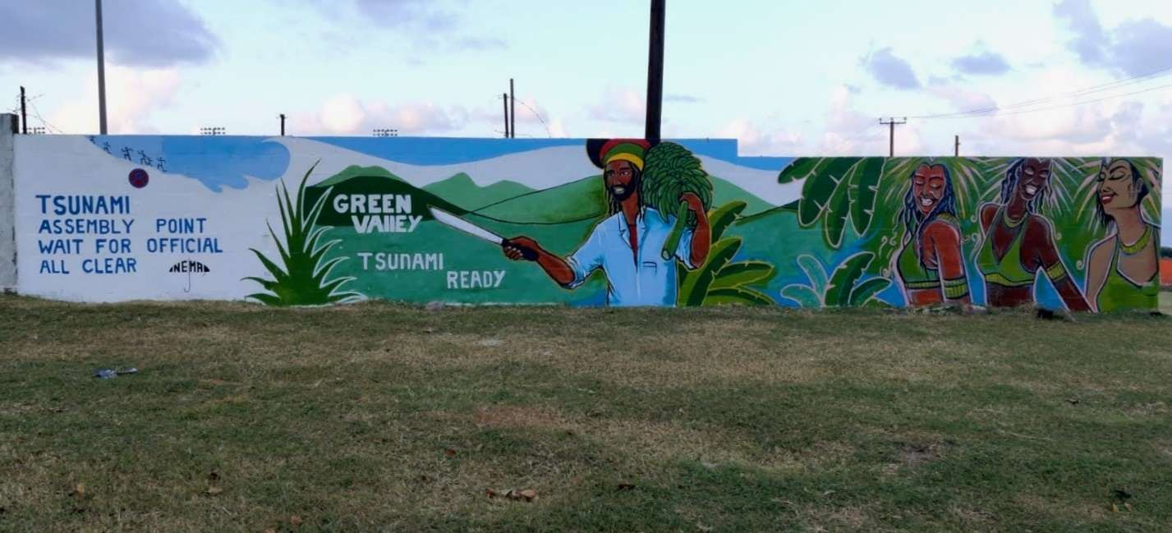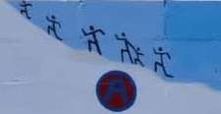
Figure 1. Mural in Saint Kitts indicating a Tsunami Assembly Point. As part of their TR Recognition renewal process, which was completed on February 4, 2022, Saint Kitts and Nevis had murals painted in the community to display Tsunami Hazard Information. Community and government members participated in the process. More pictures online.

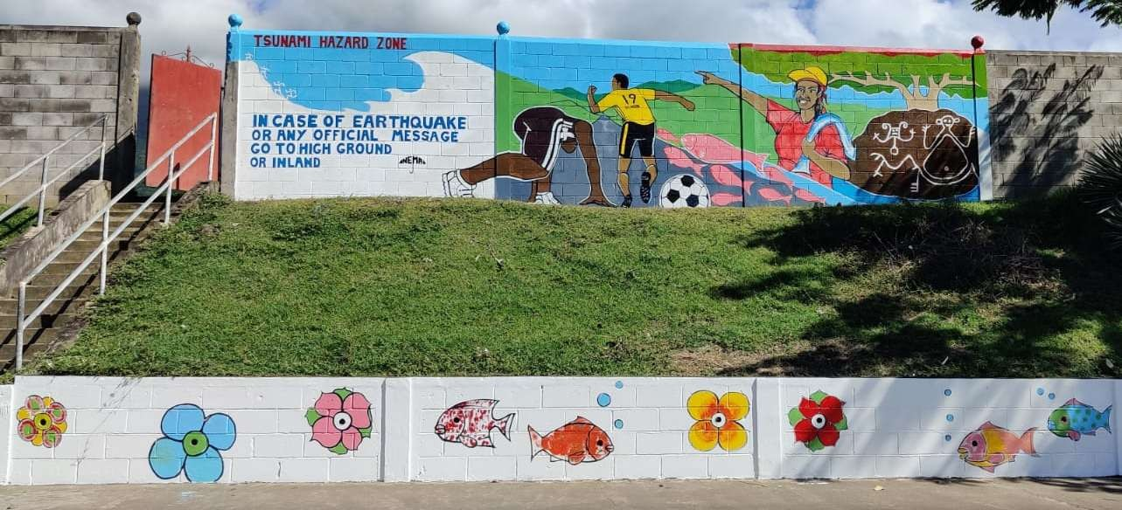
Figure 2. Mural in Verchilds, St. Kitts indicating a Tsunami Hazard Zone. As part of their TR Recognition renewal process, which was completed on February 4, 2022, Saint Kitts and Nevis had murals painted in the community to display Tsunami Hazard Information. Community and government members participated in the process.

Saint Vincent and the Grenadines - Billboards
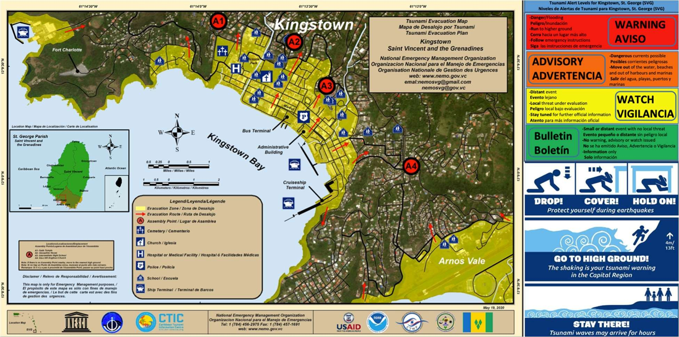
Figure 3. Billboard including the Evacuation Map of Kingstown, Saint Vincent and the Grenadines and educational information tsunami response.

Puerto Rico – Road Marking and Murals
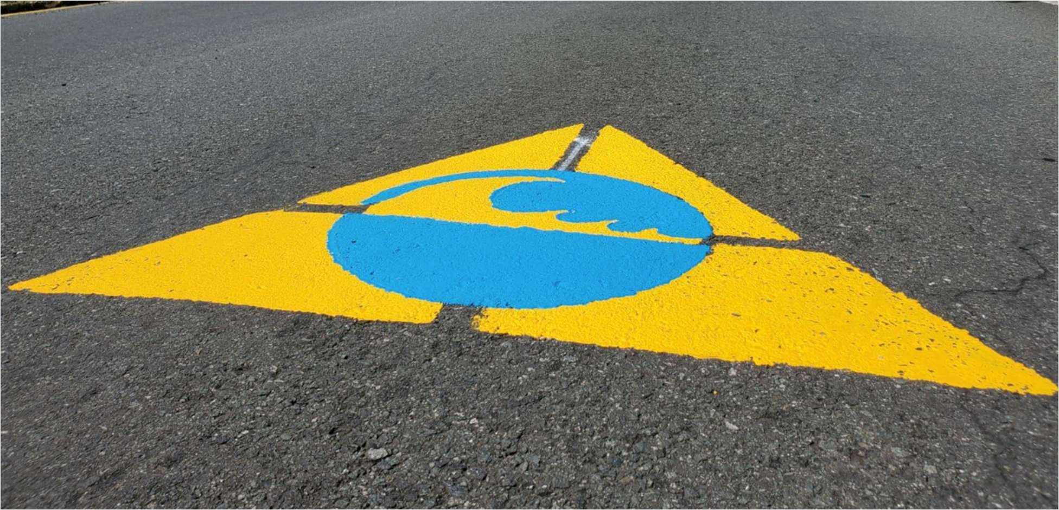
Figure 4. Tsunami evacuation route road marking in Toa Baja, Puerto Rico. More pictures online.

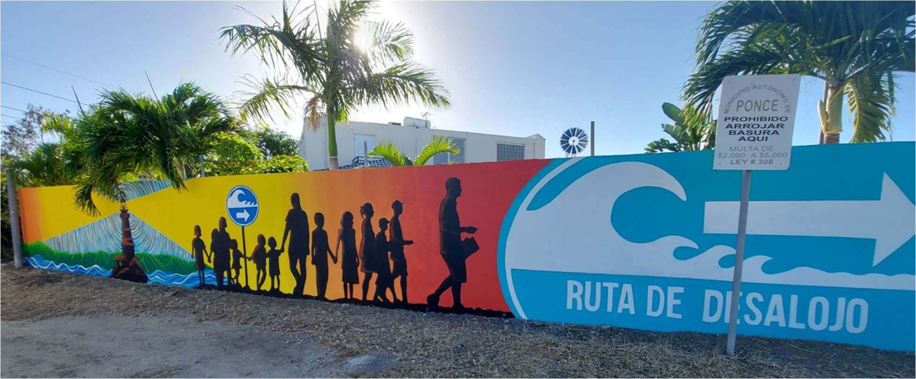
Figure 5. Mural in Villa del Carmen - Ponce, Puerto Rico indicating an Evacuation Route. More pictures online.

Nicaragua – Tsunami Wall-Color
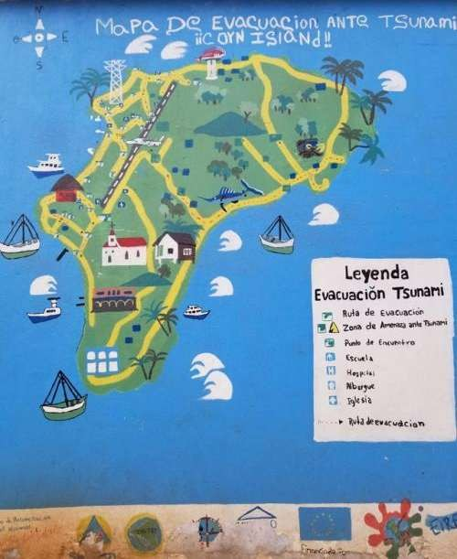
Figure 6. Tsunami Wall-Color in Corn Island, Nicaragua showing the Tsunami Evacuation Map. Picture by Christine Duran. The Tsunami Wall-Color is a recent and innovative and alternative public display adapted by some communities that consists of painting signs and tsunami evacuation maps directly on the walls. It is an important component of planning strategies to educate communities and reduce the impacts and risks from tsunamis.

Blue Line Project
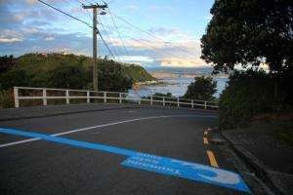
Figure 7. Photo showing the Blue Line tsunami safe zone signage on a road in Island Bay, New Zealand. Retrieved from: https://wremo.nz/about-us/initiatives/blue-lines/

Blue Lines are road markings that show the maximum reach of a large tsunami and delimit the areas that the community members need to pass to get to a safety zone. The main goal of the project is to alert and prepare vulnerable communities of the extent of tsunami inundation and be able to self-evacuate in the case of a long or strong earthquake or if a tsunami warning is issued.
In 2010, Wellington City Council's Emergency Management team and the residents of Island Bay developed this effective and innovative public education campaign to show where the largest tsunami might reach. After seven months of planning, a community-driven tsunami awareness plan, which included the blue lines, was prepared. The Wellington City Council painted blue the lines across the streets at the maximum possible run-up heights (Figure A). These lines are based on modelling by GNS Science and Greater Wellington Regional Council. It was very well received and has deemed to be effective.
Based on the New Zealand initiative, the State of Oregon introduced the Blue Line concept, becoming the first to do so in the USA. The signage was painted along the roadway and was coordinated by the Oregon Office of Emergency Management and the Oregon Department of Geology and Mineral Industries. Depending where a person is located on the Oregon coast, it could take between 5 to 30 minutes to reach a higher ground.
Yellow and blue road markings were painted in some streets in Toa Baja, Puerto Rico to show the tsunami evacuation route in the community (Figure 4). This was the first municipality in the island to use this type of marking. The initiative was carried out as an alternative additionally to the existing signage.

Previous Event Signs
This type of signage highlights the elevation a historic tsunami reached. The objective of these signs is to make people aware of the past tsunami and their reach in a specific place. The idea is to create greater community awareness. Nevertheless, these signs may give a false sense of security if past tsunamis have been smaller than expected future events. The message on these signs should be simple and clearly state the event is represented (historic, maximum credible, date, etc.). This signage is included in the New Zealand National Tsunami Signage Manual (Figure C).
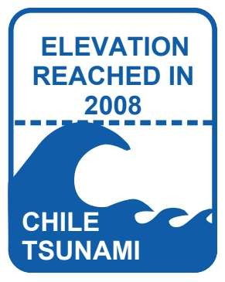
Figure 6. An example of Previous Event Sign. Retrieved from:
https://www.civildefence.govt.nz/assets/Uploads/publications/ts-01-08-national-tsunami-signage.pdf

Recommendations
The inventory and review of signage used in the Caribbean and Adjacent Regions and other communities at risk from tsunamis highlights the diversity of signage used by the different member states to indicate areas at risk, evacuation routes, assembly areas as well as the public display of maps of tsunami warning information. While it would be advantageous to have a harmonized and consistent signage throughout the region, especially considering the flux of tourists and travel between countries, it is recognized that the choice of signage is a national responsibility and prerogative. To enhance uniformity and consistency it would be advantageous for countries that do not have a National Tsunami Signage Plan to consider elaborating one. It would probably also be a good practice to annually update the inventory of signage.

Acknowledgements
Working Group IV appreciates the International Tsunami Information Center Caribbean Office for preparing the ICG/CARIBE-EWS inventory and reports. A special thanks to Desireé Bayouth García for preparing the 2022-2023 report, Stephanie Soto, Josué Aceituno Díaz and Luis Espada for preparing the 2020 report, and Stephanie Soto and Josué Aceituno Díaz for preparing the 2019 report.

Appendix
ISO 20712 - Beach Safety Flags and Water Safety Signs Standards
Announcement Flyer, 17 July 2008
News and media News 2008
ISO standard on beach safety flags and water safety signs for an accident-free summer
Ref.: 1147
ISO standard on beach safety flags and water safety signs for an accident-free summer
Summer time very often rhymes with time spent on the beach or in aquatic parks and playgrounds, but, whether it is the sea, the lake or the pool, the aquatic environment can be risky, particularly when climatic or water conditions are unfavorable. Water safety signs and flags can therefore be an invaluable aid in bringing people's attention to hazards and indicating where safety aids or lifeguards are available. Naturally, these flags and signs must be understandable to all.
The new ISO 20712 standard answers the need to standardize a system for giving safety information related to aquatic activity that relies as little as possible on the use of words to achieve understanding. Continued growth in international travel and mobility requires a common method of communicating safety information at an international level and lack of standardization may lead to confusion and possible injury and death.
ISO 20712 answers this need for an internationally harmonized approach. The standard, which was developed in close collaboration with the International Life Saving Federation (ILS) and other experts in the field, consists of three parts:
ISO 20712-1:2008 (Now under review. Will be replaced by ISO/FDIS 7010 (now under development), Water safety signs and beach safety flags – Specifications for water safety signs used in workplaces and public areas, is intended for use by owners and operators of aquatic environments and by manufacturers of signs and equipment. It categorizes water safety signs according to their function:
- means of escape and emergency equipment signs
- mandatory action signs
- prohibition signs
- warning signs.
The shape and colour required for safety signs, together with the corresponding graphical symbols, are given as prescribed by ISO 3864-1 and ISO 3864-3, respectively the standards on design principles for safety signs and design principles for graphical symbols for use in safety signs.
ISO 20712-2:2007, Water safety signs and beach safety flags – Specifications for beach safety flags – Colour, shape, meaning and performance, specifies requirements for the shape and colour of beach safety flags for the management of activities on coastal and inland beaches, to be used for giving information on wind and water conditions and other hazardous conditions, and to indicate the location of swimming and other aquatic activity zones extending from the beach into the water and when lifeguards are on duty.
ISO 20712-3, Water safety signs and beach safety flags – Guidance for use reflects good practice in the use of water safety signs and beach safety flags. The illustrations show examples of the selection and location of water safety signs and beach safety flags designed to provide information about aquatic hazards and the action necessary to avoid those hazards. It also has a section covering the need for signs in tsunami hazard areas. This third part will be published in the coming months.
ISO 20712-1:2008 and ISO 20712-2:2007 were developed by ISO technical committee 145, Graphical symbols, subcommittee 2, Safety identification, signs, shapes, symbols and colour. The publications cost respectively 154 and 56 Swiss francs and are available from ISO national member institutes (see the complete list with contact details) and from ISO Central Secretariat through the ISO Store or by contacting the Marketing & Communication department (see right-hand column).
Warning: Tsunami Hazard Zone
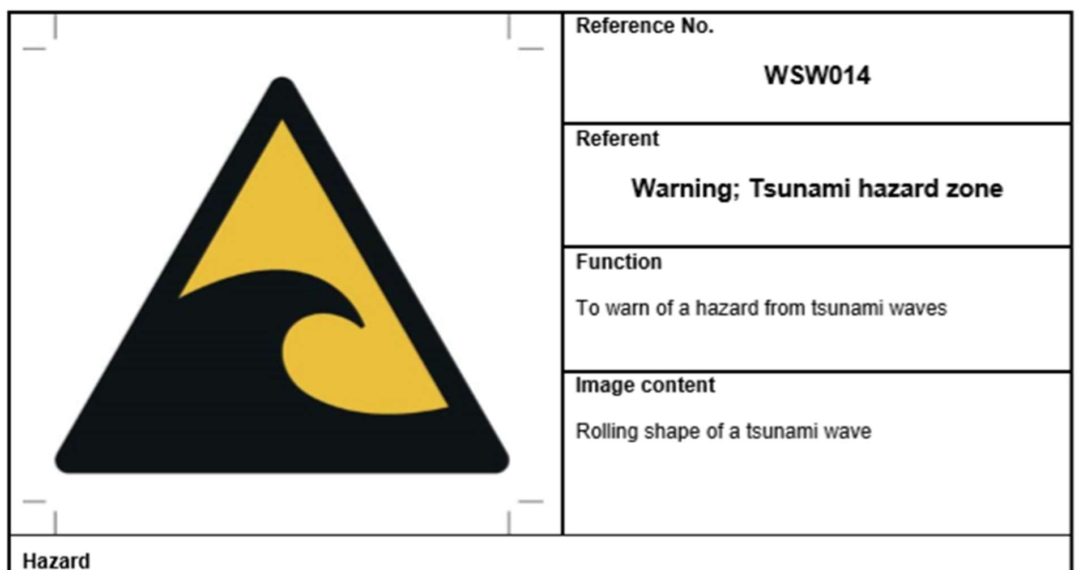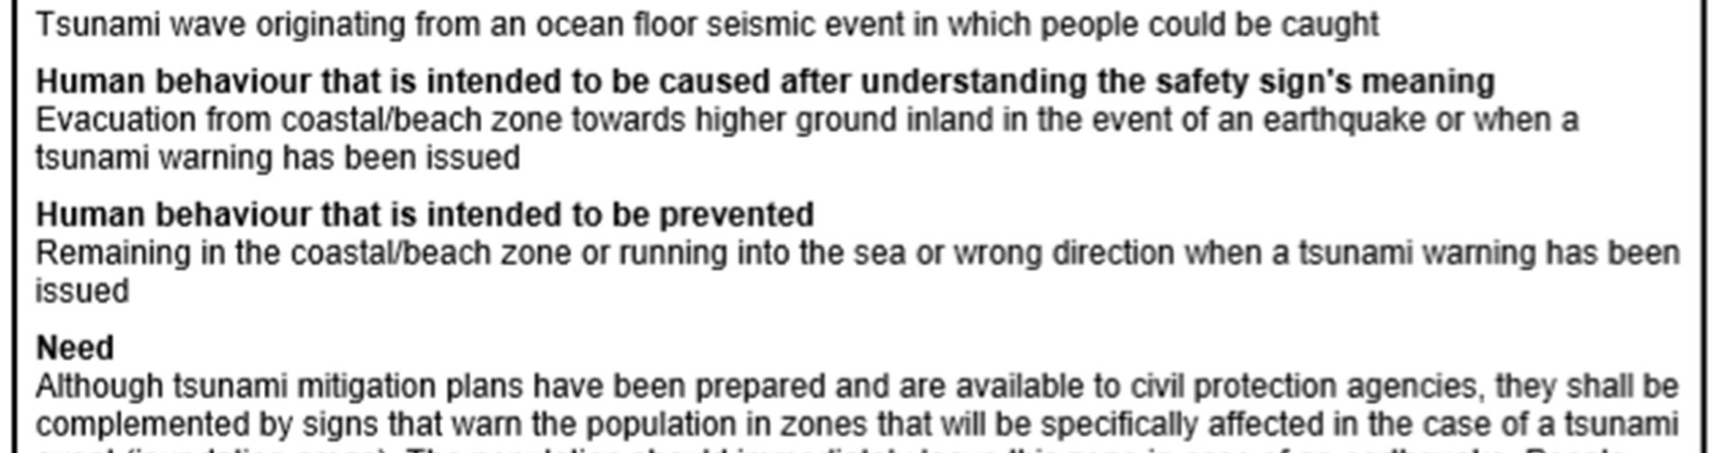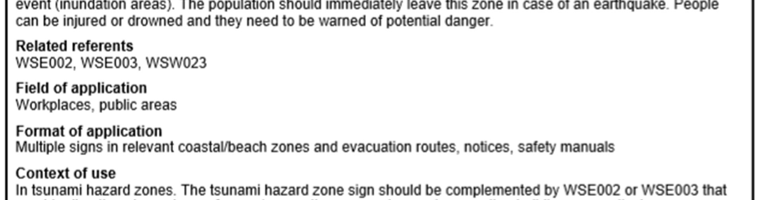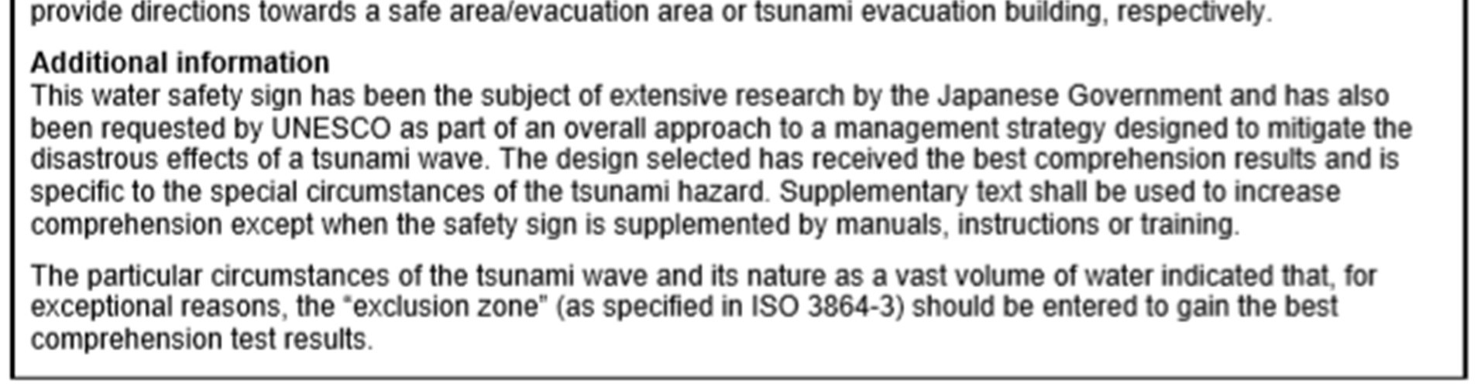
Tsunami Evacuation Area
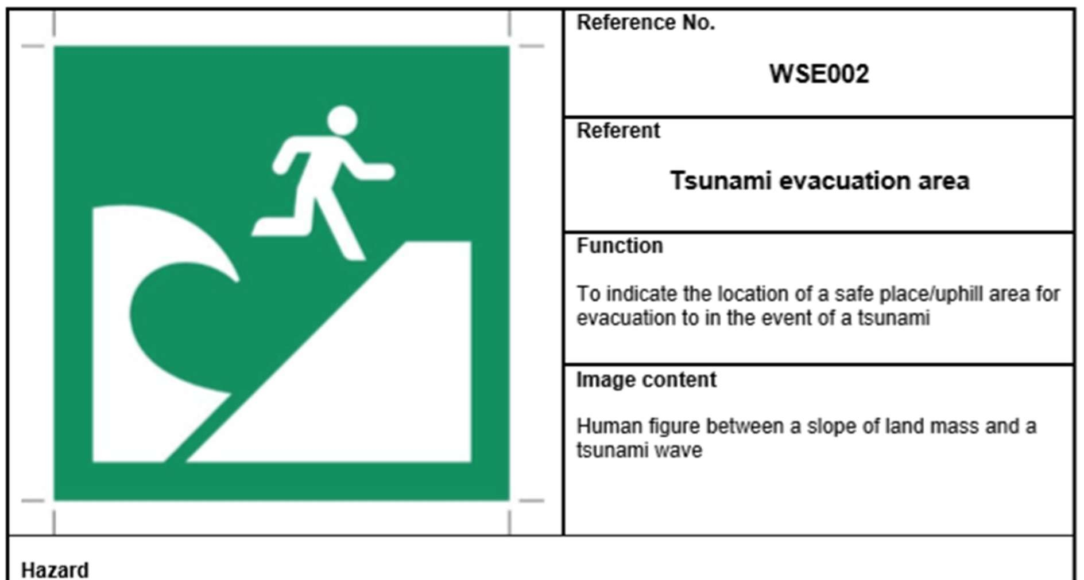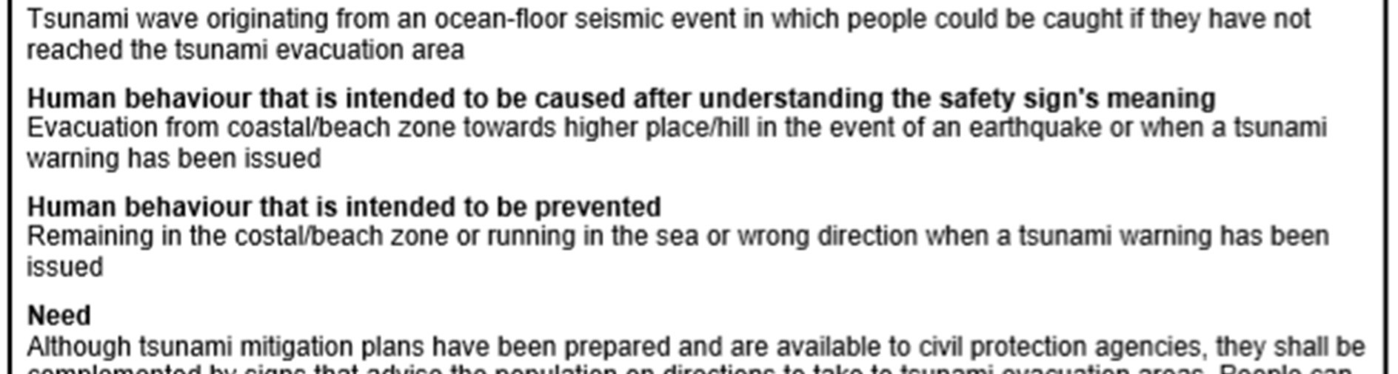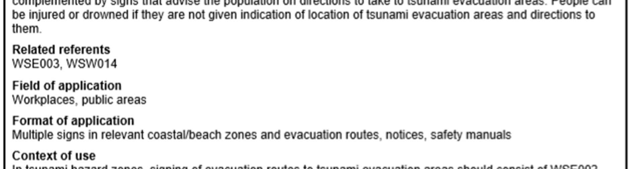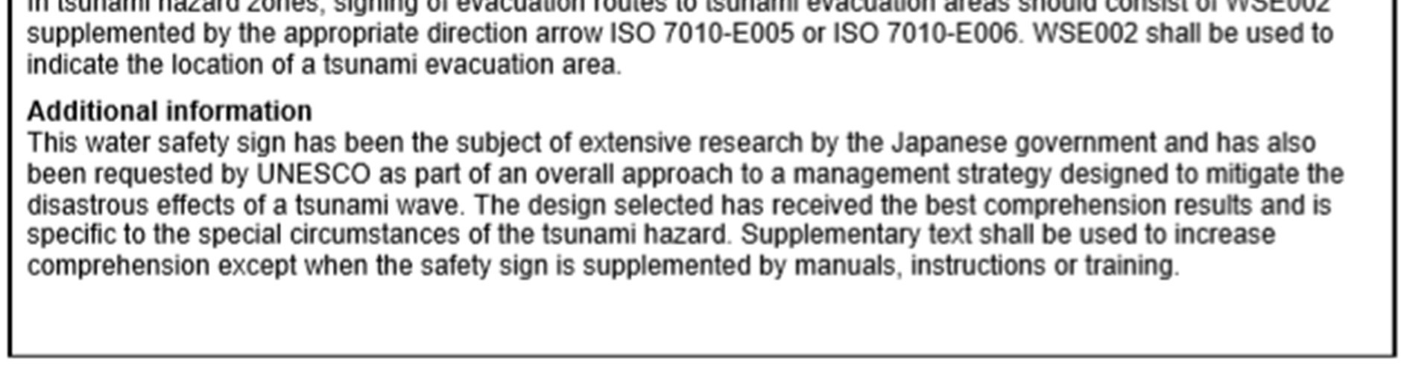
Tsunami Evacuation Building
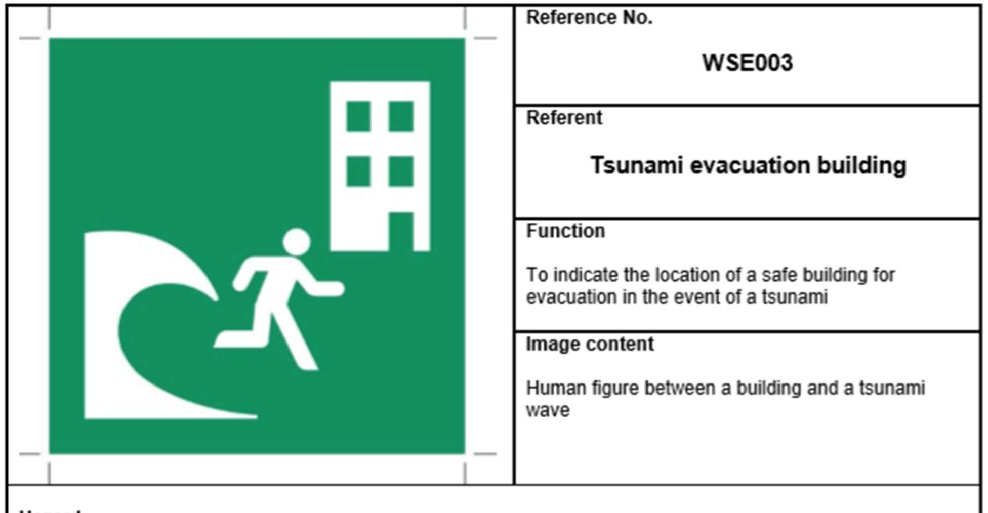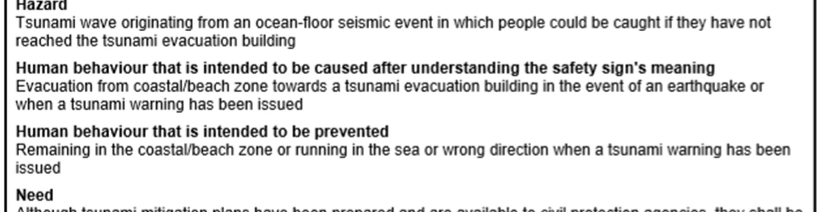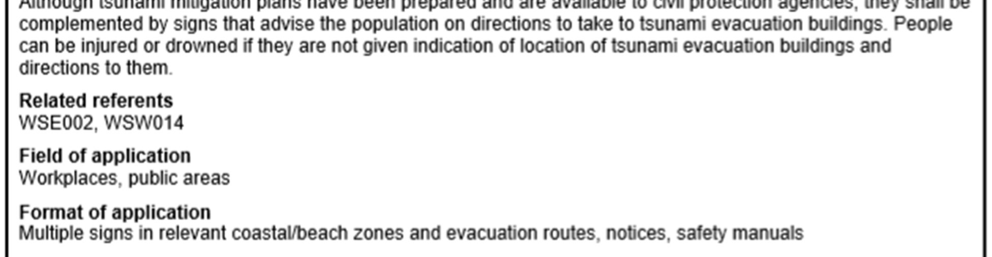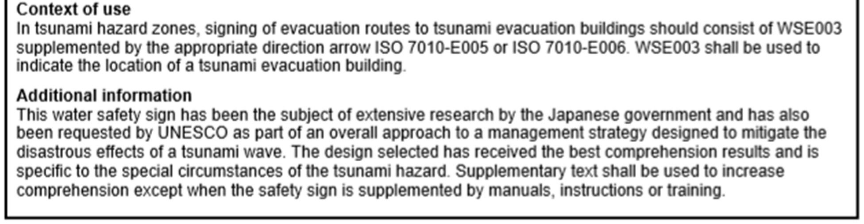
Examples of Tsunami Signing Systems
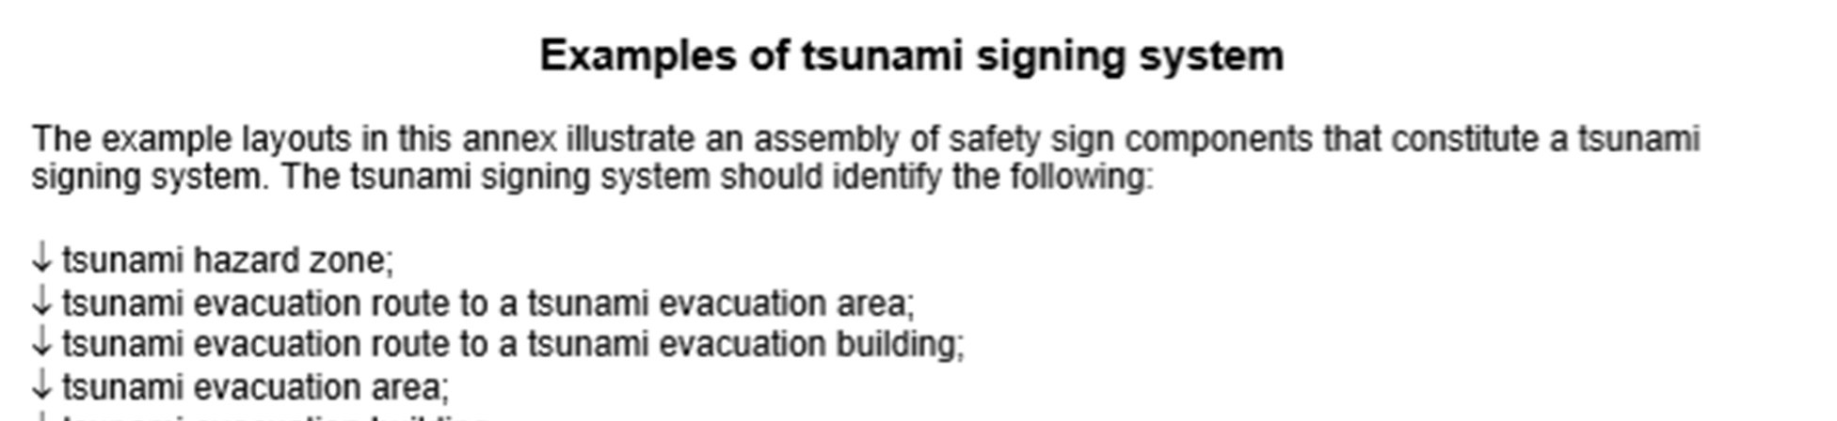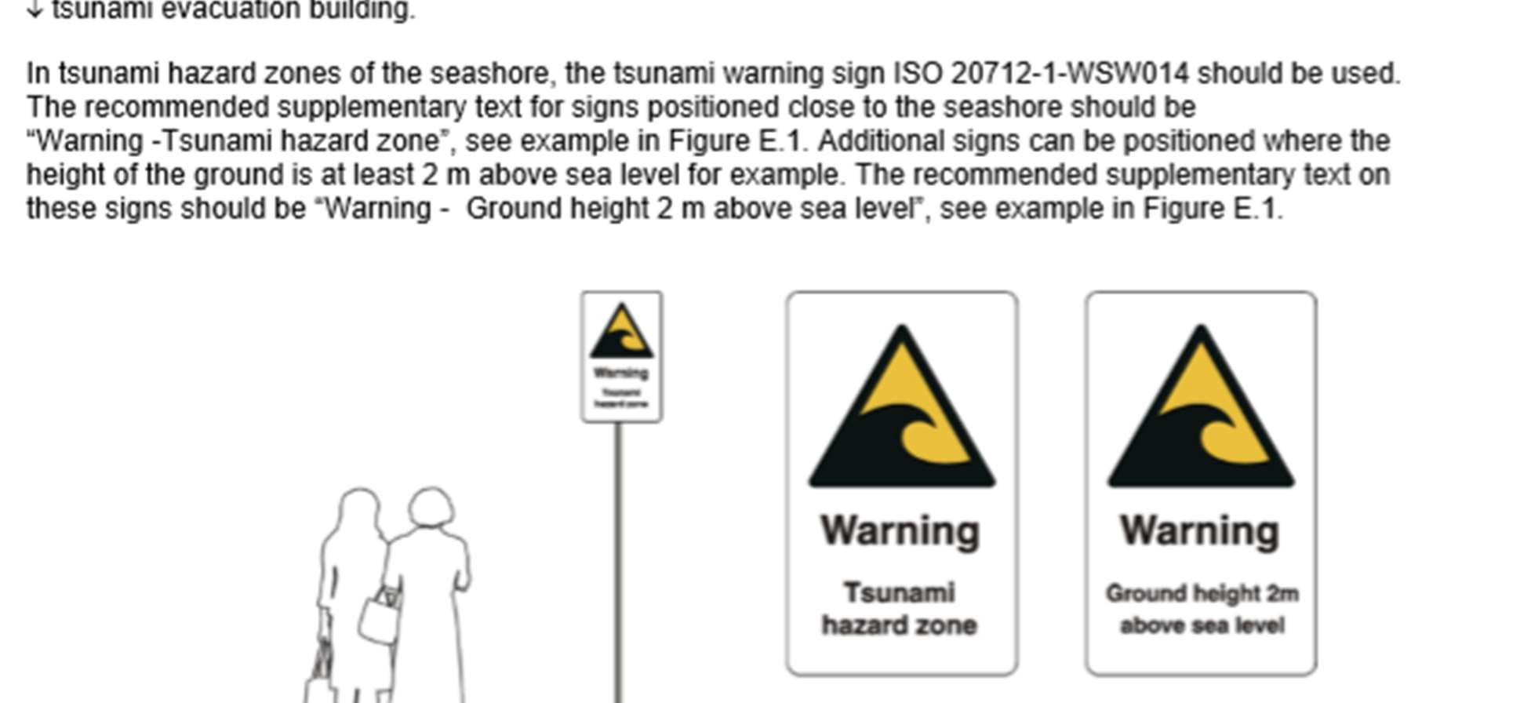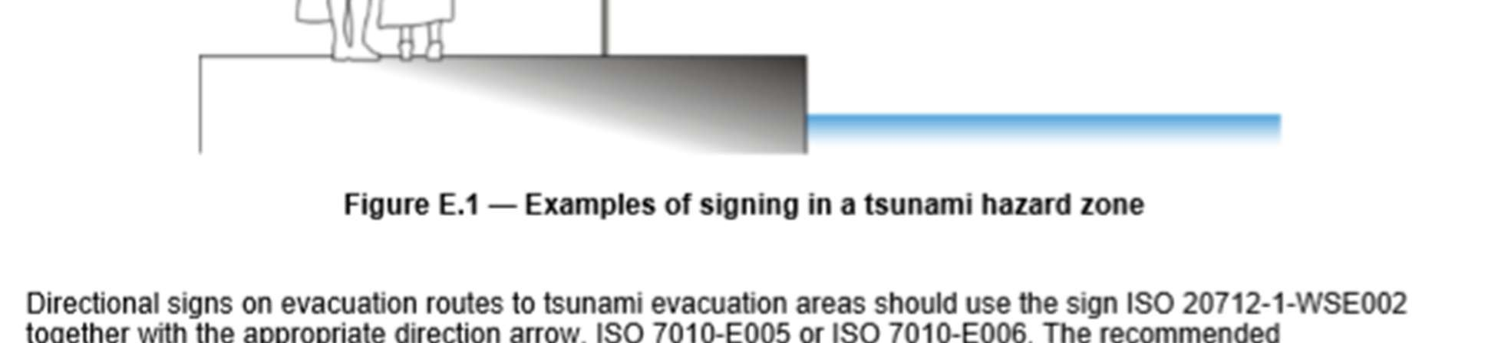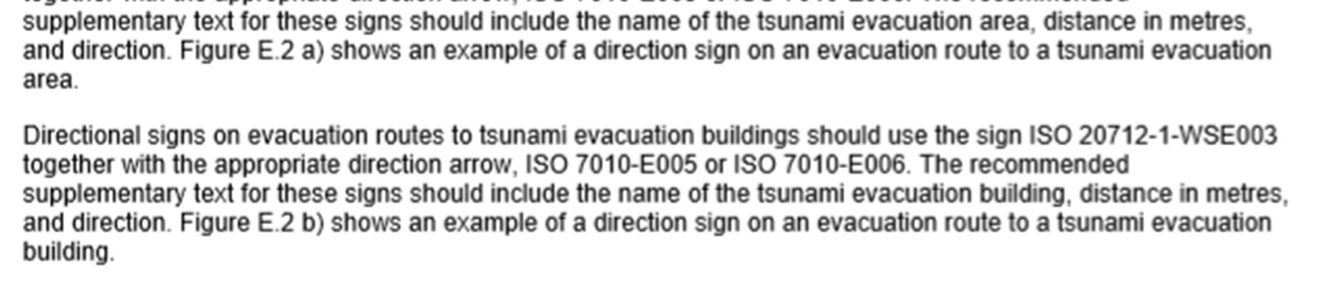

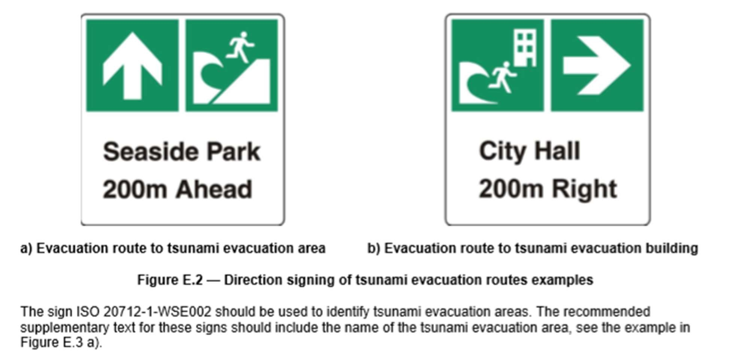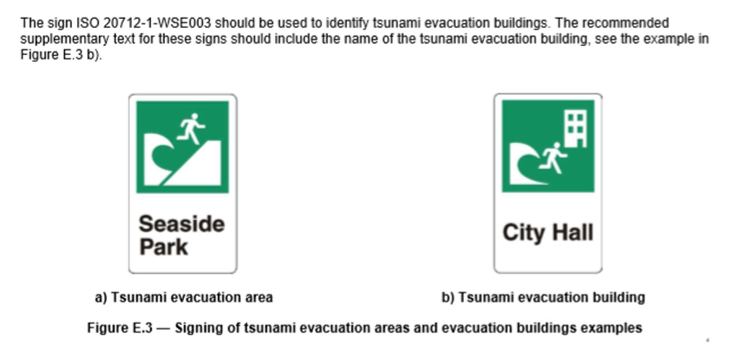

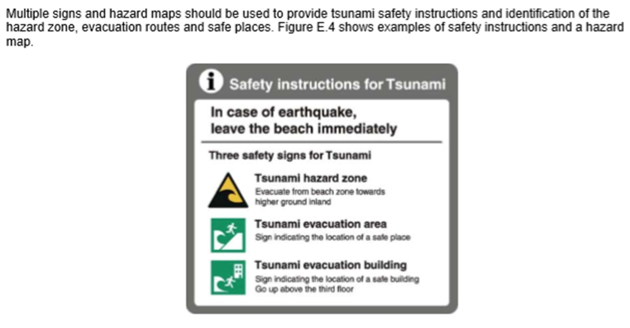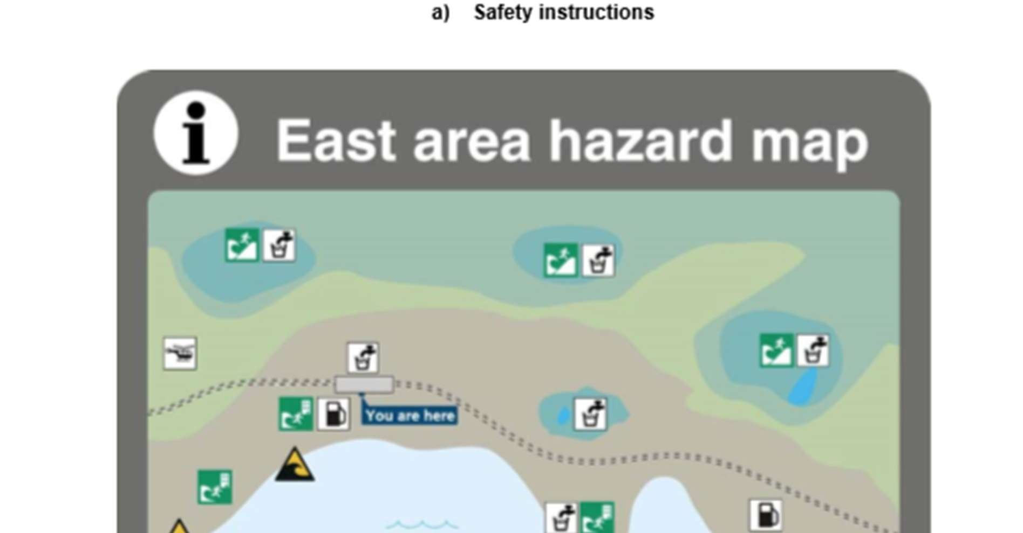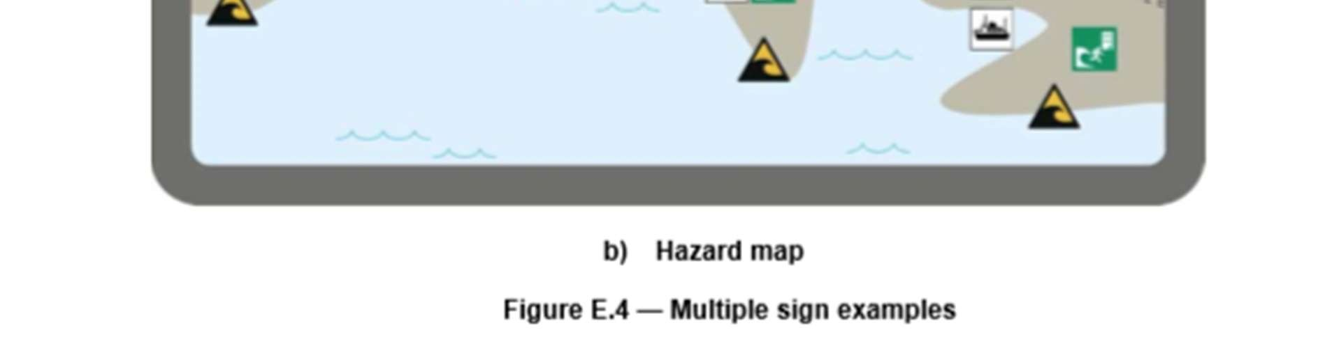

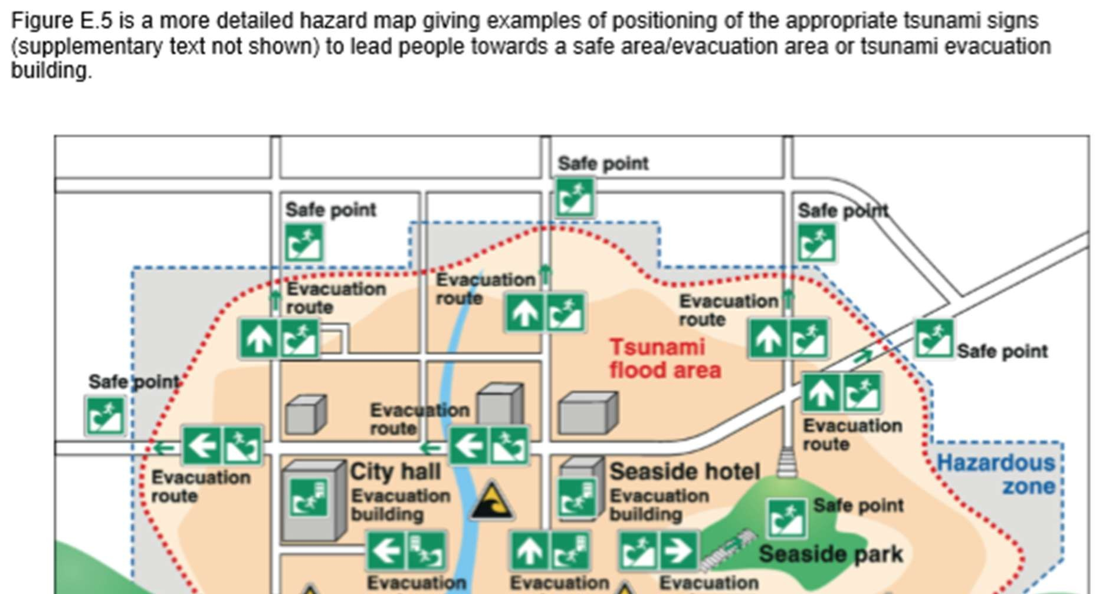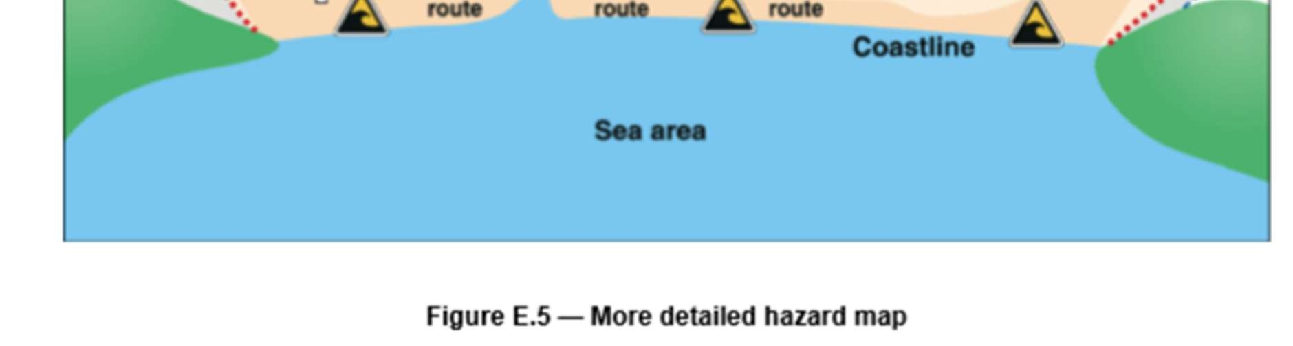

DEVELOPMENT OF ISO-APPROVED SIGNAGE
IOC/IUGG 3rd International Workshop on Tsunami Mitigation Beyond 2000, 5-6 October 2001, and ICG/ITSU-XVIII, 8-11 October 2001, Cartagena, Colombia
The Workshop, oriented on practical methods of tsunami mitigation and disaster reduction, built upon the recommendations of the ITSU Tsunami Master Plan (1999) to identify activities to further advance the tsunami programme in the years after 2000 and to consider how to advance the development of regional tsunami mitigation programmes, such as in the Intra-America Sea region (now ICG/CARIBEEWS). The 11 participating countries recommended that an international standardised set of symbols and signage be developed as a high priority.
During the subsequent ICG/ITSU-XVIII, the Group agreed with the Workshop’s Recommendation, recognizing the need to establish appropriate internationally standardized and recognized signs and symbols as an important instrument for contributing to tsunami preparedness for saving human lives and property. A roundtable survey organized by the ITSU Chairman showed that symbols and signs had already been developed in at least five countries. The Group established through Recommendation ITSUXVIII.2 an intersessional working group consisting of experts from Canada, Chile, Colombia, ITIC, Peru, and the Chairman of the IOCARIBE Tsunami Steering Group of Experts, Prof. G. Maul (USA), chaired by the ITSU Past Chairman, Mr. H. Gorziglia (Chile), to address the issues.
ICG/ITSU-XIX, 29 September – 2 October 2003, Wellington, New Zealand ITSU and Japan ISOcompliant signage
The Working Group, tasked with providing guidance on the development of signs and symbols to be used in the field and on tsunami inundation and evacuation maps, and educational material, presented its recommendations to the ICG/ITSU-XIX in 2003 (http://ioc3.unesco.org/itic/contents.php?id=71). The Group accepted two signs, “Tsunami Hazard Zone” and “Tsunami Evacuation Route”, and agreed that there was no need for a “Tsunami Refuge Zone” sign. It accepted the design and use of text on the signs that in their English-language versions read “Tsunami Hazard Zone” and “Tsunami Evacuation Route” noting that text was necessary to make sure the public would understand, but also expressing concern since careful translation into many languages would be required. The Group requested the Executive Secretary IOC to submit an application to the ISO using the agreed-upon tsunami signs, and including the different language versions and acceptable ISO color schemers. Upon ISO approval, the Group tasked the ITIC to distribute information on the adopted signs widely. The UNESCO IOC submitted an application to the ISO, with assistance from the French Standardization Association, in November 2004.
At about the same time starting in November 2004, an ad-hoc committee in Japan was convened to unify the pictogram for tsunami awareness and countermeasure in Japan. The committee discussed what signs should be the most appropriate from the viewpoint of simplicity so that people can easily acknowledge and understand the meaning. In March 2005, the Committee recommended signage and symbols for “Tsunami Prone Area,” “Tsunami Shelter/Safe Place,” and “Tsunami Evacuation Building.” These were then forwarded to the ISO technical committee 145, Graphical symbols, subcommittee 2, Safety identification, signs, shapes, symbols and colour, Working Group 4 (ISO/TC 145/SC 2/WG 4) for discussion and action. Subsequently, Japan provided more information on its tsunami wave shape and test findings on how it was chosen to WG 4.
In May 2005, the ISO/TC 145/SC 2/WG 4 Technical Secretary, prepared signage forms for consideration by members of WG 4 for each proposed sign based upon wording in the Japan and UNESCO proposal forms and incorporating the revised Japanese images (ISO/TC145/SC2/WG4 N068). These images were approved by WG 4, SC 2, TC 145, and the full ISO and published in 2008.

