Intergovernmental Oceanographic Commission
Technical Series | 198


EXERCISE CARIBE WAVE 26
A Caribbean and Adjacent Region Tsunami Warning Exercise
19 March 2026
(Cayman Islands and Kick ‘em Jenny Scenarios)
Volume 1 Participant’s Handbook

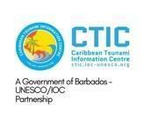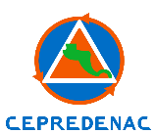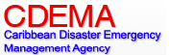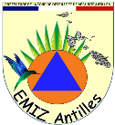

Intergovernmental Oceanographic Commission
Technical Series | 198

EXERCISE CARIBE WAVE 26
A Caribbean and Adjacent Region Tsunami Warning Exercise
19 March 2026
(Cayman Islands and kick ‘em Jenny Scenarios)
Volume 1 Participant’s Handbook

UNESCO 2026
IOC Technical Series, 198 (volume 1)
Paris, 20 January 2026
English only

The designations employed and the presentation of the material in this publication do not imply the expression of any opinion whatsoever on the part of the Secretariats of UNESCO and IOC concerning the legal status of any country or territory, or its authorities, or concerning the delimitation of the frontiers of any country or territory.

NOTE: The United Nations Educational, Scientific and Cultural Organization (UNESCO) and the Intergovernmental Oceanographic Commission (IOC) pattern the contents of this handbook after the Exercises CARIBE WAVE 2011, 2013, 2014, 2015, 2016, 2017, 2018, 2019, 2020, 2021, 2022, 2023, 2024, and 2025. Each of these exercises has a handbook published as part of the IOC Technical Series. These CARIBE WAVE exercises followed the Pacific Wave exercises which commenced in 2008 with a manual published by the Intergovernmental Oceanographic Commission (Exercise Pacific Wave 08: A Pacific-wide Tsunami Warning and Communication Exercise, 28–30 October 2008, IOC Technical Series, 82, Paris, UNESCO 2008). The UNESCO How to Plan, Conduct and Evaluate Tsunami Wave Exercises, IOC Manuals and Guides, 58 rev., Paris, UNESCO 2013 (English and Spanish) is another important reference.
Based on these previous exercises, global guidelines for CARIBE WAVE exercises have been developed in the IOC Technical Series, 194 (2024). These guidelines serve as a common core for the preparation of any regional exercise and should be considered in conjunction with the Participants’ Manual before each exercise.

For bibliographic purposes, this document should be cited as follows:
IOC-UNESCO. 2026. Exercise CARIBE WAVE 26. A Caribbean and Adjacent Region Tsunami Warning Exercise, 19 March 2026 (Cayman Islands and Kick ‘em Jenny Scenarios). Volume 1: Participant’s Handbook. IOC Technical Series No. 198, Vol. 1. Paris: UNESCO (English only)
The evaluation report of the exercise will be published as Volume 2 of this publication.
Report prepared by the IOC Intergovernmental Coordination Group for the Tsunami and other Coastal Hazards Warning System for the Caribbean and Adjacent Regions (ICG/CARIBE-EWS)

Published in 2026
by United Nations Educational, Scientific
and Cultural Organization
7, Place de Fontenoy, 75352 Paris 07 SP
© UNESCO 2026

(IOC/2026/TS/198 Vol.1)

TABLE OF CONTENTS

1. INTRODUCTION 1
2. CAYMAN ISLANDS SCENARIO 1
3. KICK ‘EM JENNY SCENARIO 2
4. EARTHQUAKE IMPACT 3
5. TIMELINE 3
6. PRODUCTS, STAGING AND DISSEMINATION 4
6.1 GENERAL 4
6.2 PACIFIC TSUNAMI WARNING CENTER (PTWC) 4
6.2.1 Master Schedule (Exercise Script) 4
Cayman Islands Scenario 4
Kick ‘em Jenny Scenario 5
6.3 CENTRAL AMERICA TSUNAMI ADVISORY CENTER (CATAC) 6
6.3.1 Master Schedule (Exercise Script) 6
Cayman Islands Scenario 6
6.4 SEISMIC RESEARCH CENTER (SRC) 6
6.4.1 Master Schedule (Exercise Script) 7
Kick ‘em Jenny Scenario 7
7. POST-EXERCISE EVALUATION 9
8. REFERENCES 9

ANNEXES
- TSUNAMI SOURCE SCENARIOS DESCRIPTION
- EARTHQUAKE IMPACT SCENARIOS
- PTWC DUMMY (START OF THE EXERCISE) MESSAGES
- PTWC EXERCISE MESSAGES | Cayman Islands | Kick ‘em Jenny scenario
- CATAC EXERCISE MESSAGES | Cayman Islands scenario (English & Spanish)
- SRC VONUT MESSAGES | Kick ‘em Jenny scenario

INTRODUCTION
The Intergovernmental Coordination Group for Tsunami and Other Coastal Hazards Warning System for the Caribbean and Adjacent Regions (ICG/CARIBE-EWS) of the Intergovernmental Oceanographic Commission (IOC) of the United Nations Educational, Scientific, and Cultural Organization (UNESCO) will be conducting its annual tsunami exercise, CARIBE WAVE, on 19 March 2026 at 1500 UTC. The exercise CARIBE WAVE 26 will provide simulated tsunami threat messages based on two hypothetical scenarios: a tsunami generated by a magnitude 7.6 earthquake located southwest of the Cayman Islands and a tsunami generated by a flank collapse of the Kick ‘em Jenny submarine volcano (Figure 1). Below is a description of the proposed scenarios for the exercise.

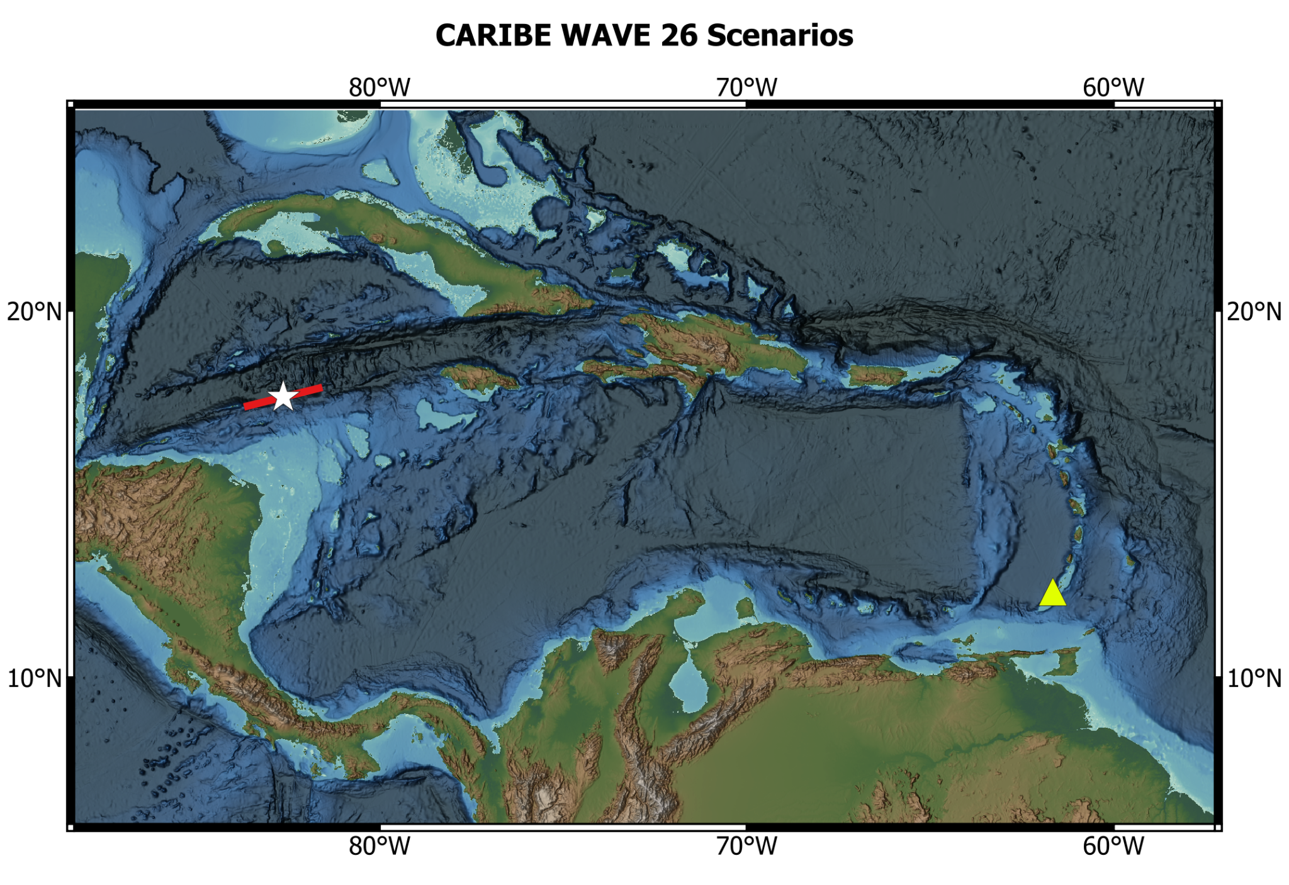
Figure 1. Map of the CARIBE WAVE 26 scenarios. White star indicates epicentral location and the red box indicates the map view of the ruptured fault segment of the Cayman Islands scenario, while the yellow triangle indicates the volcano location of the Kick ‘em Jenny scenario. The figure is underlain by ETOPO 2022 model of NOAA National Centers for Environmental Information (2022). This figure was generated using QGIS.

CAYMAN ISLANDS SCENARIO
The Swan Islands Transform Fault is located along the boundary of the North American and Caribbean Plates (Peirce et al., 2019). This left-lateral fault marks the southern wall of the Cayman Trough together with the Oriente fault (Cheng and Wang, 2020). Here, the North America plate moves west-southwest at a rate of approximately 20 mm/yr (Dixon et al, 1998; DeMets et al, 2000). Several significant earthquakes have been recorded in the region. These include the 10 January 2018, M7.5 earthquake near Honduras that caused limited damage as well as a small tsunami (USGS, 2025). Before this, there was the May 2009 and February 1976 earthquakes that resulted in many fatalities (Cheng and Wang, 2020). The most recent event occurred on 8 February 2025, when a M7.6 earthquake struck south-southwest of the Cayman Islands (USGS, 2025). Strike-slip faults typically have a lower potential of producing tsunamigenic earthquakes as there is less vertical displacement of the seafloor and in turn less vertical displacement of the water column. However, these events, when striking near land, still have the potential to trigger underwater landslides which may lead to a tsunami. Due to the distance offshore of the 8th February event, large impactful tsunami waves were not recorded (Kusky et al., 2025). However, for this earthquake, a preliminary magnitude of 8.0 was announced by the PTWC, initially raising concerns about a potential tsunami being generated before it was revised with a final magnitude of 7.6 (tsunami.gov). A tsunami threat message was issued indicating potential tsunami impact in 20 countries and territories; countries including but not limited to the Cayman Islands, Cuba, Jamaica, and Part of Central America, were initially issued a tsunami warning (tsunami.gov; Kusky et al., 2025). Regional review of the event response led to the identification of procedural gaps for some Member States and territories. Consequently, the CARIBE WAVE 26 exercise was selected to emulate the February 8th event to permit Member States and territories to put lessons learned into practice.
Cayman Islands Earthquake Scenario Parameters:
Origin Time 15:00:00 UTC March 19, 2026
Latitude 17.646º
Longitude: -82.6285º
Magnitude 7.6 – Mw
Depth 10 km

KICK ‘EM JENNY SCENARIO
There are many different ways volcanic tsunamis can be generated, including by pyroclastic flows, landslides, caldera collapse, and more (Schindelé et al., 2024). The scenario will be simulating a tsunami caused by flank instability of a volcano. Kick ‘em Jenny is a submarine composite volcano sitting 185 m below the surface of the sea, located approximately 8 km north of Grenada at 12.30ºN, 61.64ºW (Lindsay, 2005; Global Volcanism Program, 2025). It is located along the seismically active region of the Lesser Antilles island arc which formed as a result of the subduction of the South American plate beneath the Caribbean plate. This submarine volcano has an elevation of 1,300 m above the seafloor and 300 m wide at its summit (Latchman et al., 2017). Previous investigations have revealed that it lies within a collapse scar created from a past flank instability episode (Dondin et al., 2017). On 24 July 1939, Kick ’em Jenny’s had its first eruption on record that caused tsunami-like waves of around 2 m in amplitude in the Grenadines and the Grenada Island (Harbitz et al., 2012). Since then, it has erupted at least 14 times, making it the most frequently active volcano in the eastern Caribbean (Latchman et al., 2017). According to the U.S. National Oceanic and Atmospheric Administration (NOAA), Kick ‘em-Jenny dome has been destroyed during eruptions. One of its eruptions occurred on 23 July 2015. More than 400 events were recorded during this period, with M3.7 the greatest one. The most recent magmatic eruption occurred on 29 April 2017; an advisory notice was issued by the Grenada National Disaster Management Agency (NaDMA) upon reports from the Seismic Research Centre (SRC) on increased seismicity with a high-amplitude signal that lasted 25 seconds. During this period, the largest magnitude recorded was 3.3. Subsequent eruptive activity consisted of one event that lasted 14 minutes, followed by about an hour of tremor (Latchman et al, 2017). More recently, during the period from 20 February to 20 March and October 2018, the SRC reported periods of increased seismic activity at the volcano. This exercise provides the opportunity to test procedures and products for tsunamis generated from volcanic activity through the Kick ‘em Jenny scenario.

Kick ‘em Jenny Scenario Parameters:
Origin Time 15:00:00 UTC March 19, 2026
Latitude 12.30 ºN
Longitude 61.63 ºW

EARTHQUAKE IMPACT
According to the USGS, the CARIBE WAVE 26 simulated earthquake for the Cayman Islands scenario would produce an earthquake shaking green alert. Modified Mercalli intensity of up to V on the Mercalli Modified Scale could be observed for this scenario. It is estimated that over 44.5 million people would be exposed to Modified Mercalli intensities from II up to V. Complete information about the ShakeMap and PAGER output for the exercise scenario, is available in the Annex II of this handbook. In addition to tsunamis, secondary hazards could also include liquefaction and landslides. There is no ShakeMap or PAGER for the Kick ‘em Jenny scenario as this is a non-seismic event.

TIMELINE
The process of planning CARIBE WAVE takes more than a year; from the decision of the Intergovernmental Coordination Group (ICG) to conduct the exercise and the choice of the scenario(s) until the final reports are prepared and distributed. The timeline in Table 1 lists the main actions to be taken before, during and after CARIBE WAVE 26.
ACTION | DUE DATE
Handbook Draft Circulated among ICG CARIBE-EWS CARIBE WAVE 26 Task Team | October 2025
Deadline for Comments | November 2025
Circular Letter Issued by IOC to MS | January 2026
Exercise Handbook Available Online | January 2026
First Webinar CW | 20 January 2026 – English  21 January 2026 – Spanish  22 January 2026 – French
Second Webinar CW | 24 February 2026 – English  25 February 2026 – Spanish  26 February 2026 – French
Countries Indicate Selected Scenario | 6 March 2026
Exercise | 19 March 2026
Hot-Wash | 31 March 2026
Exercise Evaluation Due | 3 April 2026
Draft CARIBE WAVE 26 Report | 21 April 2026
Table 1. Timeline of actions to be taken before, during and after CARIBE WAVE 26.

PRODUCTS, STAGING AND DISSEMINATION

6.1 GENERAL
Expected impacts for these events are determined from pre-computed tsunami forecast models for the Cayman Islands scenario, while Kick ‘em Jenny messages are based on simulated communications with the corresponding volcano observatory responsible for monitoring. Annex I provides the model results for the Cayman Islands scenario.
Each Member State needs to select one scenario for CARIBE WAVE 26. By 6 March 2026, they must complete the following survey (https://www.surveymonkey.com/r/CW26_ScenarioSelection) to select the scenario their country will use for the exercise. If the Member State does not inform the TSP and ITIC-CAR, the organizers will decide for which scenario the TSP will send the products. For the exercise, the TWFP/NTWC will receive only the simulated product for that scenario.

6.2 PACIFIC TSUNAMI WARNING CENTER (PTWC)
Tsunami messages for this exercise are issued by the PTWC based on the two hypothetical Cayman Islands and Kick ‘em Jenny scenarios.
Participants should note the schedule in Tables 2 and 3 for each scenario, and the times the PTWC messages will be issued. Those tables include the timelines for when messages would be issued by the PTWC if this were a real event and can be used by EMOs to drive the exercise timing. The messages (as shown in Annex IV) cover a period of time between 5 minutes to 3 and a half hours from earthquake origin time, however in an actual event messages may continue for a much longer period of time. The dummy message will be sent through all of PTWC’s standard broadcasting channels, and messages thereafter will be sent through email only. CARIBE WAVE 26 exercise will also be testing communication between the PTWC and NAVAREA operators in the Caribbean (NAVAREA VI) through NTWC.
Details on the PTWC Enhanced Products for the CARIBE-EWS are provided in the User’s Guide (for) the Pacific Tsunami Warning Center Enhanced Products for the Tsunami and other Coastal Hazards Warning System for the Caribbean and Adjacent Regions (CARIBE-EWS) (IOC Technical Series, 135). As an additional planning tool, videos on the PTWC Enhanced Products and Staging for the Caribbean and Pacific were developed in English by ITIC (https://vimeo.com/showcase/8956022). To request access password, email christa.vonh@noaa.gov.

6.2.1 Master Schedule (Exercise Script)

Cayman Islands Scenario
Tsunami generated by a magnitude 7.6 earthquake with epicenter at 17.646ºN, 82.6285ºW occurring the 19 of March 2026 at 1500 UTC. The initial alert is disseminated at 1505 UTC and will indicate a preliminary magnitude of 8.0. The magnitude will then be adjusted to 7.6 in message 3 with the dissemination of the graphical products.

Date | Time (UTC) | PTWC
Date |  | Type of Product | Transmission Method
3/19/26 | 1500 | - - - - E a r t h q u a k e O c c u r s - - - -
3/19/26 | 1500 | Dummy | NWWS, GTS, EMWIN, AISR, Email
3/19/26 | 1505 | Initial Tsunami Threat Message #1 | Email
3/19/26 | 1515 | Tsunami Threat Message #2 | Email
3/19/26 | 1530 | Tsunami Threat Message #3 with Forecast and Graphical Enhanced Products | Email
3/19/26 | 1600 | Tsunami Threat Message #4 | Email
3/19/26 | 1700 | Tsunami Threat Message #5 | Email
3/19/26 | 1715 | Final Tsunami Threat Message #6 | Email
Table 2. Timeline Messages issued by PTWC for the Cayman Islands scenario.

Kick ‘em Jenny Scenario
A tsunami generated by a flank landslide of the Kick ‘em Jenny submarine volcano occurring the 19 of March 2026 at 1500 UTC. These messages are generated based on the information received from the SRC. The initial alert is disseminated at 1510 UTC.
Date | Time (UTC) | PTWC
Date |  | Type of Product | Transmission Method
3/19/26 | 1500 | - - - - E r u p t i o n O c c u r s - - - -
3/19/26 | 1500 | Dummy | NWWS, GTS, EMWIN, AISR, Email
3/19/26 | 1510 | Initial Tsunami Information Statement #1 | Email
3/19/26 | 1545 | Tsunami Threat Message #2 | Email
3/19/26 | 1630 | Tsunami Threat Message #3 | Email
3/19/26 | 1730 | Tsunami Threat Message #4 | Email
3/19/26 | 1830 | Final Tsunami Threat Message #5 | Email
Table 3. Timeline Messages issued by PTWC for the Kick ‘em Jenny scenario.

6.3 CENTRAL AMERICA TSUNAMI ADVISORY CENTER (CATAC)
Tsunami messages for this exercise are issued by CATAC based on the hypothetical Cayman Islands earthquake scenario.
Expected impacts for these events are determined from pre-computed tsunami forecast models. Annex V provides the model results of CATAC for the Cayman Islands scenario.
Participants should note the schedule in Table 4 for the scenario, and the times the messages will be issued. This table includes the timeline for when messages would be issued by the CATAC if this were a real event and can be used by EMOs to drive the exercise timing. The messages (as shown in Annex V) cover a period between 3 minutes and 2 hours from earthquake origin time, however in an actual event, messages may continue for a much longer period of time.

6.3.1 Master Schedule (Exercise Script)

Cayman Islands Scenario
Tsunami generated by a magnitude 7.6 earthquake with epicenter at 17.646ºN, 82.6285ºW occurring the 19 of March 2026 at 1500 UTC. The initial alert is disseminated at 1503 UTC and will indicate a preliminary magnitude of 8.0. The magnitude will then be adjusted to 7.6 in message 3.
Date | Time (UTC) | CATAC
Date |  | Type of Product | Transmission Method
3/19/26 | 1500 | - - - - E a r t h q u a k e O c c u r s - - - -
3/19/26 | 1500 | Dummy Message | Email
3/19/26 | 1503 | Initial Tsunami Threat Message #1 | Email
3/19/26 | 1509 | Tsunami Threat Message # 2 | Email
3/19/26 | 1530 | Tsunami Threat Message #3 | Email
3/19/26 | 1600 | Tsunami Threat Message #4 | Email
3/19/26 | 1700 | Final Tsunami Threat Message #5 | Email
Table 4. Timeline Messages issued by CATAC for the Cayman Islands scenario.

6.4 SEISMIC RESEARCH CENTER (SRC)
For the Kick ‘em Jenny scenario, the SRC is the corresponding volcano observatory responsible for monitoring and determining the potential of a volcano induced tsunami threat. For the exercise, the SRC issues the Volcano Observatory Notice for tsUnami Threat (VONUT) text message, derived from the Volcano Observatory Notice for Aviation (VONA), which informs on any change in volcano alert levels or significant changes on volcanic eruptions and volcano flank destabilization (Clouard et al., 2024; Schindelé et al., 2024).
There are three messages. The first two VONUT will inform the PTWC of Kick ‘em Jenny volcanic activity, including the likelihood of an imminent eruption and possible flank collapse. The third VONUT alerts the PTWC of an eruption and major volcano flank collapse. This alert will be issued at the start of the CARIBE WAVE 26 exercise (Annex VI).
Participants should note the schedule in Table 5, and the times the SRC messages will be issued. The simulated messages prepared by the SRC are provided only for the PTWC, CATAC, and ICG-CARIBE EWS officers and institutions. Based on these products, the PTWC issues corresponding messages. Through this exercise, Member States are encouraged to review the simulated PTWC products and discuss potential tsunami generated from a volcanic eruption with their observatories, in order to better understand roles and responsibilities around potential volcanic events.

6.4.1 Master Schedule (Exercise Script)

Kick ‘em Jenny Scenario
A tsunami generated by a flank landslide of the Kick ‘em Jenny submarine volcano occurring the 19 of March 2026 at 1500 UTC. The initial volcano alert is sent to PTWC at 1130 UTC.
Date | Time (UTC) | SRC
Date |  | Type of Product | Transmission Method
3/19/26 | 1130 | VONUT Message #1 | Email
3/19/26 | 1430 | VONUT Message #2 | Email
3/19/26 | 1500 | - - - - Eruption O c c u r s - - - -
3/19/26 | 1500 | VONUT Message #3 | Email
Table 5. Timeline Messages issued by SRC for the Kick ‘em Jenny scenario.
Person | Agency | Email
Gisela Báez-Sánchez  CARIBE WAVE Task Team Chair, | Puerto Rico Seismic Network, USA | gisela.baez1@upr.edu
Antonio Aguilar  CARIBE WAVE Task Team Vice Chair, | FUNVISIS, Venezuela | antoniodesastres@gmail.com
Gérard Metayer  CARIBE EWS Chair | Service Maritime et de Navigation  Haiti | gerard_metayer@yahoo.fr
Fréderic Dondin  Chair WG 1 Risk Knowledge | BGRM | fredericdondin@gmail.com
Raphaël Paris  Member WG 1 Risk Knowledge | Université Blaise Pascal et CNRS-LMV | Raphael.paris@uca.fr
Elizabeth Vanacore  Chair WG 2 Tsunami Detection, Analysis and Forecasting | Puerto Rico Seismic Network, USA | elizabeth.vanacore@upr.edu
Christa von Hillebrandt-Andrade  Chair WG 3 Tsunami Warning Dissemination and Communication | ITIC-CAR | christa.vonh@noaa.gov
Jacob Munakwa Ngumbah  Chair WG 4 Preparedness, Readiness and Resilience | NDMD, St. Kitts and Nevis | jack_dmc2011@yahoo.com
Matthieu Péroche  Chair of TsunamiReady Task Team | University of Montpellier Paul-Val | mathieu.peroche@gmail.com
Erouscilla Joseph  Scientific Expert – Kick em Jenny Scenario | UWI Seismic Research Centre | Erouscilla.joseph@sta.uwi.edu
Valérie Clouard  Scientific Expert – Kick em Jenny Scenario | GET/OMP, Univ. Toulouse Paul Sabatier | valerie.clouard@get.omp.eu
Anne Lemoine  Scientific Expert – Cayman Islands Scenario | BGRM | A.Lemoine@brgm.fr
Elizabeth Riley  Director CDEMA | CDEMA | elizabeth.riley@cdema.org
Adherbal de la Rosa Toulier  Executive Secretary CEPREDENAC | CEPREDENAC | cgarcia@cepredenac.org
Lt. Colonel Daniel Polinacci  Chief EMIZ Antilles | EMIZ Antilles | daniel.polinacci@martinique.pref.gouv.fr
Charles McCreery / Carolina Hincapié  PTWC, USA | PTWC, USA | charles.mccreery@noaa.gov  carolina.hincapie@noaa.gov
Wilfried Strauch  CATAC, Nicaragua | CATAC, Nicaragua | wilfried.strauch@yahoo.com
David Wald / Kristin Marano  Scientific Experts – Earthquake Impact Products | United States Geological Survey | wald@usgs.gov  kmarano@usgs.gov
Alison Brome  Director CTIC | CTIC | a.brome@unesco.org

Person | Agency | Email
Öcal Necmioglu (up to November 2025)  Technical Secretary CARIBE EWS | CARIBE EWS
Patrick Tyburn  CARIBE WAVE Task Team Member | STIS,  Saint Barthélemy | patrick.tyburn@sdis972.fr
José A. Tojil Jimenez  CARIBE WAVE Task Team Member | INSIVUMEH | jatojil@insivumeh.gob.gt
Kaza Hippolyte  CARIBE WAVE Task Team Member, | STLFS, Saint Lucia | kazagr81@hotmail.com
Lucius Lake  CARIBE WAVE Task Team Member | NEOC | lucius.yl@gmail.com
Mabius Francis  CARIBE WAVE Task Team Member, | STLFS, Saint Lucia | mabiusfrancis@me.com
Malcom Job  CARIBE WAVE Task Team Member | NEMO, Saint Lucia | job@nemo.gov.lc
Table 5. Members of the CARIBE WAVE 26 Task Team.

POST-EXERCISE EVALUATION
Each ICG/CARIBE-EWS Member State and territory is requested to provide feedback on the exercise. This feedback will assist the evaluation of CARIBE WAVE 26 and the development of subsequent exercises. It will also help response agencies to document lessons learned and lead to improvements of the national systems. To facilitate feedback, the online evaluation survey can be accessed at the following link:
https://www.surveymonkey.com/r/CW26_Evaluation.
The deadline for completing the evaluation is 3 April 2026.

REFERENCES
Cheng, C., and Wang, D., 2020, Imaging the rupture process of the 10 January 2018 MW7.5 Swan island, Honduras earthquake: Earthquake science, v. 33, p. 194–200, https://doi.org/10.29382/eqs-2020-0194-03.
Clouard, V., von Hillebrandt-Andrade, C., McCreery, C., & Cortés, J. J. S. (2024). Implementation of tsunami warning procedures in the Caribbean in case of a volcano crisis: Use of a Volcano Notice for tsUnami Threat (VONUT). Bulletin of Volcanology, 86(2). https://doi.org/10.1007/s00445-023-01702-8
DeMets, C., Jansma, P. E., Mattioli, G. S., Dixon, T. H., Farina F., Bilham, R., Calais, E., and Mann, P., 2000. GPS geodetic constraints on Caribbean‐North America plate motion, Geophysical Research Letters. 27, 437–440. https://doi.org/10.1029/1999GL005436.
Dixon, T. H., Farina, F., DeMets, C., Jansma, P. E., Mann, P., and Calais, E., 1998. Relative motion between the Caribbean and North American plates and related boundary zone deformation from a decade of GPS observations: Journal of Geophysical Research, 103, 15,157–15,182. https://doi.org/10.1029/97JB03575.
Dondin, F., Heap, M., Robertson, R., Dorville, J. and Carey, S., 2017. , Flank instability Instability assessment Assessment at Kick-’em-Jenny Submarine Volcano (Grenada, Lesser Antilles): A Multidisciplinary Approach using experiments Experiments and modeling. Bulletin of Volcanology, Vol. 79, No. :5, pp. 1–15.
Global Volcanism Program, 2025. Kick ‘em Jenny (360160) in [Database] Volcanoes of the World (v. 5.3.1; 6 Aug. 2025). Distributed by Smithsonian Institution, compiled by Venzke, E. https://volcano.si.edu/
Harbitz, C.B., Glimsdal, S., Bazin, S., Zamora, N., Løvholt, F., Bungum, H., Smebye, H., Gauer, P., and Kjekstad, O., 2012, Tsunami hazard in the Caribbean: Regional exposure derived from credible worst case scenarios: Continental shelf research, v. 38, p. 1-23, https://doi.org/10.1016/j.csr.2012.02.006
Kusky, T.M., Mann, P., and Meng, J., 2025, The February 8, 2025, swan islands (Caribbean sea) earthquake: Lessons for geohazards on transform plate and micro-plate boundaries: Journal of earth science, v. 36, p. 852–855, https://doi.org/10.1007/s12583-025-0176-7.
Latchman J., Robertson R., Lynch L., Dondin F., Ramsingh C., Stewart R., Smith P., Stinton A., Edwards S., Ash C., Juman A., Joseph E., Nath N., Juman I., Ramsingh H., Madoo F., 2017., 2017/04/29 Eruption of Kick-'em- Jenny Submarine Volcano. St. Augustine, SRC Open File Report Kick-'em-Jenny, Grenada 201706_VOLC1, Seismic Research Centre, The University of the West Indies., St. Augustine, Trinidad, West Indies.
Lindsay. J. M., Shepherd, J.B., and Wilson, D., 2005. Volcanic and Scientific Activity at Kick ’em Jenny Submarine Volcano 2001-2002: Implications for Volcanic Hazards in the Southern Grenadines, Lesser Antilles. Natural Hazards, Volume 34: Natural Hazards No. 1, pp. 1–-24
NOAA National Centers for Environmental Information, 2022. ETOPO2022 60 Arc-Second Global Relief Model: NOAA National Centers for Environmental Information. https://doi.org/10.25921/fd45-gt74. Accessed August 2025.
Peirce, C., Robinson, A.H., Campbell, A.M., Funnell, M.J., Grevemeyer, I., Hayman, N.W., Van Avendonk, H.J.A., and Castiello, G., 2019, Seismic investigation of an active ocean–continent transform margin: the interaction between the Swan Islands Fault Zone and the ultraslow-spreading Mid-Cayman Spreading Centre: Geophysical journal international, v. 219, p. 159–184, https://doi.org/10.1093/gji/ggz283.
Schindelé, F., Kong, L., Lane, E. M., Paris, R., Ripepe, M., Titov, V., & Bailey, R. (2024). A review of Tsunamis Generated by volcanoes (TGV) source mechanism, modelling, monitoring and warning systems. Pure and Applied Geophysics, 181(6), 1745–1792. https://doi.org/10.1007/s00024-024-03515-y
USGS, 2025. M7.6 Earthquake Southwest of Cayman Islands. Retrieved from https://earthquake.usgs.gov/

ANNEX I. TSUNAMI SOURCE SCENARIOS DESCRIPTION

Tsunami Source Scenarios Description

The following scenarios use a standard format to define the tsunami sources as described in the Figure I-1 below. Each fault segment is defined by 4 corner points where point A is the lower left corner of the fault plane. Line segment A-D indicates the downdip bottom rectangular source area, whereas line B-C is the top portion of the rupture plane that is nearest to the sea-floor surface. Letters W and L represent the width and length of the plane, respectively. Letter W_{ap} represents apparent width and applies to the dimensions when observing the fault plane in map view.

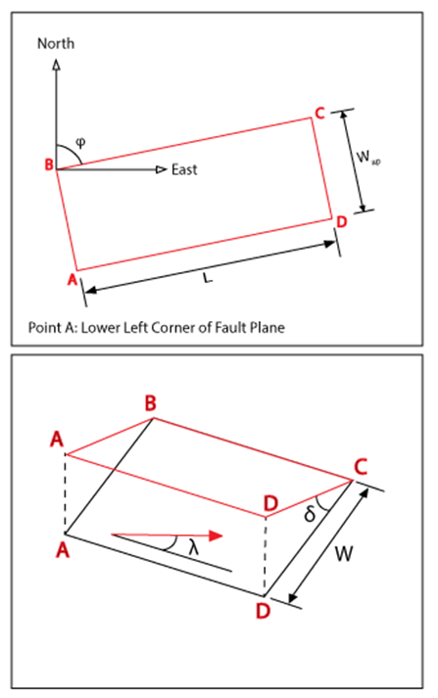

Figure I-1: Schematic of the standard used to describe all fault planes in the CARIBE WAVE Exercise scenarios.

Cayman Islands Earthquake Scenario

The Cayman Islands earthquake scenario consists of a rupture of a fault segment along the Swan Islands Fault with hypocenter at:

- Name of Scenario: CARIBE WAVE 26 Jamaica Scenario
- EQ Origin Time: 1500 UTC
- Hypocenter Latitude: 17.646º
- Hypocenter Longitude: -82.6285º
- Hypocenter Depth (km): 10 km
- EQ Magnitude (Mw): 7.6
- Slip (m): 2.4
- Shear modulus: 3.3x10¹¹ dyne/cm²
- Seismic Moment: 3.06x10¹⁰ dyne-cm

Corner Point A |  |  | Corner Point C
Latitude | 17.406º |  | Latitude | 17.886º
Longitude | -83.6º |  | Longitude | -81.657º
Depth (km) | 20 |  | Depth (km) | 0
Corner Point B |  |  | Corner Point D
Latitude | 17.406º |  | Latitude | 17.886º
Longitude | -83.6º |  | Longitude | -81.657º
Depth (km) | 0 |  | Depth (km) | 20

Other Fault Parameters
Strike (ϕ phi) | 255º
Dip (𝛿 delta) | 90º
Rake (λ lambda) | 0º
Length (km) | 212.5
Width (W in km) | 20
Width in Map View (km)  [W_{ap} = W * cos(delta)] | 0

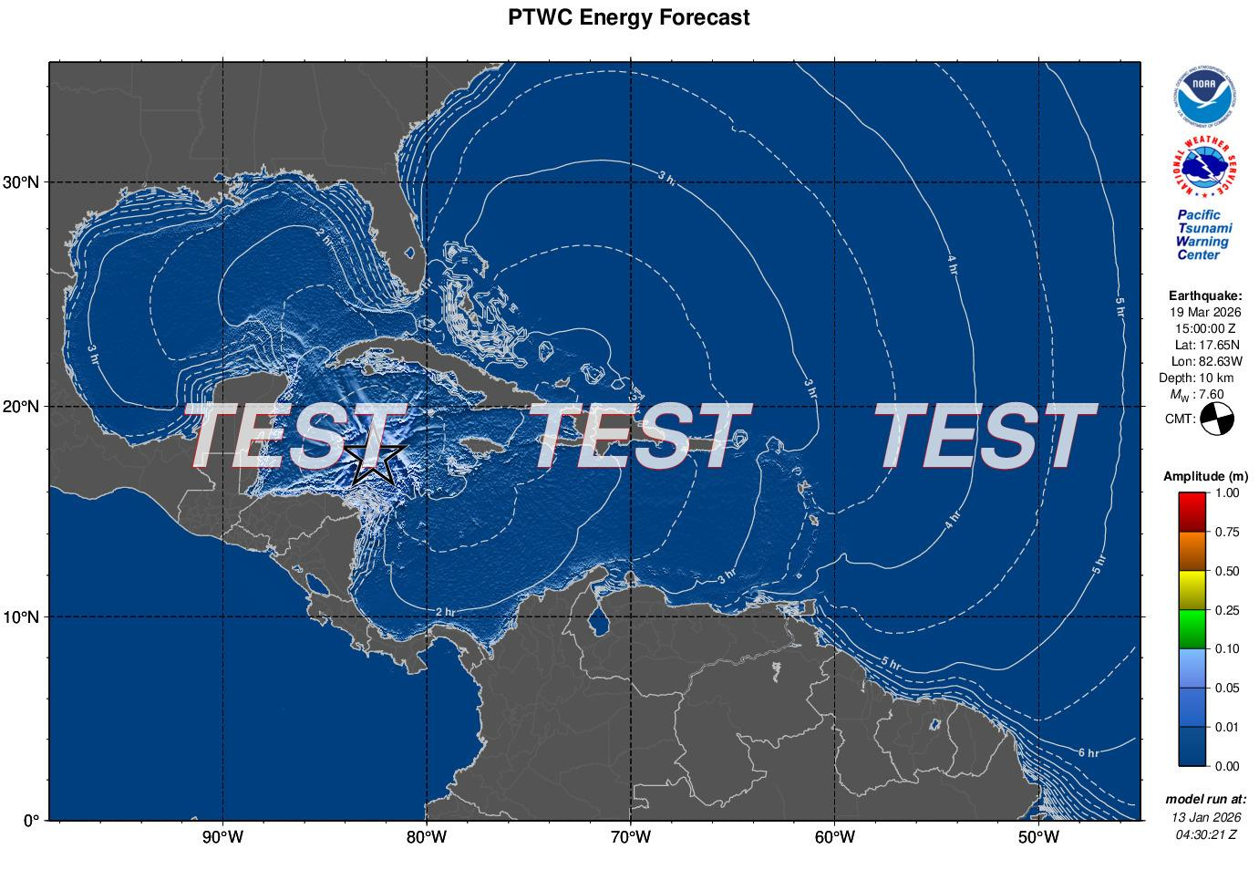
Figure I-2. RIFT maximum amplitude map for the Caribbean and Adjacent Regions for the Cayman Islands scenario. During a real event this product will only be made available to officially designated Tsunami Warning Focal Points and National Tsunami Warning Centers.
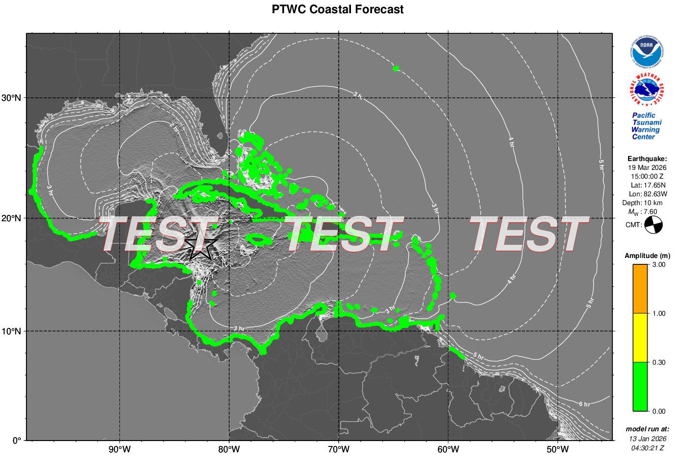
Figure I-3. RIFT coastal tsunami amplitude map for the Caribbean and Adjacent Regions for the Cayman Islands scenario. During a real event this product will only be made available to officially designated Tsunami Warning Focal Points and National Tsunami.

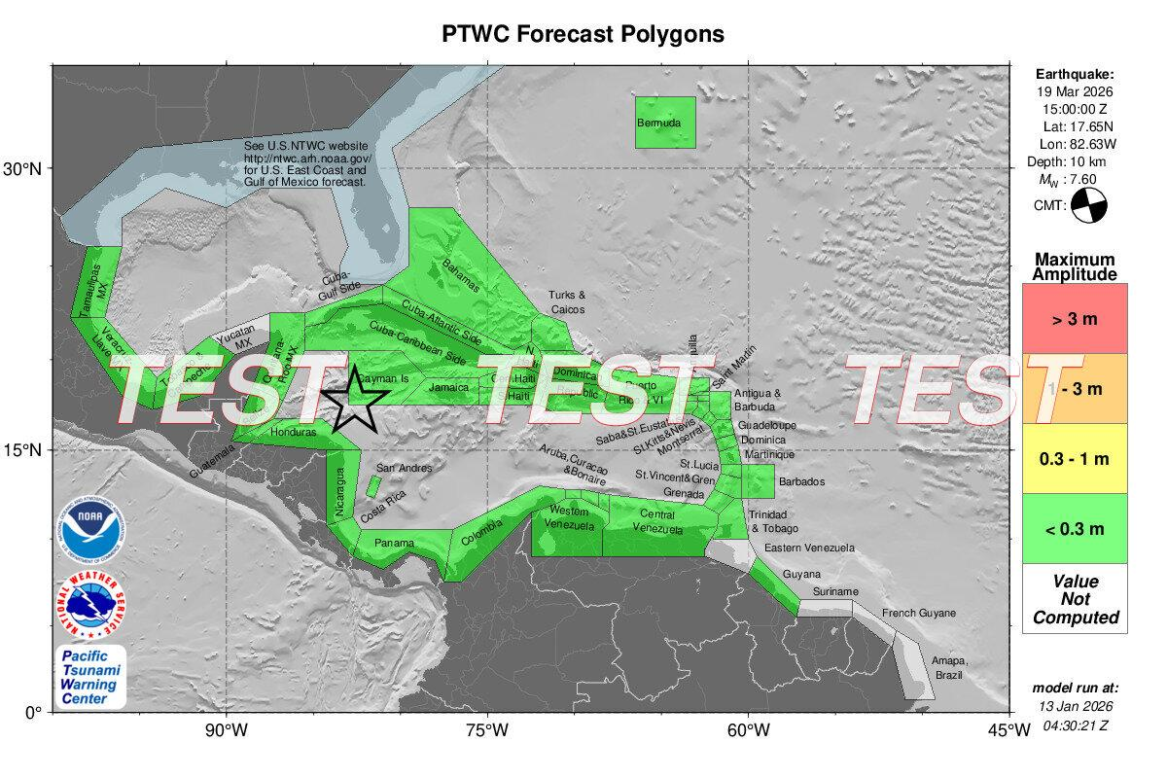
Figure I-4. RIFT forecast polygons for the Caribbean and Adjacent Regions for the Cayman Islands scenario. During a real event this product will only be made available to officially designated Tsunami Warning Focal Points and National Tsunami Warning Centers.

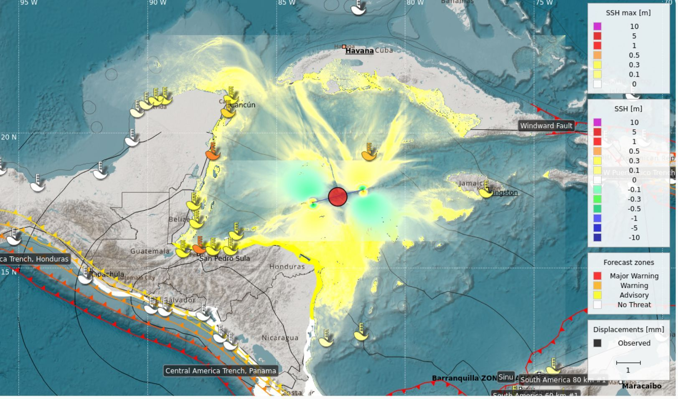
Figure I-5. CATAC Tsunami Heights and forecast zones for the Cayman Islands scenario.

Kick ‘em Jenny Volcanic Scenario

For the Kick ‘em Jenny scenario, data from previous studies and observations from the Seismic Research Center was used. This is a non-seismic scenario. Therefore, no earthquake point source or earthquake parameters were required.

ANNEX II. EARTHQUAKE IMPACT SCENARIOS

When planning for a tsunami it is important to also take into consideration the potential earthquake impact in areas close to the source, as these impacts can affect tsunami response and increase the tsunami impact by hindering evacuation and contributing debris to be carried by the waves. For earthquake impact, the USGS has developed ShakeMap and the Prompt Assessment of Global Earthquakes for Response (PAGER). The main purpose of ShakeMap is to display the levels of ground shaking produced by the earthquake. The ground shaking event levels in the region are studied depending on the magnitude of the earthquake, the distance from the earthquake source, rock and soil behavior in the region, and propagation of the seismic waves through the Earth’s crust. Based on the output of ShakeMap, PAGER estimates the population exposed to earthquake shaking, fatalities and economic losses.

Earthquake Event

The input information for ShakeMap include the earthquake magnitude and the four corners of the rectangles from the fault plane and the depths at each of these four vertices. ShakeMap is then used as the shaking input for PAGER loss estimates. For the case of CARIBE WAVE 26, the fault plane is represented by one segment for the Cayman Islands scenario. The Cayman Islands scenario fault plane is 212.5 km long and 20 km wide.

Figures II-1, II-2, and II-3, show ShakeMap and PAGER outputs for the CARIBE WAVE 26 Cayman Islands earthquake scenario.

The ShakeMap shows intensities up to V on the Mercalli Modified Scale (Figure II-1). The strongest ground shaking is predicted near the southwest of the Cayman Islands and northeast of Honduras.

According to PAGER, (Figure II-3) the CARIBE WAVE 26 simulated earthquakes would produce an earthquake shaking green alert for the Cayman Islands scenario. There is a low likelihood of casualties and damage.

Regarding the population exposed to weak to moderate earthquake shaking, it is estimated that over 44.5 million people would be exposed to Modified Mercalli intensities from II to V (according to pager).

Note: There are no ShakeMap or PAGER products for the Kick ‘em Jenny scenario as they are not needed for a nonseismic event such as this one.

Cayman Islands Earthquake Scenario
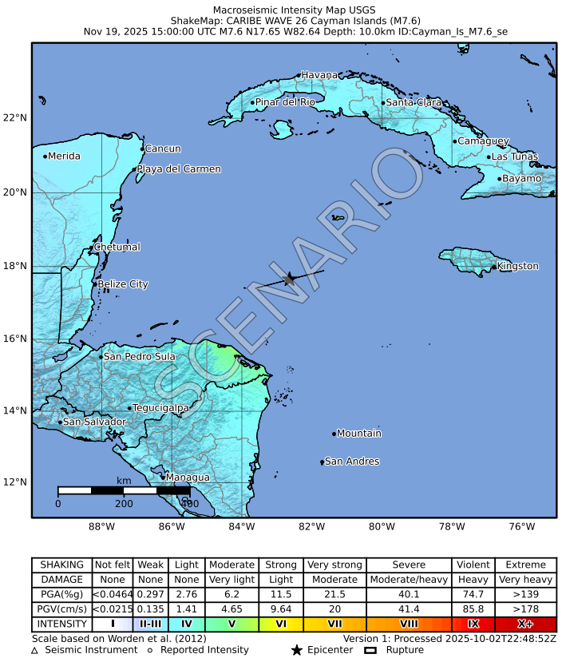
Figure II-1. ShakeMap output for the CARIBE WAVE 26 Cayman Islands earthquake scenario. Macroseismic Intensity (USGS).

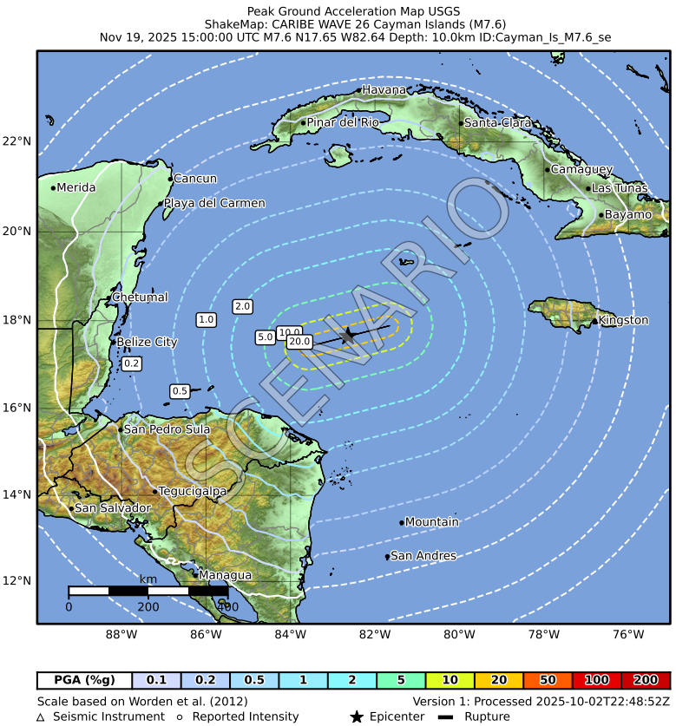
Figure II-2. ShakeMap output for the CARIBE WAVE 26 Cayman Islands earthquake scenario. Peak Ground Acceleration (USGS).
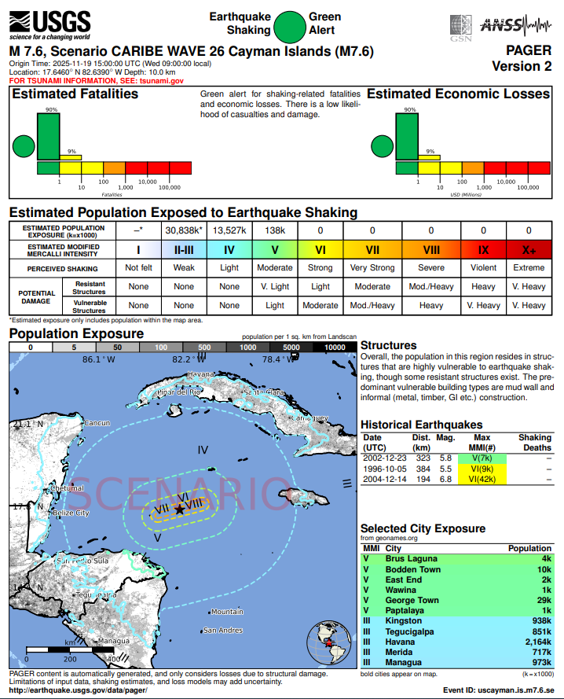
Figure II-3. PAGER output for CARIBE WAVE 26 Cayman Islands earthquake scenario (USGS).

ANNEX III. PTWC DUMMY (START OF EXERCISE) MESSAGES

PTWC

WECA41 PHEB 191500
TSUCAX

TEST...INITIAL DUMMY START OF EXERCISE MESSAGE...TEST
NWS PACIFIC TSUNAMI WARNING CENTER/NOAA/NWS
ISSUED AT 1500Z 19 MAR 2026

...TEST... CARIBE WAVE 26 TSUNAMI EXERCISE DUMMY MESSAGE.
REFER TO THE EXERCISE HANDBOOK. THIS IS AN EXERCISE ONLY. TEST...

THIS MESSAGE IS BEING USED TO START THE CARIBE WAVE 26
TSUNAMI EXERCISE AND TEST COMMUNICATIONS WITH UNESCO IOC CARIBE
EWS NTWCS AND TWFPS. THIS WILL BE THE ONLY EXERCISE MESSAGE
BROADCAST FROM THE PACIFIC TSUNAMI WARNING CENTER EXCLUDING
SPECIAL EMAIL MESSAGES DISCUSSED IN THE HANDBOOK. THE HANDBOOK
IS AVAILABLE AT THE WEBSITE CARIBEWAVE.ORG. THE EXERCISE
PURPOSE IS TO EXERCISE AND EVALUATE THE CARIBE EWS TSUNAMI
WARNING SYSTEM.
$$

ANNEX IV. PTWC EXERCISE MESSAGES

Cayman Islands Scenario – PTWC Products

The following simulated messages were created by the PTWC for the CARIBE WAVE 26 tsunami exercise. They are representative of the official standard products that would be issued by the PTWC for a magnitude 7.6 earthquake and subsequent tsunami originating along the Swan Islands fault. During a real event, the PTWC would also post the text products on tsunami.gov. The alerts would likely persist longer during a real event than is depicted in this exercise.

PTWC Message #1

ZCZC
WECA41 PHEB 191505
TSUCAX

TEST...Tsunami Message Number 1...TEST
NWS Pacific Tsunami Warning Center Honolulu HI
1505 UTC Thu Mar 19 2026

...THIS MESSAGE IS FOR TEST PURPOSES ONLY...
...TEST TSUNAMI THREAT MESSAGE TEST...

**** NOTICE **** NOTICE **** NOTICE **** NOTICE **** NOTICE *****

This is a test message. This message is issued for information
only in support of the UNESCO/IOC Tsunami and Other Coastal
Hazards Warning System for the Caribbean and Adjacent Regions
and is meant for national authorities in each country of that
system.

This is a test message. National authorities will determine the
appropriate level of alert for each country and may issue
additional or more refined information.

**** NOTICE **** NOTICE **** NOTICE **** NOTICE **** NOTICE *****

TEST... PRELIMINARY EARTHQUAKE PARAMETERS ...TEST
-------------------------------------------------

* Magnitude 8.0
* Origin Time 1500 UTC Mar 19 2026
* Coordinates 17.6 North 82.6 West
* Depth 10 KM / 6 Miles
* Location North Of Honduras

TEST... EVALUATION ...TEST
--------------------------

* This is a test message. An earthquake with a preliminary
magnitude of 8.0 occurred north of Honduras at 1500 UTC on
Thursday March 19 2026.

* This is a test message. Based on the preliminary earthquake
parameters... widespread hazardous tsunami waves are
possible.

TEST... TSUNAMI THREAT FORECAST ...TEST
-------------------------------------------------

* This is a test message. Hazardous tsunami waves from this
earthquake are possible within the next three hours along
some coasts of

ARUBA... BAHAMAS... BARBUDA... BELIZE... BONAIRE... BR
VIRGIN IS... CAYMAN ISLANDS... COLOMBIA... COSTA RICA...
CUBA... DOMINICAN REP... GUATEMALA... HAITI... HONDURAS...
JAMAICA... MEXICO... PANAMA... PUERTO RICO... SABA... SAN
ANDRES PROVID... TURKS N CAICOS and US VIRGIN IS

TEST... RECOMMENDED ACTIONS ...TEST
-----------------------------------

* This is a test message. Government agencies responsible for
threatened coastal areas should take action to inform and
instruct any coastal populations at risk in accordance with
their own evaluation... procedures and the level of threat.

* This is a test message. Persons located in threatened coastal
areas should stay alert for information and follow
instructions from national and local authorities.

TEST... ESTIMATED TIMES OF ARRIVAL ...TEST
------------------------------------------

* This is a test message. Estimated times of arrival -ETA- of
the initial tsunami wave for places within the region
identified with a potential tsunami threat. Actual arrival
times may differ and the initial wave may not be the
largest. A tsunami is a series of waves and the time between
waves can be five minutes to one hour.

LOCATION COORDINATES ETA(UTC)
------------------------------------------------------
CAYMAN ISLANDS
Grand Cayman 19.3N 81.3W 1526 03/19
Cayman Brac 19.7N 79.9W 1530 03/19
CUBA
Cienfuegos 22.0N 80.5W 1549 03/19
Santiago D Cuba 19.9N 75.8W 1556 03/19
Baracoa 20.4N 74.5W 1626 03/19
La Habana 23.2N 82.4W 1633 03/19
Gibara 21.1N 76.1W 1646 03/19
HONDURAS
Puerto Cortes 15.9N 88.0W 1557 03/19
Trujillo 15.9N 86.0W 1643 03/19
MEXICO
Cozumel 20.5N 87.0W 1558 03/19
JAMAICA
Montego Bay 18.5N 77.9W 1605 03/19
Kingston 17.9N 76.9W 1644 03/19
HAITI
Jeremie 18.6N 74.1W 1616 03/19
Cap Haiten 19.8N 72.2W 1638 03/19
Jacamel 18.1N 72.5W 1641 03/19
Port Au Prince 18.5N 72.4W 1719 03/19
BAHAMAS
Great Inagua 20.9N 73.7W 1633 03/19
Mayaguana 22.3N 73.0W 1646 03/19
Long Island 23.3N 75.1W 1706 03/19
San Salvador 24.1N 74.5W 1706 03/19
Exuma 23.6N 75.9W 1716 03/19
Crooked Island 22.7N 74.1W 1721 03/19
Cat Island 24.4N 75.5W 1725 03/19
Eleuthera Island 25.2N 76.1W 1733 03/19
Bimini 25.8N 79.3W 1740 03/19
Andros Island 25.0N 77.9W 1742 03/19
Nassau 25.1N 77.4W 1754 03/19
SAN ANDRES PROVID
San Andres 13.4N 81.4W 1641 03/19
Providencia 12.6N 81.7W 1651 03/19
TURKS N CAICOS
West Caicos 21.7N 72.5W 1643 03/19
Grand Turk 21.5N 71.1W 1657 03/19
DOMINICAN REP
Puerto Plata 19.8N 70.7W 1649 03/19
Santo Domingo 18.5N 69.9W 1718 03/19
Cabo Engano 18.6N 68.3W 1729 03/19
BELIZE
Belize City 17.5N 88.2W 1707 03/19
COLOMBIA
Santa Marta 11.2N 74.2W 1712 03/19
Cartagena 10.4N 75.6W 1713 03/19
Barranquilla 11.1N 74.9W 1731 03/19
Punta Caribana 8.6N 76.9W 1746 03/19
Riohacha 11.6N 72.9W 1755 03/19
PANAMA
Aligandi 9.2N 78.0W 1718 03/19
Puerto Carreto 8.8N 77.6W 1728 03/19
Puerto Obaldia 8.7N 77.4W 1741 03/19
Colon 9.4N 79.9W 1742 03/19
Bocas Del Toro 9.4N 82.2W 1746 03/19
PUERTO RICO
Mayaguez 18.2N 67.2W 1726 03/19
San Juan 18.5N 66.1W 1729 03/19
COSTA RICA
Puerto Limon 10.0N 83.0W 1729 03/19
ARUBA
Oranjestad 12.5N 70.0W 1737 03/19
BONAIRE
Onima 12.3N 68.3W 1743 03/19
US VIRGIN IS
Christiansted 17.7N 64.7W 1749 03/19
GUATEMALA
Puerto Barrios 15.7N 88.6W 1749 03/19
BR VIRGIN IS
Anegada 18.8N 64.3W 1753 03/19
SABA
Saba 17.6N 63.2W 1802 03/19
BARBUDA
Castle Bay 17.6N 61.7W 1804 03/19

TEST... POTENTIAL IMPACTS ...TEST
---------------------------------

* This is a test message. A tsunami is a series of waves. The
time between wave crests can vary from 5 minutes to an hour.
The hazard may persist for many hours or longer after the
initial wave.

* This is a test message. Impacts can vary significantly from
one section of coast to the next due to local bathymetry and
the shape and elevation of the shoreline.

* This is a test message. Impacts can also vary depending upon
the state of the tide at the time of the maximum tsunami
waves.

* This is a test message. Persons caught in the water of a
tsunami may drown... be crushed by debris in the water... or
be swept out to sea.

TEST... NEXT UPDATE AND ADDITIONAL INFORMATION ...TEST
------------------------------------------------------

* This is a test message. The next message will be issued in
one hour... or sooner if the situation warrants.

* This is a test message. Authoritative information about the
earthquake from the U.S. Geological Survey can be found on
the internet at earthquake.usgs.gov.

* This is a test message. Further information about this event
may be found at www.tsunami.gov.

* This is a test message. Coastal regions of the US Gulf
Coast... US East Coast... and the Maritime Provinces of
Canada should refer to U.S. National Tsunami Warning Center
messages that can be found at www.tsunami.gov.

THIS IS A TEST MESSAGE. DO NOT TAKE ACTION BASED ON THIS TEST
MESSAGE.

$$

NNNN
PTWC Message #2

ZCZC
WECA41 PHEB 191515
TSUCAX

TEST...Tsunami Message Number 2...TEST
NWS Pacific Tsunami Warning Center Honolulu HI
1515 UTC Thu Mar 19 2026

...THIS MESSAGE IS FOR TEST PURPOSES ONLY...
...TEST TSUNAMI THREAT MESSAGE TEST...

**** NOTICE **** NOTICE **** NOTICE **** NOTICE **** NOTICE *****

This is a test message. This message is issued for information
only in support of the UNESCO/IOC Tsunami and Other Coastal
Hazards Warning System for the Caribbean and Adjacent Regions
and is meant for national authorities in each country of that
system.

This is a test message. National authorities will determine the
appropriate level of alert for each country and may issue
additional or more refined information.

**** NOTICE **** NOTICE **** NOTICE **** NOTICE **** NOTICE *****

Magnitude and Forecast updated.

TEST... PRELIMINARY EARTHQUAKE PARAMETERS ...TEST
-------------------------------------------------

* Magnitude 7.8
* Origin Time 1500 UTC Mar 19 2026
* Coordinates 17.6 North 82.6 West
* Depth 10 KM / 6 Miles
* Location North Of Honduras

TEST... EVALUATION ...TEST
--------------------------

* This is a test message. An earthquake with a preliminary
magnitude of 7.8 occurred north of Honduras at 1500 UTC on
Thursday March 19 2026.

* This is a test message. Based on the preliminary earthquake
parameters... hazardous tsunami waves are possible for
coasts that could be impacted within two hours of the
earthquake.

TEST... TSUNAMI THREAT FORECAST...UPDATED ...TEST
-------------------------------------------------

* This is a test message. Hazardous tsunami waves from this
earthquake are possible within two hours of the earthquake
along some coasts of

BAHAMAS... CAYMAN ISLANDS... CUBA... DOMINICAN REP...
HAITI... HONDURAS... JAMAICA... MEXICO... SAN ANDRES
PROVID and TURKS N CAICOS

TEST... RECOMMENDED ACTIONS ...TEST
-----------------------------------

* This is a test message. Government agencies responsible for
threatened coastal areas should take action to inform and
instruct any coastal populations at risk in accordance with
their own evaluation... procedures and the level of threat.

* This is a test message. Persons located in threatened coastal
areas should stay alert for information and follow
instructions from national and local authorities.

TEST... ESTIMATED TIMES OF ARRIVAL ...TEST
------------------------------------------

* This is a test message. Estimated times of arrival -ETA- of
the initial tsunami wave for places within the region
identified with a potential tsunami threat. Actual arrival
times may differ and the initial wave may not be the
largest. A tsunami is a series of waves and the time between
waves can be five minutes to one hour.

LOCATION COORDINATES ETA(UTC)
------------------------------------------------------
CAYMAN ISLANDS
Grand Cayman 19.3N 81.3W 1526 03/19
Cayman Brac 19.7N 79.9W 1530 03/19
CUBA
Cienfuegos 22.0N 80.5W 1549 03/19
Santiago D Cuba 19.9N 75.8W 1556 03/19
Baracoa 20.4N 74.5W 1626 03/19
La Habana 23.2N 82.4W 1633 03/19
Gibara 21.1N 76.1W 1646 03/19
HONDURAS
Puerto Cortes 15.9N 88.0W 1557 03/19
Trujillo 15.9N 86.0W 1643 03/19
MEXICO
Cozumel 20.5N 87.0W 1558 03/19
JAMAICA
Montego Bay 18.5N 77.9W 1605 03/19
Kingston 17.9N 76.9W 1644 03/19
HAITI
Jeremie 18.6N 74.1W 1616 03/19
Cap Haiten 19.8N 72.2W 1638 03/19
Jacamel 18.1N 72.5W 1641 03/19
BAHAMAS
Great Inagua 20.9N 73.7W 1633 03/19
Mayaguana 22.3N 73.0W 1646 03/19
SAN ANDRES PROVID
San Andres 13.4N 81.4W 1641 03/19
Providencia 12.6N 81.7W 1651 03/19
TURKS N CAICOS
West Caicos 21.7N 72.5W 1643 03/19
Grand Turk 21.5N 71.1W 1657 03/19
DOMINICAN REP
Puerto Plata 19.8N 70.7W 1649 03/19

TEST... POTENTIAL IMPACTS ...TEST
---------------------------------

* This is a test message. A tsunami is a series of waves. The
time between wave crests can vary from 5 minutes to an hour.
The hazard may persist for many hours or longer after the
initial wave.

* This is a test message. Impacts can vary significantly from
one section of coast to the next due to local bathymetry and
the shape and elevation of the shoreline.

* This is a test message. Impacts can also vary depending upon
the state of the tide at the time of the maximum tsunami
waves.

* This is a test message. Persons caught in the water of a
tsunami may drown... be crushed by debris in the water... or
be swept out to sea.

TEST... NEXT UPDATE AND ADDITIONAL INFORMATION ...TEST
------------------------------------------------------

* This is a test message. The next message will be issued in
one hour... or sooner if the situation warrants.

* This is a test message. Authoritative information about the
earthquake from the U.S. Geological Survey can be found on
the internet at earthquake.usgs.gov.

* This is a test message. Further information about this event
may be found at www.tsunami.gov.

* This is a test message. Coastal regions of the US Gulf
Coast... US East Coast... and the Maritime Provinces of
Canada should refer to U.S. National Tsunami Warning Center
messages that can be found at www.tsunami.gov.

THIS IS A TEST MESSAGE. DO NOT TAKE ACTION BASED ON THIS TEST
MESSAGE.

$$

NNNN

PTWC Message #3

ZCZC
WECA41 PHEB 191530
TSUCAX

TEST...Tsunami Message Number 3...TEST
NWS Pacific Tsunami Warning Center Honolulu HI
1530 UTC Thu Mar 19 2026

...THIS MESSAGE IS FOR TEST PURPOSES ONLY...
...TEST TSUNAMI THREAT MESSAGE TEST...

**** NOTICE **** NOTICE **** NOTICE **** NOTICE **** NOTICE *****

This is a test message. This message is issued for information
only in support of the UNESCO/IOC Tsunami and Other Coastal
Hazards Warning System for the Caribbean and Adjacent Regions
and is meant for national authorities in each country of that
system.

This is a test message. National authorities will determine the
appropriate level of alert for each country and may issue
additional or more refined information.

**** NOTICE **** NOTICE **** NOTICE **** NOTICE **** NOTICE *****

Magnitude and Forecast updated.

TEST... PRELIMINARY EARTHQUAKE PARAMETERS ...TEST
-------------------------------------------------

* Magnitude 7.6
* Origin Time 1500 UTC Mar 19 2026
* Coordinates 17.6 North 82.6 West
* Depth 10 KM / 6 Miles
* Location North Of Honduras

TEST... EVALUATION ...TEST
--------------------------

* This is a test message. An earthquake with a preliminary
magnitude of 7.6 occurred north of Honduras at 1500 UTC on
Thursday March 19 2026.

* This is a test message. Based on all available data...
hazardous tsunami waves are not forecast for any coasts
covered by this product. However... the forecast has not
yet been verified by any sea-level gauge observations.

TEST... TSUNAMI THREAT FORECAST...UPDATED ...TEST
-------------------------------------------------

* The numerical tsunami forecast based upon the earthquake
mechanism predicts tsunami amplitudes below 0.3 meters for
all coasts covered by this international product.

* This center will continue to issue tsunami threat messages
until the forecast can be verified or until enough time has
passed for the tsunami threat to dissipate.

TEST... RECOMMENDED ACTIONS ...TEST
-----------------------------------

* This is a test message. Government agencies responsible for
threatened coastal areas should take action to inform and
instruct any coastal populations at risk in accordance with
their own evaluation... procedures and the level of threat.

* This is a test message. Persons located in threatened coastal
areas should stay alert for information and follow
instructions from national and local authorities.

TEST... POTENTIAL IMPACTS ...TEST
---------------------------------

* This is a test message. A tsunami is a series of waves. The
time between wave crests can vary from 5 minutes to an hour.
The hazard may persist for many hours or longer after the
initial wave.

* This is a test message. Impacts can vary significantly from
one section of coast to the next due to local bathymetry and
the shape and elevation of the shoreline.

* This is a test message. Impacts can also vary depending upon
the state of the tide at the time of the maximum tsunami
waves.

* This is a test message. Persons caught in the water of a
tsunami may drown... be crushed by debris in the water... or
be swept out to sea.

TEST... NEXT UPDATE AND ADDITIONAL INFORMATION ...TEST
------------------------------------------------------

* This is a test message. The next message will be issued in
one hour... or sooner if the situation warrants.

* This is a test message. Authoritative information about the
earthquake from the U.S. Geological Survey can be found on
the internet at earthquake.usgs.gov.

* This is a test message. Further information about this event
may be found at www.tsunami.gov.

* This is a test message. Coastal regions of the US Gulf
Coast... US East Coast... and the Maritime Provinces of
Canada should refer to U.S. National Tsunami Warning Center
messages that can be found at www.tsunami.gov.

THIS IS A TEST MESSAGE. DO NOT TAKE ACTION BASED ON THIS TEST
MESSAGE.

$$

NNNN

PTWC Message #4

ZCZC
WECA41 PHEB 191600
TSUCAX

TEST...Tsunami Message Number 4...TEST
NWS Pacific Tsunami Warning Center Honolulu HI
1600 UTC Thu Mar 19 2026

...THIS MESSAGE IS FOR TEST PURPOSES ONLY...
...TEST TSUNAMI THREAT MESSAGE TEST...

**** NOTICE **** NOTICE **** NOTICE **** NOTICE **** NOTICE *****

This is a test message. This message is issued for information
only in support of the UNESCO/IOC Tsunami and Other Coastal
Hazards Warning System for the Caribbean and Adjacent Regions
and is meant for national authorities in each country of that
system.

This is a test message. National authorities will determine the
appropriate level of alert for each country and may issue
additional or more refined information.

**** NOTICE **** NOTICE **** NOTICE **** NOTICE **** NOTICE *****

No updates

TEST... PRELIMINARY EARTHQUAKE PARAMETERS ...TEST
-------------------------------------------------

* Magnitude 7.6
* Origin Time 1500 UTC Mar 19 2026
* Coordinates 17.6 North 82.6 West
* Depth 10 KM / 6 Miles
* Location North Of Honduras

TEST... EVALUATION ...TEST
--------------------------

* This is a test message. An earthquake with a preliminary
magnitude of 7.6 occurred north of Honduras at 1500 UTC on
Thursday March 19 2026.

* This is a test message. Based on all available data...
hazardous tsunami waves are not forecast for any coasts
covered by this product. However... the forecast has not
yet been verified by any sea-level gauge observations.

TEST... TSUNAMI THREAT FORECAST ...TEST
---------------------------------------

* The numerical tsunami forecast based upon the earthquake
mechanism predicts tsunami amplitudes below 0.3 meters for
all coasts covered by this international product.

* This center will continue to issue tsunami threat messages
until the forecast can be verified or until enough time has
passed for the tsunami threat to dissipate.

TEST... RECOMMENDED ACTIONS ...TEST
-----------------------------------

* This is a test message. Government agencies responsible for
threatened coastal areas should take action to inform and
instruct any coastal populations at risk in accordance with
their own evaluation... procedures and the level of threat.

* This is a test message. Persons located in threatened coastal
areas should stay alert for information and follow
instructions from national and local authorities.

TEST... POTENTIAL IMPACTS ...TEST
---------------------------------

* This is a test message. A tsunami is a series of waves. The
time between wave crests can vary from 5 minutes to an hour.
The hazard may persist for many hours or longer after the
initial wave.

* This is a test message. Impacts can vary significantly from
one section of coast to the next due to local bathymetry and
the shape and elevation of the shoreline.

* This is a test message. Impacts can also vary depending upon
the state of the tide at the time of the maximum tsunami
waves.

* This is a test message. Persons caught in the water of a
tsunami may drown... be crushed by debris in the water... or
be swept out to sea.

TEST... NEXT UPDATE AND ADDITIONAL INFORMATION ...TEST
------------------------------------------------------

* This is a test message. The next message will be issued in
one hour... or sooner if the situation warrants.

* This is a test message. Authoritative information about the
earthquake from the U.S. Geological Survey can be found on
the internet at earthquake.usgs.gov.

* This is a test message. Further information about this event
may be found at www.tsunami.gov.

* This is a test message. Coastal regions of the US Gulf
Coast... US East Coast... and the Maritime Provinces of
Canada should refer to U.S. National Tsunami Warning Center
messages that can be found at www.tsunami.gov.

THIS IS A TEST MESSAGE. DO NOT TAKE ACTION BASED ON THIS TEST
MESSAGE.

$$

NNNN

PTWC Message #5

ZCZC
WECA41 PHEB 191700
TSUCAX

TEST...Tsunami Message Number 5...TEST
NWS Pacific Tsunami Warning Center Honolulu HI
1700 UTC Thu Mar 19 2026

...THIS MESSAGE IS FOR TEST PURPOSES ONLY...
...TEST TSUNAMI THREAT MESSAGE TEST...

**** NOTICE **** NOTICE **** NOTICE **** NOTICE **** NOTICE *****

This is a test message. This message is issued for information
only in support of the UNESCO/IOC Tsunami and Other Coastal
Hazards Warning System for the Caribbean and Adjacent Regions
and is meant for national authorities in each country of that
system.

This is a test message. National authorities will determine the
appropriate level of alert for each country and may issue
additional or more refined information.

**** NOTICE **** NOTICE **** NOTICE **** NOTICE **** NOTICE *****

Evaluation updated

TEST... PRELIMINARY EARTHQUAKE PARAMETERS ...TEST
-------------------------------------------------

* Magnitude 7.6
* Origin Time 1500 UTC Mar 19 2026
* Coordinates 17.6 North 82.6 West
* Depth 10 KM / 6 Miles
* Location North Of Honduras

TEST... EVALUATION ...TEST
--------------------------

* This is a test message. An earthquake with a preliminary
magnitude of 7.6 occurred north of Honduras at 1500 UTC on
Thursday March 19 2026.

* This is a test message. Based on all available data...
hazardous tsunami waves are not forecast for any coasts
covered by this product.

* This is a test message. Small tsunami waves have now been
observed that are in agreement with the forecast.

TEST... TSUNAMI THREAT FORECAST ...TEST
---------------------------------------

* This is a test message. Actual amplitudes at the coast may
vary from forecast amplitudes due to uncertainties in the
forecast and local features. In particular maximum tsunami
amplitudes on atolls or small islands and at locations with
fringing or barrier reefs will likely be much smaller than
the forecast indicates.

* This is a test message. For all areas covered by this
message... there is no tsunami threat although small sea
level changes may occur.

TEST... RECOMMENDED ACTIONS ...TEST
-----------------------------------

* This is a test message. Government agencies responsible for
threatened coastal areas should take action to inform and
instruct any coastal populations at risk in accordance with
their own evaluation... procedures and the level of threat.

* This is a test message. Persons located in threatened coastal
areas should stay alert for information and follow
instructions from national and local authorities.

TEST... POTENTIAL IMPACTS ...TEST
---------------------------------

* This is a test message. A tsunami is a series of waves. The
time between wave crests can vary from 5 minutes to an hour.
The hazard may persist for many hours or longer after the
initial wave.

* This is a test message. Impacts can vary significantly from
one section of coast to the next due to local bathymetry and
the shape and elevation of the shoreline.

* This is a test message. Impacts can also vary depending upon
the state of the tide at the time of the maximum tsunami
waves.

* This is a test message. Persons caught in the water of a
tsunami may drown... be crushed by debris in the water... or
be swept out to sea.

TEST... TSUNAMI OBSERVATIONS ...TEST
------------------------------------

* This is a test message. The following are tsunami wave
observations from coastal and/or deep-ocean sea level gauges
at the indicated locations. The maximum tsunami height is
measured with respect to the normal tide level.

COORDINATES TIME TSUNAMI MS PER
GAUGE LOCATION LAT LON UTC AMPLITUDE TP MIN
---------------------------------------------------------------
MEXICO
Puerto Morelos 20.9N 86.9W 1603 0.11M/ 0.4FT H 13

TIME UTC - Time of the reported observation
MS TP - Measurement Type
C is the maximum crest
T is the maximum trough
H is half maximum crest-to-trough
PER MIN - Tsunami wave period in minutes

TEST... NEXT UPDATE AND ADDITIONAL INFORMATION ...TEST
------------------------------------------------------

* This is a test message. The next message will be issued in
one hour... or sooner if the situation warrants.

* This is a test message. Authoritative information about the
earthquake from the U.S. Geological Survey can be found on
the internet at earthquake.usgs.gov.

* This is a test message. Further information about this event
may be found at www.tsunami.gov.

* This is a test message. Coastal regions of the US Gulf
Coast... US East Coast... and the Maritime Provinces of
Canada should refer to U.S. National Tsunami Warning Center
messages that can be found at www.tsunami.gov.

THIS IS A TEST MESSAGE. DO NOT TAKE ACTION BASED ON THIS TEST
MESSAGE.

$$

NNNN

PTWC Message #6

ZCZC
WECA41 PHEB 191715
TSUCAX

TEST...Tsunami Message Number 6...TEST
NWS Pacific Tsunami Warning Center Honolulu HI
1715 UTC Thu Mar 19 2026

...THIS MESSAGE IS FOR TEST PURPOSES ONLY...
...TEST FINAL TSUNAMI THREAT MESSAGE TEST...

**** NOTICE **** NOTICE **** NOTICE **** NOTICE **** NOTICE *****

This is a test message. This message is issued for information
only in support of the UNESCO/IOC Tsunami and Other Coastal
Hazards Warning System for the Caribbean and Adjacent Regions
and is meant for national authorities in each country of that
system.

This is a test message. National authorities will determine the
appropriate level of alert for each country and may issue
additional or more refined information.

**** NOTICE **** NOTICE **** NOTICE **** NOTICE **** NOTICE *****

TEST... PRELIMINARY EARTHQUAKE PARAMETERS ...TEST
-------------------------------------------------

* Magnitude 7.6
* Origin Time 1500 UTC Mar 19 2026
* Coordinates 17.6 North 82.6 West
* Depth 10 KM / 6 Miles
* Location North Of Honduras

TEST... EVALUATION ...TEST
--------------------------

* This is a test message. An earthquake with a preliminary
magnitude of 7.6 occurred north of Honduras at 1500 UTC on
Thursday March 19 2026.

* This is a test message. Based on all available data... the
tsunami threat from this earthquake has passed and there is
no further threat.

TEST... TSUNAMI THREAT FORECAST ...TEST
---------------------------------------

* This is a test message. The tsunami threat has now largely
passed.

TEST... RECOMMENDED ACTIONS ...TEST
-----------------------------------

* This is a test message. Government agencies responsible for
any impacted coastal areas should monitor conditions at the
coast to determine if and when it is safe to resume normal
activities.

* This is a test message. Persons located near impacted coastal
areas should stay alert for information and follow
instructions from local authorities.

* This is a test message. Remain observant and exercise normal
caution near the sea.

TEST... POTENTIAL IMPACTS ...TEST
---------------------------------

* This is a test message. Minor sea level fluctuations up to 30
cm above and below the normal tide may occur in coastal
areas near the earthquake over the next few hours.... and
continuing for up to several hours.

TEST... TSUNAMI OBSERVATIONS ...TEST
------------------------------------

* This is a test message. The following are tsunami wave
observations from coastal and/or deep-ocean sea level gauges
at the indicated locations. The maximum tsunami height is
measured with respect to the normal tide level.

COORDINATES TIME TSUNAMI MS PER
GAUGE LOCATION LAT LON UTC AMPLITUDE TP MIN
---------------------------------------------------------------
COLOMBIA
San Andres 12.6N 81.7W 1701 0.02M/ 0.1FT H 9
MEXICO
Puerto Morelos 20.9N 86.9W 1603 0.11M/ 0.4FT H 13

TIME UTC - Time of the reported observation
MS TP - Measurement Type
C is the maximum crest
T is the maximum trough
H is half maximum crest-to-trough
PER MIN - Tsunami wave period in minutes

TEST... NEXT UPDATE AND ADDITIONAL INFORMATION ...TEST
------------------------------------------------------

* This is a test message. This will be the final statement
issued for this event unless new information is received or
the situation changes.

* This is a test message. Authoritative information about the
earthquake from the U.S. Geological Survey can be found on
the internet at earthquake.usgs.gov.

* This is a test message. Further information about this event
may be found at www.tsunami.gov.

* This is a test message. Coastal regions of the US Gulf
Coast... US East Coast... and the Maritime Provinces of
Canada should refer to U.S. National Tsunami Warning Center
messages that can be found at www.tsunami.gov.

THIS IS A TEST MESSAGE. DO NOT TAKE ACTION BASED ON THIS TEST
MESSAGE.

$$

NNNN

Kick ‘em Jenny Scenario

PTWC created the following messages for the CARIBE WAVE 26 tsunami exercise. These messages are generated based on the information received from the SRC for a tsunami generated by a flank landslide of the Kick ‘em Jenny submarine volcano. During a real event, the PTWC would also post the text products on tsunami.gov. The alerts would probably persist longer during a real event than is depicted in this exercise.

PTWC Message #1

ZCZC
WECA43 PHEB 191510
TIBCAX

TEST...Tsunami Information Statement Number 1...TEST
NWS Pacific Tsunami Warning Center Honolulu HI
1510 UTC Thu Mar 19 2026

...THIS MESSAGE IS FOR TEST PURPOSES ONLY...
...TEST TSUNAMI INFORMATION STATEMENT TEST...

**** NOTICE **** NOTICE **** NOTICE **** NOTICE **** NOTICE *****

This is a test message. This message is issued for information
only in support of the UNESCO/IOC Tsunami and Other Coastal
Hazards Warning System for the Caribbean and Adjacent Regions
and is meant for national authorities in each country of that
system.

This is a test message. National authorities will determine the
appropriate level of alert for each country and may issue
additional or more refined information.

**** NOTICE **** NOTICE **** NOTICE **** NOTICE **** NOTICE *****

TEST... EVALUATION ...TEST
--------------------------

* This is a test message. The University of the West Indies
Seismic Research Centre has reported that a significant
volcanic event occurred at Kick-em-Jenny Volcano
in Grenada at around 1500 UTC on Thursday March 19 2026.
Kick-em-Jenny Volcano is located at 12.30N and 61.63W.

* This is a test message. It is not known whether hazardous
tsunami waves were generated by this event. The Pacific
Tsunmi Warning Center is monitoring the nearest sea level
gauges and will issue further information if tsunami waves
are observed.

TEST... RECOMMENDED ACTIONS ...TEST
-----------------------------------

* This is a test message. Government agencies responsible for
responding to tsunami threats should be aware of this
volcanic activity and be prepared to act if tsunami waves are
observed that threaten their coasts.

* This is a test message. Persons located in nearby coastal
areas should stay alert for information and follow
instructions from their national and local authorities.

TEST... NEXT UPDATE AND ADDITIONAL INFORMATION ...TEST
------------------------------------------------------

* This is a test message. The next message will be issued in
one hour... or sooner if the situation warrants.

* This is a test message. Authoritative information about
Kick Em Jenny Volcano from the University of the West Indies
Seismic Research Centre - UWI-SRC - can be found on
the internet at uwiseismic.com.

* This is a test message. Coastal regions of the US Gulf
Coast... US East Coast... and the Maritime Provinces of
Canada should refer to U.S. National Tsunami Warning Center
messages that can be found at www.tsunami.gov.

THIS IS A TEST MESSAGE. DO NOT TAKE ACTION BASED ON THIS TEST
MESSAGE.

$$

NNNN

PTWC Message #2

ZCZC
WECA41 PHEB 191545
TSUCAX

TEST...Tsunami Message Number 2...TEST
NWS Pacific Tsunami Warning Center Honolulu HI
1545 UTC Thu Mar 19 2026

...THIS MESSAGE IS FOR TEST PURPOSES ONLY...
...TEST TSUNAMI THREAT MESSAGE TEST...

**** NOTICE **** NOTICE **** NOTICE **** NOTICE **** NOTICE *****

This is a test message. This message is issued for information
only in support of the UNESCO/IOC Tsunami and Other Coastal
Hazards Warning System for the Caribbean and Adjacent Regions
and is meant for national authorities in each country of that
system.

This is a test message. National authorities will determine the
appropriate level of alert for each country and may issue
additional or more refined information.

**** NOTICE **** NOTICE **** NOTICE **** NOTICE **** NOTICE *****

TEST... EVALUATION ...TEST
--------------------------

* This is a test message. Volcanic activity associated with the
Kick-em-Jenny Volcano in Grenada occurred around 1500 UTC on
Thursday March 19 2026. Kick-em-Jenny Volcano is located at
12.30N and 61.63W.

* This is a test message. Tsunami waves generated by this
volcanic activity have been observed on one or more nearby
sea level gauges indicating a hazardous tsunami threat
for some coasts in the region.

TEST... TSUNAMI THREAT FORECAST ...TEST
---------------------------------------

* This is a test message. Tsunami waves from volcanic activity
cannot be accurately forecast in real time. However, based
on all available information hazardous tsunami waves from
this volcano are possible along the some coasts of

BARBADOS... DOMINICA... GRENADA... MARTINIQUE... SAINT
LUCIA... SAINT VINCENT and TRINIDAD TOBAGO

* This is a test message. As further data are received the
estimated area of tsunami threat may expand or contract in
future messages.

TEST... RECOMMENDED ACTIONS ...TEST
-----------------------------------

* This is a test message. Government agencies responsible for
threatened coastal areas should take action to inform and
instruct any coastal populations at risk in accordance with
their own evaluation... procedures and the level of threat.

* This is a test message. Persons located in threatened coastal
areas should stay alert for information and follow
instructions from national and local authorities.

TEST... ESTIMATED TIMES OF ARRIVAL ...TEST
------------------------------------------

* This is a test message. Estimated times of arrival -ETA- of
the initial tsunami wave for places within the region
identified with a potential tsunami threat. Actual arrival
times may differ and the initial wave may not be the
largest. A tsunami is a series of waves and the time between
waves can be five minutes to one hour.

LOCATION COORDINATES ETA(UTC)
------------------------------------------------------
TRINIDAD TOBAGO
Pirates Bay 11.3N 60.6W 1523 03/19
GRENADA
Saint Georges 12.0N 61.8W 1524 03/19
BARBADOS
Bridgetown 13.1N 59.6W 1527 03/19
SAINT VINCENT
Kingstown 13.1N 61.2W 1529 03/19
SAINT LUCIA
Castries 14.0N 61.0W 1537 03/19
MARTINIQUE
Fort De France 14.6N 61.1W 1543 03/19
DOMINICA
Roseau 15.3N 61.4W 1552 03/19

TEST... POTENTIAL IMPACTS ...TEST
---------------------------------

* This is a test message. A tsunami is a series of waves. The
time between wave crests can vary from 5 minutes to an hour.
The hazard may persist for many hours or longer after the
initial wave.

* This is a test message. Impacts can vary significantly from
one section of coast to the next due to local bathymetry and
the shape and elevation of the shoreline.

* This is a test message. Impacts can also vary depending upon
the state of the tide at the time of the maximum tsunami
waves.

* This is a test message. Persons caught in the water of a
tsunami may drown... be crushed by debris in the water... or
be swept out to sea.

TEST... TSUNAMI OBSERVATIONS ...TEST
------------------------------------

* This is a test message. The following are tsunami wave
observations from coastal and/or deep-ocean sea level gauges
at the indicated locations. The maximum tsunami height is
measured with respect to the normal tide level.

COORDINATES TIME TSUNAMI MS PER
GAUGE LOCATION LAT LON UTC AMPLITUDE TP MIN
---------------------------------------------------------------
GRENADA
Prickley Bay 12.0N 61.8W 1530 1.05M/ 3.4FT H 12
SAINT_VINCENT_AND_THE_GRENADINES
Calliaqua 13.1N 61.2W 1528 0.57M/ 1.9FT H 11
Chateaubelair 13.3N 61.2W 1521 0.71M/ 2.3FT H 8

TIME UTC - Time of the reported observation
MS TP - Measurement Type
C is the maximum crest
T is the maximum trough
H is half maximum crest-to-trough
PER MIN - Tsunami wave period in minutes

TEST... NEXT UPDATE AND ADDITIONAL INFORMATION ...TEST
------------------------------------------------------

* This is a test message. The next message will be issued in
one hour or sooner if the situation warrants.

* This is a test message. Authoritative information about
Kick-em-Jenny Volcano from the University of the West Indies
Seismic Research Centre can be found on the internet at
uwiseismic.com/volcanoes/kick-em-jenny

* This is a test message. Coastal regions of the US Gulf
Coast... US East Coast... and the Maritime Provinces of
Canada should refer to U.S. National Tsunami Warning Center
messages that can be found at www.tsunami.gov.

THIS IS A TEST MESSAGE. DO NOT TAKE ACTION BASED ON THIS TEST
MESSAGE.

$$

NNNN

PTWC Message #3

ZCZC
WECA41 PHEB 191630
TSUCAX

TEST...Tsunami Message Number 3...TEST
NWS Pacific Tsunami Warning Center Honolulu HI
1630 UTC Thu Mar 19 2026

...THIS MESSAGE IS FOR TEST PURPOSES ONLY...
...TEST TSUNAMI THREAT MESSAGE TEST...

**** NOTICE **** NOTICE **** NOTICE **** NOTICE **** NOTICE *****

This is a test message. This message is issued for information
only in support of the UNESCO/IOC Tsunami and Other Coastal
Hazards Warning System for the Caribbean and Adjacent Regions
and is meant for national authorities in each country of that
system.

This is a test message. National authorities will determine the
appropriate level of alert for each country and may issue
additional or more refined information.

**** NOTICE **** NOTICE **** NOTICE **** NOTICE **** NOTICE *****

The threat forecast is updated in this message.

TEST... EVALUATION ...TEST
--------------------------

* This is a test message. Volcanic activity associated with the
Kick-em-Jenny Volcano in Grenada occurred around 1500 UTC on
Thursday March 19 2026. Kick-em-Jenny Volcano is located at
12.30N and 61.63W.

* This is a test message. Tsunami waves generated by this
volcanic activity have been observed on one or more nearby
sea level gauges indicating a hazardous tsunami threat
for some coasts in the region.

TEST... TSUNAMI THREAT FORECAST...UPDATED ...TEST
---------------------------------------

* This is a test message. Tsunami waves from volcanic activity
cannot be accurately forecast in real time. However, based
on all available information hazardous tsunami waves from
this volcano are possible along the some coasts of

ANGUILLA... ANTIGUA AND BARBUDA... ARUBA... BAHAMAS...
BARBADOS... BONAIRE... BR VIRGIN IS... COLOMBIA...
CURACAO... DOMINICA... DOMINICAN REP... GRENADA...
GUADELOUPE... HAITI... MARTINIQUE... MONTSERRAT... PUERTO
RICO... SABA... SAINT BARTHELEMY... SAINT KITTS... SAINT
LUCIA... SAINT MARTIN... SAINT VINCENT... SINT
EUSTATIUS... SINT MAARTEN... TRINIDAD TOBAGO... TURKS N
CAICOS... US VIRGIN IS and VENEZUELA

* This is a test message. As further data are received the
estimated area of tsunami threat may expand or contract in
future messages.

TEST... RECOMMENDED ACTIONS ...TEST
-----------------------------------

* This is a test message. Government agencies responsible for
threatened coastal areas should take action to inform and
instruct any coastal populations at risk in accordance with
their own evaluation... procedures and the level of threat.

* This is a test message. Persons located in threatened coastal
areas should stay alert for information and follow
instructions from national and local authorities.

TEST... ESTIMATED TIMES OF ARRIVAL ...TEST
------------------------------------------

* This is a test message. Estimated times of arrival -ETA- of
the initial tsunami wave for places within the region
identified with a potential tsunami threat. Actual arrival
times may differ and the initial wave may not be the
largest. A tsunami is a series of waves and the time between
waves can be five minutes to one hour.

LOCATION COORDINATES ETA(UTC)
------------------------------------------------------
SAINT LUCIA
Castries 14.0N 61.0W 1537 03/19
MARTINIQUE
Fort De France 14.6N 61.1W 1543 03/19
DOMINICA
Roseau 15.3N 61.4W 1552 03/19
GUADELOUPE
Basse Terre 16.0N 61.7W 1601 03/19
ANTIGUA AND BARBUDA
Green Island 17.1N 61.7W 1617 03/19
Castle Bay 17.6N 61.7W 1625 03/19
Palmetto Point 17.6N 61.9W 1639 03/19
Carlisle Bay 17.0N 61.8W 1645 03/19
Saint Johns 17.1N 61.9W 1647 03/19
MONTSERRAT
Plymouth 16.7N 62.2W 1619 03/19
SAINT KITTS
Basseterre 17.3N 62.7W 1629 03/19
BONAIRE
Onima 12.3N 68.3W 1630 03/19
US VIRGIN IS
Christiansted 17.7N 64.7W 1633 03/19
Charlotte Amalie 18.3N 64.9W 1728 03/19
SINT EUSTATIUS
Sint Eustatius 17.5N 63.0W 1633 03/19
SABA
Saba 17.6N 63.2W 1634 03/19
CURACAO
Willemstad 12.1N 68.9W 1638 03/19
TRINIDAD TOBAGO
Port Of Spain 10.6N 61.5W 1642 03/19
VENEZUELA
Cumana 10.5N 64.2W 1644 03/19
Maiquetia 10.6N 67.0W 1646 03/19
SINT MAARTEN
Simpson Baai 18.0N 63.1W 1652 03/19
PUERTO RICO
Mayaguez 18.2N 67.2W 1653 03/19
San Juan 18.5N 66.1W 1659 03/19
ARUBA
Oranjestad 12.5N 70.0W 1654 03/19
ANGUILLA
The Valley 18.3N 63.1W 1659 03/19
BR VIRGIN IS
Anegada 18.8N 64.3W 1700 03/19
Roadtown 18.4N 64.6W 1733 03/19
DOMINICAN REP
Santo Domingo 18.5N 69.9W 1703 03/19
Cabo Engano 18.6N 68.3W 1706 03/19
Puerto Plata 19.8N 70.7W 1727 03/19
SAINT BARTHELEMY
Saint Barthelemy 17.9N 62.8W 1704 03/19
SAINT MARTIN
Baie Lucas 18.1N 63.0W 1708 03/19
Baie Grand Case 18.1N 63.1W 1710 03/19
Baie Blanche 18.1N 63.0W 1721 03/19
HAITI
Jacamel 18.1N 72.5W 1721 03/19
Cap Haiten 19.8N 72.2W 1743 03/19
COLOMBIA
Riohacha 11.6N 72.9W 1737 03/19
Barranquilla 11.1N 74.9W 1743 03/19
TURKS N CAICOS
Grand Turk 21.5N 71.1W 1738 03/19
West Caicos 21.7N 72.5W 1751 03/19
BAHAMAS
Mayaguana 22.3N 73.0W 1750 03/19
Great Inagua 20.9N 73.7W 1756 03/19
Crooked Island 22.7N 74.1W 1758 03/19

TEST... POTENTIAL IMPACTS ...TEST
---------------------------------

* This is a test message. A tsunami is a series of waves. The
time between wave crests can vary from 5 minutes to an hour.
The hazard may persist for many hours or longer after the
initial wave.

* This is a test message. Impacts can vary significantly from
one section of coast to the next due to local bathymetry and
the shape and elevation of the shoreline.

* This is a test message. Impacts can also vary depending upon
the state of the tide at the time of the maximum tsunami
waves.

* This is a test message. Persons caught in the water of a
tsunami may drown... be crushed by debris in the water... or
be swept out to sea.

TEST... TSUNAMI OBSERVATIONS ...TEST
------------------------------------

* This is a test message. The following are tsunami wave
observations from coastal and/or deep-ocean sea level gauges
at the indicated locations. The maximum tsunami height is
measured with respect to the normal tide level.

COORDINATES TIME TSUNAMI MS PER
GAUGE LOCATION LAT LON UTC AMPLITUDE TP MIN
---------------------------------------------------------------
USA-PUERTO_RICO
Yabucoa 18.1N 65.8W 1630 0.34M/ 1.1FT H 14
USA-VIRGIN_ISLANDS
Limetree 17.7N 64.8W 1622 0.19M/ 0.6FT H 8
St Croix 17.7N 64.7W 1627 0.14M/ 0.4FT H 11
DART-DEEP_OCEAN_GAUGES
Caribbean 42407 15.3N 68.2W 1622 0.06M/ 0.2FT H 14
MONTSERRAT
Little Bay 16.8N 62.2W 1611 0.49M/ 1.6FT H 8
GUADELOUPE
Point A Pitre 16.2N 61.5W 1607 0.07M/ 0.2FT H 9
Deshaies 16.3N 61.8W 1559 0.62M/ 2.0FT H 10
BARBADOS
Consett Bay Jetty 13.2N 59.5W 1556 0.36M/ 1.2FT H 12
Bridgetown Port 13.1N 59.6W 1549 0.47M/ 1.6FT H 13
Port St Charles 13.3N 59.6W 1557 0.40M/ 1.3FT H 13
SAINT_LUCIA
Ganters Bay 14.0N 61.0W 1600 0.40M/ 1.3FT H 13
Soufriere 13.9N 61.1W 1557 0.63M/ 2.1FT H 13
DOMINICA
Portsmouth 15.6N 61.5W 1554 0.47M/ 1.5FT H 11
Roseau 15.3N 61.4W 1550 1.53M/ 5.0FT H 11
MARTINIQUE
Fort De France 14.6N 61.1W 1547 0.25M/ 0.8FT H 7
GRENADA
Prickley Bay 12.0N 61.8W 1530 1.05M/ 3.4FT H 12
SAINT_VINCENT_AND_THE_GRENADINES
Calliaqua 13.1N 61.2W 1528 0.57M/ 1.9FT H 11
Chateaubelair 13.3N 61.2W 1521 0.71M/ 2.3FT H 8
MEXICO
Puerto Morelos 20.9N 86.9W 1603 0.11M/ 0.4FT H 13

TIME UTC - Time of the reported observation
MS TP - Measurement Type
C is the maximum crest
T is the maximum trough
H is half maximum crest-to-trough
PER MIN - Tsunami wave period in minutes

TEST... NEXT UPDATE AND ADDITIONAL INFORMATION ...TEST
------------------------------------------------------

* This is a test message. The next message will be issued in
one hour... or sooner if the situation warrants.

* This is a test message. Authoritative information about
Kick-em-Jenny Volcano from the University of the West Indies
Seismic Research Centre can be found on the internet at
uwiseismic.com/volcanoes/kick-em-jenny

* This is a test message. Coastal regions of the US Gulf
Coast... US East Coast... and the Maritime Provinces of
Canada should refer to U.S. National Tsunami Warning Center
messages that can be found at www.tsunami.gov.

THIS IS A TEST MESSAGE. DO NOT TAKE ACTION BASED ON THIS TEST
MESSAGE.

$$

NNNN

PTWC Message #4

ZCZC
WECA41 PHEB 191730
TSUCAX

TEST...Tsunami Message Number 4...TEST
NWS Pacific Tsunami Warning Center Honolulu HI
1730 UTC Thu Mar 19 2026

...THIS MESSAGE IS FOR TEST PURPOSES ONLY...
...TEST TSUNAMI THREAT MESSAGE TEST...

**** NOTICE **** NOTICE **** NOTICE **** NOTICE **** NOTICE *****

This is a test message. This message is issued for information
only in support of the UNESCO/IOC Tsunami and Other Coastal
Hazards Warning System for the Caribbean and Adjacent Regions
and is meant for national authorities in each country of that
system.

This is a test message. National authorities will determine the
appropriate level of alert for each country and may issue
additional or more refined information.

**** NOTICE **** NOTICE **** NOTICE **** NOTICE **** NOTICE *****

TEST... EVALUATION ...TEST
--------------------------

* This is a test message. Volcanic activity associated with the
Kick-em-Jenny Volcano in Grenada occurred around 1500 UTC on
Thursday March 19 2026. Kick-em-Jenny Volcano is located at
12.30N and 61.63W.

* This is a test message. Tsunami waves generated by this
volcanic activity have been observed on one or more nearby
sea level gauges indicating a hazardous tsunami threat
for some coasts in the region.

TEST... TSUNAMI THREAT FORECAST ...TEST
---------------------------------------

* This is a test message. Tsunami waves from volcanic activity
cannot be accurately forecast in real time. However, based
on all available information hazardous tsunami waves from
this volcano are possible along the some coasts of

ANGUILLA... ANTIGUA AND BARBUDA... ARUBA... BAHAMAS...
BARBADOS... BONAIRE... BR VIRGIN IS... COLOMBIA...
CURACAO... DOMINICA... DOMINICAN REP... GRENADA...
GUADELOUPE... HAITI... MARTINIQUE... MONTSERRAT... PUERTO
RICO... SABA... SAINT BARTHELEMY... SAINT KITTS... SAINT
LUCIA... SAINT MARTIN... SAINT VINCENT... SINT
EUSTATIUS... SINT MAARTEN... TRINIDAD TOBAGO... TURKS N
CAICOS... US VIRGIN IS and VENEZUELA

* This is a test message. As further data are received the
estimated area of tsunami threat may expand or contract in
future messages.

TEST... RECOMMENDED ACTIONS ...TEST
-----------------------------------

* This is a test message. Government agencies responsible for
threatened coastal areas should take action to inform and
instruct any coastal populations at risk in accordance with
their own evaluation... procedures and the level of threat.

* This is a test message. Persons located in threatened coastal
areas should stay alert for information and follow
instructions from national and local authorities.

TEST... ESTIMATED TIMES OF ARRIVAL ...TEST
------------------------------------------

* This is a test message. Estimated times of arrival -ETA- of
the initial tsunami wave for places within the region
identified with a potential tsunami threat. Actual arrival
times may differ and the initial wave may not be the
largest. A tsunami is a series of waves and the time between
waves can be five minutes to one hour.

LOCATION COORDINATES ETA(UTC)
------------------------------------------------------
BONAIRE
Onima 12.3N 68.3W 1630 03/19
US VIRGIN IS
Christiansted 17.7N 64.7W 1633 03/19
Charlotte Amalie 18.3N 64.9W 1728 03/19
SINT EUSTATIUS
Sint Eustatius 17.5N 63.0W 1633 03/19
SABA
Saba 17.6N 63.2W 1634 03/19
CURACAO
Willemstad 12.1N 68.9W 1638 03/19
ANTIGUA AND BARBUDA
Palmetto Point 17.6N 61.9W 1639 03/19
Carlisle Bay 17.0N 61.8W 1645 03/19
Saint Johns 17.1N 61.9W 1647 03/19
TRINIDAD TOBAGO
Port Of Spain 10.6N 61.5W 1642 03/19
VENEZUELA
Cumana 10.5N 64.2W 1644 03/19
Maiquetia 10.6N 67.0W 1646 03/19
SINT MAARTEN
Simpson Baai 18.0N 63.1W 1652 03/19
PUERTO RICO
Mayaguez 18.2N 67.2W 1653 03/19
San Juan 18.5N 66.1W 1659 03/19
ARUBA
Oranjestad 12.5N 70.0W 1654 03/19
ANGUILLA
The Valley 18.3N 63.1W 1659 03/19
BR VIRGIN IS
Anegada 18.8N 64.3W 1700 03/19
Roadtown 18.4N 64.6W 1733 03/19
DOMINICAN REP
Santo Domingo 18.5N 69.9W 1703 03/19
Cabo Engano 18.6N 68.3W 1706 03/19
Puerto Plata 19.8N 70.7W 1727 03/19
SAINT BARTHELEMY
Saint Barthelemy 17.9N 62.8W 1704 03/19
SAINT MARTIN
Baie Lucas 18.1N 63.0W 1708 03/19
Baie Grand Case 18.1N 63.1W 1710 03/19
Baie Blanche 18.1N 63.0W 1721 03/19
HAITI
Jacamel 18.1N 72.5W 1721 03/19
Cap Haiten 19.8N 72.2W 1743 03/19
COLOMBIA
Riohacha 11.6N 72.9W 1737 03/19
Barranquilla 11.1N 74.9W 1743 03/19
TURKS N CAICOS
Grand Turk 21.5N 71.1W 1738 03/19
West Caicos 21.7N 72.5W 1751 03/19
BAHAMAS
Mayaguana 22.3N 73.0W 1750 03/19
Great Inagua 20.9N 73.7W 1756 03/19
Crooked Island 22.7N 74.1W 1758 03/19

TEST... POTENTIAL IMPACTS ...TEST
---------------------------------

* This is a test message. A tsunami is a series of waves. The
time between wave crests can vary from 5 minutes to an hour.
The hazard may persist for many hours or longer after the
initial wave.

* This is a test message. Impacts can vary significantly from
one section of coast to the next due to local bathymetry and
the shape and elevation of the shoreline.

* This is a test message. Impacts can also vary depending upon
the state of the tide at the time of the maximum tsunami
waves.

* This is a test message. Persons caught in the water of a
tsunami may drown... be crushed by debris in the water... or
be swept out to sea.

TEST... TSUNAMI OBSERVATIONS ...TEST
------------------------------------

* This is a test message. The following are tsunami wave
observations from coastal and/or deep-ocean sea level gauges
at the indicated locations. The maximum tsunami height is
measured with respect to the normal tide level.

COORDINATES TIME TSUNAMI MS PER
GAUGE LOCATION LAT LON UTC AMPLITUDE TP MIN
---------------------------------------------------------------
DOMINICAN_REPUBLIC
Port San Andres 18.4N 69.6W 1719 0.37M/ 1.2FT H 11
Punta Cana 18.5N 68.4W 1652 0.41M/ 1.3FT H 11
USA-VIRGIN_ISLANDS
Charlotte-amalie 18.3N 64.9W 1707 0.08M/ 0.3FT H 12
Lameshurbay 18.3N 64.7W 1705 0.21M/ 0.7FT H 7
Limetree 17.7N 64.8W 1622 0.19M/ 0.6FT H 8
St Croix 17.7N 64.7W 1627 0.14M/ 0.4FT H 11
USA-PUERTO_RICO
Arecibo 18.5N 66.7W 1711 0.05M/ 0.2FT H 9
Salinas 17.9N 66.2W 1658 0.15M/ 0.5FT H 11
Aguadilla 18.5N 67.2W 1658 0.21M/ 0.7FT H 13
Mayaguez 18.2N 67.2W 1649 0.10M/ 0.3FT H 13
Mona Island 18.1N 67.9W 1646 0.44M/ 1.5FT H 12
Esperanza Vieques 18.1N 65.5W 1633 0.70M/ 2.3FT H 7
Guayanilla 18.0N 66.8W 1633 0.39M/ 1.3FT H 14
Yabucoa 18.1N 65.8W 1630 0.34M/ 1.1FT H 14
CURACAO
Bullen Bay 12.2N 69.0W 1638 0.18M/ 0.6FT H 13
ANGUILLA
Road Bay 18.2N 63.1W 1700 0.10M/ 0.3FT H 12
GRENADA
Prickley Bay 12.0N 61.8W 1530 1.05M/ 3.4FT H 12
TRINIDAD_AND_TOBAGO
Port Of Spain 10.6N 61.5W 1654 0.04M/ 0.1FT H 8
DART-DEEP_OCEAN_GAUGES
Caribbean 42407 15.3N 68.2W 1622 0.06M/ 0.2FT H 14
MONTSERRAT
Little Bay 16.8N 62.2W 1611 0.49M/ 1.6FT H 8
GUADELOUPE
Point A Pitre 16.2N 61.5W 1607 0.07M/ 0.2FT H 9
Deshaies 16.3N 61.8W 1559 0.62M/ 2.0FT H 10
BARBADOS
Consett Bay Jetty 13.2N 59.5W 1556 0.36M/ 1.2FT H 12
Bridgetown Port 13.1N 59.6W 1549 0.47M/ 1.6FT H 13
Port St Charles 13.3N 59.6W 1557 0.40M/ 1.3FT H 13
SAINT_LUCIA
Ganters Bay 14.0N 61.0W 1600 0.40M/ 1.3FT H 13
Soufriere 13.9N 61.1W 1557 0.63M/ 2.1FT H 13
DOMINICA
Portsmouth 15.6N 61.5W 1554 0.47M/ 1.5FT H 11
Roseau 15.3N 61.4W 1550 1.53M/ 5.0FT H 11
MARTINIQUE
Fort De France 14.6N 61.1W 1547 0.25M/ 0.8FT H 7
SAINT_VINCENT_AND_THE_GRENADINES
Calliaqua 13.1N 61.2W 1528 0.57M/ 1.9FT H 11
Chateaubelair 13.3N 61.2W 1521 0.71M/ 2.3FT H 8
PANAMA
El Porvenir 9.6N 78.9W 1728 0.03M/ 0.1FT H 14
COLOMBIA
Isla Naval 10.2N 75.8W 1726 0.03M/ 0.1FT H 8
Cartagena 10.4N 75.5W 1722 0.04M/ 0.1FT H 14
Santa Marta 11.2N 74.2W 1726 0.04M/ 0.1FT H 14
San Andres 12.6N 81.7W 1701 0.02M/ 0.1FT H 9
MEXICO
Puerto Morelos 20.9N 86.9W 1603 0.11M/ 0.4FT H 13

TIME UTC - Time of the reported observation
MS TP - Measurement Type
C is the maximum crest
T is the maximum trough
H is half maximum crest-to-trough
PER MIN - Tsunami wave period in minutes

TEST... NEXT UPDATE AND ADDITIONAL INFORMATION ...TEST
------------------------------------------------------

* This is a test message. The next message will be issued in
one hour or sooner if the situation warrants.

* This is a test message. Authoritative information about
Kick-em-Jenny Volcano from the University of the West Indies
Seismic Research Centre can be found on the internet at
uwiseismic.com/volcanoes/kick-em-jenny

* This is a test message. Coastal regions of the US Gulf
Coast... US East Coast... and the Maritime Provinces of
Canada should refer to U.S. National Tsunami Warning Center
messages that can be found at www.tsunami.gov.

THIS IS A TEST MESSAGE. DO NOT TAKE ACTION BASED ON THIS TEST
MESSAGE.

$$

NNNN

PTWC Message #5

ZCZC
WECA41 PHEB 191830
TSUCAX

TEST...Tsunami Message Number 5...TEST
NWS Pacific Tsunami Warning Center Honolulu HI
1830 UTC Thu Mar 19 2026

...THIS MESSAGE IS FOR TEST PURPOSES ONLY...
...TEST FINAL TSUNAMI THREAT MESSAGE TEST...

**** NOTICE **** NOTICE **** NOTICE **** NOTICE **** NOTICE *****

This is a test message. This message is issued for information
only in support of the UNESCO/IOC Tsunami and Other Coastal
Hazards Warning System for the Caribbean and Adjacent Regions
and is meant for national authorities in each country of that
system.

This is a test message. National authorities will determine the
appropriate level of alert for each country and may issue
additional or more refined information.

**** NOTICE **** NOTICE **** NOTICE **** NOTICE **** NOTICE *****

TEST... EVALUATION ...TEST
--------------------------

* This is a test message. Volcanic activity associated with the
Kick-em-Jenny Volcano in Grenada occurred around 1500 UTC on
Thursday March 19 2026. Kick-em-Jenny Volcano is located at
12.30N and 61.63W.

* This is a test message. Based on all available data... the
tsunami threat from this volcanic event has now passed and
there is no further tsunami threat.

* This is a test message. However... because volcanic activity
may occur in multiple phases the Pacific Tsunami Warning
Center will continue to stay in contact with the University
of the West Indies Seismic Research Centre about future
Kick-em-Jenny Volcano activity and will continue monitor
nearby sea level gauges in case of any subsequent tsunami
threats.

TEST... TSUNAMI THREAT FORECAST...UPDATED ...TEST
-------------------------------------------------

* This is a test message. The tsunami threat has now largely
passed.

TEST... RECOMMENDED ACTIONS ...TEST
-----------------------------------

* This is a test message. Government agencies responsible for
any impacted coastal areas should monitor conditions at the
coast to determine if and when it is safe to resume normal
activities.

* This is a test message. Persons located near impacted coastal
areas should stay alert for information and follow
instructions from local authorities.

* This is a test message. Remain observant and exercise normal
caution near the sea.

TEST... POTENTIAL IMPACTS ...TEST
---------------------------------

* This is a test message. Minor sea level fluctuations above
and below the normal tide may continue over the next few
hours.

TEST... TSUNAMI OBSERVATIONS ...TEST
------------------------------------

* This is a test message. The following are tsunami wave
observations from coastal and/or deep-ocean sea level gauges
at the indicated locations. The maximum tsunami height is
measured with respect to the normal tide level.

COORDINATES TIME TSUNAMI MS PER
GAUGE LOCATION LAT LON UTC AMPLITUDE TP MIN
---------------------------------------------------------------
DOMINICAN_REPUBLIC
Port San Andres 18.4N 69.6W 1719 0.37M/ 1.2FT H 11
Punta Cana 18.5N 68.4W 1652 0.41M/ 1.3FT H 11
USA-VIRGIN_ISLANDS
Charlotte-amalie 18.3N 64.9W 1707 0.08M/ 0.3FT H 12
Lameshurbay 18.3N 64.7W 1705 0.21M/ 0.7FT H 7
Limetree 17.7N 64.8W 1622 0.19M/ 0.6FT H 8
St Croix 17.7N 64.7W 1627 0.14M/ 0.4FT H 11
USA-PUERTO_RICO
Arecibo 18.5N 66.7W 1711 0.05M/ 0.2FT H 9
Salinas 17.9N 66.2W 1658 0.15M/ 0.5FT H 11
Aguadilla 18.5N 67.2W 1658 0.21M/ 0.7FT H 13
Mayaguez 18.2N 67.2W 1649 0.10M/ 0.3FT H 13
Mona Island 18.1N 67.9W 1646 0.44M/ 1.5FT H 12
Esperanza Vieques 18.1N 65.5W 1633 0.70M/ 2.3FT H 7
Guayanilla 18.0N 66.8W 1633 0.39M/ 1.3FT H 14
Yabucoa 18.1N 65.8W 1630 0.34M/ 1.1FT H 14
CURACAO
Bullen Bay 12.2N 69.0W 1638 0.18M/ 0.6FT H 13
ANGUILLA
Road Bay 18.2N 63.1W 1700 0.10M/ 0.3FT H 12
GRENADA
Prickley Bay 12.0N 61.8W 1530 1.05M/ 3.4FT H 12
TRINIDAD_AND_TOBAGO
Port Of Spain 10.6N 61.5W 1654 0.04M/ 0.1FT H 8
DART-DEEP_OCEAN_GAUGES
Caribbean 42407 15.3N 68.2W 1622 0.06M/ 0.2FT H 14
MONTSERRAT
Little Bay 16.8N 62.2W 1611 0.49M/ 1.6FT H 8
GUADELOUPE
Point A Pitre 16.2N 61.5W 1607 0.07M/ 0.2FT H 9
Deshaies 16.3N 61.8W 1559 0.62M/ 2.0FT H 10
BARBADOS
Consett Bay Jetty 13.2N 59.5W 1556 0.36M/ 1.2FT H 12
Bridgetown Port 13.1N 59.6W 1549 0.47M/ 1.6FT H 13
Port St Charles 13.3N 59.6W 1557 0.40M/ 1.3FT H 13
SAINT_LUCIA
Ganters Bay 14.0N 61.0W 1600 0.40M/ 1.3FT H 13
Soufriere 13.9N 61.1W 1557 0.63M/ 2.1FT H 13
DOMINICA
Portsmouth 15.6N 61.5W 1554 0.47M/ 1.5FT H 11
Roseau 15.3N 61.4W 1550 1.53M/ 5.0FT H 11
MARTINIQUE
Fort De France 14.6N 61.1W 1547 0.25M/ 0.8FT H 7
SAINT_VINCENT_AND_THE_GRENADINES
Calliaqua 13.1N 61.2W 1528 0.57M/ 1.9FT H 11
Chateaubelair 13.3N 61.2W 1521 0.71M/ 2.3FT H 8
PANAMA
Bocas Del Toro 9.4N 82.3W 1755 0.03M/ 0.1FT H 13
El Porvenir 9.6N 78.9W 1728 0.03M/ 0.1FT H 14
COLOMBIA
Isla Fuerte 9.4N 76.2W 1749 0.03M/ 0.1FT H 9
Sapzurro 8.7N 77.4W 1754 0.03M/ 0.1FT H 12
Covenas 9.4N 76.2W 1742 0.03M/ 0.1FT H 7
Ballenas 11.7N 72.7W 1745 0.04M/ 0.1FT H 13
Isla Naval 10.2N 75.8W 1726 0.03M/ 0.1FT H 8
Cartagena 10.4N 75.5W 1722 0.04M/ 0.1FT H 14
Santa Marta 11.2N 74.2W 1726 0.04M/ 0.1FT H 14
San Andres 12.6N 81.7W 1701 0.02M/ 0.1FT H 9
COSTA_RICA
Limon 10.0N 83.0W 1738 0.03M/ 0.1FT H 14
MEXICO
Puerto Morelos 20.9N 86.9W 1603 0.11M/ 0.4FT H 13

TIME UTC - Time of the reported observation
MS TP - Measurement Type
C is the maximum crest
T is the maximum trough
H is half maximum crest-to-trough
PER MIN - Tsunami wave period in minutes

TEST... NEXT UPDATE AND ADDITIONAL INFORMATION ...TEST
------------------------------------------------------

* This is a test message. This will be the final statement
issued for this event unless new information is received or
the situation changes.

* This is a test message. Authoritative information about
Kick-em-Jenny Volcano from the University of the West Indies
Seismic Research Centre can be found on the internet at
uwiseismic.com/volcanoes/kick-em-jenny

* This is a test message. Coastal regions of the US Gulf
Coast... US East Coast... and the Maritime Provinces of
Canada should refer to U.S. National Tsunami Warning Center
messages that can be found at www.tsunami.gov.

THIS IS A TEST MESSAGE. DO NOT TAKE ACTION BASED ON THIS TEST
MESSAGE.

$$

NNNN

ANNEX V. CATAC EXERCISE MESSAGES

Cayman Islands Scenario – Central America Tsunami Advisory Products

The following messages created for the CARIBE WAVE 26 tsunami exercise are representative of the official standard products issued by the Central America Tsunami Advisory Center (CATAC) for a magnitude 7.6 earthquake and subsequent tsunami originating along the Swan Islands Fault. During a real event, CATAC would also post the text products on http://catac.ineter.gob.ni/. The alerts may persist longer during a real event than is depicted in this exercise.

CATAC MESSAGES ENGLISH:

Dummy Message:

!This is just a test message sent by CATAC in support of Exercise CaribeWave 26!
*******************************************************************************

Central America Tsunami Advisory Center (CATAC)

XXXXXXX THIS IS AN EXERCISE XXXXXXXXXXXX THIS IS AN EXERCISE XXXXXXXXXXXXXXXX

Notice: This message is published for information purposes only in
support of Central American countries. National authorities
are responsible for determining the level of alert and for
taking appropriate measures for their country.

Isuued : 2026-03-19 09:00 Central American Time
2026-03-19 10:00 Panama Time
2026-03-19 15:00 Time (UTC)

This message is being used to initiate the Caribe Wave 2026 tsunami exercise, originating near Cayman Islands.

The exercise messages are available on the web site https://catac.ineter.gob.ni/.
The purpose of the exercise is to provide emergency management advice.
It is a scenario to test tsunami response plans in the Central American countries.

XXXXXXX THIS IS AN EXERCISE XXXXXXXX THIS IS AN EXERCISE XXXXXXXXXXXX THIS IS AN EXERCISE XXXXXXXXXXXX

CATAC Message #1:

!This is just a test message sent by CATAC in support of Exercise CaribeWave 26!
*******************************************************************************

Central America Tsunami Advisory Center (CATAC)

XXXXXXX THIS IS AN EXERCISE XXXXXXXXXXXX THIS IS AN EXERCISE XXXXXXXXXXXXXXXX

Notice: This message is published for information purposes only in
support of Central American countries. National authorities
are responsible for determining the level of alert and for
taking appropriate measures for their country.

Tsunami Bulletin N° 01

Isuued: 2026-03-19 09:03 Central American Time
2026-03-19 10:03 Panama Time
2026-03-19 15:03 (UTC) Time

An earthquake has occurred with the following these preliminary parameters:

Magnitude : 8.0
Date : 19/03/2026
Time : 09:00 Central American Time, 10:00 Panama Time, 15:00
UTC Time
Latitude : 17.646 N
Longitude : 82.629 W
Depth : 10 Km
Location : Cayman Islands

Assessment:

There is a high possibility of tsunami considering the magnitude, depth of the hypocenter,
and the location of the earthquake.

Recommended Actions:

Immediate actions are urgently needed for the protection of the population on the Caribbean coasts of Central America.
More information will be provided in the next few minutes.
*******************************************************************************************************

XXXXXXX THIS IS AN EXERCISE XXXXXXXX THIS IS AN EXERCISE XXXXXXXXXXXX THIS IS AN EXERCISE XXXXXXXXXXXX
CATAC Message #2:

!This is just a test message sent by CATAC in support of Exercise CaribeWave 26!
*******************************************************************************

Central America Tsunami Advisory Center (CATAC)

XXXXXXX THIS IS AN EXERCISE XXXXXXXXXXXX THIS IS AN EXERCISE XXXXXXXXXXXXXXXX

Notice: This message is published for information purposes only in
support of Central American countries. National authorities
are responsible for determining the level of alert and for
taking appropriate measures for their country.

Tsunami Bulletin N° 02

Isuued: 2026-03-19 09:09 Central American Time
2026-03-19 10:09 Panama Time
2026-03-19 15:09 (UTC) Time

An earthquake has occurred with the following these parameters:

Magnitude : 7.8
Date : 19/03/2026
Time : 09:00 Central American Time, 10:00 Panama Time, 15:00 UTC Time
Latitude : 17.646 N
Longitude : 82.629 W
Depth : 10 Km
Location : Cayman Islands

Evaluation:

According the analysis of the Moment Tensor of the earthquake there is a mayor possibility that a tsunami may have been produced which would affect with greater intensity the nearest coasts,about 100 km from the epicenter of the earthquake.
Authorities should take actions corresponding to their response plans.

Tsunami simulation results:

Estimated Time of Arrival (ETA) in local time and Maximum Height (AM) of tsunami waves, at different forecast points:

Site Country ETA (Local Time) AM(m)
Isla del Cisne HONDURAS 2026-03-19 15:09:45 2.52
Cabo Gracias a Dios HONDURAS 2026-03-19 16:05:15 0.64
Colón HONDURAS 2026-03-19 16:34:15 0.60

Updates:

More information will be provided in the next few minutes.

Countries may additionally receive messages from the Pacific Tsunami Warning Center (PTWC).
In case of differences between CATAC and PTWC results, we recommend to prefer conservatively,the estimates that correspond to a higher hazard.

Additional information:

Detailed earthquake and tsunami information can be found at the website.
https://catac.ineter.gob.ni

*******************************************************************************************************
XXXXXXX THIS IS AN EXERCISE XXXXXXXX THIS IS AN EXERCISE XXXXXXXXXXXX THIS IS AN EXERCISE XXXXXXXXXXXX

CATAC Message #3:

!This is just a test message sent by CATAC in support of Exercise CaribeWave 26!
*******************************************************************************

Central America Tsunami Advisory Center (CATAC)

XXXXXXX THIS IS AN EXERCISE XXXXXXXXXXXX THIS IS AN EXERCISE XXXXXXXXXXXXXXXX

Notice: This message is published for information purposes only in
support of Central American countries. National authorities
are responsible for determining the level of alert and for
taking appropriate measures for their country.

Tsunami Bulletin N° 03

Isuued: 2026-03-19 09:30 Central American Time
2026-03-19 10:30 Panama Time
2026-03-19 15:30 (UTC) Time

A tsunami warning is in effect for the coastal areas of Central American countries.

An earthquake has occurred with the following parameters:

Magnitude : 7.6
Date : 19/03/2026
Time : 09:00 Central American Time, 10:00 Panama Time, 15:00
UTC Time
Latitude : 17.646 N
Longitude : 82.629 W
Depth : 10 Km
Location : Cayman Islands

Evaluation:

According the analysis of the Moment Tensor of the earthquake there is a
mayor possibility that a tsunami may have been produced which would affect
with greater intensity the nearest coasts, about 100 km from the epicenter of the earthquake.
Authorities should take actions corresponding to their response plans.

Tsunami simulation results:

Estimated Time of Arrival (ETA) in local time and Maximum Height (AM) of tsunami waves,
at different forecast points:

Site Country ETA (Local Time) Status AM(m)
Isla del Cisne HONDURAS 2026-03-19 15:09:45 2.52
Cabo Gracias a Dios HONDURAS 2026-03-19 16:05:15 0.64
Colón HONDURAS 2026-03-19 16:34:15 0.60

Graphical result:

Review in the attachment to this message, the color-coded forecast zones according to hazard, for the Caribbean Sea coastal areas of Central America according our numerical tsunami simulations.

Sea level station measurements:

Code Coordinates(°) Country ETA (Local (Time) AM(m)
VZ.PCOR 15.84N 87.96W Honduras 2026-03-19 17:38:45 0.57
VZ.GEOR 19.30N 81.38W Cayman Islands 2026-03-19 15:50:15 0.42
VZ.BDTO 9.35N 82.26W Panama 2026-03-19 22:34:45 0.29
VZ.PRBA 15.69N 88.62W Guatemala 2026-03-19 19:56:45 0.29
VZ.TELA 15.78N 87.45W Honduras 2026-03-19 20:58:00 0.27
VZ.CEIB 15.79N 86.76W Honduras 2026-03-19 20:57:00 0.22
VZ.CABC 16.80N 88.08W Belize 2026-03-19 21:07:30 0.20
VZ.POBE 17.47N 88.20W Belize 2026-03-19 18:37:30 0.19
VZ.RTAS 16.35N 86.54W Honduras 2026-03-19 22:05:45 0.16
VZ.PTRO 17.93N 76.85W Jamaica 2026-03-19 20:30:00 0.10
VZ.ELPO 9.56N 78.95W Panama 2026-03-19 20:38:30 0.10
VZ.COIS 12.33N 83.07W Nicaragua 2026-03-19 22:32:15 0.05
VZ.LIMON 9.99N 83.02W Costa Rica 2026-03-19 21:12:45 0.03

Updates:

More information will be provided in the next few minutes.

Countries may additionally receive messages from the Pacific Tsunami Warning Center (PTWC).
In case of differences between CATAC and PTWC results, we recommend to prefer conservatively,the estimates that correspond to a higher hazard.

Additional information:

Detailed earthquake and tsunami information can be found at the website.
https://catac.ineter.gob.ni

*******************************************************************************************************
XXXXXXX THIS IS AN EXERCISE XXXXXXXX THIS IS AN EXERCISE XXXXXXXXXXXX THIS IS AN EXERCISE XXXXXXXXXXXX

CATAC Message #4:

!This is just a test message sent by CATAC in support of Exercise CaribeWave 26!
*******************************************************************************

Central America Tsunami Advisory Center (CATAC)

XXXXXXX THIS IS AN EXERCISE XXXXXXXXXXXX THIS IS AN EXERCISE XXXXXXXXXXXXXXXX

Notice: This message is published for information purposes only in
support of Central American countries. National authorities are
responsible for determining the level of alert and for taking
appropriate measures for their country.

Tsunami Bulletin N° 04

Isuued: 2026-03-19 10:00 Central American Time
2026-03-19 11:00 Panama Time
2026-03-19 16:00 (UTC) Time

A tsunami warning is in effect for the coastal areas of the Caribbean Sea
of the Central American countries.

An earthquake has occurred with the following parameters:

Magnitude : 7.6
Date : 19/03/2026
Time : 09:00 Central American Time, 10:00 Panama Time, 15:00 UTC
Time
Latitude : 17.646 N
Longitude : 82.629 W
Depth : 10 Km
Location : Cayman Islands

Evaluation:

A tsunami has been recorded affecting the Caribbean coast of
Honduras and, to a lesser extent, the rest of the Central American countries.
Authorities should take actions corresponding to their response plans.

Tsunami simulation results:

Estimated Time of Arrival (ETA) in local time and Maximum Height (AM) of tsunami waves, at different forecast points:

Site Country ETA (Local Time) AM(m)
Isla del Cisne HONDURAS 2026-03-19 15:09:45 2.52
Cabo Gracias a Dios HONDURAS 2026-03-19 16:05:15 0.64
Colón HONDURAS 2026-03-19 16:34:15 0.60

Sea level station measurements obtained:

Code Coordinates (°) Country ETA (Local Time) AM(m)
VZ.PCOR 15.84N 87.96W Honduras 2026-03-19 17:38:45 0.57
VZ.GEOR 19.30N 81.38W Cayman Islands 2026-03-19 15:50:15 0.42
VZ.BDTO 9.35N 82.26W Panama 2026-03-19 22:34:45 0.29
VZ.PRBA 15.69N 88.62W Guatemala 2026-03-19 19:56:45 0.29
VZ.TELA 15.78N 87.45W Honduras 2026-03-19 20:58:00 0.27
VZ.CEIB 15.79N 86.76W Honduras 2026-03-19 20:57:00 0.22
VZ.CABC 16.80N 88.08W Belize 2026-03-19 21:07:30 0.20
VZ.POBE 17.47N 88.20W Belize 2026-03-19 18:37:30 0.19
VZ.RTAS 16.35N 86.54W Honduras 2026-03-19 22:05:45 0.16
VZ.PTRO 17.93N 76.85W Jamaica 2026-03-19 20:30:00 0.10
VZ.ELPO 9.56N 78.95W Panama 2026-03-19 20:38:30 0.10
VZ.COIS 12.33N 83.07W Nicaragua 2026-03-19 22:32:15 0.05
VZ.LIMON 9.99N 83.02W Costa Rica 2026-03-19 21:12:45 0.03

Updates:

More information will be provided in the next few minutes.

Countries may additionally receive messages from the Pacific Tsunami Warning Center (PTWC).
In case of differences between CATAC and PTWC results, we recommend to prefer conservatively,the estimates that correspond to a higher hazard.

Additional information:

Detailed earthquake and tsunami information can be found at the website.
https://catac.ineter.gob.ni

*******************************************************************************************************
XXXXXXX THIS IS AN EXERCISE XXXXXXXX THIS IS AN EXERCISE XXXXXXXXXXXX THIS IS AN EXERCISE XXXXXXXXXXXX

CATAC Message #5:

!This is just a test message sent by CATAC in support of Exercise CaribeWave 26!
*******************************************************************************

Central America Tsunami Advisory Center (CATAC)

XXXXXXX THIS IS AN EXERCISE XXXXXXXXXXXX THIS IS AN EXERCISE XXXXXXXXXXXXXXXX

Notice: This message is published for information purposes only in
support of Central American countries. National authorities
are responsible for determining the level of alert and for
taking appropriate measures for their country.

Tsunami Bulletin N° 05

Isuued: 2026-03-19 11:00 Central American Time
2026-03-19 12:00 Panama Time
2026-03-19 17:00 (UTC) Time

An earthquake has occurred with the following parameters:

Magnitude : 7.6
Date : 19/03/2026
Time : 09:00 Central American Time, 10:00 Panama Time, 15:00
UTC Time
Latitude : 17.646 N
Longitude : 82.629 W
Depth : 10 Km
Location : Cayman Islands

Sea level station measurements obtained:

Code Coordinates(°) Country ETA (Local Time) AM(m)
VZ.PCOR 15.84N 87.96W Honduras 2026-03-19 17:38:45 0.57
VZ.GEOR 19.30N 81.38W Cayman Islands 2026-03-19 15:50:15 0.42
VZ.BDTO 9.35N 82.26W Panama 2026-03-19 22:34:45 0.29
VZ.PRBA 15.69N 88.62W Guatemala 2026-03-19 19:56:45 0.29
VZ.TELA 15.78N 87.45W Honduras 2026-03-19 20:58:00 0.27
VZ.CEIB 15.79N 86.76W Honduras 2026-03-19 20:57:00 0.22
VZ.CABC 16.80N 88.08W Belize 2026-03-19 21:07:30 0.20
VZ.POBE 17.47N 88.20W Belize 2026-03-19 18:37:30 0.19
VZ.RTAS 16.35N 86.54W Honduras 2026-03-19 22:05:45 0.16
VZ.PTRO 17.93N 76.85W Jamaica 2026-03-19 20:30:00 0.10
VZ.ELPO 9.56N 78.95W Panamá 2026-03-19 20:38:30 0.10
VZ.COIS 12.33N 83.07W Nicaragua 2026-03-19 22:32:15 0.05
VZ.LIMON 9.99N 83.02W Costa Rica 2026-03-19 21:12:45 0.03

Assessment:

According to our simulations, higher amplitudes could occur in the next few hours.
the national authorities of the different countries should make the appropriate decisions,according to their response plans.

PTWC messages:

Countries may additionally receive messages from the Pacific Tsunami Warning Center (PTWC).
In case of differences between CATAC and PTWC results, we recommend preferring conservatively,the estimates that correspond to a higher hazard.

Additional information:
This will be the last message issued by CATAC about this event.

Detailed earthquake and tsunami information can be found at the website.
https://catac.ineter.gob.ni

*******************************************************************************************************
XXXXXXX THIS IS AN EXERCISE XXXXXXXX THIS IS AN EXERCISE XXXXXXXXXXXX THIS IS AN EXERCISE XXXXXXXXXXXX

CATAC MESSAGES IN SPANISH
Mensaje Dummy:

¡Este es sólo un mensaje de prueba enviado por CATAC en apoyo al Ejercicio CaribeWave 26!
******************************************************************************************

Centro de Asesoramiento de Tsunami para América Centra (CATAC)

XXXXXXX ESTE ES UN EJERCICIO XXXXXXXXXX ESTE ES UN EJERCICIO XXXXXXXXXXX

Aviso: Este es un mensaje de inicio del ejercicio Caribe Wave 2026,
para los países de América Central, como apoyo a la Comisión
Oceanográfica Intergubernamental (COI),de la UNESCO y al
ICG/CARIBE-EWS.

Emisión: 2026-03-19 09:00 Hora de Centroamérica
2026-03-19 10:00 Hora de Panamá
2026-03-19 15:00 Hora (UTC)

Este mensaje se está utilizando para iniciar el ejercicio de tsunami Caribe Wave 2026, con origen en la Región de Islas Caimán.

Los mensajes de este ejercicio están disponibles en el sitio web https://catac.ineter.gob.ni/

El propósito del ejercicio es proporcionar asesoría a la gestión de emergencias.

Es un escenario para poner a prueba los planes de respuesta ante tsunamis en los países de América Central

XXXXXXX ESTE ES UN EJERCICIO XXXXXXXXXX ESTE ES UN EJERCICIO XXXXXXXXXXX

Mensaje CATAC #1:

¡Este es sólo un mensaje de prueba enviado por CATAC en apoyo al Ejercicio CaribeWave 26!
*****************************************************************************************************

Centro de Asesoramiento de Tsunami para América Central - CATAC

XXXXXXX ESTE ES SOLO UN EJERCICIO XXXXXXXXXXXXXXXXXXXXXXXXXXXXXXXXXXXXXXXXXXXXXXXXXXXXXXXXXXXXXXXXXXXXX

Aviso: Este es un mensaje de inicio del ejercicio Caribe Wave 2026,
para los países de América Central, como apoyo a la Comisión
Oceanográfica Intergubernamental (COI), de la UNESCO y al
ICG/CARIBE-EWS.

Boletín sobre tsunami N° 01

Emisión: 2026-03-19 09:03 Hora de Centroamérica
2026-03-19 10:03 Hora de Panamá
2026-03-19 15:03 Hora (UTC)

Un terremoto ha ocurrido con los siguientes estos parámetros preliminares:

Magnitud : 8.0
Fecha : 19/03/2026
Hora : 09:00 Hora de Centroamérica, 10:00 Hora de Panamá, 15:00
Hora UTC
Latitud : 17.646 N
Longitud : 82.629 O
Profundidad : 10 Km
Ubicación : Islas Caimán

Evaluación:

Existe una muy alta posibilidad de tsunami, considerando magnitud, profundidad del hipocentro, y ubicación del terremoto, para las zonas costeras del mar Caribe de América Central.

Acciones recomendadas:

Se urge tomar acciones inmediatas para la protección de la población, ubicadas en las costas del Caribe de América Central.
Se proveerá mayor información en los próximos minutos.
*******************************************************************************************************

XXXXXXX ESTE SOLO ES UN EJERCICIO XXXXXXXXXXXXXXXXXXXXXXXXXXXXXXXXXXXXXXXXXXXXXXXXXXXXXXXXXXXXXXXXXXXXX

Mensaje CATAC #2:

¡Este es sólo un mensaje de prueba enviado por CATAC en apoyo al Ejercicio CaribeWave 26!
*****************************************************************************************************

Centro de Asesoramiento de Tsunami para América Central - CATAC

XXXXXXX ESTE ES SOLO UN EJERCICIO XXXXXXXXXXXXXXXXXXXXXXXXXXXXXXXXXXXXXXXXXXXXXXXXXXXXXXXXXXXXXXXXXXXXX

AVISO: Este mensaje se publica únicamente a título informativo como
apoyo a los países de América Central. Las autoridades
nacionales son responsables de determinar el nivel de alerta
y efectuar las medidas adecuadas para su país, según sus
protocolos de actuaciones.

Boletín sobre tsunami N° 02

Emisión: 2026-03-19 09:09 Hora de Centroamérica
2026-03-19 10:09 Hora de Panamá
2026-03-19 15:09 Hora (UTC)

Un terremoto ha ocurrido con los siguientes estos parámetros preliminares:

Magnitud : 7.8
Fecha : 19/03/2026
Hora : 09:00 Hora de Centroamérica, 10:00 Hora de Panamá, 15:00
Hora UTC
Latitud : 17.646 N
Longitud : 82.629 O
Profundidad : 10 Km
Ubicación : Islas Caimán

Evaluación:

Por magnitud, profundidad y ubicación del terremoto existe la posibilidad de que se haya producido un tsunami que afectaría con mayor intensidad a las costas más cercanas, a unos cien kilómetros del epicentro del terremoto, degradando su afectación a mayores distancias.
Las autoridades deben tomar acciones correspondientes, de acuerdo a sus planes de respuestas.

Resultados estimados de la simulación de tsunami:

Estimados de Tiempos de Arribo (ETA) en hora local y Altura Máxima (AM) de olas del tsunami, en diferentes puntos de pronóstico:

Sitio País ETA (Hora local) AM(m)
Isla del Cisne HONDURAS 2026-03-19 15:09:45 2.52
Cabo Gracias a Dios HONDURAS 2026-03-19 16:05:15 0.64
Colón HONDURAS 2026-03-19 16:34:15 0.60

Actualizaciones:

Se proveerá más información en los próximos minutos.

Los países podrán recibir adicionalmente, mensajes del Centro de Alerta de Tsunami para el Pacífico (PTWC).
En caso de diferencias entre los resultados de CATAC y del PTWC, recomendamos preferir de manera conservativa,las estimaciones que corresponden a un mayor peligro.

Información adicional:

Información detallada del sismo y tsunami se encuentra en el sitio web
https://catac.ineter.gob.ni

*******************************************************************************************************

XXXXXXX ESTE ES SOLO UN EJERCICIO XXXXXXXXXXXXXXXXXXXXXXXXXXXXXXXXXXXXXXXXXXXXXXXXXXXXXXXXXXXXXXXXXXXXX

Mensaje CATAC #3:

¡Este es sólo un mensaje de prueba enviado por CATAC en apoyo al Ejercicio CaribeWave 26!
*****************************************************************************************************

Centro de Asesoramiento de Tsunami para América Central - CATAC

XXXXXXX ESTE ES SOLO UN EJERCICIO XXXXXXXXXXXXXXXXXXXXXXXXXXXXXXXXXXXXXXXXXXXXXXXXXXXXXXXXXXXXXXXXXXXXX

AVISO: Este mensaje se publica únicamente a título informativo como
apoyo a los países de América Central. Las autoridades
nacionales son responsables de determinar el nivel de alerta
y efectuar las medidas adecuadas para su país, según sus
protocolos de actuaciones.

Boletín sobre tsunami N° 03

Emisión: 2026-03-19 09:30 Hora de Centroamérica
2026-03-19 10:30 Hora de Panamá
2026-03-19 15:30 Hora (UTC)

Un terremoto ha ocurrido con los siguientes estos parámetros preliminares:

Magnitud : 7.6
Fecha : 19/03/2026
Hora : 09:00 Hora de Centroamérica, 10:00 Hora de Panamá, 15:00
Hora UTC
Latitud : 17.646 N
Longitud : 82.629 O
Profundidad : 10 Km
Ubicación : Islas Caimán

Evaluación:

Según el análisis del momento tensor del terremoto, existe una
gran posibilidad de que se haya producido un tsunami que afectaría
con mayor intensidad a las costas más cercanas, a unos 100 km del epicentro del terremoto.
Las autoridades nacionales deben tomar las medidas correspondientes a sus planes de respuesta.

Resultados de la simulación de tsunami:

Estimados de Tiempos de Arribo (ETA) en hora local y Altura Máxima (AM) de olas del tsunami, en diferentes puntos de pronóstico:

Sitio País ETA (Hora local) AM(m)
Isla del Cisne HONDURAS 2026-03-19 15:09:45 2.52
Cabo Gracias a Dios HONDURAS 2026-03-19 16:05:15 0.64
Colón HONDURAS 2026-03-19 16:34:15 0.60

Resultado gráfico:

Revise en el archivo adjunto a este mensaje, las zonas de pronóstico codificados con colores según el peligro,para las zonas costeras del Mar Caribe de América Central de acuerdo a la simulación numérica.

Mediciones en estaciones del nivel del mar:

Código Coordenadas(°) País ETA (hora UTC) AM(m)
VZ.PCOR 15.84N 87.96O Honduras 2026-03-19 17:38:45 0.57
VZ.GEOR 19.30N 81.38O Islas Caimán 2026-03-19 15:50:15 0.42
VZ.BDTO 9.35N 82.26O Panamá 2026-03-19 22:34:45 0.29
VZ.PRBA 15.69N 88.62O Guatemala 2026-03-19 19:56:45 0.29
VZ.TELA 15.78N 87.45O Honduras 2026-03-19 20:58:00 0.27
VZ.CEIB 15.79N 86.76O Honduras 2026-03-19 20:57:00 0.22
VZ.CABC 16.80N 88.08O Belize 2026-03-19 21:07:30 0.20
VZ.POBE 17.47N 88.20O Belize 2026-03-19 18:37:30 0.19
VZ.RTAS 16.35N 86.54O Honduras 2026-03-19 22:05:45 0.16
VZ.PTRO 17.93N 76.85O Jamaica 2026-03-19 20:30:00 0.10
VZ.ELPO 9.56N 78.95O Panamá 2026-03-19 20:38:30 0.10
VZ.COIS 12.33N 83.07O Nicaragua 2026-03-19 22:32:15 0.05
VZ.LIMON 9.99N 83.02O Costa Rica 2026-03-19 21:12:45 0.03

Actualizaciones:

Se proveerá más información en los próximos minutos.

Los países podrán recibir adicionalmente, mensajes del Centro de Alerta de Tsunami para el Pacífico (PTWC).
En caso de diferencias entre los resultados de CATAC y del PTWC, recomendamos preferir de manera conservativa,las estimaciones que corresponden a un mayor peligro.

Información adicional:

Información detallada del sismo y tsunami se encuentra en el sitio web
https://catac.ineter.gob.ni

*******************************************************************************************************

XXXXXXX ESTE ES SOLO UN EJERCICIO XXXXXXXXXXXXXXXXXXXXXXXXXXXXXXXXXXXXXXXXXXXXXXXXXXXXXXXXXXXXXXXXXXXXX
Mensaje CATAC #4:

¡Este es sólo un mensaje de prueba enviado por CATAC en apoyo al Ejercicio CaribeWave 26!
*****************************************************************************************************

Centro de Asesoramiento de Tsunami para América Central - CATAC

XXXXXXX ESTE ES SOLO UN EJERCICIO XXXXXXXXXXXXXXXXXXXXXXXXXXXXXXXXXXXXXXXXXXXXXXXXXXXXXXXXXXXXXXXXXXXXX

AVISO: Este mensaje se publica únicamente a título informativo como
apoyo a los países de América Central. Las autoridades
nacionales son responsables de determinar el nivel de alerta
y efectuar las medidas adecuadas para su país, según sus
protocolos de actuaciones.

Boletín sobre tsunami N° 04

Emisión: 2026-03-19 10:00 Hora de Centroamérica
2026-03-19 11:00 Hora de Panamá
2026-03-19 16:00 Hora (UTC)

Un terremoto ha ocurrido en el Mar Caribe, con los siguientes parámetros preliminares:

Magnitud : 7.6
Fecha : 19/03/2026
Hora : 09:00 Hora de Centroamérica, 10:00 Hora de Panamá, 15:00
Hora UTC
Latitud : 17.646 N
Longitud : 82.629 O
Profundidad : 10 Km
Ubicación : Islas Caimán

Evaluación:

Se ha registrado un tsunami que afecta a las costas del Mar Caribe de los países de Honduras y en menor medida al resto de países de América Central.
Las autoridades nacionales, deben tomar acciones correspondientes a sus planes de respuestas.

Resultados de la simulación de tsunami:

Estimados de Tiempos de Arribo (ETA) en hora local y Altura Máxima (AM) de olas del tsunami, en diferentes puntos de pronóstico:

Sitio País ETA (Hora local) AM(m)
Isla del Cisne HONDURAS 2026-03-19 15:09:45 2.52
Cabo Gracias a Dios HONDURAS 2026-03-19 16:05:15 0.64
Colón HONDURAS 2026-03-19 16:34:15 0.60

Mediciones en estaciones del nivel del mar:

Código Coordenadas(°) País ETA (hora UTC) AM(m)
VZ.PCOR 15.84N 87.96O Honduras 2026-03-19 17:38:45 0.57
VZ.GEOR 19.30N 81.38O Islas Caimán 2026-03-19 15:50:15 0.42
VZ.BDTO 9.35N 82.26O Panamá 2026-03-19 22:34:45 0.29
VZ.PRBA 15.69N 88.62O Guatemala 2026-03-19 19:56:45 0.29
VZ.TELA 15.78N 87.45O Honduras 2026-03-19 20:58:00 0.27
VZ.CEIB 15.79N 86.76O Honduras 2026-03-19 20:57:00 0.22
VZ.CABC 16.80N 88.08O Belice 2026-03-19 21:07:30 0.20
VZ.POBE 17.47N 88.20O Belice 2026-03-19 18:37:30 0.19
VZ.RTAS 16.35N 86.54O Honduras 2026-03-19 22:05:45 0.16
VZ.PTRO 17.93N 76.85O Jamaica 2026-03-19 20:30:00 0.10
VZ.ELPO 9.56N 78.95O Panamá 2026-03-19 20:38:30 0.10
VZ.COIS 12.33N 83.07O Nicaragua 2026-03-19 22:32:15 0.05
VZ.LIMON 9.99N 83.02O Costa Rica 2026-03-19 21:12:45 0.03

Actualizaciones:

Se proveerá más información en los próximos minutos.

Los países podrán recibir adicionalmente, mensajes del Centro de Alerta de Tsunami para el Pacífico (PTWC).
En caso de diferencias entre los resultados de CATAC y del PTWC, recomendamos preferir de manera conservativa,las estimaciones que corresponden a un mayor peligro.

Información adicional:

Información detallada del sismo y tsunami se encuentra en el sitio web
https://catac.ineter.gob.ni

*******************************************************************************************************

XXXXXXX ESTE ES SOLO UN EJERCICIO XXXXXXXXXXXXXXXXXXXXXXXXXXXXXXXXXXXXXXXXXXXXXXXXXXXXXXXXXXXXXXXXXXXXX

Mensaje CATAC #5:

¡Este es sólo un mensaje de prueba enviado por CATAC en apoyo al Ejercicio CaribeWave 26!
*****************************************************************************************************

Centro de Asesoramiento de Tsunami para América Central - CATAC

XXXXXXX ESTE ES SOLO UN EJERCICIO XXXXXXXXXXXXXXXXXXXXXXXXXXXXXXXXXXXXXXXXXXXXXXXXXXXXXXXXXXXXXXXXXXXXX

AVISO: Este mensaje se publica únicamente a título informativo como
apoyo a los países de América Central. Las autoridades
nacionales son responsables de determinar el nivel de alerta
y efectuar las medidas adecuadas para su país, según sus
protocolos de actuaciones.

Boletín sobre tsunami N° 05

Emisión: 2026-03-19 11:00 Hora de Centroamérica
2026-03-19 12:00 Hora de Panamá
2026-03-19 17:00 Hora (UTC)

Una advertencia de tsunami, está en efecto para las zonas costeras
del Mar Caribe, de los países de América Central, debido a terromto ocurido, con los siguientes parámetros:

Magnitud : 7.6
Fecha : 19/03/2026
Hora : 09:00 Hora de Centroamérica, 10:00 Hora de Panamá, 15:00
Hora UTC
Latitud : 17.646 N
Longitud : 82.629 O
Profundidad : 10 Km
Ubicación : Islas Caimán

Mediciones en estaciones del nivel del mar:

Código Coordenadas(°) País ETA (hora UTC) AM(m)
VZ.PCOR 15.84N 87.96O Honduras 2026-03-19 17:38:45 0.57
VZ.GEOR 19.30N 81.38O Islas Caimán 2026-03-19 15:50:15 0.42
VZ.BDTO 9.35N 82.26O Panamá 2026-03-19 22:34:45 0.29
VZ.PRBA 15.69N 88.62O Guatemala 2026-03-19 19:56:45 0.29
VZ.TELA 15.78N 87.45O Honduras 2026-03-19 20:58:00 0.27
VZ.CEIB 15.79N 86.76O Honduras 2026-03-19 20:57:00 0.22
VZ.CABC 16.80N 88.08O Belize 2026-03-19 21:07:30 0.20
VZ.POBE 17.47N 88.20O Belize 2026-03-19 18:37:30 0.19
VZ.RTAS 16.35N 86.54O Honduras 2026-03-19 22:05:45 0.16
VZ.PTRO 17.93N 76.85O Jamaica 2026-03-19 20:30:00 0.10
VZ.ELPO 9.56N 78.95O Panamá 2026-03-19 20:38:30 0.10
VZ.COIS 12.33N 83.07O Nicaragua 2026-03-19 22:32:15 0.05
VZ.LIMON 9.99N 83.02O Costa Rica 2026-03-19 21:12:45 0.03

Evaluación:

Según nuestras simulaciones, el tsunami afectará únicamente las costas de Panamá y Costa Rica,en el Mar Caribe. Las autoridades nacionales de los diferentes paíes,deben tomar las decisiones adecuadas, de acuerdo a sus planes de respuesta.

Mensajes del PTWC:

Los países podrán recibir adicionalmente, mensajes del Centro de Alerta de Tsunami para el Pacífico (PTWC).
En caso de diferencias entre los resultados de CATAC y del PTWC, recomendamos preferir de manera conservativa,las estimaciones que corresponden a un mayor peligro.

Información adicional:

Este será el último mensaje emitido por CATAC, para este evento.

Información detallada del sismo y tsunami se encuentra en el sitio web
https://catac.ineter.gob.ni

*******************************************************************************************************
XXXXXXX ESTE ES SOLO UN EJERCICIO XXXXXXXXXXXXXXXXXXXXXXXXXXXXXXXXXXXXXXXXXXXXXXXXXXXXXXXXXXXXXXXXXXXXX

ANNEX VI. SRC EXERCISE MESSAGES

Kick ‘em Jenny Scenario – Seismic Research Center VONUT products

The following are VONUT messages created for the CARIBE WAVE 26 tsunami exercise by the Seismic Research Centre (SRC) for a flank collapse of the Kick ‘em Jenny volcano and subsequent tsunami. During a real event, the messages prepared by the SRC are provided only for the PTWC, CATAC, and ICG-CARIBE EWS officers and institutions. Based on these products, the PTWC issues corresponding messages.

VONUT Message #1

TEST...VONUT NUMBER 1...TEST

...THIS MESSAGE IS FOR THE CARIBEWAVE26 EXERCISE ONLY...

TEST...VOLCANO OBSERVATORY NOTICE FOR TSUNAMI THREAT ...TEST
TEST...VONUT...TEST

(2) TEST... Issued: 20260319/1130Z

(3) TEST... Volcano: Kick’em Jenny 360160

(4) TEST... Current Aviation Colour Code: Orange

(5) TEST... Previous Aviation Colour Code: Yellow

(6) TEST... Source: SRC

(7) TEST... Notice Number: 2026-01

(8) TEST... Volcano Location: 1218N 6138W

(9) TEST... Area: Offshore north Grenada, Lesser Antilles

(10) TEST... Summit Elevation: -607 FT (-185 M)

(11) TEST... Volcanic Activity Summary:
Increase in seismicity, including tremor and several M>3 earthquakes at shallow depths, over the past 6 hours

(12) TEST... Sea sector of the impact (North, South, East, West)
Most probably western flanks of Kick’em Jenny

(13) TEST... Name of the sea (Caribbean, Atlantic, Dominique Channel)
Caribbean Sea

(14) TEST... Closest tide gauges
pric: https://www.ioc-sealevelmonitoring.org/station.php?code=pric
calq: https://www.ioc-sealevelmonitoring.org/station.php?code=calq
chat: https://www.ioc-sealevelmonitoring.org/station.php?code=chat
ftfr2: https://www.ioc-sealevelmonitoring.org/station.php?code=ftfr2

(15) TEST... Remarks:
The possibility of submarine eruption with or without destabilisation of the volcano’s western flank is high within the next few hours.

(16) TEST... Contacts:
Dr. Erouscilla Joseph
tel: + 1 868 763 7203
Email: erouscilla.joseph@uwi.edu

(17) TEST... Next Notice:
A new VONUT will be issued if conditions change significantly. Volcanic information can be found at:
https://uwiseismic.com/volcanoes/kick-em-jenny/

THIS IS A TEST MESSAGE. DO NOT TAKE ACTION BASED ON THIS TEST MESSAGE.
VONUT Message #2

TEST...VONUT NUMBER 2...TEST

...THIS MESSAGE IS FOR THE CARIBEWAVE26 EXERCISE ONLY...

TEST...VOLCANO OBSERVATORY NOTICE FOR TSUNAMI THREAT ...TEST
TEST...VONUT...TEST

(1) TEST... VOLCANO OBSERVATORY NOTICE FOR TSUNAMI THREAT - VONUT

(2) TEST... Issued: 20260319/1430Z

(3) TEST... Volcano: Kick’en Jenny 360160

(4) TEST... Current Aviation Colour Code: Red

(5) TEST... Previous Aviation Colour Code : Orange

(6) TEST... Source: SRC

(7) TEST... Notice Number: 2026-02

(8) TEST... Volcano Location: 1218N 6138W

(9) TEST... Area: Offshore north Grenada, Lesser Antilles

(10) TEST... Summit Elevation: -607 FT (-185 M)

(11) TEST... Volcanic Activity Summary:
Highly elevated levels of shallow VT seismicity (M 3.5 – 3.8) with increased banded tremor and LP events observed in the last 30 minutes

(12) TEST... Sea sector of the impact (North, South, East, West)
Most probably the western flanks of Kick’em Jenny

(13) TEST... Name of the sea (Caribbean, Atlantic, Dominique Channel)
Caribbean Sea

(14) TEST... Closest tide gauges
pric: https://www.ioc-sealevelmonitoring.org/station.php?code=pric
calq: https://www.ioc-sealevelmonitoring.org/station.php?code=calq
chat: https://www.ioc-sealevelmonitoring.org/station.php?code=chat
ftfr2: https://www.ioc-sealevelmonitoring.org/station.php?code=ftfr2

(15) TEST... Remarks:
Activity could transition to an underwater ex-plosion with or without destabilisation of the volcano’s western flank with no further warning

(16) TEST... Contacts:
Dr. Erouscilla Joseph
tel: + 1 868 763 7203
Email: erouscilla.joseph@uwi.edu:

(17) TEST... Next Notice:
A new VONUT will be issued if conditions change significantly. Volcanic information can be found at:
https://uwiseismic.com/volcanoes/kick-em-jenny/

THIS IS A TEST MESSAGE. DO NOT TAKE ACTION BASED ON THIS TEST MESSAGE.
VONUT Message #3

TEST...VONUT NUMBER 3...TEST

...THIS MESSAGE IS FOR THE CARIBEWAVE26 EXERCISE ONLY...

TEST...VOLCANO OBSERVATORY NOTICE FOR TSUNAMI THREAT ...TEST
TEST...VONUT...TEST

(1) TEST... VOLCANO OBSERVATORY NOTICE FOR TSUNAMI THREAT - VONUT

(2) TEST... Issued: 20260319/1500Z

(3) TEST... Volcano: Kick’en Jenny 360160

(4) TEST... Current Aviation Colour Code: Red

(5) TEST... Previous Aviation Colour Code : Red

(6) TEST... Source: SRC

(7) TEST... Notice Number: 2026-03

(8) TEST... Volcano Location: 1218N 6138W

(9) TEST... Area: Offshore north Grenada, Lesser Antilles

(10) TEST... Summit Elevation: -607 FT (-185 M)

(11) TEST... Volcanic Activity Summary:
Highly elevated levels of shallow VT seismicity (M 3.5 – 3.8) with T-phase signal observed at 1500Z

(12) TEST... Sea sector of the impact (North, South, East, West)
Most probably the western flanks of Kick’em Jenny

(13) TEST... Name of the sea (Caribbean, Atlantic, Dominique Channel)
Caribbean Sea

(14) TEST... Closest tide gauges
pric: https://www.ioc-sealevelmonitoring.org/station.php?code=pric
calq: https://www.ioc-sealevelmonitoring.org/station.php?code=calq
chat: https://www.ioc-sealevelmonitoring.org/station.php?code=chat
ftfr2: https://www.ioc-sealevelmonitoring.org/station.php?code=ftfr2

(15) TEST... Remarks:
An underwater explosion with or without destabilization of the volcano’s western flank has occurred at KeJ

(16) TEST... Contacts:
Dr. Erouscilla Joseph
tel: + 1 868 763 7203
Email: erouscilla.joseph@uwi.edu:

(17) TEST... Next Notice:
A new VONUT will be issued if conditions change significantly. Volcanic information can be found at:
https://uwiseismic.com/volcanoes/kick-em-jenny/

THIS IS A TEST MESSAGE. DO NOT TAKE ACTION BASED ON THIS TEST MESSAGE.

