The History of ODIS

2017

2017: In preparation for the 24th Session of the IODE Committee (March 2017) Document IOC/IODE-XXIV/6.2.1 was prepared.
Authors T. Spears; P. Simpson; C. Chandler; Y. Michida; P. Pissierssens

March 2017: The 24th Session of the IODE Committee (March 2017) adopted Decision IODE-XXIV.4 (Ocean Data and Information System) which decided: “(i) that IODE will work with existing stakeholders, linked and not linked to the IOC, to improve the accessibility and interoperability of existing data and information, and to contribute to the development of a global ocean data and information system, to be referred to as the IOC Ocean Data and Information System, leveraging established solutions where possible; and (ii) to establish an inter-sessional working group to finalize the concept paper for the Ocean Data and Information System”.

June 2017: The 29^{the} Session of the IOC Assembly (2017) adopted the following text as part of Decision IOC-XXIX/6.2.1 on IODE: “Instructs the IODE inter-sessional working group to further develop the concept paper for the IOC Ocean Data and Information System, taking into account, inter alia, the results and functioning of the IODE Ocean Data Portal as well as comments and suggestions received from Member States, and submit the final document to the Assembly at its 30th session in 2019 together with a draft implementation plan, supported by a cost-benefit analysis as feasible.”

2018

The First Session of the Intersessional Working Group to Develop a Concept Paper for an Ocean Data and Information System was held at the IOC Project Office for IODE, Oostende, Belgium between 5-7 March 2018.

The Group had recognized that there is a range of options for what ODIS can become, from a simple list of URLs to a complex system that generates products and that the audience will also have different needs ranging from numerical data to data products/services.
The Group then considered 3 potential options of what ODIS could be:
(i) List of Links (already existing on http://www.iode.org/data-national): The Group concluded that this option is too limited and does not serve the requirements.
(ii) Repository of Sources: (structured and searchable) repository of sources
(iii) Central data repository: central portal allowing discovery and access of data.

The Group concluded that option 3 is not realistic as an objective for ODIS now because of the substantial resource requirements.

The Group noted that, while ODIS will not focus on developing Option 3 now, the content of ODIS based on Option 2 could contribute to an Option 3 regardless of where and how this will be implemented.

In conclusion the IWG ODIS proposed a far simpler solution than the definition of ODIS and way forward proposed by the IODE-XXIV working document (concept paper) on ODIS. The reason for this is that the IWG concluded that the financial and human resources, currently available to IOC and its IODE, are not sufficient to implement the initially recommended System. This being said the concept diagram shown in Figure 1 still remains valid but will be developed gradually.

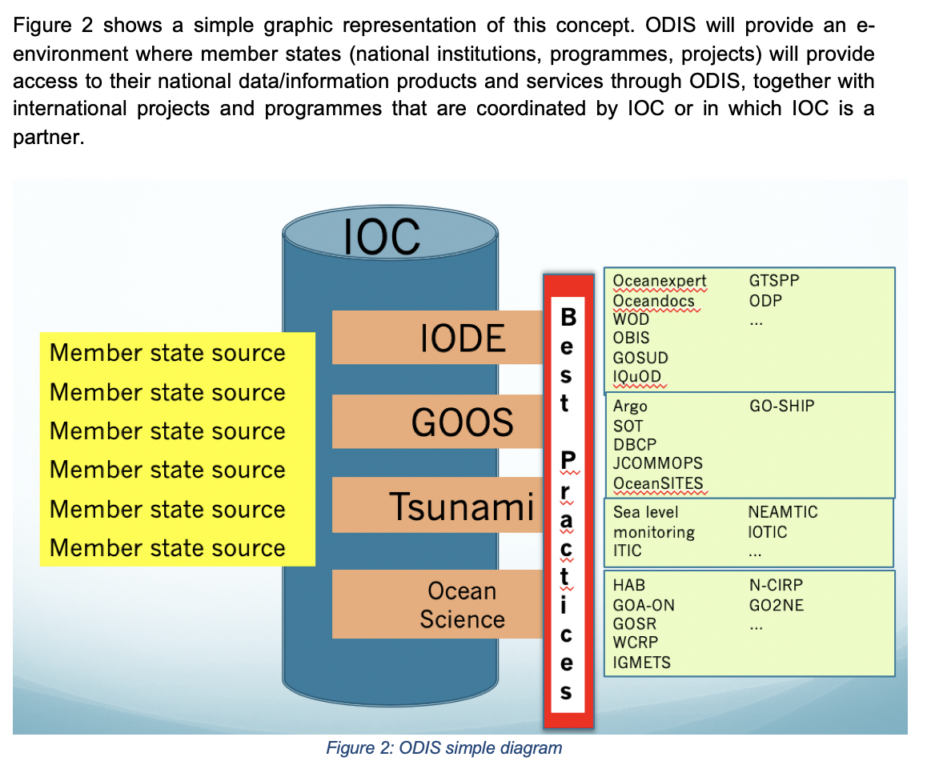Why no global data portal now?
As explained previously the IOC currently does not have the financial or human resources required to develop a “global data portal” but this does not preclude the development of such a portal in the future. In fact, there are many other factors that impede the development of such a system:
- Lack of uniform metadata structure for data sets
- Lack of uniform quality flags for data sets
- Lack of uniform definition of “data set”
- Lack of uniform controlled vocabularies
- Lack of uniform data format for sharing of data
- Lack of machine-to-machine interoperability
- Lack of global “wiring diagram” showing what data are shared with what systems
- Problem of duplicates and near-duplicates
- Unwillingness to share data “free and open”, despite the IOC data policy
- Lack of data/information management plan in projects
- Lack of expertise to manage data and information

A number of initiatives are trying to address some of the above, some regional and some global, and some of which involve IOC and its IODE but substantial efforts will still be required to resolve the above issues. It is essential that IOC, through ODIS becomes closely involved in these efforts to agree on global “best practices” or “standards” facilitating a truly global ocean data and information system that allows the discovery of and access to data at the data set (or even observation) level, as well as information, products and services using a “free and open” policy.

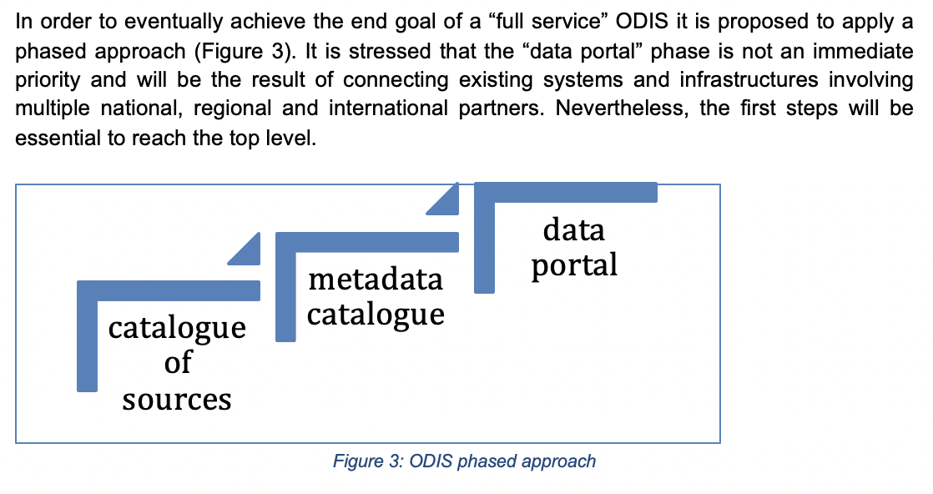

December 2018: ODISCat prototype launched. The prototype employs a model based on a review of schema.org by the former IODE Expert Team on Data Management Practices (ETDMP), and was intended to foster discussion and planning towards the broader ODIS concept. ODISCat continues to prove useful as a planning tool, identifying stakeholders and resources deemed useful by the contributors.

2019

July 2017- January 2019: In preparation for the 25th Session of the IODE Committee (February 2019) Document IOC/IODE-XXV/5.2 was prepared (IOC Ocean Data and Information System - Concept Paper and Summary Implementation Plan 2019-2020). This document reported on the work of the inter-sessional working group which included the revision of the ODIS concept (reflected in the vision statement above), a proposal for a phased approach, a proposal for the development of an ODIS Catalogue of Sources (with implementation plan for 2019-2020), and initial considerations for an ODIS metadata catalogue and ODIS “portal”. In addition the document described a few use cases.

February 2019: The 25th Session of the IODE Committee (February 2019) approved the concept paper (Document IOC/IODE-XXV/5.2). In addition IODE-XXV adopted (i) Recommendation IODE-XXV/5.2.1 (Establishment of the IOC Ocean Data and Information System Catalogue of Sources (ODISCat) project); and (ii) Decision IODE-XXV/5.2.3 *Establishment of the Inter-sessional working group to develop the implementation plan and cost-benefit analysis for the IOC Ocean Data and Information System). The latter was instructed to
i. Prepare the draft implementation plan and related cost-benefit analysis of the Ocean Data and Information System, detailing the proposed services that will be offered by ODIS, using the list included in agenda item 5.2.2 of Document IOC/IODE-XXV/2;
ii. Prepare a work plan including an initial set of services that will be developed during 2019-2021;
Submit (i) and (ii) above to the 30th Session of the IOC Assembly, for its consideration.

● 2019: in preparation for the 30th Session of the IOC Assembly (June/July 2019), the above mentioned intersessional working group prepared Document IOC-XXX/2 Annex 6 (IOC Ocean Data and Information System (ODIS): Concept, implementation plan and cost benefit analysis). The document offered 4 implementation options:
i. Option 1: List of Links
ii. Option 2: Repository of Sources (ODISCat)
iii. Option 3: Central Data Portal
iv. Option 4: Stepwise development of ODIS leveraging existing infrastructure (ODISstep)
For each option budget estimates were prepared for 2020-2021. The four options were compared in terms of benefits and weaknesses. 21. This preliminary Cost Benefit Analysis shows that Option 4 (Stepwise development of ODIS leveraging existing infrastructures (ODISstep)) will provide the maximum of benefits at a medium size cost.
The Document proposed to use Option 4: Stepwise development of ODIS leveraging existing infrastructures (ODISstep) starting with a Catalogue of Sources: (structured and searchable) repository of sources (catalogue of URLs), followed by metadata catalogues and ending with a central data/information repository, or a harmonized view of multiple data/information repositories. It further recommended 16 content types for ODISCat.

● June 2019: CHM/TMT “portal” prototype developed and presented by INVEMAR (Colombia), including presentation prior to IOC-XXX, as precursor to ODIS/OIH.(see http://portete.invemar.org.co/chm)

● June 2019: the 30th Session of the IOC Assembly (June/July 2019) “stressed the need to develop ODIS with involvement from the widest possible range of stakeholders, ensuring active participation from IOC Member States but also from other UN agencies, NGOs, national and regional programmes and projects, as well as the private sector. The Assembly noted that the IOC ODIS would form a solid and scalable basis for a UN Decade data system”. The Assembly adopted Decision IOC-XXX/7.2.2 (IOC Ocean Data and Information System (ODIS) which states:
“Endorses the ODIS Concept, Implementation Plan and Cost Benefit Analysis;
Invites the IODE Committee to prepare a fully detailed and costed project proposal for the IOC Ocean Data and Information System (ODIS) for submission to the IOC Executive Council at its 53rd session in 2020 “
It is noted that the 53rd Session of the IOC Executive Council could not be held in 2020 and accordingly this matter will be considered by the 31st Session of the IOC Assembly which will be held online in June 2021.

● July-September 2019: development of the project proposal “IOC Ocean InfoHub” and submission to the UNESCO/Flanders Funds-in-Trust for the Support of UNESCO’s activities in the Field of Science (FUST)

2020

● April 2020: start of the Ocean InfoHub project. The Ocean InfoHub (OIH) Project aims to improve access to global oceans information, data and knowledge products for management and sustainable development. The OIH will link and anchor a network of regional and thematic nodes that will improve online access to and synthesis of existing global, regional and national data, information and knowledge resources, including existing clearinghouse mechanisms. The OIH Project aims to develop the first proof-of-concepts of the Ocean Data and Information System (ODIS). The OIH Project is a three-year project funded by the Government of Flanders, Kingdom of Belgium, and implemented by the IODE Project Office of the IOC/UNESCO. (https://oceaninfohub.org)

● August 2020: recruitment consultant (August 2020 - December 2020, extended to June 2021) to “support and monitor the implementation of the ODISCat project, and in particular manage and administer, on a daily basis the ODISCat catalogue”.

2021
● January 2021: The 2021 Meeting of the IODE Management Group (Pre-Committee meeting) held 12-14 January 2021 welcomed the approval of the Ocean InfoHub project and the start of the project in April 2020. The Management Group noted that many of the 150 Member States currently do not have the required human and technical capacity to host online data and information services even when an NODC or ADU is present. As the stakeholder focus of OIH goes beyond the “traditional” IODE community it is fair to assume that the number of potential data and information sources that cannot host their own online services will be substantially higher than those we are aware of today. As such we risk missing out on a huge amount of “hidden” data and information available from potential stakeholders. It looks obvious that the efforts of Partnership Center for IODE Ocean Data Portal should be concentrated now on OIH/ODIS rather than standalone tools only as it was before. The Management Group welcomed the proposal to establish the Partnership Centre for ODIS (Document IOC/IODE-MG-2021/2.2 (Concept Note – IODE Partnership Centre for ODIS) ) and requested Dr Belov to prepare a working document for IODE-XXVI including background, objectives, expected results and deliverables, work plan and budget as well as a draft Recommendation for consideration by IODE-XXVI.

3 March 2021
Proposal for the Establishment of the IOC Ocean Data and Information System (ODIS)
FOR the Twenty-sixth Session of the IOC Committee on International Oceanographic Data and Information Exchange (IODE-XXVI) online, 20-23 April 2021

This document ( IOC/IODE-XXVI/6.1.1) provides the “fully detailed and costed project proposal for the IOC Ocean Data and Information System (ODIS)”. While this document should have been submitted to EC-53 in 2020, this was not possible due to the Covid19 pandemic. Consequently, the document shall be submitted to the thirty-first Session of the IOC Assembly in June 2021.

Vision:
The IOC Ocean Data and Information System (ODIS) will be an e-environment where users can discover data, data products, data services, information, information products and services provided by Member States, projects and other partners associated with IOC(*).
(*) while ODIS will initially focus on "partners associated with IOC" this can be expanded, taking into account the partnership established under the UN Decade of Ocean Science for Sustainable Development"

Components
ODIS will be an open-ended system of systems, where components interoperate through ODIS-Arch (see 4.1). However, the components of the ODIS ecosystem discussed in 4.2 - 4.4, will provide anchor points for the community. These either have been established or are in active development.
4.1 ODIS “digital ecosystem”
ODIS will interlink distributed, independent, systems (within and outside of the IOC) through a decentralized interoperability architecture (ODIS-Arch), to form a digital ecosystem. The initial implementation of ODIS-Arch - upon which the digital ecosystem will rely - will be supported through the Ocean InfoHub (OIH) Project (see 4.3) and will provide an interoperability layer and supporting technology to allow existing and emerging ocean data and information systems, from any stakeholder, to interoperate with one another.

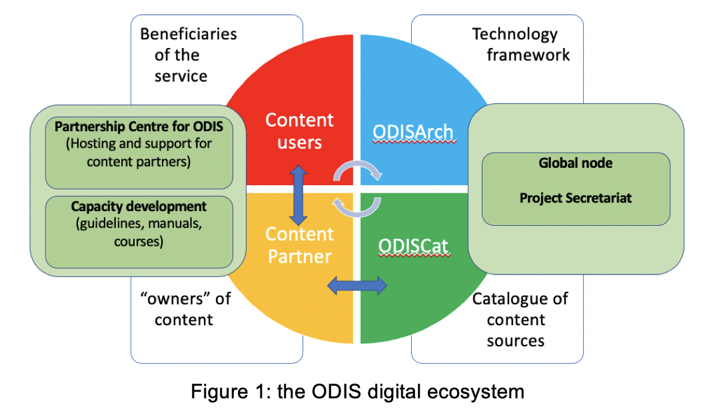

4.2 ODISCat
The ODIS "Catalogue of Sources" is the initial demonstration of an online, browsable and searchable catalogue of existing ocean related web-based sources/systems of data and information, products, and services. Services such as ODISCat will provide an index and backbone for technologies navigating the ODIS ecosystem.

4.3 Ocean InfoHub
The Ocean InfoHub (OIH) Project aims to improve access to global ocean information, data and digitised knowledge products for management and sustainable development. Leveraging ODIS-Arch and the contributions from partners in ODIS (see 4.1), the OIH will link and anchor a network of regional and thematic nodes that will improve online access to and synthesis of existing global, regional and national data, information and knowledge resources, including existing clearinghouse mechanisms. The project will not establish a new centralized database but will support discovery and interoperability of existing information systems over the Web.
Based on feedback from the three pilot regions (noted below), the initial thematic focus of OIH will be on (i) experts and institutions/organizations, (ii) documents, (iii) Spatial data and maps, (iv) research vessels, (v) education and training opportunities, (vi) projects.

4.4 Partnership Centre for ODIS
Multilateral partnership is at the core of both OIH and ODIS. These efforts will develop and support multi-way digital exchange: within each region, the partners who interoperate through ODIS-Arch will simultaneously contribute data and information to a digital commons and have access to the contributions of others, either directly or through hubs such as OIH.

Within IODE it has been widely recognized that many of the 150 Member States currently do not have the required human and technical capacity to host online data and information services even when an NODC or ADU is present. As the stakeholder focus of OIH goes beyond the “traditional” IODE community it is fair to assume that the number of potential data and information sources that cannot host their own online services will be substantially higher than those we are aware of today. As such, we risk a huge amount of data and information being effectively invisible and unable to help us face humanity’s common challenges and meet our shared opportunities..

It is thus recommended that the efforts of the Partnership Center for IODE Ocean Data Portal (hosted by the Russian Federation in Obninsk) should be concentrated now on OIH/ODIS, rather than on standalone tools (its previous focus) . It is proposed that the IOC Partnership Centre for ODIS will support the digital ecosystem as follows:

- Provide a toolkit that contains reference implementations of software that would enable nodes to ingest, describe, quality control, and transmit (meta)data to and from the Partnership Centre and other stakeholders;
- Provide training and support as well as documentation for the use of ODIS-related software;
- Provide secondary quality control of data/information received from stakeholders/providers through ODIS software (in terms of compliance with agreed methodologies);
- Archive and make available online data sets received from the stakeholders/providers, if requested by the data provider;
- Provide a secure archive/mirror of all stakeholders/providers who cannot ensure/assure the long-term and secure archival of their data/information, if requested;
- Make all its data and information holdings available globally through the ODIS-Arch and systems like OIH;
- Coordinate and broker, with their respective secretariats/hosts, the submission of data held by the Partnership Centre to the World Ocean Database (WOD) and Ocean Biodiversity Information System (OBIS);
- Make all data and information managed by the Partnership Centre available through a mirror site at the IOC Project Office for IODE, Oostende, Belgium;
- Report on activities to the IODE Management Group, including member state contacts, status of work (data hosting, data sharing, ODIS integration, data use, etc.).

Costs of ODIS
We refer to Document IOC-XXX/2 Annex 6 (IOC Ocean Data and Information System (ODIS): Concept, implementation plan and cost benefit analysis) that identified Option 4: Stepwise development of ODIS leveraging existing infrastructure (ODISstep) as the preferred option with maximum benefits at a medium cost (Table 1).

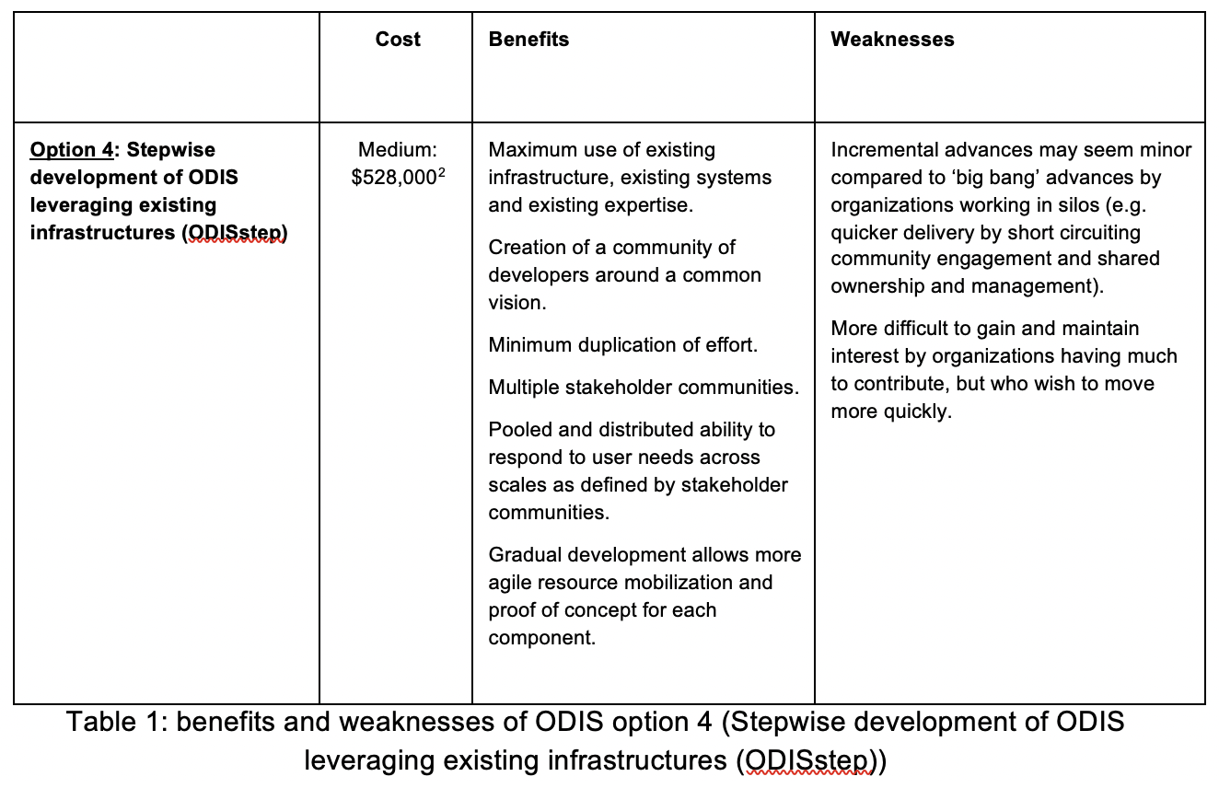

Work packages were outlined, but the initial scope was to work through the OIH Project under WP2: technology development. Budgets for additional resources were developed as follows:

Secretariat operations:
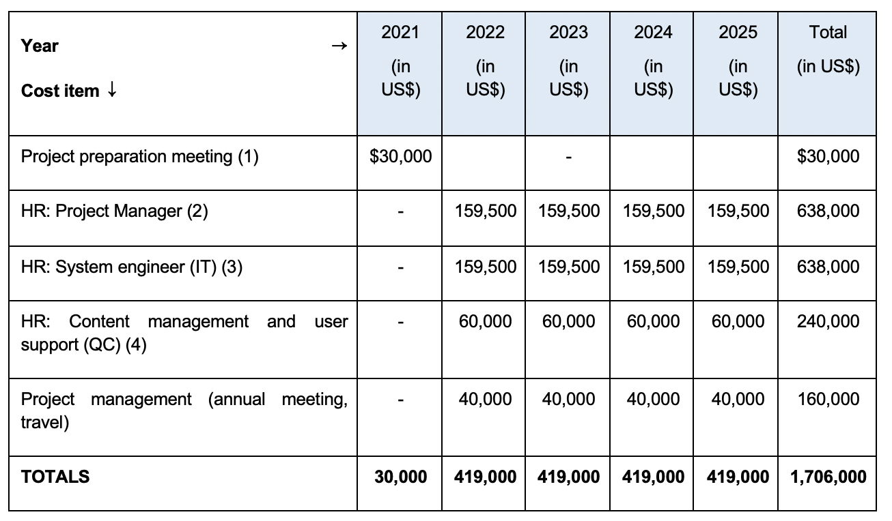
Capacity development and support to member states:
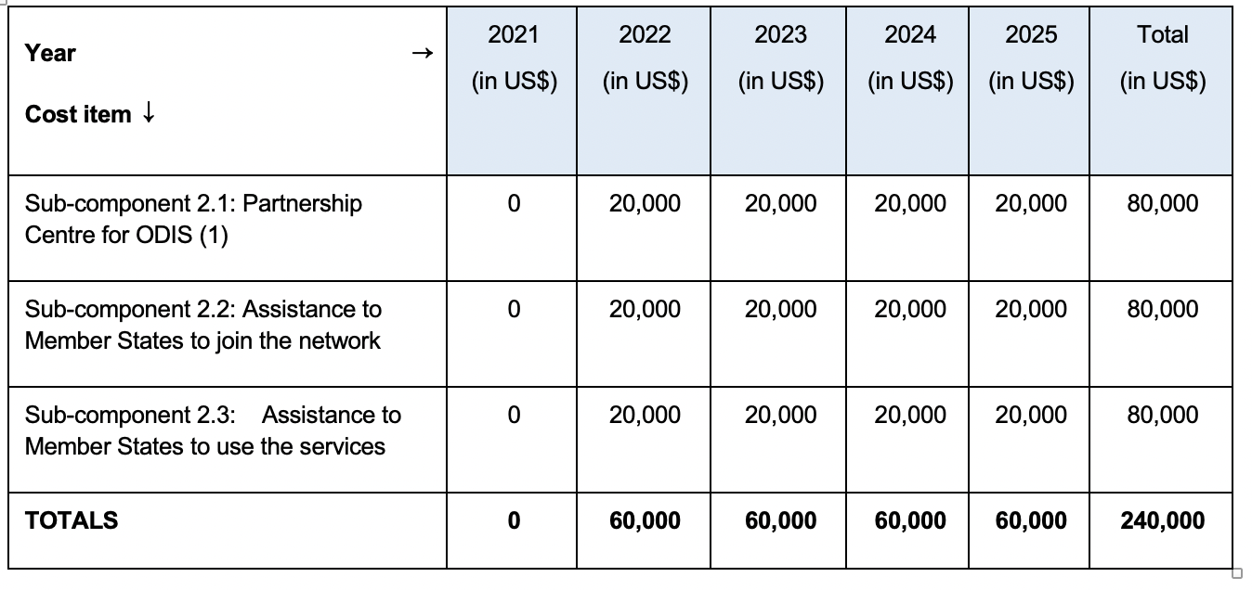

ODIS-Cat

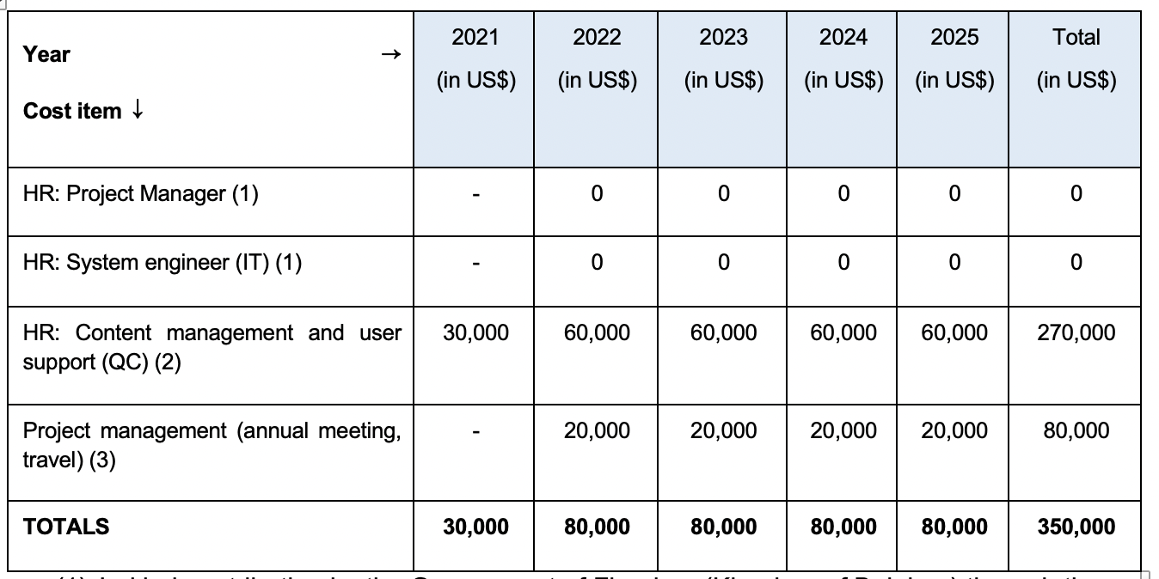
(1) In-kind contribution by the Government of Flanders (Kingdom of Belgium) through the Flanders Marine Institute (IT system engineer)

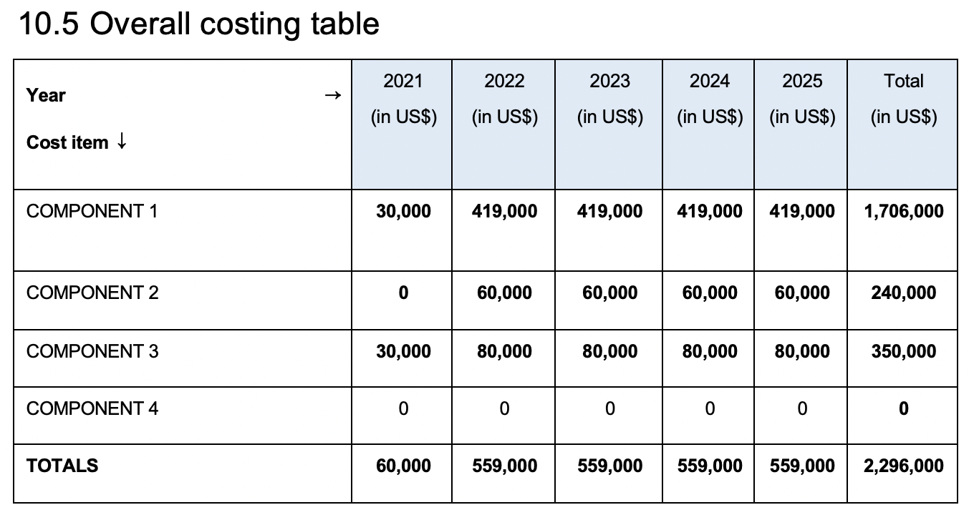
Component 4 is national activities which were proposed to be in-kind

April 2020: start of the Ocean InfoHub project.

IODE-XXVI (2021) recommended the establishment of the IOC Ocean Data and Information System (ODIS) through Recommendations IODE-XXVI/6.1.1.

The IOC Assembly at its 31st Session (2021) formally established ODIS through Decision A-31/3.4.2.

IODE-XXVII (2023) decided to designate ODIS as one of three IODE Programme Components.

