Task Team CARIBE WAVE 25
UNESCO/IOC
ICG CARIBE-EWS

CARIBE WAVE 2025

Supplement Report

Kimberly Maisonet González
Christa von Hillebrandt-Andrade
International Tsunami Information Center Caribbean Office
April 2025

Summary of CARIBE WAVE

The CARIBE WAVE exercise is conducted within the framework of the UNESCO Intergovernmental Coordination Group for Tsunamis and other Coastal Hazards for the Caribbean and Adjacent Regions (CARIBE-EWS). The 2025 annual tsunami exercise took place on March 20th to test Tsunami Warning Systems and promote tsunami preparedness in the Caribbean and adjacent regions. The exercise was coordinated by the CARIBE WAVE task team, the NOAA International Tsunami Information Center Caribbean Office, and supported by the Caribbean Tsunami Information Center and Pacific Tsunami Warning Center. It was left up for Member States and Territories to choose between the Jamaica and Portugal scenarios and to decide the level of participation and activity to be held in their country.
CARIBE WAVE exercises focus on communications and evaluating procedures and programs within Member States and Territories. The Pacific Tsunami Warning Center (PTWC), the Regional Tsunami Service Provider, issued a “Dummy” message through the different warning systems at 1500 UTC to test communications with Tsunami Warning Focal Points (TWFP) and National Tsunami Warning Centers (NTWC). Different methods of communication were used to test and disseminate the message: The World Meteorological Organization (WMO), Advanced Weather Interactive Processing System (AWIPS), Aeronautical Information Replacement System (AIRS), NOAA Weather Wire, GEONETCast Americas, Fax, Email, and social media. According to feedback as well as social media and web posts, the dummy message was successfully received. The Central America Tsunami Advisory Center also disseminated simulated products for the Jamaica Scenario to its stakeholders.

When PTWC issued its simulated “end of threat” messages for the exercise, over 500,000 people from across the entire Caribbean basin had participated, according to member states and territories. The majority of the participants from across the region were from K-12 Schools and Districts, as well as Preparedness Organizations, State Government, and Local Government. Social media platforms, which have become the primary source for communicating tsunami awareness, reached many people worldwide during the exercise.

Sea level data availability is important to forecast and confirm a real tsunami event. If a tsunami had occurred during the day of the exercise, data of 91 of the 165 sea-level stations in the region would have been available for event analysis. Only one of the Deep Ocean Assessment and Reporting on Tsunamis (DARTs) in the Atlantic and Caribbean that were included in the simulated PTWC products was operational during the exercise. CARIBE WAVE has been improving and validating tsunami preparedness since 2011, which is why tsunami exercises are crucial to maintain readiness in case of a real tsunami event.

Supplement Survey Results

Caribe Wave 2025 Survey Report from TWFP/TNC

CARIBE WAVE 25 exercise was conducted at various levels and sophistications. The survey was available through the Survey Monkey services from the start of the exercise on March 20 and extended through April 23. The following Member States and Territories participated in the post-exercise evaluation:

- Antigua and Barbuda
- Barbados
- Belize
- Brazil
- Colombia
- Cuba
- Dominica
- Dominican Republic
- France (Guadeloupe, Martinique, Saint Martin, St. Barthelemy)
- Guatemala
- Guyana
- Haiti
- Honduras
- Jamaica
- Mexico
- Netherlands
  - Aruba
  - Bonaire, Saba, Sint Eustatius
  - Sint Maarten
- Nicaragua
- Panama
- Saint Kitts and Nevis
- Saint Vincent and the Grenadines
- Trinidad and Tobago
- United Kingdom
  - Anguilla
  - Bermuda
  - British Virgin Islands
  - Cayman Islands
- United States
  - Puerto Rico
  - U.S. Virgin Islands
- Venezuela

Contact Information – Agency

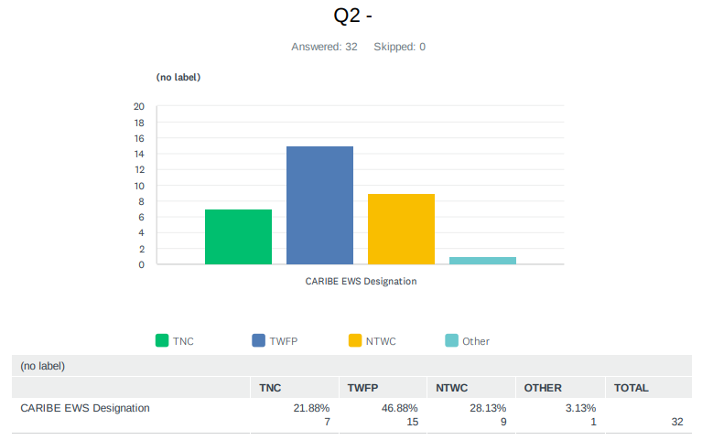

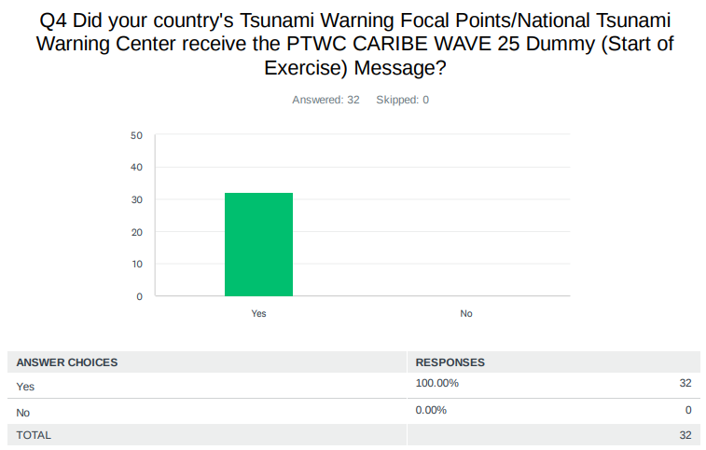
Comments:

Anguilla: It was received via email

NL - Sint Maarten: none

Panama: via Fax form PTWC and email form PTWC and CATAC

Saint Kitts and Nevis: It was received timely.

US - Puerto Rico: 15:00 UTC

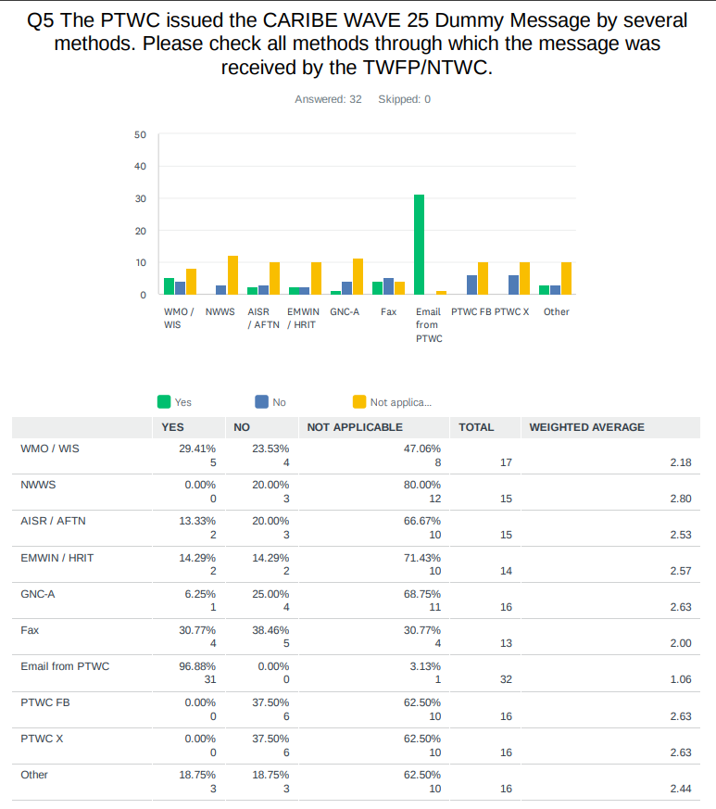

Comments:

Antigua and Barbuda: PTWC Website

Saint Kitts and Nevis: Email is the only method used by us.

Trinidad and Tobago: Currently this (email) is our only method of receiving messages from PTWC

UK - British Virgin Islands: Puerto Rico Seismic Network also made phone calls

US - Puerto Rico: AWIPS (NWS-SJ) and EMWIN (PREMB & PRSN)
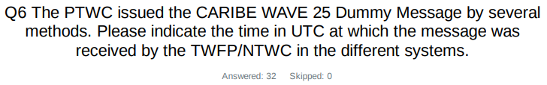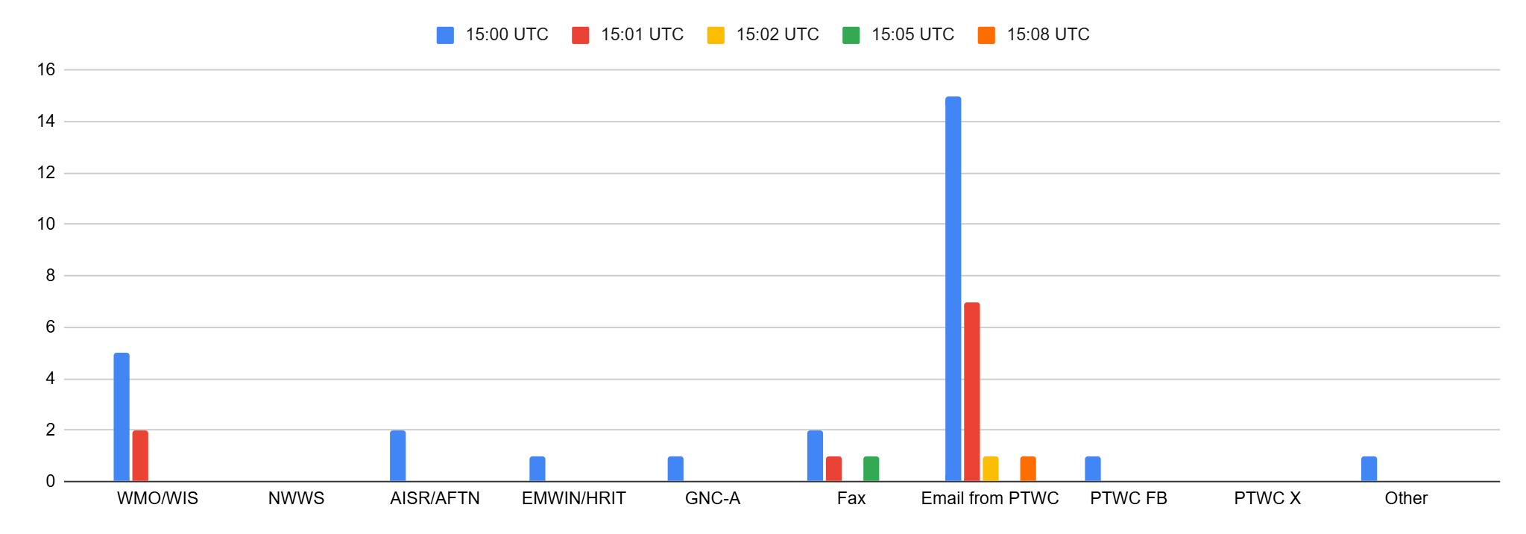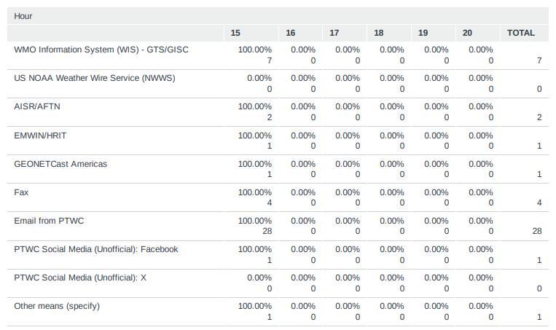

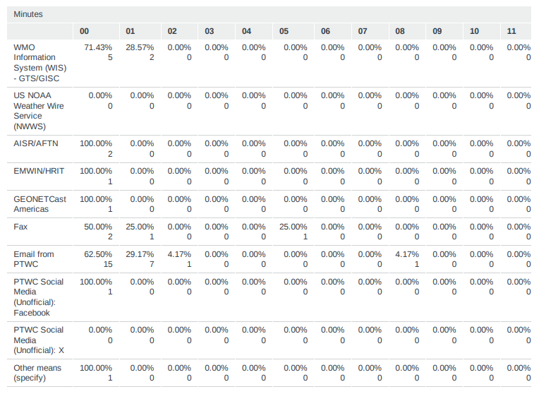

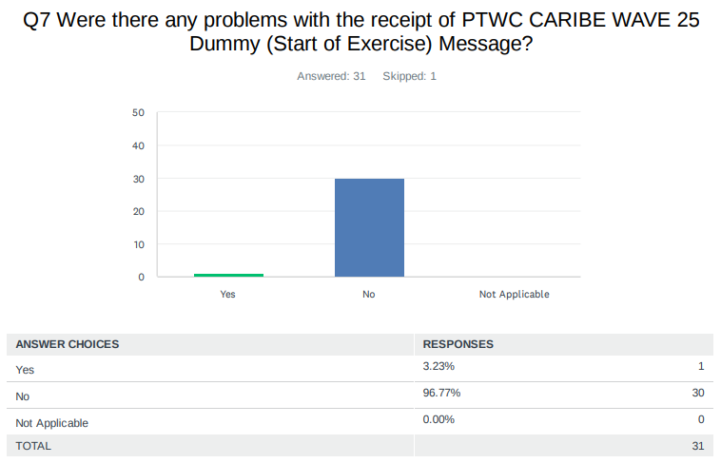

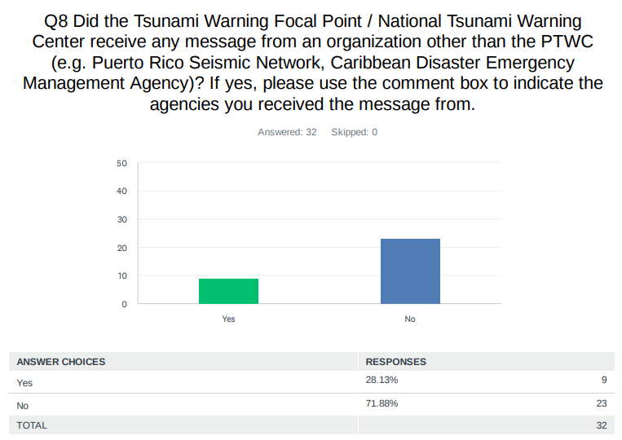
Comments:

Costa Rica: CATAC

Dominican Republic: Puerto Rico Seismic Network.

Guatemala: We received a message from the "Central American Tsunami Advisory Center (CATAC)"

Honduras: Yes, we received exercise start messages from the Central America Tsunami Advisory Center (CATAC)

Panama: from CATAC - Central America Tsunami Advice Centre

St. Kitts and Nevis: We only receive messages from the PTWC.

UK - British Virgin Islands: The Puerto Rico Seismic Network called the TWFP and TNC

USA - Puerto Rico: PREMB and NWS-SJ received messages from PRSN.

USA - US Virgin Islands: Puerto Rico Seismic Network

Venezuela: The Venezuelan Seismological Service sent notice

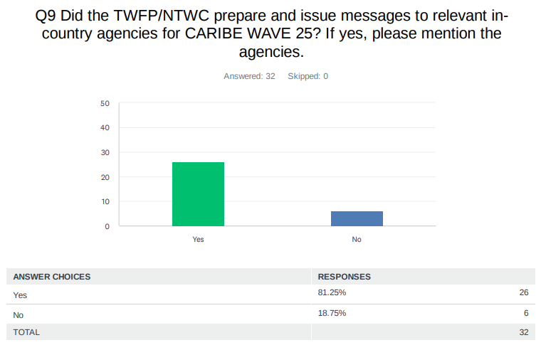
Comments:

Antigua and Barbuda: National Office Of Disaster Services, government agencies, general public etc.

Aruba: Fire Department, Police, Red Cross, Social Affairs, Private Sector, Hotels, Schools, Government

Barbados: DEM

Colombia: Servicio Geológico Colombiano Unidad Nacional para la Gestión del Riesgo de Desastres

Costa Rica: We sent the information to a local government, Talamanca

Dominican Republic: Yes, we prepared a preliminary tsunami warning bulletin, a preliminary tsunami advisory bulletin, seventeen advisories, and a tsunami cancellation bulletin. For a total of 22 bulletins, these were sent to the Emergency Operations Center (COE).

Grenada: National Disaster Management Agency (NaDMA)

Guatemala: We issued messages through bulletins to the risk management agency in Guatemala: "CONRED"

Guyana: Civil Defense Commission which the National Disaster Response Agency in Guyana

Haiti: DGPC, CRH, UHM, BME

Mexico: Coordinadora Nacional De Protección Civil, Dirección General De Protección Civil de la Secretaría de Seguridad y Protección Ciudadana, Capitanías de Puerto. Mandos Navales. Secretaría de la Defensa Nacional. (National Civil Protection Coordinator, General Directorate of Civil Protection of the Secretariat of Security and Citizen Protection, Harbor Masters. Naval Commands. Secretariat of National Defense).

Netherlands - Bonaire, Saba, Sint Eustatius: exercise email-messages distributed as well as phone calls made to 1) local governments on the islands Saba, St. Eustatius, Bonaire; 2) government crisis center DCC, 3) Rijksvertegenwoordiger

Nicaragua: In our function as TSP we sent our messages also to our national contacts.

Panama: The NTWC sent a message to SINAPROC (Sistema Nacional de Protección Civil) Panama's National Civil Protection System.

St Kitts and Nevis: Exercise Control issued the relevant messages according to our planned scenarios.

Trinidad and Tobago: The messages from PTWC were emailed to the Office of Disaster Preparedness and Management which is the NTWC, as well as Tobago Emergency Management Agency and receipt was confirmed, as per the SOP.

UK - Anguilla: The Initial message was sent to the National Disaster Management Committee via WhatsApp chat and the Emergency Alerts WhatsApp Chat. Message was also sent via the Warning system and to our local telecoms provider

UK - Bermuda: The Emergency Measures Organization of the Bermuda Government

UK - British Virgin Islands: The National Disaster Management Council , National Emergency Operation Centre Grouping

UK - Cayman Islands: Department of Education, 911, etc

USA - Puerto Rico: PRSN issued messages to Service List: PREMB, PREMB Zones, Municipalities, NWS-SJ, 911-PR, Puerto Rico Judicial System, SJU International Airport, 911-St. Thomas, 911-St. Croix, VITEMA, BVI Police, DDM-BVI.

USA - US Virgin Islands: 1. VITEMA ALERVT-VI (Everbridge) - mass message (subscription) 2. VITEMA / FMEA (IPAWS) - to PEP

Venezuela: The seismological service of Venezuela in Funvisis issued messages to the focal points and the communication center

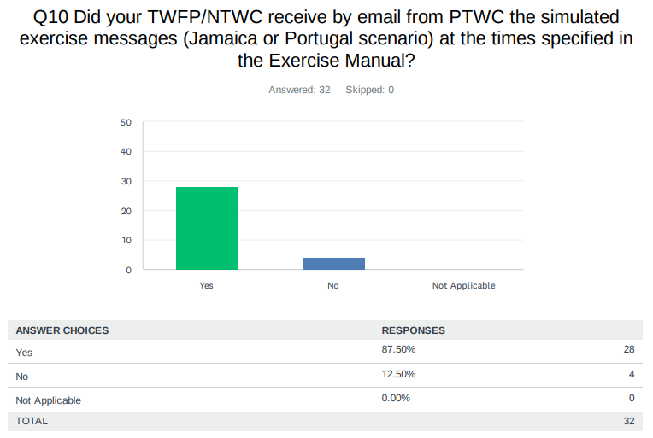
Comments:
Colombia: El mensaje 1 se recibió a las 15:08 UTC, El mensaje 3 se recibió a las 16:02 UTC

Dominican Republic: No, we only receive the simulate for Portugal exercise

France: The French NTWC correctly and timely received the emails. The French TWFP did not received the emails timely: they arrived two days after the exercise (they were blocked in mta6.iscinternational.com server before delivery the 22nd of March.

Guyana: However, I must note that the messages were not sent to Guyana. I had to inform Christa von Hillebrandt-Andrade, ITIC-CAR Manager (christa.vonh@noaa.gov) about this issue and then she forwarded the messages to us. After 1600 UTC we began to receive the messages via email from PTWC

UK - Cayman Islands: Time difference of 1-2 minutes from times listed in exercise manual

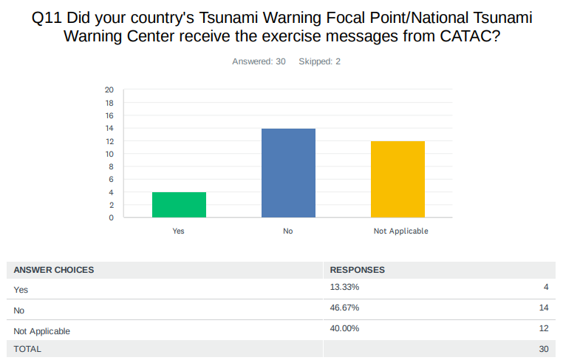

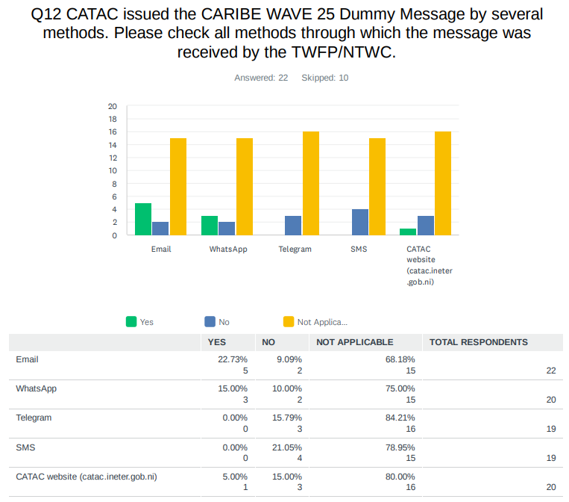

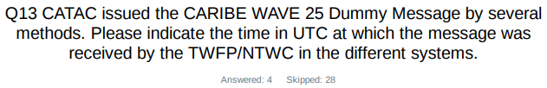
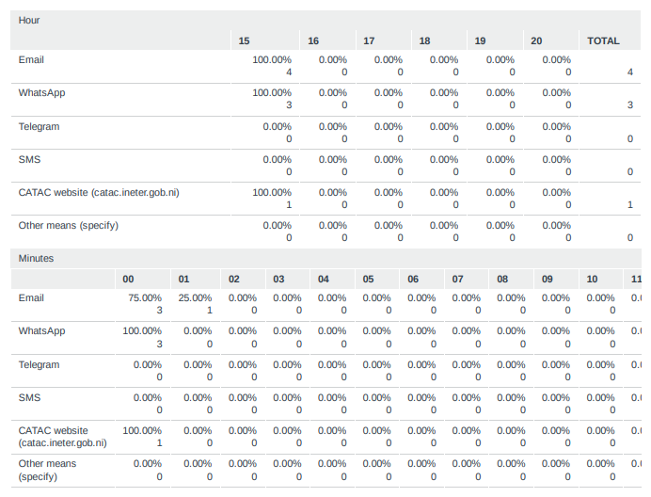

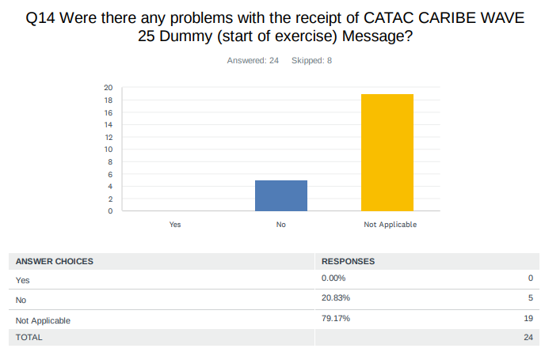

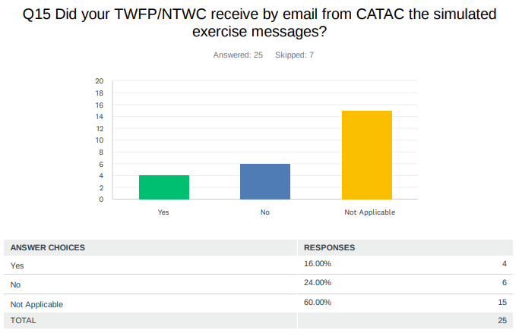

Comments:
Panama: the NTWC received all the messages

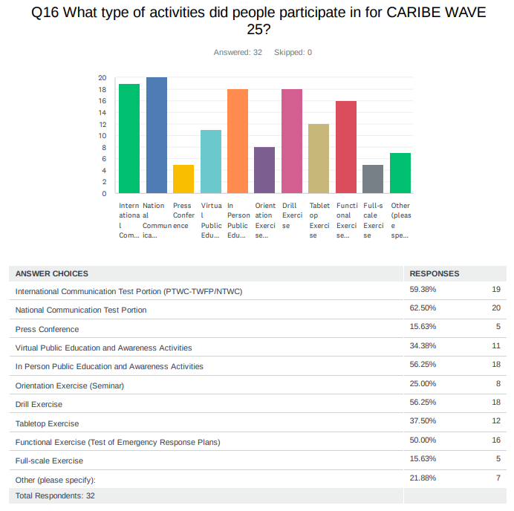

Comments:

Belize: None.

Dominican Republic: A tabletop simulation exercise was conducted, including responses to emergency plans. These actions for this Caribe Wave exercise were carried out with the active participation of the Emergency Operations Center (COE).

Grenada: We engaged with Coyoba Beach Resort to development maps of their evacuation routes...some schools education programme through videos on Tsunami Carriacou engaged in public education and Grenada Airport Authority tested communication and Royalton Grenada Resort did a partial while NEWLO did a full scale evacuation, St. George's methodist did a Tsunami Walk along their evacuation route
NL - Bonaire, Saba, Sint Eustatius: national communication testing of TWFP-->local stakeholders (islands, crisis center)

UK - British Virgin Islands: A number of government and private sector agencies evacuated to Tsunami Safe locations using tsunami designated routes.

USA - Puerto Rico: EAS activation via BMH (NWS-SJ)

USA - US Virgin Islands: Mock Press Conference

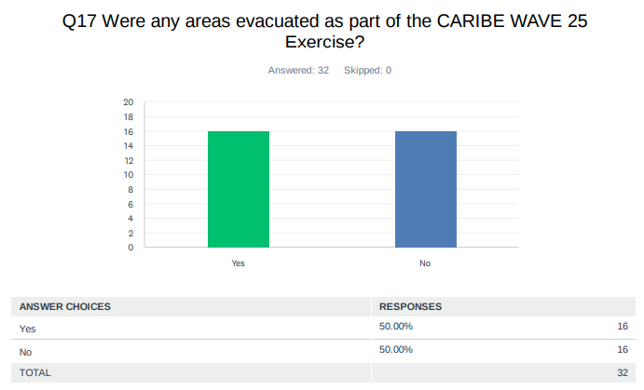

Comments:

Barbados: Some areas in the selected evacuation areas were evacuated.

Belize: Our country was not listed in the affected countries list for the Jamaica scenario, perhaps a scenario that would be more inclusive

Costa Rica: Cahuita

Grenada: Royalton Resort and New Life Organization (NEWLO)

Haiti: In a school in the southeast of the country. 96 students ave evacuated

Honduras: Evacuations were carried out at the Sotero Barahona Mixed Rural School and the Javier Calix kindergarten in the municipality of Omoa, Cortes, with the participation of approximately 200 children, parents, and teachers.

Jamaica: One Industrial Plant in Old Harbour Bay

Nicaragua: We did CW25 only as table top exercise. Our national multihazard exercise was done on March 27

UK - British Virgin Islands: Several areas around territory on the four main islands Tortola, Virgin Gorda, Anegada, Jost Van Dyke

Venezuela: All coastal states in Venezuela carried out evacuations on selected coasts and In funvisis, plan and protocols were activated before earthquake and tsunami

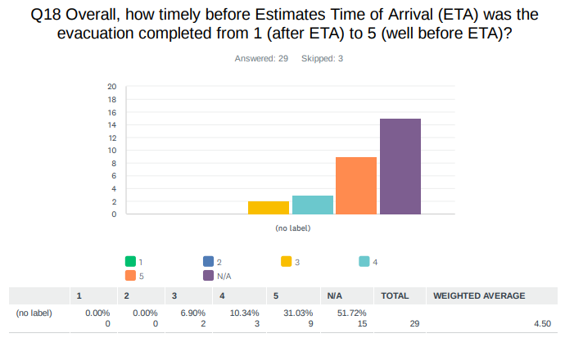

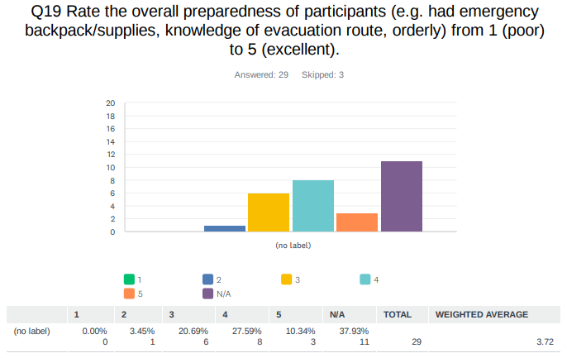

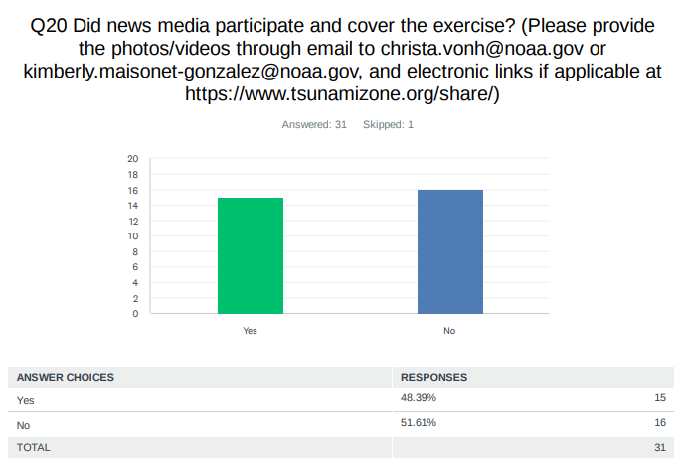

Comments:

Antigua and Barbuda: https://www.youtube.com/watch?v=rmf5CCsmUQ8

Barbados: Not seeing any coverage at the moment.

France: See the file sent by email with a list of electronic links (~30)

Grenada: Government Information Service (GIS)

NL - Bonaire, Saba, Sint Eustatius: internal press center will also be informed in warning procedure

St. Kitts and Nevis: The government Radio and Television Station, ZIZ, covered the government facilities that were evacuated.

USA - US Virgin Islands: St Thomas Source (online) and St Croix Source (online)

Venezuela: https://www.vtv.gob.ve/tag/caribe-wave-2025/ https://www.dailymotion.com/video/x9gn7ju
https://www.vtv.gob.ve/realizan-simulacro-caribe-wave-2025- merida/

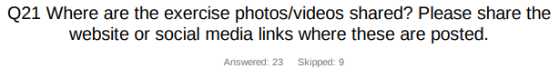
Antigua and Barbuda: Instagram - https://www.instagram.com/nods__antiguabarbuda/?hl=en | Facebook - https://www.facebook.com/NodsAntiguaAndBarbuda/

Barbados: https://www.facebook.com/dem246

Colombia: https://www.instagram.com/reel/DHg7A8ZJ-vz/?igsh=Y3Z6aG03OTU4bDlp https://portal.gestiondelriesgo.gov.co/Paginas/Noticias/2025/Colombia-fortalece-su-preparacion-ante-tsunamis-con-la-participacion-enel-ejercicio-de-simulacion-internacional-Caribe-Wav.aspx

Dominican Republic: We will share later.

France: See the file sent by email with a list of electronic links (~30)

Grenada: nadma.gd /gisgrenada

Guatemala: https://www.facebook.com/insivumeh/posts/insivumeh-realiz%C3%B3-el-taller-preparatorio-en-el-marco-del-simulacro-de-tsunami-ca/1077563491076081/

Guyana: Facebook-Hydrometerological Service Guyana

Haiti: https://www.transfernow.net/dl/20250404TpY3YcsV

Honduras: https://www.facebook.com/share/v/16F8aXSxFv/?mibextid=oFDknk https://www.facebook.com/share/v/15SmPZwkAH/? mibextid=oFDknk https://www.facebook.com/share/p/15cj6UkpBX/?mibextid=oFDknk

Jamaica: The exercises were nit Photos were not shared. However photos of exercises available.

Mexico: https://canal13mexico.com/noticias-2/regionales/campeche/campeche-participa-en-el-simulacro-internacional-de-tsunamis-caribewave-25/

https://www.gob.mx/cms/uploads/attachment/file/984947/COMUNICADOS_024_NAVCHAMP_21.03.25.pdf

https://www.eluniversal.com.mx/mundo/sismo-de-magnitud-8-sacude-el-caribe-de-honduras-declaran-alerta-por-amenaza-de-tsunami/

NL - Aruba: cmo-aruba.com/facebook/crisis management office

Panama: Institute's Instagram social network: https://www.instagram.com/igcpanamaup?igsh=MzNkZzEyazZ6cmpi

St. Kitts and Nevis: The link will be provided later

St. Vincent and the Grenadines: exercise photos/videos were not shared

Trinidad and Tobago: https://www.facebook.com/share/r/1BgkLoEguK/?mibextid=wwXIfr

UK - Anguilla: https://www.facebook.com/ddmaxa

UK - British Virgin Islands: bviddm facebook, twitter , instagram

UK - Cayman Islands: https://www.facebook.com/share/158xUJ9gWj/

USA - US Virgin Islands: Yes

Venezuela: https://www.instagram.com/funvisis/p/DHT7nr5uqBN/ https://www.instagram.com/ab_shn.ve/reel/DHb5RgGRw2l/ https://www.instagram.com/luis.jacobo.salazar/reel/DHcjUvlC9a8/ https://www.instagram.com/elfarodelaguaira/reel/DHhd89-MTq3/ https://www.instagram.com/funvisis/p/DHYmSqROFo6/ https://gobiernonuevaesparta.com/mas-de-650-estudiantes-participaron-en-elcaribe-wave-2025/ https://www.instagram.com/unitvnoticias/reel/DHe-yV5Jpc0/ https://www.instagram.com/ven911nuevaesparta/reel/DHbzsw3xD2t/ https://www.instagram.com/cpnb_redip_insular/reel/DHb_cQMOZ3q/ https://www.youtube.com/watch?v=bY4nL9zjf80
http://www.funvisis.gob.ve/noticia.php?id=2775 https://www.instagram.com/ubvaldia/p/DHbdfvnsJjT/?img_index=1 https://www.facebook.com/reel/863009129280076 https://www.instagram.com/zodine_71.fanb/reel/DHdcpPERXJu/ https://www.instagram.com/ven911nuevaesparta/p/DHbsgOoxMh7/?img_index=1 https://notiespartano.com/mas-de-650-estudiantesparticiparon-en-el-caribe-wave-2025/ https://x.com/GobernacionNe/status/1903564109091684515 http://www.funvisis.gob.ve/noticia.php?id=2774 https://www.instagram.com/pcivil_venezuela/p/C4qTujsroVX/ https://www.instagram.com/funvisis/p/DEp5fL-xbrd/ https://www.instagram.com/funvisis/p/DHJapVGu6oM/participa-en-el-caribe-wave2025-%C3%BAnete-al-simulacro-internacional-de-tsunami-org/ https://www.instagram.com/jrafaelvegas/p/DHRP_fhgrT8/?img_index=1 https://www.instagram.com/pcguanta/p/DHMIHLAz7iP/?img_index=1

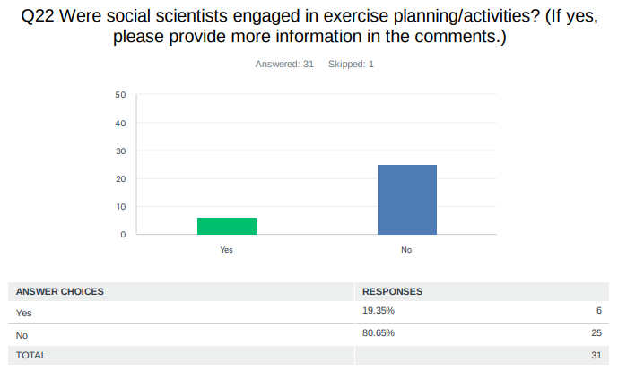

Comments:

Dominican Republic: Lic. Ramon Delanoy director of the National Center of Seismology of the UASD, a representative of the National Geological Service.

Costa Rica: Evaluation

Jamaica: Officers of the Social Development Commission were involved in selected targeted communities

Venezuela: since the domain exercised by natural and basic sciences on the problem of disasters in the Latin American subcontinent is almost total. The study of seismic and climatological patterns, terrestrial dynamics, etc., places a notorious emphasis on prediction problems and on the adaptation of structures to the physical parameters of natural events that threaten society. But society does not appear in the formula, neither as an object of study, nor as an object of action and change in terms of its patterns of behavior and incidence in the realization of disaster situations. We have two social scientists who have participated as observers in the exercise and have made important reflections that indicate the importance of incorporating the social issue into the Caribe Wave exercise. Researchers gave workshops and seminars on the Caribe Wave 24 exercise, material for Civil Protection and Disaster Management was sent locally and regionally

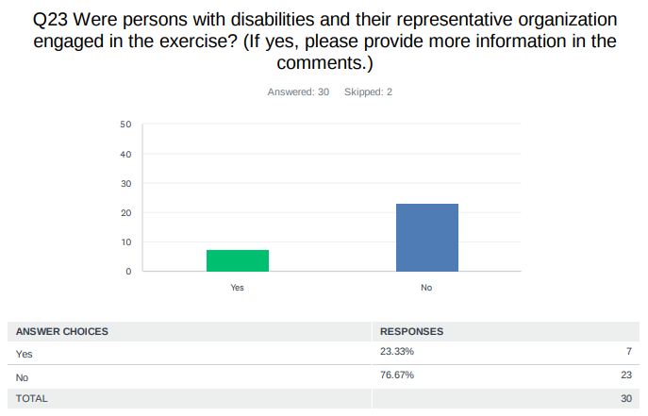

Comments:
Antigua and Barbuda: The Care Project was part of the exercise as a disability center for young children.
Barbados: Patients from the St. Lucy District Hospital were evacuated. More information can be acquired from the Department of Emergency Management.
France: Probably among all the participants, but not specifically targeted
Jamaica: Jamaica Council for Persons with Disabilities participated on March 20 in the Functional Exercise and the Communications test at the National Level. Other entities were engaged but did not participate in the functional but were incorporated into the communication tests
Mexico: We do not know for sure, but probably yes.
St. Kitts and Nevis: They were tested in a previous exercise.
UK - British Virgin Islands: The school registered for participation

UK - Cayman Islands: One of the schools HMCI attended as observers was Lighthouse School which is a school for students with special needs. Some preparation practices were altered for their needs.

Venezuela: People with visual impairments gave workshops on the Caribe Wave exercise

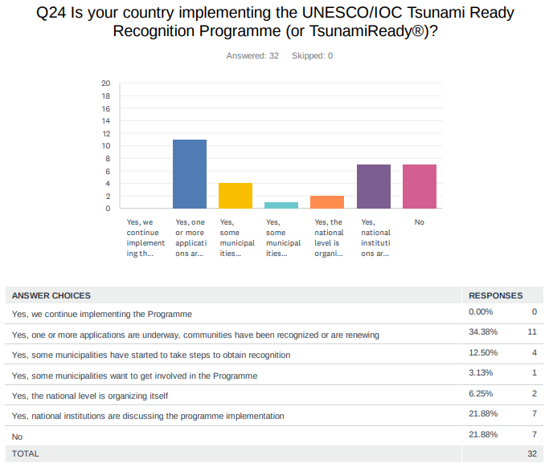

Comments:

Dominican Republic: San Felipe, Puerto Plata and San Gregorio de Nigua in San Cristobal Province

Haiti: Not now

NL - Bonaire, Saba, Sint Eustatius: The implementation of programs falls under the authority of the local governments.

St. Kitts and Nevis: Renewal is upcoming.

UK - British Virgin Islands: Our recognition is still valid at the moment

USA - US Virgin Islands: St Croix, St Thomas, St John (3-total)

Venezuela: Yes, community activities are started in favor of the tsunami ready program, there are still a lack of resources for the respective visits and observations
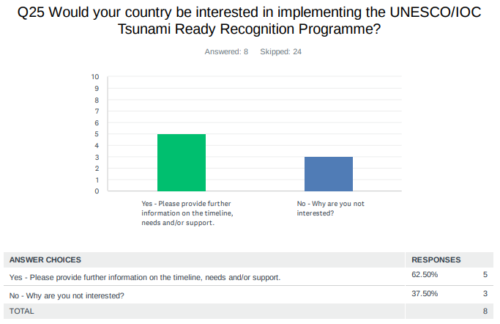
Comments:

Antigua and Barbuda: We would have started some aspects of the program and are willing to further continue it.

Brazil: Not at the moment. Yes for the future. We need to improve other elementary processes first, such as mapping the territory, identifying the threats.

Colombia: Colombia estima implementar los indicadores del programa Tsunami Ready para dos municipios costeros en el Pacífico para 2030 El proyecto requiere recursos económicos por cual aún no se ha iniciado.

Haiti: After Fort-Liberte, Jeremie would be candidate for Tsunami Ready Recognition

NL - Bonaire, Saba, Sint Eustatius: The implementation falls under the authority of the local governments.

UK - British Virgin Islands: We currently still have a recognized program in place.

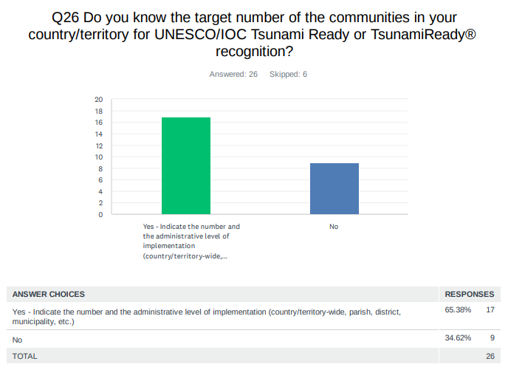
Comments:

Barbados: Shermans Holetown Worthing

Colombia: 31 Municipios: Necoclí, Arboletes, San Pedro de Urabá, Turbo, Barranquilla, Juan de Acosta, Piojó, Puerto Colombia, Tubará, Cartagena, Santa Catalina, Acandí, Unguía, Los Córdobas, Moñitos, Puerto Escondido, San Antero, San Bernardo del Viento, Dibulla, Manaure, Rioacha, Uribia, Cienaga, Puebloviejo, Santa Marta, Sitionuevo, San Andrés, Providencia, Coveñas, San Onofre, Santiago de Tolú

Cuba: Baracoa City, in the eastern region of Cuba

Dominica: Town on portsmouth completed. Hoping to implement in other northern and north eastern communities

Dominican Republic: We've identified three, and efforts have already been made to identify them. However, we need to make efforts to identify others, especially on the north coast.

France: 1

Haiti: Cap-haitien, Port-de-paix, Saint-Louis du Nord, Anse-aFoleur, Jeremie, Cayes, Anse-a-Veau, Gonaives, Saint Marc, Arcahaie

Honduras: three communities: 1. Omoa, Cortes 2. Tornabe, Tela in Atlantida 3. Cedeño, Marcovia in Choluteca

Jamaica: Old Harbour Bay, Port Maria, Alligator Pond and Treasure Beach.

Mexico: More than 100.

Nicaragua: Too many

St. Kitts and Nevis: Entire Country.

St. Vincent and the Grenadines: 6 zones on mainland St. Vincent 7 inhabited Grenadine Islands

UK - Anguilla: One - we are a small Island so we are targeting the entire island as a community

UK - Bermuda: Bermuda has 9 parishes

UK - Cayman Islands: Mainly coastal (beachfront) single storey properties on all three (3) islands

USA - Puerto Rico: Puerto Rico - 47 Tsunami Ready communities in PR (46 municipalities and the Luis Muñoz Marín International Airport-SJU) and 17 Tsunami Ready Supporters in PR. US Virgin Islands - 3 Tsunami Ready communities in USVI.

USA - US Virgin Islands: St Croix, St Thomas, St John

Venezuela: At least three communities have begun preparations

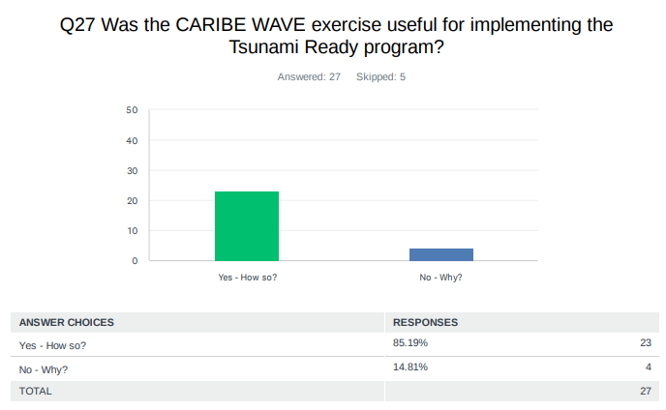

Comments:

Antigua and Barbuda: It allowed for persons to be informed and educated about tsunamis and the impacts they could have on our daily lives. Also, it allowed persons to know their risks for tsunami impacts and what level of preparedness is required.

Belize: It engages the necessary entities and serves as a means to test the countries' readiness for tsunami relates events.

Colombia: Todavía no se está implementando el programa en el país.

Costa Rica: Cahuita es Tsunami Ready, They participated in the drill

Cuba: It strengthens the operational capacities and products of the modeling and allows for improving risk assessments every year

Dominican Republic: Yes, it allows communities to prepare and thus mitigate the impact of these events.

France: Motivation for communities which have already expressed their intention to participate to the Tsunami Ready recognition program and for new ones

Guatemala: As of today, we are in discussions with the risk management agency in Guatemala to implement the Tsunami Ready program along the coasts of Guatemala.

Haiti: No meeting yet for discussing

Honduras: The SOPs established during the Tsunami Ready program surveys in the communities were implemented

Jamaica: For Old Harbour Bay it serves as an opportunity to continue to actively participate in activities. For Alligator Pond with the assistance of the Social Development Commission a plan has been produced in 2023. The Caribwave Exercise was used to reorient the community to the response plan and plan a drill for the upcoming months.

Mexico: Because in some way the Tsunami Ready program informs and helps the population in vulnerable areas in the face of a tsunami, so with the information provided to them during the exercise, these people are in a position to obtain more information about this phenomenon.

Nicaragua: We did CW 2025 not for this purpose.

NL - Sint Maarten: Yes, it help to recognize several gaps that needs to be taken into consideration moving forward.

Panama: No, because as a country, the implementation of this is not yet a defined objective or goal of the government

St. Kitts and Nevis: Continued efforts are made to educate the public, test first responders response, testing the Tsunami communication protocols, and testing the evacuation plans of various institutions

St. Vincent and the Grenadines: provide communities business and schools and opportunity to create, update and exercise their tsunami SOPs offers an opportunities to the TWFP and NTWC operational staff to understand the message and practices the communication and dissemination sections of the National Tsunami SOP.

Trinidad and Tobago: Because it sensitized the public on being Tsunami prepared

UK - Anguilla: We were able to engage persons in one on one conversations and our public awareness efforts were rewarded. The testing of a new school bell system that incorporates our Warning System and allows the schools to send silent alarms. We recorded a podcast as well that was aired on our local radio station.

UK - Bermuda: Continued awareness allows for more and more people, businesses, organizations, etc. to keep this closer to the front of their minds as we continue to advocate for country wide alerts and/or alarms.

UK - Cayman Islands: The exercise encouraged us to review school plans which included determining a school's distance from the coast, elevation above sea level and the associated risk levels. One Primary school which was close to the sea (approx. 200ft and 6-7 feet above sea level) was advised to have children and staff evacuate to a nearby Civic Center (in walking distance) that was over 600+ft from the shore and approx. 14ft above sea level. The school's original plan included having the children and staff transported to a different location approx. 10-15 minutes away by bus.

USA - Puerto Rico: Participation in the Caribe Wave is important, as we exposed the hazard potential to the public we can also work together to develop or update our operational plan during a tsunami event. All coastal municipalities need to check if their plan covers all necessities for their communities before, during and after a Tsunami event.

USA - US Virgin Islands: Tsunami Evacuation Maps for each island (St. Thomas, St Croix, St John)

Venezuela: Some coastal communities are already beginning to review their plans to prepare to be recognized as Tsunami Ready communities.

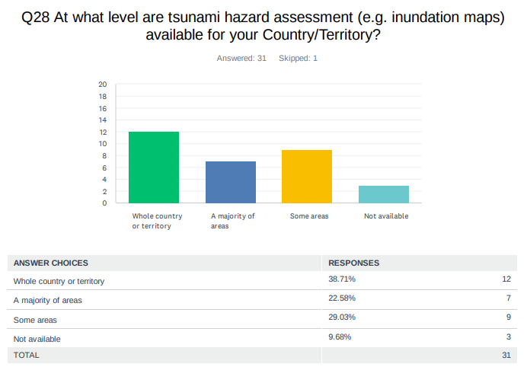

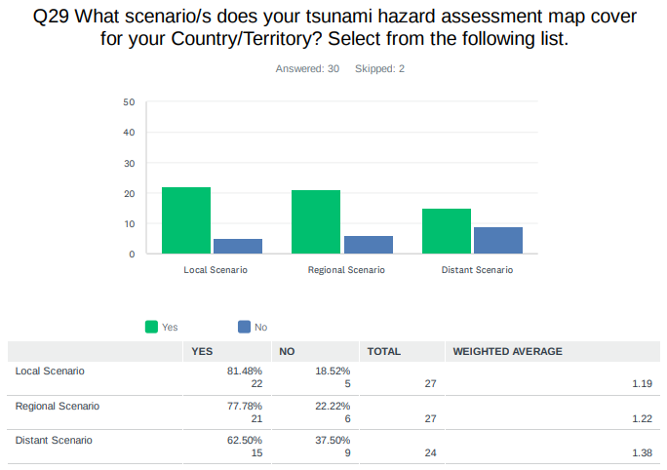
Comments:

Brazil: Needs more studies to evaluate the regions of submarine landslides. Brazil is far from active plates or hotspots.

Dominican Republic: Sab Felipe Puerto Plata.

Panama: As a research project of educational scope on the tsunami phenomenon in Panama, two coastal communities in the Caribbean region of Panama were studied.

UK - Anguilla: The map takes into consideration all types of Tsunami local, regional and tele tsunami

UK - British Virgin Islands: The maps illustrate the coastal areas and specific communities that can be inundated.

UK - Cayman Islands: Simulated large earthquake on the Oriente fault. Similar to the 7.7 experienced in 2020.

USA - US Virgin Islands: No specific scenario

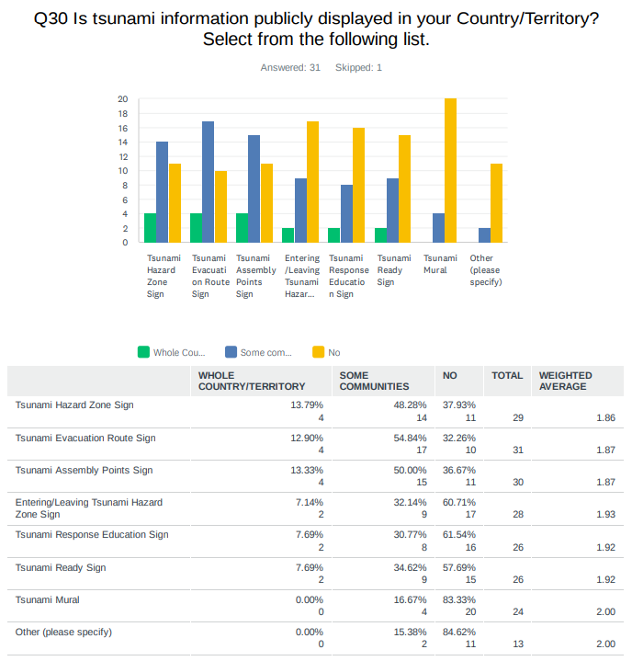
Comments:

Barbados: 40 in 3 communities.

Brazil: Zero.

Haiti: 100 about.

Jamaica: Approximately 26

Nicaragua: Only those left from the UNESCO projects on Tsunami ready. Generally it is doubted whether the signs are necessary in Nicaragua as the communities under risk are small or very small.
UK - Anguilla: Currently we have 14 signs although half of them need to replaced due to weather exposure. Also our evacuation/assembly points have changed due to new modelling.

UK- Cayman Islands: The average height above sea level on Grand Cayman is 7 feet.

USA - Puerto Rico: Tsunami Pavement Marking

USA - US Virgin Islands: 50

Venezuela: approximately 14 communities.

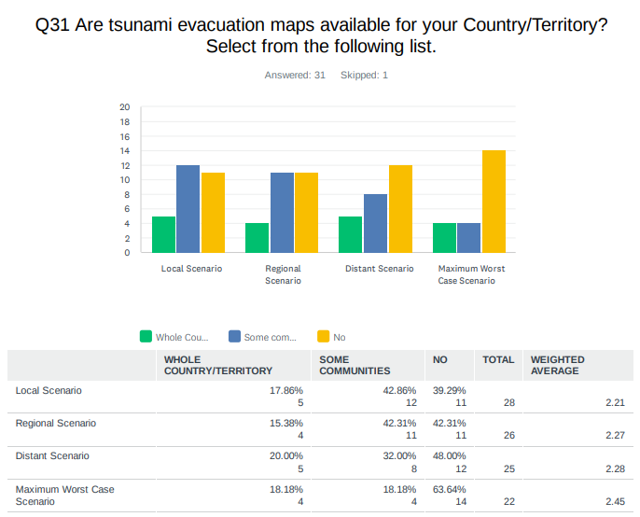
Comments:

Antigua and Barbuda: Bathtub model, Fixedheight/distance

Barbados: Numerical modelling

Haiti: numerical modeling

Honduras: numerical modeling

Nicaragua: all of these models

UK - Anguilla: expert scientific modeling was used with funding from ITIC/CITIC and NOAA

UK - British Virgin Islands: fixed height/distance

Venezuela: Local capacities are being generated so that the municipal Civil Protection and communities prepare their own maps

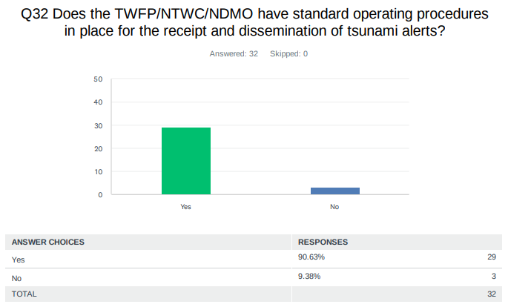
Comments:

Belize: The SOP is being reevaluated for effectiveness.

Brazil: We communicate the National Tsunami Center who is responsible to disseminate the alert for the local authorities and the public

Dominican Republic: from 2014 we have the operating standard

Haiti: need workshops

NL - Bonaire, Saba, Sint Eustatius: 24/7 operation; phone calls will be made to the local governments after first incoming warning; information is automatically distributed

Panama: The NTWC uses the procedures established in the IOC technical report 105, 2014

UK - Anguilla: They are currently being revised and additional persons being trained as the 911 call centre has been assigned this responsibility from the Police guard room

USA - Puerto Rico: PREMB Tsunami Protocol and PRSN SOP-Tsunami Protocol

Venezuela: Yes, the seismological service of Venezuela has developed an action protocol in case of earthquake and tsunami, it is currently in execution and the Vice Ministry of Risk Management and Civil Protection has generated the official Operational Plan for action in case of tsunami
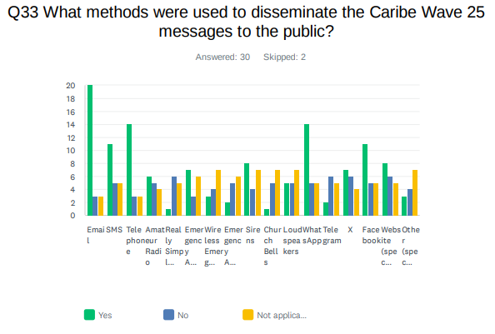
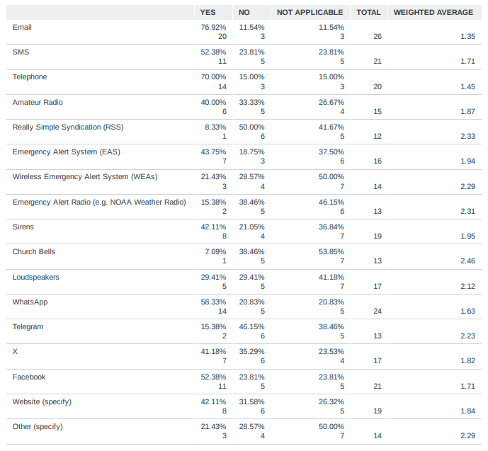

Comments:

Belize: NONE - Belize was not listed in the affected countries section of the information message.

Brazil: The TWFP are not allowed to disseminate directly to the public. We need to send e-mail to NTC

Dominica: exercise was not done with communities hence messages were not disseminated

Dominican Republic: Instagram

Guyana: CAP

Mexico: App TSUNAMI MX

Nicaragua: In CW25 we did not send messages to the public

NL - Bonaire, Saba, Sint Eustatius: Other means of warning can be utilized by the local governments

NL - Sint Maarten: Government website

St. Kitts and Nevis: Emergency vehicle announcing message over PA systems

UK - British Virgin Islands: bviddm.com

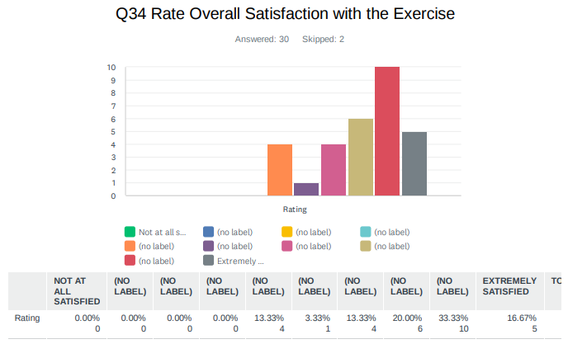

Comments:

Dominican Republic: The exercise was well organized, the handbook was clear and specific

Trinidad and Tobago: We need to have a more efficient method other than calling the NTWC on the phone for confirming receipt when we pass on the tsunami messages. Solutions like MissionMode would be a more efficient way to communicate emergency advisories but we lack the funding for such software.

Venezuela: It was very good, because we had to think about a regional tsunami, and educate our new authorities and new staff.

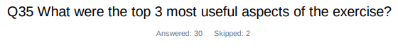
Country | Exercise Caribe Wave 25
Antigua and Barbuda | CAP. CAP App, National involvement of various sectors, involvement from the various national emergency agencies in evaluating the exercise
Aruba | Scenario ,PTWC Message, Communication National Coordination Center.
Barbados | The testing of the communications  Procedures in the evacuation of selected communities from the evacuation zone areas.
Belize | The timeliness of the messages. A suitable tool to measure readiness for tsunami events. A test for the effectiveness of the national SOP.
Brazil | It is mandatory that we at least once a year check the communication between PTWC and our 24/7 room. This year we include two different teams on the exercise once the phenomena last long period of time. It was important to check if the team shift affects the processes.
Colombia | El ejercicio permitió:  1. Entrenar al personal de las salas de monitoreo de las entidades del Sistema Nacional de Detección y Alerta de Tsunami  2. Probar el protocolo nacional de detección y alerta de tsunami  3. La difusión de los productos de la Unidad Nacional para la Gestión del Riesgo de Desastres (DMO) a las oficinas territoriales.
Costa Rica | -Night drill.  -The local government does not have easily accessible maps.  -We need to remove some information from the maps, so they're easier to read in an emergency.
Cuba | Acquiring experience in forecasting  Improving the operational functioning  Strengthening regional cohesion
Dominica | -tests response  -tests the communication flow  -tests knowledge about tsunamis  - tests preparedness
Dominican  Republic | It was the first time we exercised a distant event (Portugal). It allowed us to identify the alert issuance process and the evolution and arrival time of tsui waves in an event of this nature
France | Annual exercise  TSP messages  Each year different scenarios
Guatemala | 1. Training among institutional entities to understand the tsunami phenomenon.  2. The training of INSIVUMEH technicians in identifying information received from the PTWC in alert emails  3. The response of INSIVUMEH technicians during the drill in determining the type of information to be sent to the risk management agency for each alert issued.
Haiti | 1. Receiving the PTWC messages from different channels  2. Disseminating the Tsunami alerts by the NTWC  3. Prompt reaction of NDMO
Honduras | Test the institutional organization  Verify response times  Local organization
Jamaica | Receiving the scenario and products  Garnering feedback from stakeholders on the interpretación of the messages  Identifying gaps
Mexico | The operation of the National Tsunami Warning Center (SINAT) was exercised and evaluated. The issuance of Tsunami Warning Center (CAT) products was validated. Response times were tested. Procedures for responding to a locally generated tsunami were validated. The operational capacity of the Local Civil Protection Units to support the population was exercised. The dissemination of alerts and information/advice to emergency units and the population was validated. The decision-making organization (tsunami response procedures) regarding public warnings and evacuations was validated. Communications to the population were validated to ensure they were accurate and timely. Cooperation between agencies was evaluated.
Nicaragua | In the preparation we succeeded to solve problems of our messaging. In the execution we detected mistakes in our scripts which did not affect the general success but could be harmful in some moment. We saw that the Social networks might be more reliable and effective in the future than email.
NL-Bonaire, Saba, and Sint Eustatius | - real event simulated  - very good preparation well beforehand  - allows a full-scale exercise if needed
NL - Sint Maarten | Communication lines Procedures
Panama | The messages were received appropriately by the PTWC and CATAC. Messages between the NTWC and SINAPROC were timely.
St. Kitts and Nevis | 1. Chain of command followed.  2. Targeted areas were exercised.  3. Response plans were tested and Gaps identified.
St. Vincent and the Grenadines | 1. The opportunity for participants to understand how information is relayed from PTWC (time between messages, etc.  2. familiarizing participants with the message format  3. orienting participants with the critical information capacity in the message ( ETA, Wave Heights, possible impacts)
Trinidad and Tobago | Testing communications  Sensitizing the public  Identifying gaps
UK - Anguilla | Testing the WhatsApp group  Testing the communication link with our local cell providers and testing the school emergency alert system
UK- Bermuda | The timing of the earthquake vs the arrival of the waves The communications test, and the reminding that tsunamis are indeed a threat
UK - British Virgin Islands | 1.Persons realize that getting to locations are difficult than think many were in shape and now realize what is needed from a physical standpoint  2.Many were not aware of evacuation routes and now have a better understanding  3.More public outreach is needed as many still do not understand that routes or evacuating further inland or higher ground is what is required. For example persons felt they had to travel back to their communities to get to higher ground.
UK- Cayman Islands | 1. Testing of the National Emergency Notification System  2. Validation of existing school emergency plans  3. Opportunity for Public Education/Sensitization to message flow
USA- Puerto Rico | Communication, Operational Plan, Practice a Tsunami Distant Scenario.
USA-US Virgin Islands | 1. Test Sirens  2. Evacuation (walking) to safe zone area  3. Activation of Emergency Operations Centers (3 total)
Venezuela | Planning  Communications  Links between senior management, risk management personnel, and communities

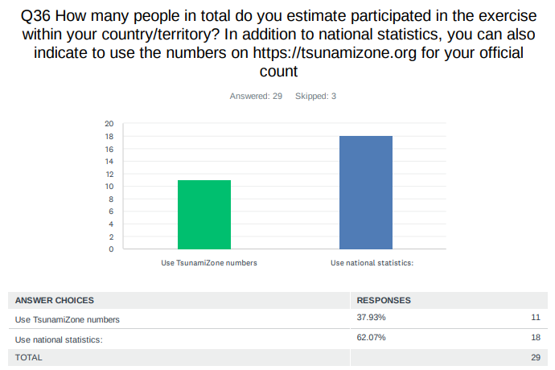

Country |  | Participants according to Member States
Antigua and Barbuda |  | 7,000
Aruba |  | 27,000
Bahamas |  | 0*
Barbados |  | 400
Belize |  | 3
Brazil |  | 9
Colombia |  | 162
Costa Rica |  | 25
Cuba |  | 300
Curacao |  | 144*
Dominica |  | 4*
Dominican Republic |  | 1,132
France |  | 107,328
Grenada |  | 8,893*
Guatemala |  | 25
Guyana |  | 10
Haiti |  | 522
Honduras |  | 400
Jamaica |  | 1,289
Mexico |  | 850
Netherlands  (Bonaire, Saba, Sint Eustatius, other) |  | 39
Nicaragua |  | 440
Panama |  | 6
Saint Kitts and Nevis |  | 7,202*
Saint Lucia |  | 1,403*
Saint Vincent and the Grenadines |  | 25
Sint Maarten |  | 22
Suriname |  | 0*
Trinidad and Tobago |  | 294*
United Kingdom | Anguilla | 45
United Kingdom | Bermuda | 326
United Kingdom | British Virgin Islands | 6,855
United Kingdom | Cayman Islands | 11,501
United Kingdom | Montserrat | 0*
United Kingdom | Turks and Caicos | 375*
United States | Puerto Rico | 172,141
United States | US Virgin Island | 18,144
Venezuela |  | 136,046
TOTAL |  | 510,360

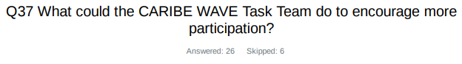
Country | Exercise Caribe Wave 25
Antigua and Barbuda | Continue your promotions as per usual with greater emphasis on vulnerable communities.
Aruba | More social media promotion.
Barbados | More advertising about the event on social media
Belize | A bit more outreach
Brazil | Keep using scenarios that affect Brazil
Costa Rica | I loved the work that they did.
Cuba | Incorporate young people recently graduated from college to work jointly with each expert, who can thus reach the new generations easier and better
Dominican  Republic | I understand that many countries need cooperation with canvas templates or another platform that allows us to generate infographics for social media
Guatemala | 1.Enhanced Outreach and Communication  2.Tailored Training and Workshops to the people  3.Stronger Institutional Engagement  4.Increased Community Involvement
Guyana | Awareness
Haiti | Give AWARDS to 3 Members States having more participation
Honduras | Involve more communities, schools and minority groups
Jamaica | Teach us how to have meaningful dialogue with decision makers of the country to provide the necessary investment for the tsunami programme
Mexico | We believe that all the logistics carried out for the Pacific 25 exercise were adequate on the part of the organizers and we believe that national institutions should further strengthen their methodologies for the dissemination of this type of exercises.
Nicaragua | We will try to combine CW and PW with our national exercises.
NL - Sint Marteen | This would have to come from our side as we need to finalize our tsunami ready project.
St. Kitts and Nevis | Create PSA's and use all media platforms to disseminate message
St. Vincent and the Grenadines | 1.start caribe wave public education in December and January 2.solicit participation from target group by the final quarter of the previous year
UK - Anguilla | Not sure. I think a lot of information was provided I think we should use the information provided earlier and hype up the exercise
UK- Bermuda | With more resources we could do greater outreach to schools and the public
UK - British Virgin Islands | The actual February event highlighted the importance of being ready. I think the task team can look at ways TWFP, TNC , Disaster Organizations can market Tsunami readiness's in ourselves meaning. The public forgets quickly but it is to ensure we the experts are always ready to provide as much information and education as possible so that persons would remember what to do when a real one strikes.
UK- Cayman Islands | Share videos of how people can participate.
USA- Puerto Rico | Consistency
USA-US Virgin Islands | Continue to work with schools
Venezuela | It would be interesting to incorporate social science practitioners into the Caribe Wave regarding the options and needs of their contributions to research and action. Where the disaster is an occasion of crisis or social stress, observable in time and space, in which societies or their components (communities, regions, etc.) suffer physical damage or loss and alterations in their routine functioning.

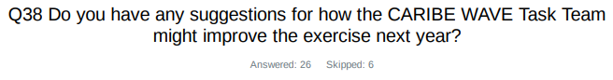
Country | Exercise Caribe Wave 25
Antigua and Barbuda | Great work has been done so far
Aruba | More Social Media involvement
Belize | Our country was not listed in the affected countries list for the Jamaica scenario, perhaps a scenario that would be more inclusive.
Brazil | It is doing good for the moment
Costa Rica | A night drill option.
Cuba | Historically, we have had intense hurricane seasons. ¿Is it possible to consider the probability of occurrence of an intense hurricane and an earthquake/tsunami in the Caribbean basin at the same time?
Dominican Republic | It would be good to explore ways to help countries identify how we can downgrade tsunami warning levels. For example, moving from warning to alert. This would be a form of recommendation.
France | Find a way to disseminate messages to people registered through TsunamiZone : sending the messages directly or sending before the beginning of the exercise the email list to NTWC ?
Haiti | translation in French and Spanish of the Caribe Wave document
Honduras | Conduct more training on the use of products
Jamaica | Expose us to various apps available that alert us to earthquakes that are free of cost especially those that vibrate
Mexico | At the moment we do not have any suggestions to the organizers of this event, we consider that everything went according to plan
Nicaragua | Promote the use of social networks for tsunami warning
NL-Bonaire, Saba, and Sint Eustatius | Provide the tsunami messages in text format separately
St. Vincent and the Grenadines | 1.early planning with staff and targeted communities.  2. engage all media platforms in January of every years to commence sensitization on the exercise  3. work with more organization to develop plans with the aim of participating in next year's exercise
UK - Anguilla | I think the team is doing a great job.
UK - Bermuda | No, we appreciate the webinars, all the information, the meticulous organization it all runs very smoothly
UK - British Virgin Islands | Any videos that can be released for publishing , experiments created in labs, a link where all you need for tsunami promotion that can be found a simple hash tag that can get people to such information as well as a short url: example tready, tsunamiready
UK- Cayman Islands | Sharing the participant sign-up information given through tsunamizone, such as name and email address to make participant briefing streamlined.
USA - Puerto Rico | Envolve more the public schools
USA - US Virgin Islands | Engage with movie theaters to host for a very small fee ($1 dollar per person) the viewing a movie which is focused on a Tsunami.
Venezuela | I would like to improve communication between countries, so that emergency management offices operating communications can be seen in real time

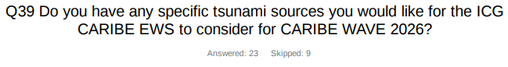
Country | Exercise Caribe Wave 25
Aruba | Honduras
Brazil | We know there were recent earthquakes at Sandwich Islands. Recent studies pointed to a changing behaviour on the plates activities, and the region is very active. We registered 10cm in our tide gauges along the south/southeastern coast.
Costa Rica | Limon 91. Costa Rica
Cuba | North of the Dominican Republic
Dominican  Republic | Considering the events of 2018 in northern Honduras and the recent one on February 8, 2025, we would like to emulate a tsunami event in suction zones in this area. It would be a regional tsunami for my country.
France | A volcanic source from an Antilles arc volcano
Haiti | Northern Fault of Hispaniola (NHTF)
Jamaica | NOAA
Mexico | Near Haiti or on some submarine volcano in the Lesser Antilles.
Panama | The 1991 Limon earthquake, M7.7, Costa Rica
St. Vincent and the Grenadines | Focal on a local scale event that give participants lime response time. An event that will trigger the precautionary evacuation clause
Trinidad and Tobago | In light of the underwater volcano Kick ‘em Jenny being in close proximity to T&T it would be nice to have one of the future CARIBEWAVE exercises simulate an eruption of a submarine volcano to test our response and preparedness for not just tsunamis but other marine hazards caused by such events. With no protocols for volcano-generated tsunami alerts, simulating a submarine eruption in CARIBE-WAVE exercises could identify gaps, test response systems and guide the development of effective procedures.
Venezuela | I would like to repeat the local tsunami of 1900 in Venezuela

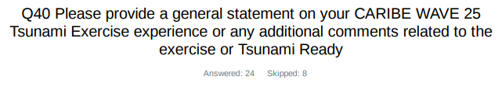

Country | Exercise Caribe Wave 25  General Statements
Antigua and Barbuda | In general there was tremendous support nationally for the exercise. However, there are still vulnerable areas we need to do some more work with. Also, strengthening our various communication methods with the public to utilize as many options as possible.
Belize | All test messages related to the exercise were received accordingly. However, Belize was not listed in the list of affected countries, so there was no actions to be taken other than just take note of the incoming messages.
Brazil | Year by year we are getting more involved with the Tsunami Warning System, even though the priority is still low to zero in comparison with others events like summer floods or landslides.
Colombia | Estos ejercicios permiten preparar a los países para poner a prueba sus protocolos y estrategias para responder en caso de un tsunami
Dominican  Republic | The CARIBE WAVE 25 Tsunami Exercise provided an invaluable opportunity to enhance our preparedness for a potential tsunami event. Participating in the exercise allowed us to simulate real-life scenarios, testing our communication systems, coordination efforts, and response strategies. It also highlighted areas where further improvement public education, and the integration of early warning systems.
France | Many thanks to all for your commitment
Haiti | Caribe wave is a good exercice to improve the tsunami preparedness andTsunami Ready Program. For Haiti the problem that prevents more participation in Caribe wave exercice is the socio-political problem. It's very hard. Hope Haiti will know best days to increase the participation.
Honduras | It was our first experience as a country in the CaribeWave simulation. It was a fantastic opportunity to test tsunami protocols, and we were able to draw conclusions that will help us improve
Jamaica | Caribe Wave always presents the opportunity For the country to raise awareness. What is lacking in Jamaica is the lack of investment and dedicated leadership to move the programme forward.  In 2025 an additional Alternate TWFP is being added.
Mexico | The exercise was very useful to check the receipt of bulletins by all participants, plan and practice the emergency action and response protocols, and improve the areas of opportunity that need to be strengthened.
Nicaragua | We will use the experience with CW and PW to carry out exercises for Central America. Tsunami Ready should be national programs. We started already to discuss this with SINAPRED our national civil protection organization.
NL - Bonaire, Saba, Sint Eustatius | Exercise was used to test internal communication lines, review the protocols and practice for an event. It is very helpful as it helps us identify potential weak spots in the procedure and improve upon them as well as to practice the warning chain for a real event.
Panama | As NTWC, we consider that the objectives of validating the message communication protocols between both the PTWC and CATAC centers with the NTWC and the messages between the NTWC and the SINAPROC national response center were met.
St. Kitts and Nevis | CARIBE WAVE 25 Tsunami Exercise reminded us of the importance of constantly exercise to test preparedness and response. The exercise allowed for a critical look at the messaging to determine its effectiveness.
St. Vincent and the Grenadines | The information from PTWC was timely and messages were received as planned. NEMO faced some challenges with the planning and executing of the 2025 exercise. Planning arrangements started late and so target groups did not have enough time to be fully engaged or participate. The table-top was informative and insightful for most participants. However, the majority were not familiar with the National Tsunami SOPs primarily the warning and dissemination mechanism and the decision support tree.  NEMO took the opportunity to test emergency operations in response to a tsunami and several gaps arose. Most notably, there is no procedure detailing actions to be taking e.g. 2hours, 1hour or half an hour before regional or distant event. In addition there is no document that speaks specifically to processes that leads to the activation of the NEOC for tsunami event. As a result the pre exercise response and expected outcomes were not met, but valuable actions to be taken were identified.
Sint Maarten | We only participated in the communication timeline part of the exercise making sure the messages were forwarded to the different government organizations and the amount of time needed to get the message to the organizations.
Trinidad and Tobago | From the TWFP's perspective, the exercise was fairly routine. The NTWC initially chose the Portugal scenario but had to switch to the Jamaica one because, logistically, the duration of the teleseismic exercise was not feasible for us to make the necessary preparations. Their intention was to tailor the exercise so that our National Emergency Operations Centre could be activated as part of it. However, making the Portugal scenario feasible would have required shortening its timeline, which was unfortunately not logistically possible. As a result, we opted for the Jamaica scenario at the last minute.
UK - Anguilla | Anguilla's active participation in the regional CARIBE WAVE 25 Tsunami Exercise, was not as robust as it had been in the past. However, we were able to test our alert and evacuation procedures in collaboration with a local school, emergency services, and regional partners. The simulation allowed the Department of Disaster Management (DDM) to assess communication channels, response times, and community readiness, particularly in coastal zones. The school chosen for the evacuation is almost on the beach  The exercise was a key milestone on Anguilla’s journey toward TsunamiReady recognition, we have been working diligently to meet the program's criteria. We are thinking outside the box and created a podcast and had a question and answer session with the children and teachers after the evacuation exercise. We also held a couple of briefing  The CARIBE WAVE 25 experience highlighted progress made and identified areas for improvement, reinforcing Anguilla’s commitment to building resilience and ensuring safety in the face of tsunami threats.
UK - Bermuda | I personally was not able to be part of the exercise this year, but a review of the notes left for me showed that our messages were received and sent out in a smooth and timely manner.
UK- British Virgin Islands | Our participation did go up a bit as our leaders saw the importance and made it mandatory that the entire civil service participated. The February 8th event also sparked interest from the private sector and this too would have contributed to their participation. From our end it is an ongoing activity in keeping persons engaged as once an earthquake or tsunami does not occur for sometime persons tend to relax.
UK- Cayman Islands | For Caribe wave 25, the Cayman Islands tested our National Emergency Notification System via both Radio Interrupt and Cell app alert. This exercise was valuable as it highlighted improvements that could be made within the systems. It also assisted with raising public awareness in relation to the existence of these notification systems as well as their importance.  Additionally, we focused on our schools' response. A lesson learnt from the 2020 earthquake, was that parents feared for their children and rushed to collect them causing gridlock traffic. Following the strong Earthquake was a tsunami threat that could have led to a significant loss of life. The Caribe wave 25 exercise provided parents with reassurance as they became aware of the robust emergency plans within our schools. One of the schools were videoed during the exercise, depicting just how educated and prepared the students and staff were for such an event.
USA- Puerto Rico | PREMB, NWS-SJ, and PRSN received all the PTWC products for the Portugal Scenario via e-mail in a timely manner. PREMB and NWS-SJ also received PRSN messages and information. EMWIN was useful at the state and local levels.
USA-US Virgin Islands | Each year the US Virgin Islands increases the number of activities it plans for individuals, groups, and families to participate. For the Caribe Wave 25, the timing (20 March) came a few weeks after the Earthquake (North of Honduras) on 8 Feb (Saturday evening at 7:20 pm) which generated a Tsunami Advisory for Puerto Rico and the US Virgin Islands. The public became more aware of the need to understand the threat and the threat levels, as many questioned why the USVI did not sound the 44 tsunami sirens on 8 February
Venezuela | This Caribe Wave 25 exercise was very active. Contacts were reestablished with the highest authorities, and the new authorities were convinced of the importance of the Caribe Wave 25 exercise. Coordination with scientists and communities was crucial. State and municipal civil protection agencies, given their experience in previous exercises, enthusiastically took part using their own methodologies and adapted their participation to the selected coastal areas. They reported to the situation room and worked extensively with the document prepared by the Vice Ministry of Risk Management and Civil Protection and its team, called the "Order of Operations" for Caribe Wave. With the participation of radio amateurs, communications were strengthened during this exercise. The COBO toolbox tool was used, with the participation of ONU representatives. We must restore international communications with other warning centers in the region to obtain confirmation and exchange data, among other things. An assessment will be conducted of coastal areas that can be prepared for the tsunami ready program.

