International Tsunami Information Center
A UNESCO/IOC – NOAA Partnership
E-mail: itic.tsunami@noaa.gov URL : http://www.tsunamiwave.info

MARINE PREPAREDNESS
Tsunami waves easily turn tidy towns into debris fields of crushed homes, buildings, automobiles. In addition, as water recedes and returns, strong water currents can break splinter docks and large vessels break from their moorings ramming into docks and floating onto building or other structures.
The 2011 Japan tsunami, and the many images and videos showing the destructive nature of the waves as they inundated and damaged vessels and docks not only in Japan but across the Pacific in Hawaii and California, have provided a wealth of science information to help us improve our marine preparedness. A number of States and Territories have determined safe minimum offshore depts for vessel movement for tsunamis, and the potential damage from strong currents in ports and harbors through modeling ground-truthed by tsunami event observations.
Over the last 10 years, the US National Tsunami Hazard Mitigation Program has compiled best practices and guidance from amongst US States, Territories, and Commonwealths. These are available online at 'Tsunami Maritime Guidance: A Resource for Tsunami Hazard Planning and Preparedness for Maritime Communities' through the portal at https://arcg.is/0DeHrG

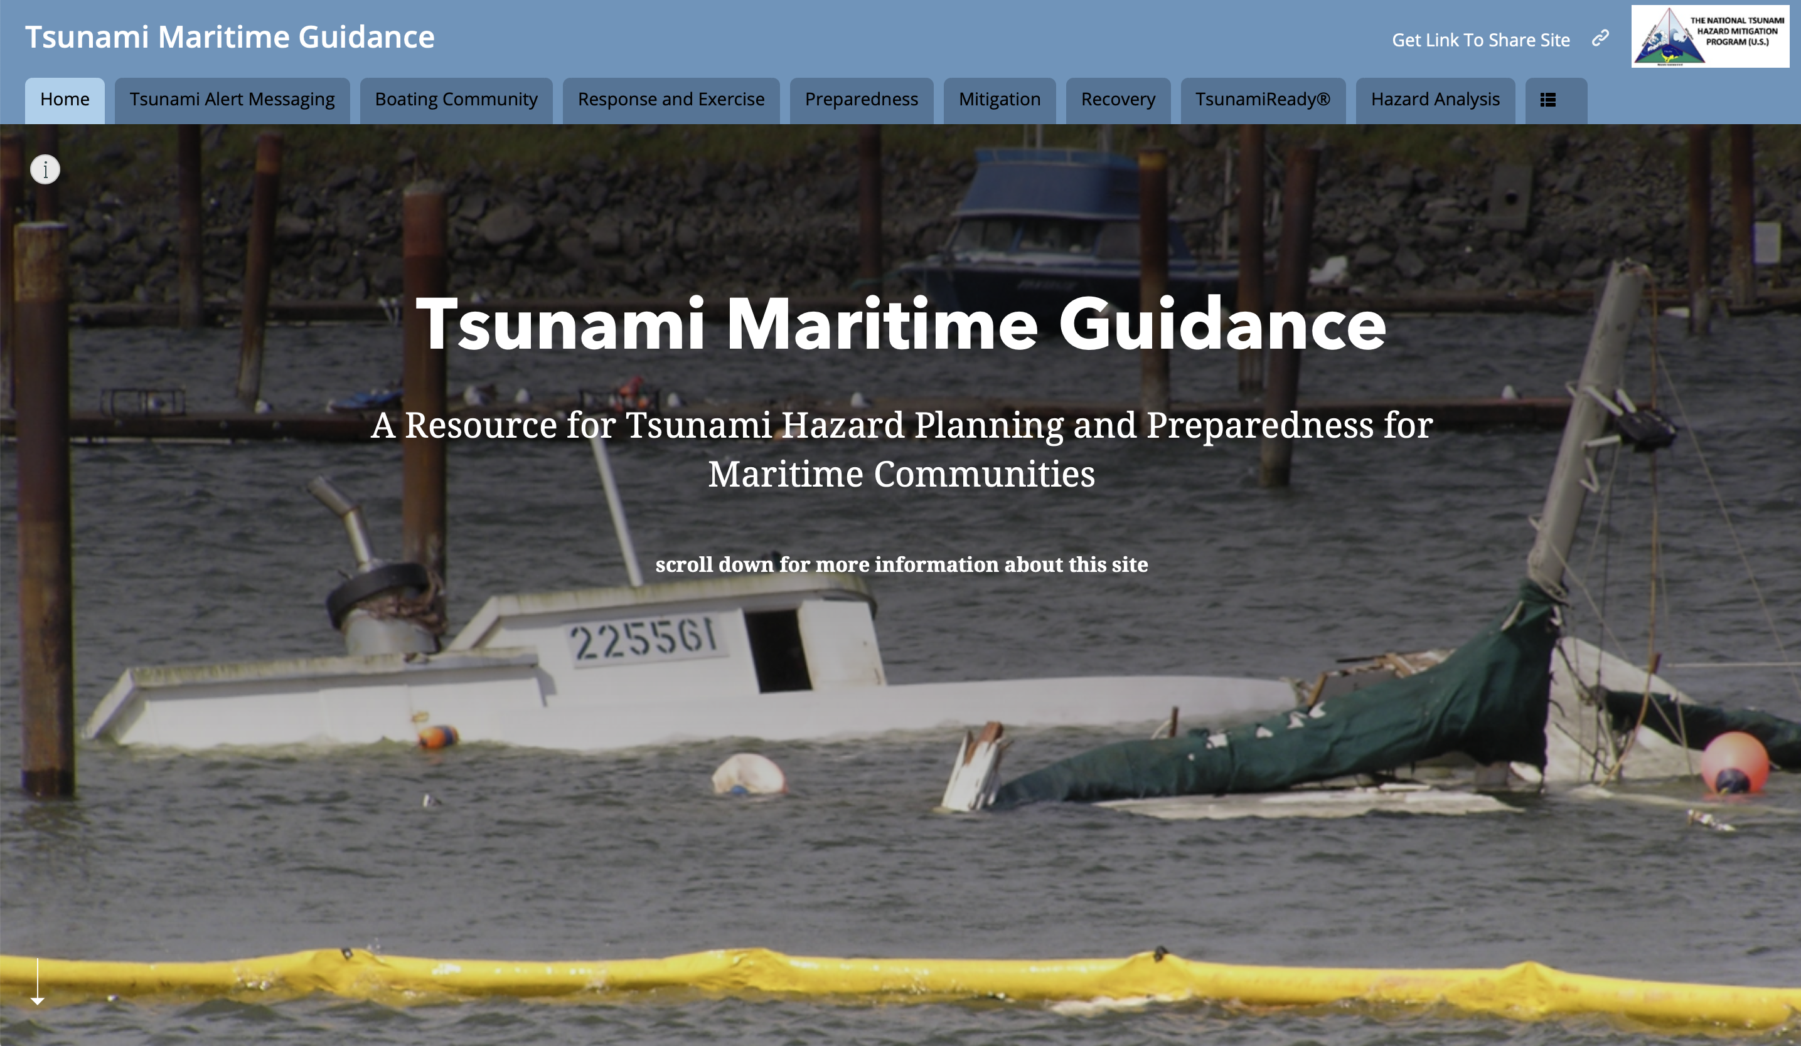

DAMAGE TO PORTS AND HARBORS
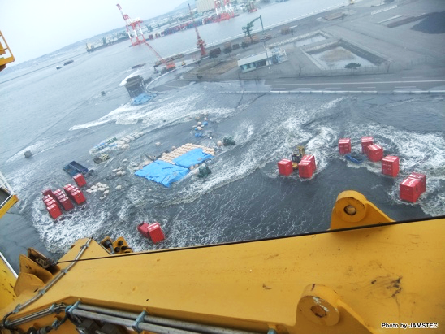
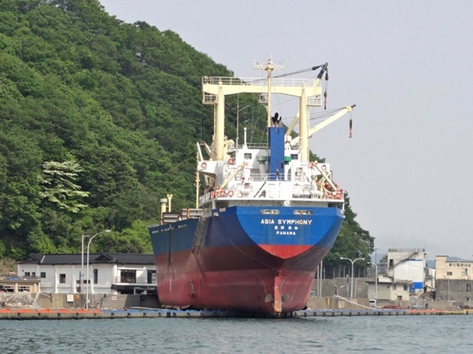

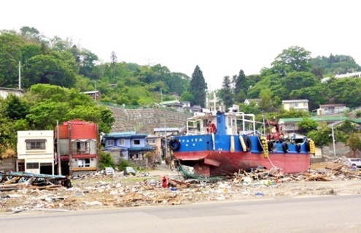
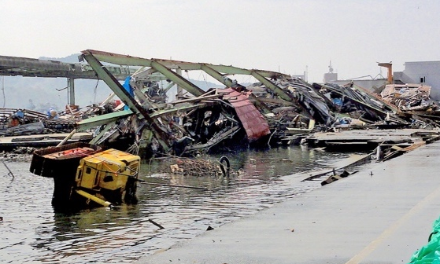

Figure 1. Top: Left. The ship Asia Symphony was carried onto the adjacent pier during the 2011 Japan Tsunami. Kamaishi, Japan (Photo source: ITIC). Right. Tsunami floods shipping dock, Hakodate, Japan (Photo source: JAMSTEC). Bottom: Waves crushed port facilities in Kesenuma (left) and transported a boat far inland in Miyako (right) during the 2011 Japan tsunami. (Photo Sources: ITIC).
In Crescent City, Santa Cruz, and Long Beach, California, $55 million in damage was inflicted on small boat harbors by sudden water-level fluctuations, drawdown leaving boats stranded on dry ground, strong unpredictable currents, bores, eddies, and whirlpools, and collisions with other boats, docks and debris. Along the California coast prior to arrival, many boat owners evacuated offshore without adequate supplies or knowledge of how long they would need to stay offshore. As a result, boaters tried to re-enter harbors too early, while dangerous tsunami conditions still existed. They put themselves and harbor personnel at risk of injury and death.

Figure 2. (Source: Kong, Dunbar and Arcos, eds. Pacific Tsunami Warning System: A Half Century of Protecting the Pacific, 1965-2015. Honolulu: International Tsunami Information Center, 2015)

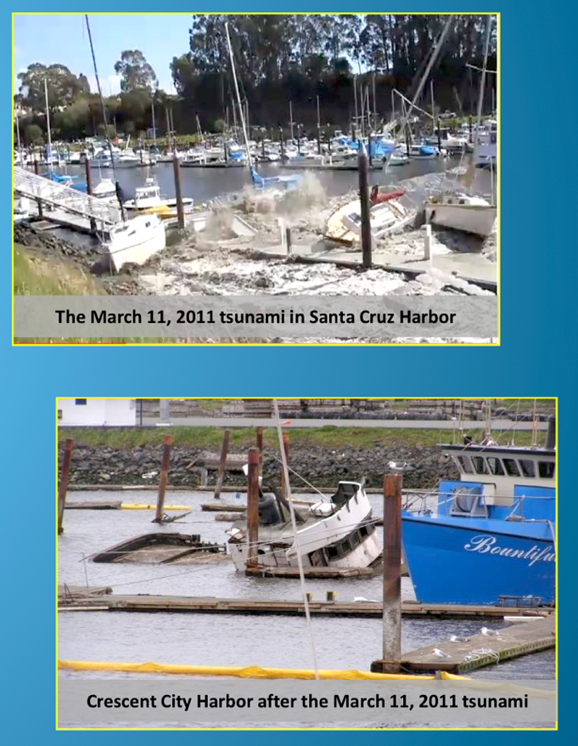
Figure 3. Small boat harbor damage in Santa Cruz and Crescent City, California from the 2011 Japan Tsunami. (Source: Tsunamis! What Boaters should know (brochure), Cal EMA, CGS, Humboldt State Univ, 2015)

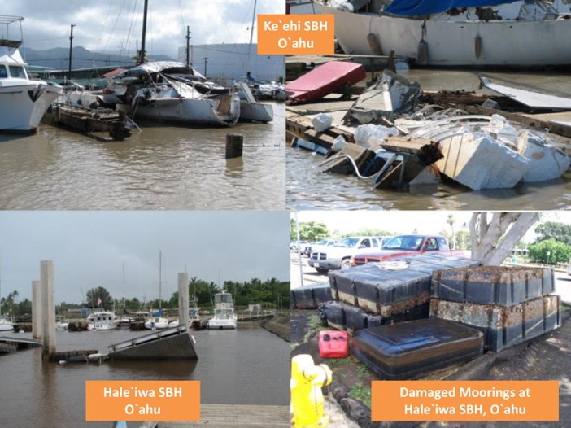
Figure 4. Small boat harbor damage in Hawaii from the 2011 Japan Tsunami. (Source: Hawaii State Emergency Management Agency)

PREPAREDNESS
For land evacuation by people out of the tsunami hazard or evacuation zones, the public should follow the instructions of the State or Local emergency management agency.
For vessels at sea, such as recreational and fishing boats, and commercial vessels, the US NTHMP and States have prepared a number of publications to provide understanding on tsunamis and for planning what to do. These include both public safety information on how to prepare for and what to do before, during and after a tsunami, such as the 2011 Tsunami Guideline Plan for Operators of Caribbean Ports and more recent materials, as well as 2017 technical guidance, such for mariners who want to take their boat safely offshore before or during a tsunami
(https://nws.weather.gov/nthmp/documents/GuidanceforSafeMinimumOffshoreDepthforVesselMovement.pdf)

PUBLIC AND RECREATIONAL BOATERS
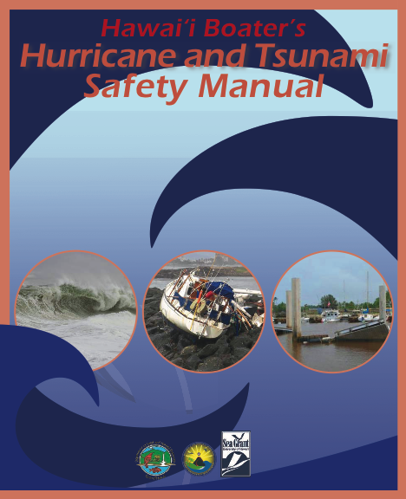
In Hawaii, the Hawaii State Emergency Management Agency, with University of Hawaii tsunami numerical modeling support, has worked with the US Coast Guard to establish a marine tsunami evacuation maps for Honolulu Harbor and other Hawaii commercial ports, as well as vessel evacuation thresholds. The Hawai’i Boater’s Hurricane and Tsunami Safety Manual (2013) gives boat owner emergency plan guidance including for evacuation, and for what boats at sea during and after a tsunami should do. The State of Hawaii Dept of Land and Natural Resources Division of Boating and Ocean Recreation Tsunami Emergency Plan guidance (DLNR DOBOR, 2013) provided guidance to boaters to help develop their own emergency plan since ultimately each will have to act on their own, in concert with DOBOR procedures for closing harbors, to safeguard their vessel and property during a tsunami.
Figure 4. Hawaii safety information for boaters.

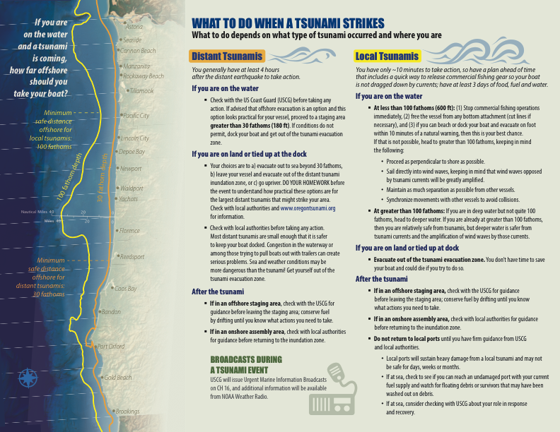
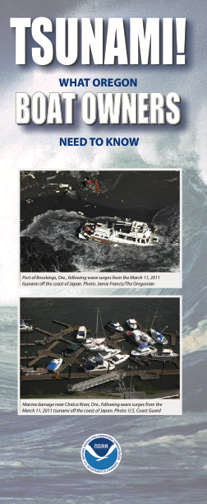
In Oregon, Maritime Tsunami Response Guidance (MTRG, Dept of Geology and Mineral Industries DOGAMI) is available for the Port of Astoria and Lower Columbia River Estuary and for port of Newport-Toledo for small craft (e.g. recreational sailing, motor vessels, and commercial fishing vessels) for distant tsunamis. Additionally, the brochure “Tsunami! What Oregon Boat Owners Need to Know,” gives practical statewide guidance for all types of tsunamis. Through numerical tsunami modeling, DOGAMI determined that the minimum safe distance offshore for boaters to evacuate to for local and distant tsunamis is 100 and 30 fathoms, respectively.

Figure 5. Oregon safety information for boaters.

COMMERCIAL PORTS, SMALL BOAT HARBORS
In the U.S., commercial harbors are under the control of the U.S. Coast Guard (USCG) Captain of the Port, or harbormaster, whose duties include port safety and security. During a tsunami, boat and vessel captains should follow the instructions of the Captain of the Port for marine evacuations out to sea, and afterward, on when to know when it is safe for boats to return home. For emergency communications, every boat should have a ship-to-shore marine VHF-FM radio to monitor Channel 16 for information from the USCG and/or other harbor management agencies, and for emergency distress signaling. Additionally, mariners may also want to have a NOAA Weather Radio (NWR), whose coverage usually extends to about 40 miles from the coast, to receive tsunami warning information for land evacuations, and other weather and ocean information.
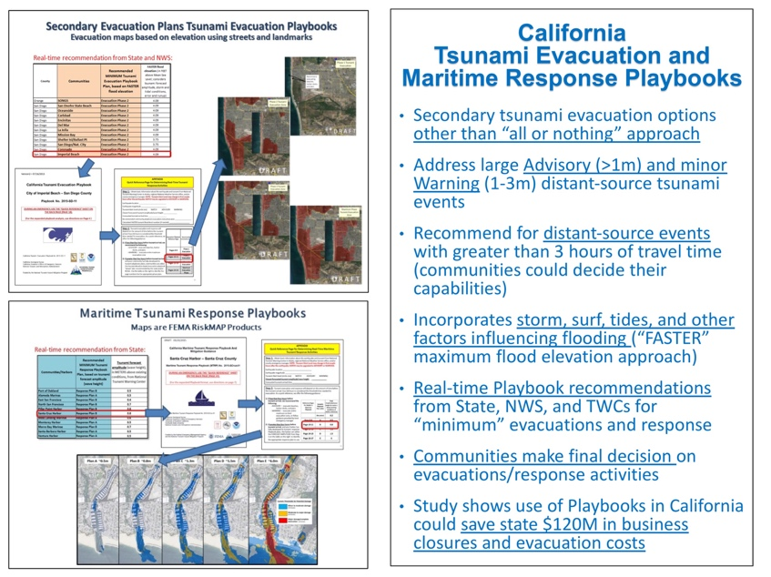
PLANS AND PLAYBOOKS
In California, the Office of Emergency Services and Geological Survey have worked with the local harbormasters and Coast Guard regions to develop response playbooks. Numerical modeling is used to calculate expected tsunami impacts from the different scenarios. When a real event occurs, response agencies will carry out their emergency response actions using the appropriate playbook.
Figure 6. California Response Playbooks

CRUISE SHIPS
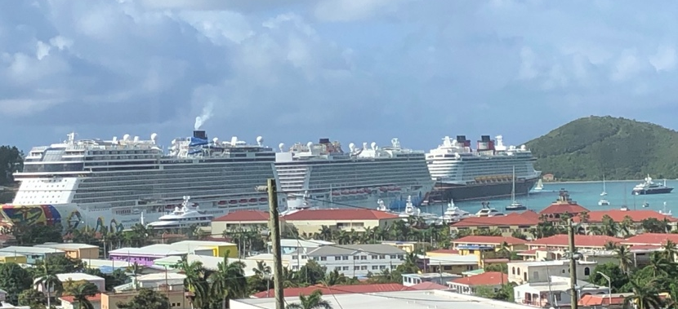

Figure 7. Cruise ships docking at Havensight dock, US Virgin Islands. Each ship can carry over 5000 guests when all berths are full, meaning in this photo that over 15,000 tourist, plus their crews. (Photo credit: R. Watlington, Feb 2020)

In the US Virgin Islands, Puerto Rico, Florida, Hawaii, and other vacation destinations, many cruise ships visit throughout the year for short stays. These ships often accommodate thousands of passengers (and their crew), who are on vacation and likely will not know about the local tsunami hazard, nor have tsunami safety or evacuation on their minds. Thus, cruise ships are especially vulnerable. Pre-tsunami response and evacuation planning are essential to mitigate the tsunami hazard.
If a local tsunami hits, the reality is that many will be caught unaware and not know what to do, and this could result in many casualties.
If a distant tsunami warning is issued, and the cruise ship has a tsunami evacuation plan, then there could be time for safe tsunami evacuation by its passengers (such as onto land or by staying on the boat) and also for evacuation of the ship to sea.

