Summary
This report provides an overview of the implementation of the 2022–2023 budget as at 31 December 2023, including updates on voluntary contributions mobilized, budgetary gap filling by function and staffing situation.
Voluntary contributions (VC) include:
- Cash contributions to the IOC Special Account
- Cash contributions to specific projects/Funds-in-Trust (FITs)
- Additional cash contributions (AC) intended to directly reinforce an existing regular programme budget line
- In-kind contributions.
All financial information in this report is aligned with the authoritative reporting presented to the UNESCO Executive Board at its 219th session. The reference currency in this document is the US dollar. All incurred expenditures are shown at the United Nations operational rate of exchange (UNORE).
Proposed decision: This document is part of the report of the Executive Secretary to the Executive Council. It will be further examined by the statutory sessional open-ended Financial Committee and the decision reflected in the Draft Resolution that the Financial Committee will submit for adoption by the Assembly under item 5.4 in accordance with paragraph 15 of the Revised guidelines for the preparation and consideration of draft resolutions (IOC/INF-1315).

OVERVIEW OF BUDGET IMPLEMENTATION

- In compliance with Member States’ decisions, the 2022–2023 budget was based on an Integrated Budgetary Framework (IBF), allowing greater transparency of resources and helping to align resources with the collectively decided priorities.
- Following the approval of the Organization’s Programme and budget for 2022–2023 by the UNESCO General Conference at its 41st session, the actual working budget of the Commission was set in accordance with the total IBF of $31,815,240: $11,236,000 for the IOC from UNESCO’s regular budget plus $20,579,240 of targeted Voluntary Contributions (of which $4,386,240 were secured at the moment of the budget adoption and $16,193,000 of projected resources to be mobilized and spent during the biennium (gap).
Table 1. IOC Integrated Budgetary Framework 2022–2023 at IOC function level

Table 2. Consolidated report on 2022-2023 expenditure, including obligations, as at 31 December 2023
IOC Function/Activity | Regular Budget | Voluntary Contributions | Total
IOC Function/Activity | $ | $ | $
FUNCTION A (Ocean Research) | 201,964 | 1,467,223 | 1,669,187
FUNCTION B (Observing Systems/Data Management) | 501,413 | 3,560,961 | 4,062,374
FUNCTION C (Early Warning & Services) | 340,925 | 2,783,548 | 3,124,473
FUNCTION D (Assessment & Information for Policy) | 135,027 | 285,082 | 420,109
FUNCTION E (Sustainable Management & Governance) | 591,706 | 6,815,131 | 7,406,837
FUNCTION F (Capacity Development) | 249,594 | 2,900,025 | 3,149,619
Sub-total | 2,020,627 | 17,811,970 | 19,832,599
Common country programming
UN reform
Evaluations | 33,342 |  | 33,342
IOC Operating costs | 41,029 |  | 41,029
TOTAL NON-STAFF | 2,094,998
STAFF ALLOCATION | 8,664,186 |  | 8,664,186
TOTAL | 10,759,184 | 17,811,970 | 28,571,154

Chart 1. 2022–2023 expenditure, including obligations, by source of funding (total of $28,571,154)

Chart 2. 2022–2023 expenditure, including obligations, by IOC function – all sources
(total of $19,832,599)

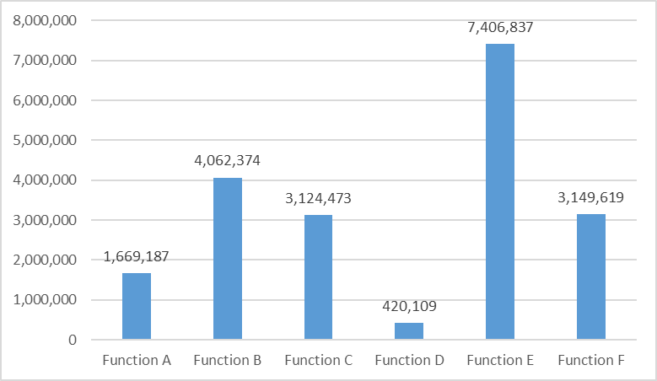
Table 3. 2022–2023 Expenditure analysis, including obligations, by main categories of nature of cost

Chart 3. Expenditure, including obligations, by source of funds (total of $28,571,154)

Table & Chart 4. Status of extrabudgetary gap filling as at 31 December 2023

IOC Function | 41 C/5 Voluntary Contributions (VC) |  |  | VC in hand as at 31.12.2023
IOC Function | In-hand | Gap | Total | VC in hand as at 31.12.2023
IOC Function | $ | $ | $ | $
A | 203,400 | 550,000 | 753,400 | 2,005,796
B | 1,714,500 | 3,382,000 | 5,096,500 | 5,604,680
C | 578,977 | 3,000,000 | 3,578,977 | 3,695,160
D | 171,980 | 900,000 | 1,071,980 | 982,348
E | 515,400 | 5,436,000 | 5,951,400 | 7,937,322
F | 1,201,983 | 2,925,000 | 4,126,983 | 3,743,244
Total | 4,386,240 | 16,193,000 | 20,579,240 | 23,968,550

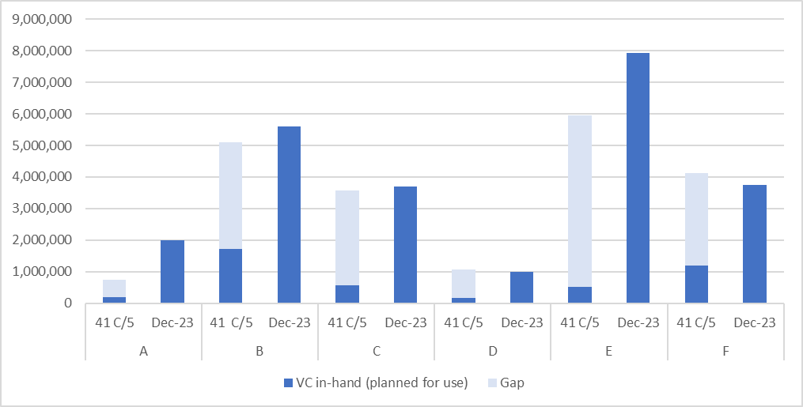

Table & Chart 5. Signed funding agreements 1 January 2022–31 December 2023
Rank | Contributor | Amount in USD
1 | UNDP | 7,530,994
2 | European Union | 5,199,538
3 | PRADA | 3,567,400
4 | Norway | 2,490,915
5 | UNEP | 1,291,500
6 | Belgium | 1,089,109
7 | France | 954,144
8 | Sweden | 765,178
9 | Australia | 678,450
10 | REV Ocean Inc | 505,000
11 | China | 490,295
12 | Japan | 472,643
13 | UNESCAP | 370,200

Rank | Contributor | Amount in USD
14 | Germany | 292,209
15 | Canada | 263,786
16 | Iceland | 244,107
17 | Republic of Korea | 204,490
18 | Colombia | 191,966
19 | WMO | 125,572
20 | The Ocean Foundation | 95,000
21 | E.ON Energia SpA | 64,725
22 | Ireland | 55,066
23 | Subsea Data Systems, Inc | 50,000
24 | ETT S.p.A. | 48,685
25 | Portugal | 42,897
26 | Flanders Marine Institute | 41,754
27 | Monaco | 41,615
28 | International Foundation for Aids to Navigation | 32,362
29 | India | 29,220
30 | LifeWatch ERIC | 23,414
31 | FUGRO | 17,584
32 | Mercator Ocean international | 12,808
33 | United Kingdom | 10,030
34 | Ocean Visions Inc | 8,132
34 | Tula Foundation | 8,132
36 | Eric EURO-ARGO | 5,476
36 | Ocean Souls Films Ltd | 5,476
38 | Barbados | 5,000
38 | Schmidt Ocean Institute | 5,000
40 | European Marine Biological Resource Center EMBRC-ERIC | 1,739
 | TOTAL | 27,331,611

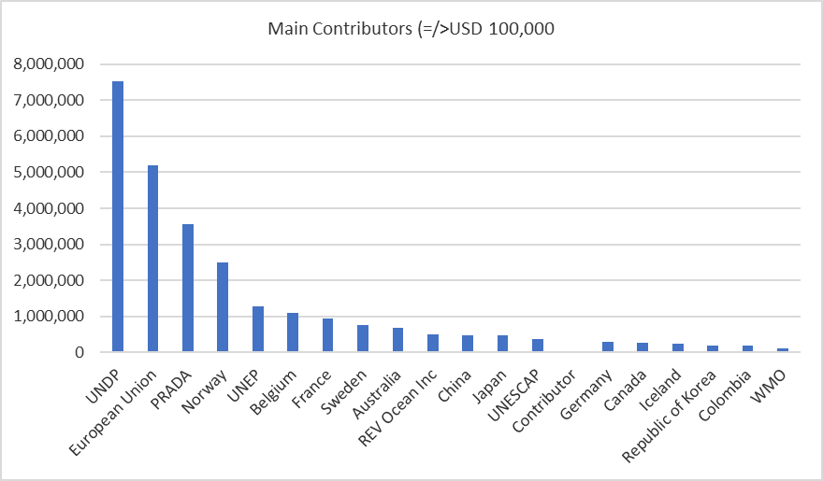

Table 6. In-kind contributions received in 2022–2023, as at 31 December 2023

DETAILED INFORMATION ON EXPENDITURE BY SOURCE OF FUNDS
- REGULAR BUDGET

Table 7. IOC 2022–2023 regular budget allocations and expenditure as at 31 December 2023

- VOLUNTARY CONTRIBUTIONS

ADDITIONAL CONTRIBUTIONS
Table 8.Expenditure as at 31 December 2023

IOC SPECIAL ACCOUNT

Table 9. Expenditure as at 31 December 2023

FUNDS-IN-TRUST

Table 10. Expenditure as at 31 December 2023

- OVERVIEW OF THE IOC STAFFING 2022–2023

Chart 7. Regular budget staff establishment
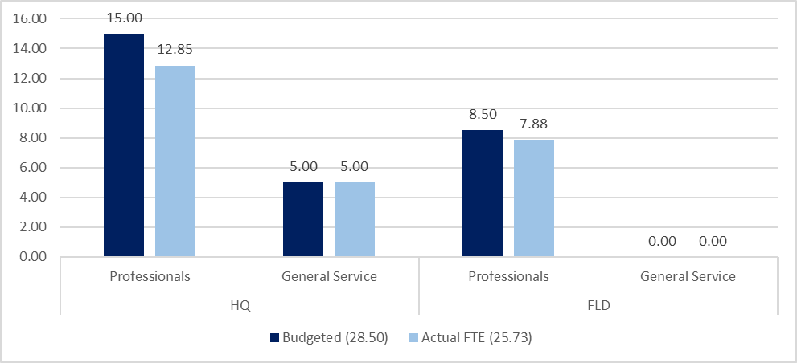
Chart 8. Actual FTE, all sources of funding
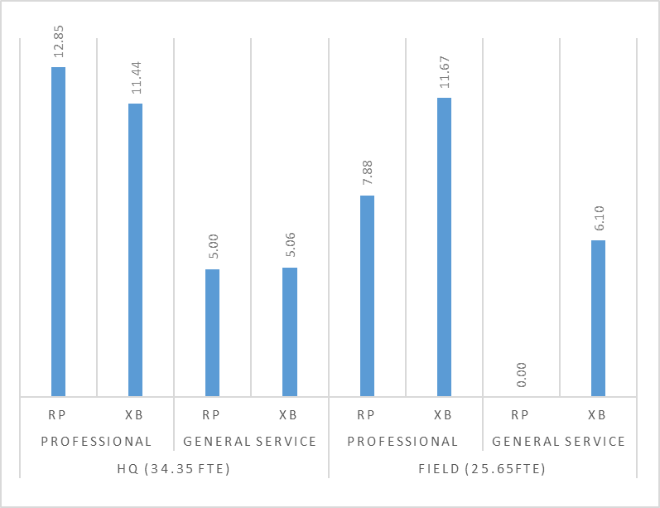

Reference IOC Resolution A-31/2 and IOC/A-31/4.2.Doc; Resolution EC-55/2 and IOC/EC-55/3.1.Doc(2); Resolution A-32/4 and IOC/A-32/3.2.Doc(2)

