Intergovernmental Oceanographic Commission
Technical Series | 151



EXERCISE CARIBE WAVE 24
A Caribbean and Adjacent Regions Tsunami Warning Exercise
21 March 2024
(Puerto Rico Trench and Panama)
Volume 2 Draft Summary Report

UNESCO

Intergovernmental Oceanographic Commission
technical series | 151

EXERCISE CARIBE WAVE 24
A Caribbean and Adjacent Regions Tsunami Warning Exercise
21 March 2024
(Puerto Rico Trench and Panama)
Volume 2 Summary Report

UNESCO 2024
IOC Technical Series, 151 (volume 2)
Paris, June 2022
English only

The designations employed and the presentation of the material in this publication do not imply the expression of any opinion whatsoever on the part of the Secretariats of UNESCO and IOC concerning the legal status of any country or territory, or its authorities, or concerning the delimitation of the frontiers of any country or territory.

NOTE: The United Nations Educational, Scientific and Cultural Organization (UNESCO) and the Intergovernmental Oceanographic Commission (IOC) pattern the contents of this handbook after the CARIBE WAVE 2011, 2013, 2014, 2015, 2016, 2017, 2018, 2019, 2020, 2021, 2022 and 2023 Exercises. Each of these exercises has a handbook published as IOC Technical Series. These CARIBE WAVE exercises followed the Pacific Wave exercises which commenced in 2008 with manual published by the Intergovernmental Oceanographic Commission (Exercise Pacific Wave 08: A Pacific-wide Tsunami Warning and Communication Exercise, 28–30 October 2008, IOC Technical Series, 82, Paris, UNESCO 2008). The UNESCO How to Plan, Conduct and Evaluate Tsunami Wave Exercises, IOC Manuals and Guides, 58 rev., Paris, UNESCO 2013 (English and Spanish) is another important reference.
For bibliographic purposes, this document should be cited as follows:
UNESCO/IOC. 2024. Exercise CARIBE WAVE 2024. A Caribbean and Adjacent Region Tsunami Warning Exercise, 21 March 2024 (Puerto Rico Trench Northern Panama). Volume 2: Summary Report. Paris, UNESCO, IOC Technical Series No 151, Vol. 2. (English only)
Report prepared by: Intergovernmental Coordination Group for the Tsunami and other Coastal Hazards Warning System for the Caribbean and Adjacent Regions (ICG/CARIBE-EWS)
Authors: Kimberly Maisonet Gonzalez, Claudia Guzman Soto, and Christa von Hillebrandt-Andrade

Published in 2024
by United Nations Educational, Scientific and Cultural Organization
7, Place de Fontenoy, 75352 Paris 07 SP
(IOC/2019/TS/151 Vol.2)

TABLE OF CONTENTS

Summary 7
1. BACKGROUND 8
2. EXERCISE CONCEPT 9
2.1 PURPOSE 9
2.2 OBJECTIVES AND GOALS 9
2.3 TYPE OF EXERCISES 11
3. EXERCISE OUTLINE 12
3.1 GENERAL 12
3.2 MASTER SCHEDULE (EXERCISE SCRIPT) 14
3.3 ACTIONS IN THE CASE OF A REAL EVENT AND FALSE ALARMS 15
3.4 REGISTRATION PROCEDURE 15
3.5 STATUS OF SEA LEVEL STATIONS DURING EXERCISE 18
3.6 RESOURCES 20
3.7 MEDIA ARRANGEMENTS 21
3.8 POST-EXERCISE EVALUATION 21
4. REFERENCES 26
ANNEX I. CATAC Dummy (Start of Exercise) Message 27
ANNEX II. CATAC Exercise Messages 29
ANNEX III. List Of Acronym 50

Summary
The CARIBE WAVE exercise is conducted within the framework of the UNESCO Intergovernmental Coordination Group for Tsunamis and other Coastal Hazards for the Caribbean and Adjacent Regions (CARIBE-EWS). The 2024 annual tsunami exercise took place on March 21 to test Tsunami Warning Systems and promote tsunami preparedness in the Caribbean and adjacent regions. The exercise was coordinated by the CARIBE WAVE task team, the NOAA International Tsunami Information Center Caribbean Office, and supported by the Caribbean Tsunami Information Center and Pacific Tsunami Warning Center. It was left up for Member States and Territories to choose between the Puerto Rico Trench and the Panama scenarios and to decide the level of participation and activity to be held in their country.
CARIBE WAVE exercises focus on communications and evaluating procedures and programs within Member States and Territories. The Pacific Tsunami Warning Center (PTWC), the Regional Tsunami Service Provider, issued a “Dummy” message through the different warning systems at 1500 UTC to test communications with Tsunami Warning Focal Points (TWFP) and National Tsunami Warning Centers (NTWC). Different methods of communications were used to test and disseminate the message: The World Meteorological Organization (WMO), Advanced Weather Interactive Processing System (AWIPS), Aeronautical Information Replacement System (AIRS), NOAA Weather Wire, GEONETCast Americas, Fax, Email, and social media. According to feedback as well as social media and web posts, the dummy message was successfully received. The Central America Tsunami Advisory Center (CATAC) also disseminated simulated products for the Panama scenario to its stakeholders.

When PTWC issued its simulated “end of threat” messages for the exercise, over 475,000 people from across the entire Caribbean basin had registered on the Tsunami Zone website (tsunamizone.org, April 26, 2024). The majority of the participants were from K-12 Schools. State governments, universities and preparedness organizations also had a high level of participation. Social media platforms, which has become the primary source for communicating tsunami awareness, had worldwide reach.

Sea level data availability is important to forecast and confirm a real tsunami event. If a tsunami had occurred during the day of the exercise, data of 67 of the 100 sea-level stations in the region would have been available for event analysis. All three of the Deep Ocean Assessment and Reporting on Tsunamis (DARTs) were operational during the exercise. CARIBE WAVE has been improving and validating tsunami preparedness since 2011, which is why tsunami exercises are crucial to maintain readiness in case of a real tsunami event.

1. BACKGROUND
The UNESCO IOC Intergovernmental Coordination Group for the Tsunami and Other Coastal Hazards Warning System for the Caribbean and Adjacent Regions at its Eighth session (ICG/CARIBE-EWS-VIII, Port of Spain, Trinidad and Tobago, 29 April – 1 May 2013), decided to conduct exercises named CARIBE WAVE on an annual basis leaving each Member State to define its level of participation. At its Sixteenth session (ICG/CARIBE-EWS-XVI, San Jose, Costa Rica, 25 - 28 April 2024), the ICG/CARIBE-EWS recommended that Exercise CARIBE WAVE 24 take place on 21 March 2024 at 1500 UTC, with two hypothetical tsunami scenarios. The first scenario simulates a tsunami generated by a magnitude 8.7 earthquake located in the Puerto Rico Trench and the second scenario is generated by an 8.47 earthquake in the North Panama Deformed Belt.
Historical tsunami records from sources such as the NOAA National Centers for Environmental Information (NCEI) show that from the years 1530 to 2023 tsunamis from earthquake, landslide, and volcanic sources have all impacted the region. According to NCEI, in the past 500 years, over 65 confirmed tsunamis have been observed and approximately 4,500 people have lost their lives to tsunamis in the Caribbean and adjacent regions. Since the most recent devastating tsunami of 1946, there has been an explosive population growth and influx of tourists along the Caribbean and Western Atlantic coasts increasing the tsunami vulnerability of the region (von Hillebrandt-Andrade, 2013).
Recognizing the need for an early warning system, especially after the lessons learned from the 2004 Indian Ocean tsunami, the Intergovernmental Coordination Group for the Tsunami and other Coastal Hazards Warning System for the Caribbean and Adjacent Regions (ICG/CARIBE-EWS) was established in 2005 as a subsidiary body of the IOC/UNESCO with the purpose of providing assistance to all Member States of the region to establish their own early tsunami warning system. The main objective of the CARIBE-EWS is to identify and mitigate the hazards posed by local, regional and distant tsunamis. The ultimate goal is to create a fully integrated end-to-end warning system comprising four key components: monitoring and detection systems, hazard assessment, tsunami related services (dissemination), and community preparedness, readiness and resilience.

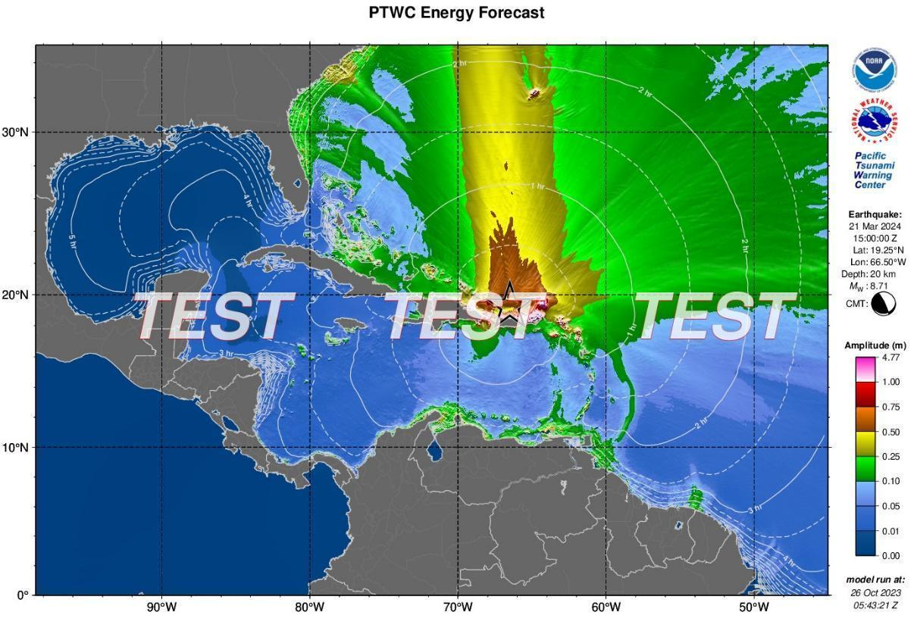
Figure 1. PTWC maximum deep-ocean amplitude map generated using RIFT
for the Puerto Rico Trench scenario.

2. EXERCISE CONCEPT

2.1 PURPOSE
The purpose of the exercise was to improve Tsunami Warning System effectiveness in the Caribbean and adjacent regions. The exercise provided an opportunity for emergency management organizations throughout the region to exercise their operational lines of communications, review their tsunami response procedures, and promote tsunami preparedness. Regular exercising of response plans is critical to maintain readiness in case of an emergency. This is particularly true for the Caribbean and adjacent regions, where tsunamis are infrequent but can be of very high impact. Every emergency management organization (EMO) was encouraged to participate.

2.2 OBJECTIVES AND GOALS

Each organization developed its objectives for the exercise depending on its level of involvement in the scenario. There were three principal overarching objectives for the exercise.
- Exercise and evaluate communications between Regional Tsunami Service Providers and Member States/Territories.
  - Validate the issuance of tsunami products from the PTWC.
  - Validate receipts of tsunami products by CARIBE-EWS Tsunami Warning Focal Points (TWFPs) and/or National Tsunami Warning Centers (NTWCs).
- Evaluate the tsunami procedures and programs within Member States/Territories.
  - Validate readiness to respond to a tsunami.
  - Validate the operational readiness of the TWFPs/NTWCs and/or the National Disaster Management Office (NDMO).
  - Improve operational readiness. Before the exercise, ensure appropriate tools and response plan(s) have been developed, including public education materials.
  - Validate that the dissemination of warnings and information/advice by TWFPs and NTWCs, to relevant in-country agencies and the public is accurate and timely.
  - Evaluate the status of the implementation of the UNESCO/IOC Tsunami Ready programme.
ICG/CARIBE-EWS has established metrics to evaluate the goals of the exercise (Table 1). 80% of MS and Territories submitted the Post-Exercise Survey, with 100% who answered being satisfied with the exercise.

Goals | 2016  Results | 2017  Results | 2018  Results | 2019  Results | 2020  Results | 2021  Results | 2022  Results | 2023  Results | 2024  Metrics | 2024  Results
TWFP receive the dummy message | 84% | 95% | 100% | 89% | 97% | 97% | 91% | 97% | 100% | 100%
Participation of Member States of ICG/CARIBE-EWS with designated focal warning point | 100% | 100% | 97% | 100% | 92% | 98% | 100% | 94% | 100% | 98%
Community involvement (including agencies beyond TWFP) | 73% | 82% | 77% | 66% | 38% | 56% | 43% | 41% | 95% | 79%
Number of participants* | 332,812 | 679,985 | 643,403 | 793,353 | 4,622 | 333,518 | 413,281 | 422,913 | +10% | 467,685**
Countries who participate submit exercise questionnaire | 100% | 100% | 91% | 82% | 92% | 95% | 100% | 93% | 100% | 80%
Members State and territories are satisfied with exercise |  |  |  | 82% | 76% | 96% | 88% | 97% | 100% | 100%
Table 1. Goals and Metrics. * As reported by Member States and Territories or in default tsunamizone.org. **If the number of participants Venezuela reported in theirNational Report, the total would be 622,797.

2.3 TYPE OF EXERCISES

The CARIBE WAVE 24 was planned for Caribbean countries to carry exercises at various scales of magnitude and sophistication. It was up for Member States and territories to decide the type of exercise that would be carried out. Communication tests were carried out to validate the issuance and receipt of the messages distributed by the Pacific Tsunami Warning Center (PTWC), the Regional Tsunami Service Provider, and evaluations of the tsunami procedures and programs within Member States and Territories. The Central America Tsunami Advisory Center (CATAC) also distributed messages during the exercise. Several of the National and local Offices of Emergency Management (OEM) were able to extend the exercise down to the level of testing local notification systems such as the Emergency Alert System (EAS), sirens and loudspeakers.
According to the Member States, the number of participants in the exercise was 467,685 people throughout the Caribbean and adjacent regions. The participants in the twelfth annual regional tsunami exercise hailed from forty-six out of the forty-eight Member States and territories. It represented a participation rate of 96% of all the Member States of the UNESCO Intergovernmental Coordination Group for Tsunamis and other Coastal Hazards for the Caribbean and Adjacent Regions (CARIBE-EWS).
Exercises were conducted at various scales of magnitude and sophistication. Exercises simulated the development, training, testing, and evaluation of Disaster Plans and Standard Operating Procedures (SOPs). The reported exercises included a variety of activities including testing communication systems, performing tabletop exercises, conducting seminars and drills (Figure 2). Additionally, the Task Team organized a post-exercise “hot wash” webinar to permit Member States and Territories to discuss and provide feedback on the exercise in an open forum. Discussions on what was the overall impression towards the exercise, unique successes and lessons learned, as well as strength and gaps on the exercise was shared. Some of the feedback was on the successful reception of the messages despite having some issues. The exercise also helped Emergency Managers identify gaps in communication and to adjust their Standard Operating Procedures. Many schools, businesses/hotels, and government officials participated. Future CARIBE WAVE exercise scenarios were discussed during the webinar, the ICG CARIBE EWS recommended the use of the Jamaica 1692 Port Royal earthquake, and the 1755 earthquake in Lisbon, Portugal as scenarios.
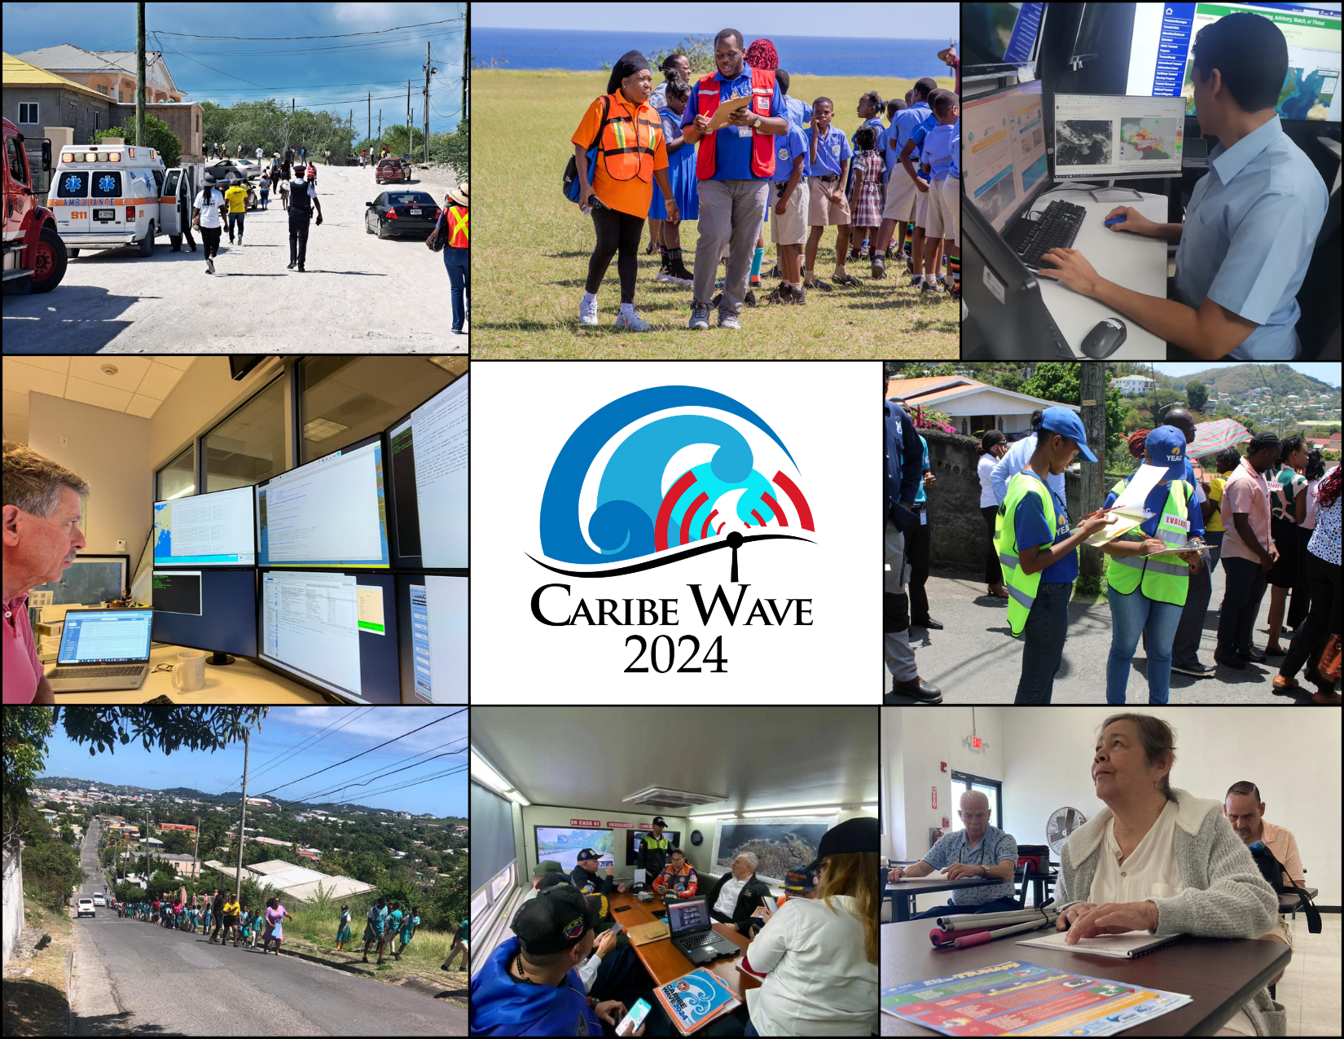
a

Figure 2. Participation of the exercise, CARIBE WAVE 24. From left to right, top to bottom, Turks and Caicos, St. Kitts and Nevis, Panama, PTWC, Grenada, Antigua and Barbuda, Venezuela, and Puerto Rico.

3. EXERCISE OUTLINE

3.1 GENERAL

The tsunami messages that were issued for this exercise by the PTWC were based a hypothetical earthquake with the following hypocenter parameters for the Puerto Rico Trench and Panama:
Puerto Rico Trench Scenario:
Origin Time 15:00:00 UTC March 21, 2024
Latitude 19.25°N
Longitude 66.50°W
Magnitude 8.7 – Mw
Depth 20 km

Panama Scenario:
Origin Time 15:00:00 UTC March 21, 2024
Latitude 9.80°N
Longitude 77.75°W
Magnitude 8.47 - Mw
Depth 25 km

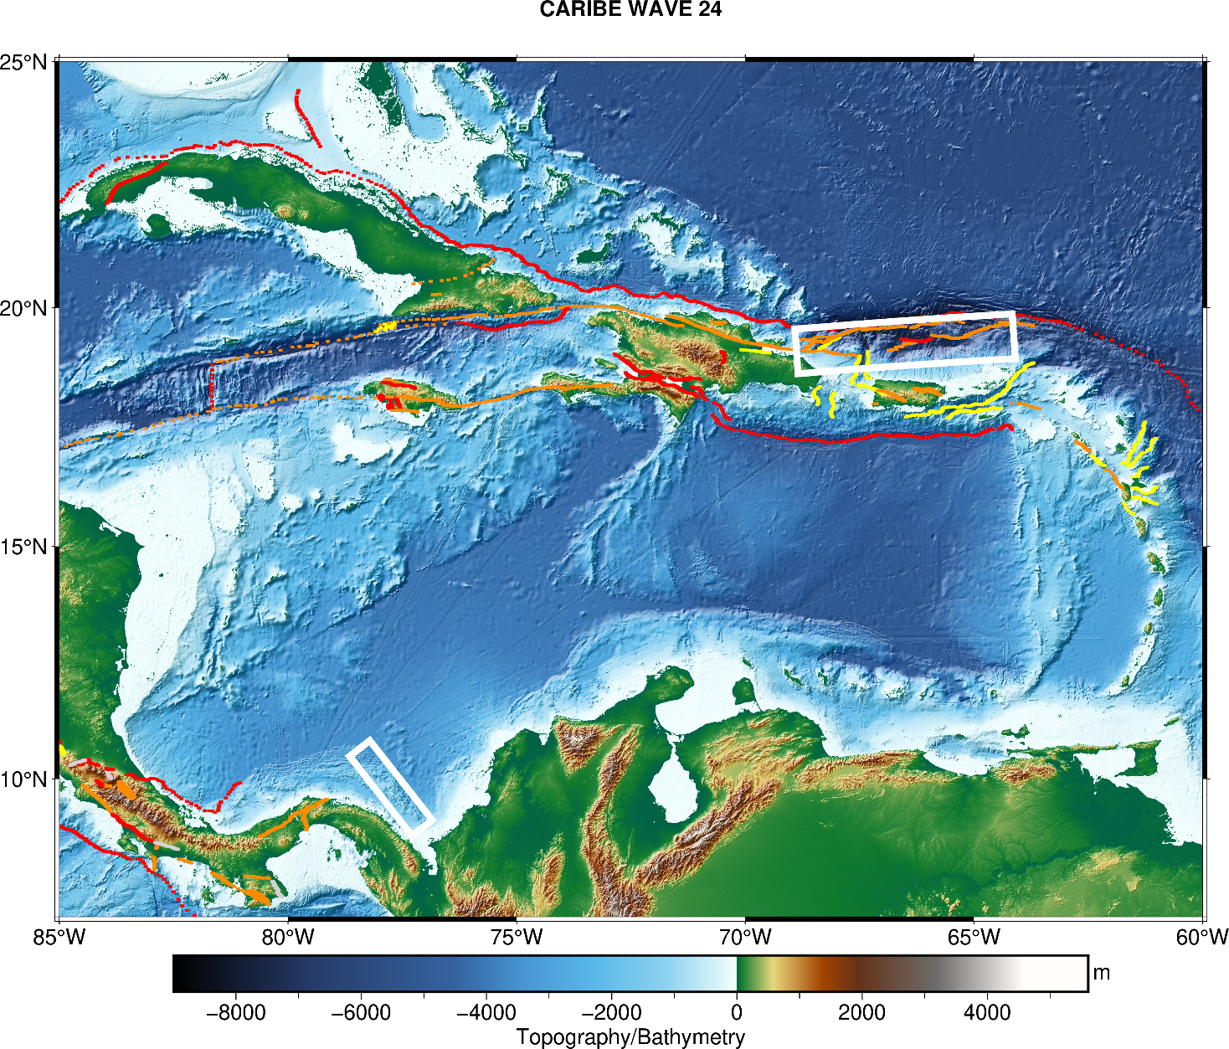

Figure 3. Map of the CARIBE WAVE 24 scenarios. The white rectangle indicates the map view of the ruptured fault segments. The faults are based on the GEMS model; red lines indicate convergent faults, yellow lines are divergent, and orange lines are for strike-slip. This figure was generated using PyGMT (Uieda et al., 2021) and GEBCO 2021 background model (GEBCO, 2021).

Messages Issued by the PTWC
The PTWC issued (18) international simulated messages for CARIBE WAVE 24. The first tsunami threat message for the Puerto Rico Trench and Panama scenarios was based on the tsunami earthquake and source event parameters, and the estimated tsunami travel times. While as of the third messages were based on simulated tsunami wave forecast, rather than seismic information. Tsunami threat forecast indicated the levels of threat that have been forecast and to which the countries or places they apply. The levels are tsunami heights of 0.3-1 meters, 1-3 meters, and greater than 3 meters above the normal tide levels are determined. The threats were updated usually within half-hour to an hour.
Member States were required to select one scenario by March 7 for the 2024 exercise. Those who did not select a scenario, the organizers decided for which scenario the PTWC would send the products. All simulated products (text and graphical) were disseminated through email to the corresponding TWFPs and NTWCs and were made available in the Exercise Handbook. Any further dissemination was the responsibility of the corresponding national and local authorities.
The PTWC also issued live over all standard broadcast channels (WMO/AWIPS IDs WECA41 PHEB/TSUCAX) the initial dummy message to start the exercise at 1500 UTC on 21 March 2024.
Messages Issued by CATAC
The initial dummy message was issued through email to start the exercise at 1500 UTC on 21 March 2024 and test communications. According to the Member States and Territories feedback, the message was successfully received by three of the five Member States of Central America in the CARIBE EWS. ITIC CAR and PTWC both received at 1500 UTC.
CATAC issued five (5) simulated messages in English and Spanish for CARIBE WAVE 24, with a similar format as the PTWC products. The first tsunami threat message was based on the earthquake magnitude and location. The third message included the simulated tsunami wave forecast and graphical products with predicted amplitudes at sea gauges and coastal zones. The messages were disseminated by email to only for the Panama scenario to NTWC and TWFP’s of Central American countries member os CARIBE EWS, PTWC, ITIC-CAR and CTIC. To note is that their products 3 and 4 indicated that there was an “Advertencia de Tsunami” in Spanish bulletin and Tsunami Warning in the English bulletin. Reception delays of 6 to 40 minutes were reported for Messages 1 - 4.
CATAC made modifications to the simulated messages that were included in the handbook. Therefore, the Dummy message as well as the tsunami simulated messages that were issued are included in Annex I of this report.

3.2 MASTER SCHEDULE (EXERCISE SCRIPT)

CARIBE-EWS Tsunami Service Provider (PTWC) issued the initial dummy message for the two scenarios on March 21, 2024 at 1500 UTC. This message was used to test communications with TWFPs and NTWCs, and to start the exercise. The transmission methods used to send the dummy message were GTS - WIS (WMO Information System), EMWIN, AISR, NWWS, GNC-A, Email, Fax, and AWIPS (Advanced Weather Interactive Processing System), using header IDs WECA41 PHEB/TSUCAX. All simulated products (text and graphical) were disseminated only through email to TWFPs and NTWCs. Nine (9) threat messages were issued for the Puerto Rico Trench scenario, and nine (9) for the Panama scenario. The graphical enhanced products were included in the third threat message each scenario. As in past years, the most common methods to receive the Dummy messages were Email and Fax. WMO Information System (WIS) was also a method where several countries received the message (Figure 4).
While NOAA confirmed that the PTWC products were broadcast on GNC-A, none of the countries which have these systems reported receiving them through this platform. During a pre exercise on line training on GNC-A, many of the countries indicated that while they had the equipment they had issues and were not using in operations. Likewise, NOAA noted that the products were also issued over EMWIN/HRIT. Only one TWFP (Puerto Rico Seismic Network) reported receiving the Dummy Message through this platform. The PRSN does operate a DART system for satellite download.
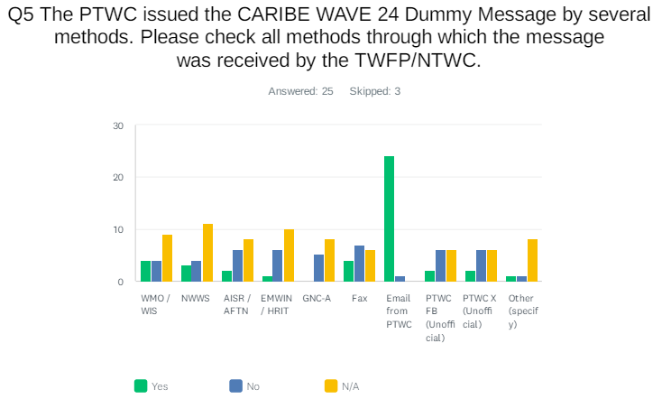
Figure 4. Methods that the CARIBE-EWS TWFPs/NTWCs used to receive the Dummy message by the PTWC.

3.3 ACTIONS IN THE CASE OF A REAL EVENT AND FALSE ALARMS
No significant real events and false alarms were reported by the Member States and Territories during the exercise. No actions were thus required.

3.4 REGISTRATION PROCEDURE
As for past exercises, the CARIBE-EWS teamed up with TsunamiZone.org for online registration (Figure 5). The link used for the registration was http://www.tsunamizone.org/register/. Under the “Register Here” Tab, participants were able to sign up and choose among the three major categories:
- Myself and/or my family,
- My school, district, college/university, or childcare center, and
- My organization, department, or agency (including TNCs. TWFPs and NTWCs). EMOs were encouraged to promote this registration system.
Most people registered directly on the TsunamiZone.org which is an open registration system available during the whole year. As of 26 April 2024, 475,147 people had registered (Table 2). There were people from almost every category participating. Nevertheless, according to Member States who answered the post-exercise survey the estimated number of people actually participating were approximately 467,685 (Table 3).
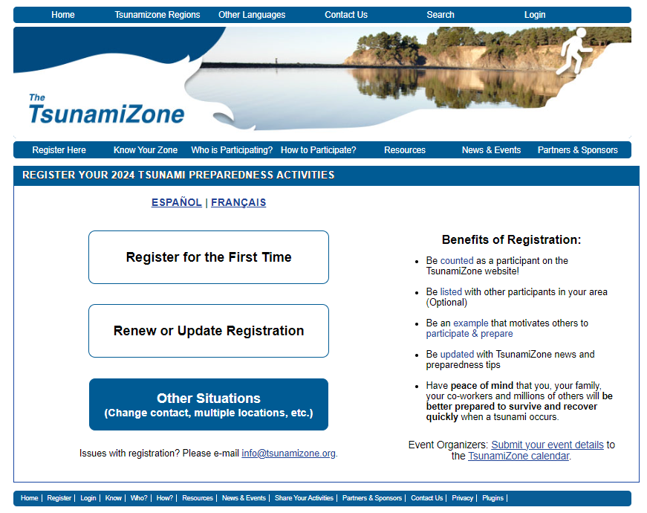
Figure 5. Registration by categories and Country for the CARIBE WAVE 24 Regional Tsunami Exercise.

Category | Number of Participants
Individuals/Families | 1,985
Childcare and Pre-Schools | 7,990
K-12 Schools and Districts | 225,145
Colleges and Universities | 35,432
Local Government | 35,095
State Government | 43,025
Federal/National Government (Including Military) | 16,504
Tribes/Indigenous Peoples | 0
Businesses | 5,231
Hotels and Other Lodgings | 4,521
Healthcare | 19,490
Senior Facilities/Communities | 855
Disability/AFN Organizations | 135
Non-Profit Organizations | 9,245
Neighborhood Groups | 1,774
Preparedness Organizations | 48,363
Faith-based Organizations | 6,766
Museums, Libraries, Parks, etc. | 125
Volunteer/Service Clubs | 81
Youth Organizations | 450
Animal Shelter/Service Providers | 35
Agriculture/Livestock Sector | 169
Volunteer Radio Groups | 1,776
Science/Engineering Organizations | 382
Media Organizations | 6,407
Other | 4,166
Total | 475147
Table 2. List of registrants and participants by Categories on TsunamiZone.org in the Caribbean
(as of 04/26/2024)

Country |  | Participants according to Member States | Participants according to Tsunami Zone
Antigua and Barbuda |  | 7,034* | 7,034
Aruba |  | 27,000 | 7,190
Bahamas |  | 0* | 0
Barbados |  | 500 | 872
Belize |  | 2* | 2
Brazil |  | 13* | 13
Colombia |  | 50 | 43
Costa Rica |  | 120 | 124
Cuba |  | 200 | 0
Curacao |  | 20 | 50
Dominica |  | 19* | 19
Dominican Republic |  | 1,500 | 808
France |  | 173,823 | 173,823
Grenada |  | 14,724* | 14,724
Guatemala |  | 1,500 | 27
Guyana |  | 1,240 | 10
Haiti |  | 40 | 322
Honduras |  | 0* | 0
Jamaica |  | 85 | 555
Mexico |  | 11,000 | 658
Netherlands  (Bonaire, Saba, Sint Eustatius, other) |  | 40 | 41
Nicaragua |  | 30* | 30
Panama |  | 1,240 | 10,784
Saint Kitts and Nevis |  | 2,100* | 2,100
Saint Lucia |  | 313* | 313
Saint Vincent and the Grenadines |  | 35 | 203
Sint Maarten |  | 0 | 25
Suriname |  | 0* | 0
Trinidad and Tobago |  | 450* | 450
United Kingdom | Anguilla | 51* | 51
United Kingdom | Bermuda | 324 | 324
United Kingdom | British Virgin Islands | 4,000 | 634
United Kingdom | Cayman Islands | 25 | 7,424
United Kingdom | Montserrat | 0* | 0
United Kingdom | Turks and Caicos | 10* | 10
United States | Puerto Rico | 135,952 | 136,111
United States | US Virgin Island | 23,672 | 23,672
Venezuela |  | 60,573*(215,119**) | 86,701
TOTAL |  | 467,685* (622,797**) | 475,147
Table 3. List of participants by Country/Territory (as of 04/26/2023)
*Number taken from TsunamiZone.org for cases where countries did not report the number of participants in survey. *Number of participants of Venezuela per Survey. **Number of participants of Venezuela per National Report.

3.5 STATUS OF SEA LEVEL STATIONS DURING EXERCISE
An analysis of sea level stations status was carried out by the International Tsunami Information Center Caribbean Office (ITIC-CAR) as part of the CARIBE WAVE 24 Regional Tsunami Exercise. This allowed ITIC-CAR to analyze the availability of sea level data. The PTWC provided simulated forecasted maximum wave heights for 100 CARIBE-EWS stations in the simulated bulletins. Only about 66% of these sea level stations were online on the IOC Sea Level facility during the exercise period (Figures 6 and 7). Similarly, the Tide Tool system used by many Tsunami Warning Centers had around 70% of stations operational, this is a slight increase over the 68% data availability in 2023. All three reported DART stations were streaming data in the Caribbean/Gulf and Atlantic during the day of the exercise. (Figure 10).

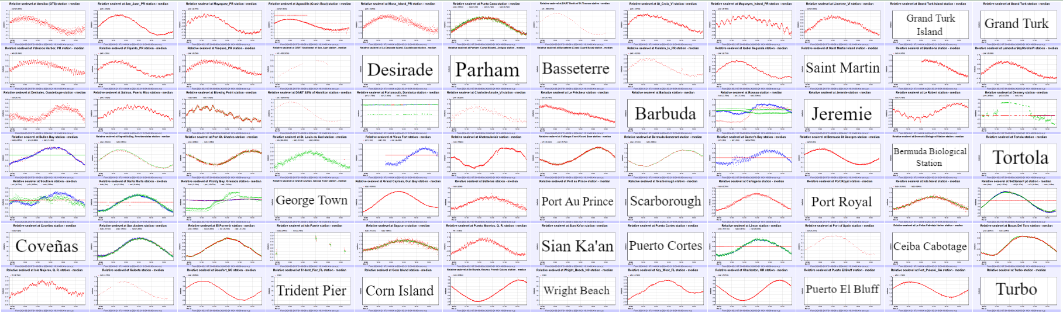
Figure 6. 84 stations for which PTWC include sea level observations for the Puerto Rico Trench scenario in its simulated product. Stations for which the name of the station is provided and not the wave form, are stations that had no data on the IOC Sea Level Monitoring Facility.

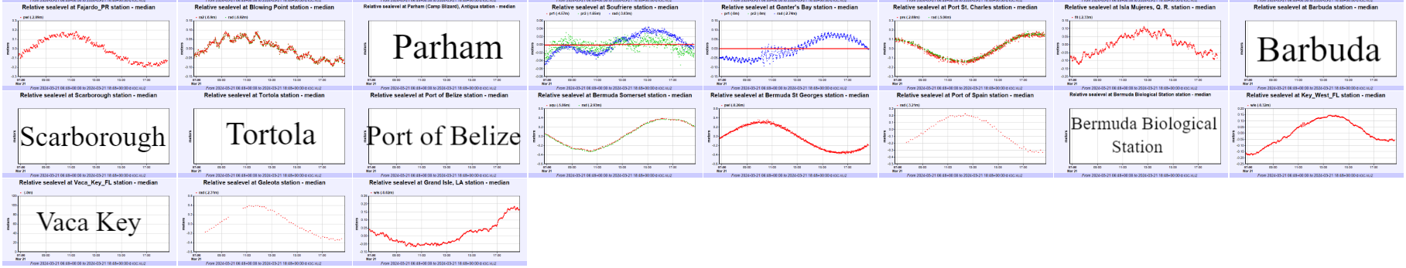
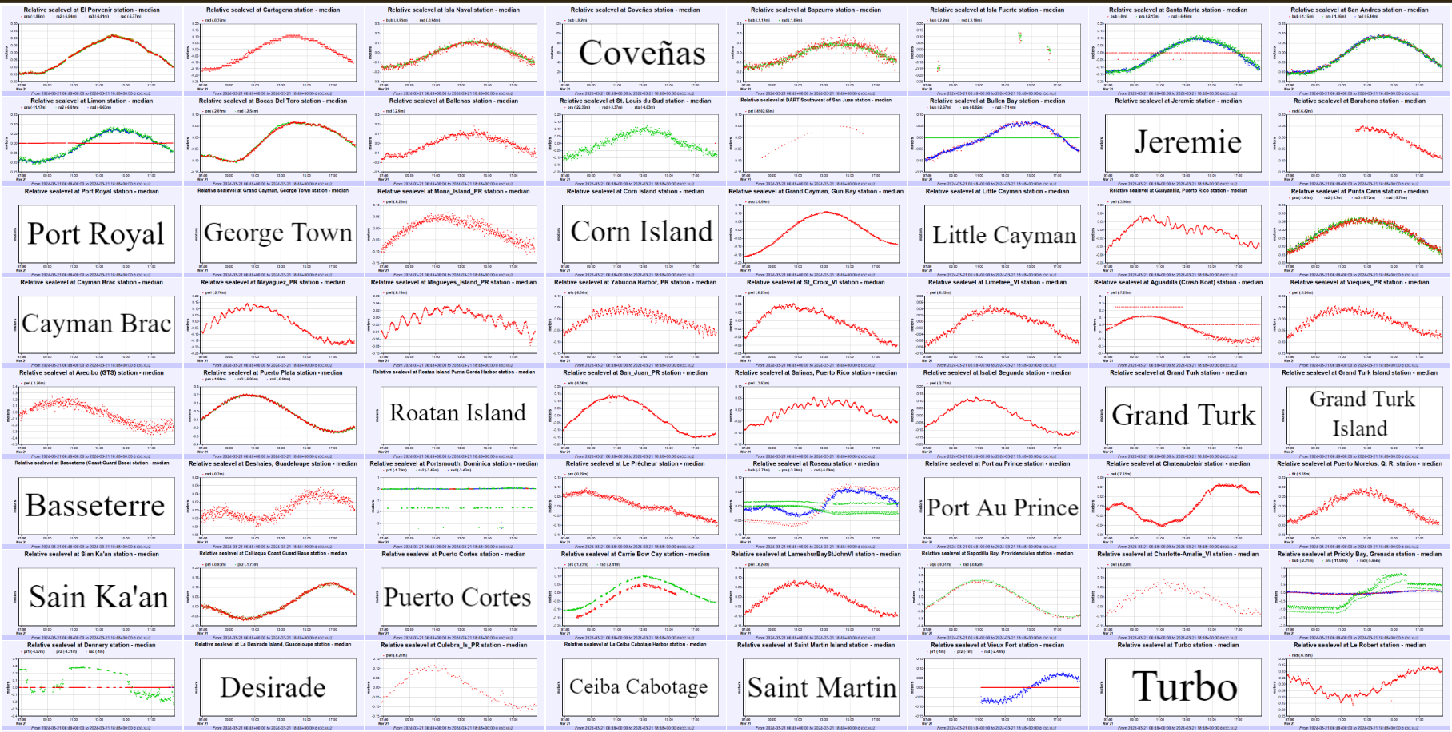

Figure 7. 83 stations for which PTWC include sea level observations for the Panama scenario in its simulated product. Stations for which the name of the station is provided, and not the wave form, are stations that had no data on the IOC Sea Level Monitoring Facility .

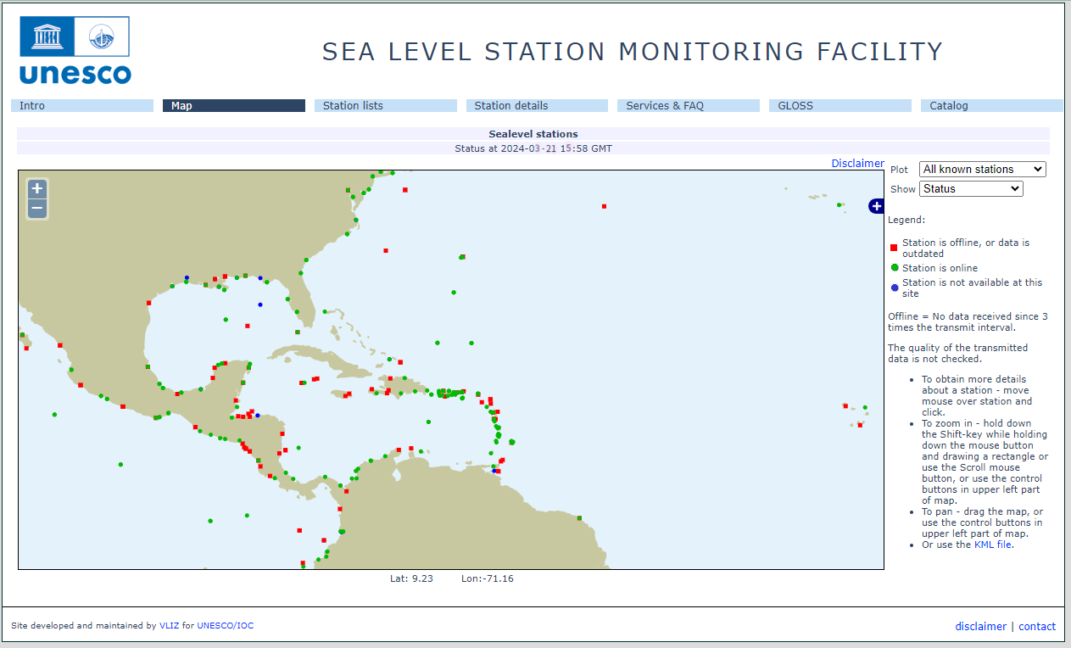
Figure 8. Screenshot showing IOC Sea Level facilities operating during the CARIBE WAVE 24 exercise. In green are stations for which data were available, red dots are for station for which there were no data.

3.6 RESOURCES
This year Antonio Aguilar and Gisela Báez-Sánchez were the Exercise Chairs; while Elizabeth Vanacore and Alberto López were the scientific experts that helped in the determination of the Puerto Rico Trench scenario; Nestor Luque was the scientific expert for the Panama scenario. ITIC-CAR coordinated the exercise for CARIBE-EWS.
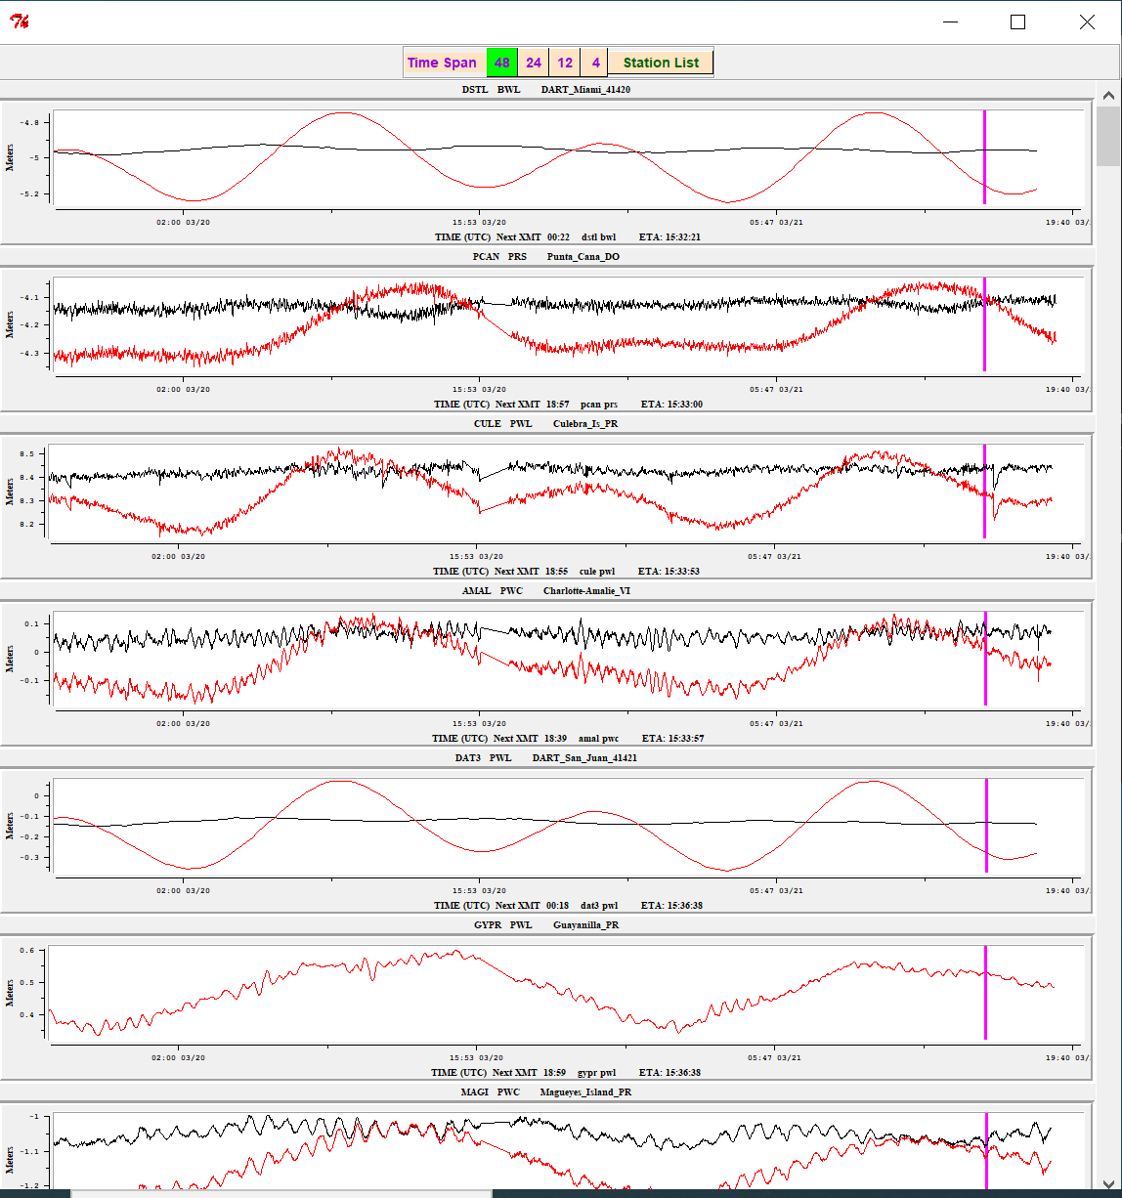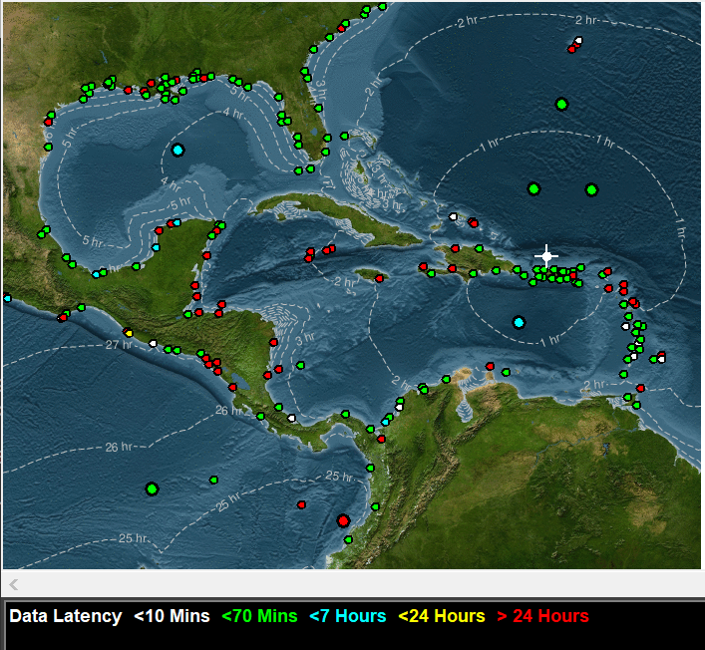
Figure 9. Screenshot from Tide Tool for the CARIBE WAVE 24 Puerto Rico Trench Scenario. Tide Tool includes both coastal gauges and DARTs. In White and Green are operational stations, in red are stations with no data over the past 24 hours (non-operational). The Isochrons represent the travel time from the source of the simulated tsunami from. The Strip Chart to the left includes the marigrams from the closest 7 stations. The magenta stripe marks the estimated time of arrival.

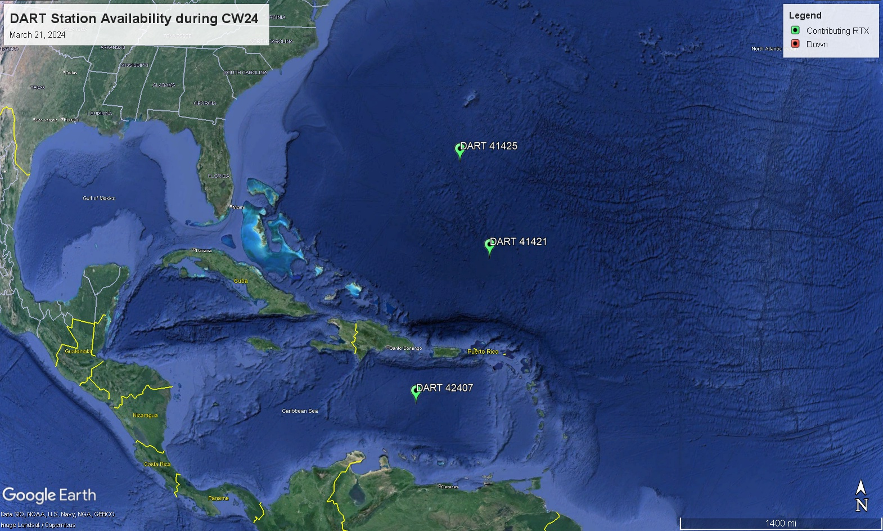
Figure 10. Map of operational and non-operational DARTs on March 21, 2024.

3.7 MEDIA ARRANGEMENTS
One advantage in conducting exercises is that it provides a venue to promote tsunami awareness. The exercise offers an opportunity to collaborate with the media and disseminate more broadly information on the warning system. The CARIBE-EWS Member States and Territories indicated that about 38% of the news media participated and covered the exercise. Most countries and territories publicized the exercise through social media to encourage the participation of the community using the hashtag #CARIBEWAVE to track their activities on March 21rst, resulting in worldwide reach. Several Emergency Management agencies from countries informed citizens through online article publications and social media posts that their country would participate in the exercise. The International Tsunami Information Center Caribbean Office, as well as the Puerto Rico Seismic Network also published informative posts related to tsunami awareness in preparation for CARIBE WAVE.

3.8 POST-EXERCISE EVALUATION
All participating countries were requested to provide feedback on the exercise through an online questionnaire. This feedback assists the ICG/CARIBE-EWS and UNESCO-IOC Tsunami Resilience Section in the evaluation of CARIBE WAVE 24 and the development of subsequent exercises, to identify strengths and challenges in the warning system and in the implementation of the UNESCO/IOC Tsunami Ready Programme. It also helps response agencies document lessons learned and lead to improvements of the national systems. The survey contained 39 questions and was conducted by the IOC UNESCO using the Survey Monkey service. In total, 28 surveys were completed representing the feedback from 80% of the MS and Territories (down from 100% in 2023).*
The survey was available until April 15th, a few weeks after the day of the exercise. Overall, the results indicated that the Dummy (Start of Exercise) message from PTWC and CATAC were received by 100% of the CARIBE-EWS Member States and Territories.
There was a strong dependency on email for the reception of products from the PTWC. The message was received by most countries within the first 1-5 minutes, and few countries reported delays.
79% of the MS indicated that the TWFP/NTWC issued follow up messages to relevant in-country agencies. The exercise planning went well under extenuating circumstances, resulting in a 100% of satisfaction of MS and territories, and a total participation of 467,685 people from the Caribbean. The questions as well as the answers and comments are contained in the Supplement.
The results for the status of the implementation of the UNESCO/IOC Tsunami Ready Recognition Programme indicated that 89% of the countries are interested in implementing the program and 82% already implementing it with 114 as total number of target communities to be recognized as Tsunami Ready (Table 4), this number is a lot smaller than indicated in previous years..
In addition, the survey provided the MS an opportunity to provide statements on the exercise (Table 5). Many of the countries highlight their active participation and importance and relevance of the exercise.

Country | Already Implementing | Interested in Implementing | TsunamiReady® or Tsunami Ready Communities (as reported by Member States) | TsunamiReady® or Tsunami Ready Communities (IOC Records For CARIBE EWS) | Target Number
Antigua and Barbuda | - | Yes | - | 1 | -
Aruba | No | - | - | 0 | -
Bahamas | - | - | - | 0 | -
Barbados | Yes | - | - | 2 | -
Belize | Yes | Yes | - | 0 | -
Brazil | - | - | - | 0 | -
Colombia | No | - | 0 | 0 | -
Costa Rica | Yes | Yes | 10 | 0 | 11
Cuba | No | Yes | 0 | 0 | -
Curacao | Yes | Yes | - | 0 | -
Dominica | Yes | Yes | 1 | 0 | -
Dominican Republic | Yes | Yes | - | 0 | 4
France | Yes | Yes | - | 1 | 2
Grenada | - | - | - | 2 | -
Guatemala | Yes | Yes | 0 | 0 | 2
Guyana | - | - | - | 0 | -
Haiti | Yes | Yes | 3 | 1 | 10
Honduras | - | - | - | 2 | -
Jamaica | Yes | Yes | 2 | 1 | 50
Mexico | Yes | Yes | 0 | 0 | 3
NL- Bonaire, Saba, and Sint Eustatius | No | - | - | 0 | -
Nicaragua | - | - | - | 2 | -
Panama | Yes | Yes | 1 | 0 | 6
Saint Kitts and Nevis | - | - | - | 1 | -
Saint Lucia | - | - | - | 0 | -
Saint Vincent and the Grenadines | Yes | Yes | 2 | 2 | 12
Sint Maarten | - | - | - | 0 | -
Suriname | - | - | - | 0 | -
Trinidad and Tobago | - | - | - | 1 | -
UK- Anguilla | Yes | Yes | - | 1 | 1
UK- Bermuda | Yes | Yes | - | 0 | 9
UK- British Virgin Islands | Yes | - | 1 | 1 | 1
UK- Cayman Islands | Yes | Yes | 1 | 0 | -
UK- Montserrat | - | - | - | 0 | -
UK- Turks and Caicos | - | - | - | 0 | -
USA- Puerto Rico | Yes | - | 46 | 46* | -
USA- US Virgin Islands | Yes | - | - | 3* | -
Venezuela | Yes | Yes | 0 | 0 | 3
TOTAL | 20 YES | 18 INTERESTED | 68 | 67 | 114
Table 4. Status of Implementation of the Pilot CARIBE EWS Tsunami Ready Recognition Program. In the case of Puerto Rico and the USVI, the TR recognition is through the US NWS TsunamiReady Program

Country | Exercise Caribe Wave 24  General Statements
Aruba | Dedicated Tsunami Risk for the Region. Motivation in the All Hazard Early Warning System for the Region.
Barbados | The Caribe wave exercise was good overall in Barbados. Bulletins were issued in a timely manner across all platforms used during the exercise. Radio etiquette training and tsunami bulletins are required for the BMS Staff.
Bermuda | We really appreciate the annual exercise. Our small staff size limits what we can do and the Government also has limited resources to  implement plans. We continue to advocate for improvements.
Colombia | It was a very useful tabletop exercise. As NTWC we would like to generate a bigger scope in the next participation, so we have to coordinate with national agencies for an evacuation exercise.
Cuba | In general, this exercise was carried out in tabletop modality in the new conditions in which the Physical Oceanography group is already working in the Marine Meteorology Center of the Meteorological Institute of Cuba, which is located very close to the National General Staff. of the Civil Defense. From the exercise itself, it was possible to appreciate the benefits that these conditions have for immediacy in the management of an alert system.
Curacao | As indicated the exercise served as an eyeopener for NDMO in to what needs to be done to achieve tsunami ready status.
Dominican  Republic | The timing of the exercise's publication should be to publish it in December or the first week of January. This allows us to better organize actions. This year's exercise was well organized, it was not complex to take on. Congratulations to the entire organizing team. We are grateful for continued efforts to improve our preparation to respond to and provide early warning of tsunamis.
France | Many thanks to the CARIBEWAVE task team
Guatemala | This kind of exercise tests our dissemination tsunami warning message and evaluates time to react in case of a real hazard. Also i think, to encourage more participation, it would possible send a invitation to CONRED.
Jamaica | CARIBE WAVE is a great way to promote Tsunami Preparedness and Response. The correspondence invitation was very informative and was disseminated to relevant parties. We hope Jamaica will be able to conduct more live exercises and even include the Executive of the country participating as we have seen in countries such as the BVI.
Mexico | The exercise was very useful to check the receipt of the alert, follow-up and cancellation bulletins by all participants, plan and practice the emergency action and response protocols, and improve the areas of opportunity that need to be strengthened.
Panama | The CARIBE WAVE 24 Tsunami Exercise brought a lot of new experiences especially because of the participation of more people and institutions, everyone doing their respective tasks. At the end we accomplish the objectives and, of course, there are a lot of things to improve mostly in evacuation procedures, effective participation including disable people, and technically in tsunami inundation maps.
Saint Vincent and the Grenadines | The exercise was a success for NEMO SVG (NTWC). We were really able to go through the messages and discuss the implications for SVG including making determinations on the appropriate Alert levels. Operational staff were able to practices dissemination of messages that provided participants with an opportunity to simplify messages with the pertinent information require by stakeholders. Participants seemed very engaged but opined that there is a lot to execute in a short period of time. As such the general reflection was a greater need for more exercises to increase familiarity with Sops, messages and use of the decision support tools.
UK - Anguilla | The team from PTWC has been very supportive and helpful in our Tsunami recognition.
UK- British Virgin Islands | The exercise is helpful in kicking off preparation for the hurricane season. The felt earthquakes in the last few months & over the years have helped persons to take it seriously. Tsunami Ready is a valuable process in ensuring all mechanisms and systems are functional and that all SOPs and protocals are up to date.
UK- Cayman Islands | Wonderful job again - you are doing so much to build awareness and encourage us to prepare for this threat in the Caribbean region. Thank you - your efforts are appreciated!
USA- Puerto Rico | The scenario was an amazing opportunity to put on practice our tsunami evacuation plans and communication plans taking under consideration a tsunami with a major impact in our coast. It helps us to reinforce our relationship with Tsunami Ready Supporters agencies. More communities got organized and evacuate like Villa del Carmen in Ponce. (Complete response in supplement report.)
USA-US Virgin Islands | The US Virgin Islands deliberately increased the number of activities for the 2024 exercise. Besides the normal evacuations to safe elevations drills with schools, local businesses, and government agencies, VITEMA sounded its 44 tsunami sirens, and activated two (2) emergency operations centers and provided exercise messages of damages which required interagency coordination. VITEMA conducted a Tactics meeting to determine priority of efforts based on approved exercise objectives. A COOP exercise was also conducted for one (1) EOC which was in the tsunami inundation zone. VITEMA conducted 30-minute After Action Review / Hotwash on the EOC actions and a 30-minute After Action Review / Hotwash on the COOP activities. Governor Bryan and the USVI Cabinet members were provided Dummy Message and provided updates on anticipated arrival times / wave heights through the existing group WhatsApp. FEMA Region 2 liaison officer was notified of the exercise dummy message and participated in the exercise as observers at the EOCs. Amateur Radio Operators (Auxiliary Coms / ARES) provided alternate communications on exercise Dummy message.
Venezuela | This Caribe Wave 24 was very active, contacts were resumed with the highest authorities and it was possible to convince the authorities of the importance of the Caribe Wave 24 exercise, coordination with scientists and communities was very important. With great enthusiasm, the state and municipal civil protections, given their experience in previous exercises, assumed participation with their own methodologies and adapted their participation. The authorities decided in this exercise to establish a command and control post with the objective of monitoring the entire country, in the event of a possible tsunami warning. This drill was vital to evaluate our protocols and improve coordination between the various security agencies and government entities. We worked with the document prepared by the Vice Ministry of Risk Management and Civil Protection and its team called “Order of Operations” for the Caribe Wave, with the participation of radio amateurs, communications were strengthened in this exercise. We must rescue international communications with the other alert centers in the region, to obtain confirmation and exchange of data, among others. Evaluations were carried out on coastal areas that can be prepared for the tsunami ready program.
Table 5. General statements on CARIBE WAVE 24 Tsunami Exercise experience from countries
that participated.

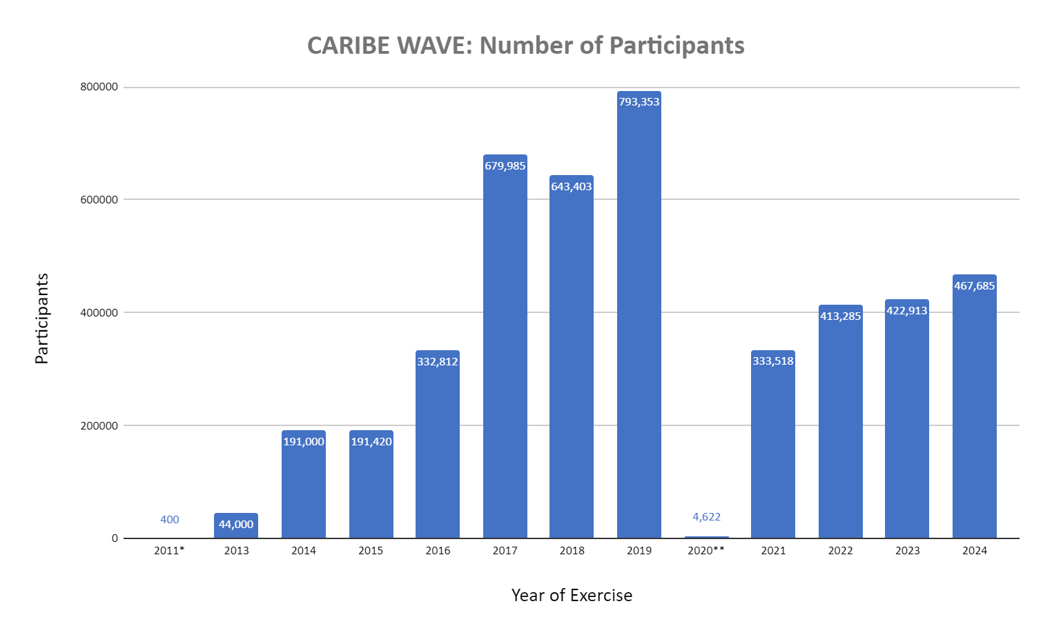
Figure 11. Number of participants for all the CARIBE WAVE exercises as reported by the member states

REFERENCES

GEBCO Compilation Group (2021) GEBCO 2021 Grid (doi:10.5285/c6612cbe-50b3-0cff-
e053-6c86abc09f8f)

Uieda, L., Tian, D., Leong, W. J., Jones, M., Schlitzer, W., Toney, L., Grund, M., Yao, J.,
Magen, Y., Materna, K., Newton, T, Anant, A., Ziebarth, M., Wessel, P., & Quinn, J.
(2021). PyGMT: A Python interface for the Generic Mapping Tools (v0.5.0). Zenodo.
https://doi.org/10.5281/zenodo.5607255

von Hillebrandt-Andrade, Christa, 2013, Minimizing Caribbean Tsunami Risk: Science, Vol.
341, p. 966-968.

ANNEX I. CATAC Dummy (Start of Exercise) Message

CATAC DUMMY IN ENGLISH:

-Time issued: 1500 UTC-

¡This is just a test message sent by CATAC in support of Exercise CaribeWave 24!
*******************************************************************************

Central America Tsunami Advisory Center (CATAC)

XXXXXXX THIS IS AN EXERCISE XXXXXXXXXXXX THIS IS AN EXERCISE XXXXXXXXXXXXXXXX

Notice : This is a kick-off message for exercise Caribe Wave 2024 for Central American countries, such as for Central American countries in support of the Intergovernmental Oceanographic Commission (IOC), of UNESCO and the ICG/CARIBE-EWS.

Isuued : 2024-03-21 09:00 Central American Time
2024-03-21 10:00 Panama Time
2024-03-21 15:00 Time (UTC)

This message is being used to initiate the Caribe Wave 2024 tsunami exercise, originating off the northern coast of Colombia.

The exercise messages are available on the web site http://catac.ineter.gob.ni/.
The purpose of the exercise is to provide emergency management advice.
It is a scenario to test tsunami response plans in the Central American countries.

XXXXXXX THIS IS AN EXERCISE XXXXXXXX THIS IS AN EXERCISE XXXXXXXXXXXX THIS IS AN EXERCISE XXXXXXXXXXXX

...

CATAC DUMMY IN SPANISH:

-Tiempo de emisión: 1500 UTC-

¡Este es sólo un mensaje de prueba enviado por CATAC en apoyo al Ejercicio CaribeWave 24!
******************************************************************************************

Centro de Asesoramiento de Tsunami para América Centra (CATAC)

XXXXXXX ESTE ES UN EJERCICIO XXXXXXXXXX ESTE ES UN EJERCICIO XXXXXXXXXXX

Aviso: Este es un mensaje de inicio del ejercicio Caribe Wave 2024
para los países de América Central, como apoyo a la Comisión Oceanográfica Intergubernamental (COI),
de la UNESCO y al ICG/CARIBE-EWS

Emisión: 2024-03-21 09:00 Hora de Centroamérica
2024-03-21 10:00 Hora de Panamá
2024-03-21 15:00 Hora (UTC)

Este mensaje se está utilizando para iniciar el ejercicio de tsunami Caribe Wave 2024, con origen en las costas del norte de Colombia.

Los mensajes de este ejercicio están disponibles en el sitio web http://catac.ineter.gob.ni/

El propósito del ejercicio es proporcionar asesoría a la gestión de emergencias.

Es un escenario para poner a prueba los planes de respuesta ante tsunamis en los países de América Central

XXXXXXX ESTE ES UN EJERCICIO XXXXXXXXXX ESTE ES UN EJERCICIO XXXXXXXXXXX

ANNEX II. CATAC Exercise Messages

The following messages created for the CARIBE WAVE 24 tsunami exercise were issued by the Central American Tsunami Advisory Center for a magnitude 8.47 earthquake and subsequent tsunami originating in the North Panama Deformed Belt. Only Central American countries and regions by agreement with the center received the messages.

CATAC MESSAGES IN ENGLISH:

CATAC Message #1
-Time issued: 1509 UTC-

¡This is just a test message sent by CATAC in support of Exercise CaribeWave 24!
********************************************************************************

Central America Tsunami Advisory Center - CATAC

XXXXXXX THIS IS JUST AN EXERCISE XXXXXXXXXXXXXXXXXXXXXXXXXXXXXXXXXXXXXXXXXXXXXXXXXX

NOTICE : This message is published for information purposes only in support
of Central American countries. National authorities are responsible
for determining the level of alert and for taking appropriate measures for their country.

Tsunami Bulletin N° 01

Issued : 2024-03-21 09:03 Central American Time
2024-03-21 10:03 Panama Time
2024-03-21 15:03 UTC Time

An earthquake has occurred with the following these preliminary parameters:

Magnitude : 8.5
Date : 21/03/2024
Time : 09:00 Central American Time, 10:00 Panama Time, 15:00 UTC Time
Latitude : 9.80 N
Longitude : 77.75 O
Depth : 25 Km
Location : Near the North Coast of Colombia

Assessment:

There is a high possibility of tsunami considering the magnitude, depth of the hypocenter,
and the location of the earthquake.

Recommended Actions:

Immediate actions are urgently needed for the protection of the population on the Caribbean coasts of Central America.
More information will be provided in the next few minutes.
*******************************************************************************************************

XXXXXXX THIS IS JUST AN EXERCISE XXXXXXXXXXXXXXXXXXXXXXXXXXXXXXXXXXXXXXXXXXXXXXXXXXXXX

CATAC Message #2
-Time issued: 1549 UTC- *issued after message #3

¡This is just a test message sent by CATAC in support of Exercise CaribeWave 24!
*****************************************************************************************************

Central America Tsunami Advisory Center - CATAC

XXXXXXX THIS IS JUST AN EXERCISE XXXXXXXXXXXXXXXXXXXXXXXXXXXXXXXXXXXXXXXXXXXXXXXXXXXXXXXXXXXXXXXXXXXXXX

NOTICE : This message is published for information purposes only in support of
Central American countries. National authorities are responsible for
determining the level of alert and for taking appropriate measures for
their country.

Tsunami Bulletin N° 02

Issued: 2024-03-21 09:09 Central American Time
2024-03-21 10:09 Panama Time
2024-03-21 15:09 UTC Time

An earthquake has occurred with the following parameters:

Magnitude : 8.5
Date : 21/03/2024
Time : 09:00 Central American Time, 10:00 Panama Time, 15:00 UTC Time
Latitude : 9.80 N
Longitude : 77.75 O
Depth : 25 Km
Location : Near the North Coast of Colombia

Evaluation:

According the analysis of the Moment Tensor of the earthquake there is a mayor possibility that a tsunami may have been produced
which would affect with greater intensity the nearest coasts, about 100 km from the epicenter of the earthquake.
Authorities should take actions corresponding to their response plans.

Tsunami simulation results:

Estimated Time of Arrival (ETA) in local time and Maximum Height (AM) of tsunami waves,
at different forecast points:

Site Country ETA (Local Time) AM(m)
San Blas Panamá 21/3/2024 10:03:30 36.21
Turtle Island Panamá 21/3/2024 10:07:45 28.26
Isla Grande Panamá 21/3/2024 10:07:45 28.26
Colón Panamá 21/3/2024 10:18:15 23.39
Limón Costa Rica 21/3/2024 09:49:15 5.65
Corn Island Nicaragua 21/3/2024 10:13:15 4.46
Atlántico Sur Nicaragua 21/3/2024 10:17:30 4.09
San Juan de Nicaragua Nicaragua 21/3/2024 10:14:00 2.64
Litle Corn Island Nicaragua 21/3/2024 10:19:45 3.00
Bocas del Toro Panamá 21/3/2024 10:48:30 6.68
Cayos de Honduras Honduras 21/3/2024 12:19:30 2.31
Atlántico Norte Nicaragua 21/3/2024 12:05:00 3.09
Cayos Misquitos Nicaragua 21/3/2024 11:46:15 2.00
Cabo Gracias a Dios Honduras 21/3/2024 12:53:30 1.88
Atlántida Honduras 21/3/2024 14:35:30 1.22
Colón Honduras 21/3/2024 12:50:00 1.14
Cortés Honduras 21/3/2024 13:12:15 1.01
Guanaja Sur Honduras 21/3/2024 14:16:30 0.88
Cayo Cochino Grande Honduras 21/3/2024 15:06:45 0.60
Islas de la Bahía Honduras 21/3/2024 12:50:30 0.78
Puerto Barrios Guatemala 21/3/2024 15:18:30 0.53

Graphical result:

Review in the attachment to this message, the color-coded forecast zones according to hazard,
for the Caribbean Sea coastal areas of Central America according our numerical tsunami simulations.

Updates:

More information will be provided in the next few minutes.

Countries may additionally receive messages from the Pacific Tsunami Warning Center (PTWC).
In case of differences between CATAC and PTWC results, we recommend to prefer conservatively,
the estimates that correspond to a higher hazard.

Additional information:

Detailed earthquake and tsunami information can be found at the website.
www.catac.ineter.gob.ni

*******************************************************************************************************

XXXXXXX THIS IS JUST AN EXERCISE XXXXXXXXXXXXXXXXXXXXXXXXXXXXXXXXXXXXXXXXXXXXXXXXXXXXXXXXXXXXXXXXXXXXXXXX

CATAC Message #3
-Time issued: 1539 UTC- *issued before message #2

¡This is just a test message sent by CATAC in support of Exercise CaribeWave 24!
*****************************************************************************************************

Central America Tsunami Advisory Center - CATAC

XXXXXXX THIS IS JUST AN EXERCISE XXXXXXXXXXXXXXXXXXXXXXXXXXXXXXXXXXXXXXXXXXXXXXXXXXXXXXXXXXXXXXXXXXXXX

NOTICE : This message is published for information purposes only in support of
Central American countries. National authorities are responsible for determining
the level of alert and for taking appropriate measures for their country.
appropriate measures for their country.

Tsunami Bulletin N° 03

Issued: 2024-03-21 09:30 Central American Time
2024-03-21 10:30 Panama Time
2024-03-21 15:30 UTC Time

A tsunami warning is in effect for the coastal areas of Central American countries.

An earthquake has occurred with the following parameters:

Magnitude : 8.5
Date : 21/03/2024
Time : 09:00 Central American Time, 10:00 Panama Time, 15:00 UTC Time
Latitude : 9.80 N
Longitude : 77.75 O
Depth : 25 Km
Location : Near the North Coast of Colombia

Evaluation:

Due to magnitude, depth and location of the earthquake there is a possibility that a tsunami may have been produced
which would affect with greater intensity the closest coasts, about 100 km from the epicenter of the earthquake.
Authorities should take actions corresponding to their response plans.

Tsunami simulation results:

Estimated Time of Arrival (ETA) in local time and Maximum Height (AM) of tsunami waves,
at different forecast points:

Site Country ETA (Local Time) AM(m)
San Blas Panamá 21/3/2024 10:03:30 36.21
Turtle Island Panamá 21/3/2024 10:07:45 28.26
Isla Grande Panamá 21/3/2024 10:07:45 28.26
Colón Panamá 21/3/2024 10:18:15 23.39
Limón Costa Rica 21/3/2024 09:49:15 5.65
Corn Island Nicaragua 21/3/2024 10:13:15 4.46
Atlántico Sur Nicaragua 21/3/2024 10:17:30 4.09
San Juan de Nicaragua Nicaragua 21/3/2024 10:14:00 2.64
Litle Corn Island Nicaragua 21/3/2024 10:19:45 3.00
Bocas del Toro Panamá 21/3/2024 10:48:30 6.68
Cayos de Honduras Honduras 21/3/2024 12:19:30 2.31
Atlántico Norte Nicaragua 21/3/2024 12:05:00 3.09
Cayos Misquitos Nicaragua 21/3/2024 11:46:15 2.00
Cabo Gracias a Dios Honduras 21/3/2024 12:53:30 1.88
Atlántida Honduras 21/3/2024 14:35:30 1.22
Colón Honduras 21/3/2024 12:50:00 1.14
Cortés Honduras 21/3/2024 13:12:15 1.01
Guanaja Sur Honduras 21/3/2024 14:16:30 0.88
Cayo Cochino Grande Honduras 21/3/2024 15:06:45 0.60
Islas de la Bahía Honduras 21/3/2024 12:50:30 0.78
Puerto Barrios Guatemala 21/3/2024 15:18:30 0.53

Graphical result:

Review in the attachment to this message, the color-coded forecast zones according to hazard,
and wave heights, for the Caribbean Sea coastal areas of Central America estiated with numerical tsunami simulations.

Sea level station measurements:

Code Coordinates Country ETA (Local Time) AM(m)
VZ..ELPO 09.56°N 78.95°O Panama 2024-03-21 09:21 24.21
VZ..BDTO 09.35°N 82.26°O Panama 2024-03-21 09:56 5.58

Updates:

More information will be provided in the next few minutes.

Countries may additionally receive messages from the Pacific Tsunami Warning Center (PTWC).
In case of differences between CATAC and PTWC results, we recommend to prefer conservatively,
the estimates that correspond to a higher hazard.

Additional information:

Detailed earthquake and tsunami information can be found at the website.
http://catac.ineter.gob.ni/

*******************************************************************************************************

XXXXXXX THIS IS ONLY AN EXERCISE XXXXXXXXXXXXXXXXXXXXXXXXXXXXXXXXXXXXXXXXXXXXXXXXXXXXXXXXXXXXXXXXXXXXXX

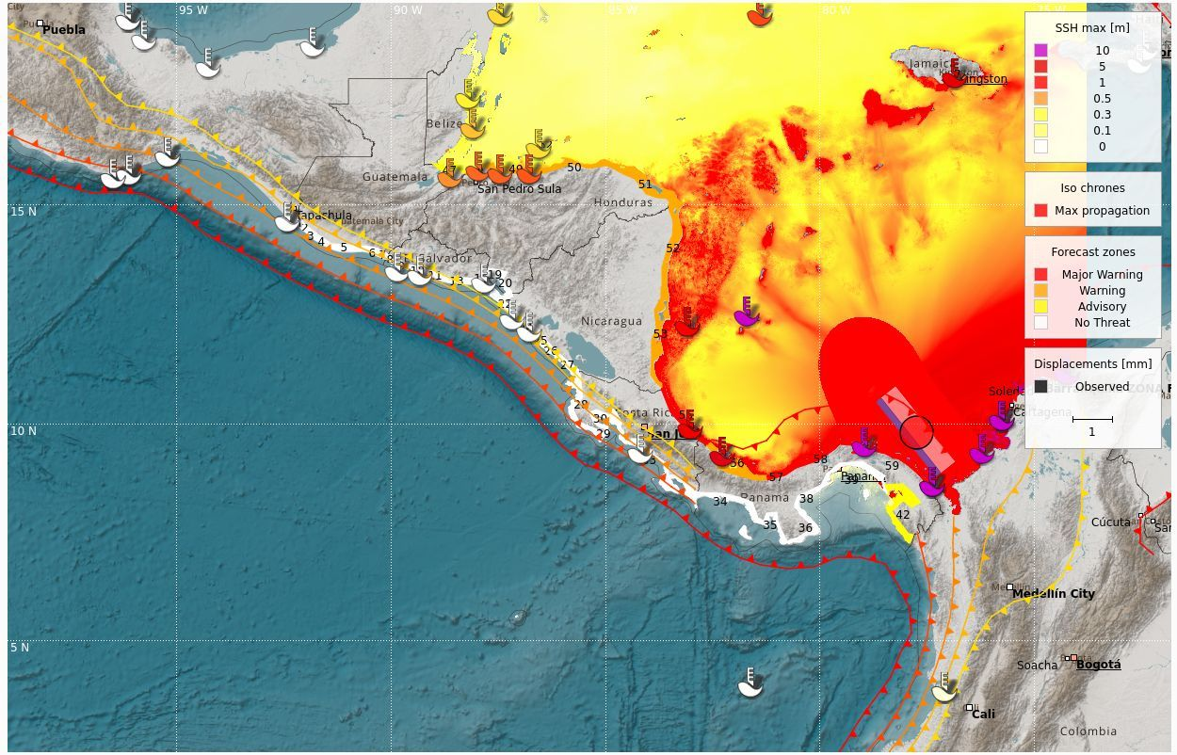

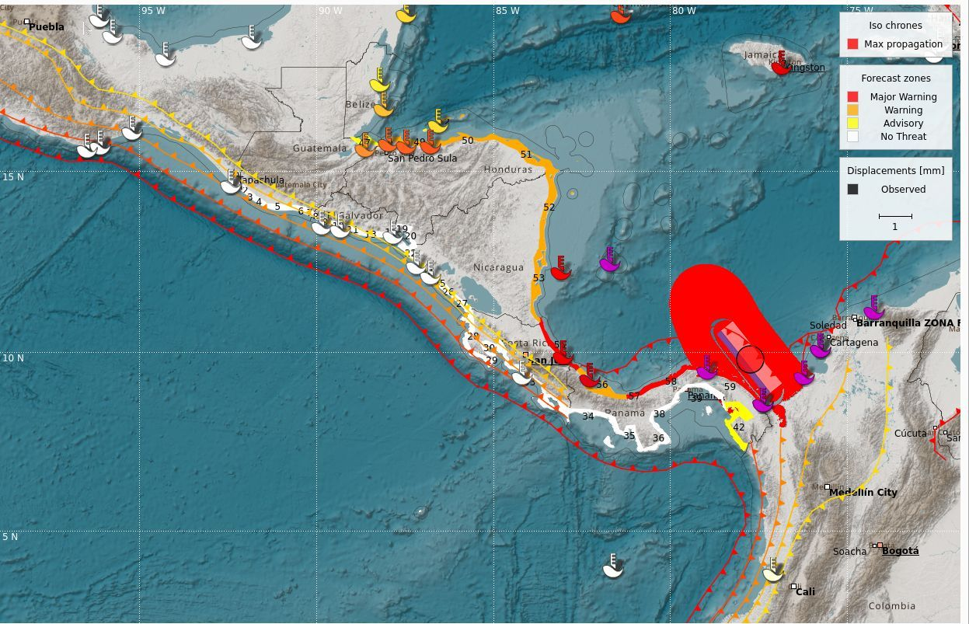

CATAC Message #4
-Time issued: 1639 UTC-

¡This is just a test message sent by CATAC in support of Exercise CaribeWave 24!
*****************************************************************************************************

Central America Tsunami Advisory Center - CATAC

XXXXXXX THIS IS JUST AN EXERCISE XXXXXXXXXXXXXXXXXXXXXXXXXXXXXXXXXXXXXXXXXXXXXXXXXXXXXXXXXXXXXXXXXXXX

NOTICE : This message is published for information purposes only in support of
Central American countries. National authorities are responsible for determining
the level of alert and for taking appropriate measures for their country.
appropriate measures for their country.

Tsunami Bulletin N° 04

Issued: 2024-03-21 10:00 Central American Time
2024-03-21 11:00 Panama Time
2024-03-21 16:00 UTC Time

A tsunami warning is in effect for the coastal areas of Central American countries.

An earthquake has occurred with the following parameters:

Magnitude : 8.5
Date : 21/03/2024
Time : 09:00 Central American Time, 10:00 Panama Time, 15:00 UTC Time
Latitude : 9.80 N
Longitude : 77.75 O
Depth : 25 Km
Location : Near the North Coast of Colombia

Evaluation:

A tsunami was produced which will affets or will affect the Caribbean coasts of Panamá, Costa Rica, Nicaragua, Honduras and Guatemala.
Authorities should take actions corresponding to their response plans.

Tsunami simulation results:

Estimated Time of Arrival (ETA) in local time and Maximum Height (AM) of tsunami waves,
at different forecast points:

Site Country ETA (Local Time) AM(m)
San Blas Panamá 21/3/2024 10:03:30 36.21
Turtle Island Panamá 21/3/2024 10:07:45 28.26
Isla Grande Panamá 21/3/2024 10:07:45 28.26
Colón Panamá 21/3/2024 10:18:15 23.39
Limón Costa Rica 21/3/2024 09:49:15 5.65
Corn Island Nicaragua 21/3/2024 10:13:15 4.46
Atlántico Sur Nicaragua 21/3/2024 10:17:30 4.09
San Juan de Nicaragua Nicaragua 21/3/2024 10:14:00 2.64
Litle Corn Island Nicaragua 21/3/2024 10:19:45 3.00
Bocas del Toro Panamá 21/3/2024 10:48:30 6.68
Cayos de Honduras Honduras 21/3/2024 12:19:30 2.31
Atlántico Norte Nicaragua 21/3/2024 12:05:00 3.09
Cayos Misquitos Nicaragua 21/3/2024 11:46:15 2.00
Cabo Gracias a Dios Honduras 21/3/2024 12:53:30 1.88
Atlántida Honduras 21/3/2024 14:35:30 1.22
Colón Honduras 21/3/2024 12:50:00 1.14
Cortés Honduras 21/3/2024 13:12:15 1.01
Guanaja Sur Honduras 21/3/2024 14:16:30 0.88
Cayo Cochino Grande Honduras 21/3/2024 15:06:45 0.60
Islas de la Bahía Honduras 21/3/2024 12:50:30 0.78
Puerto Barrios Guatemala 21/3/2024 15:18:30 0.53

Sea level station measurements obtained:

Code Coordinates Country ETA (Local Time) AM(m)
VZ..ELPO 09.56°N 78.95°O Panamá 2024-03-21 09:21 24.21
VZ..BDTO 09.35°N 82.26°O Panamá 2024-03-21 09:56 5.58

Updates:

More information will be provided in the next minutes.

Countries may additionally receive messages from the Pacific Tsunami Warning Center (PTWC).
In case of differences between CATAC and PTWC results, we recommend to prefer conservatively,
the estimates that correspond to a higher hazard.

Additional information:

Detailed earthquake and tsunami information can be found at the website.
http://catac.ineter.gob.ni/

*******************************************************************************************************

XXXXXXX THIS IS ONLY AN EXERCISE XXXXXXXXXXXXXXXXXXXXXXXXXXXXXXXXXXXXXXXXXXXXXXXXXXXXXXXXXXXXXXXXXXXXXX

CATAC Message #5
-Time issued: 1700 UTC-

¡This is just a test message sent by CATAC in support of Exercise CaribeWave 24!
*****************************************************************************************************

Central America Tsunami Advisory Center - CATAC

XXXXXXX THIS IS JUST AN EXERCISE XXXXXXXXXXXXXXXXXXXXXXXXXXXXXXXXXXXXXXXXXXXXXXXXXXXXXXXXXXXXXXXXXXXX
NOTICE : This message is published for information purposes only in support of
Central American countries. National authorities are responsible for determining
the level of alert and for taking appropriate measures for their country.

Tsunami Bulletin N° 05

Issued : 2024-03-21 11:00 Central American Time
2024-03-21 12:00 Panama Time
2024-03-21 17:00 UTC Time

An earthquake has occurred with the following parameters:

Magnitude : 8.5
Date : 21/03/2024
Time : 09:00 Central American Time, 10:00 Panama Time, 15:00 UTC Time
Latitude : 9.80 N
Longitude : 77.75 O
Depth : 25 Km
Location : Near the North Coast of Colombia

Evaluation: A tsunami was generated whch will affect the coasts of the Central American countries on the Caribbean Sea.

Sea level station measurements:

Observed Time of Arrival (ETA) in local time and Maximum Height (AM) of tsunami waves observed.

Code Coordinates Country ETA (Local Time) AM(m)
VZ..ELPO 09.56°N 78.95°O Panamá 2024-03-21 09:21 24.21
VZ..BDTO 09.35°N 82.26°O Panamá 2024-03-21 09:56 5.58
VZ..LIMON 09.99°N 83.02°0 Costa Rica 2024-03-21 10:21 2.54
VZ..COIS 12.33°N 83.02°O Nicaragua 2024-03-21 10:32 1.67

Assessment:

According to our simulations, considerably higher amplitudes could occur in the next few hours.
the national authorities of the different countries should make the appropriate decisions,
according to their response plans.

PTWC messages:

Countries may additionally receive messages from the Pacific Tsunami Warning Center (PTWC).
In case of differences between CATAC and PTWC results, we recommend preferring conservatively,
the estimates that correspond to a higher hazard.

Additional information:

Detailed earthquake and tsunami information can be found at the website.
http://catac.ineter.gob.ni/

*******************************************************************************************************
XXXXXXX THIS IS ONLY AN EXERCISE XXXXXXXXXXXXXXXXXXXXXXXXXXXXXXXXXXXXXXXXXXXXXXXXXXXXXXXXXXXXXXXXXXXXXX

XXXXXXX This is the last message, in the frame of the exercise CaribeWave 24, sent by CATAC XXXXXXXXXXXXXXX

CATAC MESSAGES IN SPANISH:

Mensaje CATAC #1:
-Tiempo de emisión: 1509 UTC-

¡Este es sólo un mensaje de prueba enviado por CATAC en apoyo al Ejercicio CaribeWave 24!
*****************************************************************************************************

Centro de Asesoramiento de Tsunami para América Central - CATAC

XXXXXXX ESTE ES SOLO UN EJERCICIO XXXXXXXXXXXXXXXXXXXXXXXXXXXXXXXXXXXXXXXXXXXXXXXXXXXXXXXXXXXXXXXXXXXXX

Aviso: Este es un mensaje de inicio del ejercicio Caribe Wave 2024 para los países de América Central, como apoyo a la Comisión Oceanográfica Intergubernamental (COI), de la UNESCO y al ICG/CARIBE-EWS

Boletín sobre tsunami N° 01

Emisión: 2024-03-21 09:03 Hora de Centroamérica
2024-03-21 10:03 Hora de Panamá
2024-03-21 15:03 Hora (UTC)

Un terremoto ha ocurrido con los siguientes estos parámetros preliminares:

Magnitud : 8.5
Fecha : 21/03/2024
Hora : 09:00 Hora de Centroamérica, 10:00 Hora de Panamá, 15:00 Hora UTC
Latitud : 9.80 N
Longitud : 77.75 O
Profundidad : 25 Km
Ubicación : Cerca de la Costa Norte de Colombia

Evaluación:

Existe una alta posibilidad de tsunami considerando la magnitud, la profundidad del hipocentro,
y la ubicación del terremoto, para las zonas costeras del mar caribe de América Central.

Acciones recomendadas:

Se urge tomar acciones inmediatas para la protección de la población, ubicadas en las costas del Caribe de América Central
Se proveerá mayor información en los próximos minutos.
*******************************************************************************************************

XXXXXXX ESTE SOLO ES UN EJERCICIO XXXXXXXXXXXXXXXXXXXXXXXXXXXXXXXXXXXXXXXXXXXXXXXXXXXXXXXXXXXXXXXXXXXXX

Mensaje CATAC #2:
-Tiempo de emisión: 1549 UTC- *emitido después de mensaje #3

¡Este es sólo un mensaje de prueba enviado por CATAC en apoyo al Ejercicio CaribeWave 24!
*****************************************************************************************************

Centro de Asesoramiento de Tsunami para América Central - CATAC

XXXXXXX ESTE ES SOLO UN EJERCICIO XXXXXXXXXXXXXXXXXXXXXXXXXXXXXXXXXXXXXXXXXXXXXXXXXXXXXXXXXXXXXXXXXXXXX

AVISO: Este mensaje se publica únicamente a título informativo como apoyo a los países de América Central. Las autoridades nacionales son responsables de determinar el nivel de alerta y efectuar las medidas adecuadas para su país.

Boletín sobre tsunami N° 02

Emisión: 2024-03-21 09:09 Hora de Centroamérica
2024-03-21 10:09 Hora de Panamá
2024-03-21 15:09 Hora UTC

Un terremoto ha ocurrido con los siguientes estos parámetros acorde la evaluación del Tensor Momento:

Magnitud : 8.5
Fecha : 21/03/2024
Hora : 09:00 Hora de Centroamérica, 10:00 Hora de Panamá, 15:00 Hora UTC
Latitud : 9.80 N
Longitud : 77.75 O
Profundidad : 25 Km
Ubicación : Cerca de la Costa Norte de Colombia

Evaluación:

Por magnitud, profundidad y ubicación del terremoto existe la posibilidad de que se haya producido un tsunami que afectaría con mayor intensidad a las costas más cercanas, a unos cien kilómetros del epicentro del terremoto.
Las autoridades deben tomar acciones correspondientes a sus planes de respuestas.

Resultados estimados de la simulación de tsunami:

Estimados de Tiempos de Arribo (ETA) en hora local y Altura Máxima (AM) de olas del tsunami, en diferentes puntos de pronóstico:

Sitio País ETA (Hora local) AM(m)
San Blas Panamá 21/3/2024 10:03:30 36.21
Turtle Island Panamá 21/3/2024 10:07:45 28.26
Isla Grande Panamá 21/3/2024 10:07:45 28.26
Colón Panamá 21/3/2024 10:18:15 23.39
Limón Costa Rica 21/3/2024 09:49:15 5.65
Corn Island Nicaragua 21/3/2024 10:13:15 4.46
Atlántico Sur Nicaragua 21/3/2024 10:17:30 4.09
San Juan de Nicaragua Nicaragua 21/3/2024 10:14:00 2.64
Litle Corn Island Nicaragua 21/3/2024 10:19:45 3.00
Bocas del Toro Panamá 21/3/2024 10:48:30 6.68
Cayos de Honduras Honduras 21/3/2024 12:19:30 2.31
Atlántico Norte Nicaragua 21/3/2024 12:05:00 3.09
Cayos Misquitos Nicaragua 21/3/2024 11:46:15 2.00
Cabo Gracias a Dios Honduras 21/3/2024 12:53:30 1.88
Atlántida Honduras 21/3/2024 14:35:30 1.22
Colón Honduras 21/3/2024 12:50:00 1.14
Cortés Honduras 21/3/2024 13:12:15 1.01
Guanaja Sur Honduras 21/3/2024 14:16:30 0.88
Cayo Cochino Grande Honduras 21/3/2024 15:06:45 0.60
Islas de la Bahía Honduras 21/3/2024 12:50:30 0.78
Puerto Barrios Guatemala 21/3/2024 15:18:30 0.53

Resultado gráfico:

Revise en el archivo adjunto a este mensaje, las zonas de pronóstico codificados con colores según el peligro,
para las zonas costeras del Mar Caribe de América Central.

Actualizaciones:

Se proveerá más información en los próximos minutos.

Los países podrán recibir adicionalmente, mensajes del Centro de Alerta de Tsunami para el Pacífico (PTWC).
En caso de diferencias entre los resultados de CATAC y del PTWC, recomendamos preferir de manera conservativa,
las estimaciones que corresponden a un mayor peligro.

Información adicional:

Información detallada del sismo y tsunami se encuentra en el sitio web
www.catac.ineter.gob.ni

*******************************************************************************************************

XXXXXXX ESTE ES SOLO UN EJERCICIO XXXXXXXXXXXXXXXXXXXXXXXXXXXXXXXXXXXXXXXXXXXXXXXXXXXXXXXXXXXXXXXXXXXXX

Mensaje CATAC #3:
-Tiempo de emisión: 1539 UTC- *emitido antes de mensaje #2

¡Este es sólo un mensaje de prueba enviado por CATAC en apoyo al Ejercicio CaribeWave 24!
*****************************************************************************************************

Centro de Asesoramiento de Tsunami para América Central - CATAC

XXXXXXX ESTE ES SOLO UN EJERCICIO XXXXXXXXXXXXXXXXXXXXXXXXXXXXXXXXXXXXXXXXXXXXXXXXXXXXXXXXXXXXXXXXXXXXX

AVISO : Este mensaje se publica únicamente a título informativo como apoyo a los países de América Central. Las autoridades nacionales son responsables de determinar el nivel de alerta y efectuar las medidas adecuadas para su país.

Boletín sobre tsunami N° 03

Emisión: 2024-03-21 09:30 Hora de Centroamérica
2024-03-21 10:30 Hora de Panamá
2024-03-21 15:30 Hora UTC

Una advertencia de tsunami está en efecto para las zonas costeras de los países de América Central

Un terremoto ha ocurrido con los siguientes estos parámetros:

Magnitud : 8.5
Fecha : 21/03/2024
Hora : 09:00 Hora de Centroamérica, 10:00 Hora de Panamá, 15:00 Hora UTC
Latitud : 9.80 N
Longitud : 77.75 O
Profundidad : 25 Km
Ubicación : Cerca de la Costa Norte de Colombia

Evaluación:

Se ha producido un tsunami que afecta a las costas de Mar Caribe de América Central.
Las autoridades deben tomar acciones correspondientes a sus planes de respuestas.

Resultados de la simulación de tsunami:

Estimados de Tiempos de Arribo (ETA) en hora local y Altura Máxima (AM) de olas del tsunami, en diferentes puntos de pronóstico:

Sitio País ETA (Hora local) AM(m)
San Blas Panamá 21/3/2024 10:03:30 36.21
Turtle Island Panamá 21/3/2024 10:07:45 28.26
Isla Grande Panamá 21/3/2024 10:07:45 28.26
Colón Panamá 21/3/2024 10:18:15 23.39
Limón Costa Rica 21/3/2024 09:49:15 5.65
Corn Island Nicaragua 21/3/2024 10:13:15 4.46
Atlántico Sur Nicaragua 21/3/2024 10:17:30 4.09
San Juan de Nicaragua Nicaragua 21/3/2024 10:14:00 2.64
Litle Corn Island Nicaragua 21/3/2024 10:19:45 3.00
Bocas del Toro Panamá 21/3/2024 10:48:30 6.68
Cayos de Honduras Honduras 21/3/2024 12:19:30 2.31
Atlántico Norte Nicaragua 21/3/2024 12:05:00 3.09
Cayos Misquitos Nicaragua 21/3/2024 11:46:15 2.00
Cabo Gracias a Dios Honduras 21/3/2024 12:53:30 1.88
Atlántida Honduras 21/3/2024 14:35:30 1.22
Colón Honduras 21/3/2024 12:50:00 1.14
Cortés Honduras 21/3/2024 13:12:15 1.01
Guanaja Sur Honduras 21/3/2024 14:16:30 0.88
Cayo Cochino Grande Honduras 21/3/2024 15:06:45 0.60
Islas de la Bahía Honduras 21/3/2024 12:50:30 0.78
Puerto Barrios Guatemala 21/3/2024 15:18:30 0.53

Resultado gráfico:

Revise en el archivo adjunto a este mensaje, las zonas de pronóstico codificados con colores según el peligro, y altura de olas, para las zonas costeras del Mar Caribe de América Central.

Mediciones en estaciones del nivel del mar:

Código Coordenadas(°) País ETA (hora local) AM(m)
VZ..ELPO 09.56°N 78.95°O Panamá 2024-03-21 09:21 24.21
VZ..BDTO 09.35°N 82.26°O Panamá 2024-03-21 09:56 5.58
VZ..LIMON 09.99°N 83.02°0 Costa Rica 2024-03-21 10:21 2.54

Actualizaciones:

Se proveerá más información en los próximos minutos.

Los países podrán recibir adicionalmente, mensajes del Centro de Alerta de Tsunami para el Pacífico (PTWC).
En caso de diferencias entre los resultados de CATAC y del PTWC, recomendamos preferir de manera conservativa, las estimaciones que corresponden a un mayor peligro.

Información adicional:

Información detallada del sismo y tsunami se encuentra en el sitio web
http://catac.ineter.gob.ni/

*******************************************************************************************************

XXXXXXX ESTE ES SOLO UN EJERCICIO XXXXXXXXXXXXXXXXXXXXXXXXXXXXXXXXXXXXXXXXXXXXXXXXXXXXXXXXXXXXXXXXXXXXX

Mensaje CATAC #4:
-Tiempo de emisión: 1639 UTC-

¡Este es sólo un mensaje de prueba enviado por CATAC en apoyo al Ejercicio CaribeWave 24!
*****************************************************************************************************

Centro de Asesoramiento de Tsunami para América Central - CATAC

XXXXXXX ESTE ES SOLO UN EJERCICIO XXXXXXXXXXXXXXXXXXXXXXXXXXXXXXXXXXXXXXXXXXXXXXXXXXXXXXXXXXXXXXXXXXXXX

AVISO : Este mensaje se publica únicamente a título informativo como apoyo a los países de América Central. Las autoridades nacionales son responsables de determinar el nivel de alerta y efectuar las medidas adecuadas para su país.

Boletín sobre tsunami N° 04

Emisión: 2024-03-21 10:30 Hora de Centroamérica
2024-03-21 11:30 Hora de Panamá
2024-03-21 16:30 Hora UTC

Un terremoto ha ocurrido con los siguientes estos parámetros:

Magnitud : 8.5
Fecha : 21/03/2024
Hora : 09:00 Hora de Centroamérica, 10:00 Hora de Panamá, 15:00 Hora UTC
Latitud : 9.80 N
Longitud : 77.75 O
Profundidad : 25 Km
Ubicación : Cerca de la Costa Norte de Colombia

Evaluación:

Se ha registrado un tsunami que afectaría con mayor intensidad a las costas más cercanas.
Las autoridades deben tomar acciones correspondientes a sus planes de respuestas.
No reportan incidencias en los países al sur de Honduras.

Resultados de la simulación de tsunami:

Estimados de Tiempos de Arribo (ETA) en hora local y Altura Máxima (AM) de olas del tsunami,
en diferentes puntos de pronóstico:

Sitio País ETA (Hora local) AM(m)
San Blas Panamá 21/3/2024 10:03:30 36.21
Turtle Island Panamá 21/3/2024 10:07:45 28.26
Isla Grande Panamá 21/3/2024 10:07:45 28.26
Colón Panamá 21/3/2024 10:18:15 23.39
Limón Costa Rica 21/3/2024 09:49:15 5.65
Corn Island Nicaragua 21/3/2024 10:13:15 4.46
Atlántico Sur Nicaragua 21/3/2024 10:17:30 4.09
San Juan de Nicaragua Nicaragua 21/3/2024 10:14:00 2.64
Litle Corn Island Nicaragua 21/3/2024 10:19:45 3.00
Bocas del Toro Panamá 21/3/2024 10:48:30 6.68
Cayos de Honduras Honduras 21/3/2024 12:19:30 2.31
Atlántico Norte Nicaragua 21/3/2024 12:05:00 3.09
Cayos Misquitos Nicaragua 21/3/2024 11:46:15 2.00
Cabo Gracias a Dios Honduras 21/3/2024 12:53:30 1.88
Atlántida Honduras 21/3/2024 14:35:30 1.22
Colón Honduras 21/3/2024 12:50:00 1.14
Cortés Honduras 21/3/2024 13:12:15 1.01
Guanaja Sur Honduras 21/3/2024 14:16:30 0.88
Cayo Cochino Grande Honduras 21/3/2024 15:06:45 0.60
Islas de la Bahía Honduras 21/3/2024 12:50:30 0.78
Puerto Barrios Guatemala 21/3/2024 15:18:30 0.53

Mediciones en estaciones del nivel del mar:

Código Coordenadas(°) País ETA (hora local) AM(m)
VZ..ELPO 09.56°N 78.95°O Panamá 2024-03-21 09:21 24.21
VZ..BDTO 09.35°N 82.26°O Panamá 2024-03-21 09:56 5.58
VZ..LIMON 09.99°N 83.02°0 Costa Rica 2024-03-21 10:21 2.54

Actualizaciones:

Se proveerá más información en los próximos minutos.

Los países podrán recibir adicionalmente, mensajes del Centro de Alerta de Tsunami para el Pacífico (PTWC).
En caso de diferencias entre los resultados de CATAC y del PTWC, recomendamos preferir de manera conservativa, las estimaciones que corresponden a un mayor peligro.

Información adicional:

Información detallada del sismo y tsunami se encuentra en el sitio web
http://catac.ineter.gob.ni/

*******************************************************************************************************

XXXXXXX ESTE ES SOLO UN EJERCICIO XXXXXXXXXXXXXXXXXXXXXXXXXXXXXXXXXXXXXXXXXXXXXXXXXXXXXXXXXXXXXXXXXXXXX

Mensaje CATAC #5:
-Tiempo de emisión: 1700 UTC-

¡Este es sólo un mensaje de prueba enviado por CATAC en apoyo al Ejercicio CaribeWave 24!
*****************************************************************************************************

Centro de Asesoramiento de Tsunami para América Central - CATAC

XXXXXXX ESTE ES SOLO UN EJERCICIO XXXXXXXXXXXXXXXXXXXXXXXXXXXXXXXXXXXXXXXXXXXXXXXXXXXXXXXXXXXXXXXXXXXXX

AVISO : Este mensaje se publica únicamente a título informativo como apoyo a los países de América Central. Las autoridades nacionales son responsables de determinar el nivel de alerta y efectuar las medidas adecuadas para su país.

Boletín sobre tsunami N° 05

Emisión: 2024-03-21 11:00 Hora de Centroamérica
2024-03-21 12:00 Hora de Panamá
2024-03-21 17:00 Hora UTC

Una advertencia de tsunami está en efecto para las zonas costeras de los países de América Central

Un terremoto ha ocurrido con los siguientes estos parámetros:

Magnitud : 8.5
Fecha : 21/03/2024
Hora : 09:00 Hora de Centroamérica, 10:00 Hora de Panamá, 15:00 Hora UTC
Latitud : 9.80 N
Longitud : 77.75 O
Profundidad : 25 Km
Ubicación : Cerca de la Costa Norte de Colombia

Mediciones en estaciones del nivel del mar:

Estimados de Tiempos de Arribo (ETA) en hora local y Altura Máxima (AM) de olas del tsunami

Código Coordenadas(°) País ETA (hora local) AM(m)
VZ..ELPO 09.56°N 78.95°O Panamá 2024-03-21 09:21 24.21
VZ..BDTO 09.35°N 82.26°O Panamá 2024-03-21 09:56 5.58
VZ..LIMON 09.99°N 83.02°0 Costa Rica 2024-03-21 10:21 2.54
VZ..COIS 12.33°N 83.02°O Nicaragua 2024-03-21 10:32 1.67

Evaluación:

Según nuestras simulaciones, el tsunami afectará todas las costas de América Central en el Mar Caribe.
Las autoridades nacionales de los diferentes países debern tomar las decisiones adecuadas, de acuerdo a sus planes de respuesta.

Mensajes del PTWC:

Los países podrán recibir adicionalmente, mensajes del Centro de Alerta de Tsunami para el Pacífico (PTWC).
En caso de diferencias entre los resultados de CATAC y del PTWC, recomendamos preferir de manera conservativa, las estimaciones que corresponden a un mayor peligro.

Información adicional:

Información detallada del sismo y tsunami se encuentra en el sitio web
http://catac.ineter.gob.ni/

*******************************************************************************************************
XXXXXXX ESTE ES SOLO UN EJERCICIO XXXXXXXXXXXXXXXXXXXXXXXXXXXXXXXXXXXXXXXXXXXXXXXXXXXXXXXXXXXXXXXXXXXXX

XXXXXXX Este el el último mensaje, en el marco del ejercicio CaribeWave 24, enitido por CATAC XXXXXXXXX

ANNEX III. List Of Acronym

AWIPS | Advanced Weather Interactive Processing System
CATAC | Central American Tsunami Advisory Centre
EAS | Emergency Alert System
EMO | Emergency Management Organization
EMWIN | Emergency Management Weather Information Network
GNC-A  GTS | GEONETCast Americas  Global Telecommunication System
ICG/CARIBE-EWS | Intergovernmental Coordination Group for the Tsunamis and Other Coastal Hazards Warning System for the Caribbean and Adjacent Regions
INETER | Instituto Nicaragüense de Estudios Territoriales
IOC  ITIC-CAR | Intergovernmental Oceanographic Commission of UNESCO  International Tsunami Information Center Caribbean Office
NCEI  NDMO  NOAA | National Centers for Environmental Information  National Disaster Management Office  National Oceanic and Atmospheric Administration
NTWC | National Tsunami Warning Centre
NWS  NWWS | National Weather Service  NOAA Weather Wire Service
PTWC | Pacific Tsunami Warning Center
RIFT | Rapid Inundation and Forecasting of Tsunamis
TWFP | Tsunami Warning Focal Points
UNESCO | United National Educational, Scientific, and Cultural Organization
WMO  WIS | World Meteorological Organization  WMO Information System

* Antigua and Barbuda, Aruba, Barbados, Belize, Colombia, Costa Rica, Cuba, Curacao, Dominica, Dominican Republic, France (Martinique, Guadeloupe, Saint Martin, St. Barthelemy), Guatemala, Guyana, Haiti, Jamaica, Mexico, Netherlands (Bonaire, Saba and Sint Eustatius), Panama, Saint Lucia, Saint Vincent and the Grenadines, Trinidad and Tobago, United Kingdom (Anguilla, Bermuda, British Virgin Islands, Cayman Islands), United States (Puerto Rico and the US Virgin Islands) and Venezuela (Bolivarian Republic of Venezuela).
* Countries answering the post-exercise survey: Antigua and Barbuda, Aruba, Barbados, Belize, Colombia, Costa Rica, Cuba, Curacao, Dominica, Dominican Republic, France (Martinique, Guadeloupe, Saint Martin, St. Barthelemy), Guatemala, Guyana, Haiti, Jamaica, Mexico, Netherlands (Bonaire, Saba and Sint Eustatius), Panama, Saint Lucia, Saint Vincent and the Grenadines, Trinidad and Tobago, United Kingdom (Anguilla, Bermuda, British Virgin Islands, Cayman Islands), United States (Puerto Rico and the US Virgin Islands) and Venezuela (Bolivarian Republic of Venezuela).

