Inventory of Tsunami Warning Dissemination and Communication Methods for the Caribbean and Adjacent Regions

Report of Working Group III

Tsunami Warning Dissemination and Communication

UNESCO/IOC CARIBE EWS
Revised: 23 April 2024 (without CW 24 results)

INDEX:

INTRODUCTION | 2
LEVELS OF DISSEMINATION | 3
DISSEMINATION METHODS | 4
REGIONAL DISSEMINATION | 26
SUB-REGIONAL DISSEMINATION | 28
NATIONAL DISSEMINATION | 29
WARNING DISSEMINATION AND COMMUNICATION FOR PEOPLE WITH DISABILITIES | 31
OTHER | 33
CHALLENGES FOR WARNING DISSEMINATION AND COMMUNICATION | 35
REFERENCES | 36
ACRONYMS | 38

INTRODUCTION:

Tsunamis are an unpredictable phenomenon and, though they are infrequent, they can be one of the most dangerous natural disasters. Over 4500 people have lost their lives to tsunamis in the Caribbean and adjacent regions (UNESCO/IOC, 2023a). This goes to show that infrequency does not protect us, but can make us dangerously complacent. That is why government and community preparedness is crucial. Another challenge is that unlike other coastal hazards, tsunamis are very rapid onset events striking minutes to hours of origin.
During a tsunami event, communication systems play a key role in ensuring proper emergency response. Adequate communication allows for governments and communities to spring into action and follow the necessary steps to avoid disaster. One of the things that countries should have in place are redundant, reliable, and effective means to timely receive, issue, and disseminate 24-hour official tsunami alerts (UNESCO/IOC, 2022).
The efficiency of these warning and dissemination strategies is extremely dependent on, among other factors, the suitability of the existing communication systems that are put in place and the level of accessibility of the information being disseminated (UNDRR, 2022). However, we often face different challenges when working with robust mechanisms to receive and disseminate warnings, and general communication. According to the UNESCO/IOC Tsunami Ready Recognition Program, communities seeking recognition require at least three mechanisms to receive and disseminate tsunami warnings. Furthermore, the Research, Development and Implementation Plan for the Ocean Decade Tsunami Programme states that countries vulnerable to tsunamis must provide at least three methods for National Tsunami Warning Centers (NTWCs) and Tsunami Warning Focal Points (TWFPs) to receive threat assessments from Tsunami service providers (TSPs), and then further disseminate them to the public (UNESCO/IOC, 2023b). These mechanisms should be integrated across hazards and tested regularly. The annual CARIBE WAVE exercise has been a great way to evaluate those communication systems and validate that the dissemination of warnings and information by TWFPs and NTWCs, to relevant in-country agencies and the public is accurate and timely.
This document has been prepared by the Intergovernmental Coordination Group for the Tsunami and Other Coastal Hazards Warning System for the Caribbean and Adjacent Regions (ICG/CARIBE-EWS) Working Group 3 with the purpose of providing an overview of the different levels and methods for tsunami warning dissemination and communication. The challenges and the special considerations for people with disabilities are also addressed. This will help ICG and countries document and enhance the warning dissemination and communication capabilities.

LEVELS OF DISSEMINATION:

An end to end tsunami warning system includes dissemination and communication at three main levels, including regional, sub-regional, and local:
- Regional Dissemination - Tsunami service providers (TSPs) disseminate the products and messages to the National Tsunami Warning Centers (NTWCs) and Tsunami Warning Focal Points (TWFPs). In addition to providing tsunami products and alerts to the respective TWFPs and NTWC, some TSPs products and information are available to the public via websites, television, social media, and other platforms.
  - TSPs monitor seismic, volcanic, and sea level activity, prepare tsunami models, and issue timely tsunami forecast information within an ICG framework to NTWCs/TWFPs and other TSPs operating within an ocean basin (IOC, 2016). They also participate in communications tests to ensure effectiveness of the systems.
  - The TSPs of the ICG/CARIBE-EWS are:
    - The Pacific Tsunami Warning Center (PTWC)
  - During the annual CARIBE WAVE exercise, the TSPs issue simulated tsunami products for countries to validate their communications systems.
- Sub-regional Dissemination -
  - The TSP of the ICG/CARIBE-EWS for sub regional dissemination:
    - The Central America Tsunami Advisory Center (CATAC) - experimental
  - Regional emergency management agencies further disseminate TSP products and other relevant information to their member states. In addition, countries may communicate and share information with each other during events.
- National Dissemination - TWFPs and NTWC in individual countries and territories are responsible for disseminating messages to relevant in-country agencies, local authorities, private sector, and to the general public.
  - NTWCs monitor and issue tsunami warnings and other related statements within their country. They receive advice from TSPs on how to utilize TSP products to determine local impacts/threats. They also conduct hazard mapping and risk assessments using source hazard information inundation models/maps and vulnerability assessment. In addition, NTWCs provide information/warnings and work with emergency management authorities on how to determine threat zones and develop/select appropriate evacuation maps (IOC, 2016).
  - TWFPs are round-the-clock points of contact (office, operational unit or position, not a person) appointed by the NTWC or the government to receive and disseminate tsunami information from an ICG-TSP according to national standard operating procedures. They provide timely updates to the contact information to IOC (IOC, 2016).
In addition to the regional scope attention and distinction can be made between point to point and broadcasting dissemination methods. While a point-to-point connection refers to a communications connection between two communication endpoints or nodes in a broadcast, many points can receive information which is transmitted by one node. While broadcasts are more efficient for mass communication, point to point may serve specific community needs and is also necessary for sharing of non public warning information.

DISSEMINATION METHODS:

Advanced Weather Interactive Processing System (AWIPS):
- AWIPS is a technologically advanced information processing, display, and telecommunications system that is the cornerstone of the National Weather Service (NWS) modernization and restructuring. AWIPS is an interactive computer system that integrates all meteorological and hydrological data with satellite and radar imagery. This helps the forecaster prepare and issue more accurate and timely forecasts and warnings.
- *Source: https://www.weather.gov/phi/TourAWIPS
- Pros
  - It can help make accurate weather predictions.
  - Can display maps and images.
- Cons
  - It can be complex and is limited to text products for CARIBE WAVE.

Aeronautical Information System Replacement (AISR):
- AISR is a web-enabled, automated means for the collection and distribution of Service B messages, weather information, flight plan data, Notice to Airmen (NOTAM) messages, Pilot Report (PIREP) message, and other operational information to all Federal Aviation Administration Air Traffic facilities (https://catalog.data.gov/dataset/aeronautical-information-system-replacement). It replaced the previous system known as the Aeronautical Fixed Telecommunications Network (AFTN)
- It is a worldwide system of aeronautical fixed circuits which is a part of the Aeronautical Fixed Service. It is used for the exchange of messages and/or digital data between aeronautical fixed stations having the same or compatible communications characteristics. The network comprises aviation entities including: ANS (Air Navigation Services) providers, aviation service providers, airport authorities and government agencies, etc. (https://dbpedia.org/page/Aeronautical_Fixed_Telecommunication_Network).
- They use two types of aeronautical fixed stations - communication centers whose primary function is to relay messages to or from a number of other interconnected stations (https://skybrary.aero/articles/aeronautical-fixed-telecommunication-network-aftn).
- It has the capabilities to warn countries in the event of a tsunami occurrence, but there has been minimal use recorded along with social media during the evaluation of CARIBE WAVE (Fig. #).
- Pros
  - It is a robust system.
  - Products have message categories and priority indicators.
- Cons
  - It is limited only for registered users within the aeronautical field like Forecast stations, and it only provides text products.
  - Needs an electronic device to be able to connect to it.

Amateur radio operators:
- Amateur (or “Ham”) radio operators engage in two-way personal communications with other operators on radio frequencies assigned to the amateur radio service. They have been granted an amateur radio license by a governmental regulatory authority after passing an examination on applicable regulations, electronics, radio theory, and radio operation. As a component of their license, amateur radio operators are assigned a call sign that they use to identify themselves during communication. About three million amateur radio operators are currently active worldwide(http://southcoastreflector.com/amateur-operators#:~:text=An%20amateur%20radio%20operator%20is,to%20the%20amateur%20radio%20service. .
- The national association for amateur radio in the U.S., known as the The American Radio Relay League (ARRL), contributes to the communications effort by dividing the different regions and further disseminating the information (https://www.arrl.org/about-arrl).
- Also contributing to the radio communications effort is the Winlink Global Radio Email®️, supported by the Amateur Radio Safety Foundation, Inc. (ARSFI) and administered entirely by licensed "Ham" volunteers. It is a network of amateur radio and authorized government stations that provide worldwide radio email using radio pathways when internet is not an option. It supports email with attachments, position reporting, weather and information bulletins, providing great support in interoperable emergency and disaster relief communications including a tsunami event. It could be beneficial for the advancement of amateur radio that countries, and maybe even the PTWC, to share their products on www.winlink.org.
- Pros
  - Does not require internet connection.
  - Can be fast and efficient.
  - Involves human contact.
  - There are many amateur radio operators.
- Cons
  - May not always be reliable or available. Prone to human error.

Cell Broadcast:
- E.g. Wireless Emergency Alerts (WEAs) - WEAs are the cell broadcast network of the United States. They are short emergency messages from authorized federal, state, local, tribal and territorial authorities that can be broadcast from cell towers to any WEA‐enabled mobile device in a locally targeted area that warn the public of an impending natural or human-made disaster and enhance public safety. It is developed as a partnership among FEMA, the FCC and wireless providers, who use cell broadcast technology for WEA message delivery. Messages can be sent to mobile devices without the need to download an app or subscribe to a service.
- *Source: https://www.fema.gov/emergency-managers/practitioners/integrated-public-alert-warning-system/public/wireless-emergency-alerts
- Pros
  - Messages are immediate, short and concise for maximum efficiency during a time-sensitive situation.
  - Provides text as well as audio messages which capture the user’s attention.
- Cons
  - The messages being short also means that some information could be lost.
  - Requires a cellphone.
  - Cannot reach remote communities and communities with limited resources.
Common Alert Protocol (CAP):
- While CAP is not a dissemination method per se, CAP is the international standard format for public emergency alerts. It has been developed by the ‘Organization for the Advancement of Structured Information Standards and adopted by the International Telecommunication Union’ (ITU) for all hazards including earthquakes, tsunamis, volcanoes, weather events, public health crises, power outages and more.
- To publish a CAP emergency warning, an alerting authority simply enters some key facts into a form that is designed to cover all types of emergencies and then posts that warning on an Internet newsfeed. This allows for vast dissemination capabilities, helping to get the warning to everyone at risk via all available media.
- When using this system, one should include things like the area affected in the emergency, the threat level, and instructions on how to act during the event.
- *Source: https://www.undrr.org/node/79145#:~:text=The%20Common%20Alerting%20Protocol%20(CAP)%20is%20the%20international%20standard%20format,International%20Telecommunication%20Union%20(ITU).
- Pros
  - It is quicker and easier than some other methods and it helps to communicate key facts clearly and avoid confusion.
  - Has a simple format for exchanging all-hazard emergency alerts and public warnings over all kinds of information and communications technology (ICT).
  - Supports audios, videos, images and text messages.
  - Can target specific geographical areas, be used to alert people with disabilities, and send alerts in different languages.
- Cons
  - If one of the delivery systems is down, CAP cannot be disseminated through that system.
  - Requires an electronic device with the downloaded application to access and may depend on internet connection.
Church Bells:
- In the absence of an official government issued siren, members of the community may use church bells to alert local citizens of oncoming dangers including that of a potential tsunami.
- Pros
  - Does not require any technology, cell service, or internet connection.
  - Allows the community to take charge during an emergency.
- Cons
  - Has limited reach.
  - Cannot deliver detailed information and could cause confusion.
CISN Display:
- CISN Display is part of a Web-enabled earthquake notification system alerting users in near real-time of seismicity, and geophysical information following a large earthquake. Its purpose is delivering graphical earthquake information to users at emergency operations centers, and other organizations.
- It features a state-full client/server relationship, a scalable message format supporting automated hyperlink creation, and a configurable platform-independent client with a GIS mapping tool. The products may be downloaded out-of-band; and with the inclusion of a GIS mapping tool users can plot organizational assets on the CISN Display map and overlay them against key spectral data.
- Source: https://ui.adsabs.harvard.edu/abs/2002AGUFM.S71A1073R/abstract
- Data includes magnitude, location, and focal mechanism of an earthquake, ShakeMap and the Community InternetIntensity Map; loss estimates from HAZUS; ground displacement information from the GPS network; and various reports from OES and commentary from seismologists. It also has the potential to select certain information of particular interest to the user. The system includes the OpenMapGIS mapping tool that can be used to plot organizational assets and facilities on the Display’s map base.
- Source: https://home.csulb.edu/~rodrigue/quake/goltzgooglehtml.html
- Pros
  - It is platform-independent.
  - It is customizable to a degree, robust, well-established, and reliable.
- Cons
  - It requires internet connection and an electronic device.
  - One needs to install the software and create an account to access.
  - Cant be tested in exercises

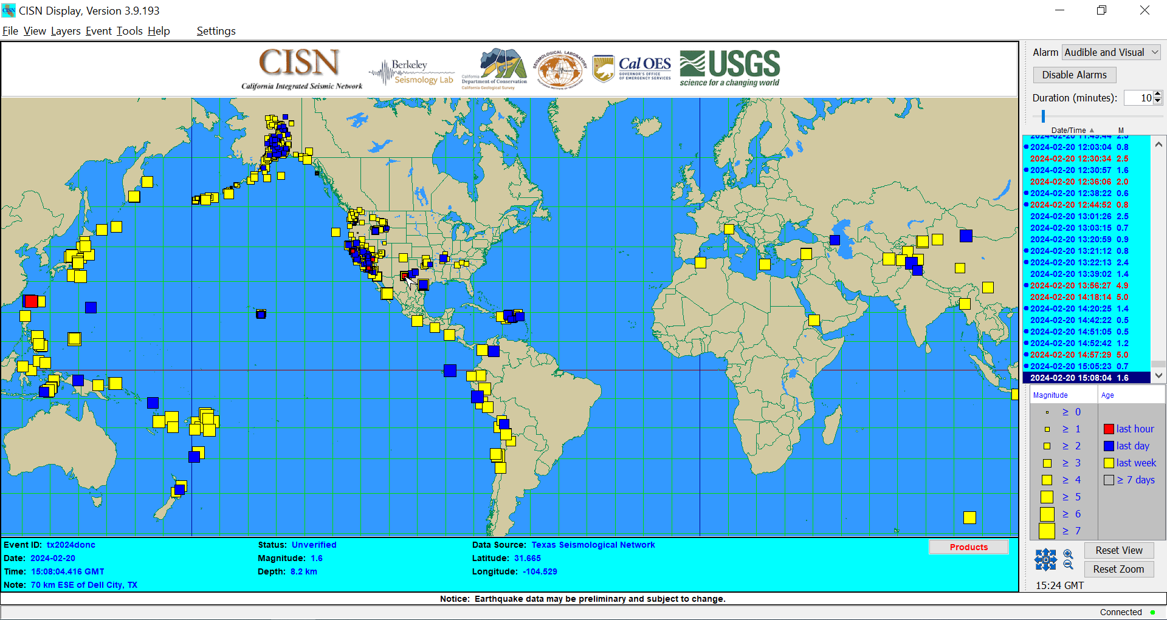
Figure. Screenshot of CISN Display

Email:
- With email, the text and graphical products are delivered via electronic message directly to its recipients.Agencies can communicate tsunami information, warnings, instructions and more amongst themselves through this system.
- This is the only way PTWC provides the detailed non-public graphical products to the respective TWFPs and NTWC.
- Also tsunami professionals and warning authorities can subscribe to public email lists and receive tsunami information updates like the following:
  - Tsunami bulletin board:
    - The TBB is an email list server hosted by ITIC that provides immediate sharing of tsunami information by and among tsunami professionals (scientists, researchers, emergency officials, and other officials). PTWC and US NTWC bulletins are immediately posted to TBB. It is not open to the media or the general public, and is not intended for advertising or activities of a commercial nature. (http://itic.ioc-unesco.org/index.php?option=com_content&view=article&id=1575&Itemid=2932).
  - IOC Public List Server:
    - This IOC email list server issues tsunami bulletins internationally by many different TSPs and NTWCs. For the Caribbean and adjacent regions, bulletins are provided by the CARIBE-EWS TSP PTWC and the US NTWC. To receive updates, one must subscribe to the mailing list (http://itic.ioc-unesco.org/index).
- This is the single most common way each participating country receives their tsunami threat messages and tsunami information statements during the CARIBE WAVE exercise. (Fig. #)
- Pros
  - System is easy, fast, and accessible to many communities.
  - One of the few ways the graphic products are disseminated, and the only way they are disseminated during the CARIBE WAVE exercise.
- Cons
  - It requires internet connection and an electronic device.
  - May not reach everybody.
Emergency Alert System (EAS)
- The EAS is a national public warning system used by state and local authorities to deliver important emergency information, including tsunami alerts, to affected communities over television and radio. State and local alerts are delivered on a voluntary basis, and Presidential alerts are required to be sent, which enable the President to address the public during a national emergency. Authorized authorities create the alerts, and the system itself is maintained by the Federal Emergency Management Agency (FEMA) and the Federal Communication Commission (FCC). FEMA is responsible for any national-level activation and tests of the Emergency Alert System.
- The majority of EAS alerts originate from the NWS through the National Weather Radio in response to severe weather events, but some alerts are sent by state, local, territorial, and tribal authorities through the FEMA’s Integrated Public Alert and Warning System.
- *Source: https://www.fcc.gov/consumers/guides/emergency-alert-system-eas
- Pros
  - The EAS is an effective way to reach a large audience.
  - Is able to send text, audio and visual messages.
  - Interrupts regular programming to announce emergencies.
- Cons
  - Prone to human error.
  - Short messages could leave out important information.
  - In some cases the regular programming are not interrupted and people do not receive the message.

Emergency broadcast radios:
- eg. NOAA Weather Radio - is a U.S. network of radio stations broadcasting continuous weather information directly from the nearest NWS office. NWR provides round-the-clock broadcasts of warnings, watches, forecast and other hazard information from the official Weather Service
- In conjunction with Federal, State, and Local Emergency Managers and other public officials, NWR also broadcasts warning and post-event information for all types of public safety, natural, and environmental hazards such as oil spills, amber alerts, and of course, tsunamis.
- The system is provided as a public service by the National Oceanic and Atmospheric Administration (NOAA), part of the Department of Commerce (DOC). NWR includes more than 1000 transmitters, covering all 50 states, adjacent coastal waters, Puerto Rico, the U.S. Virgin Islands, and the U.S. Pacific Territories. Broadcasts are found in the VHF public service band.
- *Source: https://www.weather.gov/nwr&ln_desc=NOAA+Weather+Radio/
- Pros
  - Is a quick and easy way to relay information.
  - Covers most of the U.S. Receives information related to your area.
- Cons
  - May malfunction.
  - Requires a special radio receiver or scanner capable of picking up the signal, and people need to buy the radio and set it up to be able to hear the broadcast.
  - Limited to the U.S. only.

Emergency Managers Weather Information Network (EMWIN):
- EMWIN is a system capable of receiving official NOAA alerts and bulletins by satellite or internet. It has a satellite antenna, a receiver, decoder and a program computers for alerts (http://prsnt.uprm.edu/spanish/tsunami/documentos/Guia%20para%20operadores-2022_FINAL.pdf). It is targeted at emergency managers and public safety officials who need timely weather information to make critical decisions. EMWIN disseminates the alerts, watches, warnings, observations, forecasts and climate products in text and image formats via satellite broadcast and the EMWIN FTP file server which is accessible on the public Internet (https://www.weather.gov/emwin/).
- This system allows for open public access without fee to weather forecasts, warnings, and other information directly from the NWS in almost real time. EMWIN has round-the-clock monitoring, and an estimated availability of at least 99% (https://www.weather.gov/EMWIN/about).
- Its use during the CARIBE WAVE exercise has been fluctuating over the past few years (Fig. #).
- Pros
  - It is free of charge.
  - Includes image format in some cases.
  - Sequences the most urgent products ahead of all lower priorities products.
- Cons
  - There is a slight delay compared to NWWS.
  - Users must have software available to ingest/visualize the data.
  - Both satellite broadcasts are limited in bandwidth, thus products available are limited or in lower resolution compared to GNC-A. Also it is not as simple as other communications methods.
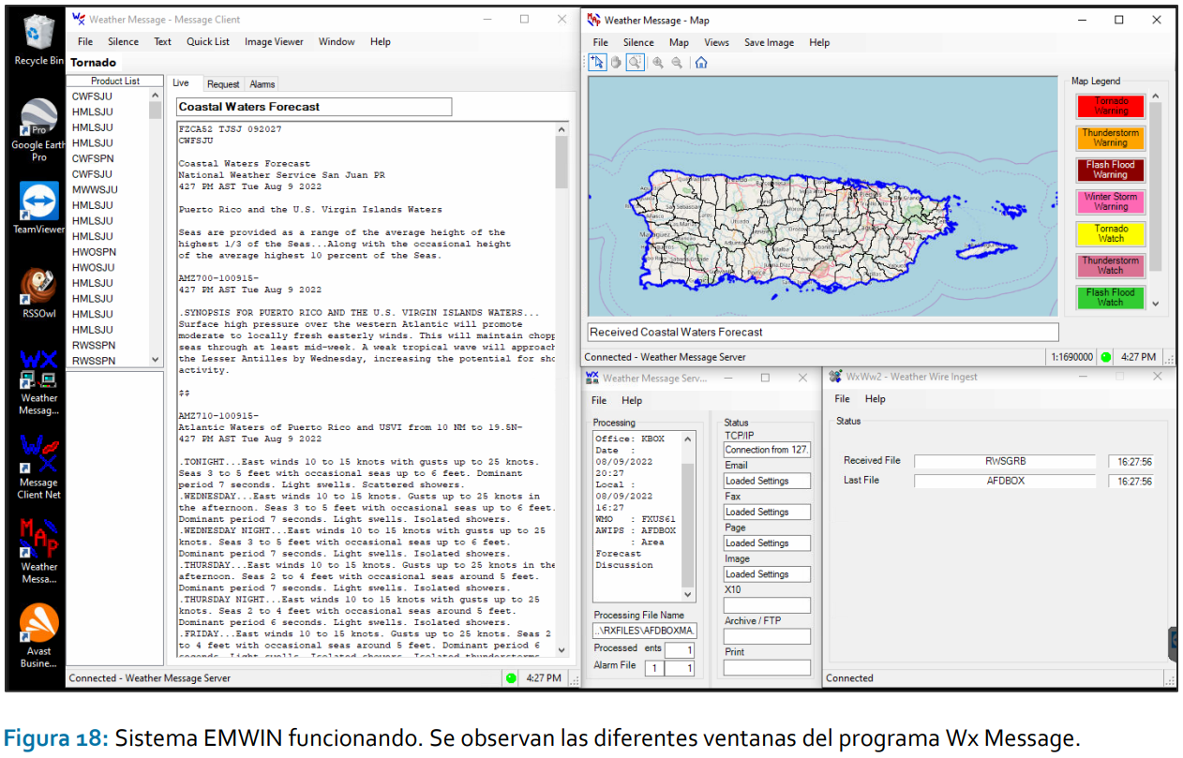
Figure. EMWIN system running. On display are the different windows for the Wx Message Program.

Fax:
- With fax, the text products are transmitted via landline from the TSPs to the TWFPs and NTWCs’ machine which is then printed out. There is also e-fax which sends the files using the internet. Agencies can communicate tsunami information, warnings, instructions and more amongst themselves through this system.
- During the CARIBE WAVE exercise, participating countries will receive a Tsunami Threat Message (ID: WECA41 PHEB) with consecutive updates.
- This is the second most used form of communication under email during the CARIBE WAVE exercise, competing with GTS/WIS (Fig. #).
- Given the complications with their delivery the ICG of the Pacific Tsunami Warning System (PTWS) has recommended phasing out the use of faxes by the TSPs.
- Pros
  - Regular fax does not necessarily require internet connection.
  - It is easy to use and understand.
  - May be more robust than internet in the event of local events
- Cons
  - Limited to text products only.
  - Size of the text is very small, hard to read
  - Requires access to the office where the machine is, needs paper, and there is a cost for telephone line.
  - E-fax is internet-dependent.
Fixed Sirens:
- Fixed sirens are high-powered public warning systems used to notify citizens about an emergency. The system is activated remotely from a console at the focal point that sends a radio signal to the system.
- These mass dissemination equipment are installed by the municipalities at different strategic points and its range depends on the power of the speakers, the wind, height, among other variables.
- They emit different sounds during different emergencies. There are protocols that establish the levels of alert in which it is activated, the tones to be used, and the monthly tests that are carried out. In the case of a tsunami warning, the tone will be a “Wail Whoop'' tone followed by a spoken message indicating the actions to follow.
- *Source: http://prsnt.uprm.edu/spanish/tsunami/documentos/Guia%20para%20operadores-2022_FINAL.pdf
- It is recommended to do an annual test, like for example, during the “CARIBE WAVE” tsunami exercise. For this test, the siren will be activated after receiving the tsunami warning message for the exercise.
- Pros
  - System reaches a wide radius of people.
  - Delivers quick short important messages.
  - Does not require cell service or internet connection.
- Cons
  - May malfunction or some people might not be able to hear it.
  - Isn’t helpful for people with disabilities.
  - Does not provide any details and may be misinterpreted.
  - The propagation of sound waves can be affected by tall buildings located near the siren, the direction and speed of the wind, as well as the topography of the area.
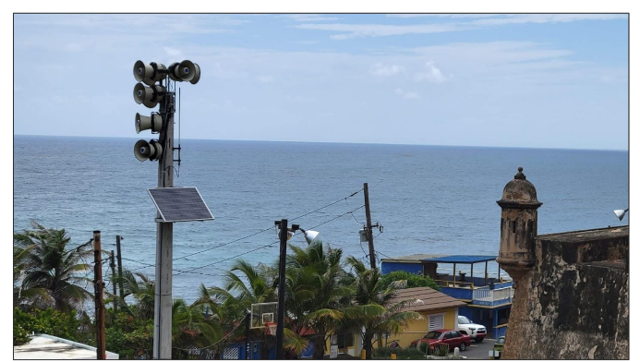
Figure. Example of coastal fixed siren installed at San Juan, Puerto Rico.

GEONETCast Americas (GNC-A):
- GEONETCast Americas is the Western Hemisphere component of GEONETCast, a near real time, global network of satellite-based data dissemination systems designed to distribute space-based, air-borne and in situ data, metadata and products to diverse communities.
- This is a user-driven, user-friendly and low-cost information dissemination service which provides global information. As a satellite-based, standalone system, it is a reliable method of communication in comparison to internet based systems whose connectivity and power source can be disrupted by natural disasters. Example: Hurricane disruption of civilian and law enforcement communications and power in Puerto Rico, and the northern Caribbean.
- Funded by NOAA, GNC-A is a service that uses the commercial Intelsat-21 satellite to broadcast US and foreign partner data and products. Users can work with GNC-A staff to request and create new products.
- In addition to RF antenna equipment, users must have FAZZT Kencast client software in order to ingest the broadcast (Requires a one-time licensing fee).
- Within the GNC-A broadcast, there are twelve International Services Communication Systems (ISCS) folders/channels for various product transmissions. Users will find all tsunami warnings, watches and advisories (WWA) within the folder labeled: “ISCS-WARN”. ISCS-WARN has the highest broadcast priority (All Tsunami WWA’s will arrive as text (TXT) files). GNC-A users must activate this channel to receive warnings within FAZZT configuration settings (https://docs.google.com/presentation/d/1O84ctgwbxy2gqtzs-KfiPIY5uBebSvaM/edit#slide=id.p12).
- Many of the 48 member states and countries are provided with GEONETCast but there is a lack of use reported during CARIBE WAVE (Fig. #).
- Pros:
  - It is user friendly, low maintenance, and distributes data to the entire hemisphere with warnings prioritized.
  - Beyond the cost of equipment, there is no fee for receiving data.
  - Provides text products, graphics, and satellite imagery.
  - C-Band satellite broadcast not affected by weather and space environmental anomalies (vs. L-Band, other government and commercial dissemination systems).
  - High data rate compared to HRIT/EMWIN
  - It is a reliable, standalone means of communicating environmental data during natural disasters, and can be powered by an emergency generator.
- Cons:
  - Users must have FAZZT Kencast client software to access.
  - There is the cost of equipment.
  - Very large satellite dish and positioning challenges
  - It is not as simple as other methods.
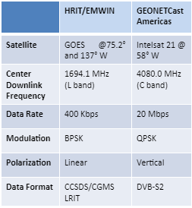

Loudspeakers:
- Audio systems or loudspeakers are often used to emit pre-recorded messages or voice announcements, sometimes accompanying an alarm or siren.
- These signals alert and inform the public and, when necessary, encourage them to evacuate. These are often paired with sirens.
- Source: https://www.slat.com/en/applications/fire-protection/sound-systems-emergency-purposes
- Pros
  - Does not require internet connection or cell service.
  - Can be fixed in place or mobile.
- Cons
  - Has a limited reach.

Megaphones:
- Local authorities or even town criers in the community may use megaphones as a way to alert the public in remote communities about an imminent tsunami.
- Pros
  - Reaches the people who may not have access to the internet, television and other methods.
  - Does not require cell service or mobile devices.
  - Allows the community to take charge during emergencies.
- Cons
  - Has very limited range and may not reach many people.
  - Limited information can be announced.
Mobile sirens / Soundtrucks:
- Mobile sirens are equipment which emit a sound to alert the public, typically mounted on different emergency vehicles like police patrols or fire trucks.
- In the event of a potential tsunami, these vehicles may enter areas at risk, alerting people about the danger and possibly evacuation to higher ground. However, in the case of a tsunami ‘warning’, it is not recommended for emergency vehicles to enter the hazard zone and should instead assist from outside.
- *Source: http://prsnt.uprm.edu/spanish/tsunami/documentos/Guia%20para%20operadores-2022_FINAL.pdf
- Pros
  - System can reach remote communities.
  - Does not require internet connection or cell service.
- Cons
  - It is a slower process, and more man-power required.
  - Might not reach everybody in the danger zone during a tsunami warning.
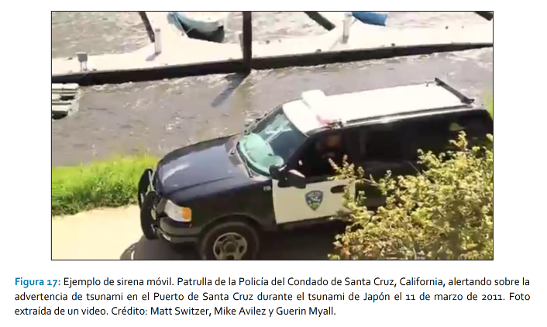
Figure. Example of a mobile siren of a police car from Condado de Santa Cruz, California alerting on a tsunami advisory (March 11,2011) Foto extracted from a video. Credit: Matt Switzer, Mke Avilez, and Gerin Myall.

National Warning System (NAWAS):
- NAWAS is a round-the-clock private line telephone system operated by FEMA used to convey warnings to federal, state, local, tribal, and territorial government and public safety officials. (https://www.nws.noaa.gov/directives/sym/pd01017010curr.pdf ).
- Among other hazards, NAWAS provides notifications to emergency management in the event of natural disasters like earthquakes and tsunamis. For these cases, agencies like the NWS has direct access to NAWAS to provide short and long-range weather forecasts, severe weather warnings and watches from any of approximately 125 Regional Offices throughout the U.S. and its territories.
- https://www.hsdl.org/?view&did=843365#:~:text=NAWAS%20was%20created%20to%20rapidly,Alternate%20Operations%20Center%20(FAOC)
- Pros
  - Can be used for simultaneous messaging to different locations.
- Cons
  - It is a voice only network.

NOAA Weather Wire Service (NWWS):
- The NWWS is an emergency alert and warning distribution system that uses both satellite and the Internet to provide the fastest and highest reliability product stream. Its purpose is to provide the public, commercial users, and local, State and Federal agencies timely delivery of meteorological, hydrologic, climatological and geophysical information. The products originate in WMO standard format from NWS Weather Forecast Offices, River Forecast Centers, and National Centers using AWIPS (https://www.weather.gov/media/nwws/NWWS%20Poster%201801271.pdf ).
- It is a combined Internet (Open Interface [NWWS-OI]) and satellite (SBN/NOAAPORT Channel 201) dissemination platform for critical weather information, alerts and warnings to the public in text format. NWWS-OI requires an XMPP reader or commercial software to access the message text. Information on configurations and software requirements is available on the NWWS webpage. It is also one method used by television and radio broadcasters to activate the local Emergency Alert System (EAS).
- Source: https://www.weather.gov/nwws/Description
- NWWS is the primary telecommunications network for NWS forecasts, warnings and other products to the mass media (newspapers, radio stations, TV, etc.) and emergency management agencies.
- The system is operated by GTE Corp., under contract to the NWS. The system uses satellite transmitting (i.e. "uplink") equipment at more than 58 major NWS forecast offices throughout the continental U.S., Alaska, Hawaii and Puerto Rico.
- Source: https://www.noaa.gov/jetstream/appendix/weather-glossary-n
- Minimal use during CARIBE WAVE exercise (mentioned in survey but not included in the Fig. #).
- Pros
  - It is an extremely fast, efficient, and robust system.
- Cons
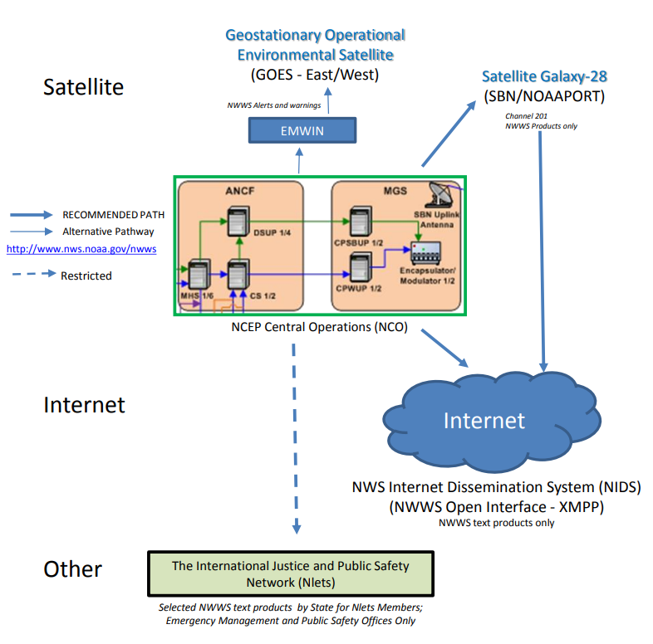
  - It is limited to text products only. Only distributed in the U.S. The NWWS Open Interface requires an NWS issued User_ID and password.

Figure. NOAA Weather Wire Service (NWWS) Providing Weather Information, Alerts, and Warnings to the United States
https://www.weather.gov/media/nwws/NWWS%20Poster%201801271.pdf

Phone call/tree:
- A call tree is an important tool of communications plans used to disseminate information to in-country emergency personnel during a disaster event like an earthquake or tsunami and coordinate recovery if necessary. The calls are distributed to all involved parties and stored in a location where it can be viewed or accessed by them. These messages delivered can be automated or manual.
- *Source: https://www.techtarget.com/searchdisasterrecovery/definition/Call-tree#:~:text=A%20call%20tree%20is%20a,role%20in%20disaster%20recovery%20plans.
- According to the Puerto Rico Seismic Network (PRSN), the information is relayed through different levels where each person will call up to a maximum of three contacts who in turn will call others three and so on. If unable to reach the first level person, the next person on the contact list is called and so on, always prioritizing the people who will respond during the emergency and then the rest of the staff.
- *Source: http://prsnt.uprm.edu/spanish/tsunami/documentos/Guia%20para%20operadores-2022_FINAL.pdf
- Pros
  - May include both an automated notification system and a traditional landline tree in case internet or cellular service is disrupted.
  - It is simple, concise, and easy-to-read.
  - Automated calls are immediate and efficient, and manual calls provide human interaction, and flexibility of the message.
- Cons
  - Manual calls are slower and are prone to inaccuracy due to its word-of-mouth nature.
  - Automated calls provide no space for human interaction or can be very limited/rigid in the information it provides.
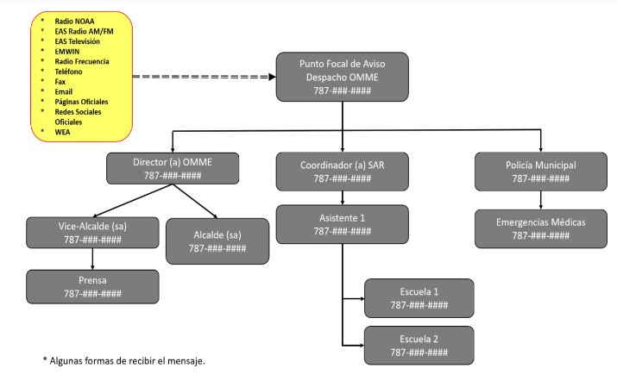
Figure. Example of a phone call tree at a local level.

RANET Alert Watcher (RAW):
- RANET is an international collaboration supported by National Hydro-Meteorological Services, related national entities, and development NGOs. RAW is an application developed by RANET with the purpose of disseminating information or alerts to national emergency managers and designated authorities, and is not open to the public. It broadcasts short SMS messages to mobile phones, informing the recipient that an official message has been issued by the PTWC.
- RAW receives messages from the PTWC on two servers, and it continually monitors the PTWC website and communication gateway for outgoing messages. This service is an entirely automated system that relies on a mobile hub to SMS gateway architecture to send messages.
- These messages do not replace other communication methods. They can serve as a quick early notification, making it an inexpensive solution which compliments a larger alert and notification system for events like earthquakes and tsunamis.
- Messages generally contain:
  - RANET (listed as title / subject to identify sender)
  - PTWC (listed as first portion of message to identify source)
  - <message type> (such as watch, bulletin, cancellation, etc.)
  - <org. date/time> (date / time of event)
  - <issue date/time> (date / time PTWC released message)
  - <lat. / long>
  - <country / geographic location>
- Source: https://oceanexpert.org/downloadFile/3771
- Source: https://oceanexpert.org/downloadFile/32426&version=1.0&lang=1&format=1
- Pros
  - The service is free to use and a good addition to agencies’ communications infrastructure, especially for those with technology shortcomings and limited access to the GTS.
  - If there are no local service providers in the region that support the carrier, RANET will provide equipment to the host.
- Cons
  - RAW cannot disseminate to the mass public due to inherent limitations of mobile networks.
  - Participants need to be in regions covered by PTWC.
  - It requires a mobile phone, phone coverage, and the service plan must support SMS.
  - In the cases that RANET needs to provide equipment, there will be some cost (generally less than $50).
  - There are no guarantees on performance.

Really Simple Syndication (RSS):
- RSS, also known as “Rich Site Summary”, is a family of web formats used to publish frequently updated digital content. Most commonly used to update news articles and other content, including audio or video files. Users of RSS content use programs called feed 'readers' or 'aggregators'. The user 'subscribes' to a feed by entering the link of the RSS feed into their RSS feed reader, which then checks the subscribed feeds to see if any have new content since the last time it checked, and if so, retrieves the new content and presents it to the user.
- Source: https://www.weather.gov/rss#:~:text=NOAA's%20NWS%20RSS%20Library,even%20video%20files%20(VodCasts).
- This system also allows users and applications to access updates to websites in a standardized, computer-readable format (XML). RSS feeds can be used to stay informed about online content that changes or is updated often, such as news articles during any kind of emergency.
- Source: https://www.noaa.gov/rss-feeds
- Pros
  - It's a convenient format that allows you to view all the new content from multiple sources in one location on your desktop or mobile device.
- Cons
  - Requires an electronic device and internet connection.
  - People need to configure the RSS in their computer to be able to use the system.

Slack:
- Slack is a messaging app created by Slack Technologies and currently owned by Salesforce used mainly for business purposes that helps with the exchange of information. It is a cloud-based cross-platform team communication tool with some features limited to premium accounts that can be used for collaboration within different organizations or agencies. It allows for the exchange of text, image, audio, and video files to large groups or individuals.
- Pros
  - It is better organized than similar platforms.
  - Great way to communicate in large groups and also has direct messaging.
  - Is not limited to text and images.
  - It is quick, efficient, flexible, and is free to use.
- Cons
  - Free account users do not have access to all the features.
  - It requires internet connection and an electronic device.
  - Even though it is fairly organized, messages could still get lost.
  - There is a file size limit on documents and media.
SMS:
- An emergency text alert system is a tool which allows schools, businesses, and especially governments to send mass SMS messages to a large audience simultaneously, similar to Amber Alerts. It has a nearly 100% open rate within the first 3 minutes and helps the public prepare for different emergencies.
- In the case of natural disasters, the government has implemented SMS alerts to prepare communities. These notifications cause cell phones to buzz with a chime sent by the NOAA to signal incoming storms, earthquakes and tsunamis.
- *Source: https://www.eztexting.com/resources/sms-resources/text-message-alerts-save-lives
- Pros
  - The reach of mobile devices is growing exponentially, which allows for efficient mass communication.
  - Allows for mass communication with nearly 100% open rate within the first three minutes.
- Cons
  - Requires mobile device and cell phone service.
  - Short messages lose important details.
  - May be overlooked by many or people may think it is a scam.

Social Media:
- Social media is one of the primary means used to disseminate tsunami information to the public. The use of the CARIBEWAVE hashtag is encouraged prior and during the exercise. It serves the purpose of targeting a larger audience and engaging more people (Soto et al, 2022). A general advantage for these platforms is that they could be adapted for people with disabilities by having features such as captioning, text-to-speech, audio descriptions, and more.
- It is mainly used to report on the event, spread awareness, and rather than disseminating products to the TWFPs and NTWC (Minimal use for products along with AISR during CARIBE WAVE (Fig. #)).
- Examples of social media platforms include the following:
  - Facebook - It is a free social networking site where users can make public posts containing text, videos, photos or links. Although its primary use is for entertainment, many people also get their news on this platform and would likely benefit from tsunami alerts here.
    - Pros - It is a quick way to get a message to a large audience, and is effort/maintenance. Can gather information from all around the world. Provides simple and concise communication free of cost.
    - Cons - Requires internet connection and electronic device. It will likely not be available during a disaster. Is susceptible to misinformation. Platform is centered around entertainment rather than news so warnings could get lost. Does not always reach the target audience. Has limited details in the short message. An account required. May take time to filter through the population.
  - Instagram - It is an American social networking service owned by Meta Platforms used to share photos and videos. It allows users to share short text, upload different media, organize with the use of hashtags, and be associated with a location via geographical tagging. It is not mainly used for news purposes, but still may get important information out to a large audience.
    - Pros - The platform is a quick way to get a message to a large audience and is low effort/maintenance. Can gather information from all around the world. Is simple, concise, and free to use.
    - Cons - Requires internet connection and electronic device. It will likely not be available during a disaster. Is highly susceptible to misinformation, and is centered around entertainment rather than news so warnings could get lost. Does not always reach the target audience. Details can be lost in the short message. Content shown to people depends on each individual 's algorithm which could work in favor or against citizens of coastal communities. Account required to access. May take time to filter through the population.
  - TikTok - It is an app that allows users to create and share short videos on many different topics. Its main purpose is for entertainment, but there has been a growth in use for transmitting important information such as the effects of natural disasters around the world.
    - Pros - The platform could reach a large audience and is free to use. Short videos capture people's attention. It is more dynamic and personal than text or images alone.
    - Cons - Not a very fast or efficient way to distribute an urgent message. Requires internet connection and mobile device. Content that people view depends on each individual’s algorithm which could work in favor or against citizens of coastal communities. Unorganized. Messages could get lost.
  - X - It is a free social networking site where users broadcast short posts known as tweets containing text, videos, photos and/or links while also having an instant messaging feature. It is used to communicate between acquaintances as well as to stay updated on current events including tsunami information and alerts.
    - Pros - It is a quick way to get a message to a large audience and is free to use. Low effort/maintenance. Can gather information from all around the world. Simple and concise communication.
    - Cons - Requires internet connection and electronic device. It will likely not be available during a disaster. Is highly susceptible to misinformation. Centered around entertainment rather than news so warnings could get lost. Does not always reach the target audience. Details can be lost in the short message. An account is required.

Telegram:
- Telegram is a cloud-based, cross platform instant messaging application. It allows users to exchange text messages, audio and video files, make payments, and make audio or calls, as well as public livestreams.
- Pros
  - It is a great way to distribute private messages with one person, or large groups.
  - Quick, simple, and free to use. Can access from more than one device.
  - Is not limited to text and images like other platforms, and there is no size limit on documents and media.
- Cons
  - Requires internet connection and mobile device. Is unorganized and messages could get lost.

Television:
- Television is a way for local news stations in each country to inform the public regarding any Tsunami Information Statement and/or Tsunami Threat message, along with instructions on how to proceed.
- Pros
  - Reaches a wide audience providing extensive information in a digestible and understandable manner while also providing instructions.
  - Can be adapted for people with disabilities (e.g. sign language interpreters, captions).
- Cons
  - Prone to misinformation or miscommunication.
  - Many, particularly younger generations prefer to get their news elsewhere.
  - Requires a television so it may not be available in lower income households.

Tsunami Flags:
- Tsunami flags feature a red and white checkered pattern, with a short side of 100 cm or more recommended for visibility. The flags have a design similar to that of the U-flag used internationally as a marine warning. (E.g. Japan)
- Source: https://www.data.jma.go.jp/eqev/data/en/tsunami/tsunami_flag.html.
- Pros
  - They are visible from afar, and relay a specific message.
  - Does not require any technology, cell service, or internet connection.
  - Ideal for people with hearing disabilities.
- Cons
  - Not everyone knows what they mean, and can be misinterpreted.
  - Does not provide important detailed information.

Websites:
- Many agencies create their own websites where they can upload a variety of content which may include tsunami warning information, bulletins, text and graphical products, shakemaps, seismographs and more. It is a great resource for the public and other agencies.
- Examples of websites used by PTWC, CATAC, and other agencies for earthquake and tsunami information include:
    - Tsunami.gov for PTWC products
    - Catac.ineter.gob.ni for CATAC products
    - Ioc-sealevelmonitoring.org
    - Earthquake.usgs.gov
    - Redsismica.uprm.edu
- Pros
  - An efficient website would be easy to maneuver, include different kinds of resources, be free to use, and more.
  - Can be adapted for people with disabilities by having features such as captioning, text-to-speech, audio descriptions, and more.
- Cons
  - Requires internet connection and an electronic device.
  - The quality of a website varies and depends entirely on each agency's design.
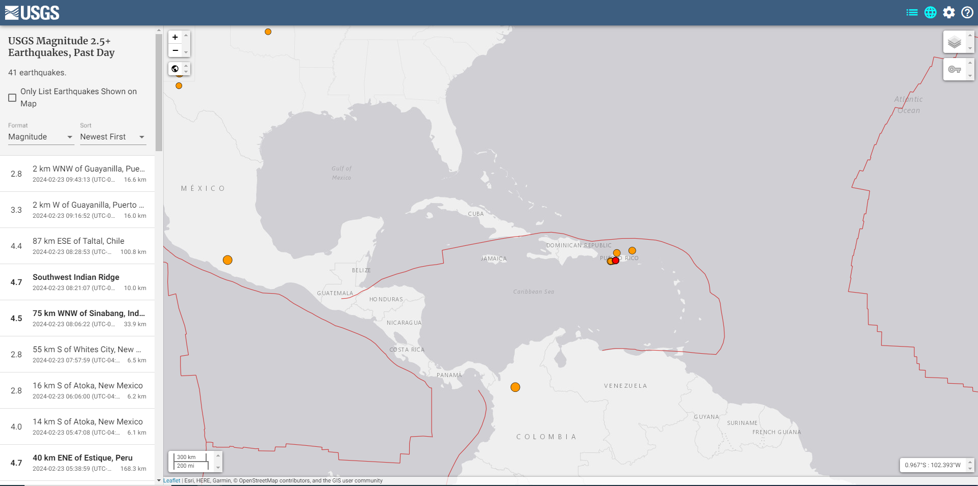
Figure. Homepage of the USGS website on earthquake information Earthquake.usgs.gov
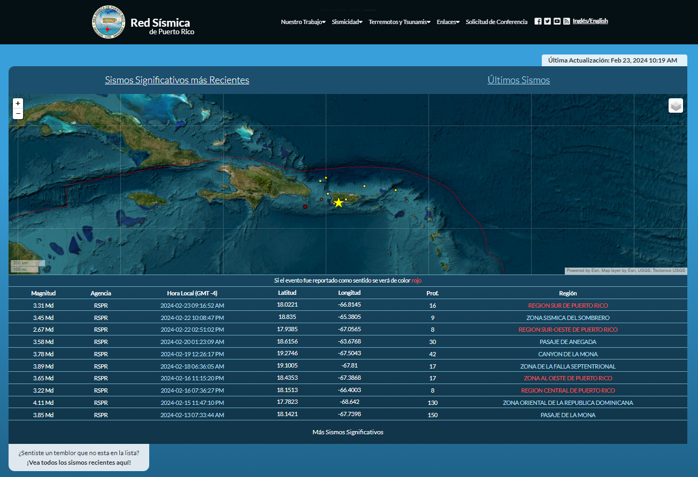
Figure. Homepage of the PRSN website Redsismica.uprm.edu

Whatsapp:
- Whatsapp is an instant messaging service under the US technology company known as Meta Platforms where users can send text, audio, video, documents, make calls, and more. It is a quick way to spread information within organizations urgently, including in the event of an emergency like a tsunami.
- Pros
  - It is a quick and efficient way to distribute private messages with one person, or with large groups.
  - It is free to use.
  - Has encrypted messages, and is not limited to text and images like other platforms.
- Cons
  - Requires internet connection and a mobile device. Is unorganized and messages could get lost. There is a size limit on files and media.

World Meteorological Organization Information System (WMO/WIS):
- WIS is a global infrastructure responsible for telecommunications and data management. It allows for an integrated approach to make routine collection of data and products, automated dissemination, data discovery, access and retrieval for all weather, climate, water and related data, produced by member states/countries and organizations (https://www.eumetsat.int/wmo-information-system).
- Two major components of WMO/WIS are the Global Information System Centres (GISC) email/FTP, and the Global Telecommunications System (GTS).
- GISCs distribute information to and from its associated WIS centers and the global WMO community. Each WIS center has a principal GISC as its entry point for receiving and distributing data by telecommunication systems like GTS. (https://community.wmo.int/en/activity-areas/wis/GISCs).
- GTS is the coordinated global system of surface and satellite-based telecommunication facilities which collect and distribute information within the World Weather Watch. This network enables real-time exchange of information, critical for forecasting and warning of hydrometeorological hazards.
- (https://community.wmo.int/en/activity-areas/global-telecommunication-system-gts).
- They facilitate the flow of data and products to the TWFPs and NTWC, ensuring that all authorized members have access to them.
- If you have direct access to GTS You will receive a Tsunami Threat Message (ID: WECA41 PHEB) or a Tsunami Information Statement (ID: WECA43 PHEB) through your GTS link. If do not have access to GTS, you can subscribe to tsunami warnings through a GISC, and you will receive the same message on your registered FTP, SFTP server or via email
- (https://www.weather.gov/media/itic-car/Users%20guide%202017.pdf).
- This system has been increasing in use for the CARIBE WAVE exercise in recent years (Fig. #).
- Pros
  - It is user-friendly, fast, and cost-effective.
  - It also provides round-the-clock reliable and near-real-time collection and distribution of all meteorological and related data, forecasts and alerts.
- Cons
  - To receive messages via GTS, you need direct access.
  - To receive messages via GISC, a subscription is required and one has to be registered as an authoritative source to be able to put in information.
  - Both GTS and GISC only provide text products.

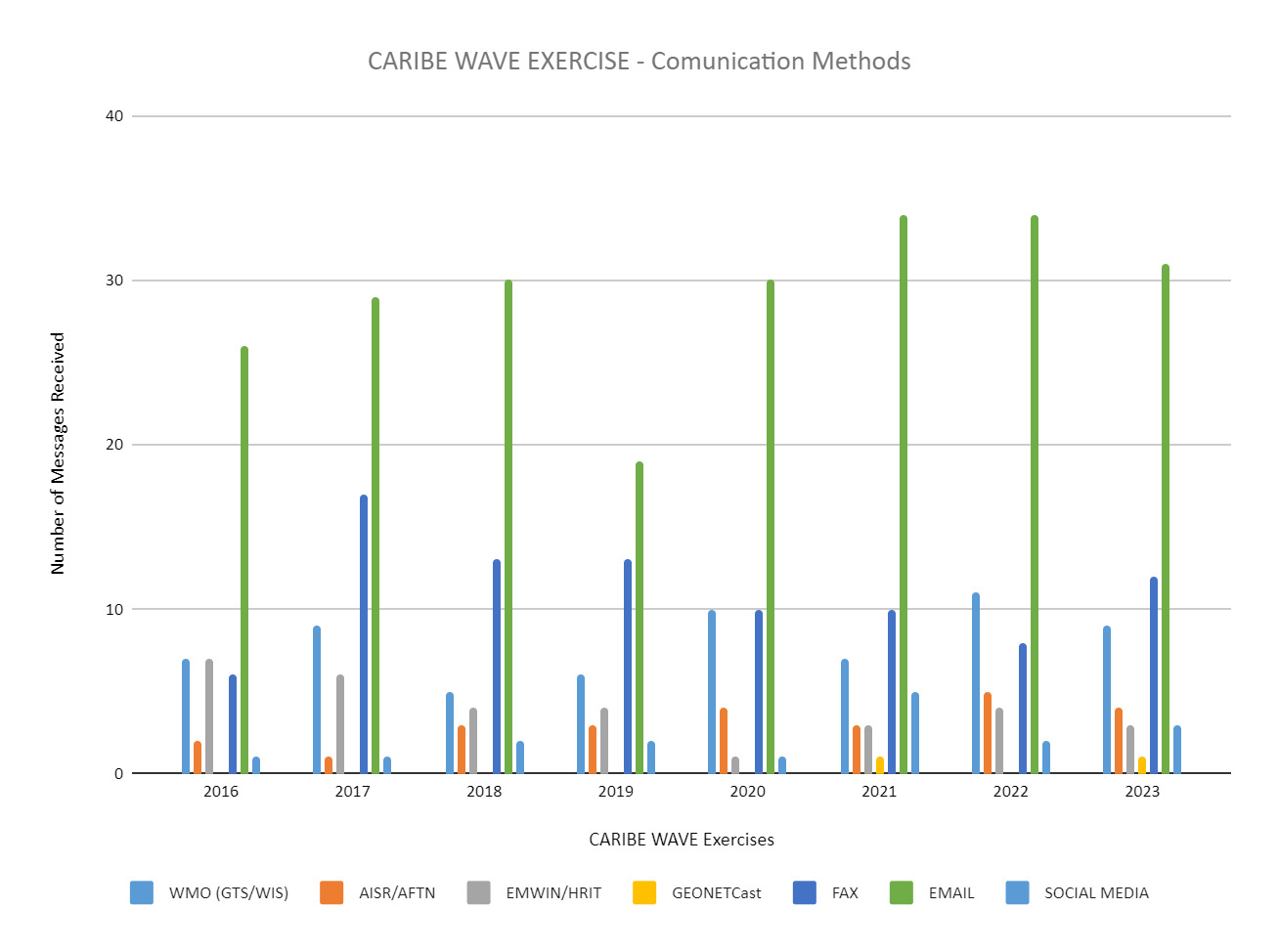

 | 2016 | 2017 | 2018 | 2019 | 2020 | 2021 | 2022 | 2023
WMO (GTS/WIS) | 7 | 9 | 5 | 6 | 10 | 7 | 11 | 9
AISR/AFTN | 2 | 1 | 3 | 3 | 4 | 3 | 5 | 4
EMWIN/HRIT | 7 | 6 | 4 | 4 | 1 | 3 | 4 | 3
GEONETCast | 0 | 0 | 0 | 0 | 0 | 1 | 0 | 1
FAX | 6 | 17 | 13 | 13 | 10 | 10 | 8 | 12
EMAIL | 26 | 29 | 30 | 19 | 30 | 34 | 34 | 31
SOCIAL MEDIA | 1 | 1 | 2 | 2 | 1 | 5 | 2 | 3
https://docs.google.com/spreadsheets/d/1z7AT5OhP1KTpn02PBhXwrpc4iVnXaNj3/edit#gid=2028923156

Regional Dissemination
Method | PTWC Dissemination | Individual countries  Message reception  (Based on CARIBE WAVE)
AISR/AFTN | PTWC provides english text products using this system TWFPs and NTWC. | Minimal use along with social media.
Email | This is the only way PTWC provides the detailed non-public graphical products to the TWFPs and NTWC. There are also subscriber-based bulletins that are open to a broad audience (e.g. Tsunami bulletin board, IOC Public List Server). | The single most common way each participating country receives their tsunami threat messages and tsunami information statements.
EMWIN | PTWC provides only the english text products using this system TWFPs and NTWC. | Its use has been fluctuating over the past few years.
Fax | PTWC has been providing the english text products using this system TWFPs and NTWC. However, they have proposed to phase out of this system. | Has been the second most used form of communication under email, competing with GTS/WIS. However, its continued use within countries may vary now with PTWC’s phasing out.
GeonetCast | PTWC provides english text products using this systemTWFPs and NTWC. | Some of the 48 member states and countries are provided with GEONETCast but there is a lack of use reported.
WMO/WIS | PTWC provides only the english text products using this systemTWFPs and NTWC. | There has been an increase in use reported.
NWWS | PTWC provides only the english text products using this system TWFPs and NTWC. | Minimal use has been reported.
Social Media | PTWC uses Facebook as an unofficial means of disseminating public tsunami information. In the past, messages were automatically posted to X. They will post manually as time and resources permit. | Minimal use specifically for dissemination along with AISR. It is mainly used to report on the event rather than disseminating products.
Websites | PTWC disseminates public bulletins on Tsunami.gov | Member states and territories have access to tsunami information on the CATAC and PTWC websites.

Table 1. Method used by the PTWC for regional dissemination of tsunami products and used by the national authorities to receive the PTWC products. The green color signifies methods that are commonly used, yellow is for the methods with minimal use reported, and red means the method is not used at all.

Besides communicating with the respective TWFPs and NTWC, TSPs can also disseminate tsunami information statements and alerts to the general public through various channels and platforms. To reach as large of an audience as possible, TSPs may use some of the following methods for dissemination to the public depending on their area of responsibility.

- The PTWC, for example, issues public bulletins via:
  - Social media - X and their Facebook page.
  - Websites: Tsunami.gov
  - Syndication - The warning centers have Atom feeds available.
  - CAP - The warning centers generate Common Alerting Protocol (CAP) documents for events.
  - Television - Bulletins are also made available to the news media.
  - Many of these options are available on the NOAA NWS U.S. Tsunami Warning System Message Subscriptions page.

- CATAC also distributes public tsunami products on their website catac.ineter.gob.ni and through telegram.

Sub-regional Dissemination:

Would receive the pro | CATAC Dissemination | Individual countries  Message reception  (Based on CARIBE WAVE)
Email | CATAC distributes Spanish text and graphical products to the Central American member states/countries using this system. | The single most common way institutions and designated persons (NTWC, TWFP) in the participating country receives their tsunami threat messages and tsunami information statements.
WMO/WIS | CATAC does not currently use this as an outlet for tsunami information and products but may do so in the future.
Websites | CATAC provides the graphical products (eq locations, seismic waveforms, tsunami parameters and maps, shakemaps, etc.) on their website: http://catac.ineter.gob.ni | Relevant institutions and designated persons (NTWC, TWFP) in the member states and territories have access to tsunami information on the CATAC websites.
Whatsapp | CATAC provides the graphical products to the Central American member states/countries using this system. | CATAC provides the graphical products to the Central American member states/countries using this system.
Application for Android and IPhone | CATAC is developing an application to send its product directly to the cellphones of its clients. This app is based on the software which was developed and widely tested by the project ATTAC on Earthquake Early Warning in Central America (with ETHZ/Switzerland). | TWFP and NTWC would receive the CATAC products within seconds on their phones/tablets. The system is able to inform CATAC who of the customers has received the message.
Table 1. Method used by CATAC to disseminate tsunami products in Central America and used by the national authorities to receive the CATAC products. The green color signifies methods that are commonly used, and red means the method is not used at all.

Besides communicating with the respective TWFPs and NTWC, TSPs can also disseminate tsunami information statements and alerts to the general public through various channels and platforms. To reach as large of an audience as possible, TSPs may use some of the following methods for dissemination to the public depending on their area of responsibility.

- CATAC also distributes public tsunami products on their website catac.ineter.gob.ni and through telegram.

CDEMA (uses twitter, facebook, instagram, linkedin; posts news, situation reports, and more on https://www.cdema.org/) - Need to verify
CEPREDENAC Website (in process with CATAC), uses instagram, twitter, linkedin, tiktok, and youtube; possible website)
EMIZA - (maybe website, need to confirm)
Between tsunami professionals in the region
Between Emergency Managers in different countries

National Dissemination:

It is the responsibility of each member state and country to issue and disseminate the corresponding alerts to the relevant in-country agencies and to the general public. They may use information received from the TSPs and other relevant bodies to decide to issue an alert. National alerts are different for each country following their standard operating procedures and protocols. They will decide how to disseminate the information based on the threat level, available resources, time, objectives, etc.
The national TWFPs and NTWC will communicate with each other, the emergency managers, and public authorities. Local governments will then take into their own hands how to proceed with alerting their own constituencies, communicating with the corresponding officials including police, fire department, and paramedics depending on the need for the situation. Privately owned businesses, agencies, and organizations may also work to further work to boost the message in a cascading process of warning, dissemination, and communication. Once the general public is made aware, they will immediately start communicating amongst themselves. Local committees, churches, leaders, and individuals within different communities may take charge during an emergency and continue spreading the information with the resources available to them.
In general, options for communications systems used to disseminate information within a country include some of the following:

- Phone call/tree
- Commercial Radio
- Television (TV)
- Digital TV with Early Warning Broadcasting
- Websites
- Email
- WEAs
- Amateur radio operators
- Mobile sirens
- Emergency broadcast radios
- Megaphones,
- Flags
- Whatsapp
- Slack
- Telegram
- Facebook
- X
- Instagram
- Tiktok
- EAS
- Fixed Sirens
- SMS
- Loudspeaker
- Phone apps
- Church Bells

As part of the CARIBE WAVE annual exercise, these methods may be tested and evaluated by each of the countries.
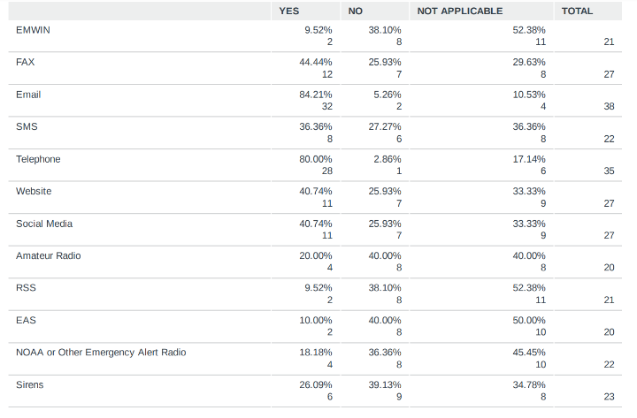
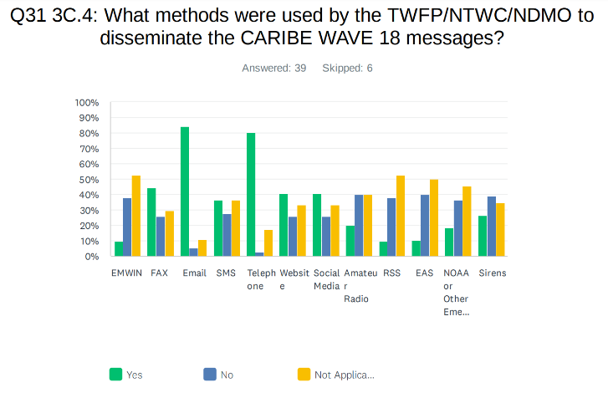

*results for 2018 post evaluation survey, question was not included in surveys 2019-2023 but will be added to the 2024 evaluation and onward.

Despite the significant advances in tsunami detection and analysis and earthquake early warning and communication outages in large local events, because of the rapid onset nature of tsunamis, in some situations, there may not be enough time for national and local authorities to issue tsunami warnings and evacuation orders. In these cases, it is very important that people are aware of the natural tsunami warning signs (feel, see, hear). In the case of Tsunami Earthquakes, which do not generate big seismic shaking but cause large tsunamis (as in 1992 in Nicaragua and 2012 in El Salvador and Nicaragua), the ground shaking may not be enough to be interpreted as a sign of a potential tsunami. In some countries (as Nicaragua, El Salvador, Costa Rica and Guatemala), there are already Earthquake Early Warning Systems in place (Wilfried Strauch, 2024, pers.com.). These systems may be extended to also issue tsunami warnings. CATAC as a TSP is experimenting with the possibility to provide EEW and immediate tsunami advice for the NTWC and TWFPs countries of Central America.

WARNING DISSEMINATION AND COMMUNICATION FOR PEOPLE WITH DISABILITIES:

People with disabilities often find themselves disproportionately affected by natural disasters, including tsunamis. Studies have shown that in some cases, vulnerable populations have lacked the capacity to access risk information and effectively prepare for threats they have faced (UNDP, 2020). This is due in part to the communication barriers, which hinder meaningful participation and inclusion of people with disabilities and their representative organizations in disaster risk reduction (UNDRR, 2023). However, there does not seem to be a real drive to provide tailored messaging that targets at-risk populations.
It is evident that most countries still need more accessible disaster risk information and assessments that are available locally and nationally to the people (UNISDR, 2013). This could be achieved through alternative means of communication and accessible formats. Some alternatives include the use of sign language, flashing lights for warnings, interpreters for televised messages and print documents available in large font and Braille, as well as providing devices that support voice-to-text and text-to-voice translations (UNDRR, 2023). Other options could also be the use of flags for people with hearing impairments, and accessible evacuation routes for people with walking impairments. “The goal of fighting inequality in disasters is not to see everyone impacted equally, but to ensure that no one is impacted at all. This starts by addressing the root causes of vulnerability” (Mizutori, M., 2023).
Countries have been implementing projects so that communicating tsunami warnings and information can be more accessible, engaging those with disabilities themselves so that they may have a voice in these matters. In particular, the United Nations Development Programme has been developing projects with the purpose of creating a ‘Resilient Future for All’ (UNDP, 2023). Some of these projects that have been proposed include the following:
- Implementation of communication tools and sensory aids, which aim to enhance mobility, communication and independence of people with disabilities before, during and after disasters.
- Digital solutions such as websites, mobile applications, and social media platforms with accessible features like captioning, audio descriptions and alternative text which are adopted to ensure critical information reaches individuals with diverse disabilities.
- Development of technology-enabled remote monitoring and alert systems, such as wearable devices (e.g. bracelets), incorporating both text and voice communication channels. These systems can provide timely warnings, assistance, and enhance inclusion in disaster response and recovery efforts.
- The use of sub-applications like “Difarisk’s” which offer text-to-speech technology, enabling individuals with hearing difficulties to access disaster risk and service information.

Volcano Generated Tsunamis

Most tsunamis in the Caribbean have been generated by earthquakes, but volcano-generated tsunamis have occurred and are possible (Soto et al, 2022). Currently, there is no protocol for how a volcano-generated tsunami message would be issued or an instrumental network that automatically provides the real-time onset and location of volcanic eruptions without human supervision. Therefore, it is important to develop a new communication system that focuses on the tsunami hazard that stems from potential volcanic eruptions.
Such systems may benefit from alert levels similar to those like VAL (Volcano Alert Levels) and VONA (Volcano Observatory Notice for Aviation), to communicate the state of risk due to an eruption. VAL includes a four-level and color scale associated with the state of the volcano quickly and is often used to communicate basic information on the unrest or ongoing eruption (Papale, 2017). They are an effective means of communicating short forecasts.
Inspired by these communication methods, there has been discussion about a potential Volcano Tsunami Alert Notification (VOTAN) system which would be made available to IOC TWFPs, NTWCs, and TSPs in regions at risk of being impacted by a tsunami (UNESCO/IOC, 2023c). This would potentially indicate as follows:
  - YELLOW - Significant unusual and/or increasing volcanic activity.
  - ORANGE - Larger increasing activity which could presage a volcanic eruption.
  - RED - Ongoing volcanic eruption with a description of the eruption including whether flank instability or a large plume is occurring.
  - GREEN - Volcanic eruption cessation.
For the development of communication plans for volcano-generated tsunamis, agencies can also reference how Volcano Ash Advisories are issued. The EUR AMHS Manual (AFSG, 2023) explains how the messages are disseminated via the Office of the International Civil Aviation Organization (ICAO) communications network with a very specific format. This network is known as the ATS Message Handling System (AMHS), which is a set of computing and communication resources implemented by Air Navigation Service Providers (ANSP) to provide the ATS Message Handling Service (ATSMHS). They define the ICAO store and forward messaging service used to exchange ATS messages between users over the ATN internet.
In terms of format, the messages sent via AMHS are composed in the International Alphabet Number 5 (IA-5), which is a modified subset of the American Standard Code for Information Interchange (ASCII) characters only supported by the AFTN and AFTN/AMHS Gateway. A message sent by an ATSMHS user has the optional heading information with a maximum of 48 characters if the message priority is “SS”, or 53 characters if it is not. Also, the extended service allows for the transfer of binary coded data, files etc. besides the use of IA-5 text.
The system itself is composed of the “Message Transfer Agent (MTA) which performs the function of the message switch, the User Agent (UA) which performs the user access to the MTA and provides an appropriate user interface, the Message Store (MS) which provides the intermediary storage between MTA and UA, and the Access Unit (AU) which provides for intercommunication with other Messaging Systems” (AFSG, 2023). Together, these systems provide connectivity between users at ATN end systems and users at AFTN Stations. This network allows for almost unlimited message length and number of addresses, indication of the message subject, and provision of non-delivery reports.
The UNESCO/IOC Intergovernmental Coordination Group for Tsunami and other Coastal Hazards Warning Systems proposed procedures by which the volcano observatories would issue messages to the Tsunami Service Providers in the case of a potentially tsunamigenic volcano event (Clouard et al, 2024). This proposed VONUT bulleting is derived from the Volcano Observatory Notice for Aviation (VONA) bulletin. The VONUT bulletin, (Volcano Observatory Notice for tsUnami Threat), is under construction in collaboration with Caribbean volcano observatories and the Pacific Tsunami Warning Center, the TSP for the Caribbean. It was tested during the annual tsunami exercise CARIBE WAVE 2023, which includes testing the communications between the Tsunami Service Provider and nationally designated tsunami authorities.

Automated Systems:
To support the need for knowledge on warning systems for non-seismic tsunami events, UNESCO/IOC (2023c) developed a report that gathered relevant information on such systems. One interesting example from this list includes the network used for the Stromboli Volcano in the southern Tyrrhenian Sea, Italy. It is summarized as follows:
The Laboratory of Geophysics of the University of Florence (LGS) developed a fully automated system to detect tsunamis quickly and is linked to the acoustic alert system of the Italian Civil Defence. For the detection of the tsunami wave, the Tsunami Early Warning S+ystem (TEWS) operating at Stromboli is based on the sea level measurements at four pressure sensors installed along two elastic beacons. The detection algorithm is based on the short-term average (STA), which is sensitive to rapid fluctuations in the sea wave amplitude, and long-term average (LTA) which provides information on the background noise. The algorithm operates on 5 consecutive steps:
  - Spike removal
  - Detrending the signal for tide removal
  - Low-pass filtering
  - Data decimation
  - STA/LTA ratio
Once a tsunami has been detected, the TEWS sends notification to the Dept. of Italian Civil Protection who then activates ii) Activation of an acoustic alert system of sirens (by DPC) deployed at Stromboli, in the Aeolian islands, and in Sicily (Milazzo). Emails/SMS are also sent to selected authorities. Since 9 September 2019, the early-warning system is fully operational and automatically linked to the acoustic alert system of the Italian Civil Defence. (For more detailed information on this and other systems, visit: www.icao.int).

CHALLENGES FOR WARNING DISSEMINATION AND COMMUNICATION

Even with all the efforts to make communication systems as efficient as possible, there will always be gaps which hinder the process. Some of the challenges that we face may include things like improperly designed warning messages, weak feedback mechanisms, insufficient accessibility of warning, and improper collaboration amongst early warning system authorities (UNDRR, 2022). These gaps have to be eliminated. Therefore, there has been a growing need for the implementation of new tactics to counter poor knowledge, decision makinglo and communication strategies. Regarding the advanced methods of dissemination, UNESCO/IOC (2023b) has highlighted some of the following issues:
- The lack of a standard format and mechanism for receiving and disseminating warnings.
  - NTWCs should apply machine readable XML formats like CAP as a tool for minimizing the overheads of using multiple channels.
- The lack of standard format and mechanism targeting people with Different Functional Abilities.
  - To leave no one behind, a trans-sectoral approach must be taken for the local warning chain. The goal is to have mechanisms in place for the effective and inclusive construction, dissemination and communication.
- Conflicting information from multiple broadcasting media sources.
  - This problem can be countered by guidelines and procedures on the use of social and broadcast media by NTWCs and emergency management.
- Technology that is not fully utilized.
  - Existing systems should be used as much as possible and integrated into a framework to create a common portal for the community to access warnings and they must also be tested regularly.
- Little to no interoperability between the systems.
  - Most countries maintain warning systems for single hazards and these systems are rarely integrated. To support redundancy, consistency, and accessibility, the focus must be on multi-hazard early warning alignment by linking hazard- specific systems together.
Moreover, everyday there is more and more growth in technology used for warning and dissemination. Despite some of the faults mentioned above, they generally make the communication process quicker, easier, and more efficient. However, these systems are not available to all. Messages that require internet connection or cell service may not reach remote communities, and some communities also may not have the sufficient resources to install certain systems. Therefore, it is crucial to promote the traditional methods like tsunami flags and church bells in all communities as well should the technology fail.
The TSP´s should be aware about the real capacities of the NTWCs and TWFPs to make the necessary decisions and timely transmit warnings to the population under risk. This is especially necessary for local tsunamis. Are the Standard Operation Procedures (SOPs) up-to-date? Do they reflect the possibility of local tsunamis for certain sections of the coast? Do the authorities know in which parts of the coast tsunamis are prone to impact within10 minutes or less after the earthquake? Do the local authorities have the organization, authority and means to issue warnings to the population before tsunamis hit? Both, the TSPs and the national authorities must work fast enough to guarantee a minimum of warning time for the population to save their lives.
Ideally, the goal is to have all these issues addressed here in the nearest possible future in order to carry out effective communication. This way, we can effectively act in the event of a tsunami and save lives.

References:
Aeronautical Fixed Service Group (AFSG), 2023. EUR AMHS Manual, Main Part. Office of the International Civil Aviation Organization (ICAO). https://www.icao.int/EURNAT/EUR%20and%20NAT%20Documents/EUR%20Documents/EUR%20Documents/020%20-%20EUR%20AMHS%20Manual/EUR%20Doc%20020%20-%20EUR%20AMHS%20Manual_v17_0.pdf

Clouard, V., von Hillebrandt–Andrade, C., McCreery, C. and Sostre Cortés, J., 2024. Implementation of tsunami warning procedures in the Caribbean in case of a volcano crisis: Use of a Volcano Notice for tsUnami Threat (VONUT), Bulletin of Volcanology 86:18, https://doi.org/10.1007/s00445-023-01702-8
Intergovernmental Oceanographic Commission (IOC), 2016. Tsunami Watch Operations. Global Service Definition Document. IOC Technical Series No. 130. Paris: UNESCO. (English) https://unesdoc.unesco.org/ark:/48223/pf0000246931#:~:text=This%20Global%20Service%20Definition%20Document,by%20the%20Intergovernmental%20Oceanographic%20Commission.
Mizutori, M., 2023. Head of UNDRR message on World Tsunami Awareness Day 2023. UNDRR. https://youtu.be/CJ9IZl9YYiA
Papale, P., 2017. Rational volcanic hazard forecasts and the use of volcanic alert levels: Journal of Applied Volcanology, v. 6, no. 13.
Planning Group, 2023. EUR AMHS Manual, Main Part. ICAO EUR Aeronautical Fixed Service Group (AFSG).
https://www.icao.int/EURNAT/EUR%20and%20NAT%20Documents/EUR%20Documents/EUR%20Documents/020%20-%20EUR%20AMHS%20Manual/EUR%20Doc%20020%20-%20EUR%20AMHS%20Manual_v17_0.pdf
Soto, S., C. von Hillebrandt-Andrade, E. A. Vanacore, S. Chacón-Barrantes, and A. Brome (2022). CARIBE WAVE: A Decade of Exercises for Validating Tsunami Preparedness in the Caribbean and Adjacent Regions, Bull. Seismol. Soc. Am. XX, 1–16, doi: 10.1785/0120220095
UNDP, 2020. Final Model National Multi-Hazard Early Warning Systems (MHEWS) Policy. https://www.undp.org/sites/g/files/zskgke326/files/migration/latinamerica/52.-CDEMA-Model-National-MHEWS-Policy-DIPECHO-II.pdf
UNDP, 2023. A Resilient Future for All: Advancing Disability Inclusion in Disaster Risk Reduction and Recovery for Building Resilience and Leaving No One Behind. https://www.undp.org/sites/g/files/zskgke326/files/2023-11/undp-a-resilient-future-for-all-advancing-disability-inclusion-in-drr.pdf
UNDRR, 2022. Disaster Risk Reduction, United Nations Office for Disaster Risk Reduction. Multi-Hazard Early Warning Systems’ Capacities in the Caribbean Region. https://www.undrr.org/publication/multi-hazard-early-warning-systems-capacities-caribbean-region
UNDRR, 2023. WORDS INTO ACTION: A Guide to Multi-hazard Early Warning Systems. https://www.undrr.org/words-into-action/guide-multi-hazard-early-warning.
UNESCO/IOC, 2022. Standard Guidelines for the Tsunami Ready Recognition Programme UNESCO IOC Manual and Guides 74. http://itic.ioc-unesco.org/images/stories/TsunamiReady/MG74_381353eng.pdf
UNESCO/IOC, 2023a. Exercise CARIBE WAVE 24. A Caribbean and Adjacent Region Tsunami Warning Exercise, 21 March 2024 (Puerto Rico Trench and Panama Scenarios). Volume 1: Participant Handbook. IOC Technical Series No. 187, Vol. 1. Paris: UNESCO (English only), (IOC Technical Series, 187 (1).
UNESCO/IOC, 2023b. Research, Development and Implementation Plan for the Ocean Decade Tsunami Programme. IOC Technical Series No 180. Paris, UNESCO (English only) https://unesdoc.unesco.org/ark:/48223/pf0000386603.locale=en
UNESCO/IOC, 2023c Monitoring and Warning for Tsunamis Generated by Volcanoes. Paris, UNESCO, IOC Technical Series No. 183.
UNISDR, 2013. From Shared Risk to Shared Value –The Business Case for Disaster Risk Reduction. Global Assessment Report on Disaster Risk Reduction. Geneva, Switzerland: United Nations Office for Disaster Risk Reduction (UNISDR). https://www.undrr.org/publication/global-assessment-report-disaster-risk-reduction-2013

Acronyms:

ATS - Air Traffic Services
CATAC - Central America Tsunami Advisory Center
CISN - California Integrated Seismic Network
EEW – Earthquake Early Warning
EWS - Early Warning System
FCC - Federal Communication Commission
FEMA - Federal Emergency Management Agency
GIS - Geographic Information System
GISC - Global Information System Centres
GTS - Global Telecommunications System
ICG CARIBE EWS - The Intergovernmental Coordination Group for the Tsunami and Other Coastal Hazards Warning System for the Caribbean and Adjacent Regions

ITIC - International Tsunami Information Center
NOAA - National Oceanic and Atmospheric Administration
NTWC - National Tsunami Warning Center
NWS - National Weather Service
PRSN - Puerto Rico Seismic Network
PTWC - Pacific Tsunami Warning Center
TSP - Tsunami Service Providers
TWFP - Tsunami Warning Focal Points
WIS - WMO Information System
WMO - World Meteorological Organization

