Restricted distribution IOC-FAO/IPHAB-XVI/Inf.17
Paris, 23 March 2023
English only

Sixteenth Session of the IOC-FAO Intergovernmental Panel

on Harmful Algal Blooms

Rome, 27-29 March 2023

Item 4.8 of the Provisional Agenda

SCOR-IOC GLOBALHAB PROGRAM PROGRESS REPORT 2021-2023

March 2023

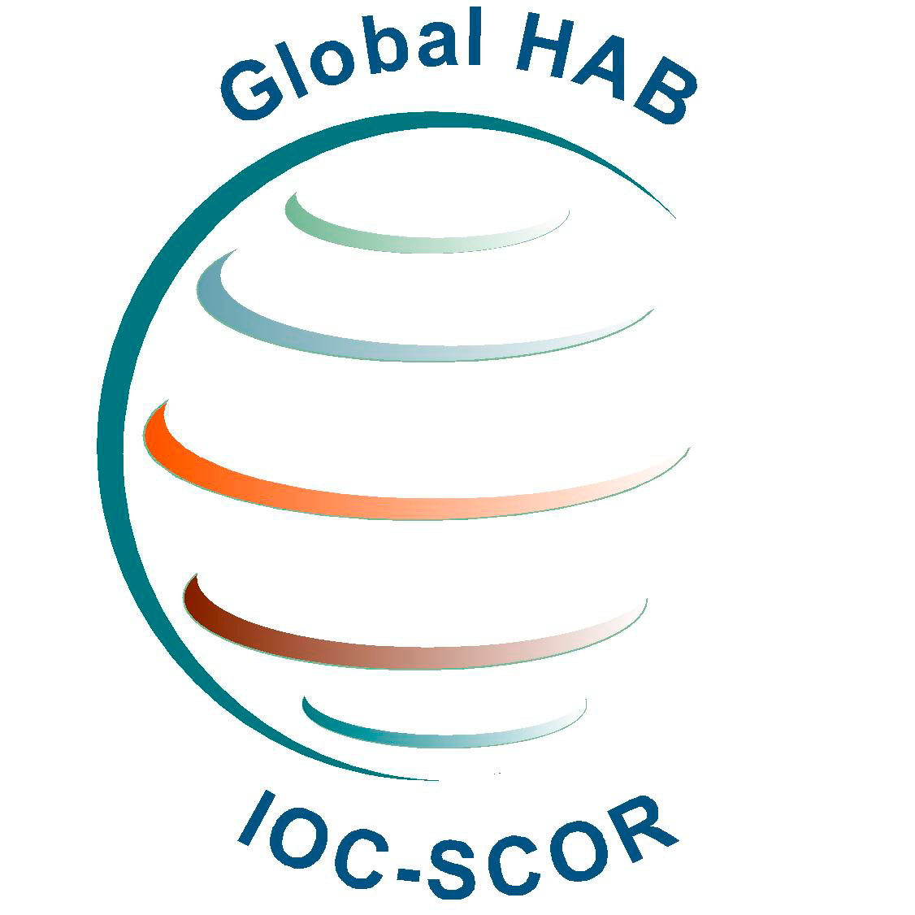
GlobalHAB Scientific Steering Committee members June 2020 - December 2022
Elisa Berdalet, Institute of Marine Sciences, CSIC, Spain, Chair
Po Teen Lim, Institute of Ocean and Earth Sciences, University of Malaya, Kuala Lumpur, Malaysia, Vice-chair

Clarissa Anderson, Southern California Coastal Ocean Observing System, Scripps Institution of Oceanography, La Jolla, California, USA
Neil S. Banas, University of Strathclyde, United Kingdom
Jeong, Hae Jin, School of Earth and Environmental Science, College of Natural Sciences, Seoul National University, Seoul, South Korea
Bengt Karlson, Swedish Meteorological and Hydrological Institute, Västra Frölunda, Sweden
Malin Olofsson, Swedish University of Agricultural Sciences, Uppsala, Sweden
Heather A. Raymond, Ohio State University, College of Food, Agricultural, and Environmental Sciences, Ohio, US
Raffaele Siano, Ifremer, DYNECO Pelagos F-29280, Plouzané, France
Susie Wood, Cawthron Institute, Nelson, New Zealand
Aletta Yñiguez, Marine Science Institute, University of the Philippines, Diliman, Philippines

Dave Clarke, Marine Institute, Ireland, ICES representative after April 2020
Raphael Kudela, University of California, Santa Cruz, USA, liaison to GOOS Bio & Eco Panel (2017-on going)
Vera L. Trainer, National Oceanic and Atmospheric Administration, USA, ISSHA and PICES representative (2016-2022)
Joe Silke, Marine Institute, Ireland, IPHAB representative (2019-2023)
Marc Suddleson, liaison to NOAA, US, (2021 – ongoing)

Henrik Enevoldsen, IOC UNESCO, IOC Science and Communication Centre on Harmful Algae at the University of Copenhagen, Denmark (2016-
Patricia Miloslavich, Scientific Committee on Oceanic Research, USA (2020-2023)
Yun Sun, Junior Professional Officer, IOC Secretariat (2021-on going)

GlobalHAB Scientific Steering Committee members until June 2020
Michele Burford, Griffith University, Australia
Timothy Davis, Bowling Green State University, USA
Christopher J. Gobler, Stony Brook University, USA
Lincoln Mackenzie, Cawthron Institute, New Zealand
Marina Montresor, Stazione Zoologica Anton Dohrn, Italy
Kedong Yin, Sun Yat-Sen (Zhongshan) University, China
Eileen Bresnan, Marine Scotland Science, United Kingdom, ICES representative
Keith Davidson, The Scottish Association for Marine Science, United Kingdom, Ex-officio
Gires Usup, Universiti Kebangsaan Malaysia, Malaysia, IPHAB representative (2015-2019)
Ed Urban, Scientific Committee on Oceanic Research, USA
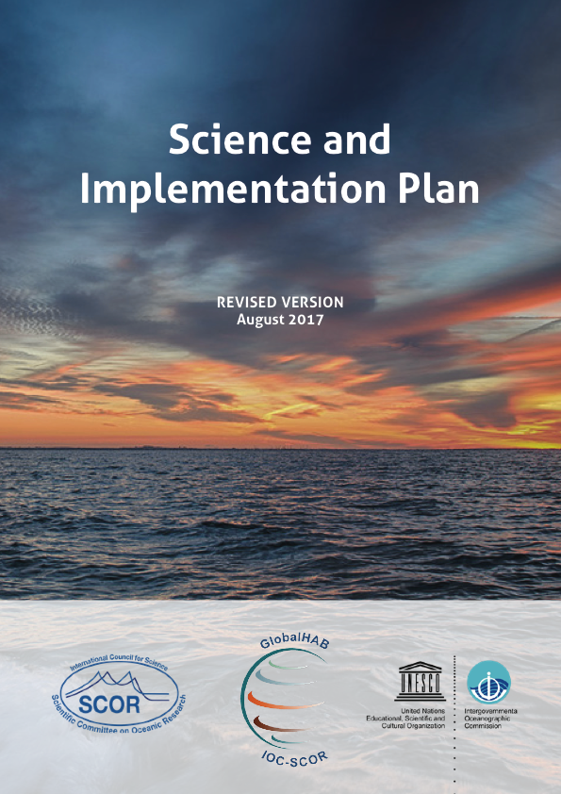
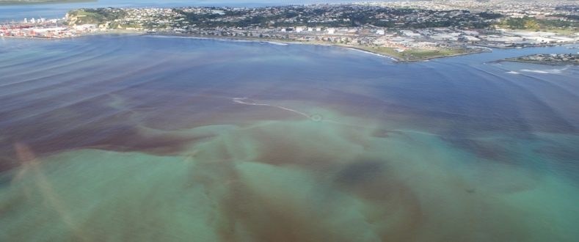

The GlobalHAB Scientific Steering Committee (SSC) acknowledges the financial and logistic support received from SCOR and IOC during the 2021-2023 period and for the activities postponed to 2022 and 2023 due to the Covid-19 pandemic.

Index

I. GlobalHAB Scientific Steering Committee: Composition and Meetings

II. Science highlights in the 2021-2023 period
II.A. Activities conducted by GlobalHAB endorsed projects
II.B. Activities conducted by the GlobalHAB SSC to represent the program at international scientific events
II.C. Activities with participation of the GlobalHAB SSC to implement the program

III. Future activities identified in the GlobalHAB Science and Implementation Plan

IV. Coordination with other international and regional programs

V. Revision of the endorsement procedure by GlobalHAB

VI. Funding

I. GlobalHAB Scientific Steering Committee: Composition and Meetings

The GlobalHAB SSC held monthly virtual meetings and email until May 13-14, 2022, when an in person meeting too place in Glasgow, Scotland, UK. Detailed information was provided in Harmful Algal News, 70, 20-22.

A second partial renewal of the SSC was conducted on March 2022. Two new members, Malin Olofsson and Heather Raymond, replaced Tim Davis (step down in December 2021) and worked with Susie Wood to lead the Freshwater HABs Theme.
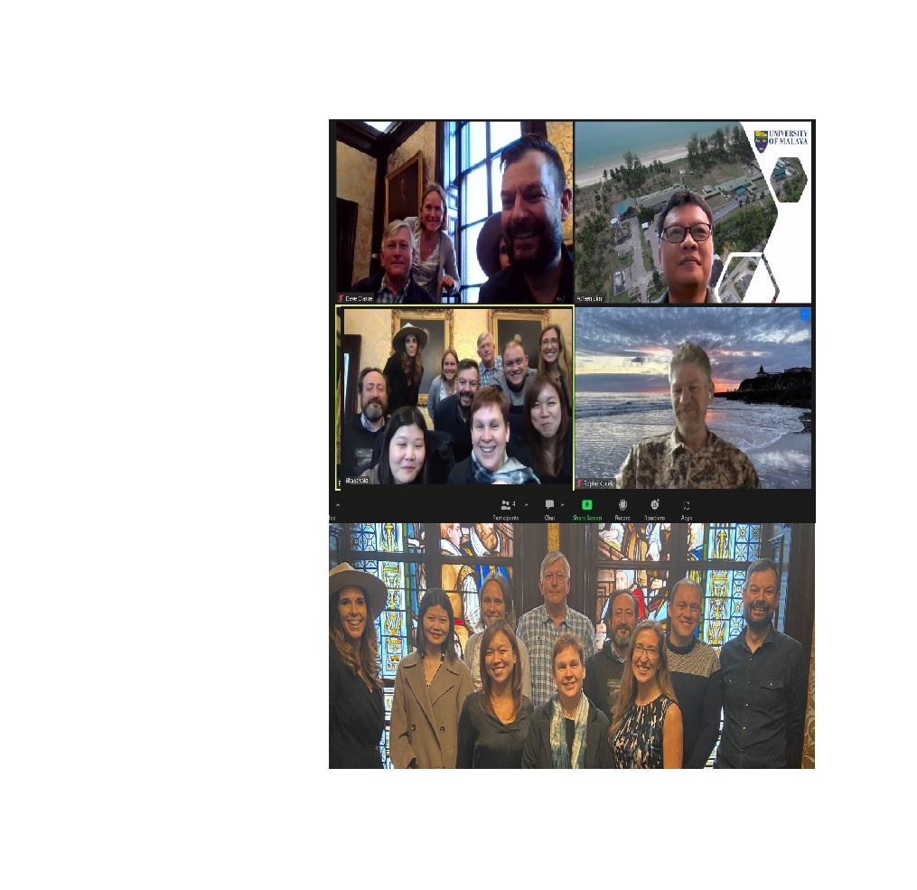

Members of the SSC at the Merchants House of Glasgow and screenshots during the remote connection. Bottom image, from left to right, first line: Aletta Yñiguez, Elisa Berdalet, Heather Raymond; second line: Clarissa Anderson, Sun Yun, Malin Olofsson, Bengt Karlson, Neil Banas, Raffaele Siano, Dave Clarke. Po Teen Lim (top, right picture), Raphael Kudela (middle, right picture), and Marc Suddleson (not pictured) joined virtually.

In December 2022, all SSC members finished their term. Accordingly, another partial renewal process of the SSC is ongoing when writing this Report. A call for nominations was launched on February 7th 2023, in coordination with IOC and SCOR. Institutions and individuals are invited to
I) Express interest or nominate individuals for Chair and/or Vice chair of the SSC;
II) Express interest or nominate individuals for members of the SSC.
The deadline for submissions is March 1st, 2023. The information is found
at: https://acrobat.adobe.com/link/review?uri=urn:aaid:scds:US:4f824945-5276-4b04-99b4-7913c3513d10, "SSC_call for expression of interest_20230206.pdf".

The SSC will analyze the nominations received in order to establish a new SSC considering scientific expertise on the GlobalHAB Themes, biogeographic and gender balance.
Apart, the GlobalHAB subcommittees will continue active until accomplishing the planed activities they are in charge.
II. Science highlights in the 2021-2023 period

II.A. Activities and outcomes from GlobalHAB endorsed projects

The international community working on HABs contributes to the implementation of the GlobalHAB scientific objectives.
Thus, GlobalHAB invites to seek endorsement of relevant research, monitoring, and modelling activities relating to HABs.
The GlobalHAB SSC agreed to make an effort to contact the international community working on HABs to apply for endorsement of their proposals to GlobalHAB as shown in the GlobalHAB webpage. The endorsement application letter was included also in HAN No 70, 20-22.
GlobalHAB acknowledges the endorsement projects whose information, including their significant outcomes, are shown in the GlobalHAB webpage. In the 2021-2023, the activities conducted by endorsed projects included:

- October 10-14, 2021. Addressing industry and global insurance needs: impacts of HABs on fish farms. A special session was held during the International Conference on Harmful Algae (ICHA19):
* Session on Oct 12, 14:00-16:00 La Paz time.
* Convenors: Vera Trainer (NOAA, US), Keith Davidson (SAMS, UK), Mark Wells (Univesity of Maine, US) and Charles Trick (The University of Saskatchewan, Canada).

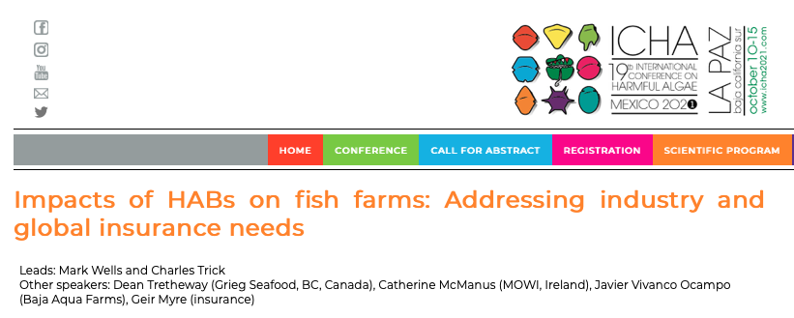
In this ICHA19 side session, HAB scientists, the insurance industry and on-the-ground aquaculture industry representatives discussed future research directions and how to work together to address impacts of HABs on aquaculture, risk thresholds, early warning and mitigation cost benefits.

- November 26, 2021. UN Decade Action Incubator 12 "Fostering transformative HAB sciences for societal applications". A special session was held during the UN Ocean Decade Kickoff Conference for the Western Pacific and its Adjancent Areas:
* Friday 26 November 2021, 1030-1230 (UTC+7, Bangkok time).
* Conveners: Kazumi Wakita (Tokai University, Japan), Po Teen Lim (University of Malaya, Malaysia). The meeting was held with attendance of 77 participation from nine WESTPAC member states.

HAB research priorities, challenges and future works were discussed. The summary key points of the session were:

1. Continue with the effort in capacity building in HAB sciences through various training workshops and promoting more involvement of social scientists.
2. Promote application of advanced techniques in HABs monitoring and early warning system.
3. Promote sharing of good practices of HAB monitoring, mitigation and adaptation.
4. Encourage the application of mitigation measures to minimize impact especially to mariculture industries with due consideration on its social acceptance.
5. Strengthen coordination with other national and regional HABs program and IPHAB in development of UN Decade actions on HAB.

- February 22-23, 2022. Workshop-based scoping study for developing an early warning system for Harmful Algal Blooms (HABs) in the Arabian Gulf. A two-days virtual workshop was held in 22 and 23 February 2022, coordinated by Dr Ross Brown (University of Exeter, UK) and Dr Qusaie Karam (Kuwait Institute for Scientific Research, Kuwait) sponsored by the UK and Kuwait Governments.

The aims of the activity were to explore existing knowledge and data on HABs and impacts on fisheries and finfish aquaculture in the Arabian Gulf. The first day was focused on understanding the susceptibility of the Arabian Gulf and adjoining sea areas to HABs and impacts on fish health and food safety; the second day was centered on developing early warning systems (EWS) for HABs for mitigating impacts on fisheries and aquaculture.

The program, videos and proceedings of the workshop are available at the GlobalHAB webpage.

II.B. Activities conducted by the GlobalHAB SSC to represent the program at international scientific events

The SSC members are committed to represent and inform about the GlobalHAB program at international meetings, as indicated in the Terms of Reference. The following presentations have been conducted since 2021:

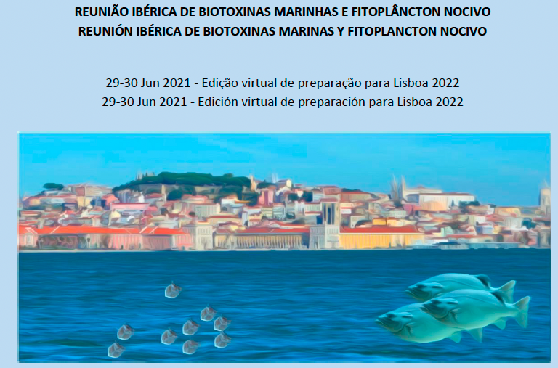
- June 29, 2021. Presentation of the GlobalHAB program at the "Reunión Ibérica de Biotoxinas Marinas y Fitoplancton Nocivo" REDIBAL", by Elisa Berdalet, plenary session.

E. Berdalet. "The GlobalHAB (IOC-UNESCO and SCOR) program: International coordination for sound knowledge of HABs and management of their impacts", Lisbon, Portugal, virtual meeting.

- Presentation of GlobalHAB Scientific Steering Committee updates by Dave Clarke, at:
- Annual meeting of the ICES-IOC Working Group on Harmful Algal Bloom Dynamics, 14th – 17th June 2022, Centre for the Environment and Fisheries Science, Weymouth, UK
- Workshop on Modelling and Prediction of Harmful Algal Blooms 9th-12th May 2022, University of Strathclyde, Glasgow, UK (see section 3.2)

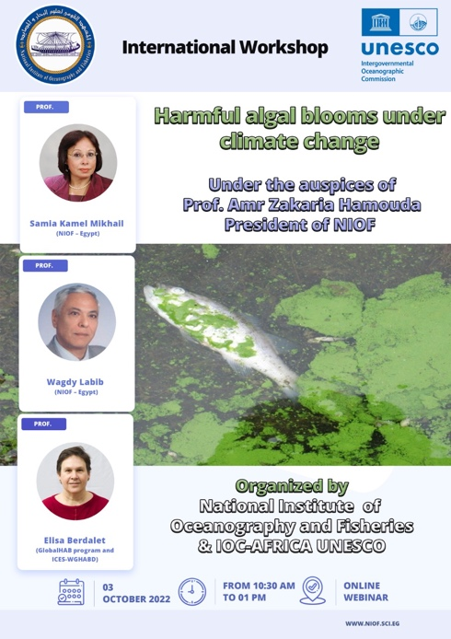
- October 3, 2022. Participation in the "International Workshop on Harmful Algal Blooms under Climate Change", virtual event. Elisa Berdalet and Dave Clarke gave the lecture on "Harmful Algal Blooms in Africa: present and future threats", followed by discussion with the attendants.

- October and December 2022. Participation of Dave Clarke and Sun Yun in two Expert Missions in Africa:
Namibia – Ministry of Fisheries and Marine Resources, Swakopmund 5th – 6th October
Morocco - L'Institut National de Recherche Halieutique, Casablanca 5th – 8th December

Based on the cooperation agreement between UNESCO and the Norwegian Agency for Development Cooperation (NORAD), the project led by UNESCO's IOC in partnership with FAO and IAEA addresses issues related to HABs, which have significant impacts on food safety and nutrition, through contamination of fish and shellfish, or massive kills of marine organisms. The expert missions in Africa aim to contribute to the implementation of HAB Early Warning Systems (EWSs), in the framework of the guidelines elaborated under the umbrella of the IOC IPHAB Task Team on EWSs. The development and testing of EWS for HAB will serve to meet local/national requirements of seafood safety regulations and the main goals are to protect public health, reduce economic disruptions and minimize associated economic losses on fisheries due to HABs.

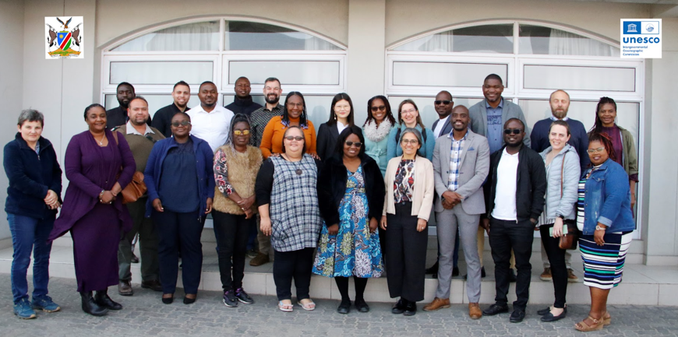
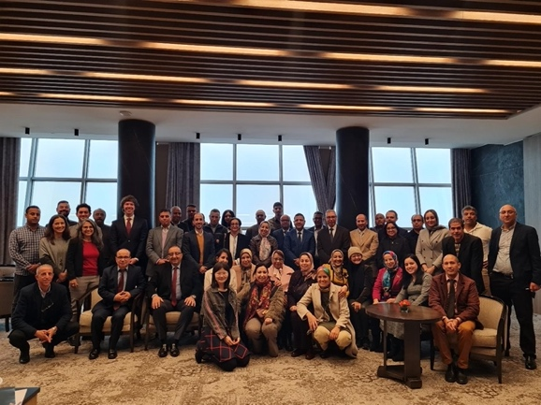
Participants in the two Expert Missions un Africa, Namibia (left image), Morocco (right image).

- January 9-12, 2023. Symposium in Xiamen and session summary for HAB session "HABs under changing climate" (https://melmeeting.xmu.edu.cn/xmas/session.asp). Po Teen Lim presented the program GlobalHAB in this HAB session.

Convenors: Po Teen Lim (University of Malaya), DaZhi Wang (Xiamen University), HaiFeng, Gu (Third Institute of Oceanography, MNR, Xiamen), YingZhong Tang (Institute of Oceanology, Chinese Academy of Science, IO-CAS).

Session Description: Harmful Algal Blooms (HABs) occur due to the proliferation of harmful microalgae in the aquatic ecosystems, resulting in deleterious effects on the coastal communities. This included the contamination of commercially important shellfish, massive mortality of farmed or wild finfish, and damage to the value of the marine ecosystem. The increasing impacts of HABs on the socio-economy and public health are tremendous, affecting regionally and globally, partly because of the emergence of new HAB events in areas with no prior record, also, involving novel toxic species. Owing to the increasing HAB occurrence and intensity, sustainable development of the rapidly growing aquaculture industries in many coastal countries has been hindered by HAB-related fish kill and shellfish toxicity events. In this proposed session, we will focus on several aspects of HABs: 1) dynamics of HABs, from molecular to ecological levels; 2) physiological and molecular responses of HAB species to biotic and abiotic drivers; 3) monitoring and forecasting of HABs using novel tools and instrumentation for early detection and warning; 4) development and application of techniques to mitigate and minimize the impact of HABs. Trends of HAB events (species, occurrence, and frequency) under the changing climate will also be a topic of interest in this session. Presentations related to the collaborative effort to strengthen regional and international collaborations and joint research efforts in addressing the expanding HAB issues in the region are also welcomed.

II.C. Activities with participation of the GlobalHAB SSC to implement the program

The SSC members have been working to coordinate and manage GlobalHAB activities in accordance with the GlobalHAB Science and Implementation Plan. The accomplishments are presented indicating the GlobalHAB themes they addressed:

Theme 9. Observation, Modelling and Prediction. Cross cutting activities. Responsible: Clarissa Anderson and Neil Banas

- June 2021 - November 2021. GlobalHAB Webinar Series - Modelling and Prediction of Harmful Algal Blooms
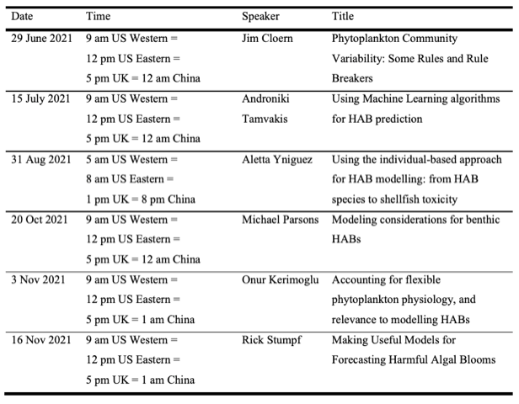
In June 2021, an online series of open seminars and discussions have started to address the challenge of predicting HABs. This monthly series was delivered by six experts and the topics covered size-based models, acclimation models, model validation, and machine learning. The detailed schedule is listed below.

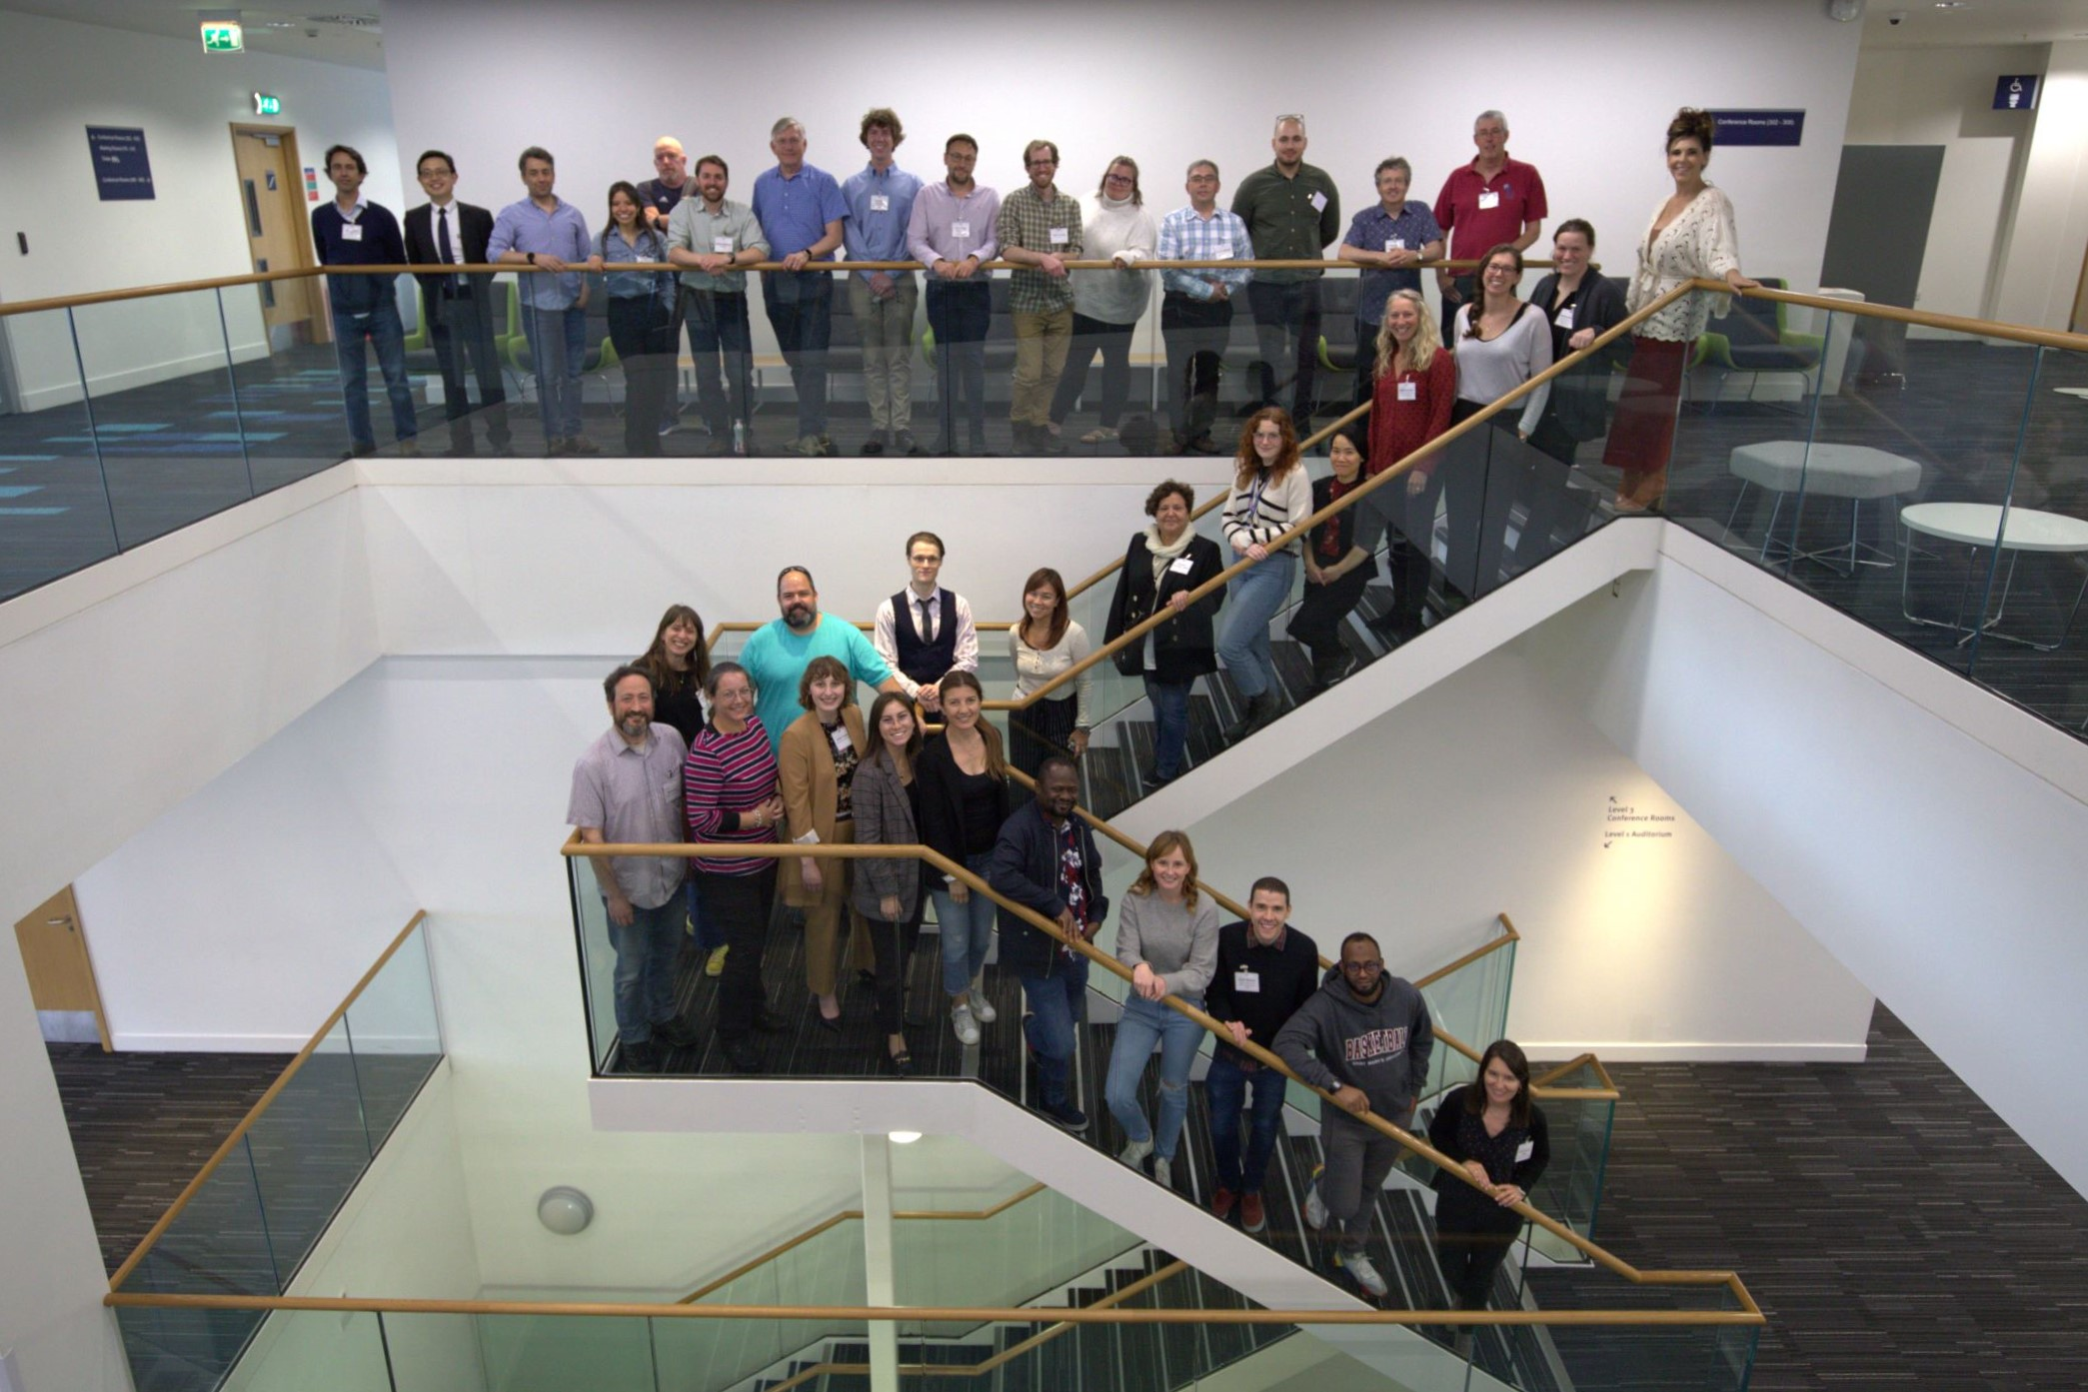
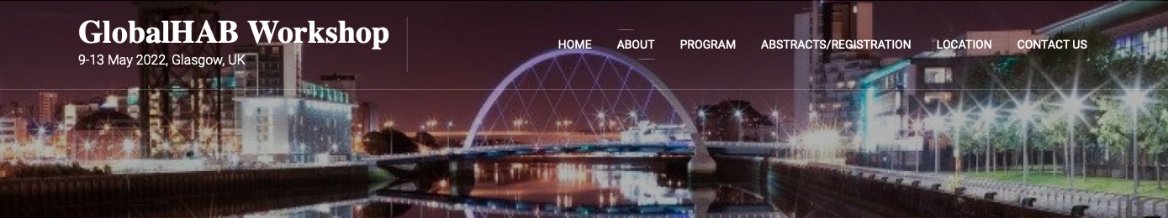
- 9-12 May 2022. “Modeling and prediction of harmful algal blooms, from event response to multi-decadal projections”

The GlobalHAB/Euro Marine Workshop was held on 9-12 May 2022, University of Strathclyde, Glasgow, UK.

The typical HAB is a regional- or local-scale phenomenon, a “perfect storm” of environmental conditions, ocean transport and mixing patterns, and microbial ecology. Because of this complexity, prediction of HABs is a grand challenge that requires multidisciplinary dialogue among physical scientists, biologists, computer modellers, and technologists, as well as community stakeholders and the government and industry end-users of prediction systems. This 4-day workshop brought together 39 scientists from 17 countries for a combination of oral and poster presentations, round-table discussions, and tutorials, in order to increase awareness of the range of modelling and observational tools that are in our community toolbox, and help scientists and technologists develop creative approaches to meeting the needs of coastal communities, governments, and industry worldwide. An update of the GlobalHAB program was included (see section 2.2.).

Discussions consisted of
- Engaging with stakeholders (facilitated by Aletta Yñiguez and Dave Clarke)
- Scalable solutions: bringing large-scale community tools to local applications (facilitated by Clarissa Anderson)
- Building blocks of early-warning systems (facilitated by Dave Clarke)
- Combining automated plankton observations and modelling (facilitated by Bengt Karlson)
- New directions in mechanistic plankton modeling: where do HABs fit in? (facilitated by Neil Banas, Onur Kerimoglu, and Bingzhang Chen)
- HAB model-observation systems for 2050: anticipating future societal needs and assessment tools (facilitated by Clarissa Anderson)

Tutorials consisted of
- Getting started with machine learning using tidymodels in R (Johnathan Evanilla, Kasia Kenitz, and Bingzhang Chen)
- Satellite methods (Clarissa Anderson)
- Getting started with Individual-based modeling (Aletta Yñiguez)

Organising committee:
Representing GlobalHAB: Neil Banas (U Strathclyde, UK), Clarissa Anderson (Scripps/SCCOOS, USA), Dave Clarke (Marine Institute, Ireland), Aletta Yñiguez (U Philippines Diliman), Bengt Karlson (SMHI, Sweden)
Local committee: David McKee, Bingzhang Chen, Paul Udom (U Strathclyde), Sofie Spatharis, Martin Llewellyn (U Glasgow), Keith Davidson, Dmitry Aleynik (SAMS)

Sponsors:
The workshop was supported by GlobalHAB, NOAA’s National Centers for Coastal Ocean Science (NCCOS) Competitive Research Program (CRP), NOAA’s Integrated Ocean Observing System (IOOS), and EuroMarine. A follow-on, one-day event on Industry Perspectives supported by the Sustainable Aquaculture Innovation Centre deepened the engagement between workshop participants, the Scottish aquaculture industry, and companies building systems and monitoring technology to support that industry.

- 22-26 August 2022. Symposium on automated in situ observations of plankton.
In recent years novel in situ instrumentation has been developed for automated high frequency HAB detection in near real time. Also instruments for observing grazers, e.g., microzooplankton and multicellular zooplankton are becoming available commercially. These instruments are now being adopted in research and also in monitoring programs.

The aim of the mini-symposium was to bring together experts on, and users of, automated imaging in-flow systems to present methods and recent results and to share experiences about the use of these methods for different ecological research purposes, including studies on HABs. Another aim was to carry out a comparison of results when analysing plankton communities quantitatively. Young scientists were particularly encouraged to attend the symposium. The mini-symposium/workshop on automated plankton observations took place at Kristineberg Centre in Fiskebäckskil, Sweden, 22-26 August 2022 (after being postponed since June 2020, due to the Covid19). The participants enjoyed nice weather and good company. Financial support was provided by GlobalHAB, FORMAS (Sweden) and the companies that brought the commercialized instruments used in the Symposium.

Most of the presentations made are available as pdf’s on the GlobalHAB activities section and information was also presented in Harmful Algal News Nº 71. Two main conclusions of the symposium are:
- Best practices are needed to establish routines for handling of instruments, images and data. At least two best practice documents about automated phytoplankton identification are at present in production, one in Europe and one in the USA.
- The successful application of these new instruments results from the intrinsic link between technology progress and phytoplankton identification specialists.

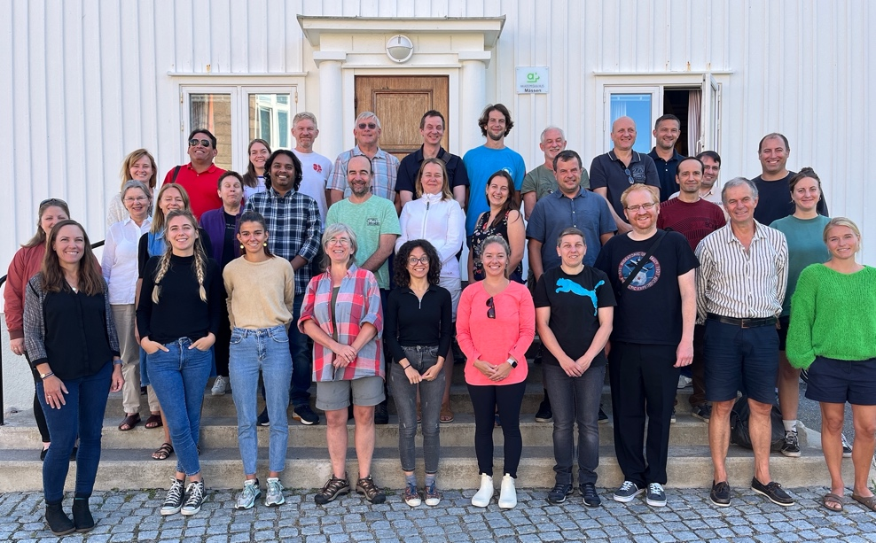

Participants of the GlobalHAB mini-symposium on automated plankton observations

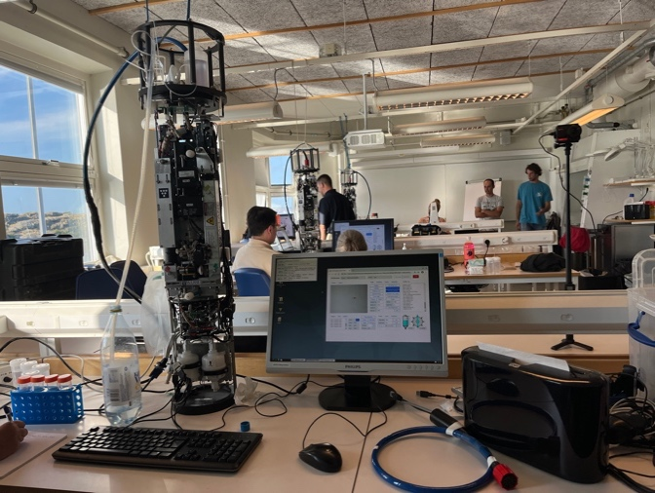
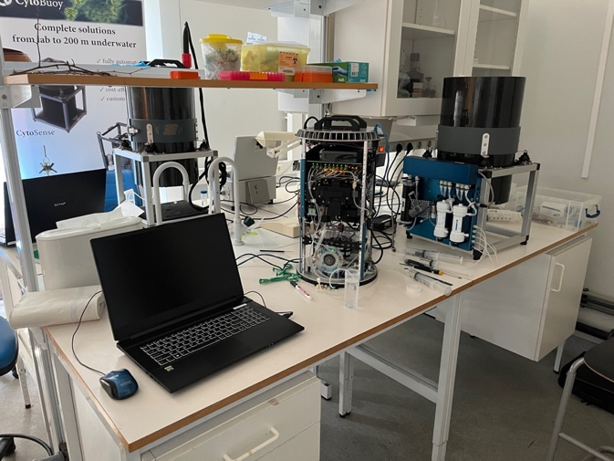

LEFT: Three Imaging FlowCytobot’s (IFCB’s) were used during the mini-symposium. RIGHT: Two Cytosense/Cytobuoy’s were used during the mini-symposium. The instruments were removed from their water proof housings during the work in the laboratory.
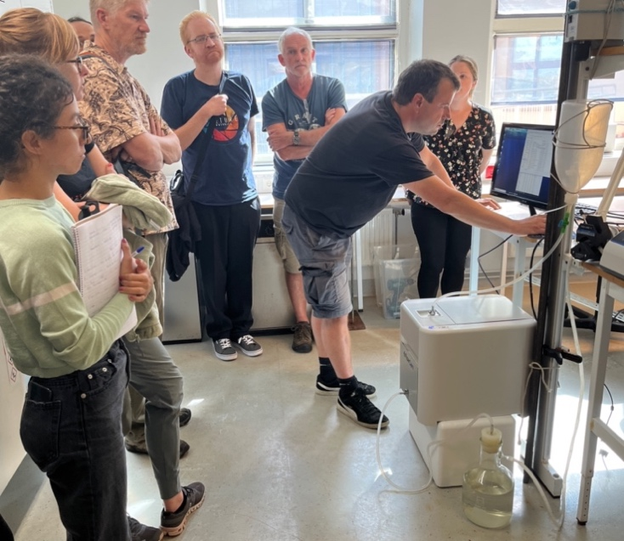

The FlowCam 8400 (in this picture) and one FlowCam Macro were used during the mini-symposium.

Theme 12. Climate Change

- Publication of the "Best Practice Guidelines for the Study of HABs and Climate Change", Mark Wells, Michele Burford, Anke Kremp, Marina Montresor, Grant Pitcher and Gires Usup (eds), available at: https://unesdoc.unesco.org/ark:/48223/pf0000380344
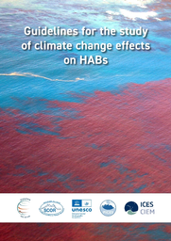
HABs impact human societies and ecosystems, and there is concern that climate-driven changes in aquatic systems will increase the frequency, distribution, and intensity of these ecological events. Developing a foundation for HAB prediction under accelerating shifts in environmental conditions requires a quantitative, mechanistic-based understanding of climate-HAB linkages. Addressing this challenge requires a common strategy based on the multidisciplinary knowledge gained in recent years and new methodologies.

The intent of these guidelines is to communicate standardized strategies, tools, and protocols to assist researchers studying how climate change drivers may increase or decrease future HAB prevalence in aquatic ecosystems. The guidelines are designed and published as an on-line resource to the HAB/climate change research community which is invited to contribute in future updates of the document.

The Manual includes six chapters:
Chapter 1 - Rationale and Introduction (Editorial Board)
Chapter 2 - Observing changes in harmful algal blooms over time: long-term observations for studying impacts from climate change. A. J. Richardson, R. Eriksen, G. M. Hallegraeff, W. Rochester, G. C. Pitcher, M. Burford
Chapter 3 - HABs under global change: Experimental conditions and approaches. D. B. Van de Waal, L. Bach, E. Berdalet, K. M. Brandenburg, S. Suikkanen, S. Wohlrab, P. J. Hansen, A. Kremp
Chapter 4 - Studying the acclimation and adaptation of HAB species to changing environmental conditions. G. Hennon, J. Sefbom, E. Schaum, S. Dyhrman, A.Godhe
Chapter 5 - Databases for the study of harmful algae, their global distribution and their trends. A. Zingone, L. Escalera, E. Bresnan, H. Enevoldsen, P. Provoost, A. J. Richardson, G. M. Hallegraeff
Chapter 6 - Future Perspectives in Modeling Harmful Algal Blooms (HABs) - Guidelines for HABs modelling. I. Hense, C. R. Anderson, D. Hamilton, S. Chapra
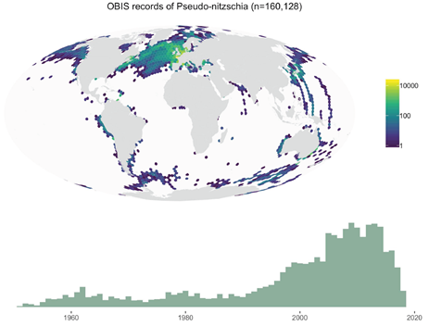
OBIS maps and time series of records of potentially toxic and non-toxic species of the genus Pseudo-nitzschia between 1950 and 2019, obtained by merging the datasets specifically established within HABMAP-OBIS with all data from other sources that are present in OBIS. These data suggest, but do not demonstrate, increasing frequencies of Pseudo-nitzschia blooms over time. Figure 2, Chapter 5, Zingone et al.

Funds for the working meeting of the editorial team to start the organization of the Manual in April 2018 were provided by GlobalHAB. The final edition received the support of IOC. The initiative of the Best Practices Manual for HAB and Climate Change is in line with the activities of SCOR WG149 that is focusing on Changing Ocean Biological Systems (COBS) and particularly on "How will biota respond to a changing ocean?" (https://scor149-ocean.com/).

- Publication of the "IOC-UNESCO. 2022. Multiple Ocean Stressors: A Scientific Summary for Policy Makers. P.W. Boyd, S. Dupond, K. Isensee (eds). Paris, UNESCO. 20 pp. (IOC Information Series, 1404) doi:10.25607/OBP-1724.
Available at: https://unesdoc.unesco.org/ark:/48223/pf0000380891

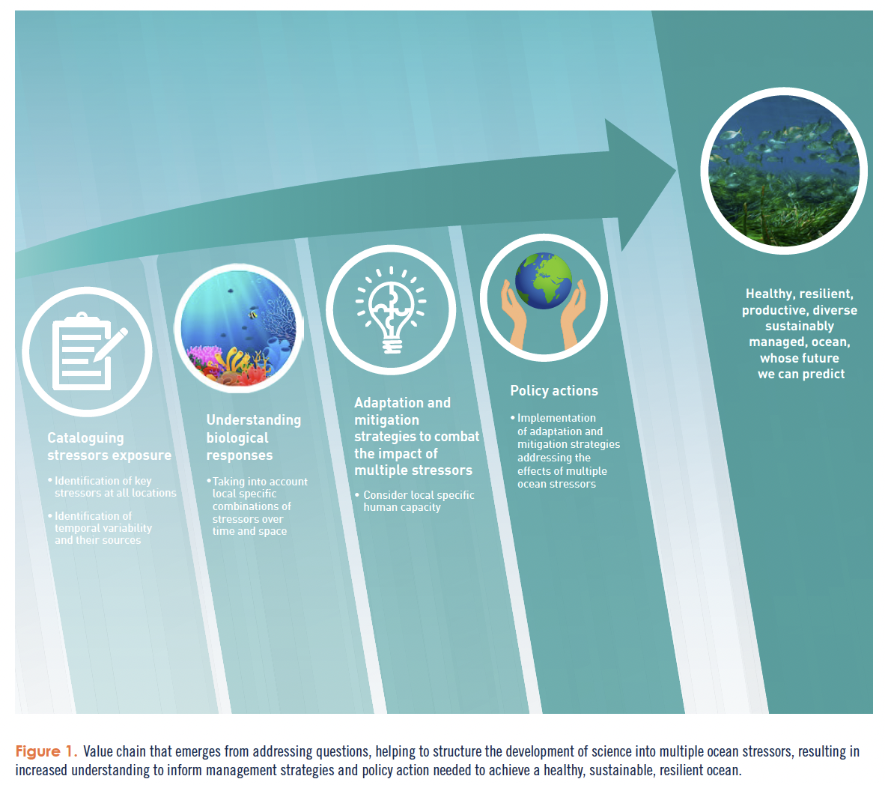
The document is "a call to action underlining the urgency to understand, model and manage multiple ocean stressors now. We cannot manage what we do not understand, and we cannot be efficient without prioritization of ocean actions appropriate to the place and time." and "it supports the UN Decade of Ocean Science for Sustainable Development".

Raphael Kudela and Henrik Enevoldsen (GlobalHAB) participated as author and Production Editor, respectively. The work presented in this publication by members (Boyd, Dupont) of the SCOR COBS (Changing Ocean Biological Systems), benefited in part, from funding provided by national committees of the Scientific Committee on Oceanic Research (SCOR) and from a grant to SCOR from the U.S. National Science Foundation (OCE-1840868).

III. Future activities identified in the GlobalHAB Science and Implementation Plan

Different activities are planned and some new activities are under analysis by the SSC in order to implement the different GlobalHAB Themes. The implementation of each activity is still partially dependent on the evolution of the Covid19 pandemics, availability of funds and other logistics.

Theme 1. Biogeography and Biodiversity. Responsible: Raffaele Siano
Promotion of the qPCR and eDNA techniques for HAB species detection. The analyses of environmental DNA (eDNA) are becoming conventional for microbial community and species distribution studies. The qPCR approach based on eDNA is one of the most adapted methods for HAB species detection, allowing the precise identification of a species in the environment and with potential to be incorporated into HAB monitoring systems. A Workshop on Environmental DNA methods is being organized, coordinated by R. Siano, A. Yñiguez, D. Clarke and P. T. Lim.

A small group of 15 experts in the field (over 80 invited) will meet to discuss and agree on common protocols for HAB species detection. The Workshop will be held in Hiroshima (Japan) for two and a half days prior to the ICHA event. This would same time, economy and carbon food print related to the trip. The design of the activities is been carried out in parallel with the ICES-WGHABD (ToR –I: Use of eDNA analyses to study and monitor HAB species dynamics) and with eventual coordination with the workshop to be held in Vigo (IEO-CSIC) organized by Francisco Rodríguez.
During 2022 and 2023, several virtual meeting will have been conducted to discuss the objectives, outputs, procedure, event site, date and duration.
The workshop will be supported by GlobalHAB funds.

Theme 2. Adaptive Strategies. Responsible: Jae Jin Jeong
Analysis of the information available about growth rate, mortality rate due to predation, inhibition rate due to competitors, and mortality rate due to physical forces, of HAB species in order to find trends. A Task Group coordinated by Hae Jin and including GlobalHAB SSC members and external scientists will be constituted to address this objective.

Theme 3. Toxins. Responsible: Po Teen Lim and Aletta Yñiguez
New activities in Asia are explored in the context of Toxins and Aquaculture, following the recently conducted training workshop to identify toxic-fish killing microalgae in the Philippines with the support of aquaculture industries and in coordination with IOC WESTPAC.

Theme 7. Aquaculture. Responsible: Po Teen Lim
Finalization and publication of the White paper on Fish Killing algal blooms and their effects, with the outcomes of the workshop conducted in Puerto Varas, Chile, on October 2019. The document will identify the present challenges and opportunities and potential future activities.

Theme 5. Freshwater and Cyanobacteria HABs. Responsible: Malin Olofsson and Heather Raymond
Theme 11. Economy. Responsible: Vera Trainer and Elisa Berdalet
GlobalHAB International Workshop on Solutions to Control HABs in Marine and Estuarine Waters.
A workshop on solutions to control HABs in marine and estuarine waters that will build on lessons learned from freshwater HAB control is planned.
Organizers: Vera Trainer, Quay Dortch, Marc Suddleson, Zhiming Yu, Tae-Gyu Park, Natsuko Nakayama, Don Anderson, Heather Raymond

Sponsors: GlobalHAB, ICES/PICES, NOAA. Working on endorsement from the UN Decade of Ocean Sciences for Sustainable Development.

Timeframe: The workshop is scheduled in October 2023). New information will be provided soon.

Theme 12. Climate Change. Responsible: Neil Banas

- A Scientific Summary for Policy Makers (SSPM) on HABs and Climate Change will be elaborated based on, among other recently published documents, an update of the main key messages in the different papers in the special issue on Climate Change in Harmful Algae 91, the Manual on Best Practices to investigate HABs and Climate Change, the special issue on the CoCliME project in Harmful Algae 119, The SSPM could be linked to the two IPCC 1.5C special reports that are coming out this year and next year. The GlobalHAB SSC is developing it, coordinated by Po Teen Lim, and plan to have it finished by June 2023.

Theme 13: New GlobalHAB Theme on Sargassum Blooms. Responsible: Elisa Berdalet

The GlobalHAB Science and Implementation Plan identifies that new emerging HAB related issues can be incorporated into the program after its launch. This is the case of the blooms of Sargassum.

Since 2020, a joint GlobalHAB-GESAMP Open Science Meeting (OSM), with support of the EuroSea European funded project was planned to identify research priorities to understand Sargassum growth dynamics and to develop adequate forecasting and warning systems to allow long term preventive measures for Sargassum beaching. Due to the Covid19 pandemics and limited funding, the OSM initially planned in May 2020, hosted by the Universidad Autónoma Nacional de México (UNAM could not be held. Instead, GlobalHAB funds have been invested in a consultancy (managed by IOC) to produce a White Paper on the research priorities to progress in the understanding of the Sargassum blooms and beaching. The consultancy started in January 2023, will last for nine months and will work in coordination with the GlobalHAB Subcommittee on Sargassum.

IV. Coordination with other international and regional programs

The Terms of Reference of the GlobalHAB SSC indicate that it will "Collaborate, as appropriate, with intergovernmental organizations and their subgroups (e.g., IAEA, ICES, IOC/FANSA, IOC/ANCA, IOC/HANA, IOC/WESTPAC, PICES, UNEP/NOWPAP), and within related projects (e.g., IOCCG, IMBER)".

The activities presented in the present report (implemented and programmed) illustrate how the SSC is taking into consideration the active link with them. Many other actions can be conducted jointly with these and other organizations. They are invited to contact the GlobalHAB SSC and work together on joint initiatives.

V. Revision of the endorsement procedure by GlobalHAB

As explained in the former report, the GlobalHAB SSC analyzed the status of the projects endorsed by GlobalHAB. Endorsement is aimed to facilitate the participation of the international community in the GlobalHAB program. In turn, the endorsed projects and activities can help on the diffusion of GlobalHAB the program.

The SSC reviewed the procedures and criterion for obtaining GlobalHAB endorsement of science activities, which are indicated in the GlobalHAB web site. The Benefits of GlobalHAB endorsement and the responsibilities from the endorsed project are better explained. Among the benefits, GlobalHAB facilitates dissemination of project information through web site (http://www.globalhab.info/activities/globalhab-endorsed-projects).

And the end of the project, the Principal Investigators will contact or will be contacted by the SSC to gather information of the outcomes and progress of the endorsed projects. The information of the projects finished by 2022 has been incorporated in the webpage as explained also in section II.A in this Report. The endorsed projects are also asked to acknowledge endorsement by GlobalHAB in the published papers and inform GlobalHAB. This will allow to elaborate a database of GlobalHAB related projects and activities contributing to the implementation of the program.

These actions have been technically supported by Ms Sun Yun, who joined the at the IOC Secretariat, OSS Section, on 4 November 2020. Sun Yun is a Junior Professional Officer (JPO) seconded by China. GlobalHAB acknowledges Sun Yun commitment, intense and efficient work with GlobalHAB.

VI. Funding

The implementation of the GlobalHAB program through different activities is supported by:
- IOC/UNESCO
- SCOR, with funding from the U.S. National Science Foundation (Grant OCE-1840868) to SCOR and from funds contributed by national SCOR committees, until 2019
- NOAA’s National Centers for Coastal Ocean Science (NCCOS) Competitive Research Program (CRP) via the US National HAB Office as earmarked contributions to the University of Copenhagen, Denmark. Funds are managed by the IOC Science and Communication Centre on Harmful Algae at University of Copenhagen
- In-kind contributions from the institutions of the GlobalHAB SSC members
- Specific contributions by different entities and organizations (e.g., ICES, PICES, IPHAB, EuroSea project, Gobierno de Chile, etc.) co-organizing with GlobalHAB and participating in the specific activities indicated previously.

GlobalHAB acknowledges all this valuable support

