Summary
This document complements the information and analyses presented in IOC/INF-1416 presented to the 31st Session of the IOC Assembly in June 2021. It updates the status of IOC-led initiatives that have been registered as Decade Actions and identifies other endorsed Decade Actions where IOC is playing a key role. It discussed central and decentralised coordination structures where IOC is playing a lead role and identifies opportunities, challenges including issues related to resource mobilisation, and perspectives for future IOC contributions to the Decade.

Introduction
This document has been prepared to provide updated information on the IOC contribution to the UN Decade of Ocean Science for Sustainable Development (‘the Ocean Decade’). It builds on and complements the information and analyses provided in IOC/INF-1416 presented to the 31st Session of the IOC Assembly in June 2021 and addresses both Decade Actions and coordination mechanisms where IOC is playing a lead role.
The previous analysis mapped existing IOC programmes and activities to the Ocean Decade Challenges and identified numerous points of intersection. This mapping has been updated and reinforces the earlier conclusion that the current set of IOC activities make a significant direct contribution to almost all initial Decade challenges (refer Table 1). It also identified an opportunity for IOC to use the Decade as a unifying framework to deliver on its mandate, simultaneously contributing to the achievement of Decade outcomes.
This document provides an update on newly registered Decade Actions, identifies the newly endorsed Decade Actions where IOC is a key partner, provides an overview of the central and decentralised coordination mechanisms where IOC is playing a lead role, and discusses key challenges and opportunities for IOC’s future contribution to the Decade.
Table 1: Mapping of Ocean Decade Challenges and Existing IOC Programmes and Activity
Ocean Decade Challenge | Existing IOC programme/activity
Ocean Decade Challenge 1:  Understand and map land and sea-based sources of pollutants and contaminants and their potential impacts on human health and ocean ecosystems and develop solutions to mitigate or remove them. | - IOC-UNEP Nutrients and Coastal Impacts Research Programme (N-CIRP), SDG 14.1.1a  - GESAMP WG 40 on Plastics and Micro-plastics in the Ocean: Marine Plastics (SDG 14.1.1b
Ocean Decade Challenge 2:  Understand the effects of multiple stressors on ocean ecosystems, and develop solutions to protect, monitor, manage and restore ecosystems and their biodiversity under changing environmental conditions, including climate. | - Ecosystem based management-related work  - WG on Multiple Ocean Stressors  - GOA-ON and IOC work on ocean acidification, SDG 14.3.1  - Marine Spatial Planning, Coastal Zone Management, Large Marine Ecosystems, decision-support tools  - Global Ocean Oxygen Network (GO2NE)  - IOC International Group for Marine Ecological Time Series (IGMETS)  - IOC WG on Climate Change and Global Trends of Phytoplankton in the Ocean (TrendsPO)  - GOOS  - OBIS  - GEBCO
Ocean Decade Challenge 3:  Generate knowledge, support innovation, and develop solutions to optimise the role of the ocean in sustainably feeding the world’s population under changing environmental, social and climate conditions. | - Contributions from the Harmful Algal Blooms portfolio of activities, ecosystem-based management-related work, Marine Spatial Planning, Coastal Zone Management, Bio-Eco module of GOOS
Ocean Decade Challenge 4:  Generate knowledge, support innovation, and develop solutions to contribute to equitable and sustainable development of the ocean economy under changing environmental and social conditions. | - Engagement in Ocean Action 2030 Coalition promoting sustainable ocean planning in the context of the High-Level Panel for a Sustainable Ocean Economy  - IOC Marine Spatial Planning, coastal zone management, and ecosystem-based management-related work, decision-support tools
Ocean Decade Challenge 5:  Enhance understanding of the ocean-climate nexus and use this understanding to generate solutions to mitigate, adapt and build resilience to the effects of climate change, and to improve services including improved predictions and forecasts for weather, climate, and the ocean. | - Integrated Ocean Carbon Research Group (IOC-R)  - GESAMP WG 41 on Ocean Interventions for Climate Change Mitigation  - Blue Carbon Initiative (BCI) and International Blue Carbon Partnership (IBCP)  - IOC-WMO-ISC World Climate Research Programme (WCRP)  - GOOS  - GLOSS  - Coastal Adaptation through coastal zone management (ICAM)
Ocean Decade Challenge 6:  Expand multi-hazard warning systems for all biological, geophysical, and weather and climate related ocean hazards, and mainstream community preparedness and resilience. | - IOC Tsunami Programme  - The Harmful Algal Blooms portfolio of activities and emerging work on ocean and human health
Ocean Decade Challenge 7:  Ensure a sustainable ocean observing system that delivers timely data and information accessible to all users on the state of the ocean across all ocean basins. | - GOOS  - GLOSS  - Joint IOC-WMO Collaborative Board
Ocean Decade Challenge 8:  Through multi-stakeholder collaboration, develop a comprehensive digital representation of the ocean, including a dynamic ocean map, which provides free and open access for exploring, discovering, and visualizing past, current, and future ocean conditions in a manner relevant to diverse stakeholders. | - IOC International Oceanographic Data and Information Exchange Programme (IODE)  - IOC Ocean Data and Information System (ODIS)  - GEBCO  - WCRP CMIP  - Ocean Prediction activities  - GOOS  - GLOSS  - OBIS (Ocean Biodiversity Information System)
Ocean Decade Challenge 9:  Ensure comprehensive capacity development and equitable access to data, information, knowledge and technology across all aspects of ocean science and for all stakeholders regardless of geography, gender, culture, or age. | - IOC Capacity Development activities (implementing the IOC Capacity Development Strategy)  - Transfer of Marine Technology (TMT)  - A key focus of work of IOC Regional Subsidiary Bodies and their Secretariats  - IOC Intergovernmental Oceanographic Data and Information Exchange Programme (IODE)  - OceanTeacher Global Academy and its Regional/Specialized Training Centres  - Regional Training and Research Centres (WESTPAC)  - UNESCO Category 2 Centres associated with IOC  - UNESCO Chairs in Marine Sciences
Ocean Decade Challenge 10:  Ensure that the multiple values and services of the ocean for human wellbeing, culture, and sustainable development are widely understood, and identify and overcome barriers to behaviour change required for a step change in humanity’s relationship with the ocean. | - IOC Ocean Literacy activity  - IOC communication work

Progress on existing IOC Decade Actions and Decade Actions with IOC as a partner
IOC has been leading or is a key partner in several ongoing endorsed Decade Actions:
- Ocean Observing Co-Design: Evolving Ocean Observing for a Sustainable Future (IOC Lead Programme: The Global Ocean Observing System (GOOS) through lead sponsor of the Intergovernmental Oceanographic Commission of UNESCO)
- Observing Together: Meeting Stakeholder Needs and Making Every Observation Count (IOC Lead Programme: The Global Ocean Observing System (GOOS) through lead sponsor of the Intergovernmental Oceanographic Commission of UNESCO)
- Ocean Practices for the Decade (IOC Lead Programme: International Oceanographic Data and Information Exchange (IODE) & the Global Ocean Observing System (GOOS) of UNESCO)
- Ocean Literacy With All (OLWA): the change we need for the ocean we want (IOC Lead Programme: Ocean literacy)
- CoastPredict - Observing and Predicting the Global Coastal Ocean (Lead institution(s): Alma Mater Studiorum, University of Bologna, Lead IOC Programme: The Global Ocean Observing System (GOOS))
- Ocean Acidification Research for Sustainability (Lead institution(s): Global Ocean Acidification Observing Network (GOA-ON), Lead IOC Programme: Ocean Science Section)
- Global Ocean Oxygen Decade (Lead institution(s): GEOMAR Helmholtz Centre for Ocean Research Kiel, on behalf of the Global Ocean Oxygen Network (GO2NE), Lead IOC Programme: Ocean Science Section)
Implementation of these programmes has advanced solidly over the last year, with all programmes soliciting new projects via Call for Decade Actions No. 02/2021 and actively participating in Communities of Practice and other Decade activities and events. Several of the programmes have secured some new resources e.g. in the form of consultants or seconded staff to support their implementation, however all these Actions are hindered by a lack of financial and in-kind resources for their full implementation.
Newly Registered IOC Decade Actions
Table 2 lists the IOC-led Decade Actions that have been registered in the last period. Aside from UN8 and UN11 which are funded initiatives, the remaining IOC-led Decade Actions in Table 2 require additional financial or in-kind resources for their implementation.
Table 2: Newly registered IOC-led Decade Actions
Reference Number | Decade Action | Lead IOC Programme
UN8 | E-DNA expeditions in marine World Heritage sites | IOC IODE Programme and Marine World Heritage Centre of UNESCO
UN10 | OceanTeacher Global Academy: Building Capacity and Accelerated Technology Transfer for the Ocean Decade | UNESCO/IOC Project Office for IODE
UN11 | Pacific Islands Marine Bioinvasions Alert Network | IOC-UNESCO
UN21 | Accelerate Marine Spatial Planning in the Western Pacific | IOC Sub-Commission for the Western Pacific, IOC/UNESCO
UN22 | Stem the tide of Asia’s riverine plastic emission into the ocean | IOC Sub-Commission for the Western Pacific (WESTPAC), IOC/UNESCO
UN23 | Accelerating capacity development transformations in the Western Pacific - Regional Network of Training and Research Centers (RTRCs) on Marine Science | IOC Sub-Commission for the Western Pacific (WESTPAC), IOC/UNESCO & UNESCO Bangkok
UN24 | Explore the strongest ocean current in the Western Pacific: the 2nd Cooperative Study of Kuroshio and Adjacent Regions – from its sciences to human well beings | IOC Sub-Commission for the Western Pacific (WESTPAC), IOC/UNESCO & UNESCO Bangkok
UN25 | An Ocean Data and Information System supporting the UN Decade of Ocean Science for Sustainable Development – OceanData 2030 | International Oceanographic Data and Information Exchange (IODE) of the Intergovernmental Oceanographic Commission (IOC).
136,2 | Enhancing capacity development in the TAC Region | UNESCO IOC Regional Secretariat for the Caribbean and Adjacent Regions Sub-Commission IOCARIBE
138,2 | Integrating Coastal Hazard Warning Systems for TAC | UNESCO IOC Regional Secretariat for the Caribbean and Adjacent Regions Sub-Commission IOCARIBE
140,2 | MACHC-IOCARIBE Seabed 2030 Project | UNESCO IOC Regional Secretariat for the Caribbean and Adjacent Regions Sub-Commission IOCARIBE
IOC involvement in newly endorsed Decade Actions
IOC is a key partner in two newly endorsed Decade programmes that were submitted via Call for Decade Actions No. 02/2021. The Global Ocean Decade Programme for Blue Carbon, which is led by the University of St Andrews, will enhance understanding of the ocean-climate nexus and generate new knowledge and solutions to mitigate the effects of climate change. The Healthy Rivers Healthy Ocean Programme is led by the Global Water Partnership and is designed to assist in addressing disconnects and systemic gaps and enable accelerated source-to-sea action at regional, national, and sub-national levels. Both of these programmes have initial secured resources to commence implementation but will require significant additional resources for their full implementation.
IOC-led Decade Coordination Structures

Decade Coordination Unit
The Decade Coordination Unit (DCU) is housed within the IOC Secretariat and comprises two part-time regular programme staff, one full time secondment from France, one full loan from Fugro and a number of consultants supported by extra-budgetary resources. Excluding the costs of regular programme staff, the current operational costs of the DCU are in the order of USD 800,000 / year. However, as widely recognised in previous reporting on the status of Decade implementation, the small DCU team is under-resourced for the functions that it is required to play. This amount therefore represents the lower end of the envelope required for full and effective functioning of the DCU.
Several key positions within the DCU remain unstaffed, including science coordination, capacity development, resource mobilisation, and monitoring and evaluation positions. While the extrabudgetary resources provided by Member States to support consultants are fundamental to the operation of the DCU, the unpredictable nature of extrabudgetary support affects the DCU’s ability to attract and retain key staff over the long-term. Urgent financial or in-kind support is needed to fill these crucial positions and also to increase the security of consultant positions within the team.

Decade Coordination Offices
In addition to the Decade Actions, IOC is proposing to lead three Decade Coordination Offices as follows.
Decade Coordination Office for the Western Pacific: Hosted within the IOC Sub-Commission for Western Pacific and supported by Thailand, the WESTPAC Decade Coordination Office will coordinate Decade Actions across all Ocean Decade Challenges in the Western Pacific region and its adjacent areas. It will assure the creation of synergies and links between existing Decade Actions, catalyse new Decade Actions, assist in resource mobilisation and outreach, and coordinate monitoring and evaluation of Decade progress in the region. The DCO will ensure close interactions with the South Pacific DCC hosted in PCCOS to avoid overlap and maximize the Decade benefits to SIDS in the South Pacific region. The DCO is being fully supported by Thailand. The Terms of Reference for this DCO and the support letter from Thailand are included in Annex 1.
Decade Coordination Office for Ocean Observing: The core focus of the Decade Coordination Office (DCO) for Ocean Observing, which will be hosted within the GOOS Secretariat, will be on supporting the Ocean Decade Challenge 7, which specifically identifies the need to ensure a sustainable ocean observing system across all ocean basins that delivers accessible, timely and actionable data and information to all users. Sustained and fit for purpose ocean observations will also be key to the fulfilment of most of the remaining challenges, including for example those related to the ocean climate nexus, ecosystem management, marine pollution and resilience.
The role of the DCO for Ocean Observing is to coordinate synergistic efforts among the diverse stakeholders that contribute to the Ocean Decade, to ensure efforts are not duplicated and opportunities are maximised and leveraged appropriately across the actions aimed at lifting GOOS and global and the Ocean Decade. The DCO will provide a focal point for liaising across the Ocean Decade on ocean observing related issues and undertaking communications to a broad range of stakeholders regarding the need for ocean observing to deliver the Ocean we want. The DCO will liaise with the Decade Coordination Unit for reporting, fundraising efforts and identifying needs or gaps to meet Challenge 7, helping scope future Ocean Decade Calls to support this.
The proposal for the Ocean Observing DCO was developed by the GOOS Secretariat and the proposal submitted to the Decade Coordination Unit approved by the GOOS Steering Committee during its 11th Session on 25 April 2022. The Steering Committee noted that the establishment of the DCO would be subject to additional resources being secured. The Terms of Reference for this DCO are attached in Annex 2.
To fully operationalize the DCO additional resources would be required as the scope and mandate of the Office are outside the available resources and means of the GOOS Secretariat. It is estimated that on average an additional USD780,000 / year in in-kind or financial resources would be required for the operation of the DCO. Much of this budget is in the form of staff costs that could be met via secondments or loans of expert staff to the DCO. The estimated budget needs for the DCO are attached in Annex 2.
Decade Coordination Office for Ocean Data Sharing: The core focus of the DCO for Ocean Data Sharing, which will be hosted within the IODE programme, will be on supporting Ocean Decade Challenge 8, supporting the development of the capacity, functionality and interoperability of the management of and accessibility to ocean data, information and knowledge. The DCO aims to drive the Data Management component of the digital data ecosystem needed for the Ocean Decade to be successful. The activities of this DCO will promote sustained digital interoperability between the data, information, and digital knowledge generated through Decade Actions. It will bring together digital stakeholders - across regions, organizational scales, and capacity levels - to negotiate and establish clear agreements on their co-development of the Decade’s digital ecosystem.
Building on the Ocean Decade’s implementation vision and in line with the considerations of the Ocean Decade Data Coordination Group, the DCO’s activities will ensure that well-defined, transparent and functional digital value chains are maintained and inclusively interlink the Decade’s stakeholders in a robust, interoperable digital commons. To achieve this, the DCO will assess and strengthen links between the observations, operations and modelling communities, digital twin initiatives, and other key stakeholders such as local communities and indigenous data stewards. In addition, the DCO will work towards equitable participation of all IOC Member States (and related regional organizations) in the Decade data activities to drive capacity development through its OceanTeacher Global Academy, Ocean InfoHub and other related IODE projects.
The proposal for the DCO was presented to and endorsed by the meeting of the IODE Management Group on 22 March 2022 (ref. Summary Report IOC/IODE-MG-2022/3, dated 28 March 2022), and based on the proposal submitted by the IODE Project Office to the Decade Coordination Unit on 21 February 2022. The Management Group approved the proposal and decided to submit the proposal to the DCU on behalf of IODE for endorsement. Further the Management Group urged Member States and other donors to support the DCO proposal. The Terms of Reference for this DCO are attached in Annex 3.
To fully operationalize the DCO additional resources would be required as the scope and mandate of the Office are outside the available resources and means of the IODE Programme. It is estimated that on average an additional USD 670,000 / year in in-kind or financial resources would be required for the operation of the DCO. Much of this budget is in the form of staff costs that could be met via secondments or loans of expert staff to the DCO. The estimated budget needs for the DCO are attached in Annex 3.
Opportunities, Challenges and Perspectives
As the mandated coordinating agency of the Ocean Decade, the IOC occupies a unique position to make a substantive contribution to the Decade through the implementation of the High-Level Objectives contained in the IOC Medium Term Strategy 2022–2029 and the Programme and Budget for 2022–2026. This position has been reinforced following the first eighteen months of implementation of the Ocean Decade. Over this period IOC-UNESCO has become the leading UN entity in terms of the number of Decade Actions registered as part of the Decade and has become the first UN entity to develop proposals for Decade Coordination Offices.
The recent evaluation carried out by UNESCO’s Internal Oversight Service “The Evaluation of the Strategic Positioning of IOC-UNESCO” IOS/EVS/PI/197 and the subsequent draft Action Plan presented to this session of the Executive Council in IOC/EC-55/AP, further highlighted the unique opportunity that IOC’s lead role in the Decade creates for the long term reinforcement and growth of the Secretariat. Notably, this analysis highlighted the opportunity presented to coalesce initiatives of the Ocean Decade under the umbrella of sustainable ocean management and use this momentum to create a lead role globally for the IOC in sustainable ocean planning and management by aligning the work of the Ocean Decade with the ambitions of the High-Level Panel for a Sustainable Ocean Economy. Such an approach builds on the recommendations contained in the 2021 analysis of the links between the Ocean Decade and the Ocean Panel.
Provided that adequate resources area available, the creation of the DCU generates opportunities to attract new talent and expertise within the IOC Secretariat, including skills that have traditionally not been represented in the Secretariat team. Such skills will have flow on effects to other programmatic work within the IOC and may create the foundation for a diversified and enhanced Secretariat beyond the Decade. Similarly, the creation of DCOs with GOOS and IODE offers a significant opportunity to bolster these IOC programmes and assure their leadership as coordinating structures in their respective areas of work throughout the Decade and beyond. It also creates opportunities for broadening partnerships with stakeholders in the downstream of the value chain, i.e. end-users.
The Decade also provides an opportunity for the strengthening of the regional sub-commissions. Building on the example set by the Western Pacific Regional Sub-Commission (WESTPAC) with the support of Thailand in the development of a regional DCO, the regional sub-commissions for the Caribbean and Adjacent Regions (IOCARIBE) and for Africa and the Adjacent Island States (IOCAFRICA) also have the potential to play a key regional coordination role in the framework of the Decade. Such a role is particularly important in the context of the Ocean Decade given the recent launch of the Ocean Decade Africa Roadmap that identifies nine future priority Decade Actions for the region, and the submission of several projects led by IOCARIBE to Call for Decade Actions No. 02/2021. Such a role would reinforce the positioning and visibility of the sub-commissions as regional hubs for ocean science and would open opportunities for strengthened or new partnerships and resource mobilisation.
However, such opportunities also generate challenges; the main challenges in this regard relate to the need for increased and sustained resource mobilisation for Decade coordination structures, both the Decade Coordination Unit and the proposed Decade Coordination Offices, and Decade Actions that IOC is leading or engaged in. Table 3 provides an overview of resource needs for different aspects of IOC’s engagement in the Decade.
Table 3: Overview of Resource Needs for IOC Contributions to Decade
Item | Estimated Resource Needs | Comment
Selected IOC led Decade Actions and Decade Actions where IOC is a key partner | USD 408 million between 2022 and 2025 | To date, this information has only been collected for the following Decade Actions (i.e. those via Call for Decade Actions No. 01/2020 and UN led Actions that were registered before August 2021):  - CoastPredict  - OARS  - GOOD  - Ocean Best Practices Programme  - GOOS Observing Together  - GOOS Observing Co-Design  - Ocean Literacy With All Programme  Detailed information on resource needs for each programme are available and can be provided to Member States. In August 2022 this information will be updated to include all IOC-led and partner Decade Actions.
Decade Coordination Unit | >USD 800,000 per year for current level of activity | To maintain the current rate of growth of the Decade, future support to the DCU will also need to increase beyond this baseline level. Key future support needs relate to the filling of key staff positions in:  - Ocean science  - Monitoring and evaluation  - Capacity Development  - Resource mobilisation and partnerships
Data Sharing DCO | USD 780,000 per year | In kind and financial resources
Ocean Observing DCO | USD 670,000 per year | In kind and financial resources

Urgent in-kind or financial support is required from Member States and other partners to meet the resource needs for IOC-led Decade Actions and Actions in which IOC is playing a key role, as well as for Decade coordination structures. Such support could take the form of extrabudgetary resources or in-kind resources, including secondments or loans of expert staff members. Previous reporting to the Executive Council and Assembly has highlighted such needs, however with the significantly increased momentum and visibility of the Decade over the last eighteen months, such needs are now critical. Failure to attract necessary resources will undermine the capacity of IOC to continue playing a lead role in Decade Actions and will handicap its coordination functions. Combined, this could lead to the loss of significant opportunities to use the Decade as a lever for the future development and strengthening of IOC as envisaged in the draft Action Plan presented to this session of the Executive Council in IOC/EC-55/AP.
Future IOC Contributions to Ocean Decade
Initial discussions are underway with nation members of the High Level Panel on Sustainable Ocean Economy and other partners in relation to the development of a collaborative Decade programme related to sustainable ocean planning. This initiative would build on IOC’s significant experience in marine spatial planning and act as a natural framework to galvanise different aspects of IOC’s work. This initiative is in line with the recommendations of the recent evaluation of the strategic positioning of IOC (refer below).
An Ocean Decade Tsunami Programme is currently being developed for registration as a Decade Action and is described in Document IOC/A-31/3.4.1.Doc(1). This programme aims to achieve transformational advances in tsunami detection, observing and warning, including tsunamis generated by non-seismic sources, making 100% of communities at risk of tsunami prepared for and resilient to tsunamis by 2030 through the implementation of the UNESCO/IOC Tsunami Ready Programme.
The registration of the following IOC-led initiatives as Decade Actions is also planned: Ocean Biodiversity Information System (OBIS) and the registration of the World Ocean Database (WOD) as a programme.
Planning of future IOC contributions to the Decade will follow the process that was presented in IOC/INF-1383 to the 53rd Executive Council, namely:
- Consideration of programmatic contributions to the Decade: Governance structures of IOC programmes will consider programmatic contributions to the Decade through the addition of a corresponding standing item on their meeting agendas. Programmatic governance structures are encouraged to consider creating Decade specific task teams or working groups to lead inter-sessional discussions and development of proposals for future Decade contributions.
- Engagement of IOC Member States and experts in Decade structures: A number of national, regional and thematic stakeholder initiatives are emerging in the framework of the Decade. Broad discussions take place between different actors on proposed Decade Actions, across themes or geographies. Participation by IOC Member States and IOC – affiliated experts in these initiatives (or leading the establishment of related structures or bodies where they do not yet exist, including, for example, regional and national committees) will provide an important pathway to ensuring that IOC’s future contributions to the Decade are developed in keeping with principles of co-design and co-delivery and thus contribute to a shared, collective effort.
- Reporting of IOC Decade activities: Annual reporting of the progress of IOC’s contributions to the Decade will be provided to the Governing Bodies; proposals for future contributions will also be communicated. To avoid duplication of efforts in collecting and analysing data on progress of Decade Actions that involve IOC, information on progress will be collated from the annual reports that each Decade Action will prepare and submit to the DCU.

ANNEX 1
TERMS OF REFERENCE AND SUPPORT LETTER FOR WESTPAC DECADE COORDINATION OFFICE
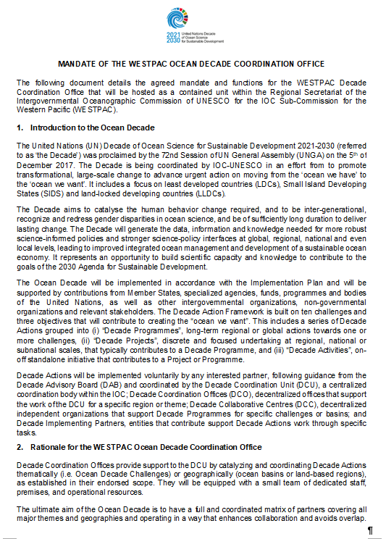
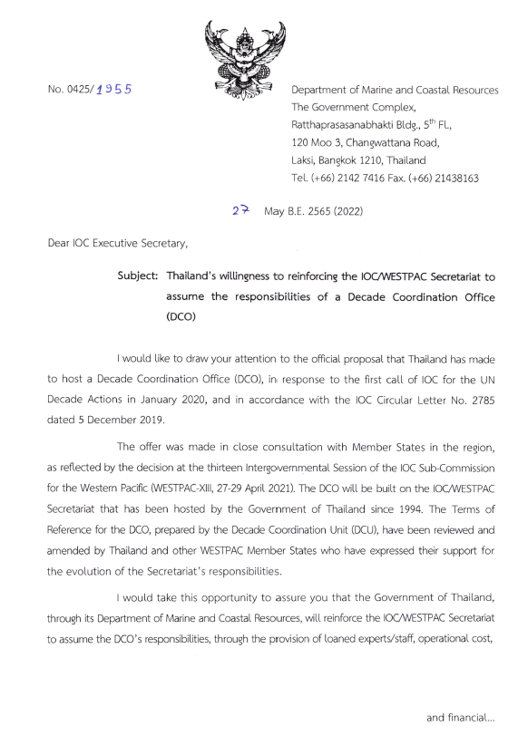

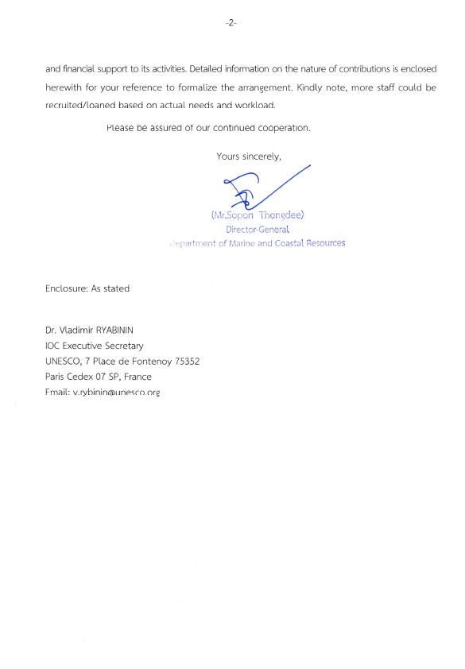

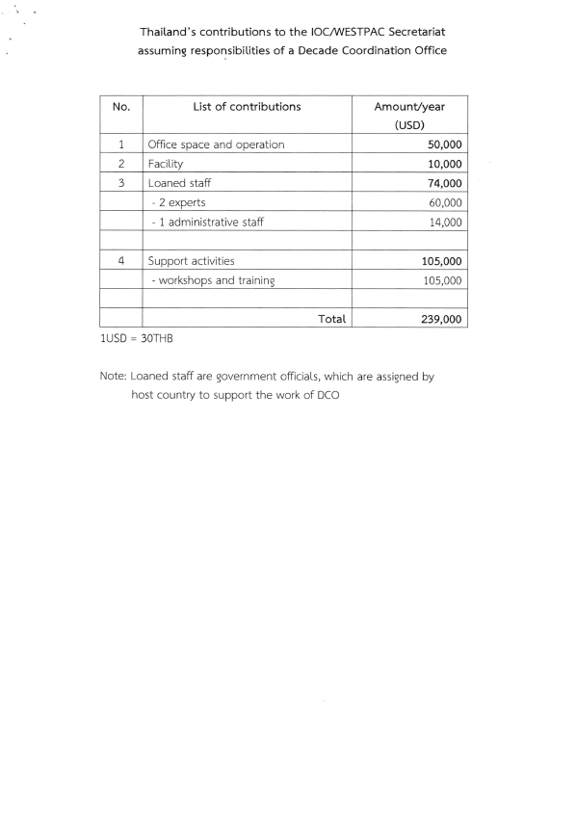

ANNEX 2

TERMS OF REFERENCE AND BUDGET NEEDS
FOR OCEAN OBSERVING DECADE COORDINATION OFFICE
Ocean Decade Coordination Office for Ocean Observing
Terms of Reference
The following document details the terms of reference for the Decade Coordination Office for Ocean Observing, in accordance with the decision made by the Global Ocean Observing System (GOOS) Steering Committee during its 11th Session on 25 April 2022, and based on the proposal submitted by the GOOS Office on 15 April 2022.

Overview
The core focus of the Decade Coordination Office (DCO) for Ocean Observing will be on supporting the Ocean Decade Challenge 7 to “Ensure a sustainable ocean observing system across all ocean basins that delivers accessible, timely, and actionable data and information to all users.” This is strongly aligned with the vision of the GOOS 2030 Strategy, and the aims of the Ocean Decade.
Challenge 7 in the Ocean Decade
Ocean Decade Challenge 7 specifically identifies the need to ensure a sustainable ocean observing system across all ocean basins that delivers accessible, timely and actionable data and information to all users. However, sustained and fit for purpose ocean observations will also be key to the fulfilment of most of the remaining challenges, including for example those related to the ocean climate nexus, ecosystem management, marine pollution and resilience. A GOOS supported DCO to cover Challenge 7 fits well with GOOS 2030 Strategy to create a truly integrated global ocean observing system that delivers the essential information needed for our sustainable development, safety, wellbeing and prosperity.
There are now over 121 endorsed Ocean Decade Programmes and Projects, a significant number (56%) of which are directly contributing to meeting the Ocean Decade Challenge 7 related to observations. Many of these actions have roots in GOOS, including the Observing Air-Sea Interactions Strategy (OASIS), Ocean Practices for the Decade, Marine Life 2030, the Ocean Biomolecular Observing Network (OBON), OneArgo, GO-SHIP Evolve, AniBOS, and Odyssey. GOOS is also leading three transformative Ocean Decade Programmes that address major gaps in the system and will deliver priority elements of the GOOS 2030 Strategy; Ocean Observing Co-Design, CoastPredict and Observing Together, which together focus on capacity development, revolutionizing observing and forecasting into the coast, and at the same time evolving system design to be increasingly user and application driven, with tools to evaluate ROI. Other actions represent new entrants that are not yet connected to sustained infrastructure within GOOS or are beyond the current scope of GOOS, for example monitoring for fishing and pollution.
Why a DCO for Ocean Observing?
The quantity of Decade Actions focused on Challenge 7, highlight the pressing need to ensure connection across the Ocean Decade, and to ensure actions are built for the future, and that the coordination goes beyond GOOS’ existing scope, which the DCO for Ocean Observation aims to deliver. In return, there is a clear opportunity for the DCO to have a transformational effect that will lift ocean observing capacity, help the Ocean Decade reach its aims, and lead to transformation of GOOS within the Ocean Decade to meet the challenges beyond 2030, leaving behind a practical legacy.
The broad scope of the Ocean Decade is a major opportunity for the accelerated development of sustained observations, to identify and fill gaps in capacity, to connect the data and the use across silos, to answer the pull to deliver solutions for sustainable economic growth. There needs to be engaged oversight of what we achieve through the Decade so that we do make a difference over the next 10 years and leave users with solutions, and an integrated and sustainable legacy.
Although focused on Challenge 7, sustained and fit-for-purpose ocean observations will also be key to the fulfilment of many of the remaining Decade Challenges, including those related to the ocean climate nexus, ecosystem management, marine pollution and resilience, and development of a sustainable ocean economy. The DCO’s work will support GOOS and stakeholders to enhance the coverage, breadth, quality and utility of ocean observations, and hence the societal value of ocean observing.
Role of the DCO for Ocean Observing
The role of the DCO for Ocean Observing is as follows (see also Annex 1 for a general description of a DCO within the Ocean Decade framework):
- Coordinating synergistic efforts among the diverse stakeholders that contribute to the Ocean Decade, to ensure efforts are not duplicated and opportunities are maximised and leveraged appropriately; ensuring that intersections of the Ocean Decade actions and GOOS activities are identified, coordinated and connected, towards an improved ocean observing system and legacy of Ocean Decade actions; supporting appropriate connections and collaboration across the actions focused on Challenge 7.
- Supporting specific identified tasks aimed at lifting GOOS and the Ocean Decade, towards achieving Challenge 7.
- Liaising with the Decade Coordination Unit (DCU) for reporting, fundraising, other management functions for the Ocean Decade Actions focused on Challenge 7.
- Coordinating closely with the key infrastructure coordination hubs, namely DCO for Ocean Data (IODE), and DCC for Ocean Prediction (Mercator Ocean International).
- Providing a focal point for liaising and responding across the Ocean Decade on ocean observing related issues, to support the aims of the Ocean Decade.
- Identifying needs or gaps to meet Challenge 7, and scoping future Ocean Decade Calls to support this.
- Undertaking communication regarding the need for ocean observing and how meeting Challenge 7 within the Ocean Decade will deliver the Ocean we want for the future we need.
The expected duration of the DCO will be 4 to 5 years (from 25 April 2022), with possible renewal after review and depending on available resources.

Terms of Reference
The DCO for Ocean Observing shall carry out the following actions in support of the Decade:

Coordination of Decade Actions
- Identify opportunities and support collaboration between Decade Actions.
- Support links between Decade Actions and existing infrastructure, such as GOOS, IODE, WMO, UNEP, etc., aiming for longevity of observing advances made under the Ocean Decade.
- Liaise across the Ocean Decade with the help of the DCU to identify gaps in ocean observing capacity and infrastructure from the perspective of the other Ocean Decade challenges.
- Provide strategic advice to the Decade, to the Actions and to GOOS (and other observing infrastructure), in aligning actions, in addressing gaps in existing infrastructure, and by informing future Calls for Actions.
- Encourage the development of any technical and scientific capacities needed to support the Decade Actions.
- Coordinate intersections of the Ocean Decade and GOOS activities leading to an improved ocean observing system and legacy of Ocean Decade Actions.
- Maintain an updated list of relevant Decade Programmes, Projects, and Activities, as well as Decade Contributions, when they are relevant for the DCO’s scope of work, including information on relevant contacts, status, partners, and its expected activities and outcomes.

Facilitation and Engagement of Stakeholder Communities
- Support broader connection across all observing communities represented within the Ocean Decade Actions (i.e. beyond GOOS).
- Liaise with similar bodies focused on Ocean Data (IODE DCO) and Ocean Forecasting (Mercator Ocean International DCC) to support information flow and structural planning around the connections between these components of the information delivery system.
- Identify and share lessons learned by the observing community related to Challenge 7.
- Proactively facilitate the structuring and engagement of a Communities of Practice around ocean observing via the Global Stakeholder Forum to facilitate dialogue and exchange between other Decade stakeholders.

Supporting Decade Calls for Action
- Provide advice to the DCU on scoping of future calls for Decade Actions related to ocean observing. Actions solicited through these Calls can be one-off contributions (e.g. funding) or programmes, noting that decisions on the solicitation of projects lie with the Decade Programmes.
- Provide advice to the DCU in reviewing requests for endorsement of Decade Actions that fall within its purview.

Monitoring & Reporting
- Organize regular reporting by all DCCs, DIPs, programmes and projects within the scope of work of the DCO and in line with the requirements of the Monitoring and Evaluation Framework of the Ocean Decade
- Provide advice and data to the DCU on monitoring and evaluating progress of the Decade Programs, Projects and Activities under its scope of work.
- Deliver an annual workplan to the DCU and the GOOS Steering Committee on the first semester of each year, setting out the DCO’s priorities, tasks, goals, and timing for the year, to make sure there is alignment with the Ocean Decade goals, GOOS Strategy, the other DCOs/DCCs, and other relevant Decade stakeholders.
- Present an annual financial and activity report for the previous calendar year, to be presented during the first trimester of the following year to the DCU and GOOS Steering Committee.
- Contribute to Decade annual reporting, including the preparation of programmatic / geographic summaries of Decade Actions under their scope of work, case studies or more in-depth thematic or geographic analyses.
Communications & Mobilization of Resources
- Raise awareness of ocean observing, encourage stakeholder engagement, and assist with fundraising and sourcing of resources through communications activities.
- Seek partnerships, voluntary commitments, sponsorship and funding to strengthen the implementation and impact of a truly integrated global ocean observing system.

Other Agreed Activities for Legacy and Impact
- Undertaking identified transformational tasks/functions that will improve the global ocean observing system, lift GOOS and the Ocean Decade, and leave a practical legacy for the work of the DCO, initially including:
  - Supporting a cross-GOOS Data Team (see SC-11 Decision 3): working closely with GOOS components, the DCO Ocean Data, and relevant Ocean Decade actions, this cross-GOOS data team will aid GOOS and the Ocean Decade to support frictionless data flow within the global ocean observing system. The DCO will also help secure support for gaps identified in the implementation of a data strategy.
  - Identifying promising new technology or applications from within the Ocean Decade actions that could have the potential to enhance and evolve the global ocean observing system, and also identify ways to engage or pilot this technology within GOOS.
  - Others that are identified and agreed as part of the DCO Work Plan
- Provide funding and administrative support for additional coordination meetings across GOOS to facilitate discussion about how to respond to the integration needs, gaps, ideas and requests from the Challenge 7 focused Decade Actions. This will include cross-GOOS meetings for: GOOS Expert Panels, GOOS implementers (GRAs, OCG, and ETOOFS), and GOOS Projects.
- Encourage adherence to best practices and FAIR data principles within the Decade Actions.

Governance & operating principles
The DCO’s lead institution is the Global Ocean Observing System (GOOS). GOOS is led by the Intergovernmental Oceanographic Commission (IOC) of UNESCO, and co-sponsored by the World Meteorological Organization (WMO), the United Nations Environment Programme (UNEP) and the International Science Council (ISC). Oversight is provided by a multinational Steering Committee, which governs and coordinates the components of GOOS, steering its work to achieve objectives of the GOOS 2030 Strategy. GOOS terms of reference are given by IOC Resolution XXVI-8 (2011).
The DCO for Ocean Observing will be embedded within the GOOS Office. The DCO will take on integrative work across GOOS and the Ocean Decade actions with a focus on Challenge 7 to ensure close connection and non-duplication of existing work. It will report to the GOOS Office, as with other GOOS Components, and report to the GOOS Steering Committee and DCU on major decisions regarding funding, scope and direction, and to report on progress and annual Work Plan, similar to other GOOS Components.
The DCO’s core team includes a full-time Coordinator who will be the Focal Point, will manage the office and provide high level support for its activities; a technical specialist in the domain of data flow; a communications / engagement specialist; and a part-time administrative assistant. The DCO Manager will act as the focal point, responsible for maintaining communications with other Decade organizations, such as the DCU and other DCOs/DCCs.
The organizational chart below provides an overview of the lines of authority and communication:
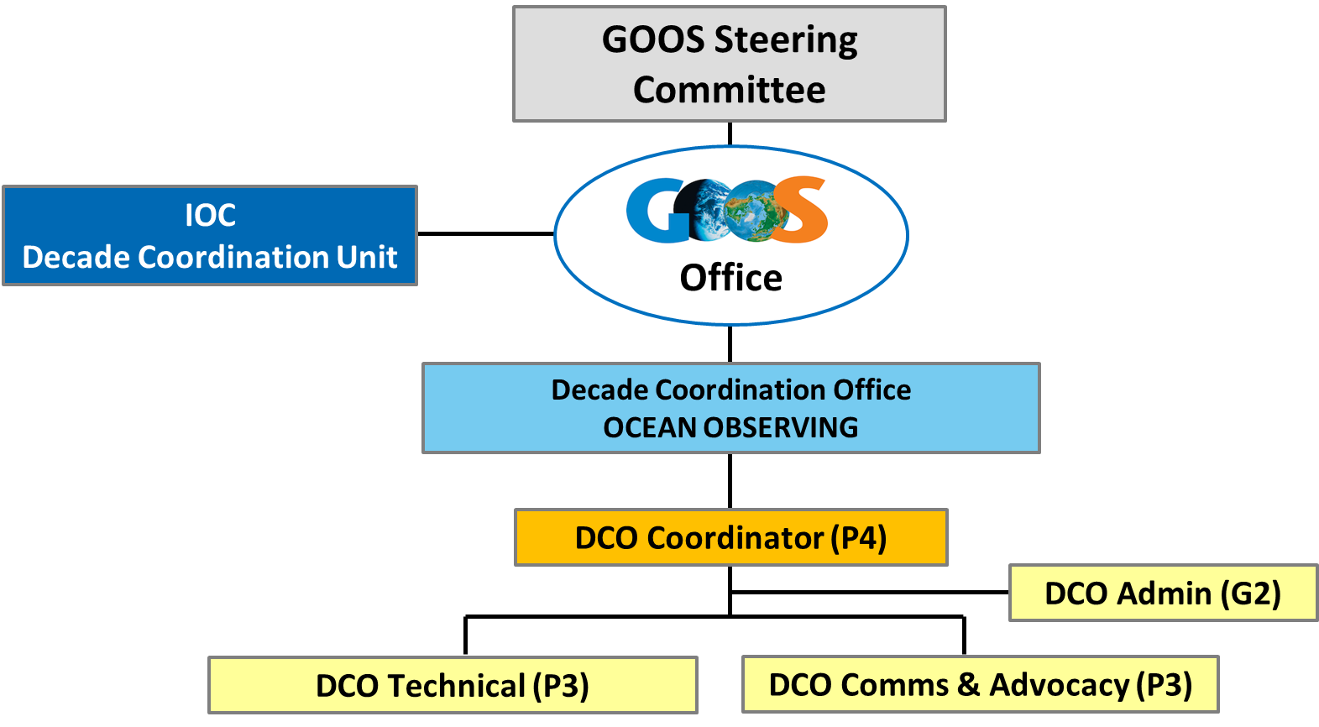

Support
The implementation of this DCO requires specific staffing and funding, as described in the DCO proposal, which will be sourced beyond the existing GOOS budget. However, there are several institutions, as described below, that form an enabling environment providing support to the DCO, for example in terms of in-kind support, expertise and ongoing promotion.
The Global Ocean Observing System (GOOS) coordinates sustained ocean observing activities across the global ocean, to support the delivery of information to those taking decisions across climate adaptation and policy, regarding hazard warnings and weather, for marine resource management, and for marine transport and operations. GOOS has three key delivery areas: climate, forecasts and warnings, and ocean health.
The GOOS community encompasses local, national and regional ocean observing systems and programmes, principal investigators, scientists and technicians undertaking sustained observations within national programs and global ocean observing networks, and many individuals contributing to the work of GOOS.
Through the work of its core components, GOOS leads the community in creating the frameworks and partnerships required to meet the needs of the diverse array of end users, across climate, weather and hazard forecasts, and ocean health. They include:
- The GOOS Observations Coordination Group (OCG) strengthens implementation of 12 global ocean observing networks. Together these networks deliver common data streams from a range of the different ocean and above ocean observing platforms. Eighty-six countries support these 12 global ocean-observing networks, with some 8,900 in situ observing platforms in operation monitoring a broad range of Essential Ocean Variables (EOVs). The OCG works across the global networks to support integrated system design, efficiency, and the timely delivery of high-quality ocean data; best practices, technological innovation, and the evolution of networks to meet future requirements are important parts of this work.
- The GOOS BioEco Panel supports the development of observing networks in the biological realm, it coordinates 13 BioEco networks, such as microbes, phytoplankton, fish, marine mammals, macroalgae and seagrass.
- A technical coordination team at OceanOPS and IODE’s Ocean Biodiversity Information System (OBIS) supports the implementation of GOOS through the integration and harmonization of metadata – basic information about data that makes it easier to find and use. This metadata management allows for accurate monitoring of ongoing global ocean observing activity across the 12 OCG networks and helps to ensure that data and metadata can be delivered to stakeholders.
- Fifteen GOOS Regional Alliances (GRAs), support and coordinate implementation at a regional level with the mandate to connect “Global to Regional to National level”. GRAs coordinate across national systems to solve regional priorities, differing by need, resources and culture. These interact with each other to learn and share best practice in implementing observing systems.
- The Expert Team on Operational Ocean Forecasting (ETOOFS) creates guidance to improve the global quality, interoperability and capacity for ocean forecast products.
The GOOS Components and community will be part of the implementing environment that will support the work of the DCO.

Annex 1: The UN Ocean Decade & the role of a Decade Coordination Office
The United Nations Decade of Ocean Science for Sustainable Development
The United Nations (UN) Decade of Ocean Science for Sustainable Development 2021-2030 (referred to as ‘the Decade’) was proclaimed by the 72nd Session of UN General Assembly (UNGA) on the 5th of December, 2017. The Decade is being coordinated by IOC-UNESCO in an effort from to promote transformational, large-scale change to advance urgent action on moving from the ‘ocean we have’ to the ‘ocean we want’. It includes a focus on least developed countries (LDCs), Small Island Developing States (SIDS) and land-locked developing countries (LLDCs).
The Decade aims to catalyze the human behavior change required, and to be inter-generational, recognize and redress gender disparities in ocean science, and be of sufficiently long duration to deliver lasting change. Guided by the United Nations Convention on the Law of the Sea (UNCLOS), the Decade will generate the data, information and knowledge needed for more robust science-informed policies and stronger science-policy interfaces at global, regional, national and even local levels, leading to improved integrated ocean management and development of a sustainable ocean economy. It represents an opportunity to build scientific capacity and knowledge to contribute to the goals of the 2030 Agenda for Sustainable Development. In our information-centred, internet-linked society, the Decade will support ocean data, information, and knowledge systems to evolve to a much higher level of readiness, accessibility, and interoperability. The scale of such efforts will need to be exponentially greater than anything seen to date.
The IOC has established an Implementation Plan to guide the Decade, which will be supported by contributions from Member States, specialized agencies, funds, programmes and bodies of the United Nations, as well as other intergovernmental organizations, non-governmental organizations and relevant stakeholders. The Decade Action Framework is built on ten challenges and three objectives that will contribute to creating the “ocean we want”. This includes a series of Decade Actions grouped into (i) “Decade Programmes”, long-term regional or global actions towards one or more challenges, (ii) “Decade Projects”, discrete and focused undertaking at regional, national or subnational scales, that typically contributes to a Decade Programme, and (iii) “Decade Activities”, on-off standalone initiative that contributes to a Project or Programme.
Decade Actions will be implemented voluntarily by any interested partner, following guidance from the Decade Advisory Board (DAB) and coordinated by the Decade Coordination Unit (DCU), a centralized coordination body within the IOC; Decade Coordination Offices (DCO), decentralized offices that support the work of the DCU; Decade Collaborative Centres (DCC), decentralized independent organizations that support Decade Programmes for specific challenges or basins; and Decade Implementing Partners, entities that contribute support Decade Actions work through specific tasks.
The Role of a Decade Coordination Office
The ultimate aim of the Ocean Decade is to have a full and coordinated matrix of partners covering all major themes and geographies and operating in a way that enhances collaboration and avoids overlap.
Decade Coordination Offices provide support to the DCU by catalyzing and coordinating Decade Actions thematically (Ocean Decade Challenges) or geographically (ocean basins or land-based regions), as established in their endorsed scope. They will be equipped with a small team of dedicated staff, premises, and operational resources.
They provide technical, logistical, and financial support for scientific coordination and planning; the identification of collaboration opportunities; awareness-raising and stakeholder engagement; and technical and scientific capacities to support Decade Actions. Specifically, Coordination Offices will support, within their scope, (i) Stakeholder Coordination, Facilitation and Engagement; (ii) Calls for Action; (iii) Monitoring & Reporting the advancement of the Decade; (iv) Communications; (v) Resource Mobilization; and (vi) Coordination of Decade Actions.
The figure below provides and overview of the Ocean Decade governance and coordination structures.
Decade Coordination Offices must be proposed by UN organizations working in relevant areas of marine science such as research institutes or centres, NGOs, philanthropic Foundations, private sector entities or universities.
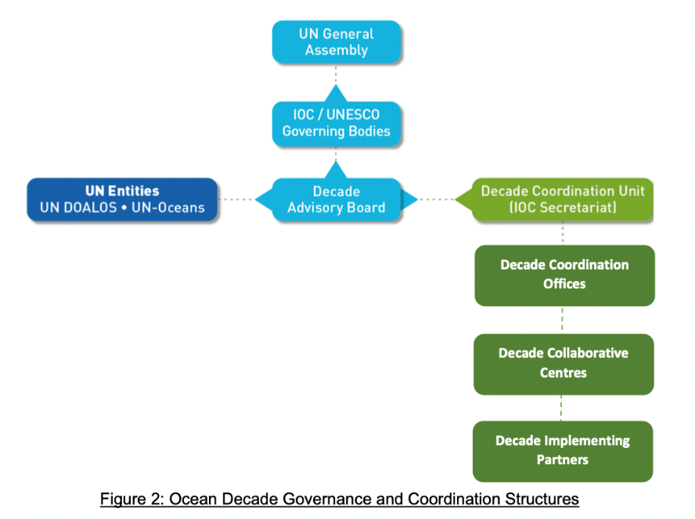
GLOSSARY
Action |  | The tangible initiatives that will be carried out across the globe over the next ten years to fulfil the Decade vision.
Activity |  | A Decade Activity is a one-off standalone Action (such as an awareness- raising event, a scientific workshop, or a training opportunity). It enables a programme or project, or directly contributes to an Ocean Decade Challenge.
Community of practice |  | Communities of Practice are mechanisms to allow coordination amongst partners working on similar themes or in similar geographies to optimize the collective impact throughout the Decade. They will be facilitated through the Global Stakeholder Forum.
Contribution |  | Supports the Decade through provision of a necessary resource (e.g. funding, resource mobilization, data, or an in-kind contribution, including staff, provision of infrastructure, or equipment). A contribution can support either the implementation of a Decade Action or the coordination functions of the Decade
Decade Advisory  Board |  | A multi-stakeholder advisory body to the IOC Governing Bodies that will provide strategic advice on Decade implementation.
Decade Collaborative Centre |  | Centre hosted by one or more countries or an international organization engaged in Decade activities that will catalyze Decade Actions at the regional or thematic level by providing technical, logistical, and financial support for: (i) scientific coordination and planning; (ii) the identification of collaboration opportunities; (iii) awareness raising and stakeholder engagement; and (iv) technical and scientific capacities to support Decade Collaborative Centres will be legally separate from the IOC and operated under the complete responsibility of the establishing entity(ies).
Decade Coordination Office |  | Offices hosted by UN Member States and requiring the establishment of a Seat Agreement with the host Member State and the provision of financial resources through IOC/UNESCO or other UN frameworks. Offices will act as ‘decentralized’ Decade Coordination Units, being organically attached to the central Decade Coordinating Unit, and will be responsible for a regional portfolio of Decade Actions and/or specific thematic initiatives
Decade Coordination Unit |  | Central coordination unit for the implementation of the Decade that will be housed within the IOC Secretariat.
Decade Implementing  Partner |  | Stakeholder institutions (e.g. research institutes, NGOs, universities) that are committed to the vision and mission of the Decade and that are  making significant and sustained efforts to support the Ocean Decade.
Decentralized  coordination structure |  | Decade Coordination Offices, Decade Collaborative Centres, and/or Decade Implementing Partners.
Global Stakeholder  Forum |  | A convening mechanism for all Decade stakeholder engagement networks. The Forum will have both virtual and physical elements.
National Decade Committee |  | Existing or new structures that coordinate actors at the national level. Committees are inclusive multi- agency and multi-stakeholder platform for  the co-design and co-delivery of Actions and facilitate access to benefits such as data, products, science-policy advice, or capacity development.
Decade Objective |  | Process objectives that describe the steps in the science value-chain that are needed to meet the Ocean Decade Challenges and thus contribute to  achieving the Decade Outcomes.
Ocean Decade Alliance |  | Resource mobilization mechanism focused on voluntary, large-scale  commitments from governments, UN entities, private sector, foundations  or other Decade supporters.
Ocean Decade  Challenge |  | Most pressing and immediate priorities of the Decade. Used to unite stakeholders around common action. May evolve throughout the Decade.
 | Ocean science |  | Encompasses natural and social science disciplines, including interdisciplinary approaches; the technology and infrastructure that supports ocean science; the application of ocean science for societal benefit, including knowledge transfer and applications in regions that are lacking science capacity; and the science-policy and science-innovation interfaces. Ocean science embraces local and indigenous knowledge as a fundamental source of knowledge. It recognizes the central role of the ocean in the earth system, and includes consideration of the land-sea interface and ocean-atmosphere and ocean-cryosphere interactions.
 | Decade Outcome |  | Describes the ‘ocean we want’ at the end of the Decade. Outcomes  describe both the desired state of the ocean, and the desired state of society’s use of, and interaction with, the ocean.
 | Decade Programme |  | A Decade Action that is typically global or regional in scale and will contribute to the achievement of one or more of the Ocean Decade Challenges. It is long-term (multi-year), interdisciplinary and multi-national. A programme will consist of component projects, and potentially enabling activities.
 | Decade Project |  | A Decade Action is a discrete and focused undertaking that is typically of a shorter duration. It may be regional, national or sub-national and it will typically contribute to an identified Decade programme.
 | Proponent |  | An institution who proposes and implements a Decade Action, Coordination Office, Collaborative Centre, Implementing Partner, or other forms of contributions to the Decade.
 | UN entity |  | United Nations agencies, funds, and programmes.

Proposed Budget for DCO Ocean Observing (GOOS) implementation (June 2022)

 | Estimated amount in US$
Resources | 2022 (H2) | 2023 | 2024 | 2025 | 2026 | Total
Staffing costs | 296,692 | 540,615 | 540,615 | 540,615 | 540,615 | 2,459,152
Operational costs (incl. comms) | 130,000 | 216,000 | 226,000 | 227,500 | 237,500 | 1,037,000
Total yearly | 326,750 | 756,615 | 766,615 | 768,115 | 778,115 | 3,496,152

ANNEX 3

TERMS OF REFERENCE AND BUDGET NEEDS
FOR DATA SHARING DECADE COORDINATION OFFICE
Ocean Decade Coordination Office for Ocean Data Sharing
Terms of Reference
The following document details the terms of reference for the Decade Coordination Office for Ocean Data Sharing, in accordance with the decision made during the Meeting of the IODE Management Group on 22 March 2022 (ref. Summary Report IOC/IODE-MG-2022/3, dated 28 March 2022), and based on the proposal submitted by the IODE Project Office to the Decade Coordination Unit on 21 February 2022.

Overview
The core focus of the Decade Coordination Office (DCO) for Ocean Data Sharing will be on supporting the Ocean Decade Challenge 8 : “Through multi-stakeholder collaboration, develop a comprehensive digital representation of the ocean, including a dynamic ocean map, which provides free and open access for exploring, discovering, and visualizing past, current, and future ocean conditions in a manner relevant to diverse stakeholders.” The DCO will thus support the development of the capacity, functionality and interoperability of the management of and accessibility to ocean data, information and knowledge.
The DCO aims to manage the Data Sharing component of the digital ecosystem needed for the Ocean Decade to be successful. Thus it will also support, interact and overlap with the other components of the digital ecosystem and therefore enables challenges 7 and 9.
- Challenge 9: “Ensure comprehensive capacity development and equitable access to data, information, knowledge and technology across all aspects of ocean science and for all, stakeholders.”
- Challenge 7: “Ensure a sustainable ocean observing system across all ocean basins that delivers accessible, timely, and actionable data and information to all users.”
See also Figure below that illustrates the Ocean Data “data structure” which demonstrates the importance of “quality” data management and sharing to ensure the reliability of data products such as models and applications.
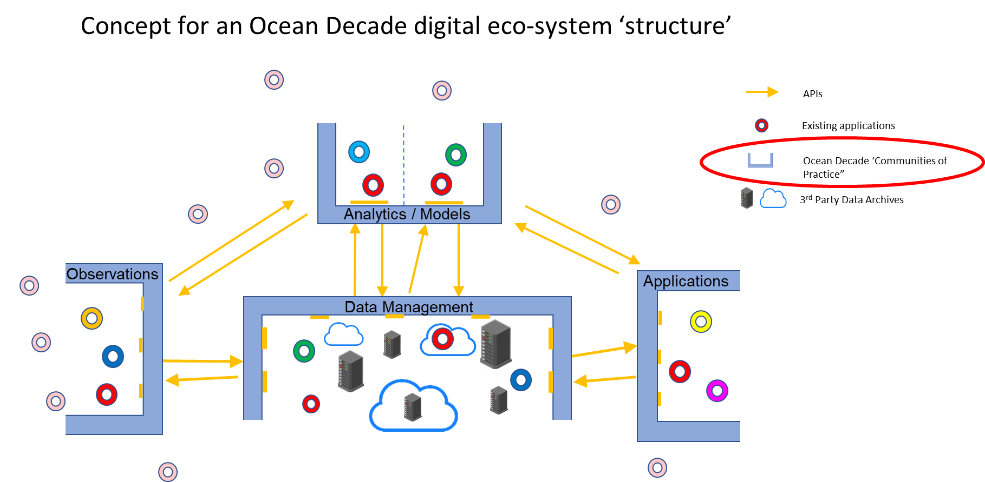
The activities of this DCO will promote sustained digital interoperability between the data, information, and digital knowledge generated by initiatives across the Decade. It will bring together digital stakeholders – across regions, organizational scales, and capacity levels – to negotiate and establish clear agreements (from high- to low-level) on their co-development of the Decade’s digital ecosystem.
The DCO for Ocean Data Sharing will continue coordinating activities towards cooperation between both UN and non-UN organizations which were started by IODE in 2020 (two workshops were held to bring together UN organizations and non-UN organizations to share information on their data activities and data holdings, and to invite them to collaborate under the Decade).
The DCO’s activities will support a transparent, structured, intelligent, interoperable, and functional co-development of the Decade’s initial interoperability strategy described in the Implementation Plan:
“No single or central digital infrastructure or system will be sufficient to meet the needs of the Decade. Implementation of the digital ecosystem will require inclusive and outward-facing co- design and co-construction of a distributed, integrated and interoperable set of digital solutions that will form components of the overall ecosystem. Collectively these components will represent the socio-ecological dimensions of the ocean, including the numerous pathways to support sustainable development. Implementation will include concrete efforts to bridge efforts across global, regional and local scales.” [para 48 of the Decade Implementation Plan Version 2.0]
“The Decade digital ecosystem will catalyse cooperation between data generators and users from diverse stakeholder groups including governments, UN entities, scientists, planners, decision-makers, as well as industry and the public. The digital ecosystem and its component parts will support users in accessing, understanding, assessing, and providing impactful feedback on raw and processed data, information and knowledge so that these better meet their specific needs.” [para 51 of the Decade Implementation Plan Version 2.0]
Building on this implementation vision and in line with the early considerations of the Ocean Decade Data Coordination Group, the DCO’s activities will ensure that well-defined, transparent and functional digital value chains are maintained and inclusively interlink the Decade’s stakeholders in a robust digital commons. These multifaceted value chains will be complex, and the DCO will leverage data-driven interoperability diagnostics to assess and strengthen links between the observations and operations communities, modelling communities, digital twin initiatives, and other key stakeholders such as local communities and indigenous data stewards. Early on, this coordination will leverage existing collaborations between IODE and initiatives such as OA, HAB, GOSR, StoR, and GOOS to pilot and tune the approach.
In addition, the DCO will, through its OceanTeacher Global Academy (OTGA), Ocean InfoHub (OIH) and other related IODE projects (which have also been submitted as Decade Actions) work towards equitable participation of all IOC Member States (and related regional organizations) in the Decade data activities, thereby also furthering the mission described in the Capacity Development chapter of the Decade Implementation Plan. These activities will anchor broader networks of data, information, and capacity sharing, while maintaining an overall strategic direction continually shaped by partner feedback.

Terms of Reference
The DCO for Ocean Data Sharing shall carry out the following actions in support of the Decade:
Coordination of Actions and Stakeholder Facilitation and Engagement
- Organization of (online) meetings for stakeholder communities (grouped or joint and in close cooperation with the Data Coordination Group) to discuss the targets of the data chapter of the Decade IP, required infrastructure and methodologies, possible contributions from stakeholder communities, benefits to stakeholder communities,
- Engage and coordinate with the Data Coordination Group and the Technical Implementation Coordination Group that will be implemented within the Data Coordination Platform set up by the DCU,
- Organization of (online) meetings with leaders of related, relevant Decade DCCs, DIPs (Decade Implementing Partners), and DCOs, Programmes and Projects to ensure coherent actions and complementarity and facilitate this through the community of practice on the global stakeholder forum,
- Establishment of technical or strategic sub-groups to co-design required actions in response to Calls for Decade Actions with attention to end user engagement and end user needs,
- Facilitate Decade Actions (eg through the IODE/GOOS OBPS) in support of best practices for data management and sharing, scientific coordination and planning, tools and resources for developing capacity on research data management and sharing, and resources for data publishing, sharing and interoperability,
- Promote cooperation with relevant IOC Programmes, related Projects, other relevant UN entities and stakeholder groups in order to advance the implementation of the Decade,
- Support capacity development under the remit of the DCO which can be provided through existing activities such as OceanTeacher Global Academy and related activities
- Maintain an updated list of relevant Decade Programmes, Projects, and Activities, as well as Decade Contributions, when they are relevant for the DCO’s scope of work, including information on relevant contacts, status, partners, and its expected activities and outcomes.
- Proactively facilitate the structuring and engagement of a Communities of Practice around ocean data sharing via the Global Stakeholder Forum to facilitate dialogue and exchange between other Decade stakeholders.

Supporting Decade Calls for Action
- Based upon requirements identified during stakeholder meetings, draft calls for action to contribute to the expected outcomes (facilitate discussions in CoPs on gaps and needs in the digital ecosystem to inform the scoping of future calls for decade actions in close cooperation with the DCG).
- Discuss and coordinate draft calls with DCU (as well as with DCCs and ongoing programmes, projects to ensure complementarity). CFDAs will be launched by DCU – role of DCO is to provide input to scoping and provide input to review process for programmes to inform endorsement decisions.
- The IODE Project Office, IODE Committee and active IODE projects regularly publish and review calls for proposals for consultants and sub-contractors, so mechanisms are in place.

Monitoring & Reporting
- Organize regular reporting by all DCCs, DIPs, programmes and projects within the scope of work of the DCO and in line with the requirements of the Monitoring and Evaluation Framework of the Ocean Decade
- Provide advice and data to the DCU on monitoring and evaluating progress of the Decade Programs, Projects and Activities under its scope of work.
- Deliver an annual workplan to the DCU and the IODE Management Group on the first semester of each year, setting out the DCO’s priorities, tasks, goals, and timing for the year, to make sure there is alignment with the Ocean Decade goals, the other DCOs/DCCs, and other relevant Decade stakeholders.
- Present an annual financial and activity report for the previous calendar year, to be presented during the first trimester to the DCU and the IODE Management Group.
- Contribute to Decade annual reporting, including the preparation of programmatic / geographic summaries of Decade Actions under their scope of work, case studies or more in-depth thematic or geographic analyses.

Communications
- Raise awareness and visibility of the Decade amongst diverse stakeholder groups and coordinate targeted communications activities in line with branding and messaging guidelines provided by the Decade Coordination Unit
- Organize regular communication of all activities undertaken by DCCs, programmes and projects under the scope of work of the DCO, through appropriate communication and public awareness channels
- Ensure communication channels between the DCO for Ocean Data Sharing, other DCOs and the DCU to ensure overall coordination of communication on data and information across all IP chapters.

Mobilization of Resources
- In close coordination with the DCU, DCCs, programmes and projects under the scope of the DCO, and supported by relevant communication efforts, undertake resource mobilization efforts to fund endorsed Decade projects and programmes through financial or in-kind contributions by member states, other organizations, private sector and foundations
- Coordinate Resource Needs Assessments of endorsed programmes and projects under the responsibility of the DCO in line with guidance provided by the DCU
- Seek partnerships, voluntary commitments, sponsorship and funding to strengthen the implementation and impact of a world-class digital data eco-system.

Other Agreed Functions & Responsibilities
- Align strategy development and implementation with:
  - The other DCOs, DIPs and DCCs that are established within the Decade that focus on the observation, management, analysis and /or delivery of data and information.
  - The Data Coordination Group and the Technical Implementation Coordination Group that will be formed under the Terms of Reference of the Data Coordination Platform, and with the Data & Knowledge Management Officer of the DCU.
- Encourage adherence to best practices (including existing data policies and terms of use) and FAIR data principles within the Decade Actions.

Governance
The IODE programme’s governing body is the IODE Committee, composed of heads of NODCs, ADUs and AIUs. IOC Member States, in addition, provide in-kind support to the IODE programme through their national data and information centres, which are members of the IODE Committee.
The IOC Project Office for IODE was formally approved for establishment by the IOC Assembly at its 22nd Session (2003) through Resolution XXII-7 and officially inaugurated on 25 April 2005. It is the decentralized secretariat of the IODE Programme. Based in Oostende, Belgium, it coordinates all project activities of the IODE Programme, as well as the IOC capacity development strategy.
The DCO for Ocean Data Sharing will be hosted by the IODE Project Office to ensure a non-duplicative coordination role and to benefit from available in-kind resources (e.g. office space, etc.). The DCO will report to the IODE Project Office on regular operations and will report to the DCU and IODE Management Group on major decisions regarding funding, scope and direction, and to report on progress, similar to other IODE components.
The DCO’s team includes a full-time Manager who will manage the office and provide high-level support for its activities; a Technical Implementation Lead; and an Administrative Assistant. The DCO Manager will act as the focal point, responsible for maintaining communications with other Decade organizations, such as the DCU and other DCOs/DCCs. The organizational chart below provides an overview of the lines of authority and communication of the DCO team:
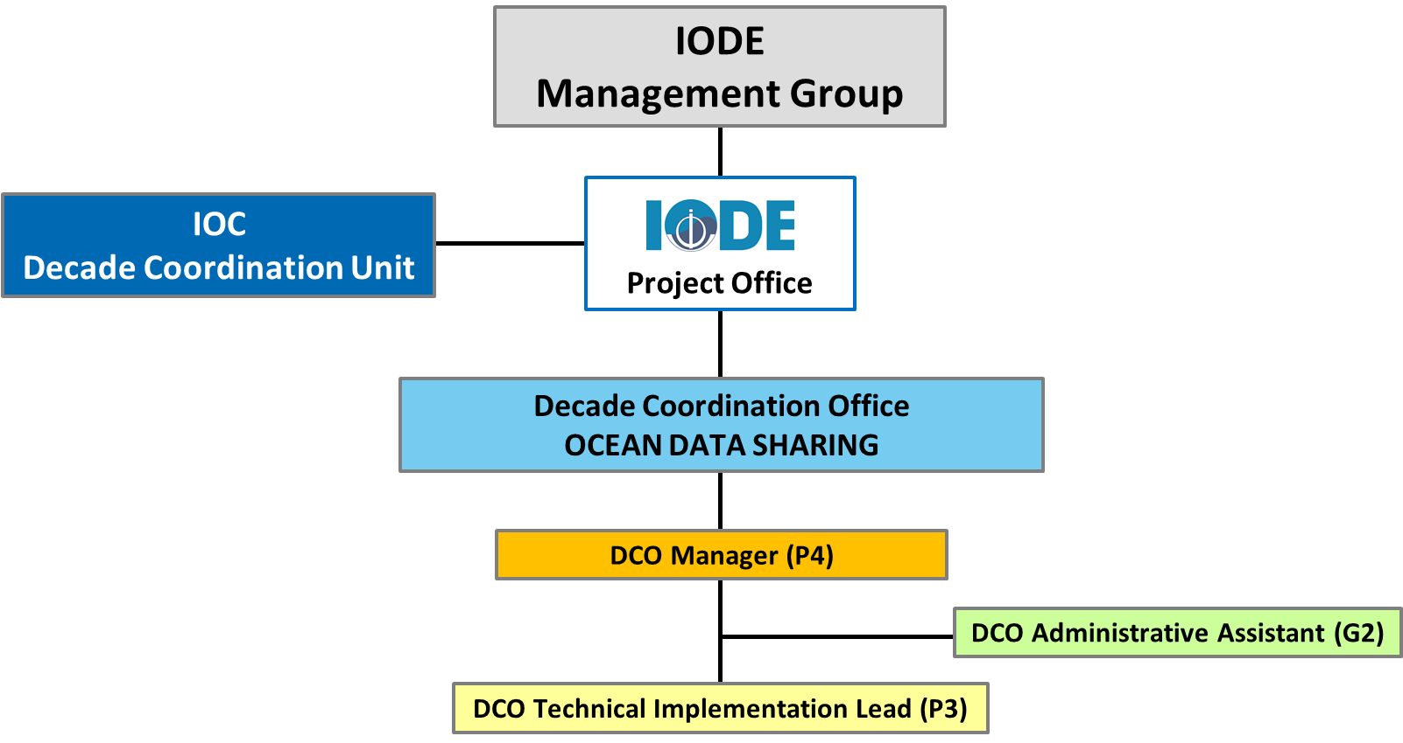

Other Supporting Institutions
We note that all members of the IODE network (see https://www.iode.org/nodc and https://www.iode.org/adu ) should be considered as partners as they will all contribute their data systems and expertise. The IODE as a programme has established a global network of 100 oceanographic data centres and information centres. It regularly approaches IOC Member States to join the global network and often partners with sub-national entities.
In addition, the expanding network of Ocean InfoHub/ODIS network (https://oceaninfohub.org ) should be considered as partners; these include member state institutions, regional and international organizations, IOC regional offices and individual experts.
Finally, several IODE members may be willing to provide financial or in-kind (staff) assistance for the operation of the DCO. This would create a long-term sustainable resource basis to ensure the long-term operation of the DCO, preferably in combination with cash funding and contractual staff.
Annex 1: The UN Ocean Decade & the role of a Decade Coordination Office
The United Nations Decade of Ocean Science for Sustainable Development
The United Nations (UN) Decade of Ocean Science for Sustainable Development 2021-2030 (referred to as ‘the Decade’) was proclaimed by the 72nd Session of UN General Assembly (UNGA) on the 5th of December, 2017. The Decade is being coordinated by IOC-UNESCO in an effort from to promote transformational, large-scale change to advance urgent action on moving from the ‘ocean we have’ to the ‘ocean we want’. It includes a focus on least developed countries (LDCs), Small Island Developing States (SIDS) and land-locked developing countries (LLDCs).
The Decade aims to catalyze the human behavior change required, and to be inter-generational, recognize and redress gender disparities in ocean science, and be of sufficiently long duration to deliver lasting change. Guided by the United Nations Convention on the Law of the Sea (UNCLOS), the Decade will generate the data, information and knowledge needed for more robust science-informed policies and stronger science-policy interfaces at global, regional, national and even local levels, leading to improved integrated ocean management and development of a sustainable ocean economy. It represents an opportunity to build scientific capacity and knowledge to contribute to the goals of the 2030 Agenda for Sustainable Development. In our information-centred, internet-linked society, the Decade will support ocean data, information, and knowledge systems to evolve to a much higher level of readiness, accessibility, and interoperability. The scale of such efforts will need to be exponentially greater than anything seen to date.
The IOC has established an Implementation Plan to guide the Decade, which will be supported by contributions from Member States, specialized agencies, funds, programmes and bodies of the United Nations, as well as other intergovernmental organizations, non-governmental organizations and relevant stakeholders. The Decade Action Framework is built on ten challenges and three objectives that will contribute to creating the “ocean we want”. This includes a series of Decade Actions grouped into (i) “Decade Programmes”, long-term regional or global actions towards one or more challenges, (ii) “Decade Projects”, discrete and focused undertaking at regional, national or subnational scales, that typically contributes to a Decade Programme, and (iii) “Decade Activities”, on-off standalone initiative that contributes to a Project or Programme.
Decade Actions will be implemented voluntarily by any interested partner, following guidance from the Decade Advisory Board (DAB) and coordinated by the Decade Coordination Unit (DCU), a centralized coordination body within the IOC; Decade Coordination Offices (DCO), decentralized offices that support the work of the DCU; Decade Collaborative Centres (DCC), decentralized independent organizations that support Decade Programmes for specific challenges or basins; and Decade Implementing Partners, entities that contribute support Decade Actions work through specific tasks.
The Role of a Decade Coordination Office
The ultimate aim of the Ocean Decade is to have a full and coordinated matrix of partners covering all major themes and geographies and operating in a way that enhances collaboration and avoids overlap.
Decade Coordination Offices provide support to the DCU by catalyzing and coordinating Decade Actions thematically (Ocean Decade Challenges) or geographically (ocean basins or land-based regions), as established in their endorsed scope. They will be equipped with a small team of dedicated staff, premises, and operational resources.
They provide technical, logistical, and financial support for scientific coordination and planning; the identification of collaboration opportunities; awareness-raising and stakeholder engagement; and technical and scientific capacities to support Decade Actions. Specifically, Coordination Offices will support, within their scope, (i) Stakeholder Coordination, Facilitation and Engagement; (ii) Calls for Action; (iii) Monitoring & Reporting the advancement of the Decade; (iv) Communications; (v) Resource Mobilization; and (vi) Coordination of Decade Actions.
The figure below provides and overview of the Ocean Decade governance and coordination structures.
Decade Coordination Offices must be proposed by UN organizations working in relevant areas of marine science such as research institutes or centres, NGOs, philanthropic Foundations, private sector entities or universities.

GLOSSARY
Action |  | The tangible initiatives that will be carried out across the globe over the next ten years to fulfil the Decade vision.
Activity |  | A Decade Activity is a one-off standalone Action (such as an awareness- raising event, a scientific workshop, or a training opportunity). It enables a programme or project, or directly contributes to an Ocean Decade Challenge.
Community of practice |  | Communities of Practice are mechanisms to allow coordination amongst partners working on similar themes or in similar geographies to optimize the collective impact throughout the Decade. They will be facilitated through the Global Stakeholder Forum.
Contribution |  | Supports the Decade through provision of a necessary resource (e.g. funding, resource mobilization, data, or an in-kind contribution, including staff, provision of infrastructure, or equipment). A contribution can support either the implementation of a Decade Action or the coordination functions of the Decade
Decade Advisory  Board |  | A multi-stakeholder advisory body to the IOC Governing Bodies that will provide strategic advice on Decade implementation.
Decade Collaborative Centre |  | Centre hosted by one or more countries or an international organization engaged in Decade activities that will catalyze Decade Actions at the regional or thematic level by providing technical, logistical, and financial support for: (i) scientific coordination and planning; (ii) the identification of collaboration opportunities; (iii) awareness raising and stakeholder engagement; and (iv) technical and scientific capacities to support  Decade Collaborative Centres will be legally separate from the IOC and operated under the complete responsibility of the establishing entity(ies).
Decade Coordination Office |  | Offices hosted by UN Member States and requiring the establishment of a Seat Agreement with the host Member State and the provision of financial resources through IOC/UNESCO or other UN frameworks. Offices will act as ‘decentralized’ Decade Coordination Units, being organically attached to the central Decade Coordinating Unit, and will be responsible for a regional portfolio of Decade Actions and/or specific thematic initiatives
Decade Coordination Unit |  | Central coordination unit for the implementation of the Decade that will be housed within the IOC Secretariat.
Decade Implementing  Partner |  | Stakeholder institutions (e.g. research institutes, NGOs, universities) that are committed to the vision and mission of the Decade and that are making significant and sustained efforts to support the Ocean Decade.
Decentralized  coordination structure |  | Decade Coordination Offices, Decade Collaborative Centres, and/or Decade Implementing Partners.
Global Stakeholder  Forum |  | A convening mechanism for all Decade stakeholder engagement networks. The Forum will have both virtual and physical elements.
National Decade Committee |  | Existing or new structures that coordinate actors at the national level. Committees are inclusive multi- agency and multi-stakeholder platform for the co-design and co-delivery of Actions and facilitate access to benefits such as data, products, science-policy advice, or capacity development.
Objective |  | Process objectives that describe the steps in the science value-chain that are needed to meet the Ocean Decade Challenges and thus contribute to achieving the Decade Outcomes.
Ocean Decade Alliance |  | Resource mobilization mechanism focused on voluntary, large-scale commitments from governments, UN entities, private sector, foundations or other Decade supporters.
Ocean Decade  Challenge |  | Most pressing and immediate priorities of the Decade. Used to unite stakeholders around common action. May evolve throughout the Decade.
 | Ocean science |  | Encompasses natural and social science disciplines, including interdisciplinary approaches; the technology and infrastructure that supports ocean science; the application of ocean science for societal benefit, including knowledge transfer and applications in regions that are lacking science capacity; and the science-policy and science-innovation interfaces. Ocean science embraces local and indigenous knowledge as a fundamental source of knowledge. It recognizes the central role of the ocean in the earth system, and includes consideration of the land-sea interface and ocean-atmosphere and ocean-cryosphere interactions.
 | Outcome |  | Describes the ‘ocean we want’ at the end of the Decade. Outcomes describe both the desired state of the ocean, and the desired state of society’s use of, and interaction with, the ocean.
 | Programme |  | A Decade Action that is typically global or regional in scale and will contribute to the achievement of one or more of the Ocean Decade Challenges. It is long-term (multi-year), interdisciplinary and multi-national. A programme will consist of component projects, and potentially enabling activities.
 | Project |  | A Decade Action is a discrete and focused undertaking that is typically of a shorter duration. It may be regional, national or sub-national and it will typically contribute to an identified Decade programme.
 | Proponent |  | An institution who proposes and implements a Decade Action, Coordination Office, Collaborative Centre, Implementing Partner, or other forms of contributions to the Decade.
 | UN entity |  | United Nations agencies, funds, and programmes.

Proposed Budget for DCO Ocean Data Sharing (IODE) implementation (June 2022)

 | Estimated amount in US$
Resources | 2022 (H2) | 2023 | 2024 | 2025 | 2026 | Total
Staffing costs | 222,500 | 444,996 | 444,996 | 444,996 | 444,996 | 2,002,484
Operational costs (incl. comms) | 140,000 | 216,000 | 226,000 | 227,500 | 237,500 | 1,047,000
Total yearly | 362,500 | 660,996 | 670,996 | 672,496 | 682,496 | 3,049,484

Intergovernmental Oceanographic Commission (IOC)
United Nations Educational, Scientific and Cultural Organization
7, Place de Fontenoy
75 732 Paris 07 SP, France
Tel.: +33 1 45 68 03 18
http://ioc.unesco.org

