Intergovernmental Oceanographic Commission
Reports of Meetings of Experts and Equivalent Bodies

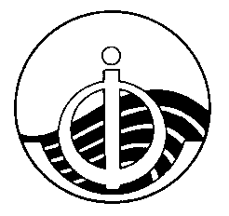

IODE Steering Group for the Ocean InfoHub Project

Report

Second Session (Virtual)
5 October 2021

5 October 2021
English only

For bibliographic purposes this document should be cited as follows:

IODE Steering Group for the Ocean InfoHub Project (SG-OIH), Second Session, 5 October (virtual meeting) 26pp. & Annexes, 2021. (Reports of Meetings of Experts and Equivalent Bodies).

Table of contents

page
1. Introduction 1
2. Opening of the meeting 1
3. Adoption of the Agenda 2
4. Overview of the OIH work plan and deliverables 2
4.1 Work package 1: Project management, coordination and evaluation 4
4.2 Work package 2: Technology development 6
4.3 Work package 3: Establishment and initial support of the global hub and regional
nodes 11
4.4 Work package 4: Training and capacity development of the nodes 17
4.5 Work package 5: Communication, user marketing and feedback 19
5. Budget 22
6. Report on actions from SG-OIH-1 23
7. Election of the chair 24
8. Next meeting: Third Session of the SG-OIH 25
9. Group photograph and close of the meeting 25

ANNEXES

ANNEX I: Provisional agenda

ANNEX II: Summary of Additional Actions

ANNEX III: List of Participants

ANNEX IV: Reference documents shared in advance

Introduction
The Second Session of the IODE Steering Group for the Ocean InfoHub Project was convened on 5 October 2021. Due to the travel restrictions imposed by countries as a result of the COVID-19 pandemic, a face to face meeting was not possible. An alternative format was adopted involving the following elements:

- Background documents were prepared and circulated internally to core project team
- Background documents were sent to all Steering Group meeting participants in advance of the meeting.
- The meeting was held virtually in two sessions. Both sessions covered the entire agenda and the duplication was in order to allow for the Latin America and Caribbean region and the Pacific region to each meet at a reasonable hour. The meeting offered simultaneous English, Spanish and French translation in Session A, and simultaneous Spanish, English translation in Session B.
Session A: 5 October 1PM-3PM UTC: https://oceanexpert.org/event/3132
Session B: 5 October 7PM-9PM UTC: https://oceanexpert.org/event/3158
The purpose of the meeting was to provide a comprehensive overview of progress on the work plan over the past 12 months, and to get feedback on plans for the next year of the project. All workshop materials will be permanently located at the Ocean Expert links provided above.

Opening of the meeting
Mr Vladimir Ryabinin, Executive Secretary of the IOC of UNESCO, welcomed participants to the meeting on behalf of the IOC. He shared some thoughts and wished the participants all the best for the meeting, and acknowledged the important support from the Government of Flanders in making this project possible. This is a very significant contribution to the future of the ocean. During recent months, there is a high and increasing pace of work on ocean science and the decade, as well as work on the management and conservation of the ocean, as well as work on ocean data. The IOC has endorsed the project Digital Twin of the Ocean and are engaged in discussions with many other key stakeholders. The oceans are more and more at the centre of attention when it comes to climate, biodiversity, ocean economy, and also in the Convention on the Law of the Sea and Areas Beyond National Jurisdiction. The plan is to conduct the second conference of the UN on the Ocean, from 27 June to 1 July 2022, and President Macron has announced the One Ocean Summit. Data and the work on data opens huge possibilities for managing the ocean. What you are developing through the Ocean InfoHub Project is developing the foundation of the system – ODIS, and capitalising on ODIScat, so the unrolling of these projects is very important work, and will have important consequences for the future of oceanography and the ocean. Good luck and thanks very much.

Mr Gert Verreet, Policy Advisor in the Government of Flanders (Vlaamse Overheid - Departement Economie, Wetenschap & Innovatie, Afdeling Onderzoek), welcomed the participants on behalf of the Government of Flanders. I’m responsible for fostering natural sciences in our region and am also participating in the IOC delegation for Belgium. We think that the Ocean InfoHub Project is a very timely initiative to create the right interoperability between a number of data and information sources that allow dynamic interaction between providers and users. I stress the word dynamic as we are not just pushing information out, but allowing users and providers to interact. This relates to the concept of a clearinghouse for the transfer of marine technology which is one of the prominent elements in the IOC guidelines and criteria for the TMT which dates from some 15 years ago. In the motivation for the funding of this particular project, the Flanders government highlighted the following strong elements in the project proposal:
- That there was a clear link to other UN and IOC programmes; Agenda 2030, the UN Decade, SAMOA Pathway, and BBNJ.
- That it allows the delivery of commonly identified priorities in the marine science community, with particular attention to least developed countries and small island developing states.
- Furthermore, it capitalizes on existing developments that IOC is already undertaking; all these information systems that the IODE programme and others have developed over the years can be formatted and accessed in a new way. And so it aligns with a number of other initiatives and focusses on interoperability.
- The project focuses on the participation of the widest possible range of end user communities; this will ensure that the projects and services are useful to end users, and there is a strong focus on national and regional involvement while also providing a global umbrella with a similar architecture across different regions of the globe.

In conclusion, I’d like to call on all the participants today, especially those of the regional nodes, to make this interaction between users and providers happen, so that it really becomes technology from people for people.

Adoption of the Agenda
Mr Nogueira (SG-OIH Chair) presented the draft agenda, which was adopted without change in both Session A and Session B.

Overview of the OIH work plan and deliverables
A presentation was made by Lucy Scott and the OIH team, covering the deliverables to date and the upcoming work plans for the five work packages. The work plan is on track with no major technical delays.

The OIH Project has 5 work packages:

WP1: Project management, coordination and evaluation
WP2: Technology development
WP3: Establishment and initial support the global hub and regional nodes
WP4: Training and capacity development of regional nodes
WP5: Communication, user marketing and feedback

An overview was given of the timeline to date (Figure 1) and the current status of the implementation of ODIS (Figure 2).

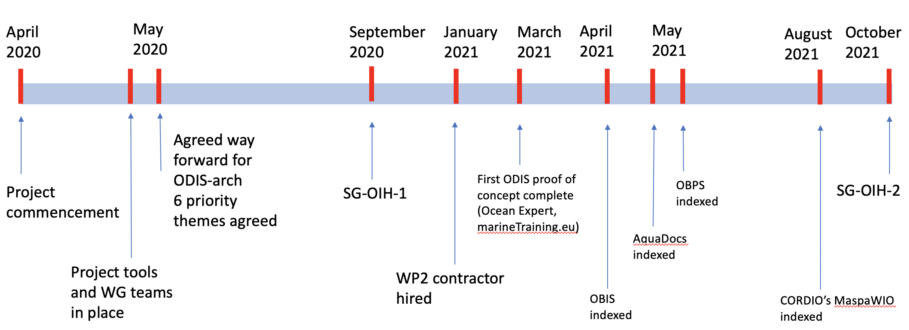

Figure 1. Overview of Ocean InfoHub Project to date

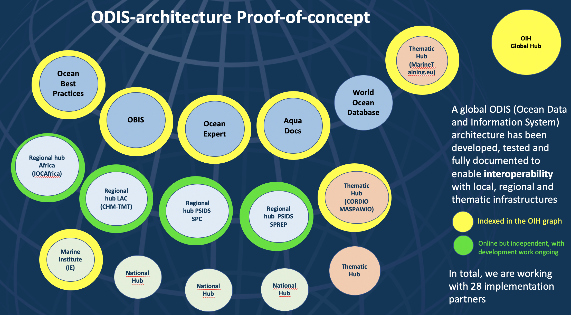

Figure 2. Current status of the implementation of the Ocean Data and information System

Work package 1: Project management, coordination and evaluation
This work package covers activities related to:
- overarching coordination and guidance
- planning and budget management
- monitoring and reporting
- risk and issue management
- project evaluation.

The role of the Steering Group is to:
- monitor and guide the implementation of the Ocean InfoHub
- propose remedial action where necessary
- advise the Project Manager
- ensure that the project serves user/region needs
- identify new opportunities and adjust the work plan according to changing needs and circumstances
- prepare annual progress reports

Table 1. Work Package 1 overview of timeline

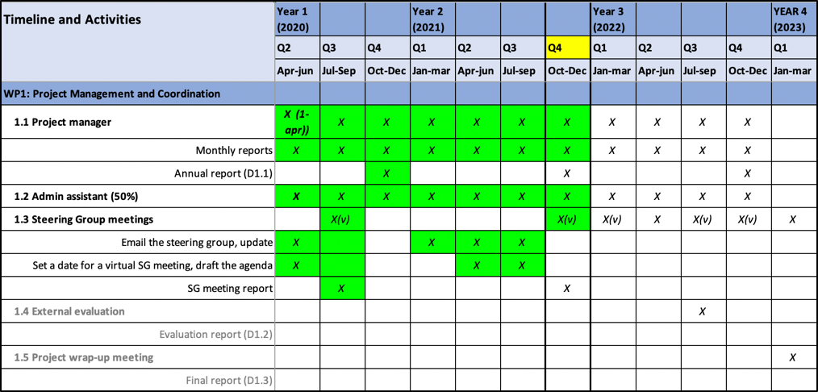

4.1.1 Deliverables October 2020-September 2021

1. Tracking sheet for all project deliverables maintained and monthly reports written. (Reference doc 1. OIH Project Timeline and Deliverables).

2. Steering Group meeting convened

3. General administration tasks (project management tools, calendars integrated, dropbox, Gdrive, regular IODE staff meetings and ad hoc UNESCO meetings).

4.1.2 Objectives 2021-2022

1. Tracking sheet for all project deliverables maintained and monthly reports written

2. Third session of the SG planned

3. General administration tasks continued

Questions, discussion and contributions from the chat

Session A
PP (via chat): PP: What data sources are now on the global hub?
LS: The data sources that are in the global hub, indexed into the OIH graph include the Ocean Biodiversity Information system, Ocean Best Practices System, Ocean Expert, AquaDocs, Marinetraining.eu (including the regional LAC CLME+ training portal), CORDIO’s MASPAWIO and the Marine Institute, Ireland. In total we are working with 28 implementation partners (these 7 plus 21).

AKL: What are the details of the participation of the Marine Institute, and could I find the details of the others in the report?
LS: Yes, we have a spreadsheet to keep track of progress with all the implementation partners, it is available online and is also in this report.(section XXX)
AL (via chat): At the Marine Institute, we were already publishing our metadata using patterns that are compatible with the OceanInfo Hub patterns and so our metadata were harvested into the knowledge graph.

Session B

No questions or interventions

Work package 2: Technology development
This work package covers the technical developments needed to support the implementation of Ocean InfoHub nodes and the proof-of-concept ODIS reference architecture which will allow the nodes to interoperate with each other and external systems.

In terms of Ocean InfoHub development, this work includes:

● development of a Global Hub
● development of Regional/Thematic Node application (Virtual nodes part of the Global Hub or as separate regional/thematic nodes)
● continued populating of ODISCat

Table 2. Work Package 2 overview of timeline

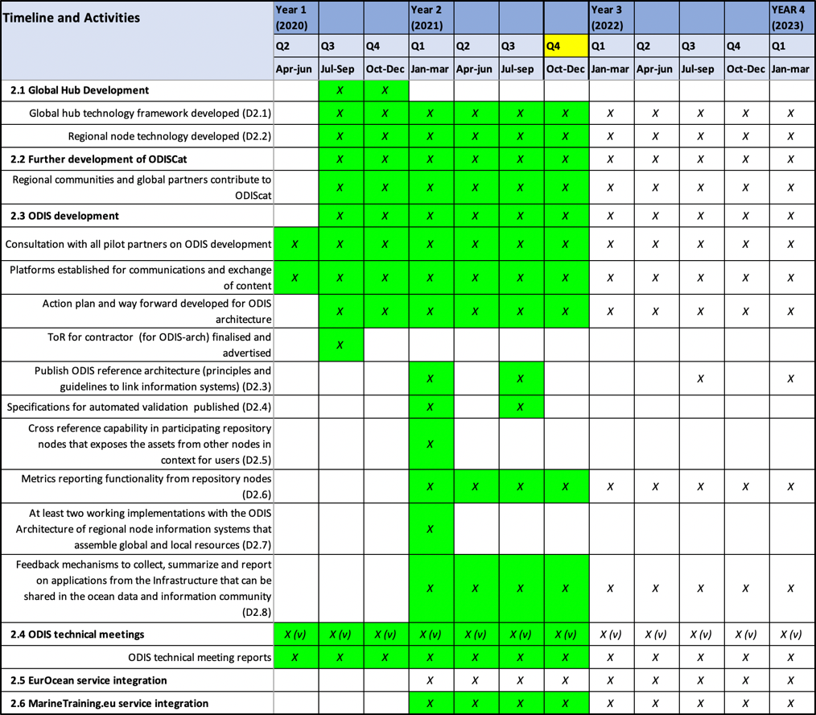

4.2.1 Deliverables October 2020-September 2021

Global Hub Development
4.2.1.1 Global hub technology framework developed (D2.1)
- We have the Ocean InfoHub website at https://oceaninfohub.org/
- We have developed and tested a reference implementation of the global hub server side architecture https://oceans.collaborium.io/index.html that demonstrates the facility to search across the existing seven working implementations. This is available online.
- We have a call open for the development of an OceanInfoHub Global Hub Search Portal as a demonstration of the ODIS. The contractor will be charged with developing a front-end web portal that dynamically builds content based on the (meta)data shared by early implementers of the ODIS-Architecture. This portal will have a high profile on the OIH web site home page.

4.2.1.2 Regional node technology developed (D2.2)
Regional nodes are currently online independently:
IOCAfrica: https://www.ioc-africa.org/
INVEMAR CHM-TMT: http://portete.invemar.org.co/chm#/
SPREP and SPC: https://www.spc.int/, https://www.sprep.org/
- We also do have regional data in the global OIH knowledge graph
- The global hub search portal will showcase the three regions.
- OIH-supported development work within each of the regions is actively bringing additional regional partners into the network.

4.2.1.3 Further development of ODISCat
Regional communities and global partners contribute to ODIScat
This is ongoing; at every new opportunity, organisations are asked to add records to ODIScat, and the projects have a close working partnership.

ODIS development

4.2.1.4 Consultation with all pilot partners on ODIS development
Regular WP2 core secretariat and partner meetings: 51 meetings over 12 months
GitHub repository: https://github.com/iodepo/odis-arch
Slack: >3,500 posts in XX channels. 50 Technical WG members.

4.2.1.5 Platforms established for communications and exchange of content
Completed

4.2.1.6 Action plan and way forward developed for ODIS architecture
Completed in the ToR for the ODIS-Arch contractor

4.2.1.7 ToR for contractor (for ODIS-arch) finalised and advertised
- Consultant hired and 8 month contract completed in September.
- New ToR is in process.
- ODIS specifications for six priority themes written and will be developed further on an ongoing basis.
- Documentation is available online at https://book.oceaninfohub.org
- Documentation is under continuous revision and improvement.

4.2.1.8 Publish ODIS reference architecture (principles and guidelines to link information systems) (D2.3)
Documentation for the Ocean InfoHub is located at https://book.oceaninfohub.org/. This documentation is structured to address the three primary personas expected in the OIH community. Those being Publisher, Aggregator and User. An introduction to these personas is found at https://book.oceaninfohub.org/personas/persona.html which links out to more specific documentation for each.

4.2.1.9 Specifications for automated validation published (D2.4)
Ocean InfoHub is leveraging and documenting the use of the W3C SHACL (https://www.w3.org/TR/shacl/) recommendation to address the issue of validation. Shape graphs for the OIH thematic types can be leveraged through existing tools to automate validation. The OIH documentation provides a reference implementation of such a validation.

4.2.1.10 Cross reference capability in participating repository nodes that exposes the assets from other nodes in context for users (D2.5)
The Ocean InfoHub Source and Provenance Approaches section (ref: https://book.oceaninfohub.org/thematics/identifier/id.html) describes some of the key approaches used to cross reference resources based on established identifiers. Specifically the documented identifier pattern (https://book.oceaninfohub.org/thematics/identifier/id.html#identifier) leverages an approach that allows both the expression of an ID value and the ID of the property itself. That is, the type of identifier it is, for example DOI and the value of that identifier.
Once encoded into the graph, the cross referencing capacity is expressed through the use of the SPARQL query language for RDF graphs. Itself documented at https://book.oceaninfohub.org/users/query.html and https://book.oceaninfohub.org/users/sparql.html.

4.2.1.11 Metrics reporting functionality from repository nodes (D2.6)
Reporting is supported both based directly on the graph generated by the providers and assembled into the Ocean InfoHub graph and by the supporting PROV (https://www.w3.org/TR/prov-overview/) based provenance data generated during the indexing processes.

This can then be used to support reporting functions as demonstrated at https://book.oceaninfohub.org/tooling/notebooks/OIH_Queries.html.

4.2.1.12 At least two working implementations with the ODIS Architecture of regional node information systems that assemble global and local resources (D2.7)
At present the following seven sources are being integrated into the Ocean InfoHub Knowledge Graph. Work is underway with several other partners to also bring their holdings into the graph.

AquaDocs; domain: https://oih.aquadocs.org/aquadocs.json
Ocean Best Practices; domain: https://oih.oceanbestpractices.org/obps.json
Marine Training EU; domain: https://marinetraining.eu/
Marine Institute Data Catalogue (1); domain: http://data.marine.ie
OceanExpert UNESCO/IOC Project Office for IODE; domain: https://oceanexpert.org/
Ocean Biodiversity Information System; domain: https://obis.org
Marine Spatial Atlas for the Western Indian Ocean (MASPAWIO) domain: https://maspawio.net

ODIS-architecture implementation by partners: proof of concept working spreadsheet.
https://docs.google.com/spreadsheets/d/13bn9IPL8mYOwwoIKtTfx1XgW4FJsvofLSivevGTG7UE/edit?pli=1#gid=0

In addition to the source list above it is useful to explore two efforts in particular.
- The MASPAWIO group is leveraging Geonode and can present on the net metadata in the Dublin Core mode encoded in XML. Code and workflows have been developed and documented in the Ocean InfoHub documentation to support the translation of this metadata into RDF for use in the Ocean InfoHub. This approach is being communicated back to MASPAWIO for them to implement locally. A locally generated graph has been included in the Ocean InfoHub but contains only a small test set of data.
- SPREP expresses data using the DCAT vocabulary and has also developed the capacity to express records in the native Ocean InfoHub schema.org patterns. These are only present on the development server for now which is not publicly available for indexing. Next steps with SPREP will be to move this to a publicly accessible service and then use the main Ocean InfoHub indexing used with other providers.

4.2.1.13 Feedback mechanisms to collect, summarize and report on applications from the Infrastructure that can be shared in the ocean data and information community (D2.8)
Ocean InfoHub has leveraged a range of approaches to collect feedback. These include the Slack channel (>3,500 posts in 25 channels. 50 Technical WG members), email, video conferencing and the GitHub repository. Results of these interactions are then documented in the ODIS OIH GitHub repository using the Jupyter Book package (https://jupyterbook.org/intro.html) which is what generates the resources at https://book.oceaninfohub.org/index.html. All documentation is done in Markdown to ensure easy re-use.

4.2.1.14 ODIS technical meetings
ODIS technical meeting reports
Regular WP2 core secretariat and partner meetings: 51 meetings over 12 months
All meetings are documented on the Project Google Drive and available to anyone interested.

4.2.1.15 EurOcean service integration
This is not complete, but we have a contract in place with EurOcean for the development work to commence this month, and to be completed within four months.

4.2.1.16 MarineTraining.eu service integration
Complete
Includes regional training course records from the CLME+ training portal

4.2.2 Objectives 2021-2022
4.2.2.1 Global hub development
- Work on the OIH website is ongoing
- A call is currently open for the development of the Global Search Hub.

4.2.2.2 Regional node development
We will continue to work closely with the regions on the three regional hubs and inclusion of additional partners.

4.2.2.3 Development of ODIScat
Continued work and SG meeting in 2021 Q4

4.2.2.4 ODIS development
Two further contracts are expected (one call open at the moment)
- A contract for the ongoing development of the ODIS-architecture and documentation.
- A second contract in support of the ODIS-architecture development (mainly to work with partners)

4.2.2.5 ODIS meetings
Regular meetings will be ongoing and partners are welcome to join.
Everything appears on the OIH google calendar which I can share with any interested SG members.

Questions, discussion and contributions from the chat

Session A

AP (via chat): Could you share your strategy to introduce the emerging capability with other UN agencies to explore their interest, participation and interoperability.
PP (via chat): This is planned through the decade data coordination platform and its coordination group which is being set up shortly.
LS: Just after the OIH Project commenced, we did participate in the 2020 meeting for data sharing between UN Agencies, which was soon followed by the meeting on data sharing between non-UN agencies, also in 2020. We have had direct discussions with other UN agencies, for example the WMO (we participated in the WMO conference, 2021), and subsequent discussions at a technical level, for example between WIS2 and ODIS. We also have shared members of technical working groups such as Tobias Spears.
PLB: The overall strategy is a careful representation of ODIS, but also direct contact with partners that are headed towards the same goal. At our recent OBPS workshop, we co-hosted the launch of the global platform for marine litter (GPML) in collaboration with UNEP, and through that data sharing platform there is existing capacity and interest to plug into systems that are linked to UN environment. We intend to grow these links as systems mature. Yesterday there was a UN world data forum meeting and Co-Data hosted a session at which I described some of our work. UNDRR was present and also using similar technologies to ODIS. As we are following common web standards, you don’t need to know about ODIS right away in order for systems to converge towards common web standards. The overall strategy though is a careful selection of partners that we will ask to test at this early phase, we will share and describe those demonstrations which will then inspire the next round of implementations. We should probably start recording UN agency links as part of our documentation.

AP (via chat): Great progress. Keen that the new development of the UNEP data initiative that IOC and UNEP are converging....and sounds like you are!
PLB (via chat): Thanks Arthur - we are aware that we should develop some stronger coordination with CODES and related UN Environment initiatives. However, a great deal of our early progress required strong focus on our project partners to build our proof of concepts.

Session B

No questions or interventions

4.3 Work package 3: Establishment and support of the global hub and regional nodes
This work package will enable the establishment of the global hub and three regional nodes covering Latin America - LAC (IOCARIBE+), Africa and Pacific SIDS at the operational level.

The technical aspects are covered by work package 2.

This work package will therefore focus on setting up procedures for the sourcing of content, submission of the content, developing of national and regional networking of content providers and users, and setting up of the matchmaking service to provide in-depth assistance to end users.

Table 3. Work Package 3 overview of timeline

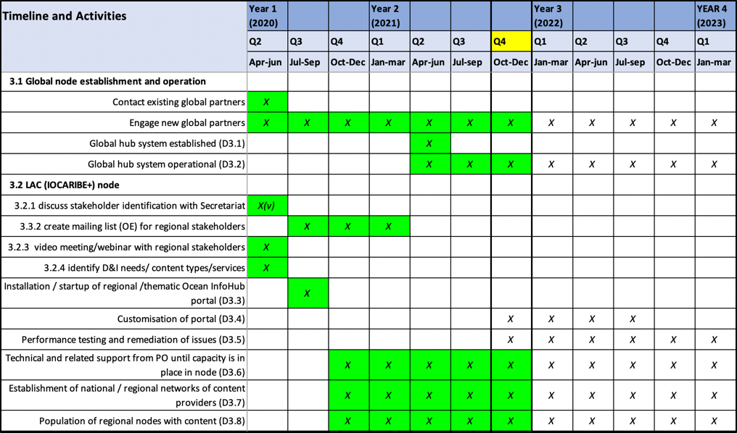
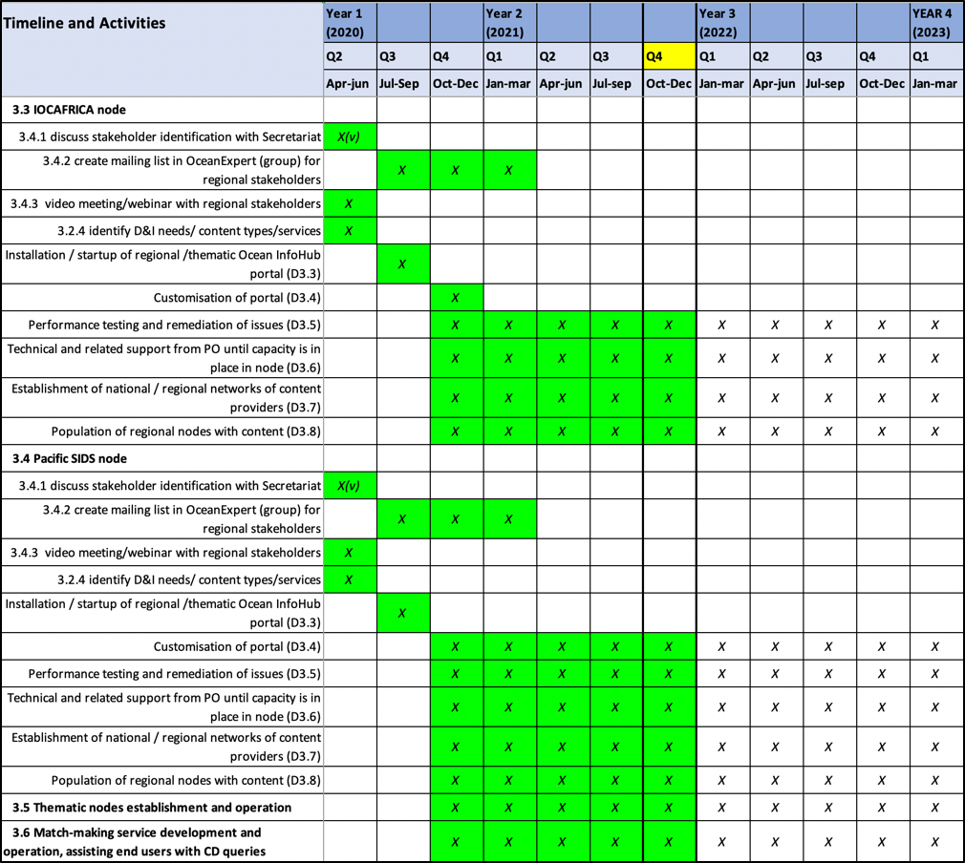

4.3.1 Deliverables October 2020-September 2021 as well as objectives for the year ahead

4.3.1.1 Global node establishment and operation
Technical aspects were reported under WP2

The project held 77 meetings under WP3 across the three regions, as well as with global partners. Three dedicated OIH webinars were held and the project participated in numerous meetings and events (reported under WP5).

4.3.1.2 Africa (Mika Odido)

Regional stakeholder consultations
Webinars held on 10 June 2020 and 10 June 2021
- Share information on regional projects involved in data and information management and data infrastructure development in Africa
- Identify existing data and information infrastructures that could be potential partners with the Ocean InfoHub
- Identify existing data and information infrastructure that address these requirements and can partner in the development of the regional hub
- Identify some initial end user needs/knowledge products not yet covered by existing initiatives
- Discuss way forward for collaboration mechanisms, and review progress in implementation
NODCs involvement, maintaining existing partner portals which would then link to OIH

Engaging potential partners
- MarCoSouth, CORDIO, IUCN, Regional Remote Sensing Centre, UNEP Nairobi Convention Secretariat etc.
- Partners have submitted documentation on data sources / architecture / vocabularies / ontologies / standards to the OIH GitHub Project
- Partner representatives added to WP2 for the development of the ODIS-architecture

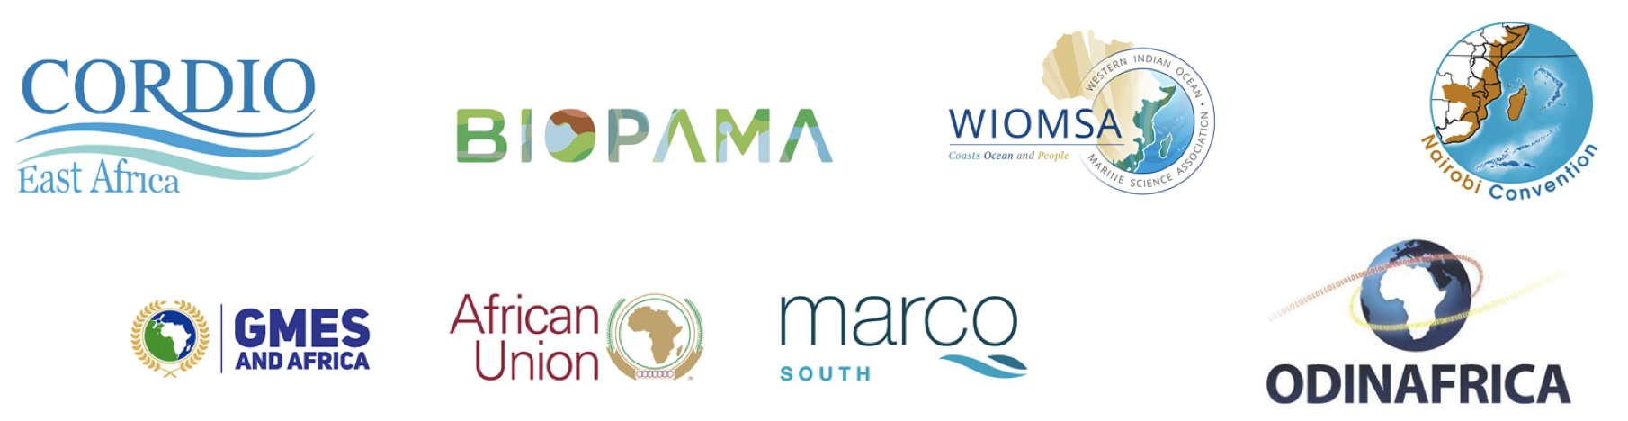

Redesign of ODINAFRICA website to provide access to IOCAFRICA databases and directories.
- People and institutions/organizations: updating of relevant records in OceanExpert, request national focal points to ensure that all experts in their institutions and institutions in their countries are covered
- Documents and Best practices ( will be linking to AquaDocs): focus has been on policy frameworks and legislation (more than 300 records collected)
- Spatial data/maps: Review of data previously collected on cruises in the region and availability of data and updates. Building on ACMA (migration to new software, clean-up, further development)
- Training and Research Opportunities: template developed and available at http://africa.marinetraining.org/, data collection ongoing and entry will commence shortly. Funding thanks to NORAD.
- Vessels (and other observation platforms): Expanded scope to include other observation platforms. Data collection ongoing
- Marine related Projects: data collection has been ongoing, building on existing database. Change in database structure ongoing (more than 100 records).
Other relevant activities

- Reactivation of the ODINAFRICA network of NODCs to support the regional development of OIH
- Revitalization of the African Coastal and Marine Atlas, migration to updated software platform and cleaning up of data, training of atlas team and further development of ACMA
- Reactivation of the ACMA editorial board
- Survey of status of Ocean Observations along the African coastline
- Training on Fundamentals of Ocean Mapping, OTGA Regional Centre at KMFRI, Mombasa (29 November – 10 December 2021)

Regional Consultations on UN Decade on Ocean Science for Sustainable Development
Data Related Issues

- Need for an improved focus on user driven data
- Challenges in data sharing related to a lack of common platforms, or incompatible metadata and data formats
- Lack of standardized policies in relation to open access data
- Technical capacity and resource limitations; and
- Lack of trust between organizations to share data.

“Data is a sensitive issue. “Fly in fly out” research is not acceptable and better systems for curating and managing African data in Africa need to be developed while still maintaining connectivity to the global data landscape”

4.3.1.3 LAC (Cesar Toro)

Establishment of the regional node covering Latin America and the Caribbean - LAC (IOCARIBE+) at the operational level.

The focus is on setting up procedures for the sourcing of content, submission of the content, developing of national and regional networking of content providers and users, and setting up of the matchmaking service to provide in-depth assistance to end users.

Important regional partners to bring on board
National and regional institutions/organizations with articulation and management capacity.
Institutions, projects or organizations with technical capacity in data management, marine information and technology transfer.

Ongoing work to develop the CHM_TMT as LAC OIH Regional node (led by INVEMAR) to incorporate ODIS specifications:
- Identify new data providers in the región
- Implement the ODIS-Arch
- Implement harvesting data module to synchronise with OIH Central
Include partners:
- CLME+ Training and Capacity Development Portal.
- The Sargassum Information Hub. An Atlantic wide Hub
- Caribbean Marine Atlas
- Other (NODCs, ADUs, vessels, programmes, etc.)

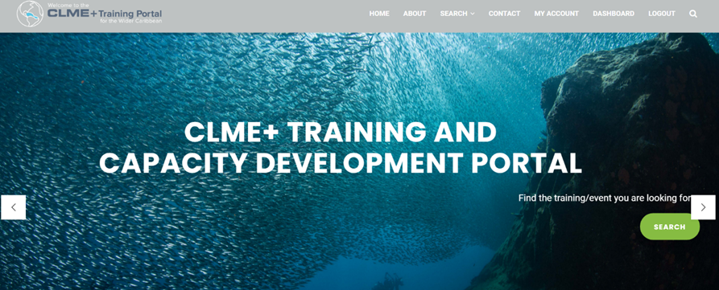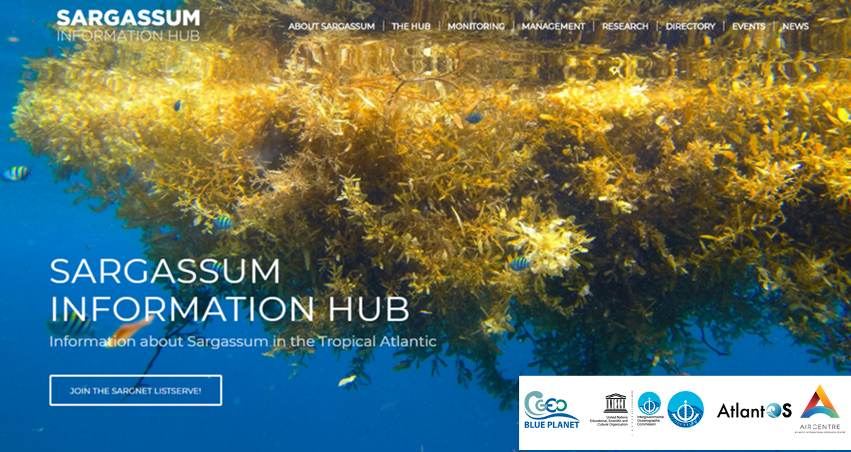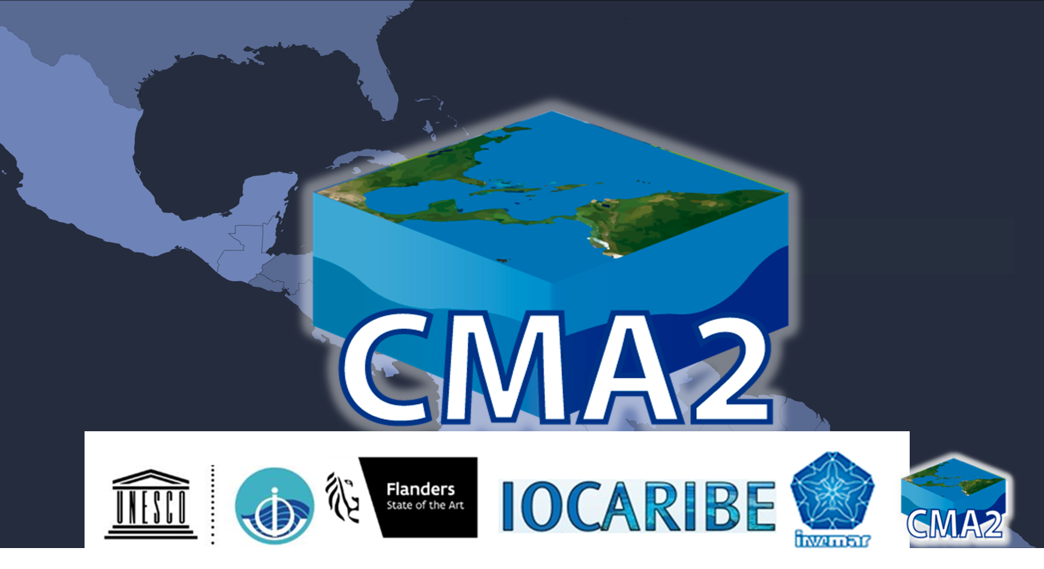

- CLME+ Training and Capacity Development Portal
clmeplus.marinetraining.org
- The Sargassum Information Hub
sargassumhub.org
- Caribbean Marine Atlas
caribbeanmarineatlas.net
- CHM_TMT LAC Regional Node
portete.invemar.org.co/chm#/

4.3.1.4 PSIDS
Ongoing work with SPC and SPREP to implement ODIS, and to develop use cases that are relevant to member states.

In Session B, Paul Anderson (SPREP) reported back on behalf of the region.

First of all, a big thanks to Lucy and Pier Luigi for all their support. Prior to this project, SPREP and SPC had established a regional community of practice around data sharing, data management and data use, and we are thrilled to expand that to the global perspective with the OIH. There are two existing platforms in the Pacific region that manage environmental data & data of all types across 14 countries and 7 territories. One is the Pacific Environment Portal network (14 national nodes, regional node at SPREP) and the other is the Pacific Data Hub which aims to organise all the datasets of SPC’s mandated areas. These two nodes are already exposed through APIs and share data between each other, and through the support of the OIH Project, Lucy and her team, we have been working on the backend architecture to share data with the global architecture and vice versa. We look forward to the eventual harvest, downward towards the countries and upward toward ODIS. Thanks the project management team for ongoing support.

PA (via chat): PDH link https://pacificdata.org/

Regional next steps
A joint SPC/SPREP Terms of Reference is in development for OIH support, based on the development of:
- Shared vocabularies
- Building capacities among users
- Testing curation of global data curation to country level (visible outputs to countries)
- Linking to INFORM project and other resources at SPC
- Possibly to have one person / contract shared between SPC and SPREP.
- Probably a data scientist, or a technician, depending on resources available.

Questions, discussion and contributions from the chat

Session A
CT: Would like to point out the importance of the work that we are doing in the region related to the UN Decade of Ocean Science for Sustainable Development, and to point out the grand challenge, concerning data and open access to data in the earth systems sciences, social sciences, and cross-sectoral participation. This is important to mobilise national constituencies, and communities, for decision making processes. In order to do that, it is extremely important to develop the capacity for an information access system, and this is what we are doing through the Ocean InfoHub Project.

Session B
JBC (via chat): I have a question related to the role/position of regional Coastal and Marine Atlases in OIH since both colleagues from Africa and Caribbean have mentioned this as an important information source.
LS: firstly from the Caribbean side, the CHM-TMT has been developed and supported by INVEMAR, who also hosts the Caribbean Marine Atlas. There is a close working relationship there, also with the global OIH team. The CMA is an active participant in our regional and technical meetings. The CMA will be one of the nodes in the LAC hub, and through the CMA there will be national contributions of spatial data. From the African side, the OIH and IOCAfrica are supporting the revitalisation of the African Coastal and Marine Atlas (ACMA), together with the support of the International Coastal Atlas Network (ICAN, a sister project of the OIH). ACMA is being migrated to an updated platform & data are being checked and cleaned up. Spatial data & maps is one of the priority themes for the OIH Project, so these activities fit very neatly into the development of these specifications in the ODIS-architecture. Tanya and Arno have been very active in supporting us with ACMA developments.

AKL (via chat): What is the status of the integration of 'Marine Regions' in the OIH?
LS: There has been ongoing and good communication with VLIZ on this, though Doug is not in the session to report on precise status.
PLB: Yes, in general, marine regions has the capacity to integrate, the main point to check is that the specifications on the ODIS-arch side correspond to the values of the digital assets in the marine regions holdings. We can also check with our contractor and will provide an update.

PLB (via chat): @Ann-Katrien: I checked some of our documentation and the communication in our Slack space. Marine Regions has some advanced approaches to sharing linked data, and much of this excites our contractor, as it allows flexible exchange across systems like ODIS/OIH. Our contractor has interacted with Marine Regions' data sharing services and - aside from a few errors here and there - there is high potential to build some advanced interfaces to ODIS/OIH. These may serve as examples for other partners wishing to use more advanced methods to exchange data. Currently, I'm directing much of this potential into a space for future development, so that we can ensure the core product is secured. If time and resources allow, we will be taking a much closer look at a joint exchange guideline based on OIH/ODIS <--> Marine Regions' interaction
Some related notes on the Marine Regions flow: https://book.oceaninfohub.org/tooling/notebooks/Exploration/LDFeed/LDFeed.htm

PS: I’d like to mention, about atlases, the CMA has been of essence in gathering information, particularly spatial data, for the LAC region. Satellite information is becoming more important, and the idea is to continue growing the atlas and to linking it to the CHM.

JBC: @Pier Luigi - For European in situ marine data and products (via EMODnet e.g.) we are currently in transition to centralise all thematic services (to be completed by end of 2022) and also updating the Geonetwork central portal catalogue to be able to publish in the manner which you may require for OIH. What are the expectations and timeline for connecting European efforts/node? Let us take this discussion offline after the meeting.

Work package 4: Training and capacity development of the nodes
This work package will focus on the development of a series of online training modules and tutorials as well as written documentation such as manuals. WP4 only commenced in 2021.

Table 4. Work Package 4 overview of timeline
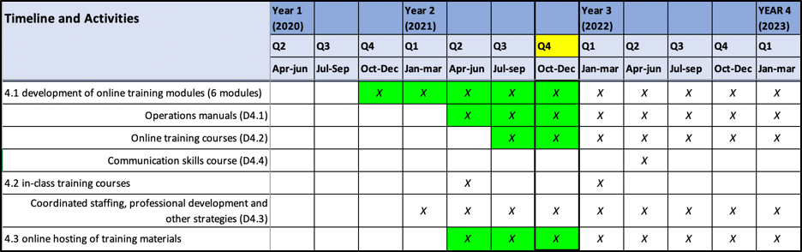

4.4.1 Deliverables October 2020-September 2021

4.4.1.1 Development of online training modules
- IOC/OTGA/OIH Training course: Implementing the Ocean Data and Information System (ODIS) architecture. 25-29 October 2021 [online]
- In development, on the OTGA e-learning platform.

4.4.1.2 Operations Manuals: ODIS-architecture documentation
https://book.oceaninfohub.org

Videos: ODIS-architecture reference (walk-through) videos
https://drive.google.com/drive/folders/1JnfiXLwxYIc3Zx0WS5-6lyqDKahHfg8f?usp=sharing

4.4.1.3 Online Training course:
IOC/OTGA/OIH Training course: Implementing the Ocean Data and Information System (ODIS) architecture. 25-29 October 2021 [online]
- Event info on OE https://oceanexpert.org/event/3256
- Actual course (not yet public) https://classroom.oceanteacher.org/course/view.php?id=722

Training course materials also contributed to:
- ICAN9 Session III – Sharing your Atlas with the World (OceanInfoHub & Schema.org)
- IOC/OTGA/RTC/Tianjin 2021 training course Course: Ocean Data Stewardship in the Decade of Ocean Science for Sustainable Development (oceanteacher.org).

4.4.1.4 Communication skills course
Not yet addressed

4.4.1.5 In-class training courses
Not yet addressed, but will be considered in 2022.

4.4.1.6 Online hosting of training materials
IOC/OTGA/OIH Training course: Implementing the Ocean Data and Information System (ODIS) architecture. 25-29 October 2021 [online]
- Event info on OE https://oceanexpert.org/event/3256
- Actual course (not yet public) https://classroom.oceanteacher.org/course/view.php?id=722

4.4.2 Objectives 2021-2022

4.4.2.1 Development of online training modules
- Further development of the course IOC/OTGA/OIH Training course: Implementing the Ocean Data and Information System (ODIS) architecture. 25-29 October 2021 [online]
- Translation of training course materials to other languages

4.4.2.2 Operations Manuals: Further development of the ODIS-architecture documentation
https://book.oceaninfohub.org

4.4.2.3 Online Training course:
IOC/OTGA/OIH Training course: Implementing the Ocean Data and Information System (ODIS) architecture. 25-29 October 2021 [online]
- Holding region-specific courses (language and time sensitive)

4.4.2.4 Communication skills course

4.5.2.5 In-class training courses
will be considered in 2022.

4.4.2.6 Online hosting of training materials
This is ongoing

Questions, discussion and contributions from the chat

Session A

No questions or interventions

Session B

PS: When will you have translated materials and when might we offer an OIH course in Spanish? Bearing in mind we have a SG in November.
LS: Would be delighted to discuss this. Holding a course in the LAC region in Spanish is a priority. We are ready to start translation in November this year, so we could be ready early in 2022 – we can also discuss this with Claudia in light of the OTGA timetable.
PS: Great, and happy to provide any support needed.

MT: Regarding training, we have someone interested in participating in the ODIS course – has the registration ended or not yet?
LS: The dates have been extended so we haven’t yet written to applicants, but this will happen very soon, and we welcome further applications.

Work package 5: Communication, user marketing and feedback
This work package covers the communications and engagement activities needed to ensure the relevance and usefulness of the Ocean InfoHub global and regional/thematic nodes, to promote community participation in the Ocean InfoHub as contributors and users, and to solicit input needed to foster ongoing development of the Ocean InfoHub nodes.

Table 5. Work Package 5 overview of timeline

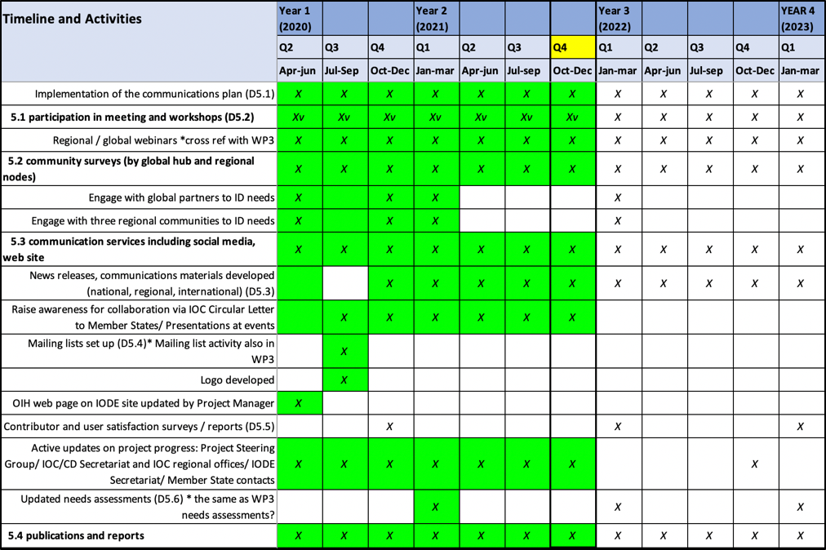

4.5.1 Deliverables October 2020-September 2021

4.5.1.1 Participation in meetings and workshops
- Altogether, the project has organised or participated in 189 documented virtual meetings, webinars or events (besides staff meetings) since the last Steering Group meeting.
- Many of these were internal WP2 or WP3 meetings, but many internal meetings include partners and can also be seen to contribute to WP5.
- At least 40 events contributed directly to awareness raising about OIH activities, objectives, and benefits of partnership.

Selected examples (a full list is available)

- International data sharing workshop for non-UN IGOs, Global and Regional organisations and projects, NGOs and private sector (12 October 2020)
- 2nd Session of the IOC Group of Experts on Capacity Development (26 October 2020)
- WMO data conference (16-19 November 2020)
- UN Decade planning meeting for Africa (3 November 2020)
- CLME+ training portal training (3 November 2020)
- GEBCO symposium (11 January 2021)
- Mapping the seafloor around Africa (2 webinars)
- VLIZ Marine Science Day (3 March 2021)
- IMDIS conference (12-14 April)
- IODE XXVI (20-23 April 2021)
- All-Atlantic Data and Policy Forum (31 May 2021)
- Towards an All-Atlantic Data Space workshop (3 June 2021)
- IUCN Regional Resource Hub Showcase (7 July 2021)
- Sargassum Webinar 5: The Sargassum Challenge: Opportunities for collaboration between West Africa and the Wider Caribbean Region (10 June 2021)
- International Coastal Atlas Network 9 (ICAN9) workshop Session III – Sharing your Atlas with the World (OceanInfoHub & Schema.org)

4.5.1.2 Community surveys and needs assessments.
The recent IOC-CD survey incorporated questions for and relevant to OIH; this will be repeated in 2022.
Many regional engagement, include the webinars, feed into identification of regional needs.

4.5.1.3 Communication services (social media, website)
The website is updated frequently and contains news items, media feeds.
We are currently using the IODE social media channels.

4.5.1.4 Awareness raising through communications and events
We use the mailing lists for important communications.
Regular communication uses Slack and email
Also see 4.6.1.1 above

4.5.1.5 Active updates on project progress
Through the website, Slack, Github and infrequent email updates.

4.5.2 Objectives 2021-2022

Multiple outreach activities ongoing & planned
Including, for example:
- Preparation & abstract submission for the International Ocean Data Conference 2022
- A submission from OIH/ODIS in support of the UN Decade of Ocean Science for Sustainable Development.

Questions, discussion and contributions from the chat

Session A
SS: This also refers to WP2 and the mention of ODIS meetings. Will they be the main mechanism of engagement between now and the next SG meeting?
PLB: The WP2 meetings will certainly continue – we make a lot of progress there. We have regular secretariat meetings and regional meetings. We also often call bilateral meetings with partners. We also have active discussions in our Slack space and via email.
LS: Yes we hold a regular WP2 meeting every two weeks, mainly to track project progress and to plan for important upcoming events and issues that we need to respond to as a project. We do have partners joining these meetings, and they all appear on our calendar. They are open for anyone to join. We have not planned a series of technical meetings (as held in 2020) as we have been focussing on working bilaterally with partners and getting the proof of concepts working. However we are very open to guidance from the SG, and if there is a gap of any kind we can work at filling that. Perhaps we could use our regular meeting slot to build in more consultation to those agendas. We are open to suggestions on how to involve more partners on a regular basis.
SS: Yes it would be useful to have 1 or 2 update WP2 meetings between now and the next SG. It would be useful for existing and potential partners to see progress and to see how they could get involved.
LS: Great, every 2-3 months we could have a general WP2 meeting for updates and progress with all partners.
AKL (via chat): fully support Sophie's suggestion there, towards partners and also new users.

Session B

PS: Regarding communications, I’d like to congratulate you as there has been wide and good dissemination of the OIH Project in the region. I’d also like to say we are within the Decade of ocean sciences and we are trying to be inclusive. We have someone working with us right now who is deaf, and is working with us to translate videos into sign language. So perhaps we could do this with OIH videos as another outreach activity?
LS: Thank you, we would definitely like to take you up on this. We are planning to develop a video and we will be in touch as soon as we have a timeline for this.

Budget
Significant cost savings were made during 2021 due to the travel restrictions imposed as a result of the global COVID-19 pandemic. Some meetings might still need to be held so a balance had to be found between additional spending (on consultancies, for example), while still retaining reserves to enable travel when permitted.

Costs to be spent for the remainder of 2021 and into 2022 include:

- Co-financing of activities at the IOC Sub-Commission for Africa
- Partial costs of AquaDocs maintenance supported.
- A contract for the ongoing development of the ODIS-architecture.
- A second contract in support of the ODIS-architecture development (mainly to work with partners)
- A contract for developing the Global Search Hub
- Co-financing of PSIDs regional activities
- A contract with INVEMAR for the further development of the CHM-TMT and the inclusion of additional regional partners through the implementation of ODIS.
- Meetings and online translation services
- Science communication services (including the development of a short video and graphics).

Questions, discussion and contributions from the chat

Session A

PLB: Just a comment on the mention of the second contractor in support of ODIS-architecture development. We see that not only is there a need to extend the technology development, but there is also a need to put resources towards working with our implementation partners. This is an important development with regard to digital strategy and policy. Many projects exist that are developing wonderful solutions, but they don’t dedicate much time to regional partners – so this is one of the outcomes of reshuffling of budgets, that will allow us to get concrete regional representation.

SS: One of the contracts that is coming to an end and is being re-advertised, does that mean there will be a change in the contractor, or will the same contractor be reappointed?
LS: We are open to the same contractor reapplying. It is an open call, so anyone who is qualified can apply. There are two calls open at the moment, to support the development of the ODIS-architecture. Plus we also have a third call open for the development of the Global Search Hub. These have been shared through our media channels but I can also share links directly by email if requested.

Session B

No questions or interventions

Report on actions from SG-OIH-1

1. Continue the work in the three regions following the regional work plans (Q4)
Report: this was continued as planned

2. Review the applications and hire Sub-contractor for WP2 (1 October 2020)
Report: This was done, a consultant (Doug) was hired and has completed his contract. A new ToR is in process.

3. Continue the ODIS-architecture development as per the work plan and the proposed work of the sub-contractor on the schema.org (Q4).
Report: This was completed.

4. Convene regional meetings for each region and one for EU Partners (Q4), October 2020.
Report: Four regional meetings were held before the close of 2020.

5. Within WP2, focus on 5 thematic meetings for (i) people and institutions, (ii) Documents and best practices, (iii) Maps and spatial data, (iv) Training opportunities, (v) Vessels (Q4).
Report: These five meetings were held, plus a sixth on Projects.

6. Consider a global oceans meeting in the spirit of OceanObs, both within the OIH and also more broadly (2021).
Report: the "International Ocean Data Conference- The Data We Need for the Ocean We Want" will be held in Sopot, Poland, between 14-16 February 2022 as a hybrid event.
https://oceandataconference.org/

https://oceanexpert.org/event/3063

7. Facilitate an online voting process for the election of a Chair for the OIH Steering Group (15 October 2020).
Report: This was completed and our current Chair, Frederico Nogueira, was elected.

8. Continue to share SG reports in advance of the meetings, and allocate less time for reporting and more time for discussion (next SG meeting).
Report: This has been done in 2021

9. Focus on developing some tangible use-cases to demonstrate the OIH to end users (Q4) by the end of 2020.
Report: The six thematic meetings towards the end of 2020 had a focus on use cases and implementation partners, and now the global search demonstration site can also be used as a demo for end users.

Questions, discussion and contributions from the chat

Session A
CT: How are you measuring project progress and performance? That goes for all elements of the project. Could you elaborate on this so we can see if we are on the right track?
LS: Absolutely, it is important to measure progress. We do have a monitoring and evaluation table, mostly geared towards measuring uptake and exchange of products – so it is really only now that we will be starting to measure the flow of information using the ODIS architecture. We have other metrics that we need to report on as a project – such as number of people trained, number of courses held. We also have the project tracking sheet for Timeline and Deliverables from which the five tables in this report are taken. So there is a record of timeline and deliverables per work package. And yes we will be collecting more metrics as more partners join ODIS.

AKL: firstly thank you to you and the great team, and then how can we help to be ambassadors of the project looking ahead? And then also a question related to co-creating, referencing what Gert Vereet said about this project meeting the needs of users – as far as possible. We do appreciate that the project has been focussing a lot (and should) on technical development, and we appreciate that there have been a lot of meetings on projects, vessels etc, and we appreciate that there will be a facilitators to work with partners. So what opportunities or elasticity to do you see for taking this forward, in addressing the needs of users. Could you give us a feel for this?

LS: With reference to end users and their needs, indeed this is extremely important and it is the driving objective behind the project as a whole. Indeed, we have had a focus on technology development, and we needed to show proof of concept so that we could demonstrate the usefulness and power of the system. Now, the three regions really have a critical role to link this technology development to end users. In the Pacific, as an example, the portals that already exist are in place to serve the specific needs of member states, and to answer questions directed to those platforms by member states. It is a great opportunity for us to create a flow of information from IOC and other global databases, through those portals to end users. So now we need to work with our implementation partners to show how information in global databases can be taken up. Not only for national institutions, but also for national reporting requirements and meeting the needs of the UN Decade of Ocean Science for Sustainable Development.

PLB: The technology helps us do the work faster – that is good technology. Indeed, the first step was to demonstrate the technology; that it works and can be sustained at a low premium. We don’t want to build something that will require partners to change their platforms as this would create a high barrier to joining. It was important to have a system that enable joining as an ODIS node without changing the way that partners work. Now that the demonstration is done, the thematic areas are the current interests of the end users. Within the ODIS-architecture we can now expand that list based on what we hear from the partners, and also to show partners how to do it themselves. There is no centralised system (beyond editorial control of the documentation, and checking that it works). Themes can be independently added and automatically validated so the system can grow by itself, organically, with some oversight to check that things are working. So this is very sustainable in the long term.

7. Election of the chair
- Frederico Nogueira was elected as chair of our SG after the first session, through an online voting process
- We are very grateful for his time and attention to the work plan over the course of the year.
- Due to factors beyond his control, he is unfortunately not available for re-election.
- I would like to request nominations (self or others) to my email address L.Scott@unesco.org by Friday 15th October, after which an online voting poll will be set up and circulated.

FN: Thanked Lucy and the project team for all the support over the year.
LS: Thanked Frederico and wished him a full and speedy recovery.
PP: We thank you for all your hard work to launch the OIH, and rest assured that you will be one of the original fathers of the OIH and we will keep in touch.

8. Next meeting: Third Session of the SG-OIH
Session A
FN: We may have two options, to make the next SG after 6 months or after one year. I suggest we continue with the regular technical meetings, and then aim for the next SG after one year, with the hope that we could meet face-to-face.
LS: Good, we will work towards a face to face meeting in 2022.

Session B
LS: A request did come from Session A to have more regular WP2 meetings, involving more SC members to be included in regular OIH meetings, and to work towards the next SG meeting in October 2022, hopefully face-to-face.

9. Group photograph and close of the meeting
Session A
LS: Thanked our Chair, Frederico for leading us through the meeting, as well as to all the presenters and the project team in the work preparing the report.
FN: Thanked all again and closed the meeting.

Session B
TDB: I would like to thank you Frederico for all your hard work as Chair of the SG, and I’m sure I speak on behalf of all of us as we wish you well and a complete recovery soon. We will certainly keep you in the loop, and appreciate that you still show interest in the project, despite health challenges.
I would also like to thank Lucy and the entire project team for making such great progress. Jan-Bart already said how impressed he was with progress made, and I am equally impressed and happy to hear about this. I look forward to the remainder of the project, especially to next year’s meeting where we will hopefully meet face to face! Thank you very much.
FN: Thanked all again and closed the meeting, wishing all a very good evening / night.

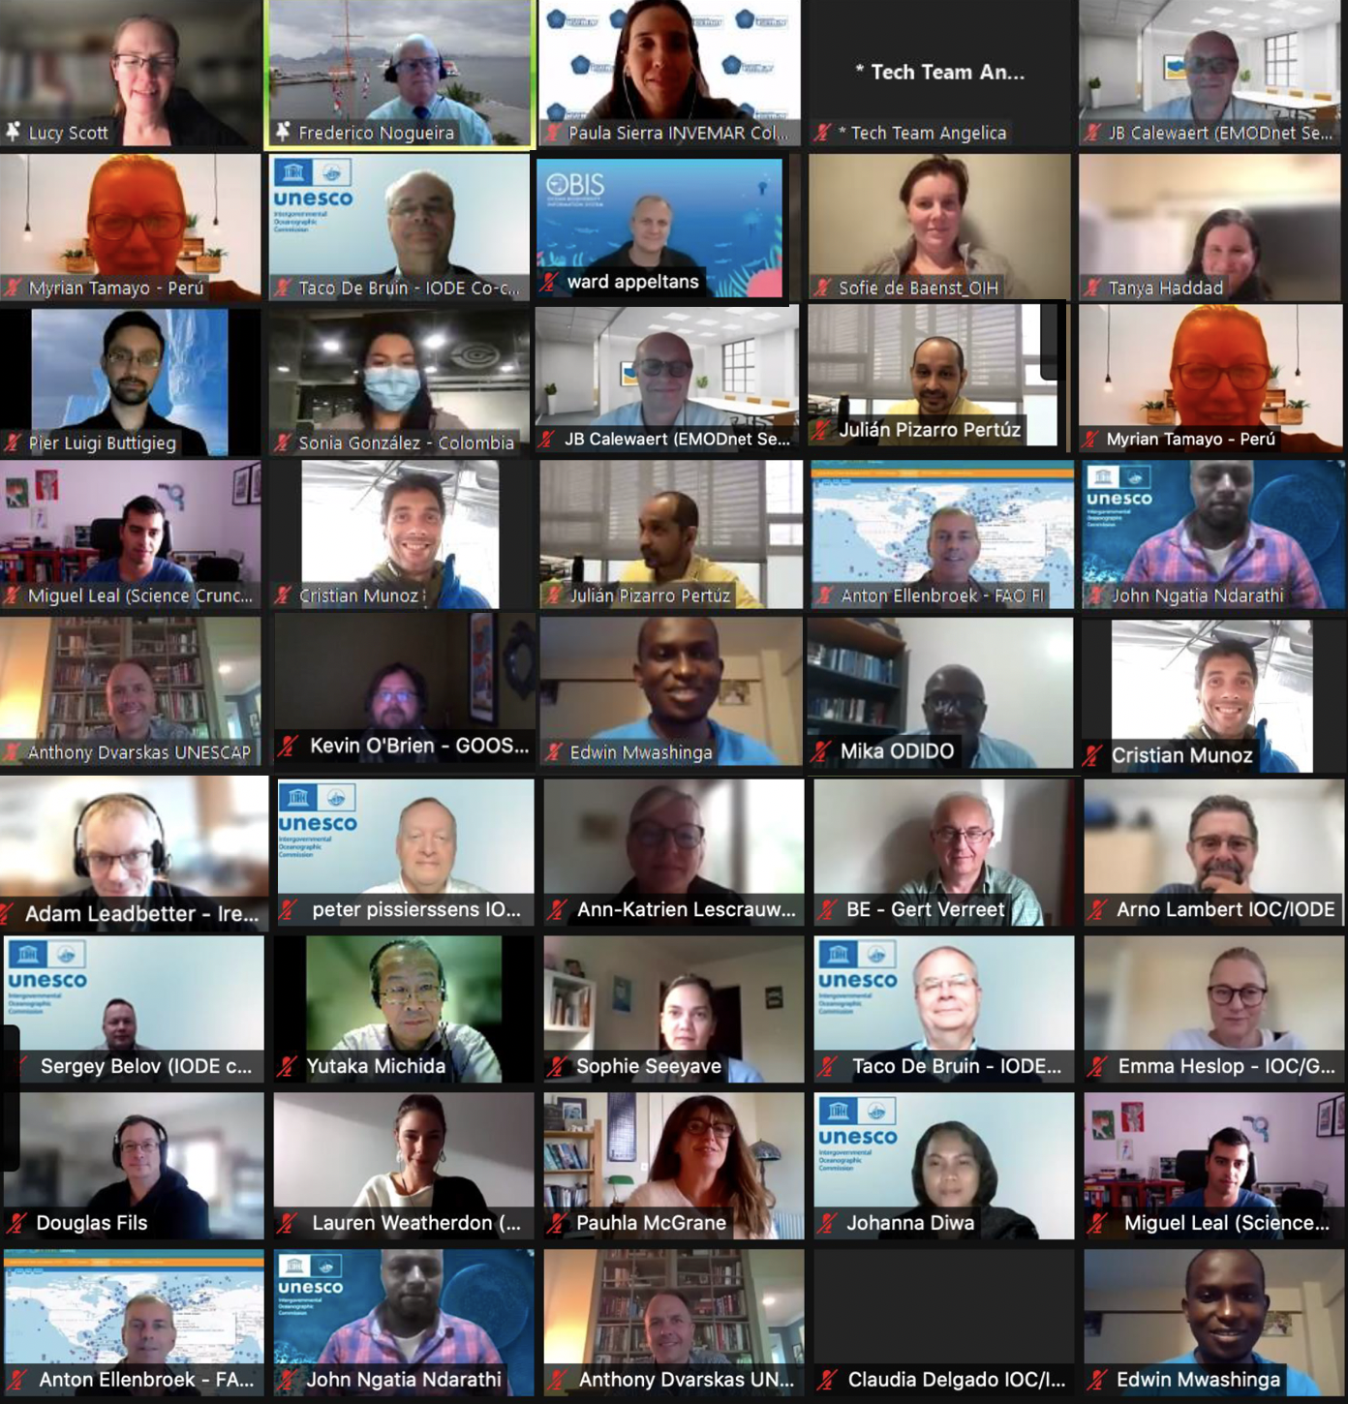

ANNEX 1

Second Session of the IODE Steering Group for the Ocean InfoHub Project

Provisional Agenda: 5 October 2021

We are pleased to share session information and a provisional agenda for the meeting.

Session A: 5 October 1PM-3PM UTC
https://oceanexpert.org/event/3132

Session B: 5 October 7PM-9PM UTC
https://oceanexpert.org/event/3158

Both sessions will cover the entire agenda and the duplication is in order to allow for all regions to each meet at a reasonable hour.

These OceanExpert event links will be updated with background documents and the Zoom connection details.

The meeting will open 20 minutes before the time; please connect early and keep your microphone on mute.
Please confirm that you have the latest version 5.2.3 at: https://zoom.us/download in order to access the translation feature. Please note, the meeting will be recorded and made available online, together with all the presentations.

Provisional Draft Agenda

1 Opening of the meeting
2. Administrative arrangements
3. Adoption of the agenda
4. Overview of the OIH work plan and deliverables (Lucy Scott and OIH team).
5. Budget
6. Report on actions from SG-OIH-1
7. Election of the Chair
8. Next meeting: Third Session of the SG-OIH
9. Close of the meeting

ANNEX II
Summary of Additional Actions

- The project team should make a note of links to other UN agencies as we make them.
- Follow up with EMODnet to connect to ODIS.
- Plan a training course for 2022, based on the 2021 training course but translated to Spanish, for the LAC region.
- Every ±3 months, hold a general WP2 meeting for overall project progress and updating of partners. Invite the Steering Group to participate.
- Once the OIH video has been produced, work with INVEMAR to make it available with sign language translation to increase accessibility.
- Plan the next steering group meeting in ±October 2022, ideally face-to-face if this is possible.

ANNEX III
LIST OF PARTICIPANTS
Session A (36)
Project Participants
Mr. Pier Luigi BUTTIGIEG
Data Scientist
Helmholtz Metadata Collaboration
GEOMAR | Helmholtz Centre for Ocean Research Kiel
Duesternbrooker Weg 20
24105 Kiel
Germany
Email: pier.buttigieg@awi.de
Mr. Hamet Diaw DIADHIOU
Directeur du CRODT
Centre de Recherche Océanographique de Dakar Thiaroye (CRODT-ISRA)/ LPAOSF-ESP-UCAD
B.P. 2241
Rte des Hydrocarbures
Dakar
Senegal
Email: hamet_diadhiou@yahoo.fr
Mr. Anton ELLENBROEK
FAO Fisheries Officer
FI - 309
FAO Food and Agriculture Organization of the UN, Headquarters
Viale delle Terme di Caracalla
00153 Roma
Italy
Email: anton.ellenbroek@fao.org
Mr. Douglas FILS
Independent Consultant
407 10th Ave Circle
Slater, IA
United States
Email: drfils@gmail.com
Ms. Tanya HADDAD
Information Systems Specialist
Department of Land Conservation and Development
Oregon Coastal Management Program
800 NE Oregon Street, Suite 1145
Portland, Oregon 97232
United States
Email: tanya.haddad@dlcd.oregon.gov
Mr. Adam LEADBETTER
Team Leader for Data Management
Marine Institute Headquarters, Galway
Rinville
Oranmore
Co. Galway H91 R673
Ireland
Email: adam.leadbetter@marine.ie
Ms. Ann-Katrien LESCRAUWAET
Director International Relations
International Relations
Vlaams Instituut voor de Zee
Wandelaarkaai 7
8400 Oostende
Belgium
Email: annkatrien.lescrauwaet@vliz.be
Ms. Pauhla MCGRANE
Project Manager SATURN & JONAS
MaREI Centre
University College Cork
MaREI Centre
Environmental Research Institute, Beaufort Building, University College Cork, Haulbowline Road, Ringaskiddy.
Cork
Co. Cork P43 C573
Ireland
Email: pauhla.mcgrane@ucc.ie
Mr. Yutaka MICHIDA
The University of Tokyo, Atmosphere and Ocean Research Institute
5-1-5 Kashiwanoha
Kashiwa, Chiba
277-8564
Japan
Email: ymichida@aori.u-tokyo.ac.jp
Mr. Edwin MWASHINGA
Environmentalist
Environmental and Earth Sciences
Pwani University, Kenya
P.O. Box 195
Kilifi
80108
Kenya
Email: edwinyambu@gmail.com
Mr. John NDARATHI
Research and Data Cordinator
IOC’s Sub Commission for Africa & the Adjacent Island States (IOCAFRICA)
UNESCO/IOC Sub Commission for Africa and the Adjacent Island States
UNESCO Nairobi Office
UN Gigiri Complex Block C
P.O. Box 30592
Nairobi
00100
Kenya
Email: nngatia@gmail.com
Mr. Kevin O'BRIEN
Senior Research Scientist
Joint Institute for the Study of the Atmosphere and Ocean
University of Washington
24 Kincaid Hall
Seattle, WA 98159
United States
Email: kevin.m.obrien@noaa.gov
Mr. Arthur PATERSON
Policy Coordination Division
National Ocean Service/National Oceanic and Atmospheric Administration
United States
Tel: +1 301 713 30770-192
Fax: +1 301-713-4307
Email: arthur.e.paterson@noaa.gov
Mr. Julian PIZARRO
Instituto de Investigaciones Marinas y Costeras José Benito Vives de Andreis
Calle 25 No. 2-55, Playa Salguero, Rodadero
Santa Marta D.T.C.H., Magdalena,
Colombia
Email: julian.pizarro@invemar.org.co
Mr. Vladimir RYABININ
IOC Executive Secretary
Intergovernmental Oceanographic Commission of UNESCO
7, place de Fontenoy
75732 Paris cedex 07
France
Email: v.ryabinin@unesco.org
Mr. Mohamed SAID
Professor of Physical Oceanography
Physical Oceanography
National Institute of Oceanography and Fisheries, Alexandria
Kayet Bay – Al Anfoushy
Alexandria
Alexandria
21556
Egypt
Email: mamsaid2@hotmail.com
Mr. Frederico SARAIVA NOGUEIRA
Institutional Adviser on IOC Affairs
Institutional Advisor on IOC affairs
Brazilian Navy Hydrographic Center, Directorate of Hydrography and Navigation
R. Barão Jaceguai s/n
Niterói, Rio de janeiro-
CEP 24048-900
Brazil
Email: frederico.asn@gmail.com
Ms. Sophie SEEYAVE
CEO
Partnership for Observations of the Global Oceans
Plymouth Marine Laboratory
Prospect Place, The Hoe
Plymouth
PL1 3DH
United Kingdom
Email: ssve@pml.ac.uk
Mr. Gert VERREET
Policy Advisor
Vlaamse Overheid - Departement Economie, Wetenschap & Innovatie, Afdeling Onderzoek
Koning Albert II-laan 35 bus 10
1030 Brussel
Belgium
Email: gert.verreet@vlaanderen.be
Ms. Lauren WEATHERDON
Senior Programme Officer; Knowledge Management Lead
UNEP World Conservation Monitoring Centre
219 Huntingdon Road
Cambridge
CB3 0DL
United Kingdom
Email: lauren.weatherdon@unep-wcmc.org
Ms. Patricia WILLS-VELEZ
Assistant Director
Office of the Head IOC-UNESCO Regional Secretariat for IOCARIBE
IOC of UNESCO Sub-Commission for the Caribbean and Adjacent Regions
Torices, Edificio Chambacu, Oficina 405Cra 3B # 26-78
Cartagena de Indias, Bolivar, 1108
Colombia
Email: patricia_wills@hotmail.com
IOC Secretariat
Mr. Ward APPELTANS
Project Manager OBIS, GOOS Biology & Ecosystems, IOC Capacity Development
UNESCO / IOC Project Office for IODE
Wandelaarkaai 7
Pakhuis 61
8400 Oostende
Belgium
Email: w.appeltans@unesco.org
Ms. Sofie DE BAENST
Administrative Assistant
UNESCO / IOC Project Office for IODE
Wandelaarkaai 7
Pakhuis 61
8400 Oostende
Belgium
Email: s.de-baenst@unesco.org
Ms. Cláudia DELGADO
OTGA Project Manager, IODE Training Coordinator
UNESCO / IOC Project Office for IODE
Wandelaarkaai 7
Pakhuis 61
8400 Oostende
Belgium
Email: c.delgado@unesco.org
Ms. Johanna DIWA
IOC Consultant
Capacity Development
UNESCO / IOC Project Office for IODE
Wandelaarkaai 7
Pakhuis 61
8400 Oostende
Belgium
Email: jp.diwa@unesco.org
Ms. Emma HESLOP
Programme Specialist
Intergovernmental Oceanographic Commission of UNESCO
7, place de Fontenoy
75732 Paris cedex 07
France
Email: e.heslop@unesco.org
Mr. Arno LAMBERT
IT Services Manager
UNESCO / IOC Project Office for IODE
Wandelaarkaai 7
Pakhuis 61
8400 Oostende
Belgium
Email: a.lambert@unesco.org
Mr. Cristian MUÑOZ MAS
Senior Engineer
The Centre for Development Cooperation in Fisheries (CDCF) at IMR
Institute of Marine Research (IMR), Bergen
Nordnesgaten 50
5005 Bergen
Norway
Email: cristianmmas@yahoo.com
Mr. Mika ODIDO
IOC Coordinator in Africa
UNESCO/IOC Sub Commission for Africa and the Adjacent Island States
UNESCO Nairobi Office
UN Gigiri Complex Block C
P.O. Box 30592
Nairobi
00100
Kenya
Email: m.odido@unesco.org
Mr. Peter PISSIERSSENS
Head, IOC Project Office for IODE, Oostende, Belgium and IOC capacity development coordinator
UNESCO / IOC Project Office for IODE
Wandelaarkaai 7
Pakhuis 61
8400 Oostende
Belgium
Email: p.pissierssens@unesco.org
Mr. Pieter PROVOOST
OBIS Data Manager
UNESCO / IOC Project Office for IODE
Wandelaarkaai 7
Pakhuis 61
8400 Oostende
Belgium
Email: p.provoost@unesco.org
Ms. Lucy SCOTT
Ocean InfoHub Project Manager; Marine Scientist
UNESCO / IOC Project Office for IODE
Wandelaarkaai 7
Pakhuis 61
8400 Oostende
Belgium
Email: l.scott@unesco.org
Mr. Cesar TORO
IOC Secretary for IOCARIBE
IOC of UNESCO Sub-Commission for the Caribbean and Adjacent Regions
Torices, Edificio Chambacu, Oficina 405Cra 3B # 26-78
Cartagena de Indias, Bolivar, 1108
Colombia
Email: xesar.toro@gmail.com
Other
Mr. Sergey BELOV
deputy director
All-Russian Research Institute Hydrometeorological Information - World Data Center, Obninsk
6, Korolev St.,Obninsk,
Obninsk
Kaluga region
249035
Russia
Email: belov@meteo.ru
Mr. Taco DE BRUIN
Scientific Data Manager
National Marine Facilities
Koninklijk Nederlands Instituut voor Onderzoek der Zee
PO Box 59
1790 AB Den Burg
Netherlands
Email: Taco.de.Bruin@nioz.nl
Ms. Miguel LEAL
Master Student
Marine Ecology
Universidade de Aveiro, Departamento de Biologia
Campus Universitário de Santiago
3810-193 Aveiro
Portugal
Email: miguelcleal@marineecology.net84.net

Session B (16)

Project participant
Mr. Paul ANDERSON
Project manager
Environment Monitoring and Goverance
Secretariat of the Pacific Regional Environment Programme.
PO Box 240
Apia
Samoa
Tel: 6857576789
Email: paula@sprep.org
Mr. Alexander BELTRAN
Especialista Tecnologico Manejo Integrado Zona Costera
Bogotá
Comisión Colombiana del Océano
Carrera 86 # 51 - 66
Oficina 306 Building World Business Center
Bogota D.C., , 111071000
Colombia
Tel: 3015517233
Email: alexanderbeltran29@gmail.com
Mr. Pier Luigi BUTTIGIEG
Data Scientist
Helmholtz Metadata Collaboration
GEOMAR | Helmholtz Centre for Ocean Research Kiel
Duesternbrooker Weg 20
24105 Kiel
Germany
Tel: +494212028984
Email: pier.buttigieg@awi.de
Mr. Jan-Bart CALEWAERT
Head of the EMODnet Secretariat
European Marine Observation and Data Network (EMODnet)
Secretariat of the European Marine Observation and Data Network (EMODnet)
Wandelaarkaai 7
8400 Oostende
Belgium
Tel: +32 497 43 33 71
Email: janbartcalewaert@gmail.com
Mr. Taco DE BRUIN
Scientific Data Manager
National Marine Facilities
Koninklijk Nederlands Instituut voor Onderzoek der Zee
PO Box 59
1790 AB Den Burg
Netherlands
Tel: +31 (0)222-369479
Email: Taco.de.Bruin@nioz.nl
Ms. Johanna ECHEVERRY HERNÁNDEZ
MSDI Manager
Marine Spatial Data Information
Dirección General Marítima Colombia
Carrera 54 No. 26 - 50 Of. 102 CAN
Bogotá D.C, ,
Colombia
Tel: 573012183187
Email: jpecheverryh@unal.edu.co
Ms. Sonia Carolina GONZÁLEZ ARÉVALO
Advisor International Affairs
Comisión Colombiana del Océano
Colombia
Bogotá, ,
Colombia
Email: scarolinaga@gmail.com
Ms. Tanya HADDAD
Information Systems Specialist
Department of Land Conservation and Development
Oregon Coastal Management Program
800 NE Oregon Street, Suite 1145
Portland, Oregon 97232
United States
Tel: +19716730962
Email: tanya.haddad@dlcd.oregon.gov
Mr. Mohamed SAID
Professor of Physical Oceanography
Physical Oceanography
National Institute of Oceanography and Fisheries, Alexandria
Kayet Bay – Al Anfoushy
Alexandria
Alexandria
21556
Egypt
Tel: +201223779117
Email: mamsaid2@hotmail.com
Mr. Frederico SARAIVA NOGUEIRA
Institutional Adviser on IOC Affairs
Institutional Advisor on IOC affairs
Brazilian Navy Hydrographic Center, Directorate of Hydrography and Navigation
R. Barão Jaceguai s/n
Niterói, Rio de janeiro-
CEP 24048-900
Brazil
Tel: +55 (21) 2189 3013
Email: frederico.asn@gmail.com
Ms. Paula SIERRA-CORREA
Research and Information Coordinator
Research and Information for Coastal Zone Management
Instituto de Investigaciones Marinas y Costeras José Benito Vives de Andreis
Calle 25 No. 2-55, Playa Salguero, Rodadero
Santa Marta D.T.C.H., Magdalena,
Colombia
Email: paula.sierra@invemar.org.co
Ms. Myriam TAMAYO INFANTES
Coordinadora técnica del Proyecto NAYLAMP
Marina de Guerra del Perú, Dirección de Hidrografía y Navegación
Calle Roca 118
Callao
Chucuito
Peru
Tel: +511 613 6767
Email: naylamp@dhn.mil.pe
IOC Secretariat
Ms. Sofie DE BAENST
Administrative Assistant
UNESCO / IOC Project Office for IODE
Wandelaarkaai 7
Pakhuis 61
8400 Oostende
Belgium
Tel: +32 59 34 14 60
Email: s.de-baenst@unesco.org
Mr. Arno LAMBERT
IT Services Manager
UNESCO / IOC Project Office for IODE
Wandelaarkaai 7
Pakhuis 61
8400 Oostende
Belgium
Tel: +32 (0)59 34 14 62
Email: a.lambert@unesco.org
Ms. Lucy SCOTT
Ocean InfoHub Project Manager; Marine Scientist
UNESCO / IOC Project Office for IODE
Wandelaarkaai 7
Pakhuis 61
8400 Oostende
Belgium
Tel: +27 (0) 82-879-5006
Email: l.scott@unesco.org
Ms. Pauline SIMPSON
IOC Consultant
UNESCO / IOC Project Office for IODE
Wandelaarkaai 7
Pakhuis 61
8400 Oostende
Belgium
Tel: +44 7715 113930
Email: p.simpson@unesco.org

ANNEX IV
Reference Documents, shared in advance of the meeting

Available on the IODE Calendar event pages for both sessions:

- OIH project timeline and deliverables
- OIH Project summary English
- OIH Project summary Spanish
- OIH Project summary French
- Recorded presentation: Overview of the OIH Project
- Provisional agenda
- Annotated agenda

