  World Meteorological Organization &  Intergovernmental Oceanographic Commission (of UNESCO)  Data Buoy Cooperation Panel Thirty Seventh Session,  Virtual meeting, 8th -11th November 2021 | 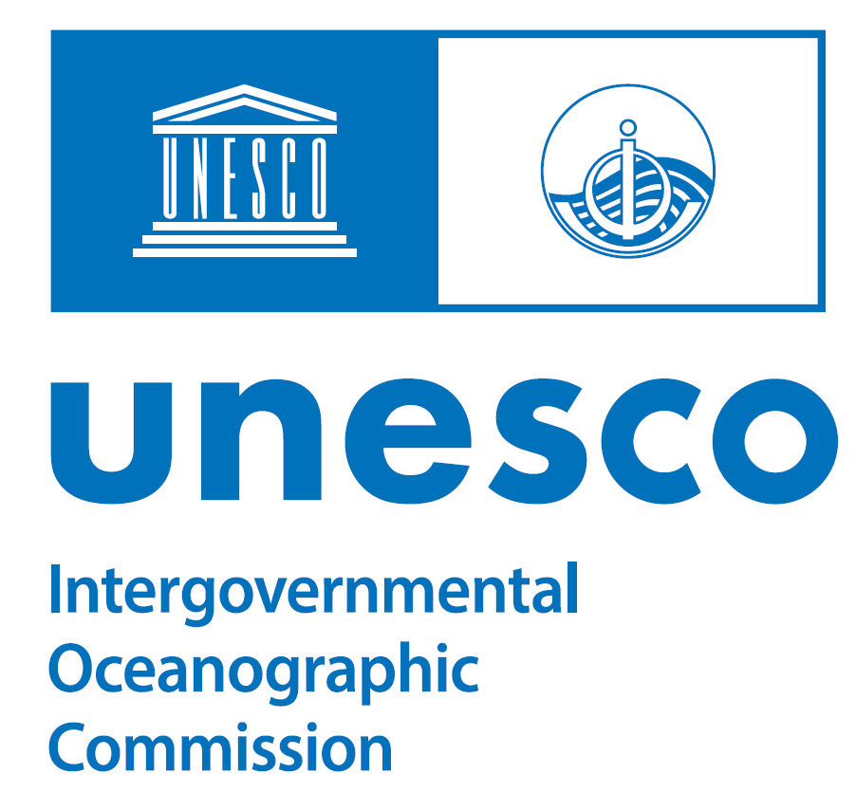  DBCP-37/Doc. 11
Submitted by:
WMO Secretariat
01.09.2021
DRAFT 1
AGENDA ITEM 11: DBCP FINANCIAL REPORT

SUMMARY

This document provides a financial report for the DBCP for calendar year 2020, the interim budget for 2021 and the anticipated budget for 2022.

SUMMARY (Draft text for inclusion in the final report):

Purpose

This report provides the status of the DBCP budget for DBCP activities, funded through national voluntary contributions and handled through the WMO/DBCP TF and IOC/DBCP TF.

Background

The DBCP-TF (DBCP Trust Fund) was first established over 30 years ago to support the activities of the DBCP Panel. The fund is managed by the DBCP Panel. Over the years, the TF evolved into a multi-user trust fund providing space for other Panels/Groups (DBCP, SOT, OceanOPS and others WMO projects) primarily to benefit from its lower service charge (3%).

At DBCP-33 session (Brest/France, October 2017), where all the funders were present, the DBCP Panel agreed to distribute its funding management responsibilities as follows: to the DBCP chair for DBCP activities, to the SOT chair for SOT activities and the GOOS OCG chair for OceanOPS activities.

At DBCP-33, the Panel also agreed that contributors to the WMO/DBCP TF should identify how the contributions should be distributed through the DBCP, SOT, OceanOPS and WMO projects. If no specific instruction is given by the funder, contributions will be distributed as follows: OceanOPS 61%, DBCP 31%, and SOT 8%. Since 2019, E-SURFMAR has instructed to distribute the annual contribution as follows: OceanOPS 70%, DBCP 15%, and SOT 15%. Funds provided to the IOC/DBCP TF from the Ministry of Natural Resources, China towards DBCP Capacity building activities are allocated 100% for the DBCP.
OceanOPS supports the DBCP activities through a technical coordinator position, with travel budget and through the overall team workplan. The OceanOPS financial report (reviewed at OCG-12 session) is available in Annex I for further information.

WMO/DBCP-TF and IOC/DBCP TF financial statements from WMO and IOC for 2020 are provided in Annex II and IV respectively. The WMO/DBCP-TF 2021 interim report is provided in Annex III.

Financial position

Table 1: Summary of 2020 National Contributions and distribution among the different budget lines
2020 Contributions | In Currency of Payment | In US$ | WMO/DBCP TF OceanOPS | WMO/DBCP TF  DBCP | WMO/DBCP TF  SOT | IOC / DBCP TF
E-SURFMAR | €55,000 | 65,032 | $42,552 | $9,755 | $9,755
Meteorological Services of New Zealand | €1,800 | 2,128 | $1,298 | $660 | $170
Environment and Climate Change Canada | CAD$ 34,000 | 27,390 | $16,708 | $8,491 | $2,191
Bureau of Meteorology, Australia | €11,700 | 13,834 | $8,439 | $4,289 | $1,107
National Institute of Ocean Technology, India | US$5,000 | 5,000 | $3,050 | $1,550 | $400
South African Weather Service (SAWS) | €4,000 | 4,730 | $2,885 | $1,466 | $378
BSH, Germany | €3,600 | 4,257 | $2,597 | $1,320 | $341
MNR-China | $20,000 | 20,000 |  |  |  | 20,000
Total |  | $142,371 | $80,499 | $27,530 | $14,342 | $20,000

As indicated in Table 1, from the regular contributions of seven Members through the DBCP TF, DBCP receives about 27,500 US$ per year on the WMO side and 20,000 US$ on the IOC side.
IOC/DBCP TF receives funds from the Ministry of Natural Resources, China towards DBCP Capacity building activities and are primarily used towards travel expenses of participants from developing nations. Due to the COVID Pandemic, regular DBCP capacity building in-person workshops did not take place. Therefore, the funds were not utilized for last year.

According to the OceanOPS financial report, the DBCP members and supporters have been contributing to OceanOPS activities at the level of 120 k$ in 2020 which is ideal for sustained support and represents 14% of the OceanOPS budget. Additional funding comes mainly from the USA/NOAA contribution to WMO (into another dedicated TF). Figures 1 and 2 below provide a view on national contributions to OceanOPS, and distribution by Observing Network, including the DBCP component. See Annex I for further information.

Figure 1: 2020 national contributions to OceanOPS
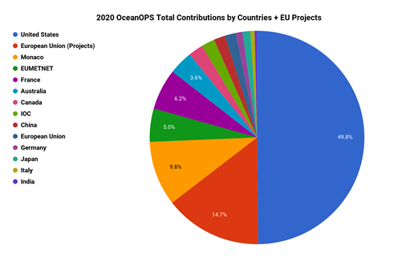

Figure 2: 2020 contributions to OceanOPS by Observing Network
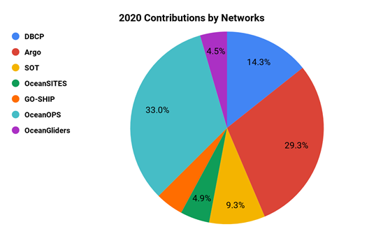

Table 2: 2020 DBCP Panel budget
$ US Currency | DBCP TF | IOC TF
Balance Brought Forward from previous year | $76,016 | $2,912
National Contributions | $27,530 | $20,000
Funds Available | $103,546 | $22,912
Expenses (Direct+indirect costs) | $1,005 | 0
Balance at Dec 2020 | $102,541 | $22,912

Table 3: 2021 estimated Panel budget
 | In Currency of Payment | In US$ (as of 02/07/2021) | Total contribution towards OceanOPS | Total contribution towards DBCP | Total contribution towards SOT | IOC
 | In Currency of Payment | Estimates | Estimates | Estimates | Estimates | Estimates
E-SURFMAR | €55,000 | 65,032 | $42,552 | $9,755 | $9,755
Meteorological Services of New Zealand | €1,800 | 2,128 | $1,298 | $660 | $170
Environment and Climate Change Canada | CAD$ 34,000 | 27,390 | $16,708 | $8,491 | $2,191
Bureau of Meteorology, Australia | €11,700 | 13,834 | $8,439 | $4,289 | $1,107
National Institute of Ocean Technology, India | US$5,000 | 5,000 | $3,050 | $1,550 | $400
South African Weather Service (SAWS)* | €4,000 | 4,730 | $2,885 | $1,466 | $378
BSH, Germany | €3,600 | 4,257 | $2,597 | $1,320 | $341
MNR-China | $20,000 | 20,000 |  |  |  | $20,000**
Total |  | $142,371 | $80,499 | $27,530 | $14,342 | $20,000
*2021 SAWS Contribution not yet arrived
** 2021 MNR-China contribution has already arrived but hasn’t yet been added to the budget code. The 20K$ for 2021 contribution will be added with next year’s budget code.

Table 4: 2021 estimated Panel budget
$ US Currency | DBCP TF | IOC TF
Balance Brought Forward from previous year | $102,541 | $22,912
National Contributions | $27,530 | $20,000 TBC
Funds Available | $130,071 | $42,912
Expenses | 0 | 0
Expenses (Direct & Indirect costs) | 0 | 0
Balance at Dec 2021 | $130,071 | $42,912

Table 5 : Estimated 2022 Panel budget available
$ US Currency | DBCP TF | IOC TF
Balance Brought Forward from previous year | $130,071 | $42,912
National Contributions | $27,530 | $20,000
Funds Available at 1st Jan 2022 | $157,601 | $62,912

The DBCP Executive Board, after reviewing the financial situation, made recommendations regarding expenditure for the coming year, and the DBCP panel adopted the estimated expenditure itemized in Table 6 for DBCP expenses for 2022 (excluding support cost).
Table 6: DBCP panel budget and maximal expenditure for 2022

DBCP – Draft Spend Plan - 2022 | WMO/DBCP TF | IOC/DBCP TF
Travel of DBCP Chairperson and other Exec Board or Panel members | $15,000
DBCP Capacity Building | $10,000 | $20,000
TT activities (e.g., tsunami workshop, baseline environmental footprint assessment) | $40,000
Wave Buoy Pilot | $20 000
Communications  (e.g., DBCP Strategy brochure, promotional material related to engagement with WMO GBON/SOFF) | $10 000
Total | $95,000 | $20,000

The 2022 budget will leave enough surplus (more than 100K$ total) to give the Panel flexibility to plan and execute future activities that help implement the DBCP strategy.

Table 7: Balance at the end of 2022 after expenditures

Item Description | WMO/DBCP TF | IOC/DBCP TF
Funds available at the 1st Jan 2022 | $157,601 | $62,912
Expenditures | $95,000 | $20,000
Support costs (3% DBCP TF; 7% IOC TF) | $2,850 | $1,400
Balance at the end of Dec 2022 | $59,751 | $41,512

B. ACTIONS/DECISIONS/Recommendations:
(a) Action: Request the Panel to approve the estimated 2022 budget for the next intersessional period.

DBCP – Draft Spend Plan - 2022 | WMO/DBCP TF | IOC/DBCP TF
Travel of DBCP Chairperson and other Exec Board or Panel members | $15,000
DBCP Capacity Building | $10,000 | $20,000
TT activities (e.g., tsunami workshop, baseline environmental footprint assessment) | $40,000
Wave Buoy Pilot | $20 000
Communications  (e.g., DBCP Strategy brochure, promotional material related to engagement with WMO GBON/SOFF) | $10 000
Total | $95,000 | $20,000
(b) Recommendation: Request Panel members to consider contributing to the DBCP-TF towards DBCP activities.
Annex I
OceanOPS Financial Report
https://goosocean.org/index.php?option=com_oe&task=viewDocumentRecord&docID=28462

Annex II
WMO/DBCP TF Financial Report – 2020
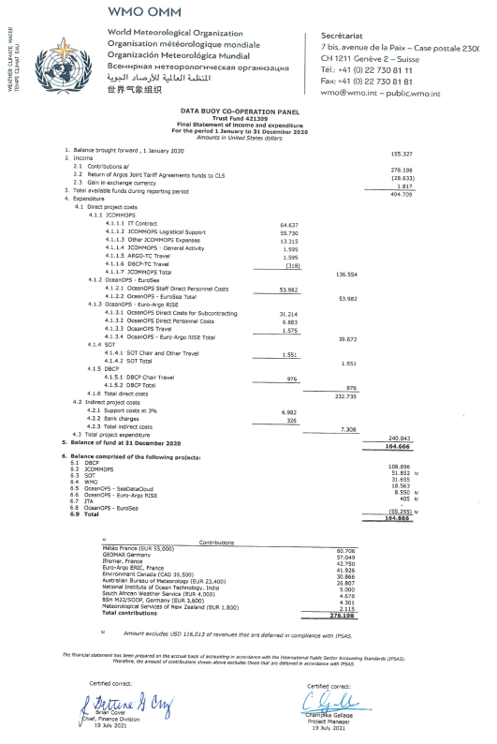

Annex III
WMO/DBCP TF – interim report, as of 15 July 2021
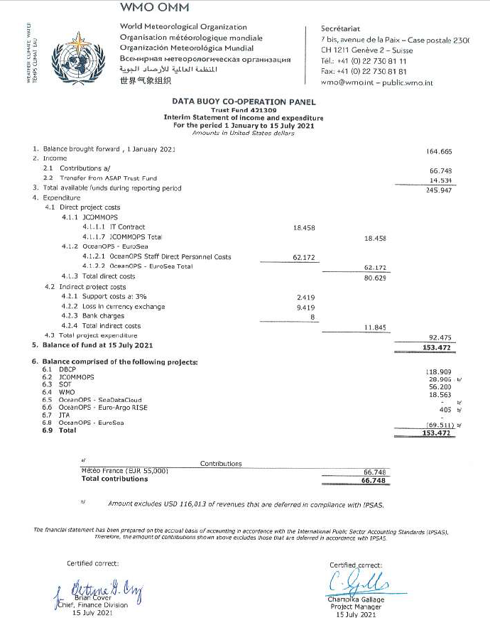
Annex IV
IOC/DBCP TF, 2020 financial statement and interim report as of 3rd November 2021
