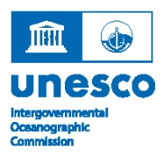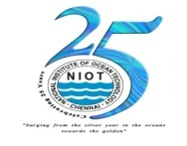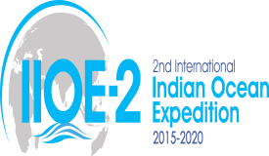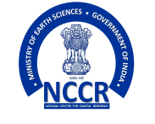
IOC Regional Committee for the Central Indian Ocean (IOCINDIO)
Scientific, Technical and Institutional Innovations for National and Regional Framework on Coastal Vulnerability Assessment and Monitoring for Sea-Level Rise and Storm Surges in the Indian Ocean Region
IOCINDIO Coastal Vulnerability Framework
1  (i)  (ii)  (iii)  (iv)  (v) | Name of the Country  Description  Population  Coastal length  Major Coastal issues  Basic socioeconomic information like GDP, economic contributions from marine resources  Port & harbor, Oil & Gas, Fisheries, Tourism, etc., | :  :  :  :  :  :  :  :
2  (i)  (ii)  (iii)  (iv)  (v)  (vi) | Name of the national contact  Professional Position  Institution (full address)  E-mail  Phone  Fax  Skype id | :  :  :  :  :  :  :
3  (i)  (ii)  (iii)  (iv)  (v) | Relevant Institutions addresses  Met Service  Marine Research Institute  Coastal Engineering Institute  Hydrographic  Others | :  :  :  :  :
4 | Ongoing programmes & initiatives
5 | Existing Policies / Framework
6 | Source of funding for the projects
7 | International Collaborations and network
8 | Major Coastal hazards in the country
(i) | Storm Surge / Coastal Flooding | :
(ii) | Tsunami | :
(iii) | Coastal Erosion | :
(iv) | Marine Pollution | :
(v) | Oil Spill | :
(vi) | Tropical Cyclone | :
(vii) | Sea water intrusion | :
(viii) | Red Tide / Harmful Algal Bloom (HAB) | :
(ix) | Sea Level Rise | :
(x) | Others (please indicates) | :
9 | Scientific Gaps in the knowledge
(i) | Data | :
(ii) | Modelling | :
(iii) | In-situ and satellite observations | :
(iv) | Products & services | :
10 | Type of vulnerability in the country
(i) | Socio – economical | :
(ii) | Environmental | :
(iii) | Physical | :
(iv) | Others | :
11 | Future mitigation / adaptation Plan
(i) | Storm Surge / Coastal Flooding | :
(ii) | Tsunami | :
(iii) | Coastal Erosion | :
(iv) | Marine Pollution | :
(v) | Oil Spill | :
(vi) | Tropical Cyclone | :
(vii) | Sea water intrusion | :
(viii) | Others (please indicates) | :
(iii) | Means to achieve i & ii
12 | Assessment or mapping requirements
(iv) | Hazard | :
(ii) | Vulnerability | :
(iii) | Risk | :
(iv) | Disaster | :
(v) | Socioeconomic Losses | :
13 | Socio-economic relief solutions and systems (insurance, recovery,  rehabilitation mechanisms) | :
14 | Anything requirement from the  IOCINDIO | :
15 | Assessment for National context | :

