Tsunami Warnings Service Requirements Survey

Background

This survey is being used to help guide an international workshop which will explore novel ways to detect tsunamis. The workshop will be hosted by the WMO/IOC Data Buoy Cooperation Panel (DBCP) in collaboration with the IOC Working Group on Tsunamis and Other Hazards Related to Sea-Level Warning and Mitigation Systems (TOWS-WG) and the IOC Tsunami Unit.

The workshop will focus on innovative, cost-effective tsunami detection solutions driven by the requirements that we are seeking through this survey. The imperative for new solutions is motivated by the significant costs associated with running the current technology (tsunameter DART systems) relied upon by all tsunami warning centres around the world.

It is anticipated that workshop participants will be drawn from a wide spectrum of disciplines, both traditional and non-traditional in relation to tsunami observations and detection. Participation will be encouraged from both the government and commercial sectors. The workshop is expected to be held over the next 6 to 12 months.

This survey is being sent to national agencies/centres with a responsibility for tsunami early warnings. The requirements that we are seeking information on fall into three requirement categories:

- Customer/user requirements
- Operational requirements and
- Technology requirements.

Customer/user requirements refer to the information that is needed in relation to the nature and characteristics of the tsunami and its impact. For example, the need to know: when and where an earthquake occurred, what is its magnitude, whether a tsunami has been generated, when will a tsunami arrive at the shoreline, where will be hit the hardest, how accurate is the prediction or warning, how to verify a prediction/warning etc.

Operational requirements refer to the information that is needed in relation to operating the tsunami detection systems. For example, the need to know: the cost of operations needs to be less than X dollars per year, the uptime of the detection service needs to be greater than Y%, the data needs to be of a minimum quality threshold, what is the minimum maintenance frequency, the detection systems need to mitigate against vandalism, the optimal number and locations of the tsunami detection systems etc.

Technology requirements refer to the information that is needed in relation to the tsunami detection system. For example, the need to know: method to measure the tsunami wave height, the measurement frequency that you need, the accuracy of the data required, timeliness/latency of the communication of the measurement to shore, the cost of the technology, maintenance requirements etc.

The workshop will be focused on innovative technology solutions that are primarily driven by the customer/user requirements and operational requirements. Consequently, please focus your responses in relation to the detection of tsunamis.

Proposed survey questions (NB there will be fields requesting contact details et cetera)

- Do your requirements for tsunami early warnings address all three requirement categories (customer/user, operational, technology)? If no,
  - Which categories do your requirements address? (Provide as check list)
- Describe your baseline requirements (please focus on customer/user and operational requirements)
- Are your requirements prioritised? If yes, how have you prioritised them i.e. what are the criteria used?
- What tsunami detection technology do you currently rely on?
- What gaps or issues do you have (e.g., requirements that are not met or only partially met) in relation to your baseline requirements?
- If you are addressing any of the gaps/issues, please describe what you would like to do or what you are doing/planning so that you can fully meet your requirements?
- Have you heard of any new or emerging technology that is promising for tsunami early warnings? If yes,
  - What is the new or emerging technology?
  - Please provide a contact for the new or emerging technology (e.g. an email address)
- Are there emerging customer and/or operational requirements for your tsunami early warning service? If yes,
  - What are these emerging requirements?
  - When do you need these emerging requirements addressed, and why?
- Do you have documentation detailing your requirements? If YES:
  - Can you share your documented requirements with us?
  - How recently was your documented list of requirements reviewed (month and year)?
  - When will you next update your list of requirements (month and year)?

- Is there anything else that you would like to add?
Supplementary questions
- Would you like to be kept up-to-date with the development of the workshop?
- Would you be interested in participating in the workshop (noting that we are likely to have to limit the number of participants)?

Deadline for receiving completed survey
One month from receiving it.

INDIA - Ministry of earth sciences (MoES)
REPORT TO THE International tsunamETER PARTNERSHIP FOR the ThirtY-SEVEN session of the DBCP
(08-11 November 2021, VIRTUAL mode )
- Summary

Name of Action Group | International Tsunameter Partnership (ITEWS contribution)
Date of report | 12 October 2021
Overview and main requirements addressed | The Indian Tsunami Early Warning System (ITEWS) deep-ocean tsunameter network comprises 4 STB (SAIC Tunami Buoys) stations and 3 ITB (Indian Tsunami buoy) stations located in the Indian Ocean, Bay of Bengal and Arabian Sea.  Tsunameter data is required to give early confirmation of tsunami wave magnitude and therefore provides important input to the threat levels. This is important because the early seismic solutions for large events are often upgraded later to higher magnitudes – the tsunameter observations can indicate earlier that this is a bigger event.
Area of interest | Indian Ocean (Arabian Sea and Bay of Bengal)
Type of platform and variables measured | Four stations are based on NOAA/PMEL DART-II® technology and three stations with Indigenous tsunami surface buoy system with M/s Sonardyne.UK make Sea Bed pressure sensor BPR unit. The Indian Tsunami buoy implemented wiih DART II format.  Variable measured: hydrostatic pressure.
Targeted horizontal resolution | See Figure 1 (Annex A)
Managers | MoES Institutions  1.National Institute of Ocean Technology (NIOT)  2.Indian National Centre for Ocean Information Services(INCOIS)
Coordinator | N/A
Participants | Dr R. Venkatesan, NIOT will be attending the 37th session through virtual mode
Data centre(s) | ITEWS Sea Level data server  NOAA’s NDBC DART buoy portal  https://www.ndbc.noaa.gov/
Website | www.incois.gov.in  www.tsunami.incois.gov.in
Meetings  (meetings held in 2019/2020; and planned in 2020/2021) | 36th session of the DBCP, 05-08 October 2020, Virtual mode  37th session of the DBCP, 08-11 November 2021, Virtual mode
Current status summary (August-2020)
  Region | WMO | Type | Status | Comment
  Arabian Sea | 23228 | STB 02 |  | All Tsunami buoys working with DART II format
  Arabian Sea | 23226 | ITB 12 | x | All Tsunami buoys working with DART II format
  Arabian Sea | 23225 | ITB 12A | x | All Tsunami buoys working with DART II format
  Bay of Bengal | 23227 | STB01 | x | All Tsunami buoys working with DART II format
  Bay of Bengal | 23217 | STB 03 | x | All Tsunami buoys working with DART II format
  Bay of Bengal | 23218 | ITB 05 | x | All Tsunami buoys working with DART II format
  Bay of Bengal | 23223 | ITB 09 |  | All Tsunami buoys working with DART II format
  Bay of Bengal | 23219 | STB05 |  | All Tsunami buoys working with DART II format
Challenges/Opportunities/Risks (intersessional period) | - Due to COVID 19 pandemic situation, couldn’t service the Tsunami buoy system.  - Materials such as lithium batteries, INMARSAT transmitters etc couldn’t imported from the OEM due to lockdown.  - Maintaining moored buoys at harsh sea conditions, cyclones in the location  - Protect the buoy from the vandalism activity  - The charging of lead-acid batteries can be hazardous. The two primary risks are from hydrogen gas formed when the battery is being charged and the sulfuric acid in the battery fluid.  - Importing and stocking the lithium battery is very challenge for developing countries  - Lithium-ion batteries can pose unique safety hazards since they contain a flammable electrolyte and may be kept pressurized. An expert notes "If a battery cell is charged too quickly, it can cause a short circuit, leading to explosions and fires".  - Measuring the water level changes during seismic event and also to measure the seabed temperature in real time.
Summary of plans for 2021/22 | One service voyage are planned for the next 12 months.  Arabian Sea  Planned to service ITB12 during November 2021.  Bay of Bengal  Planned to service the ITB05, ITB09 , STB01, STB03 and STB05 during year 2022.

- Deployments in 2020/2021

Two voyages were conducted in the last 12 months.

Bay of Bengal

Two voyage was undertaken in on-board ORV Sagar Nidhi during February and May 2021. The following activities were undertaken:
- During February 2021, Indian Tsunami Buoy ITB TB09 deployed and ITB05 retrieved from location due to system faulty.

- Deployment plans for 2021/2022

Arabian Sea:
- ITB 12 Tsunami buoy system is planned to service during November 2021 by using ORV Sagar Kanya.
- SAIC Tsunami buoy planned to service during year 2022.
Bay of Bengal:
- Two ITBs ITB09 and ITB05 planned to service during February/March 2022 using by ORV Sagar Nidhi .

- Data management

    - Distribution of the data

INCOIS made arrangements between INCOS and NDBC , The SAIC and Indian Tsunami buoy data ingested through a secure REST endpoint (Web API) to display data in NDBC website.Data is also available through NOAA’s National Data Buoy Centre
(https://www.ndbc.noaa.gov/station_page.php?station=23228)

    - Data policy

Pushing data through REST architecture technology to NDBC server and freely distributed onto the GTS

    - Real-time data exchange

- The Iridium RUDICS service is used for data communications for STB buoy systems
- The INMARSAT satellite service is used for data communication in ITB buoy systems.All Indian Tsunami Buoy system (ITBs) upgraded to DART II format and real time transmission will be DART II format. The DART II format data shall be shared in NOAA NDBC portal.

      - Data availability – see Annex A

      - Data timeliness

The ITEWS systems are located to ensure at least 30 min travel time from the source to the buoy (in order to separate the seismic signal from water perturbations). It is usual for the systems to be triggered by the seismic signal before any true water height perturbations arrive

Event Mode

- STB & ITB system - One minute averaged data reaches the ITEWS every 8 min of the first 90 min of an event and then every 16 min until approximately 180 min have elapsed since the event.

Non-event mode

- STB - Data is delivered every six hours in 15 min resolution.

- ITB – Data is delivered every six hours in 15 min resolution.

    - Delayed mode data exchange

- Data is archived at Sea Level Data Server of ITEWS at INCOIS and at NOAA NDBC.

  - Data quality

- Quality control is restricted to visual inspection of the data.

- Instrument practices

- Manufacturer’s procedures are followed where possible. Otherwise equipment is to be sent to the manufacturers place for maintenance and repair.

- Challenges

Vandalism
There was a case of Vandalism in Arabian Sea. The ITB12 surface buoy mast lost during 2020

Buoy ID | Photos | Remarks
ITB 12  (2020) | 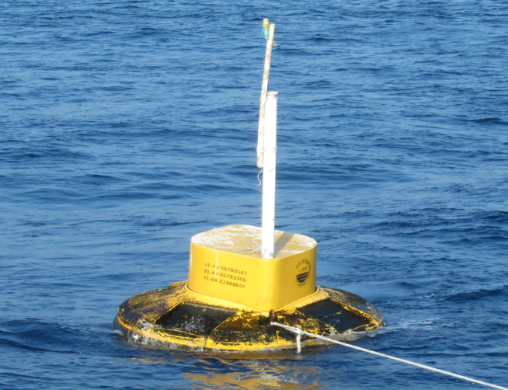 | Surface mast lost

Ship Time

- Due to COVID19 pandemic situation, the planned cruises were cancelled and postposed to fair weather

- Technological developments

7.1 Indian Tsunami Buoy System - Sagar Bhoomi Version-II

The prototype Indian Tsunami Buoy and BPR system ‘Sagar Bhoomi Version-II system is ready for deployment to check the performance. It’s planned to test in Ocean during February/March 2022.

- Overall Summary

- Two service voyage undertaken during the year in Bay of Bengal.
- Currently 3 tsunami buoys are reporting , 2 tsunami Buoy (SAIC) system and one ITB .
- Planned to service 5 tsunami buoy system ( 3 from ITBS and 2 from STBs ) during forthcoming cruise 2021-22.
- Data sharing through REST architecture to NDBC.
- Indian Tsunami buoys implemented with DART II and data being published NDBC website.
- Challenges –Vandalism.
Annex A

Status maps and graphics

A1. Map
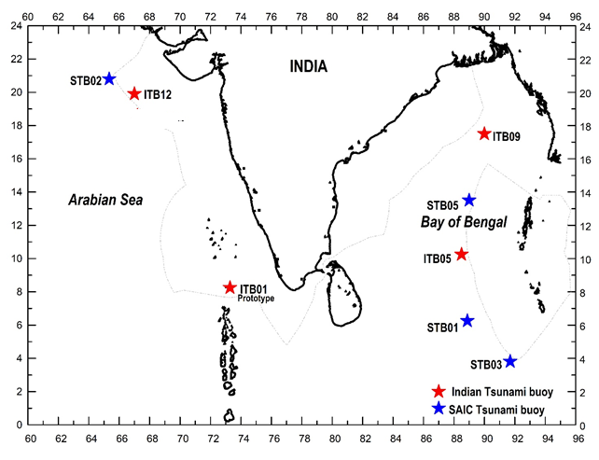
Figure 1. Indian tsunameter locations

the Report by the DBCP Action Groups to the
Thirty-SIXth session of the DBCP (DBCP-36)
(Virtual session, 05-08 Oct 2020)

1) Summary

Name of Action Group | International Tsunameter Partnership (ITP)
Date of report

Overview and main requirements addressed | US Submission
Area of interest | System Reliability and Principal
Type of platform and variables measured | Ocean Tsunami Buoys – changes in water Colum height; related parameters
Targeted horizontal resolution | Tsunami observation network operators; Tsunami Warning Centers; Emergency Managers.
Chairperson/Managers | ITP: Dr. Venkatesan (chair); Dr Christopher Moore (Co-chair)
Coordinator

Participants | NOAA NDBC (John Wasserman);
Data centre(s)

Website | US: https://nws.weather.gov/nthmp/about_tsunamis.html
Meetings  (meetings held in 2019/2020; and planned in 2020/2021) | DBCP 35; Geneva, Switzerland
Current status summary (mid-2020) | Refer to the following report
Challenges/Opportunities/Risks (intersessional period- highlighting the impact of COVID19 and mitigation plans) | Challenges: Equipment replacement; Opportunities: next generation systems.
Summary of plans for 2021 | See attached report.

2 Deployment plans for 2021 and Report of Operational Status

US Deep Ocean Assessment and Reporting of Tsunami (DART) Report:

NOAA-Tsunami (DART) Operations

The National Oceanic and Atmospheric Administration’s (NOAA) National Data Buoy Center (NDBC)

NDBC has no plans to change the locations or capacity of the US operated network in 2021. A map of the current configuration of the US Network is included in the Annex.

System Enhancements – Slack mooring DART buoy deployments have increased in number over the 2020-time frame and now have 70% of the network converted to new slack mooring design. In addition, a few more operational single housing BPRs with near-field detection capability were deployed in the Pacific Ocean. However, the system was deployed in far-field mode, but the system can be changed to near field using a back-channel command. To date, this has not been attempted on an operational station. These enhancements were put in place to counter-act reliability concerns and end of life system issues. The following charts provide supporting data to both the end of life and mooring improvements made in the short term.

Looking at 2019 data:

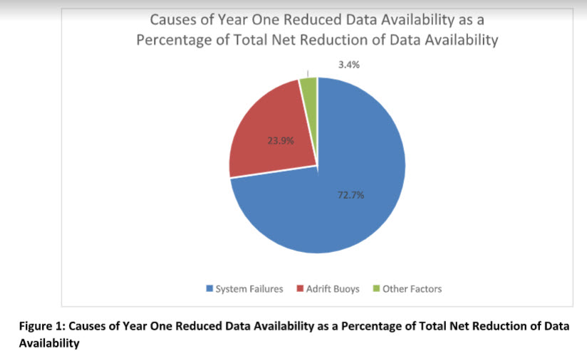

Looking over a two-year period (2018 – 2019):

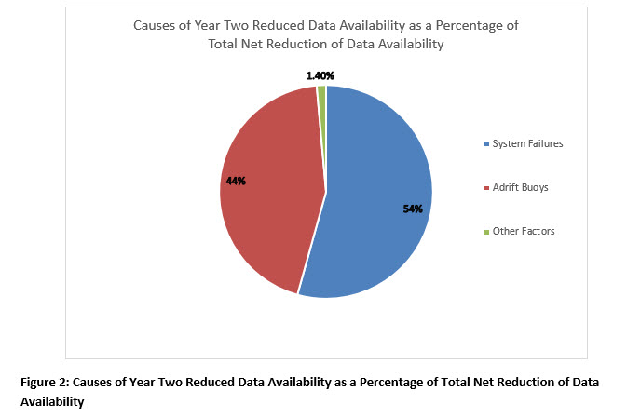

NOAA-DART Research

The National Oceanic and Atmospheric Administration’s (NOAA) Pacific Marine Environmental Lab (PMEL) continued transition to 4th generation DART technology. The effort began in 2013 for the purpose of forecasting tsunamis in the immediate area of generation. An enhanced version of the DART Easy to Deploy, the DART 4G, incorporates advanced sensors updated software, and power management to detect and precisely measure tsunamis more frequently than ever before was incorporated into NOAA’s operational tsunami network of DART stations. The increased number of measurements allows for earthquake signals to be separated from tsunami waveforms so that the 4G can be sited closer to where an earthquake occurs than any predecessor DART. DART 4G systems were deployed offshore Oregon and central Chile for testing. The system is deployed operationally by the National Weather Service (National Data Buoy Center) for refresh of the DART II operational array technology and additional testing will occur in 2021 to further test near field utility. A reconfiguration of the network could possibly result based off of this technology and placement of systems closer to subduction zones.

Figure 3. Illustration depicting filtering capacity of near field system.
Reference: Image and narrative summarized from NOAA PMEL 4G brochure.

Deployments Planned for 2021 – PMEL and the NOAAs Great Lakes Environmental Research Lab (GLERL) are planning to deploy a new DART-4G (Slim) in Lake Michigan for the purpose of meteo-tsunami research. Because of COVID the deployment has been delayed until 2021.

3 Data management

3.1 Distribution of the data

3.1.1 Data policy

NOAA National Weather Service is reviewing decision support messaging and specifically its Collaborative Messaging Process (CMP) for the Tsunami Program. The recognition is the obvious understanding that although warning systems are important to have in place, there is a need for rapid, clear and concise messaging to the public. This is paramount to having warnings that can be understood and immediately acted upon.

3.1.2 Real-time data exchange

webAPI – To strengthen data security and improve the overall data management and administration of tsunameter network data sharing; The NOAA National Data Buoy Center (NDBC) has developed and implemented an application programming interface (API) to phase-out and replace the File Transfer Protocol (FTP) used by the NDBC and its partners to exchange Deep Ocean Assessment and Reporting of Tsunamis (DART) technology data.

During the ITP session of DBCP-36, the NDBC will review and discuss the risk associated with existing FTP data mechanisms and preview opportunities and benefits presented by the new API. During DBCP-36/ITP; a recommendation will be drafted for the adoption and phase-in implementation of the new API for operational tsunameter networks seeking data dissemination via the NOAA National Data Buoy Center.

UN Decade for Ocean Science tsunami goal is that all tsunami-vulnerable communities around the world are 100% Tsunami Ready. The US NOAA NWS TsunamiReady was the model for the UNESCO IOC effort. That said, the need for continuous improvement and open collaboration with International partners must remain a high priority so that the 100% goal can be achieved.

4) Instrument practices

Repackaging of electronics in a single housing will have positive reliability impacts, thus eliminating multiple possible failure points.
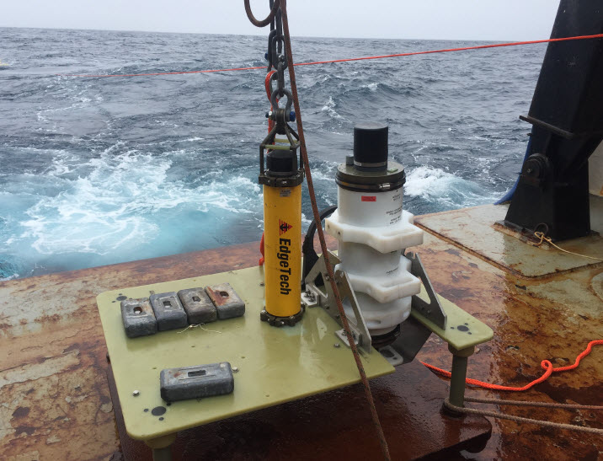

5) Details of Challenges/Opportunities/Risks

Report details on the challenges, opportunities and risks for the task team during the intersessional period.

6) Action Items:

- Replace ITP Co-Chair (vice Cucullu) –

NOAA Office of Atmospheric Research (OAR) PMEL has nominated Mr. Chris Moore to take over Co-Chair assignment. Chris has a strong inundation modelling background. A copy of Chris' bio resides at:

https://nctr.pmel.noaa.gov/Moore/chrisbio2019.pdf

Inputs to ITP report
China

National Marine Environmental Forecasting Center (NMEFC) of State Oceanic Administration (SOA) of China is responsible for operating the tsunami warning and mitigation system in China.
In South China sea, two tsunami buoys and coastal seismic stations have been deployed by SOA to detect earthquakes that may trigger local tsunamis. These buoys have been damaged many times since they were deployed, and have stopped data transmission. At present, SOA has completed the repair of one tsunami buoy by cooperating with the Shandong Technological Center of Oceanographic Instrument by integrating the existing tsunami buoy hardware and cooperate with relative departments to carry out the site selection work for new stations.
In East China sea, the deployment of tsunami buoy is finished, their operations are normal, the met-ocean observations are reliable, and the tsunami warning and mitigation system are efficient.

___
Annex (optional)

Status maps and graphics

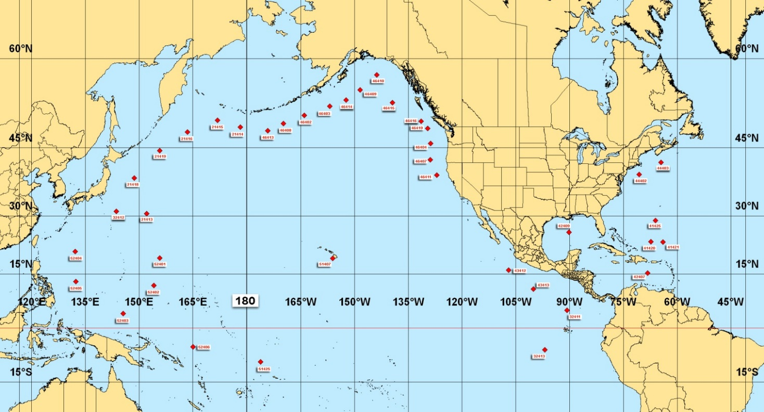
2020 United States Tsunami Deep Ocean Assessment and Reporting of Tsunami (DART) Network

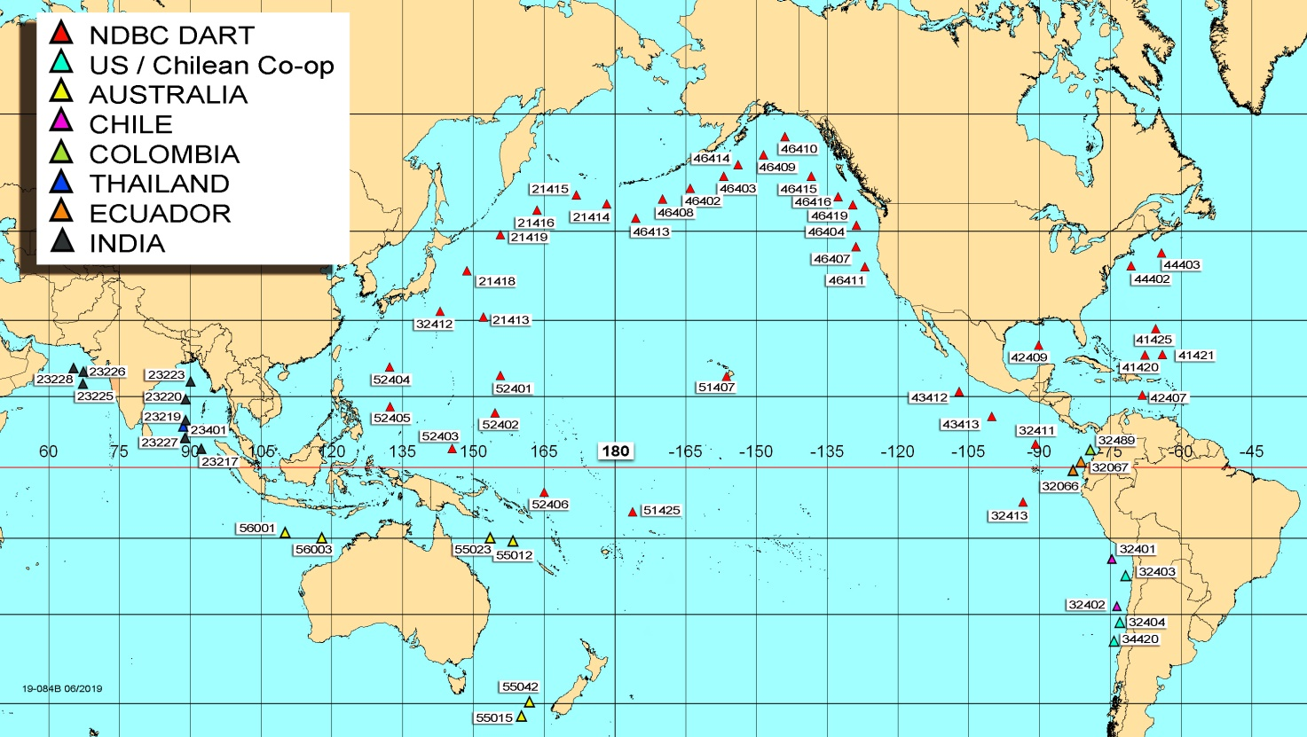
2020 DART with International Partners

__________________

