  World Meteorological Organization &  Intergovernmental Oceanographic Commission (of UNESCO)  Data Buoy Cooperation Panel Thirty Seventh Session, 8-11 2021 |   DBCP-37/Doc. 6
Submitted by:
Long JIANG
10.2021
DRAFT v1
AGENDA ITEM 6: DBCP and OceanOPS report
AGENDA ITEM 6.5: DBCP and OceanOPS report

SUMMARY

This document provides a report on status of DBCP, Technical Coordinator activities, and overall GOOS, OceanOPS activities related to DBCP, including recommendations to the panel for approval and actions/decisions required.
As of 1st September 2021, the Technical Coordinator, Dr Long Jiang, has been reallocated from Geneva, Switzerland to Brest, France working with the rest of OceanOPS team. During the intersessional period, Dr Long Jiang, has continued supporting actively work and activities of the DBCP and its Chair, Executive Board, and expert groups.
Mr Jiang’s work included supporting DBCP chair, Dr. Boris Kelly-Gerreyn, in the update, consultation, and approval of the operating principles and implementation plan to align with DBCP Strategy 2022-2027. See more details in Chair and Executive Board reports. In the same vein, Dr Jiang coordinated all the six task teams of the DBCP to examine and modify Terms of References and activities accordingly (see task team reports and more details here).
Mr Jiang continued working on metadata integration into OceanOPS and ensured nearly a complete record of operational drifting buoys metadata, and more than 95% completion of operational moored buoys metadata. In particular, almost all operational drifters metadata have been synchronized with OSCAR/WIGOS of the WMO, except for some with missing sensor metadata. Moored buoys (and other GOOS networks) metadata insertion into OSCAR is being conducted by OceanOPS. In addition, Mr Jiang has been adding some 4,000 historical drifters metadata from AOML and SIO into the system. For moored buoys metadata, Mr Jiang worked with Task Team on Moored Buoys to have updated the metadata template and contents, which was last updated in 2018 and 2021. Mr Jiang drew attention of the Panel that the GOOS OCG tasked OceanOPS to monitor OCG observing networks through ongoing efforts of integrated metadata management at OceanOPS, and at the same time OceanOPS may generate metadata as required by respective networks in csv or json. Mr Jiang has been coordinating Task Team on Moored Buoys and OceanOPS to ensure agreement on the way forward with the metadata management.
Mr Jiang reported BUFR migration stagnated at 65% for moored buoys in agreed TM315008 format. He invited moored buoys operators to continue migration efforts. He further noted all current drifters are in agreed TM315009 format and more than 95% by Iridium. He reported there may be potential change in telecommunication system due to cost issues by the global drifters program of NOAA, and reminded drifters operators need to make necessary adjustments or backup, noting no impacts to current operational drifters in water. He noted with the WMO Information System 2.0 and its demonstration projects OpenGTS and CF-NetCDF, there may be more channels and agreed formats to share oceanographic data, including buoy data. In addition, Mr Jiang noted wave spectra from drifting buoys were occasionally truncated as these data are appended to drifter buoy data template, leading to ignorance in decoding. He invited TT-Data Management and TT-Moored Buoys to have an agreement on wave data format for drifters or moored buoys, to avoid unexpected data loss.
Mr Long Jiang reported overall health status of the global drifting buoys array (Figure 1). From August 2020 to July 2021, monthly average number of drifting buoys sharing data to the GTS is 1585, 413 for moored buoys, 96 for fixed platforms, and 36 tsunameters. The global drifter array also included 65 operational high resolution sea surface temperature (HRSST) drifters that are deployed and managed by ESURFMAR and observed monthly average of 12 wave drifters operational (less than 1% of the global drifters array) in the past year, mainly by USA and Japan. 96.9% of global drifters distributed data within one hour, and averaged delay is 30.6 minutes.
Figure 1. Average amount of operational platforms
(August 2020 to July 2021)
However, Mr Jiang reported KPIs for intensity and activity of the global ocean and basin scales. KPI for coverage was also developed by OceanOPS for approximation of WMO six Regional Associations in the context of the global basic observing network (GBON). Overall, in the past intersessional period, the community totally deployed 916 drifters, compared with 1129 and 1193 of last two intersessional periods. He noted deployment activities in the Indian Ocean needs to be improved based on OceanOPS records, while the Atlantic Ocean seems to have redundant deployments for both intensity and activity. It is worth noting that global drifter coverage in open ocean by 5X5 grids remains ~76% in the past couple of months, and may pick up by early 2022, when more deployments undertaken by Australia, Denmark, France, Republic of Korea, South Africa, UK, USA, etc.
Drifter Intensity
 | Target | Intersessional Deployments | Rate
Global Ocean | 958 | 798 | 83.3%
Atlantic Ocean | 253 | 403 | 159%
Indian Ocean | 212 | 105 | 49.5%
Pacific Ocean | 493 | 290 | 72.0%
Drifter Activity
 | Target | Intersessional Activity | Rate
Global Ocean | 1300 | 1585(average) | 122%
Atlantic Ocean | 312 | 742 | 238%
Indian Ocean | 262 | 225 | 85.9%
Pacific Ocean | 608 | 652 | 107%
Regarding Global Drifters Array density and data availability (Figure 2), Mr Jiang reminded that tropical and polar regions remain least covered and least sampled area, while North Atlantic overly sampled.
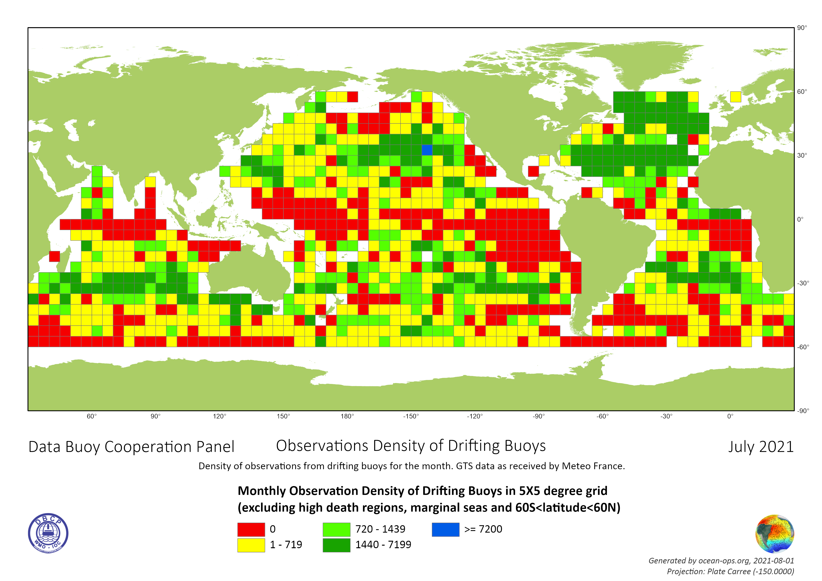

Figure 2. Density of Drifting Buoys Observations between 60S and 60N
excluding death region and marginal seas in July 2021

While monthly SLP observations averaged 56% in the past intersessional period, some key data users like ECMWF still found barometric pressure data inadequate for global numerical weather predictions (NWP), esp. for extreme events like monsoons/tropical cyclones. Mr Jiang provided an overview of barometric pressure data by platform (Figure 3) based on OceanOPS monitoring in September 2021.
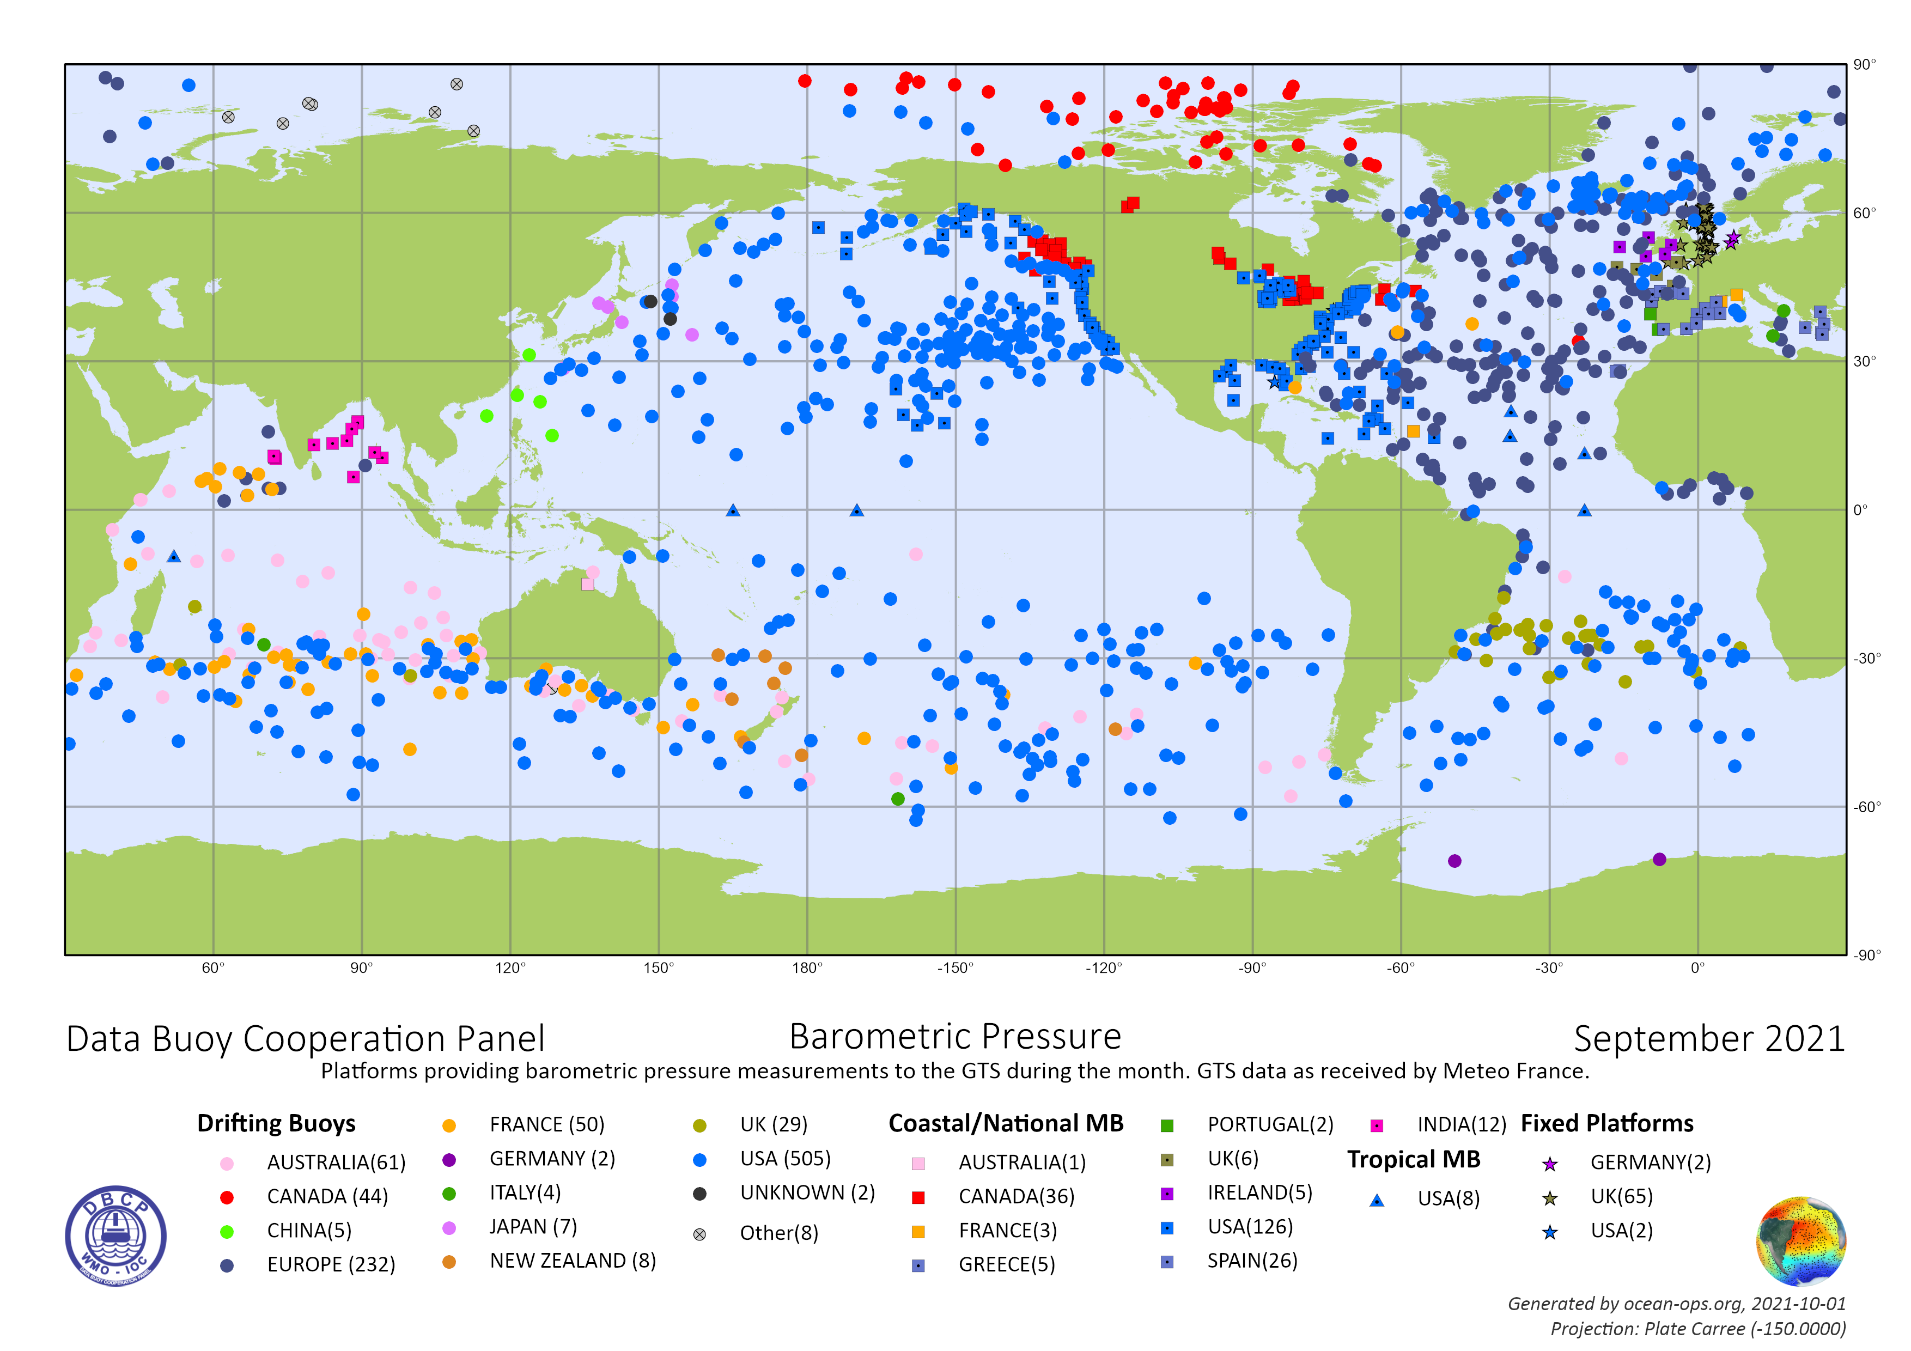
Figure 3. Barometric Pressure Observations by Platform
Long noted these least sampled regions amongst most challenging environments for deployment for technical and financial reasons. He coordinated a meeting between DBCP chair with stakeholders at ECMWF, PMEL and GOMO of NOAA. The group agreed to have a definite analysis of requirements and status and will consider a demonstration project on the barometer upgrade initiative for all buoy types coordinated by the DBCP.
Mr Jiang recalled the WMO Congress-17 requested Members to fund and install barometers on all newly deployed drifters, and made Recommendation 18 on marine observing system for numerical weather prediction, specifically on DBCP barometer drifter upgrade scheme, with the support of NOAA’s Global Drifters Program. Mr Jiang invited operators interested or need help, to contact AOML and/or Scripps for details.
He also reminded the Panel that Co-Design has been accepted by the UN Ocean Decade, and drifter operators can consider shared resources for planning and buoy deployment. In addition, Long informed WMO regional associations sessions for RA2-17 and RA5-18, both urged members to work closely with DBCP on drifter deployment and data application, along with other requirements to ocean observing infrastructures for improved marine services.
For the Global Tropical Moored Buoys Array, Mr Jiang worked with NOAA and OceanOPS to refine KPIs on targeted units as of TAO/55, RAMA-OMNI/29, and PIRATA/18, so that GTMA (102). This adjustment reflected evolution of the GTMA in different basins regarding operational and scientific requirements and pragmatic operations. Long drew attention of the Panel that in the past couple of years, GTMA experienced drop in operational performance due to interrupted redeloyments, esp. RAMA-OMNI saw less than 25% active units. However, he also noted recent encouraging renewed collaboration of NOAA with its Indian and Indonesian partners, and sustained USA-France cooperation in PIRATA, and expect progressive growth of tropical moorings, especially a new buoy data portal has been launched.
For tsunameters, the international array experienced continuous drop from August 2020 till April 2021, when the array steadily picked up with new deployments/replacements commissioned. Mr Jiang also reported he has been working with DBCP, International Tsunameter Partnership/ITP, IOC tsunami unit, and other colleagues to formulate and circulate a survey on tsunami detection technologies, and the group will organize a workshop in the coming six to twelve months based on results of the survey.
Regarding national reports, Mr Jiang noted this year 27 members (30 in 2020) submitted reports with more members participating the DBCP-37. New participating members include Armenia, Kazakhstan, Myanmar, Nigeria, Tanzania, Tunisia. Based on the national reports and records at OceanOPS, Mr Jiang commended nine members shared a good proportion of their buoy data to the GTS. Similar issue of data sharing also observed in polar buoys operations (IABP/IPAB), which are more funded from research institutes. Mr Jiang encouraged members to make efforts on data sharing and exchange and offered to technical and coordination support.
Mr Jiang also highlighted data and metadata mapping upon request of the OCG. He (and OceanOPS team) worked with Kevin O’Brien, IOC and other colleagues to have mapped out data (real time and delayed mode) and metadata flow of the community. For the time being, DBCP has completed the efforts with Argo and OceanGliders. Mr Jiang thanked comments and inputs from Mayra Pazos and Lance Braasch, and other TT-Data Management colleagues.
Mr Jiang reported successful Fifth Pacific Islands workshop (PI-5) was organized virtually by the WMO/IOC Data Buoy Cooperation Panel (DBCP), and the Pacific Community (SPC). Workshop was organized in two parts with a break in between where participants were given an assignment to complete and report back during the second part. The first part of the workshop took place on 27th and 28th May and the second part on 10th and 11th June, 2021 for three hours each day. Workshop consisted of an opening with keynote speeches and nine focused sessions. Some one hundred and sixty (160) participants from forty-one (41) members registered for the workshop. More details please see Task Team report and event page (https://goosocean.org/dbcp-pi-5). Mr Jiang provided an overview of OceanOPS strategy and web-based metadata system, and reported on all ocean observing networks status in the Pacific region that were monitored by the OceanOPS, Argo floats, DBCP, HF radars, tidal gauges/GLOSS, ocean gliders, ship based observations, saildrones, etc. He noted data buoys consisted 29% of operational platforms in the region, following 64% of Argo floats. He reiterated necessity to optimize deployments and co-design, and advocated barometer upgrade and reducing vandalisms.
In addition, based on recommendations of the PI training workshops, Mr Jiang updated the Panel that the DBCP Task Team on Capacity Building has been working with SIO to fund a pilot wave drifter deployment in selected area of the Pacific. The pilot will be supported by the DBCP Trust Fund at WMO with 20K USD, to support one or two drifting wave deployments in shallow coastal waters.
Mr Jiang also highlighted the leading efforts of the newly established Task Team on Environmental Stewardship, led by Karen Grissom, NDBC/NOAA. In particular, Karen led OCG workshop on environmental stewardship in May 2021. Long coordinated several meetings for its formation, consultation of ToRs and deliverables, etc. He set up a webpage for the TT with useful information on environmental stewardship at the UN, WMO and partner agencies, observing networks, practices and activities. (https://www.ocean-ops.org/dbcp/community/environmental.html). A similar page will be set up for the proposed Task Team on User Impact and Value https://www.ocean-ops.org/dbcp/community/data.html. Regarding vandalism, intersessional report showed 1/3 decrease to 104 incidents from last intersessional period’s 156, mostly from USA (86). Mr Jiang also invited Port Meteorological Officers to take use of their connections for buoy protection in his joint presentation with Dr Rick Lumpkin at PMO-6(16-18 March 2021). In addition, Mr Jiang thanked Republic of Korea (buoycam) and India (video) who shared buoycam and video to protect buoys.
During the intersessional period, the TC communicated closely with the WMO and IOC community. He has developed another 5 issues of DBCP newsletters, reaching more than 500 stakeholders of ocean observations of the WMO and IOC. Mr Jiang provided technical inputs to the development of WMO Bulletin (vol 70(2)-2021) on Ocean Data for Earth System Predictions, led by Sidney Thurston. He also ensured OceanOPS report card included wave drifter as showcase for technology innovation.
In addition, Mr Jiang informed the DBCP that WMO Extraordinary Congress approved its tri-strategic items: Unified Data Policy(policy framework), Global Basic Observing Network (GBON, technical regulatory framework), and Systematic Observations Financing Facility (SOFF, financial mechanism). He invited the DBCP to consider possible engagement and initiative mainstreaming with these strategies for sustained and enhanced network for the global ocean observing efforts.

OceanOPS highlights
- Mr. Mathieu Belbeoch was appointed as Manager of OceanOPS through regular budget of the WMO, which indicated stronger support of the WMO in GOOS.
- Centralized metadata management solution under development at OceanOPS: documentations, API, etc. https://www.ocean-ops.org/metadata/
- OceanOPS was able to employ a metadata clerk, Ms. Magali Krieger, from September 2021. Ms Krieger will work with technical coordinators and IT expert at OceanOPS for metadata harmonization and integration.
4. OceanOPS report card 2021 was published with a dedicated session on Ocean Oxygen, and technology innovation of wave drifters.

A. INTRODUCTION/SUMMARY:
(approximate length half (1/2) a page to include in final report)

B. ACTIONS/DECISIONS5 REQUIRED:
(a) Adopt draft Action (Decision) 0.0.0/1 —Action (Decision) title;
1) Continue moored buoys metadata management and integration with OceanOPS in format agreeable to both users and OceanOPS (TT-MB, OceanOPS, TC; Ongoing)
2) Further coordinate drifting buoys deployment plan for optimal use of resources to fill in gaps and strike balanced coverage of different ocean basins. (Pacific, Atlantic, Indian, Arctic and Antarctic)
3) Consider a pilot project to further improve barometer upgrade for both drifting and moored buoys
4)

C. RECOMMENDATIONS6 :
(a) Adopt draft Recommendation 0.0.0/1 — Recommendation title;

C. BACKGROUND INFORMATION (not to be included in the session report):

References (if any):
- OCG-12 website/documents: https://goosocean.org/index.php?option=com_oe&task=viewEventRecord&eventID=3008
- OceanOPS OCG presentation: https://goosocean.org/components/com_oe/oe.php?task=download&id=47853&version=1.0&lang=1&format=15
- OceanOPS 5-year strategy:
https://www.ocean-ops.org/strategy/
- Ocean Observing System Report Card:
https://www.ocean-ops.org/reportcard2021
- IOC-UNESCO article on Covid impact:
https://en.unesco.org/news/covid-19-disruptions-ocean-observations-could-threaten-weather-forecast-and-climate-change
- WMO article on Covid impact:
https://public.wmo.int/en/media/press-release/covid-19-impacts-observing-system
- WMO Ocean video:
https://www.youtube.com/watch?v=1WmWnHUVWtM
- OceanOPS data tracking module:
https://www.ocean-ops.org/board/wa/DataTrackingModule
- OceanOPS metadata standard for GOOS networks:
https://www.ocean-ops.org/metadata/
- Example training videos for OceanOPS dashboard:
https://youtu.be/TkOgHoa8baQ ; https://youtu.be/tmxVBRwFNu4
- Data Mapping – Draft data flow charts developed with IOC:
https://drive.google.com/drive/u/0/folders/12QJZ7N1ivpi32DE8MhOHh23WF8bRdqAP
- GOOS metadata standard, draft documentation:
https://www.ocean-ops.org/metadata
- OSCAR/WIGOS
https://oscar.wmo.int/surface/index.html#/search/station/stationReportDetails/0-22000-0-5SRJ82U
- GDP and DBCP presentation at PMO-6
https://goosocean.org/index.php?option=com_oe&task=viewEventDocs&eventID=2610
Draft Actions/Decisions
[Comment: Details on main points and arguments leading to formulation of draft actions/decision presented in this document]

Draft Recommendations
[Comment: Details on main points and arguments leading to formulation of draft actions/decision presented in this document]

Calculation based on 5x5 grid elements excluding marginal seas and latitude>60N/S (1182) and average life of a platform 450 days. i.e. units to be deployed per year (1182*(450/365)) is 958
Number of operational units against target of global 5x5 grid 1300
Number of well sampled grid elements over last month vs total (1182 grid elements in 5X5 degree grid excluding marginal seas and lat>60N/S)
Half a page or less of Summary
An Action/Decision is an item directly related to DBCP and on which DBCP can action or decide directly. Details on rational for the action/decision should be included in the Background under Draft Actions/Decisions.
A Recommendation involves proposed action(s)on another body outside of DBCP (e.g. SOT, GOOS, WMO, IOC, INFCOM etc.). Details on rational for the Recommendation should be included in the Background under Draft Recommendation.

