Summary
Part I of this report provides an overview with regard to the implementation of the 2018–2019 IOC budget as at 31 December 2019, including an update on resource mobilisation.
Part II gives an outline of the approved 2020–2021 budget and a brief overview of the financial situation of the IOC Special Account at year-end 2019, including an updated forecast for the period 2020–2021. The Financial Report of the IOC Special Account for the period 1 January 2018 to 31 December 2019 is included in Appendix I.
Proposed decision: This document is part of the report of the Executive Secretary to the Executive Council. It will be further examined by the statutory sessional open-ended Financial Committee and the decision reflected in the Draft Resolution that the Financial Committee will submit for adoption by the Assembly under item 5.2 in accordance with paragraph 15 of the Revised guidelines for the preparation and consideration of draft resolutions (IOC/INF-1315).

This report covers three types of funding that compose the IOC budget:
- Regular Programme allocation (UNESCO budget–39 C/5 for 2018–2019 + Additional Appropriations (voluntary contributions intended to directly reinforce an existing budget line), if applicable).
- Voluntary (Extrabudgetary) Contributions to the IOC Special Account:
B1. Programme Activities (191-series accounts)
B2. Earmarked Activities (193-series accounts)
- Voluntary (Extrabudgetary) Contributions for specific projects under the funds-in-trust modality.

PART I – IMPLEMENTATION OF THE IOC BUDGET IN 2018–2019
- In compliance with UNESCO Member States’ decisions, the 2018–2019 budget was based on an Integrated Budgetary Framework (IBF), allowing greater transparency of resources and helping to align resources with the collectively decided priorities.
- Following the approval of the Organization’s Programme and budget for 2018–2019 by the UNESCO General Conference at its 39th session, the actual working budget of the Commission was set in accordance with the Assembly-adopted scenario of US$ 10,681,300 for the IOC from UNESCO’s regular programme budget, plus US$ 4,800,000 of Voluntary Contributions (VC) secured at the moment of the budget adoption, plus US$ 12,776,400 resource mobilisation target (gap), or total IBF budget of US$ 28,257,700.
Table 1. IOC IBF 2018–2019 (US$ 518M Expenditure plan) at function level, as per Resolution XXIX-2.

Title | Regular Programme allocation | Voluntary Contributions target | Total
Title | $ | $ | $
FUNCTION A (Ocean Research) | 185,000 | 1,094,000 | 1,279,000
FUNCTION B (Observing Systems/Data Management) | 567,000 | 2,745,200 | 3,312,200
FUNCTION C (Early Warning & Services) | 450,000 | 3,582,000 | 4,032,000
FUNCTION D (Assessment & Information for Policy) | 287,000 | 1,877,200 | 2,164,200
FUNCTION E (Sustainable Management & Governance) | 527,700 | 4,443,000 | 4,970,700
FUNCTION F (Capacity Development) | 391,300 | 3,835,000 | 4,226,300
COMMON COSTS | 251,100 |  | 251,100
Evaluations | 20,000 |  | 20,000
IOC Operating costs | 50,000 |  | 50,000
IOC Contribution to common costs | 181,100 |  | 181,100
TOTAL OPERATIONS | 2,659,100 |  | 2,659,100
STAFF ALLOCATION | 8,022,200 |  | 8,022,200
TOTAL | 10,681,300 | 17,576,400 | 28,257,700

Table 2. IOC IBF 2018–2019 (US$ 518M Expenditure plan) at function level, as at 31 December 2019.
Title | Regular Programme allocation* | Voluntary Contributions target | Total
Title | $ | $ | $
FUNCTION A (Ocean Research) | 185,000 | 1,094,000 | 1,279,000
FUNCTION B (Observing Systems/Data Management) | 657,763 | 2,745,200 | 3,402,963
FUNCTION C (Early Warning & Services) | 450,000 | 3,582,000 | 4,032,000
FUNCTION D (Assessment & Information for Policy) | 287,000 | 1,877,200 | 2,164,200
FUNCTION E (Sustainable Management & Governance) | 527,700 | 4,443,000 | 4,970,700
FUNCTION F (Capacity Development) | 405,229 | 3,835,000 | 4,240,229
COMMON COSTS | 261,825 |  | 261,825
Evaluations | 18,725 |  | 18,725
IOC Operating costs | 62,000 |  | 62,000
IOC Contribution to common costs | 181,100 |  | 181,100
TOTAL OPERATIONS | 2,774,517 |  | 2,774,517
STAFF ALLOCATION | 8,022,962 |  | 8,022,962
TOTAL | 10,797,479 | 17,576,400 | 28,373,879
*Regular programme budget figure adjusted for additional appropriations (US$ 60.7K under Function B) and comparative transfers from Part V of UNESCO budget
Table 3. Consolidated Report on 2018–2019 Expenditure as at 31 December 2019.
Title | Regular programme budget | Special Account | Funds-in-Trust | Total
Title | $ | $ | $ | $
FUNCTION A (Ocean Research) | 184,986 | 238,180 | 154,362 | 577,528
FUNCTION B (Observing Systems/Data Management) | 657,628 | 1,063,800 | 910,810 | 2,632,238
FUNCTION C (Early Warning & Services) | 447,332 | 984,286 | 857,069 | 2,288,687
FUNCTION D (Assessment & Information for Policy) | 286,588 | 111,064 | 96,227 | 493,880
FUNCTION E (Sustainable Management & Governance) | 527,503 | 733,584 | 5,600,233 | 6,861,320
FUNCTION F (Capacity Development) | 405,066 | 475,725 | 2,548,098 | 3,428,888
COMMON COSTS | 261,797 |  |  | 261,797
Evaluations | 18,724 |  |  | 18,724
IOC Operating costs | 61,973 |  |  | 61,973
IOC Contribution to common costs | 181,100 |  |  | 181,100
TOTAL OPERATIONS | 2,770,899 | 3,606,639 | 10,166,798 | 16,544,336
STAFF ALLOCATION | 8,003,589 |  |  | 8,003,589
TOTAL | 10,774,489 | 3,606,639 | 10,166,798 | 24,547,926

Chart 1. 2018–2019 Expenditure by source of funding (Total of US$ 24,547,926).

Chart 2. 2018–2019 Expenditure on Operations by Function – all sources (total of US$ 16,544,336).

Table 4. 2018–2019 Expenditure analysis by main categories.
IPSAS category | IPSAS sub category | Regular Programme | Special Account | Funds-in-Trust | Total
IPSAS category | IPSAS sub category | $ | $ | $ | $
Consultants, Experts & Mission Costs |  | 1,281,761 | 742,444 | 2,314,686 | 4,338,891
 | Consultants | 341,034 | 335,799 | 1,793,046 | 2,469,879
 | Delegates & External Experts | 181,080 | 113,983 | 110,457 | 405,520
 | Other Contracts | 48,519 | 79,133 | 5,640 | 133,292
 | Staff Mission Costs | 711,128 | 213,529 | 405,543 | 1,330,200
Contracted Services |  | 541,939 | 328,493 | 3,288,338 | 4,158,770
 | Contracted Seminars | 3,416 | 6,000 | 197,774 | 207,190
 | Other Contracted Services | 538,523 | 322,493 | 3,090,564 | 3,951,580
Employee Benefits |  | 7,710,221 | 1,871,458 | 2,503,882 | 12,085,561
 | International & National Staff | 7,552,420 | 1,677,782 | 2,070,190 | 11,300,392
 | Other Personnel Costs | 24,608 | 59,670 | 91,609 | 175,887
 | Temporary Staff | 133,193 | 134,006 | 342,083 | 609,282
External Training, Grants & Other Transfers |  | 528,916 | 222,676 | 758,528 | 1,510,120
 | External Training & Seminars | 476,297 | 222,636 | 748,341 | 1,447,274
 | Financial Contribution | 51,182 | 0 | 5,461 | 56,643
 | Grants and Fellowship | 1,437 | 40 | 4,726 | 6,203
Finance Costs |  | 7,648 | 1,370 | 3,090 | 12,108
Other Expenses/Interfund Transfers |  | 208,571 | 261,857 | 1,014,618 | 1,485,046
Supplies, Consumable, Equipment & Maintenance |  | 495,434 | 178,340 | 283,657 | 957,431
 | Communications | 51,689 | 16,505 | 30,468 | 98,662
 | Equipment | 65,566 | 11,795 | 49,771 | 127,132
 | Leases | 36,050 | 6,808 | 264 | 43,122
 | Other Supplies | 259,524 | 143,232 | 198,786 | 601,542
 | Maintenance & Utilities | 82,605 | 0 | 4,368 | 86,973
TOTAL |  | 10,774,489 | 3,606,639 | 10,166,798 | 24,547,926

Table 5. 2018–2019 Expenditure analysis by operations and staff.

 | Regular Programme | Special Accounts | Funds-in-Trust | Total
Operations | 28% | 48% | 75% | 51%
Staff | 72% | 52% | 25% | 49%

Chart 3. 2018–2019 Expenditure analysis by operations and staff.

Table 6. Overview of the IOC staffing situation.
 | Budgeted |  | Actual |  | Budgeted |  | Actual |  | Budgeted |  | Actual
 | FTE | % | FTE | % | FTE | % | FTE | % | FTE | % | FTE | %
REGULAR BUDGET |  |  |  |  | EXTRABUDGETARY |  |  |  | TOTAL
Function A | 3.18 | 12% | 3.18 | 12% | 1.00 | 4% | 0.83 | 4% | 4.18 | 8% | 4.02 | 9%
Function B | 5.78 | 21% | 4.93 | 22% | 3.00 | 13% | 3.60 | 17% | 8.78 | 17% | 8.52 | 19%
Function C | 4.99 | 18% | 4.59 | 16% | 4.50 | 20% | 3.51 | 17% | 9.49 | 19% | 8.10 | 18%
Function D | 2.03 | 7% | 1.63 | 8% | 1.00 | 4% | 1.00 | 5% | 3.03 | 6% | 2.63 | 6%
Function E | 6.06 | 22% | 5.75 | 24% | 7.50 | 33% | 7.67 | 37% | 13.56 | 27% | 13.42 | 29%
Function F | 5.58 | 20% | 4.76 | 17% | 6.00 | 26% | 4.35 | 21% | 11.58 | 23% | 9.11 | 20%
TOTAL | 27.62 | 100% | 24.84 | 100% | 23.00 | 100% | 20.96 | 100% | 50.62 | 100% | 45.81 | 100%

Chart 4a. Overview of the IOC staffing situation by location.

Chart 4b. Overview of the IOC staffing situation by category of personnel.

A.
REGULAR PROGRAMME ALLOCATION
(UNESCO BUDGET – 39 C/5 FOR 2018–2019)
Table 7. IOC 2018–2019 regular budget allocations and expenditure as at 31 December 2019.
IOC Function/Activity | Allocation | Expenditure |  |  | Impl. Rate
IOC Function/Activity | 2018-2019 | 2018 | 2019 | Total | %
 | $ | $ | $ | $
FUNCTION A (Ocean Research)
WCRP | 50,000.00 | 28,818.50 | 21,181.50 | 50,000.00 | 100.0%
Ocean Carbon & Acidification | 75,000.00 | 28,019.95 | 46,966.21 | 74,986.16 | 100.0%
CC impact on ocean & coastal ecosystems | 60,000.00 | 29,748.08 | 30,251.92 | 60,000.00 | 100.0%
Sub-total | 185,000.00 | 86,586.53 | 98,399.63 | 184,986.16 | 100.0%
FUNCTION B (Observing Systems/Data Management)
GOOS Work Plan | 320,000.00 | 177,834.55 | 142,164.50 | 319,999.05 | 100.0%
GOOS projects through IOCAFRICA | 40,000.00 | 19,905.91 | 20,093.88 | 39,999.79 | 100.0%
GOOS Pacific Ocean projects through Perth Project Office (PPO) | 20,000.00 | 5,159.57 | 14,840.10 | 19,999.67 | 100.0%
GOOS Indian Ocean projects through PPO | 20,000.00 | 18,257.43 | 1,742.50 | 19,999.93 | 100.0%
IIOE-2 | 35,000.00 | 12,770.20 | 22,228.81 | 34,999.01 | 100.0%
JCOMM Observations* | 88,193.00 | 38,782.80 | 49,409.64 | 88,192.44 | 100.0%
IODE & OBIS core systems* | 134,570.00 | 37,822.72 | 96,615.14 | 134,437.86 | 99.9%
Sub-total | 657,763.00 | 310,533.18 | 347,094.57 | 657,627.75 | 100.0%
FUNCTION C (Early Warning & Services)
Promote integrated & sustained warning systems | 125,000.00 | 83,962.21 | 39,637.34 | 123,599.55 | 98.9%
Educating communities at risk | 60,000.00 | 28,462.57 | 31,373.88 | 59,836.45 | 99.7%
Educating communities at risk (Caribbean) | 20,000.00 | 8,853.33 | 11,146.27 | 19,999.60 | 100.0%
Educating communities at risk (South Pacific) | 40,000.00 | 15,539.97 | 24,112.67 | 39,652.64 | 99.1%
Contribute to MS capacities for assessment (global) | 60,000.00 | 25,606.63 | 34,385.71 | 59,992.34 | 100.0%
Contribute to MS capacities for assessment (Indian Ocean) | 40,000.00 | 18,806.64 | 20,444.79 | 39,251.43 | 98.1%
JCOMM Services | 65,000.00 | 14,382.32 | 50,617.68 | 65,000.00 | 100.0%
HAB research & monitoring | 40,000.00 | 16,423.42 | 23,576.58 | 40,000.00 | 100.0%
Sub-total | 450,000.00 | 212,037.09 | 235,294.92 | 447,332.01 | 99.4%
FUNCTION D (Assessment & Information for Policy)
SDG follow up & WOA | 85,000.00 | 37,195.16 | 47,797.91 | 84,993.07 | 100.0%
GEBCO | 20,000.00 | 3,633.24 | 16,365.32 | 19,998.56 | 100.0%
Science for reducing nutrient enrichment | 60,000.00 | 22,655.68 | 37,341.89 | 59,997.57 | 100.0%
IODE & OBIS products & services | 67,000.00 | 28,301.53 | 38,298.28 | 66,599.81 | 99.4%
CC adaptation in coastal zones (global) | 25,000.00 | 18,265.03 | 6,734.59 | 24,999.62 | 100.0%
CC adaptation in coastal zones (Africa) | 30,000.00 | 10,461.76 | 19,537.48 | 29,999.24 | 100.0%
Sub-total | 287,000.00 | 120,512.40 | 166,075.47 | 286,587.87 | 99.9%
FUNCTION E (Sustainable Management & Governance)
IOC Governing Bodies | 245,900.00 | 170,667.60 | 75,232.20 | 245,899.80 | 100.0%
IOCAFRICA | 40,000.00 | 19,621.91 | 20,377.53 | 39,999.44 | 100.0%
IOCARIBE | 40,000.00 | 11,214.71 | 28,774.47 | 39,989.18 | 100.0%
WESTPAC | 40,000.00 | 19,559.92 | 20,430.25 | 39,990.17 | 100.0%
IOCINDIO | 20,000.00 | 6,201.71 | 13,787.12 | 19,988.83 | 99.9%

IOC Function/Activity | Allocation | Expenditure |  |  | Impl. Rate
IOC Function/Activity | 2018-2019 | 2018 | 2019 | Total | %
Partnerships & outreach (Decade & SDG follow-up) | 81,800.00 | 33,099.55 | 48,700.38 | 81,799.93 | 100.0%
ICAM & MSP | 60,000.00 | 22,049.71 | 37,785.88 | 59,835.59 | 99.7%
Sub-total | 527,700.00 | 282,415.11 | 245,087.83 | 527,502.94 | 100.0%
FUNCTION F (Capacity Development)
CD coordination (incl. TMT, MSR & GOSR) | 75,229.00 | 18,030.32 | 57,198.65 | 75,228.97 | 100.0%
CD IOCAFRICA | 75,000.00 | 33,120.13 | 41,879.22 | 74,999.35 | 100.0%
CD IOCARIBE | 75,000.00 | 37,828.91 | 37,114.07 | 74,942.98 | 99.9%
CD WESTPAC | 75,000.00 | 35,323.95 | 39,670.38 | 74,994.33 | 100.0%
CD IOCINDIO | 20,000.00 | 0.00 | 20,000.00 | 20,000.00 | 100.0%
IODE & OBIS training & education | 85,000.00 | 36,044.62 | 48,855.44 | 84,900.06 | 99.9%
Sub-total | 405,229.00 | 160,347.93 | 244,717.76 | 405,065.69 | 100.0%
COMMON COSTS
Evaluations | 18,725.00 | 0.00 | 18,724.37 | 18,724.37 | 100.0%
IOC Operating costs | 62,000.00 | 28,376.35 | 33,596.15 | 61,972.50 | 100.0%
IOC Contribution to common costs | 181,100.00 | 90,365.00 | 90,735.00 | 181,100.00 | 100.0%
Sub-total | 261,825.00 | 118,741.35 | 143,055.52 | 261,796.87 | 100.0%
TOTAL OPERATIONS | 2,774,517.00 | 1,291,173.59 | 1,479,725.70 | 2,770,899.29 | 99.9%
STAFF ALLOCATION | 8,022,962.32 | 3,741,723.68 | 4,261,865.54 | 8,003,589.22 | 99.8%
TOTAL | 10,797,479.32 | 5,032,897.27 | 5,741,591.24 | 10,774,488.51 | 99.8%
*including additional appropriations of US$ 60,763.00 - details in table 7bis
Table 7bis. Additional Appropriations 2018–2019.
Function | Activity | Donor | Allocation | Expenditure | Impl. Rate
 |  |  | $ | $ | %
B | JCOMM Observations | IFREMER (France) | 8,193.00 | 8,192.97 | 100.0%
B | IODE & OBIS core systems | IFREMER (France) | 52,570.00 | 52,438.13 | 99.7%
TOTAL |  |  | 60,763.00 | 60,631.10 | 99.8%

Chart 5. IOC 2018–2019 Regular budget expenditure on operations by function (Total of US$ 2,509,102)

B.
IOC Special Account
Table 8. Approved budgetary appropriations for 2018–2019 under the IOC Special Account.
Function/Activity | Budget code | Amount ($)
FUNCTION A |  | 500,000.00
 | 191ORS2039 | 500,000.00
WCRP | 191ORS2039.1 | 100,000.00
Ocean Carbon & Acidification | 191ORS2039.2 | 250,000.00
Impact of climate change on ocean and coastal ecosystems | 191ORS2039.3 | 150,000.00
FUNCTION B |  | 1,950,000.00
 | 191OSD2039 | 1,500,000.00
GOOS Work plan | 191OSD2039.1 | 550,000.00
Perth Programme Office | 191OSD2039.2 | 400,000.00
IIOE-2 (developing capacities for sustained observations) | 191OSD2039.3 | 250,000.00
JCOMM Observations | 191OSD2039.4 | 200,000.00
IODE & OBIS core systems | 191OSD2039.5 | 100,000.00
JCOMMOPS | 193JCS2039 | 450,000.00
FUNCTION C |  | 2,100,000.00
ICG-IOTWMS Secretariat | 193ICG2039 | 850,000.00
 | 191EWS2039 | 1,250,000.00
ICG NEAMTWS | 191EWS2039.1 | 100,000.00
ICG PTWS | 191EWS2039.2 | 150,000.00
ICG CARIBE-EWS | 191EWS2039.3 | 250,000.00
TOWs & inter-regional coordination | 191EWS2039.4 | 100,000.00
Jakarta Tsunami Information Centre | 191EWS2039.5 | 100,000.00
GLOSS - tsunami | 191EWS2039.6 | 250,000.00
JCOMM Services | 191EWS2098.7 | 200,000.00
HAB Research & Monitoring | 191EWS2039.8 | 100,000.00
FUNCTION D |  | 550,000.00
 | 191AIP2039 | 550,000.00
SDG Follow-up & WOA | 191AIP2039.1 | 150,000.00
GEBCO | 191AIP2039.2 | 50,000.00
Science for reducing nutrient enrichment | 191AIP2039.3 | 100,000.00
IODE & OBIS products & services | 191AIP2039.4 | 100,000.00
Climate change adaptation in coastal zones | 191AIP2039.5 | 150,000.00
FUNCTION E |  | 1,510,000.00
 | 191RCG2039 | 1,510,000.00
IOC Governance (representation & intersessional coordination) | 191RCG2039.1 | 150,000.00
IOCARIBE (office support & intersessional coordination) | 191RCG2039.2 | 105,000.00
IOCAFRICA (office support & intersessional coordination) | 191RCG2039.3 | 105,000.00
WESTPAC (office support & intersessional coordination) | 191RCG2039.4 | 250,000.00
IOCINDIO (intersessional coordination) | 191RCG2039.5 | 50,000.00
UN partnerships, global governance, policy and outreach | 191RCG2039.6 | 600,000.00
ICAM & Marine Spatial Planning | 191RCG2039.7 | 250,000.00
FUNCTION F |  | 1,000,000.00
 | 191ICD2039 | 1,000,000.00
IOC Capacity development & transfer of marine technology & GOSR | 191ICD2039.1 | 400,000.00
IOCAFRICA Capacity development work plans | 191ICD2039.2 | 150,000.00
IOCARIBE Capacity development work plans | 191ICD2039.3 | 100,000.00
WESTPAC Capacity development work plans | 191ICD2039.4 | 250,000.00
IODE & OBIS Training and Education | 191ICD2039.5 | 100,000.00
TOTAL |  | 7,610,000.00

Table 9. 2018–2019 expenditure as at 31 December 2019.
Budget code | Title (short) | Expenditure
Budget code | Title (short) | 2018 | 2019 | Total
Budget code | Title (short) | $ | $ | $
FUNCTION A
191ORS2038 | Foster ocean research | -2,792.71 |  | -2,792.71
191ORS2039 | Foster ocean research | 98,552.35 | 142,420.17 | 240,972.52
Sub-total |  | 95,759.64 | 142,420.17 | 238,179.81
FUNCTION B
191OSD2038 | Observing systems & data | 14,230.64 |  | 14,230.64
191OSD2039 | Observing systems & data | 339,910.74 | 359,699.72 | 699,610.46
193JCS2038 | JCOMMOPS
193JCS2039 | JCOMMOPS | 74,830.20 | 275,129.00 | 349,959.20
Sub-total |  | 428,971.58 | 634,828.72 | 1,063,800.30
FUNCTION C
191EWS2038 | Develop early warning systems | 5,690.15 |  | 5,690.15
191EWS2039 | Develop early warning systems | 197,206.21 | 91,737.62 | 288,943.83
193ICG2038 | ICG IOTWMS | 2,962.51 |  | 2,962.51
193ICG2039 | ICG IOTWMS | 346,664.00 | 340,025.48 | 686,689.48
Sub-total |  | 552,522.87 | 431,763.10 | 984,285.97
FUNCTION D
191AIP2038 | Assessment & information | -1,378.22 |  | -1,378.22
191AIP2039 | Assessment & information | 68,200.95 | 44,241.60 | 112,442.55
Sub-total |  | 66,822.73 | 44,241.60 | 111,064.33
FUNCTION E
191RCG2038 | Enhance ocean governance | 37,755.31 |  | 37,755.31
191RCG2039 | Enhance ocean governance | 250,345.64 | 445,482.71 | 695,828.35
Sub-total |  | 288,100.95 | 445,482.71 | 733,583.66
FUNCTION F
191ICD2038 | Develop the institutional capacity | -10,976.85 |  | -10,976.85
191ICD2039 | Develop the institutional capacity | 220,122.68 | 266,578.73 | 486,701.41
Sub-total |  | 209,145.83 | 266,578.73 | 475,724.56
TOTAL |  | 1,641,323.60 | 1,965,315.03 | 3,606,638.63

C.
EXTRABUDGETaRY PROJECTS – FUNDS-IN-TRUST
Table 10. 2018–2019 expenditure under extrabudgetary projects (in US dollars).

RESOURCE MOBILISATION AND MAIN EXTRABUDGETARY DONORS

Table 11. Voluntary contributions and gap by function as at 31 December 2019.
IOC Functions |  | 39 C/5 (2018–2019) |  |  |  | Updated voluntary contributions committed
IOC Functions |  | Voluntary contributions | Gap | Total |  | Carry-over funds from 2017 | New Allotment | Total
IOC Functions |  | $ | $ | $ |  | $ | $ | $
A |  |  | 1,094,000 | 1,094,000 |  | 42,347 | 510,926 | 553,273
B |  | 505,000 | 2,240,200 | 2,745,200 |  | 146,726 | 2,135,249 | 2,281,975
C |  |  | 3,582,000 | 3,582,000 |  | 14,131 | 2,582,448 | 2,596,579
D |  | 105,000 | 1,772,200 | 1,877,200 |  | 102,126 | 611,476 | 713,602
E |  | 3,050,000 | 1,393,000 | 4,443,000 |  | 1,406,688 | 6,011,952 | 7,418,640
F |  | 1,140,000 | 2,695,000 | 3,835,000 |  | 534,402 | 3,045,915 | 3,580,317
Total ER 1 |  | 4,800,000 | 12,776,400 | 17,576,400 |  | 2,246,420 | 14,897,967 | 17,144,387
ER=Expected result
IOC Functions |  | Gap filled |  |  |  | Gap remaining
IOC Functions |  | up to the initial Gap | % | beyond the initial Gap | Total % | Gap remaining
IOC Functions |  | $ | % | $ | % | $
A |  | 553,273 | 51% |  |  | 540,727
B |  | 1,776,975 | 79% |  |  | 463,225
C |  | 2,596,579 | 72% |  |  | 985,421
D |  | 608,602 | 34% |  |  | 1,163,598
E |  | 1,393,000 | 100% | 2,975,640 | 214% | -2,975,640
F |  | 2,440,317 | 91% |  |  | 254,683
Total ER 1 |  | 9,368,747 | 73% | 2,975,640 | 23% | 432,013

Chart 6. Voluntary contributions and gap by function (in millions of US$).

Chart 7. Main extrabudgetary donors – based on 2018–2019 contributions to the IOC Special Account in US dollars ($ 3,304,343.33) and to the Funds-in-Trust Projects ($ 11,276,179.83) – total of $ 14,580,523.16.

Table 12. 2018–2019 in-kind contributions
PART Ii
approved integrated budgetary framework 2020–2021
Function/Activity | 40 C/5 RP | 40 C/5 XB |  |  | TOTAL
Function/Activity | 40 C/5 RP | in-hand | gap | target | TOTAL
FUNCTION A - Ocean Research | 205,000 | 50,000 | 994,000 | 1,044,000 | 1,249,000
WCRP | 50,000 |  | 100,000 | 100,000 | 150,000
Ocean Carbon Sources & Sinks | 75,000 | 50,000 | 400,000 | 450,000 | 525,000
Climate change impact on ocean & coastal ecosystems | 80,000 |  | 494,000 | 494,000 | 574,000
FUNCTION B - Observing systems & data | 567,000 | 220,000 | 1,722,200 | 1,942,200 | 2,509,200
GOOS design, development & impact | 290,000 |  | 603,200 | 603,200 | 893,200
GOOS Projects through IOCAFRICA | 40,000 |  | 50,000 | 50,000 | 90,000
GOOS Pacific Ocean through PPO | 20,000 |  | 100,000 | 100,000 | 120,000
GOOS Indian Ocean through PPO | 20,000 |  | 175,000 | 175,000 | 195,000
IIOE-2 | 35,000 | 170,000 | 250,000 | 420,000 | 455,000
Observing system integration and delivery | 80,000 | 50000 | 344000 | 394000 | 474,000
IODE & OBIS core systems | 82,000 |  | 200000 | 200000 | 282,000
FUNCTION C - Early warning & services | 450,000 | 550,000 | 2,130,000 | 2,680,000 | 3,130,000
Promote integrated and sustained Warning Systems | 125,000 | 150000 | 270000 | 420000 | 545000
Educating communities at risk | 60,000 |  | 150,000 | 150000 | 210000
Educating communities at risk (Caribbean) | 20,000 |  | 150,000 | 150,000 | 170000
Educating communities at risk (Pacific) | 40,000 | 200,000 | 350,000 | 550,000 | 590000
Contribute to MS capacities for assessment | 60,000 |  | 220,000 | 220,000 | 280000
Contribute to MS capacities for assessment | 40,000 | 200,000 | 340,000 | 540,000 | 580000
Ocean forecast systems and applications | 65,000 |  | 450,000 | 450,000 | 515000
HAB research & monitoring | 40,000 |  | 200,000 | 200,000 | 240000
FUNCTION D - Assessments & info for policy | 267,000 |  | 2,016,000 | 2,016,000 | 2,283,000
SDG follow up & WOA | 85,000 |  | 446,000 | 446,000 | 531,000
GEBCO | 20,000 |  | 300,000 | 300,000 | 320,000
Reducing nutrient enrichment | 40,000 |  | 300,000 | 300,000 | 340,000
IODE & OBIS products & services | 67,000 |  | 500,000 | 500,000 | 567,000
CC adaptation in coastal zones (Africa) | 30,000 |  | 200,000 | 200,000 | 230,000
CC adaptation in coastal zones | 25,000 |  | 270,000 | 270,000 | 295,000
FUNCTION E- Sustainable management | 547,908 | 1,630,000 | 4,123,000 | 5,753,000 | 6,300,908
IOC Governing Bodies | 245,900 | 100,000 | 160,000 | 260,000 | 505,900
IOCARIBE | 40,000 |  | 208,000 | 208,000 | 248,000
IOCAFRICA | 40,000 |  | 208,000 | 208,000 | 248,000
WESTPAC | 40,000 | 100,000 | 212,000 | 312,000 | 352,000
IOCINDIO | 20,000 |  | 50,000 | 50,000 | 70,000
Partnerships & outreach (SDG follow-up) | 81,800 | 200,000 | 635,000 | 835,000 | 916,800
UN Decade preparation/coordination | 20,208 | 130,000 | 1,000,000 | 1,130,000 | 1,150,208
ICAM & MSP | 60,000 | 1,100,000 | 1,650,000 | 2,750,000 | 2,810,000
FUNCTION F - Capacity development | 394,100 | 150,000 | 2,175,000 | 2,325,000 | 2,719,100
CD & TMT&GOSR | 64,100 |  | 785,000 | 785,000 | 849,100
CD IOCAFRICA | 75,000 |  | 200,000 | 200,000 | 275,000
CD IOCARIBE | 75,000 |  | 200,000 | 200,000 | 275,000
CD WESTPAC | 75,000 | 150,000 | 325,000 | 475,000 | 550,000
CD INCINDIO | 20,000 |  | 65,000 | 65,000 | 85,000
IODE & OBIS training & education | 85,000 |  | 600,000 | 600,000 | 685,000
IOC PROGRAMS NET OPERATIONS | 2,431,008 | 2,600,000 | 13,160,200 | 15,760,200 | 18,191,208
Common country programming 1% | 25,323 |  |  |  | 25,323
Evaluations 3% | 75,969 |  |  |  | 75,969
IOC Training & Development | 20,000 |  |  |  | 20,000
IOC Operating costs | 50,000 |  |  |  | 50,000
NET OPERATIONAL BUDGET | 2,602,300 | 2,600,000 | 13,160,200 | 15,760,200 | 18,362,500
IOC contribution to common charges | 201,500 |  |  |  | 201,500
TOTAL OPERATIONAL BUDGET | 2,803,800 | 2,600,000 | 13,160,200 | 15,760,200 | 18,564,000
TOTAL STAFF COSTS | 8,271,700 |  |  |  | 8,271,700
TOTAL | 11,075,500 | 2,600,000 | 13,160,200 | 15,760,200 | 26,835,700
Financial situation of the ioc special account
at year-end 2019 and forecast for 2020–2021

- In accordance with the Financial Report for the period 1 January 2018 to 31 December 2019 in Appendix I, the total income amounted to US$ 3,472,274.33, while total expenditure for the same period amounted to US$ 3,588,796.65.
- It should be noted that the only non-earmarked contributions allowing to cover the collectively agreed priorities that would have otherwise lacked resources were received from Norway in the amount of US$ 1,038,648.78 and Canada in the amount of US$ 22,721.79 (32% of total contributions). At the end of year 2019, only US$ 25,279 were committed through signed letters. In addition, contributions from the three largest donors to the Special Account—Australia, Norway and China—are traditionally paid in the second half of the year (approx. 84% of total contributions). This shows the high volatility and low predictability of funding, which requires a certain level of caution with regard to engaging expenditures.
- At year-end 2019, the Fund balance amounted to US$ 3,528,529.36 with the following breakdown:
- General reserves: $ 2,897,673.23
- JCOMMOPS reserves: $ 96,354.57
- ICG/IOTWS Secretariat reserves: $ 534,501.56
- In accordance with Articles 8.2 and 8.3 of the IOC Financial Regulations, the above-mentioned balance is carried over to year 2020 for the implementation of the entire 2020–2021 budget approved by the IOC Assembly.
- In this context, the following updated forecast for the period 2020–2021 is provided to inform the Assembly. It should be noted that the earmarked funding—69% of total income of the Special Account—is very unevenly spread between various programmes, similar to what can be seen in Table 11 and Chart 6 with regard to the achievement of the resource mobilisation targets by function. Additionally, heavy reliance on strictly earmarked project funding (funds-in-trust representing 77% of overall 2018–2019 contributions—ref. Chart 7) makes the ‘safety net’ provided by the Special Account and its working capital fund even more essential to ensure programmes and staff sustainability and continuity.

IOC Special Account
Forecast 2020–2021 as at 31 December 2019
(expressed in US Dollars)
 | Year 2020 |  | Year 2021
Opening balance: | 3,528,529
Working Capital Fund | 500,000
Opening balance available: | 3,028,529 |  | 603,808
Signed commitments from donors*:
Japan (JAMSTEC) | 10,000
Canada (DFO) | 15,279
 | 25,279 |  | 0
Sub-total Funds available or signed commitments: | 3,053,808 |  | 603,808
Income forecast based on previous years (3 main donors only):
Australia | 500,000 |  | 500,000
China | 350,000 |  | 350,000
Norway | 500,000 |  | 500,000
 | 1,350,000 |  | 1,350,000
Sub-total Funds expected (A): | 4,403,808 |  | 1,953,808
Planned expenditure (B): | 3,800,000 |  | 3,800,000
Estimated closing balance (funding gap) (C) = (A) - (B) | 603,808 |  | (1,846,192)
* commitments in currencies other than US$ are estimated using UNORE as at 31 Dec. 2019

APPENDIX I
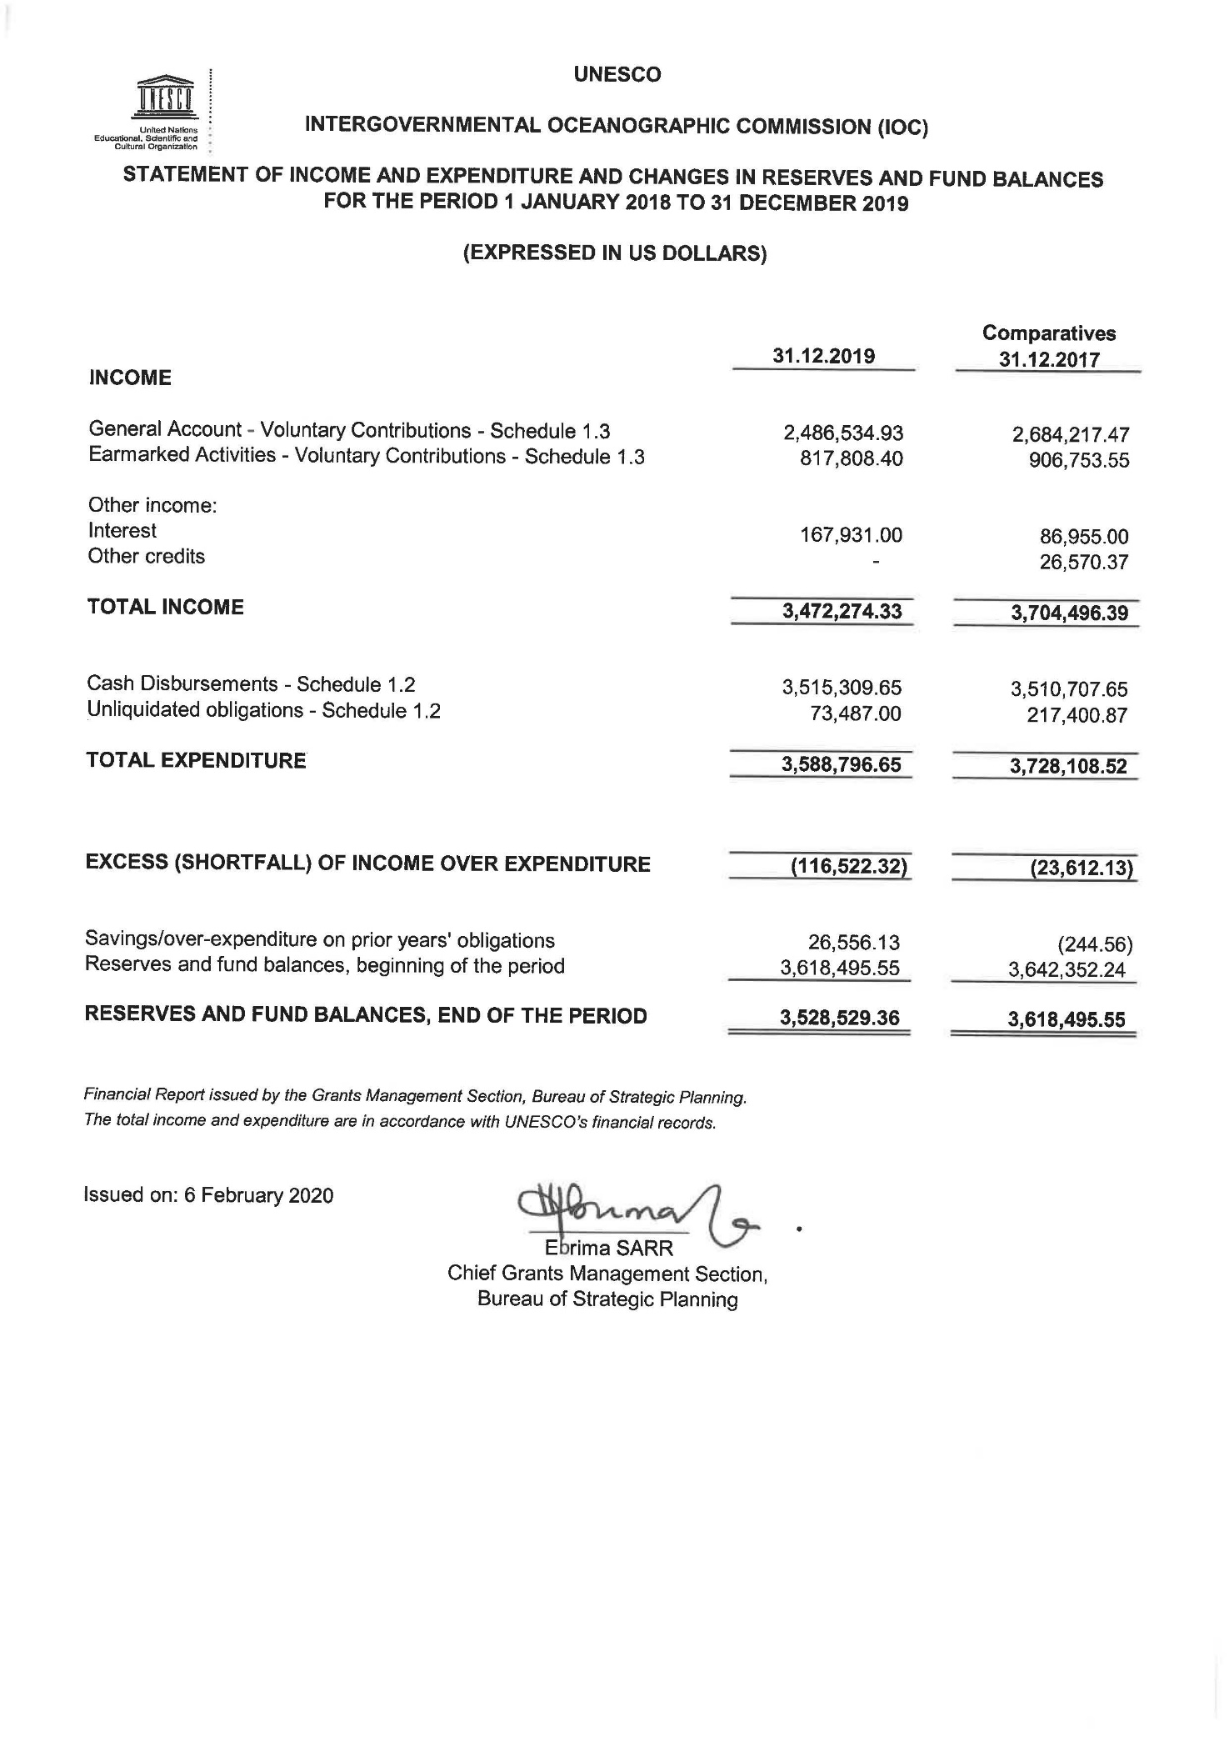

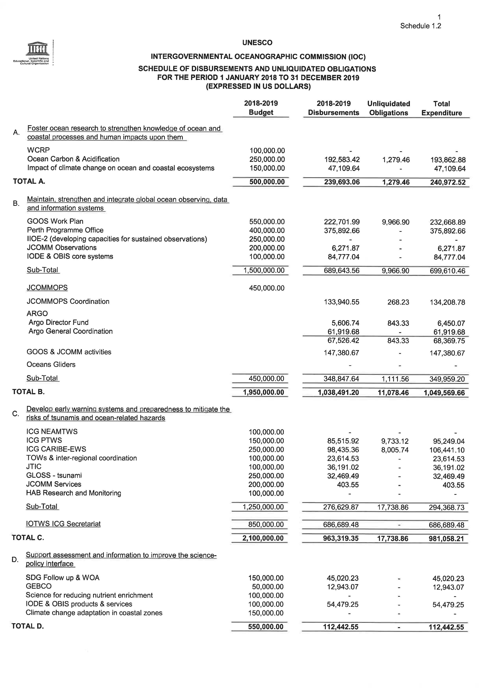

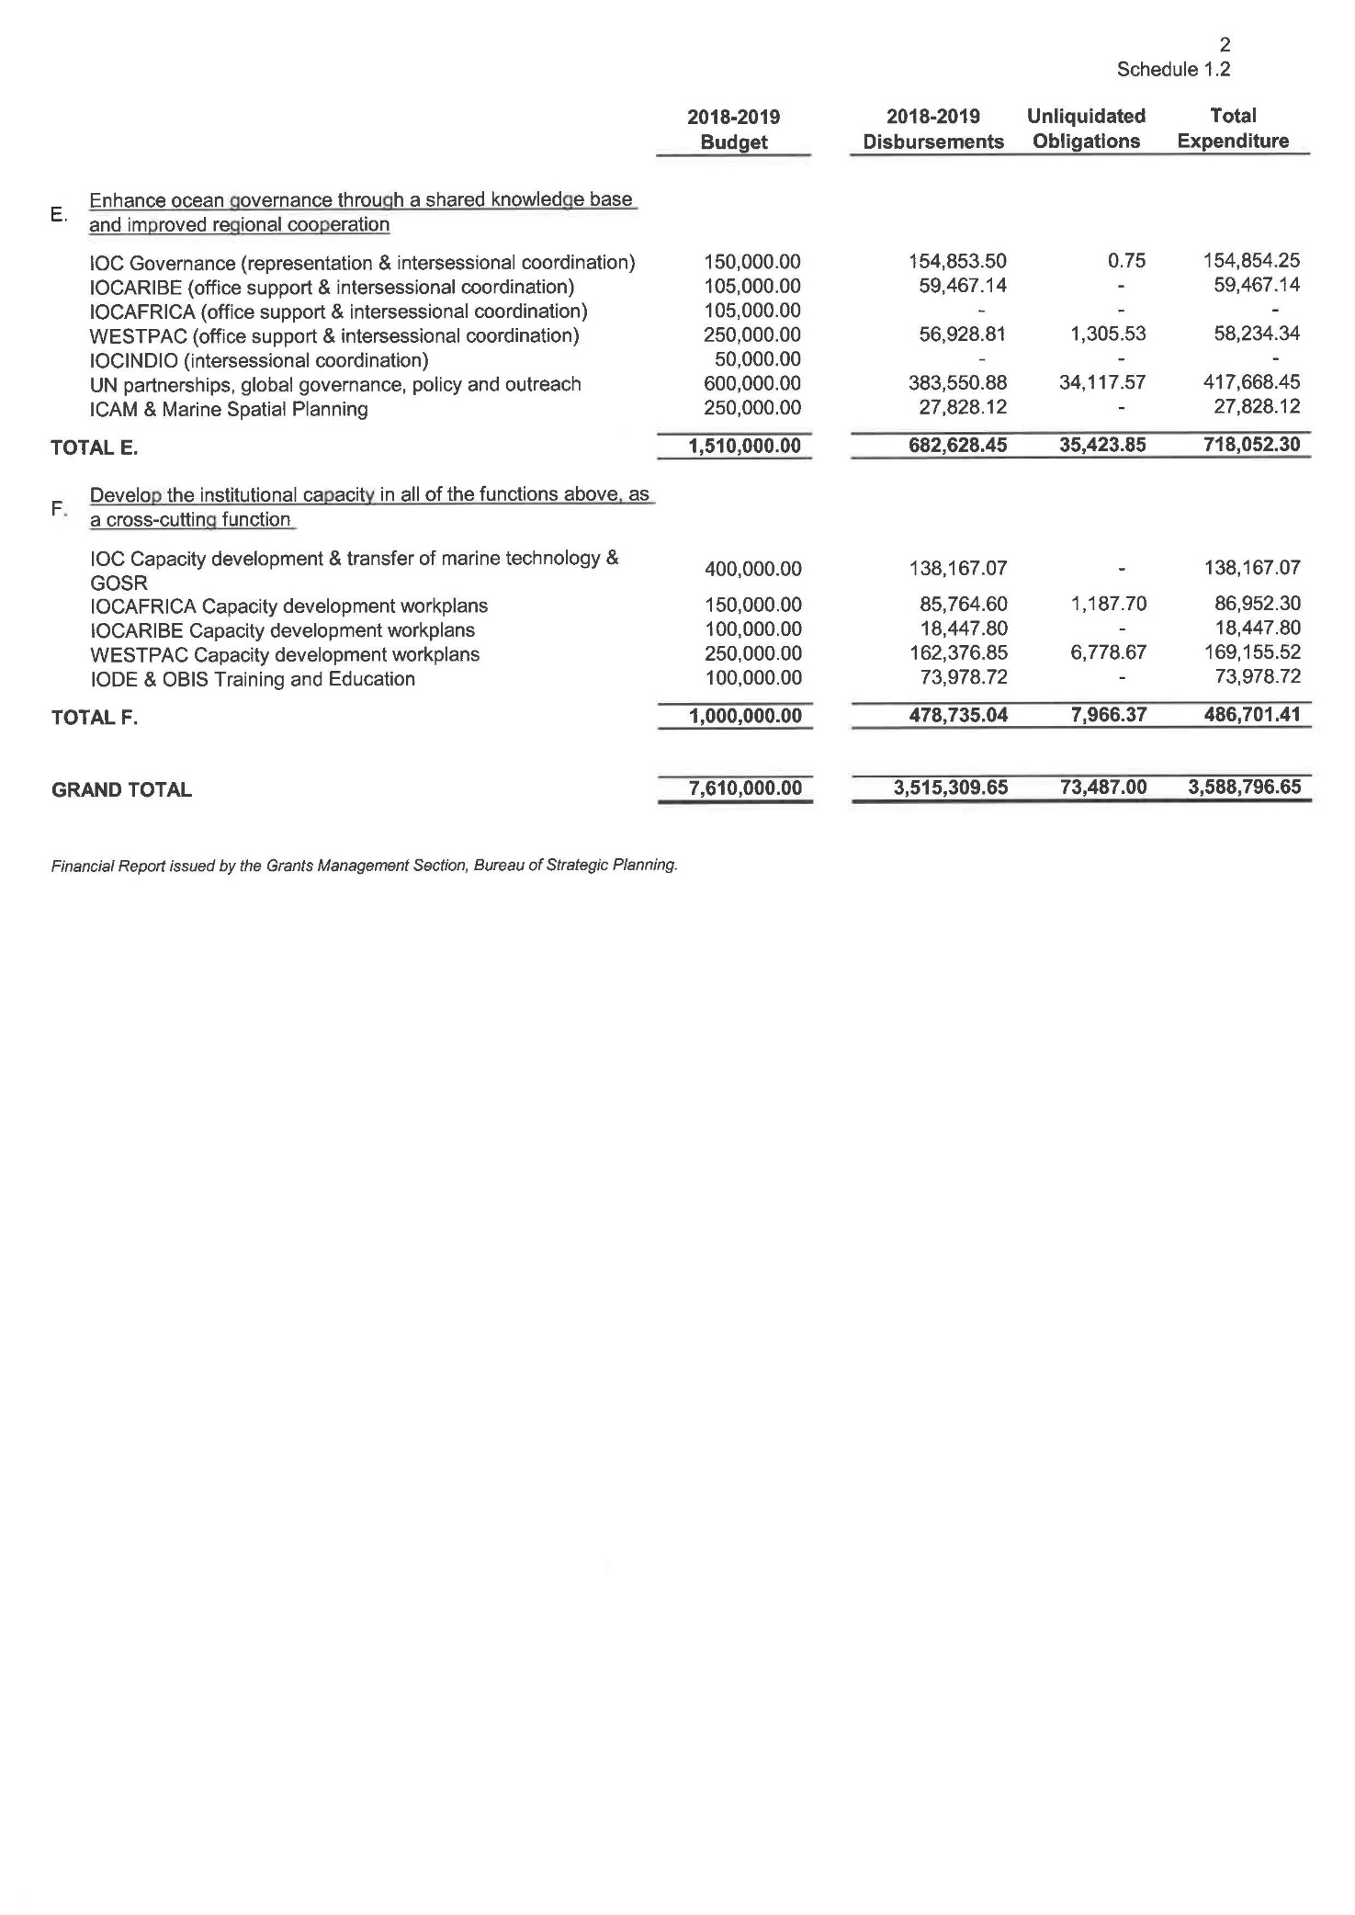

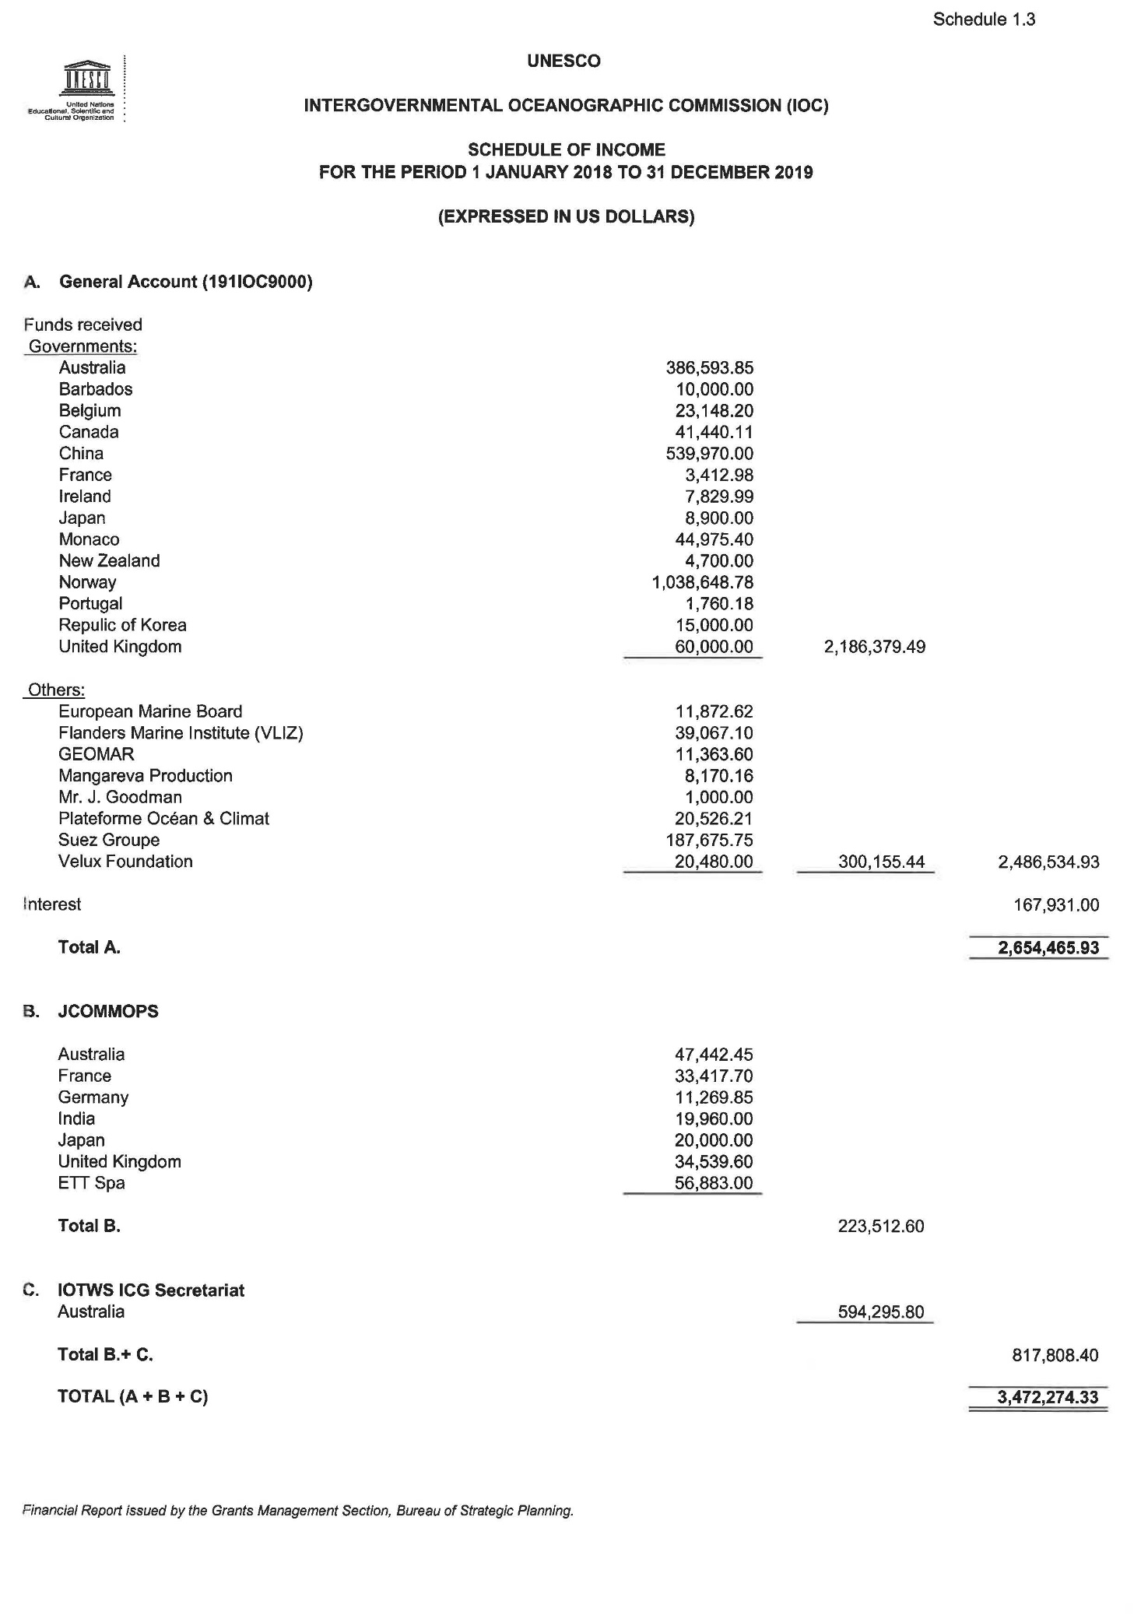

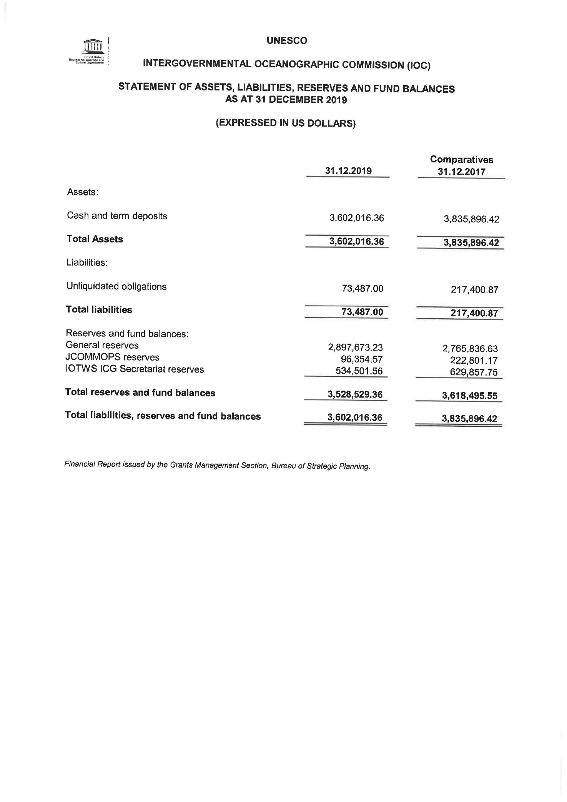

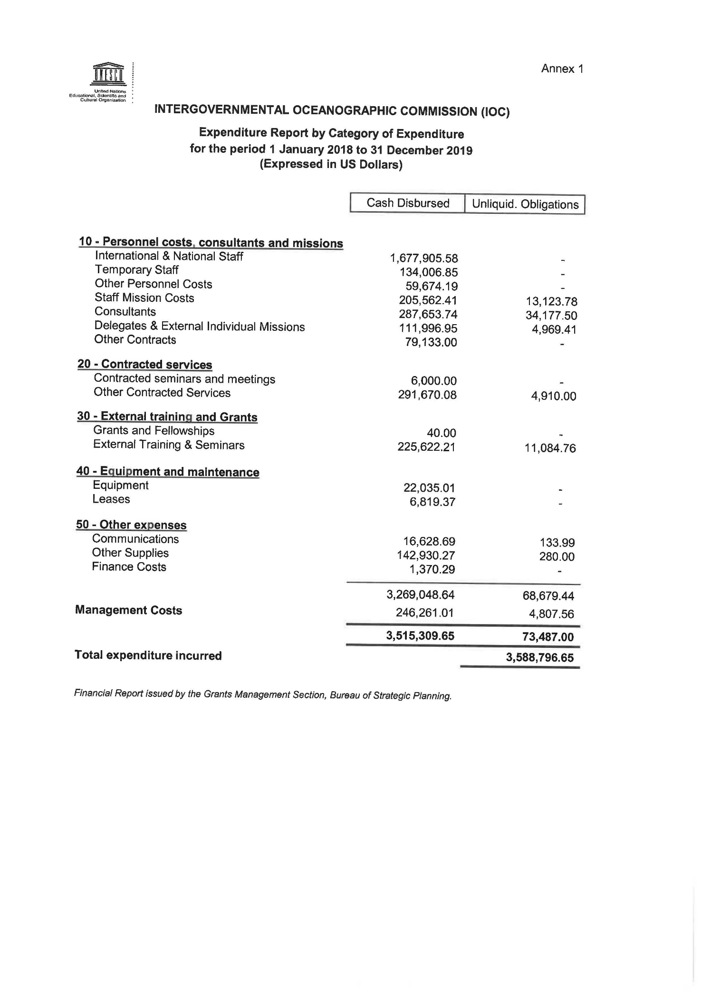

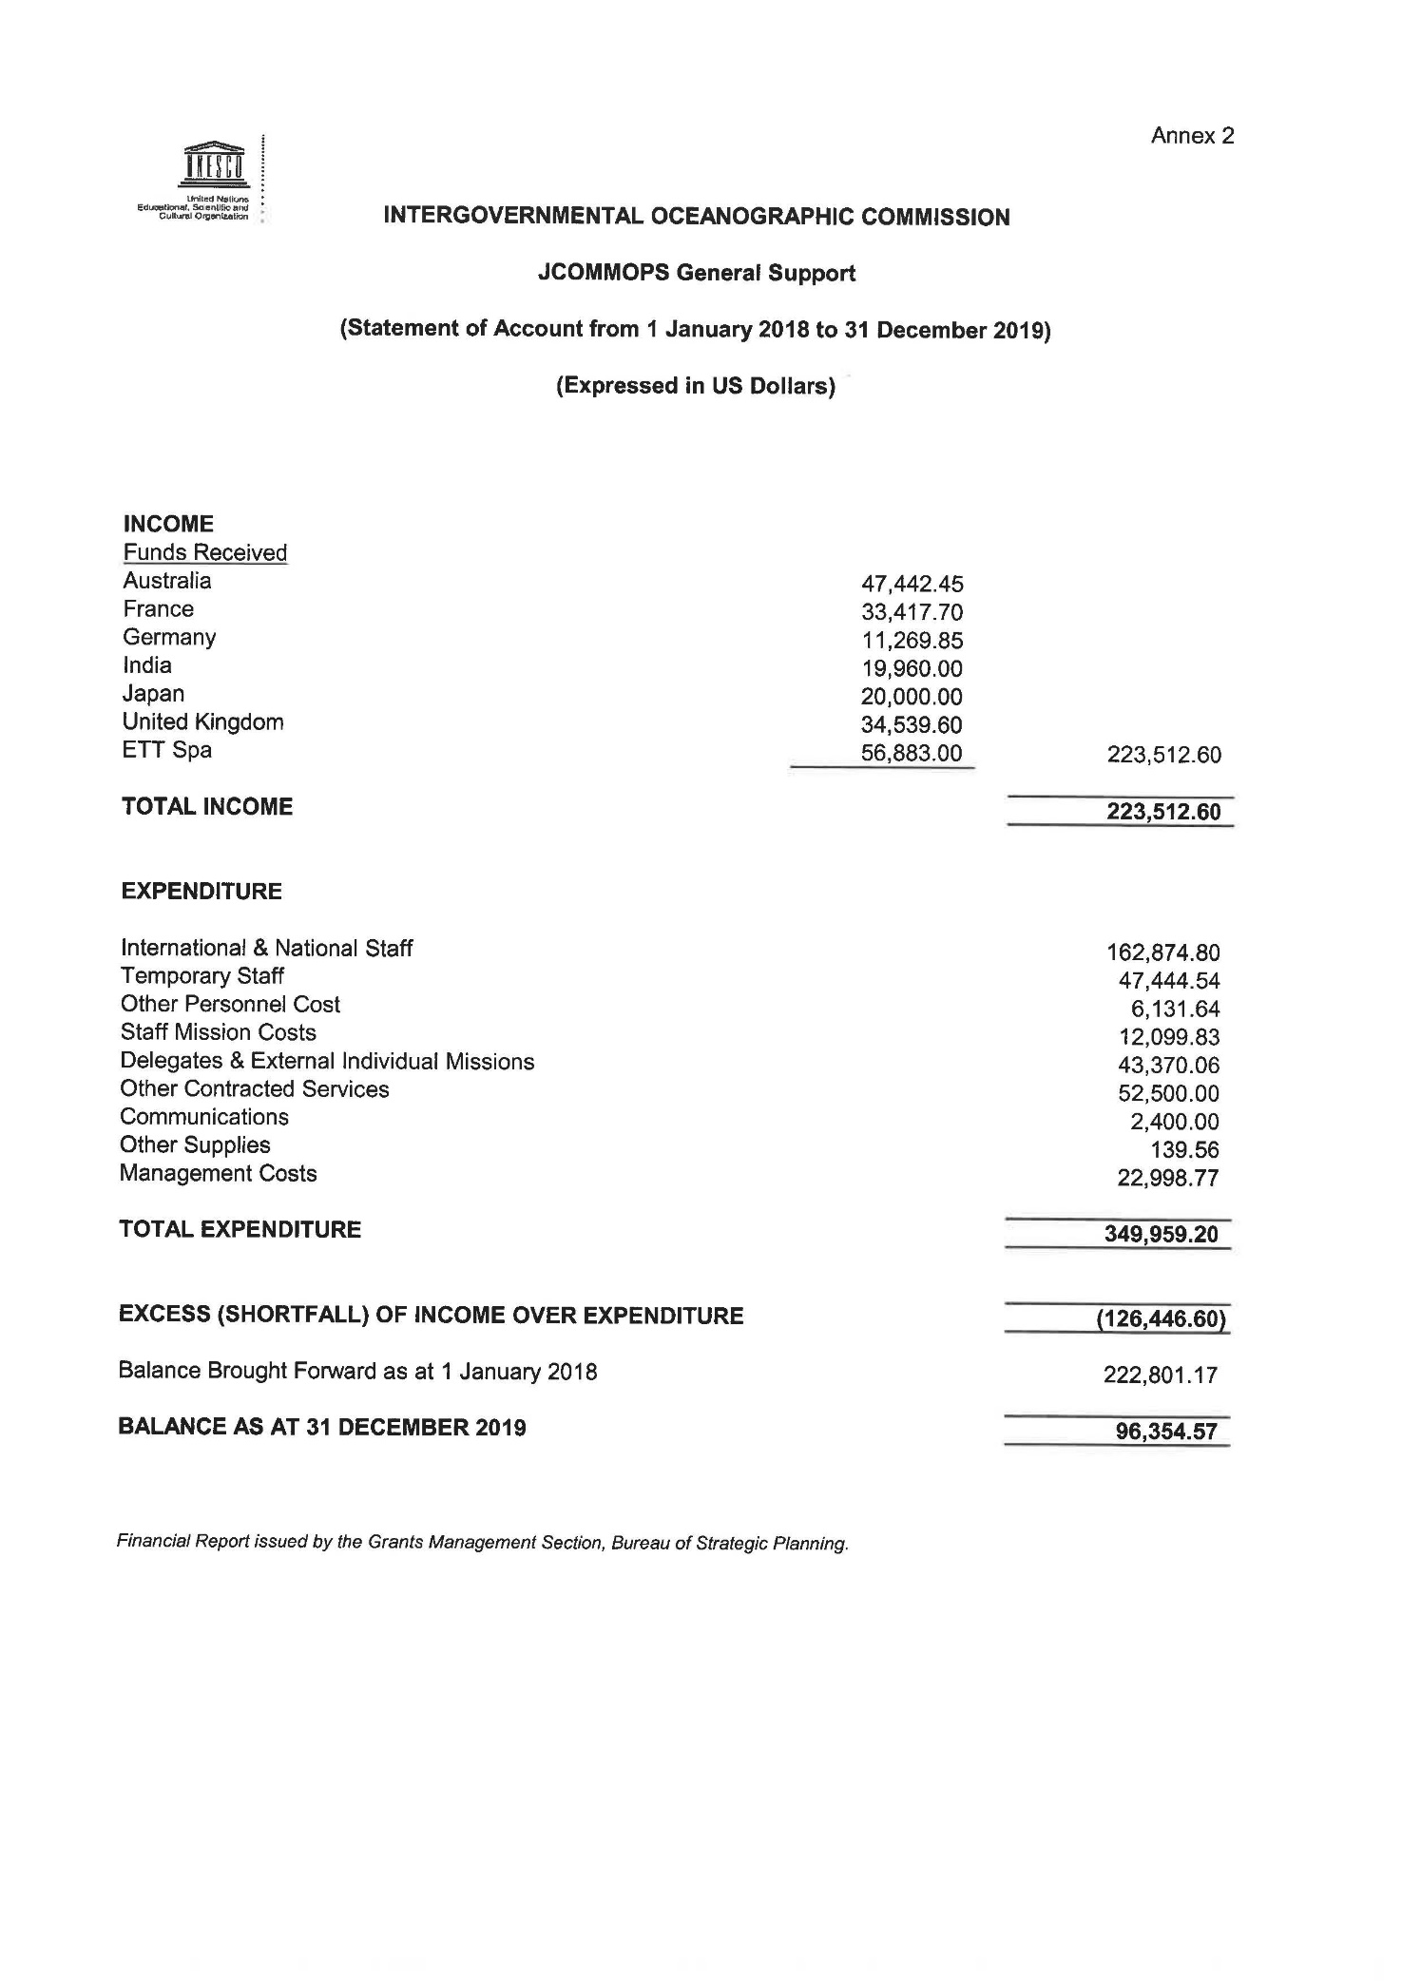

‘Other’ groups individual contributions of less than US$ 90K.
These contributions are shown separately as they do not enter the UNESCO/IOC budgetary flow. Formal letters confirming the amounts reported were sent by the relevant partner institutions to the Executive Secretary for the purpose of inclusion in this report. The total of contributions of $ 2,788,733 for 2018 was reported to the UNESCO Executive Board in Annex III-b of document 206 EX/4.II.A.INF and the total of contributions of US$ 7,411,518 for 2019 was reported to the UNESCO Executive Board in Table 3 of document 209 EX/4.II.INF.
Following the adoption by the 40th session of the General Conference of UNESCO of the budget scenario for 2020–2021 (40 C/5), based on the appropriated regular programme budget of US$ 534.6M (US$ 11,075,500 for the IOC), the Secretariat developed the work plans shown below consistent with Resolution XXX-3 and IOC-XXX/2 Annex 9.

