|  |
| --- |
| Summary  This document provides explanations on the main elements of the notion and approach related to multiple stressors as the way forward to address ecosystem responses to human activities and, therefore, to operationalize ecosystem-based management. It aims to stimulate, inspire and bring together scientists around the UN Decade of Ocean Science for Sustainable Development; and to raise the level of understanding of the issues accompanying multiple stressors among IOC Member States, policymakers as well as administrators. This brief is in a draft form and constitutes work in progress. The final brief, which will also reflect reaction from IOC Member States, is intended to be completed and made available in the fall of 2019. |

**INTRODUCTION**

Society and human health are closely linked to the ocean. To ensure a sustainable future, it is critical to minimize the multiple pressures on the ocean associated with human activities such as climate change or over-exploitation of resources. This can only be achieved through a better understanding of how multiple drivers impact the ocean.

Several key challenges/actions were identified:

* Identification of the key stressors at all locations, their temporal variability and their source(s),
* A better understanding of biological impacts as a result of the interactions between drivers,
* Prioritization of science, at the interface of science and policy, emphasizing solutions (adaptation and mitigation),
* Focusing ocean literacy activities on the importance of multiple stressors.

**OCEAN UNDER STRESS**

There are growing pressures on our oceans due to human activities. These include more harvesting to feed our growing human population, disposal of a wide range of materials such as plastics, and changes to oceanic conditions due to rising anthropogenic emissions of greenhouse gases (Figure 1). Such alteration of the ocean exposes marine life to conditions that deviate from the norm (for example, eutrophication, burning of fossil fuels coastal pollution including plastics in the food web, and extreme events such as heat waves) resulting in a suite of changes without precedent, termed here as multiple stressors or drivers.

**“A situation of stress arises when some environmental factor changes and an organism finds itself outside its ecological niche” (****Van Straalen, 2003****) (see** **Box 1****)**

Understanding the impact of multiple stressors on marine life is essential to better inform policy-making and the management of our world ocean. Some sources of changes to the ocean are local and transient in scale (e.g. episodic nutrient runoff from land), but others are global and long term (e.g. ocean warming and acidification; Figure 1).

There is an urgent need to better understand what environmental changes are putting the ocean under stress; how marine life responds to this stress; which individual stressors are most influential; and how responses to multiple stressors at the same time varies between organisms and/or communities. Such an integrated body of research and observations enables the development of a better understanding of how whole ecosystems will act in response to further changes in the ocean that are projected for the coming decades as well as the development of solutions ensuring a sustainable future.

This document is designed to strengthen the language around, and the discourse on, multiple stressors as the way forward to address ecosystem responses to human activities. It aims a) to stimulate, inspire and bring together scientists and b) to raise the level of understanding of the issues accompanying multiple stressors among policymakers, as well as administrators.

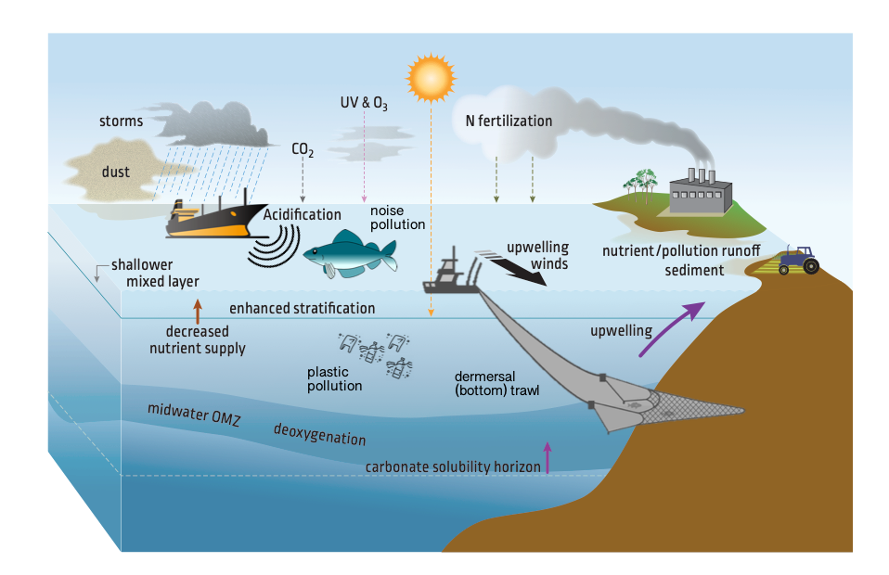

Figure 1. Examples of global (warming, acidification), regional (the ozone hole, plastics, atmospheric pollutants) and local (sedimentation, nutrient runoff) stressors and sources of stressors can each affect marine life (modified from Boyd et al., 2018). In some cases organisms may be exposed to concurrent changes in more than five categories of stressors. (Note this figure will be redrawn)

|  |
| --- |
| Box 1. Stress is relative  Organisms are naturally exposed to a wide range of environmental conditions such as oxygen, salinity, temperature and acidity that constitutes their ecological niche. As a consequence of evolution, an organism is often adapted to its niche and the concept of stress is then relative. What is a stress for an organism is normal for another one. For example, a polar fish is adapted to temperature conditions that would be lethal for a tropical species. Stress can then be defined as a condition evoked in an organism by one or more environmental factors that bring the organism near or over the edges of its ecological niche (Van Straalen 2003; Figure 2). The consequence of a stress will depend on the intensity (how much one deviates from normal conditions) and exposure (for how long). A good understanding of present natural variability encountered by an organism is then critical to define its niche and what is a true stress.    Figure 2. Scheme of the ecological niche adapted after Van Straalen (2003). |

**STEP 1: CATALOGUING STRESSORS AT THE LOCAL LEVEL**

The ocean is changing at all locales from the intertidal to the deep sea (Figure 1). Because of the differing influences of local, regional and global anthropogenic stressors, resident life may encounter very different permutations of change from locale to locale. Moreover, the contribution of any stressor will be highly dependent on their intensity following Paracelsus’ principle: “*the dose makes the poison*”. So, in order to understand the sensitivities and hence responses to multiple stressors, we need to catalogue the stressors, their intensity, whether they interact to amplify or diminish the problem in question (for example warming water carried less oxygen) and, critically, what drives these stressors. Understanding the sources(s) of each stress is critical as it will tell us how readily we can reduce stressors in the ocean through adequate policies and marine stewardship (Figure 2).

**Global anthropogenic forcing – more atmospheric CO2 – leads directly to ocean acidification, causes more greenhouse warming which results in ocean warming. In turn warming alters density stratification of the ocean, which alters nutrient supply along with oxygen concentrations at depth.**

This complex cascade of causal change in Figure 3 can be further influenced by regional stressors such as anthropogenically supplied nutrients (via the atmosphere and coastal ocean, Figure 1) that reduce ocean oxygen concentrations and can lead to alkalization or acidification. Thus, the interplay of local, regional and global processes often result in problems that are compounded. These stressors can also be superimposed on natural events/seasonal variations such as the El Niño Southern Oscillation, the Pacific Decadal Oscillation or the Atlantic Multi-decadal Oscillation (respectively: ENSO, PDO and AMO). Natural events can also cause stress to marine life (for example the occurrences of warmer waters during ENSO). Such naturally induced stress can be enhanced when anthropogenic stressors are overlaid on these events, potentially driving extreme events such as marine heat waves. We need to understand the driver(s) of each of these stressors, and whether they are cross-linked in causal cascades (Figure 2) to better forecast their spatial and temporal influence.



Figure 3. An example of causal change driven by a global stressor – increasing anthropogenic CO2 – and how it leads to other global (ocean acidification), regional (salinity) and local (such as turbidity) stressors. In turn, other regional stressors such as nutrient pollution can interact with this cascade of causal change.

## STEP 2: BIOLOGICAL RESPONSES TO MULTIPLE STRESSORS

Devise the most effective and tractable mitigation and/or adaptation strategies to combat the worst consequences of an ocean under stress require an understanding of how sensitive each key marine organism (keystone species, ecological engineers, species that provide key ecosystem services such as for food security) is to these complex clusters of multiple stressors.

Marine life exhibits a range of responses to stress that range from detrimental, to no measurable effect, to beneficial (Figure 4), due to specific sensitivities to environmental changes. The level of stress and concurrently the responses are influenced by the number of stressors, how long organisms are exposed to them, the intensity during such exposure, and clearly the interactions between the stressors. If we consider this in human terms, a little challenge may be stimulating, but increasing the exposure and or intensity of a single stressor such as workload may be debilitating and decrease performance (e.g. missing project deadlines). Additional stressors such as increased family demands, on top of a high and intense workload, may lead to harmful conditions for humans (illness). In the ocean, some marine life may encounter many stressors concurrently, and be exposed to them for different periods and with different intensities. Dealing with each stressor has a cost for an organism, or for an ecosystem. The cost of dealing with a stressor will influence performance, as it may require energy needed for other essential tasks to be diverted to offset the stress.

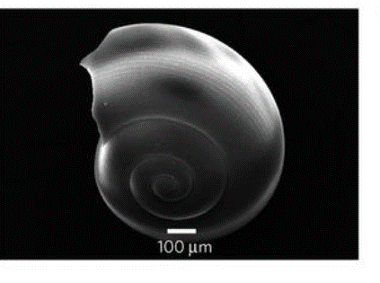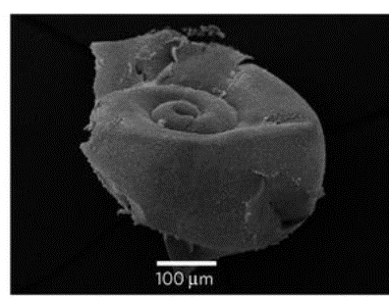



Figure 4. Stressors – for example ocean acidification – can result in negative, positive or no effect on marine life. In the upper panels, there is evidence of the detrimental effect of acidification on the shell of a pteropod (a ‘seabutterfly’) (Bednaršek et al., 2012) with dissolution at high CO2 in the upper right hand panel. In contrast, beneficial effects of CO2 are revealed for planktonic nitrogen fixers that fix more nitrogen relative to present day conditions (~415 ppm pCO2) in a higher CO2 world (panels A, B and D) in many parts of the ocean. There is no effect of higher CO2 on planktonic N fixers from the subtropical N Pacific (panel C) (Hutchins et al., 2013).

Stress is the product of exposure, intensity, and also the sensitivity of an organism to the stress. Life in the ocean has different tolerances to stress, ranging from highly vulnerable to largely invulnerable. The sensitivity to stress is controlled by many factors – some are physiological (number of biologically-influential stressors), others are driven by life history (number of juvenile life stages which are often more susceptible to stress), the ability to acclimate or adapt (over longer timescales) to altered conditions, or by ecology (organisms at different trophic levels may be more or less vulnerable to a stressor, altering the predator-prey interaction).

**Multiple stressors, acting at the same time on an organism or ecosystem, can modulate the response to the individual stressor.**

Hence, the outcome of a study into a sole stressor (such as warming or acidification) may only partly reflect the response of an organism or ecosystem to changing conditions (Figure 5). In reality, stressors interact, often in complex ways, and modulate the response of another stressor. For example, the response of sea urchins to decreased pH is modulated by temperature (Figure 3). Understanding these interactions is critical for prioritizing management.

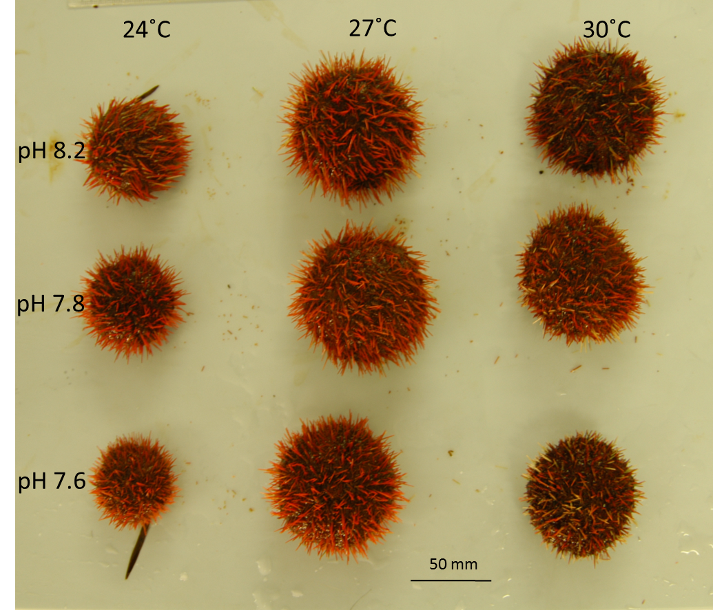

Figure 5. Influence of temperature and warming on the development and maturation of a sea urchin. Acidification alone decreases urchin size (left hand column of urchins), whereas warming increases the size of an urchin (top row of urchins). The outcome with respect to size is different when urchins are exposed to both warming and acidification (bottom right urchin). Note, that urchin size does not reflect other physiological aspects that are altered by these two stressors – chronic exposure to both stressors at pH 7.6 is detrimental to reproductive potential (from Dworjanyn and Byrne, 2018).

## SPATIAL AND TEMPORAL SCALES OF MANIFESTATION AND IMPACTS OF STRESSORS

Due variety of stressors – at global, regional and local scales – the diverse responses of marine life (Figure 4), it is seldom possible to relate the findings of one case study in a particular location to others (Boyd et al., 2018). Hence the title for this document “Ocean under stress: A changing ocean at all locations”.

In addition to the causal cascades of change of global and regional stressors (Figure 2), there will also be the confounding effects of locally sourced stressors which can include inefficient fertilizer and biocide use; a lack of existing sewage/wastewater treatment (eutrophication); chemicals from industries, medicine and plastic pollution; coastal destruction leading to increased sedimentation and runoff; overfishing and epizootics; underwater noise (shipping, military, surveying/resource exploration, construction e.g. offshore windfarms); shoreline and offshore sand mining; or deep sea mineral extraction (habitat loss, smothering, noise).

**Stressors have specific time and space scales, with corresponding time, space, and phenological responses by species.**

To illustrate the idea of a changing ocean at all locations we present two illustrative examples from Indonesia and Canada.

CASE STUDY 1. COASTAL ECOSYSTEM UNDER MULTIPLE ANTHROPOGENIC STRESSORS: A CASE OF JAKARTA BAY

A study of Jakarta Bay reef systems in Indonesia revealed that marine life there was influenced by both global (ocean warming and acidification) and local stressors (eutrophication, pollution, sedimentation, fishing pressure and blast fishing – Figure 6). The stressors were a mix of bottom up (environmental change such as acidification) and top down (blast fishing) controls on marine life.

Responses at the species level are assumed to be influenced by behavior, life stage, and evolution (adaptation). At the population and ecosystem level (Figure 6), the community responses may be driven by: species interactions, species diversity, trophic complexity, ecological history and ecosystem type.



Figure 6. Summary of the influence of global and local anthropogenic stressors on marine life in Jakarta Bay at the species, population and ecosystem level (from Kunzmann et al., 2018).

The authors report that reef degradation may increase in the near future| as these stressors become more severe:

***“Indonesia ́s continuing growth in population, especially along the coast, poses severe problems for ecosystems such as coral reefs. Reef degradation due to global and local stressors will eventually cause a loss of ecosystem services that sustain millions of people.”***

In any event, the limited understanding of the interaction between stressors and their impact on ecosystem stress limit the ability to develop strategies for the sustainable management of ocean resources and to take informed policy actions. Scientists in the region advocate for both the study of multiple stressors and their effects on marine life – from species to ecosystems – but also the need to devise management strategies to develop a way to decrease these anthropogenic pressures.

***“Any relief from stressors would help coral reefs and give them the chance to recover and provide livelihoods also for future generations. However, ocean management can no longer focus on individual stressors but must incorporate combined stressor effects.”***

CASE STUDY 2. OXYGEN AND ACIDIFICATION IN THE GULF  
OF ST. LAWRENCE, CANADA

The Gulf of Saint Lawrence has problems with low oxygen, which can influence the health of marine life. At depth, mixing from the upper ocean can replace oxygen, but in regions with low mixing, dissolved oxygen can be consumed by respiration of marine biota, and especially the microbial decomposition of particulate organic matter. Conditions for ecosystems can become serious when oxygen levels are depleted – termed hypoxia. Indeed, when oxygen levels drops to <30% of their maximum carrying capacity (set by salinity and temperature), it is viewed as severely hypoxic.

Hypoxia is a stressor since it can lower rates of growth and reduce reproductive success among biota. It can also alter the distribution of species, since most species will exit a region as hypoxia worsens. Under severe hypoxia, species that cannot move fast enough may undergo high mortality rates.

**Changes in climate can contribute to lead to occurrences of hypoxia. So too can the input of organic matter from algal blooms caused by high levels of anthropogenically produced nutrients. This has been a problem in the Gulf of St. Lawrence (****Figure 7****).**

Ocean acidification is an additional stressor in this region, and is evident from pH measurements in the Gulf made since the 1990s. Intermittent measurements extend back to the 1930s. Lower pH indicates more acidic conditions (Figure 7).

The status of, and trends within, the region was defined by the authors of the report as:

* + The greater influence of water originating from the Gulf Stream is contributing to hypoxic conditions in the deep St. Lawrence Estuary. While the deep waters of the St. Lawrence Estuary were briefly hypoxic in the early 1960s, they have been consistently hypoxic since 1984
  + Dissolved oxygen in the Gulf of St. Lawrence decreased to its lowest annual average in 2016. This corresponds to an 18% saturation level
  + In general, acidity has increased at a higher rate in Canadian Atlantic waters than in other parts of the world
  + The acidity of ocean waters adjacent to the Newfoundland Shelf (Labrador Sea) has been increasing steadily since consistent measurements started in 1993. This has been measured as a decrease in pH at a rate of about 0.02 pH units per decade
  + The acidity of the waters off the Scotian Shelf and in the Gulf of St. Lawrence has also been increasing. On the Scotian Shelf, pH has decreased at a rate of about 0.03 pH units per decade. The Gulf of St. Lawrence has experienced a decrease in pH of about 0.04 units per decade since 1934.



Figure 7. Average dissolved oxygen, pH and temperature measurements for the lower St. Lawrence Estuary at approximately 300 metres. Values of dissolved oxygen below 30% saturation are considered extremely hypoxic. Dissolved oxygen is regularly measured throughout the water column as part of oceanographic surveys done within the region (from <http://dfo-mpo.gc.ca/oceans/soto-rceo/index-eng.html>).

# TIME TO ACT

Next steps related to multiple stressors span from the identification of research priorities to illustrating further the implications and applications of such research for management. Enhancing literacy on multiple stressors affecting the world ocean is also an important step towards adopting a multi-stressor lens of how to deal with our changing ocean.

RESEARCH STRATEGY AND PRIORITIES

* A joint approach of observation, experimentation and modelling should be pursued.
* Research should focus on identifying and implementing solutions.
* Identification and monitoring of drivers and stressors at all relevant localities and temporal scales. Development of science capacity should go hand in hand with technology development (sensor development e.g. BGC Argo).
* Understanding the sensitivity of marine species and ecosystems to stressors and their tolerance thresholds. Ideally, this should lead to performance curves across a wide range of environmental conditions covering present and future natural variability, with experiments needing to reflect the wider range of changes to local ocean conditions that will occur in the coming years and decades; and researchers needing to consider how extremes and fluctuating conditions affect physiologies.
* Developing a mechanistic understanding of what are the stress response of each drivers (mode of action). This knowledge is critically needed to better understand how different stressors interact with each other and develop the capability to project biological impacts.

MANAGEMENT IMPLICATIONS/APPLICATIONS

* Research should focus on identifying and implementing and prioritizing solutions.
* The scale of the anthropogenic pressure exerted by stressors matters because it leads to different options such as implementation of mitigation action (e.g. reducing CO2 emissions, sewage treatment, MPAs, decreasing fertilizer use) and of adaptation action (e.g. MPAs, resistant aquaculture species, coastal protection, coastal urbanization, Marine Spatial Planning).

LITERACY/STEWARDSHIP

Ocean literacy is defined as “an understanding of the ocean’s influence on you, and your influence on the ocean. Ocean literacy is a way not only to increase the awareness of the public about the ocean but it is as an approach to encourage all citizens and stakeholders to have a more responsible and informed behavior towards the ocean and its resources” (Santoro et al., 2017).

There is a need to promote multiple stressors as a lens through which to approach the complexity of the effects of human activities on the ocean. There also is a need to explain the term stressor for the benefit of policymakers, the private sector, grassroots people and the general public. This will be essential in determining what methodologies should be applied to associate the multiple stressors with the socio-economic impact caused by the stressors.

There also is a clear need to develop capacity in the area of multiple ocean stressors including through the delivery of training courses; the development of best practice guides (Boyd et al., 2018); and the set-up of monitoring and mentorship schemes, including by extending relevant existing programmes (such as the ones in the area of acidification) to encompass multiple stressors which can be monitored concurrently.

**MULTIPLE STRESSORS RESEARCH, ECOSYSTEM-BASED MANAGEMENT  
AND THE UN DECADE OF OCEAN SCIENCE FOR SUSTAINABLE DEVELOPMENT**

The design of the United Nations Decade of Ocean Science for Sustainable Development (2021–2030) is unfolding on the basis of a multi-stakeholder consultative process and the co-design of a science plan. The development of the Decade follows a Roadmap supported by IOC Member States and multiple constituencies. One of the Strategic Objectives in the Roadmap document states “Understanding the effects of cumulative stressors on ocean systems including the socio-economic dimension”.

This policy brief paves the ground for the scientific community active in research related to ocean stressors, from diverse disciplines, as well as all concerned stakeholders mobilized by the Decade to gather around this important strategic objective: understanding stressors, how they interact, how they can be tackled and managed, so as to increase socio-ecological resilience.

Indeed, tackling the effects of multiple ocean stressors cuts across will speak to all societal goals of the Decade: a clean, healthy and resilient, safe and predicted, sustainably harvested and productive, and data transparent ocean by 2030.

**REFERENCES** **AND SUGGESTED READING**

Bednaršek, N, Tarling, GA, Bakker, DC, Fielding, S, Cohen, A, Kuzirian, A, McCorkle, D, Lézé, B and Montagna, R. 2012. *Description and quantification of pteropod shell dissolution: a sensitive bioindicator of ocean acidification*. Global Change Biology, 18(7), 2378-2388.

Dworjanyn SA and Byrne M. 2018. *Impacts of ocean acidification on sea urchin growth across the juvenile to mature adult life-stage transition is mitigated by warming*. Proceedings of the Royal Society. B 285: 2017.(http://dx.doi.org/10.1098/rspb.2017.2684)

Hutchins, DA., Fu FX, Webb EA, Walworth N. and Tagliabue, A. 2013. *Taxon-specific responses of marine nitrogen fixers to elevated carbon dioxide concentrations*. Nature Geoscience 6(9): 790-795. (doi: 10.1038/ngeo1858)

Kunc, HP, McLaughlin, KE and Schmidt, R. 2016. *Aquatic noise pollution: implications for individuals, populations, and ecosystems*. Proceedings of the Royal Society B: Biological Sciences, 283(1836), 20160839.

Kunzmann, A., Z. Arifin, Baum, G. 2018. *Pollution of coastal areas of Jakarta bay: water quality and biological response*. Marine Research in Indonesia, Vol 43(1): 37-51

Riebesell, U, Vichi, M, Biswas, H, Ciotti, A, Dillingham, P, Gao, K, Gehlen, M, Hurd, CL, Kurihawa, H, Navarro, J, Nilsson, GE, Passow, U and Portner, H-O. 2019. *SCOR WG149 Handbook to support the SCOR Best Practice Guide for ‘Multiple Drivers’ Marine Research*. (http://dx.doi.org/10.25959/5c92fdf0d3c7a)

Santoro F. et al. (eds). 2017. *Ocean Literacy for All – A toolkit*. IOC Manuals and Guides, 80 (revised in 2018).

Boyd, PW, Collins, S, Dupont, S, Fabricius, K, Gattuso, JP, Havenhand, J, Hutchins, DA, Riebesell, U, Rintoul, MS, Vichi, M and Biswas, H. 2018. *Experimental strategies to assess the biological ramifications of multiple drivers of global ocean change—a review. Global change biology*, 24(6): 2239-2261.

van Straalen, NM. 2003. *Ecotoxicology becomes stress ecology*. Environmental Science and Technology, 37(17):324A-330A

**Intergovernmental Oceanographic Commission (IOC)**

United Nations Educational, Scientific and Cultural Organization

7, Place de Fontenoy

75 732 Paris 07 SP, France

Tel.: +33 1 45 68 03 18

http://ioc.unesco.org