|  |
| --- |
| Summary  PartI of this report provides an overview with regard to the implementation of the 2018–2019 IOC budget as at 31 December 2018, including an update on resource mobilisation.  Part II gives a brief overview of the financial situation of the IOC Special Account at year-end 2018, including an updated forecast for the period 2018–2019. The Financial Report of the IOC Special Account for the period 1 January 2018 to 31 December 2018 prepared by the Bureau of Financial Management is included in Appendix I.  Proposed decision: This document is part of the report of the Executive Secretary to the Assembly. It will be further examined by the statutory sessional open-ended Financial Committee and the decision reflected in the Draft Resolution that the Financial Committee will submit for adoption by the Assembly under item 12.4 in accordance with paragraph 15 of the *Revised* [*guidelines for the preparation and consideration of draft resolutions*](http://www.ioc-unesco.org/index.php?option=com_oe&task=viewDocumentRecord&docID=9281) ([IOC/INF-1315](https://unesdoc.unesco.org/ark:/48223/pf0000265307.locale=fr)). |

**This report covers three types of funding that compose the IOC budget**[1]**:**

1. Regular Programme allocation (UNESCO budget–39 C/5 for 2018–2019 + Additional Appropriations (voluntary contributions intended to directly reinforce an existing budget line), if applicable).
2. Voluntary (Extrabudgetary) Contributions to the IOC Special Account:

**B1.** Programme Activities (191-series accounts)

**B2.** Earmarked Activities (193-series accounts)

1. Voluntary (Extrabudgetary) Contributions for specific projects under the funds-in-trust modality.

**PART I – IMPLEMENTATION OF THE IOC BUDGET IN 2018**

1. In compliance with UNESCO Member States’ decisions, the 2018–2019 budget was based on an Integrated Budgetary Framework (IBF), allowing greater transparency of resources and helping to align resources with the collectively decided priorities.
2. Following the approval of the Organization’s Programme and budget for 2018–2019 by the UNESCO General Conference at its 39th session, the actual working budget of the Commission was set in accordance with the Assembly-adopted scenario of $ 10,681,300 for the IOC from UNESCO’s regular programme budget, plus $ 4,800,000 of Voluntary Extrabudgetary Contributions (VC) secured at the moment of the budget adoption, plus $ 12,776,400 resource mobilisation target (gap), or total IBF budget of $ 28,257,700.

Table 1. IOC Integrated Budget 2018–2019 ($ 518M Expenditure plan) at function level.

|  |  |  |  |
| --- | --- | --- | --- |
| **IOC Function/Activity** | **RP allocation** | **VC target** | **Total** |
| $ | $ | $ |
| **FUNCTION A (Ocean Research)** | **185,000** | **1,094,000** | **1,279,000** |
| **FUNCTION B (Observing Systems/Data Management)** | **567,000** | **2,745,200** | **3,312,200** |
| **FUNCTION C (Early Warning & Services)** | **450,000** | **3,582,000** | **4,032,000** |
| **FUNCTION D (Assessment & Information for Policy)** | **287,000** | **1,877,200** | **2,164,200** |
| **FUNCTION E (Sustainable Management & Governance)** | **527,700** | **4,443,000** | **4,970,700** |
| **FUNCTION F (Capacity Development)** | **391,300** | **3,835,000** | **4,226,300** |
| **COMMON COSTS** | **251,100** |  | **251,100** |
| Evaluations | 20,000 |  | 20,000 |
| IOC Operating costs | 50,000 |  | 50,000 |
| IOC Contribution to common costs | 181,100 |  | 181,100 |
| **TOTAL OPERATIONS** | **2,659,100** |  | **2,659,100** |
| **STAFF ALLOCATION** | **8,022,200** |  | **8,022,200** |
| **TOTAL IBF APPROVED BUDGET** ([Res. XXIX-2](http://ioc-unesco.org/index.php?option=com_oe&task=viewDocumentRecord&docID=19662) & [IOC-XXIX/2 Annex 5 Rev.2](http://www.ioc-unesco.org/index.php?option=com_oe&task=viewDocumentRecord&docID=19512)) | **10,681,300** | **17,576,400** | **28,257,700** |
| **Adjustments due to Additional Appropriations (AA) & transfer from Part V[2]** | **74,467** | **(60,763)** | **13,704** |
| **TOTAL IBF APPROVED BUDGET ADJUSTED3** | **10,755,767** | **17,515,637** | **28,271,404** |

Table 2. Consolidated Report on 2018 Expenditure as at 31 December 2018.

| **IOC Function/Activity** | **Regular programme budget** | **Special Account** | **Funds-in-Trust** | **Total** |
| --- | --- | --- | --- | --- |
| $ | $ | $ | $ |
| **FUNCTION A (Ocean Research)** | **87,891** | **95,760** | **89,013** | **272,664** |
| **FUNCTION B (Observing Systems/Data Management)** | **344,994** | **428,972** | **489,973** | **1,263,939** |
| **FUNCTION C (Early Warning & Services)** | **213,646** | **552,523** | **40,713** | **806,881** |
| **FUNCTION D (Assessment & Information for Policy)** | **137,055** | **66,823** | **8,952** | **212,830** |
| **FUNCTION E (Sustainable Management & Governance)** | **328,850** | **288,101** | **2,790,294** | **3,407,245** |
| **FUNCTION F(Capacity Development)** | **171,639** | **209,146** | **1,810,154** | **2,190,938** |
| **COMMON COSTS** | **119,489** |  |  | **119,489** |
| Evaluations | 0 |  |  | 0 |
| IOC Operating costs | 29,124 |  |  | 29,124 |
| IOC Contribution to common costs | 90,365 |  |  | 90,365 |
| **TOTAL OPERATIONS** | **1,403,564** | **1,641,324** | **5,229,099** | **8,273,986** |
| **STAFF ALLOCATION** | **3,764,524** |  |  | **3,764,524** |
| **TOTAL** | **5,168,088** | **1,641,324** | **5,229,099** | **12,038,510** |

Chart 1. 2018 Expenditure by source of funding (Total of US$ 12,038,510).

Chart 2. 2018 Expenditure on Operations by Function-all sources (total of US$ 8,273,986).

Table 3. 2018 Expenditure analysis by main categories.

|  |  |  |  |  |  |
| --- | --- | --- | --- | --- | --- |
| **IPSAS category** | **IPSAS sub-category** | **Regular Programme** | **Special**  **Account** | **Funds-in-Trust** | **Total** |
|
| $ | $ | $ | $ |
| **Consultants, Experts** | | **611,154** | **284,426** | **1,068,078** | **1,963,658** |
|  | Consultants | 194,192 | 125,473 | 821,447 | 1,141,112 |
|  | Delegates & External Expert Travel | 89,910 | 55,260 | 45,944 | 191,114 |
|  | Staff Mission Costs | 327,052 | 103,693 | 200,687 | 631,432 |
| **Contracted Services** | | **273,181** | **137,076** | **1,769,630** | **2,179,887** |
|  | Contracted Seminars | 2,486 | 6,000 | 134,363 | 142,849 |
|  | Other Contracted Services | 270,695 | 131,076 | 1,635,267 | 2,037,038 |
| **Employee Benefits** | | **3,733,189** | **930,888** | **1,405,987** | **6,070,064** |
|  | International & National | 3,654,564 | 827,382 | 1,116,884 | 5,598,830 |
|  | Other Personnel Costs | 15,113 | 31,610 | 53,154 | 99,877 |
|  | Temporary Staff | 63,512 | 71,896 | 235,949 | 371,357 |
| **External Training, Grants** | | **229,888** | **93,501** | **346,480** | **669,869** |
|  | External Training | 228,451 | 93,481 | 340,290 | 662,222 |
|  | Financial Contributions |  |  | 5,461 | 5,461 |
|  | Grants and Fellowships | 1,437 | 20 | 729 | 2,186 |
| **Finance Costs** | | **3,646** | **478** | **232** | **4,356** |
| **Other Expenses** | | **8,785** | **129,008** | **560,795** | **698,588** |
| **Supplies, Consumable, Equipment & Maintenance** | | **308,244** | **65,947** | **77,897** | **452,088** |
| **TOTAL** | | **5,168,088** | **1,641,324** | **5,229,099** | **12,038,510** |

Table 4. 2018 Expenditure analysis by operations and staff.

|  |  |  |  |  |
| --- | --- | --- | --- | --- |
|  | **Regular  Programme** | **Special  Account** | **Funds-in-Trust** | **Total** |
|
| Operations | 28% | 43% | 73% | 50% |
| Staff | 72% | 57% | 27% | 50% |

Chart 3. 2018 Expenditure analysis by operations and staff.

Table 5. Overview of the IOC staffing situation.

|  |  |  |  |  |  |  |  |  |  |  |  |  |
| --- | --- | --- | --- | --- | --- | --- | --- | --- | --- | --- | --- | --- |
|  | Budgeted | | Actual | | Budgeted | | Actual | | Budgeted | | Actual | |
|
| FTE | % | FTE | % | FTE | % | FTE | % | FTE | % | FTE | % |
| **REGULAR BUDGET** | | | | | **EXTRABUDGETARY** | | | | **TOTAL** | | | |
| Function A | 3.18 | 12% | 3.18 | 12% | 1.00 | 4% | 0.67 | 3% | 4.18 | 8% | 3.85 | 8% |
| Function B | 5.78 | 21% | 5.07 | 22% | 3.00 | 13% | 4.33 | 19% | 8.78 | 17% | 9.40 | 20% |
| Function C | 4.99 | 18% | 4.35 | 16% | 4.50 | 20% | 3.50 | 15% | 9.49 | 19% | 7.85 | 16% |
| Function D | 2.03 | 7% | 2.03 | 8% | 1.00 | 4% | 1.00 | 4% | 3.03 | 6% | 3.03 | 6% |
| Function E | 6.06 | 22% | 5.88 | 24% | 7.50 | 33% | 7.50 | 33% | 13.56 | 27% | 13.38 | 28% |
| Function F | 5.58 | 20% | 4.42 | 17% | 6.00 | 26% | 5.69 | 25% | 11.58 | 23% | 10.11 | 21% |
| **TOTAL** | **27.62** | **100%** | **24.94** | **100%** | **23.00** | **100%** | **22.69** | **100%** | **50.62** | **100%** | **47.62** | **100%** |

Chart 4. Overview of the IOC staffing situation.

Chart 5. Overview of the IOC staffing situation.

**A.**

**REGULAR PROGRAMME ALLOCATION   
(UNESCO BUDGET – 39 C/5 FOR 2018–2019)**

Table 6. IOC 2018–2019 regular budget allocations and expenditure as at 31 December 2018.

| **IOC Function/Activity** | **Allocation  2018–2019** | **Expenditure 2018** | **Impl. Rate** |
| --- | --- | --- | --- |
| $ | $ | % |
| **FUNCTION A** | | | |
| WCRP | 50,000.00 | 28,818.50 | 57.6% |
| Ocean Carbon & Acidification | 75,000.00 | 29,324.70 | 39.1% |
| CC impact on ocean & coastal ecosystems | 60,000.00 | 29,748.08 | 49.6% |
| ***Sub-total*** | ***185,000.00*** | ***87,891.28*** | ***47.5%*** |
| **FUNCTION B** | | | |
| GOOS Work Plan | 290,000.00 | 190,171.54 | 65.6% |
| GOOS projects through IOCAFRICA | 40,000.00 | 19,905.91 | 49.8% |
| GOOS Pacific Ocean projects through PPO | 20,000.00 | 5,159.57 | 25.8% |
| GOOS Indian Ocean projects through PPO | 20,000.00 | 18,257.43 | 91.3% |
| IIOE-2 | 35,000.00 | 16,740.73 | 47.8% |
| JCOMM Observations* | 88,193.00 | 40,422.97 | 45.8% |
| IODE & OBIS core systems* | 134,570.00 | 54,335.95 | 40.4% |
| ***Sub-total*** | ***627,763.00*** | ***344,994.10*** | ***55.0%*** |
| **FUNCTION C** | | | |
| Promote integrated & sustained warning systems | 125,000.00 | 84,032.47 | 67.2% |
| Educating communities at risk | 60,000.00 | 28,462.57 | 47.4% |
| Educating communities at risk (Caribbean) | 20,000.00 | 8,853.33 | 44.3% |
| Educating communities at risk (South Pacific) | 40,000.00 | 15,539.97 | 38.8% |
| Contribute to MS capacities for assessment (global) | 60,000.00 | 27,144.88 | 45.2% |
| Contribute to MS capacities for assessment (IO) | 40,000.00 | 18,806.64 | 47.0% |
| JCOMM Services | 65,000.00 | 14,382.32 | 22.1% |
| HAB research & monitoring | 40,000.00 | 16,423.42 | 41.1% |
| ***Sub-total*** | ***450,000.00*** | ***213,645.60*** | ***47.5%*** |
| **FUNCTION D** | | | |
| SDG follow-up & WOA | 85,000.00 | 39,921.42 | 47.0% |
| GEBCO | 20,000.00 | 8,421.22 | 42.1% |
| Science for reducing nutrient enrichment | 60,000.00 | 22,840.51 | 38.1% |
| IODE & OBIS products & services | 67,000.00 | 33,426.24 | 49.9% |
| CC adaptation in coastal zones (global) | 25,000.00 | 19,046.05 | 76.2% |
| CC adaptation in coastal zones (Africa) | 30,000.00 | 13,399.73 | 44.7% |
| ***Sub-total*** | ***287,000.00*** | ***137,055.17*** | ***47.8%*** |
| **FUNCTION E** | | | |
| IOC Governing Bodies | 245,900.00 | 208,120.18 | 84.6% |
| IOCAFRICA | 40,000.00 | 19,621.91 | 49.1% |
| IOCARIBE | 40,000.00 | 16,971.72 | 42.4% |
| WESTPAC | 40,000.00 | 19,559.92 | 48.9% |
| IOCINDIO | 20,000.00 | 9,217.07 | 46.1% |
| Partnerships & outreach (Decade & SDG follow-up) | 81,800.00 | 33,099.55 | 40.5% |
| ICAM & MSP | 60,000.00 | 22,259.32 | 37.1% |
| ***Sub-total*** | ***527,700.00*** | ***328,849.67*** | ***62.3%*** |
| **FUNCTION F** | | | |
| CD coordination (incl. TMT, MSR & GOSR) | 61,300.00 | 20,334.97 | 33.2% |
| CD IOCAFRICA | 75,000.00 | 34,150.45 | 45.5% |
| CD IOCARIBE | 75,000.00 | 45,784.68 | 61.0% |
| CD WESTPAC | 75,000.00 | 35,323.95 | 47.1% |
| CD IOCINDIO | 20,000.00 |  | 0.0% |
| IODE & OBIS training & education | 85,000.00 | 36,044.62 | 42.4% |
| ***Sub-total*** | ***391,300.00*** | ***171,638.67*** | ***43.9%*** |
| **COMMON COSTS** | | | |
| Evaluations | 20,000.00 |  | 0.0% |
| IOC Operating costs | 50,000.00 | 29,124.42 | 58.2% |
| IOC Contribution to common costs | 181,100.00 | 90,365.00 | 49.9% |
| ***Sub-total*** | ***251,100.00*** | ***119,489.42*** | ***47.6%*** |
| **TOTAL OPERATIONS** | **2,719,863.00** | **1,403,563.91** | **51.6%** |
| **STAFF ALLOCATION** | **8,035,904.30** | **3,764,523.68** | **46.8%** |
| **TOTAL** | **10,755,767.30** | **5,168,087.59** | **48.0%** |
| *including additional appropriations of US$ 60,763.00 - details in table 6bis | | | |

Table 6bis. Additional Appropriations 2018.

|  |  |  |  |
| --- | --- | --- | --- |
| **Function** | **Activity** | **Donor** | **Amount  (in US$)** |
| B | JCOMM Observations | IFREMER (France) | 8,193.00 |
| B | IODE & OBIS core systems | IFREMER (France) | 52,570.00 |
| **TOTAL** |  |  | **60,763.00** |

Chart 6. IOC 2018 Regular budget expenditure on operations by function

**B.  
IOC Special Account**

Table 7. Approved budgetary appropriations for 2018–2019 under the IOC Special Account.

|  |  |  |
| --- | --- | --- |
| **Function/Activity** | **Budget code** | **Amount** ($) |
| **FUNCTION A** | | **500,000.00** |
|  | 191ORS2039 | 500,000.00 |
| WCRP | 191ORS2039.1 | 100,000.00 |
| Ocean Carbon & Acidification | 191ORS2039.2 | 250,000.00 |
| Impact of climate change on ocean and coastal ecosystems | 191ORS2039.3 | 150,000.00 |
| **FUNCTION B** | | **1,950,000.00** |
|  | 191OSD2039 | 1,500,000.00 |
| GOOS Workplan | 191OSD2039.1 | 550,000.00 |
| Perth Programme Office | 191OSD2039.2 | 400,000.00 |
| IIOE-2 (developing capacities for sustained observations) | 191OSD2039.3 | 250,000.00 |
| JCOMM Observations | 191OSD2039.4 | 200,000.00 |
| IODE & OBIS core systems | 191OSD2039.5 | 100,000.00 |
| JCOMMOPS | 193JCS2039 | 450,000.00 |
| **FUNCTION C** | | **2,100,000.00** |
| ICG-IOTWMS Secretariat | 193ICG2039 | 850,000.00 |
|  | 191EWS2039 | 1,250,000.00 |
| ICG NEAMTWS | 191EWS2039.1 | 100,000.00 |
| ICG PTWS | 191EWS2039.2 | 150,000.00 |
| ICG CARIBE-EWS | 191EWS2039.3 | 250,000.00 |
| TOWs & inter-regional coordination | 191EWS2039.4 | 100,000.00 |
| Jakarta Tsunami Information Centre | 191EWS2039.5 | 100,000.00 |
| GLOSS - tsunami | 191EWS2039.6 | 250,000.00 |
| JCOMM Services | 191EWS2098.7 | 200,000.00 |
| HAB Research & Monitoring | 191EWS2039.8 | 100,000.00 |
| **FUNCTION D** | | **550,000.00** |
|  | 191AIP2039 | 550,000.00 |
| SDG Follow-up & WOA | 191AIP2039.1 | 150,000.00 |
| GEBCO | 191AIP2039.2 | 50,000.00 |
| Science for reducing nutrient enrichment | 191AIP2039.3 | 100,000.00 |
| IODE & OBIS products & services | 191AIP2039.4 | 100,000.00 |
| Climate change adaptation in coastal zones | 191AIP2039.5 | 150,000.00 |
| **FUNCTION E** | | **1,510,000.00** |
|  | 191RCG2039 | 1,510,000.00 |
| IOC Governance (representation & intersessional coordination) | 191RCG2039.1 | 150,000.00 |
| IOCARIBE (office support & intersessional coordination) | 191RCG2039.2 | 105,000.00 |
| IOCAFRICA (office support & intersessional coordination) | 191RCG2039.3 | 105,000.00 |
| WESTPAC (office support & intersessional coordination) | 191RCG2039.4 | 250,000.00 |
| IOCINDIO (intersessional coordination) | 191RCG2039.5 | 50,000.00 |
| UN partnerships, global governance, policy and outreach | 191RCG2039.6 | 600,000.00 |
| ICAM & Marine Spatial Planning | 191RCG2039.7 | 250,000.00 |
| **FUNCTION F** | | **1,000,000.00** |
|  | 191ICD2039 | 1,000,000.00 |
| IOC Capacity development & transfer of marine technology & GOSR | 191ICD2039.1 | 400,000.00 |
| IOCAFRICA Capacity development workplans | 191ICD2039.2 | 150,000.00 |
| IOCARIBE Capacity development workplans | 191ICD2039.3 | 100,000.00 |
| WESTPAC Capacity development workplans | 191ICD2039.4 | 250,000.00 |
| IODE & OBIS Training and Education | 191ICD2039.5 | 100,000.00 |
| **TOTAL** |  | **7,610,000.00** |

Table 8. 2018 allotments and expenditure as at 31 December 2018.

|  |  |  |  |
| --- | --- | --- | --- |
| **Budget code** | **Title (short)** | **Allotment** | **Expenditure** |
|
| $ | $ |
| **FUNCTION A** | | | |
| 191ORS2038 | Foster ocean research | 0.00 | -2,792.71 |
| 191ORS2039 | Foster ocean research | 104,081.82 | 98,552.35 |
| ***Sub-total*** |  | ***104,081.82*** | ***95,759.64*** |
| **FUNCTION B** | | | |
| 191OSD2038 | Observing systems & data | 13,868.11 | 14,230.64 |
| 191OSD2039 | Observing systems & data | 356,143.15 | 339,910.74 |
| 193JCS2038 | JCOMMOPS | 0.00 | 0.00 |
| 193JCS2039 | JCOMMOPS | 100,771.11 | 74,830.20 |
| ***Sub-total*** |  | ***218,721.04*** | ***187,613.19*** |
| **FUNCTION C** | | | |
| 191EWS2038 | Develop early warning systems | 5,256.96 | 5,690.15 |
| 191EWS2039 | Develop early warning systems | 244,296.68 | 197,206.21 |
| 193ICG2038 | ICG IOTWMS | 2,812.46 | 2,962.51 |
| 193ICG2039 | ICG IOTWMS | 343,804.08 | 346,664.00 |
| ***Sub-total*** |  | ***596,170.18*** | ***552,522.87*** |
| **FUNCTION D** | | | |
| 191AIP2038 | Assessment & information | 0.00 | -1,378.22 |
| 191AIP2039 | Assessment & information | 87,710.84 | 68,200.95 |
| ***Sub-total*** |  | ***87,710.84*** | ***66,822.73*** |
| **FUNCTION E** | | | |
| 191RCG2038 | Enhance ocean governance | 36,261.84 | 37,755.31 |
| 191RCG2039 | Enhance ocean governance | 327,407.68 | 339,910.74 |
| ***Sub-total*** |  | ***363,669.52*** | ***377,666.05*** |
| **FUNCTION F** | | | |
| 191ICD2038 | Develop the institutional capacity | 0.00 | -10,976.85 |
| 191ICD2039 | Develop the institutional capacity | 280,837.74 | 220,122.68 |
| ***Sub-total*** |  | ***280,837.74*** | ***209,145.83*** |
| **TOTAL** |  | **1,651,191.14** | **1,489,530.31** |

**C.  
EXTRABUDGETaRY PROJECTS – FUNDS-IN-TRUST**

Table 9. 2018 allotments and expenditure under extrabudgetary projects (in US dollars).

**RESOURCE MOBILISATION AND MAIN EXTRABUDGETARY DONORS**

Table 10. Evolution of voluntary contributions and gap by function.

|  |  |  |  |  |  |  |  |
| --- | --- | --- | --- | --- | --- | --- | --- |
| **Function** | **39 C/5, 2018–2019** | | | **Updated Voluntary Contributions \*\*** | | | |
| **Voluntary Contributions (initial)\*** | **Gap** | **Total** | **Funds-in-Trust** | **Special Account** | **Additional Appropriations** | **Total** |
| $ | $ | $ | $ | $ | $ | $ |
| A | 0 | 1,094,000 | 1,094,000 | 233,027 | 318,208 |  | 551,235 |
| B | 505,000 | 2,240,200 | 2,745,200 | 952,810 | 992,618 | 60,763 | 2,006,191 |
| C | 0 | 3,582,000 | 3,582,000 | 1,066,512 | 1,390,898 |  | 2,457,410 |
| D | 105,000 | 1,772,200 | 1,877,200 | 159,639 | 153,884 |  | 313,523 |
| E | 3,050,000 | 1,393,000 | 4,443,000 | 6,370,549 | 755,308 |  | 7,125,857 |
| F | 1,140,000 | 2,695,000 | 3,835,000 | 3,052,725 | 650,960 |  | 3,703,685 |
| **Total** | **4,800,000** | **12,776,400** | **17,576,400** | **11,835,262** | **4,261,876** | **60,763** | **16,157,901** |
| * at the moment of 39 C/5 preparations | | | | | | | |
| ** as at 28 February 2019 | | | | | | | |

Table 10bis. Evolution of voluntary contributions and gap by function.

|  |  |  |  |  |  |
| --- | --- | --- | --- | --- | --- |
| **Function** | **Gap filled** | | | | **Gap remaining** |
| **up to the initial gap** | | **beyond the initial gap** | |
| $ | *%* | $ | *%* | $ |
| A | 551,235 | *50%* | 0 | *0%* | 542,765 |
| B | 1,501,191 | *67%* | 0 | *0%* | 739,009 |
| C | 2,457,410 | *69%* | 0 | *0%* | 1,124,590 |
| D | 208,523 | *12%* | 0 | *0%* | 1,563,677 |
| E | 1,393,000 | *100%* | 2,682,857 | *193%* | -2,682,857 |
| F | 2,563,685 | *95%* | 0 | *0%* | 131,315 |
| **Total** | **8,675,044** | *68%* | **2,682,857** | *21%* | **1,418,499** |

Chart 7. Evolution of voluntary contributions and gap by function (in millions of US$)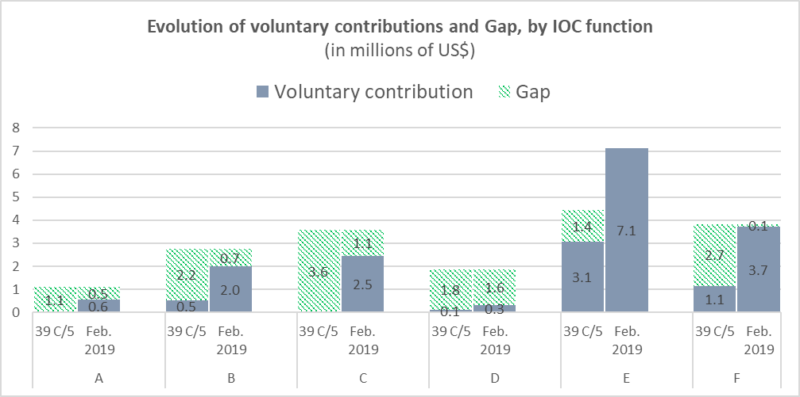.

Chart 8. Main extrabudgetary donors – based on 2018 income to the IOC Special Account in US dollars ($ 1,528,151.20) and to the Funds-in-Trust Projects ($ 7,636,853.81) – total of $ 9,165,005.01.

Table 11. 2018 in-kind contributions[3]



**PART Ii –Financial situation of the ioc special account  
at year-end 2018 and forecast for 2019**

1. In accordance with the Financial Report for the period 1 January 2018 to 31 December 2018 prepared by the Bureau of Financial Management and shown in Appendix I, the total income amounted to $ 1,528,151.20, while total expenditure for the same period amounted to $ 1,633,158.78.
2. It should be noted that the only non-earmarked contributions allowing to cover the collectively agreed priorities that would have otherwise lacked resources were received from Norway in the amount of $ 367,917.59 and Canada in the amount of $ 11,618.90 (25% of total income). At the end of year 2018, only $ 222,612 (15% of total income) were committed through signed letters. In addition, contributions from the three largest donors to the Special Account—Australia, Norway and China—are traditionally paid in the second half of the year (68% of annual income). This shows the high volatility and low predictability of funding, which requires a certain level of caution with regard to engaging expenditures.
3. At year-end 2018, the Fund balance amounted to $ 3,540,044.10 with the following breakdown:

* General reserves: $ 2,736,089.59
* JCOMMOPS reserves: $ 219,685.27
* ICG/IOTWS Secretariat reserves: $ 584,269.24

1. In accordance with Article 5.2 of the current IOC Financial Regulations, the above-mentioned balance is carried over to year 2019 for the implementation of the entire 2018–2019 budget approved by the IOC Assembly.
2. In this context, the following updated forecast for the period 2018–2019 is provided to inform the Assembly. It should be noted that the earmarked funding—75% of total income—is very unevenly spread between various programmes, similar to what can be seen in Table 10 and Chart 7 with regard to the achievement of the resource mobilisation targets by function. Additionally, heavy reliance on strictly earmarked project funding (funds-in-trust representing 83% of overall 2018 income) makes the ‘safety net’ provided by the Special Account and it is working capital fund even more essential to ensure programmes and staff sustainability and continuity.

|  |  |  |  |
| --- | --- | --- | --- |
| **IOC Special Account –** | | | |
| **Forecast 2018–2019** | | | |
| (US$) | | | |
|  | **as at 2018 year-start** | **adjusted at 2018 year-end** | |
| **Opening balance:** | **3,618,496** |  | **3,618,496** |
|  |  |  |  |
| **Working Capital Fund** | **500,000** |  | **500,000** |
|  |  |  |  |
| **Opening balance available:** | **3,118,496** |  | **3,118,496** |
|  |  |  |  |
| **Signed commitments from donors:\*** |  |  |  |
| *China (FIO)* | 180,000 | *China (FIO)* | 180,000 |
| *Suez Group* | 47,789 | *Suez Group* | 91,324 |
|  |  | *Canada* | 10,989 |
|  |  | *Plateforme Océans & Climat* | 20,526 |
|  |  | *Government of Barbados* | 5,000 |
|  |  | *Mr. John J. Goodman* | 1,000 |
|  |  | *Australia (BOM)* | 214,500 |
|  |  | *Australia (BOM)* | 294,944 |
|  |  | *Australia (CSIRO)* | 42,135 |
|  |  | *Mangareva Production* | 8,184 |
|  |  | *Monaco* | 22,831 |
|  |  | *New Zealand* | 4,700 |
|  |  | *United Kingdom (NOC)* | 40,000 |
|  |  | *United Kingdom (UKMO)* | 11,416 |
|  |  | *China (SOA)* | 150,000 |
|  |  | *China (NatComm)* | 50,000 |
|  |  | *Flanders (VLIZ)* | 39,954 |
|  |  | *Norway* | 341,258 |
|  |  | *Germany (BSH)* | 5,708 |
|  |  | *France (CNRS)* | 22,831 |
|  |  | *France (IFREMER)* | 11,416 |
|  |  | *ETT Spa* | 57,078 |
|  |  | *Japan* | 10,000 |
|  | **227,789** |  | **1,635,793** |
|  |  |  |  |
| **Sub-total Funds available or signed commitments:** | **3,346,285** |  | **4,754,288** |
|  |  |  |  |
| **Income forecast - 3 main donors:** |  |  |  |
| *Australia* | 1,120,000 | *Australia* | 550,000 |
| *China* | 400,000 | *China* | 200,000 |
| *Norway* | 710,000 | *Norway* | 355,000 |
|  | **2,230,000** |  | **1,105,000** |
|  |  |  |  |
| **Sub-total Funds expected:** | **5,576,285** |  | **5,859,288** |
|  |  |  |  |
| **Planned expenditure:** | **5,800,000** |  | **5,800,000** |
|  |  |  |  |
| **Estimated closing balance /Funding gap:** | **-223,715** |  | **59,288** |
| *\*indicative amounts, contributions in currencies other than US$ are converted using 31.12.2018 UNORE* | | | |
| *\*\*details of actual funds received in 2018 is available in Appendix 1, Schedule 1.3* | | | |

Table 12. IOC Special Account Forecast 2018–2019 (in US Dollars).

APPENDIX I

**Financial Report for the Intergovernmental Oceanographic Commission  
for the period 1 January –31 December 2018**

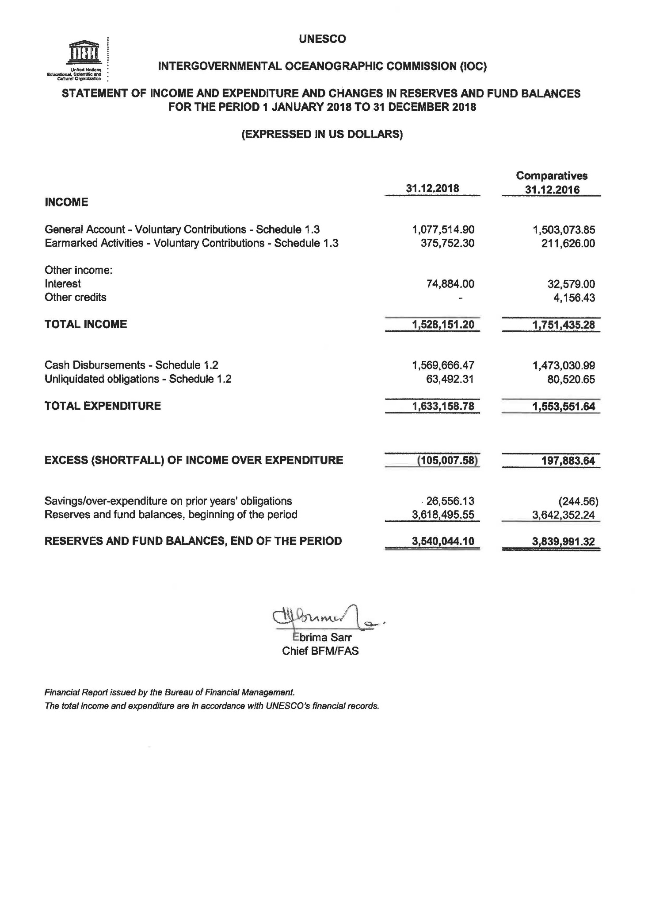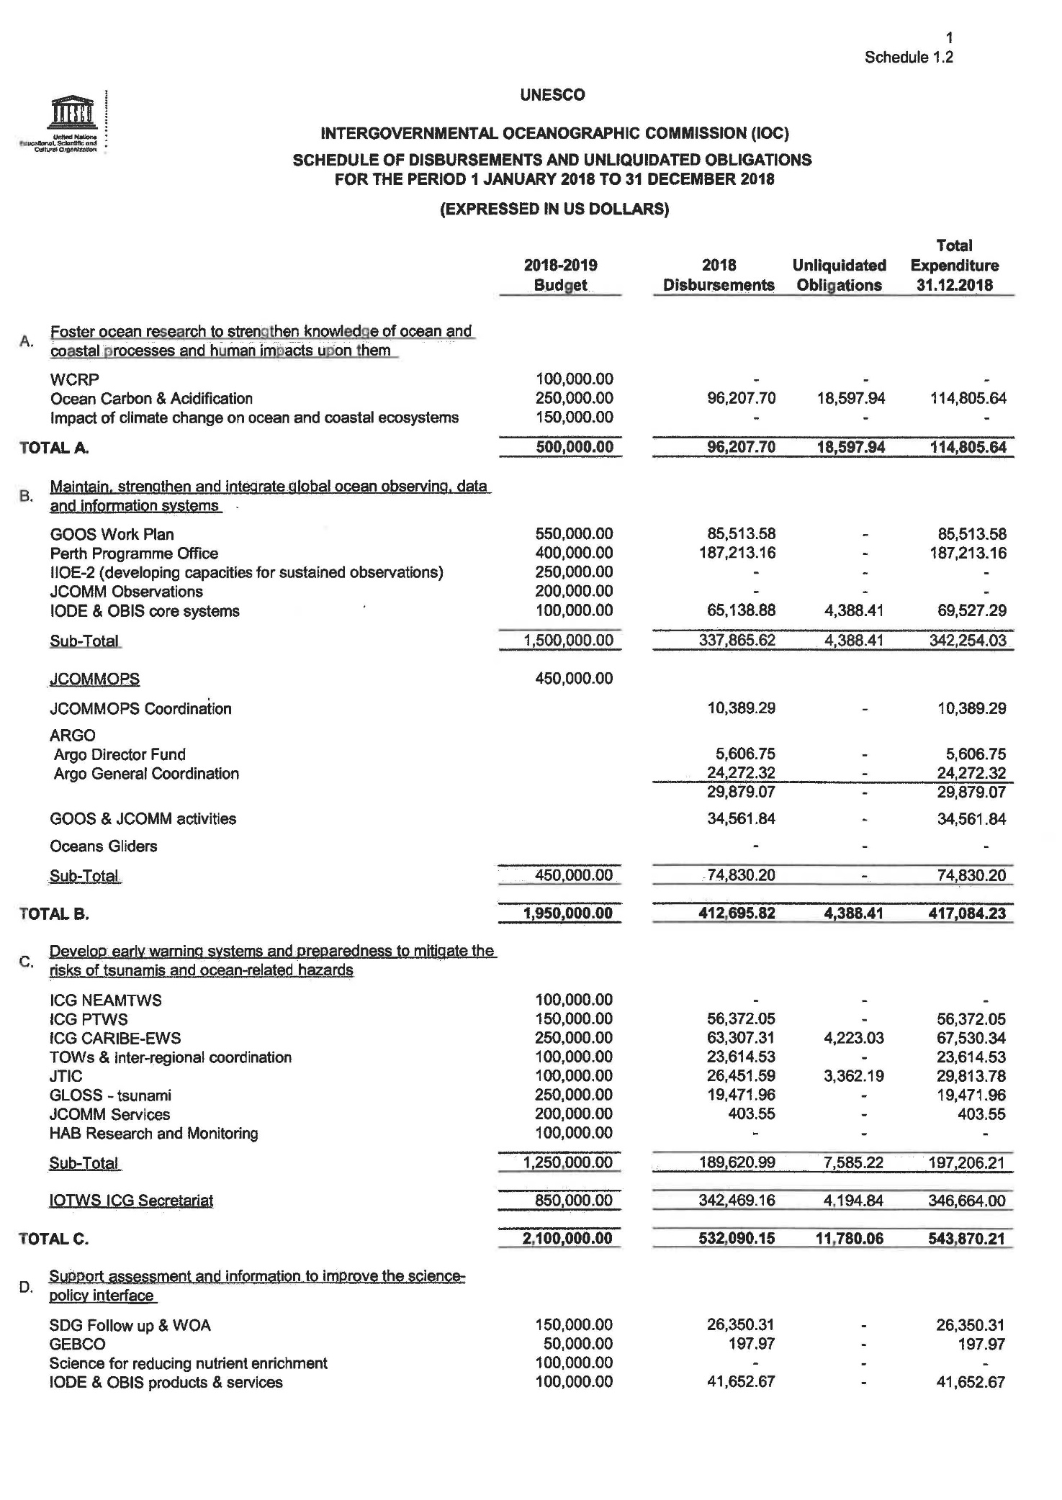

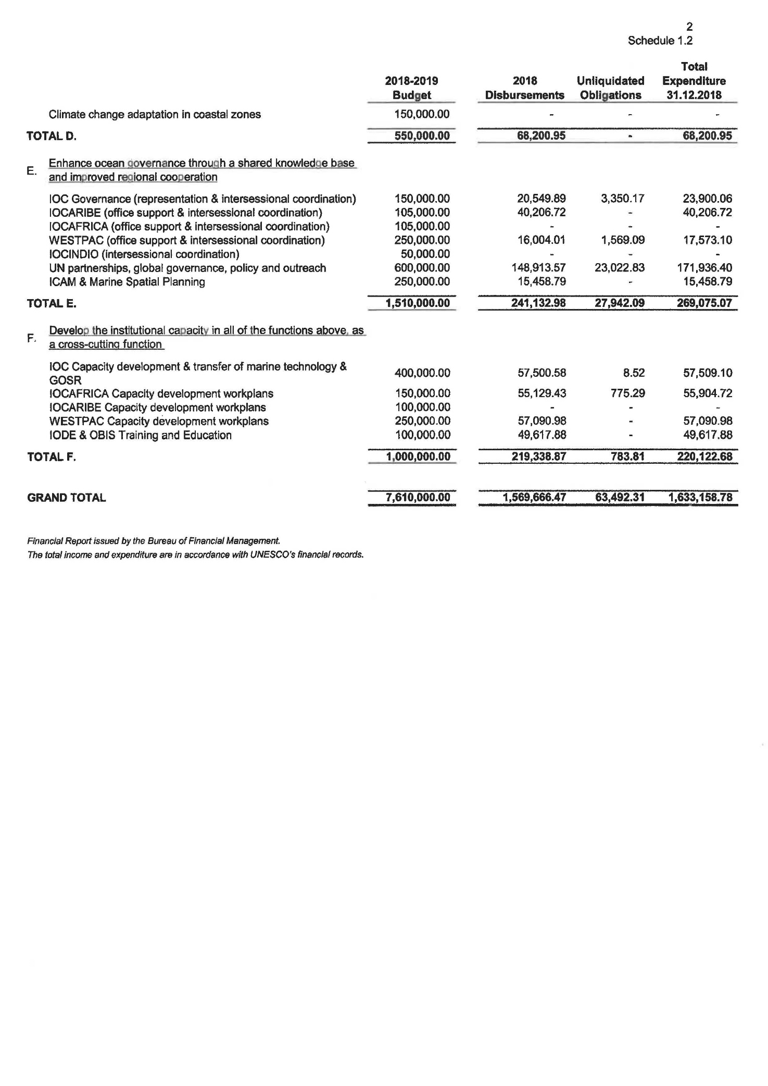

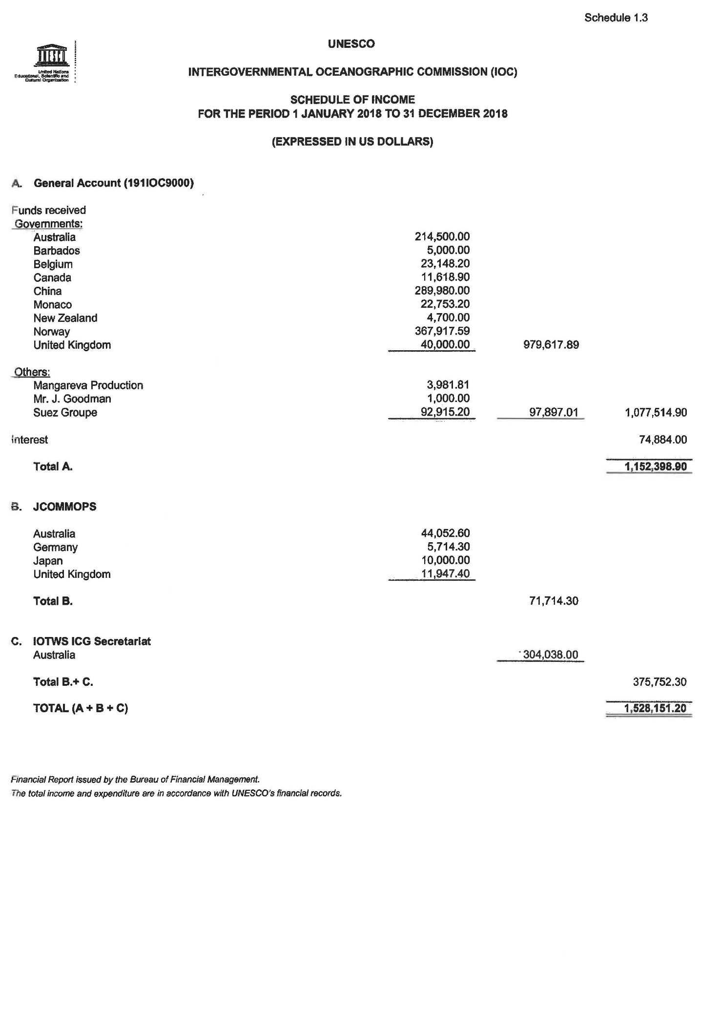

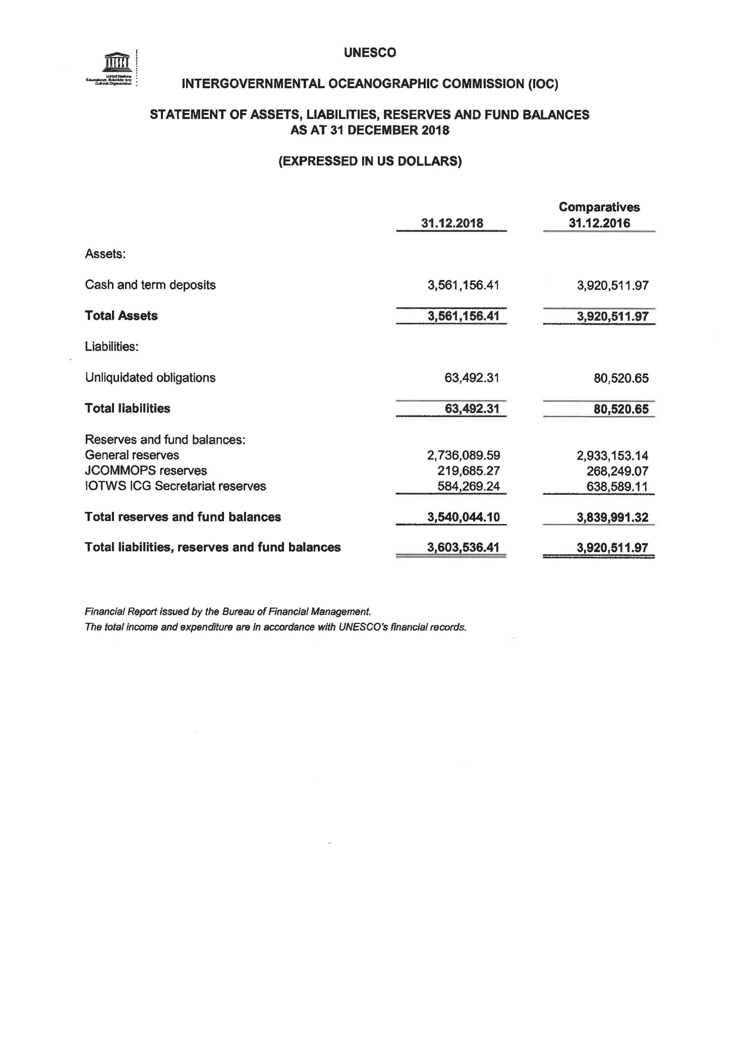

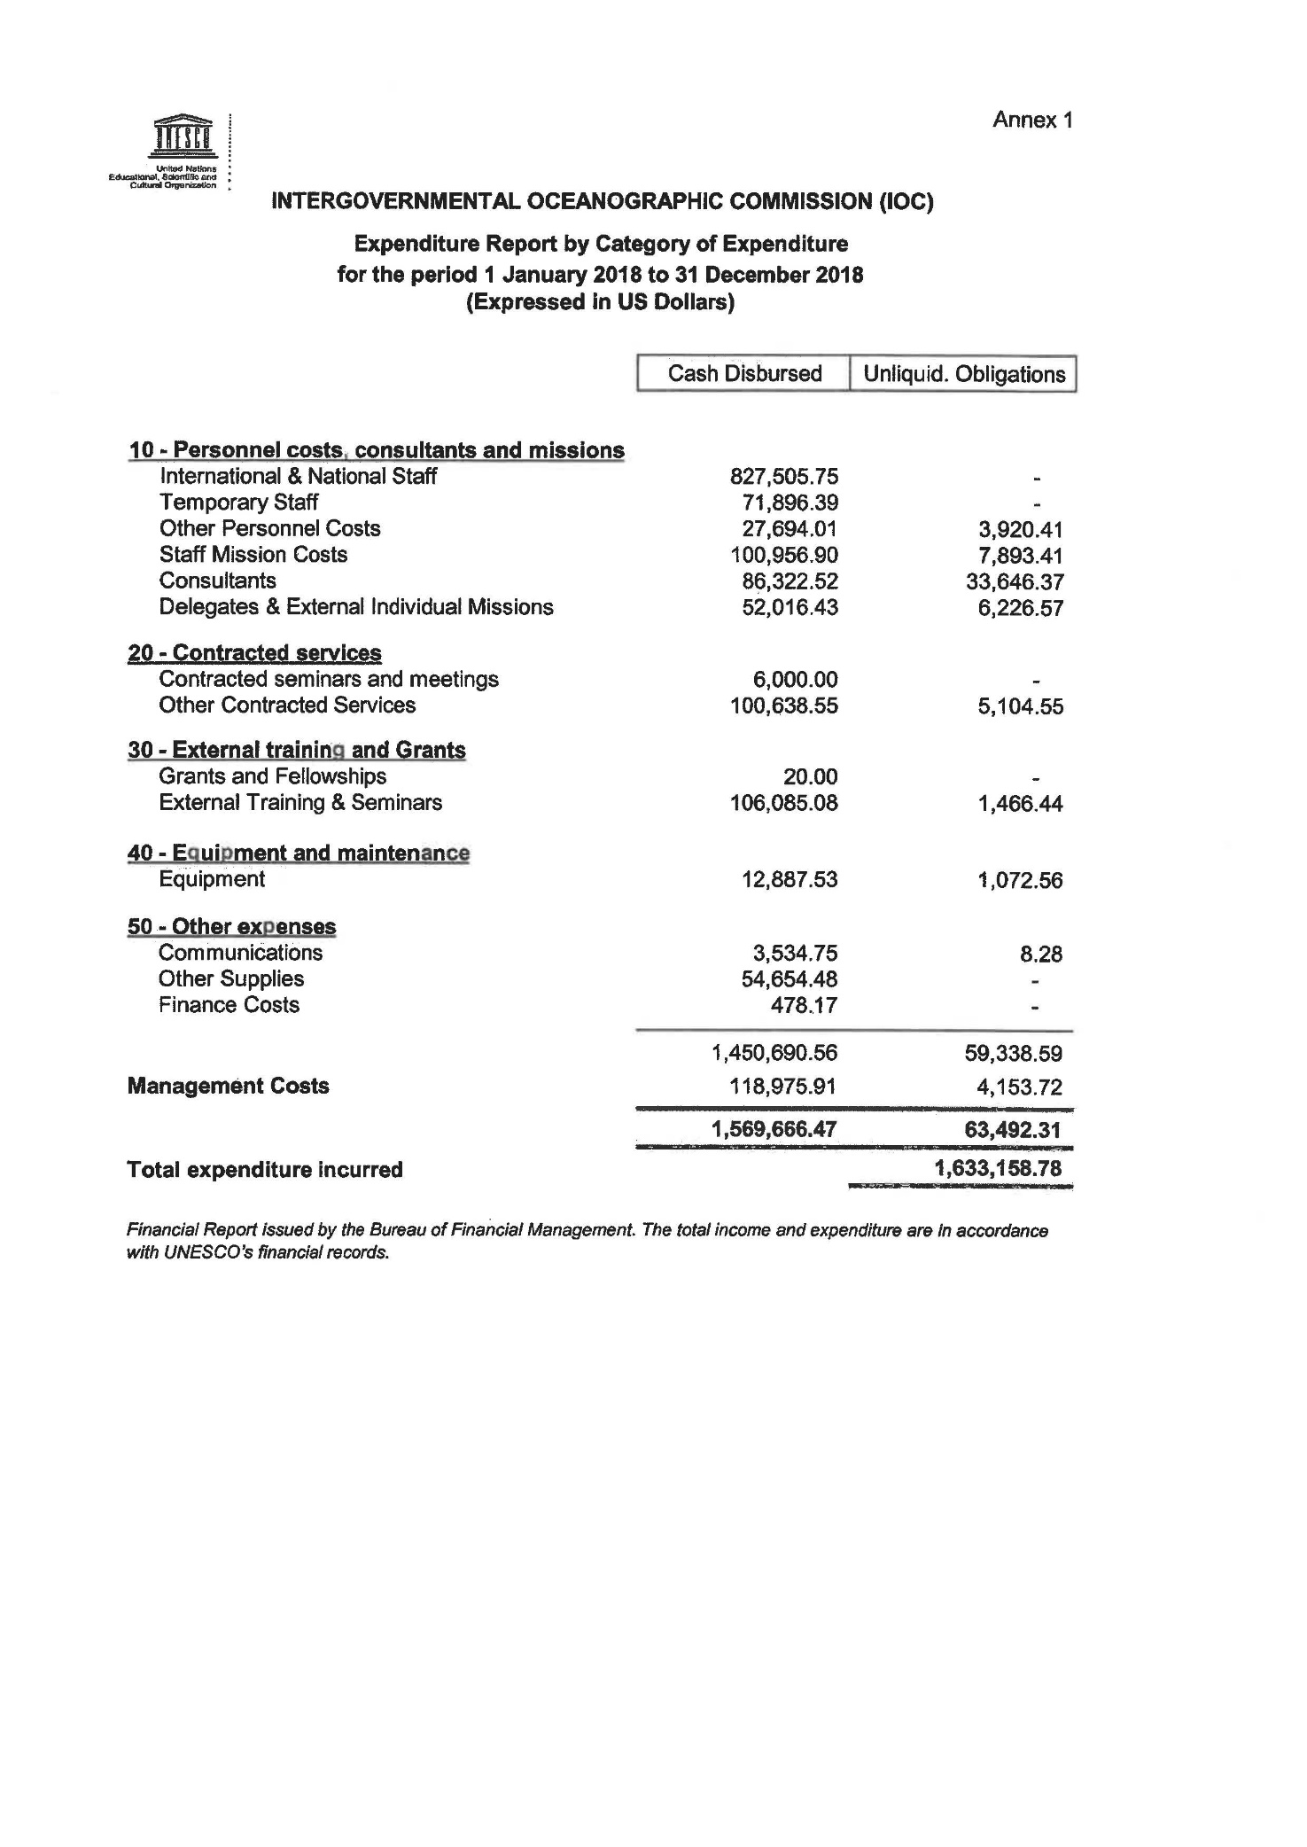

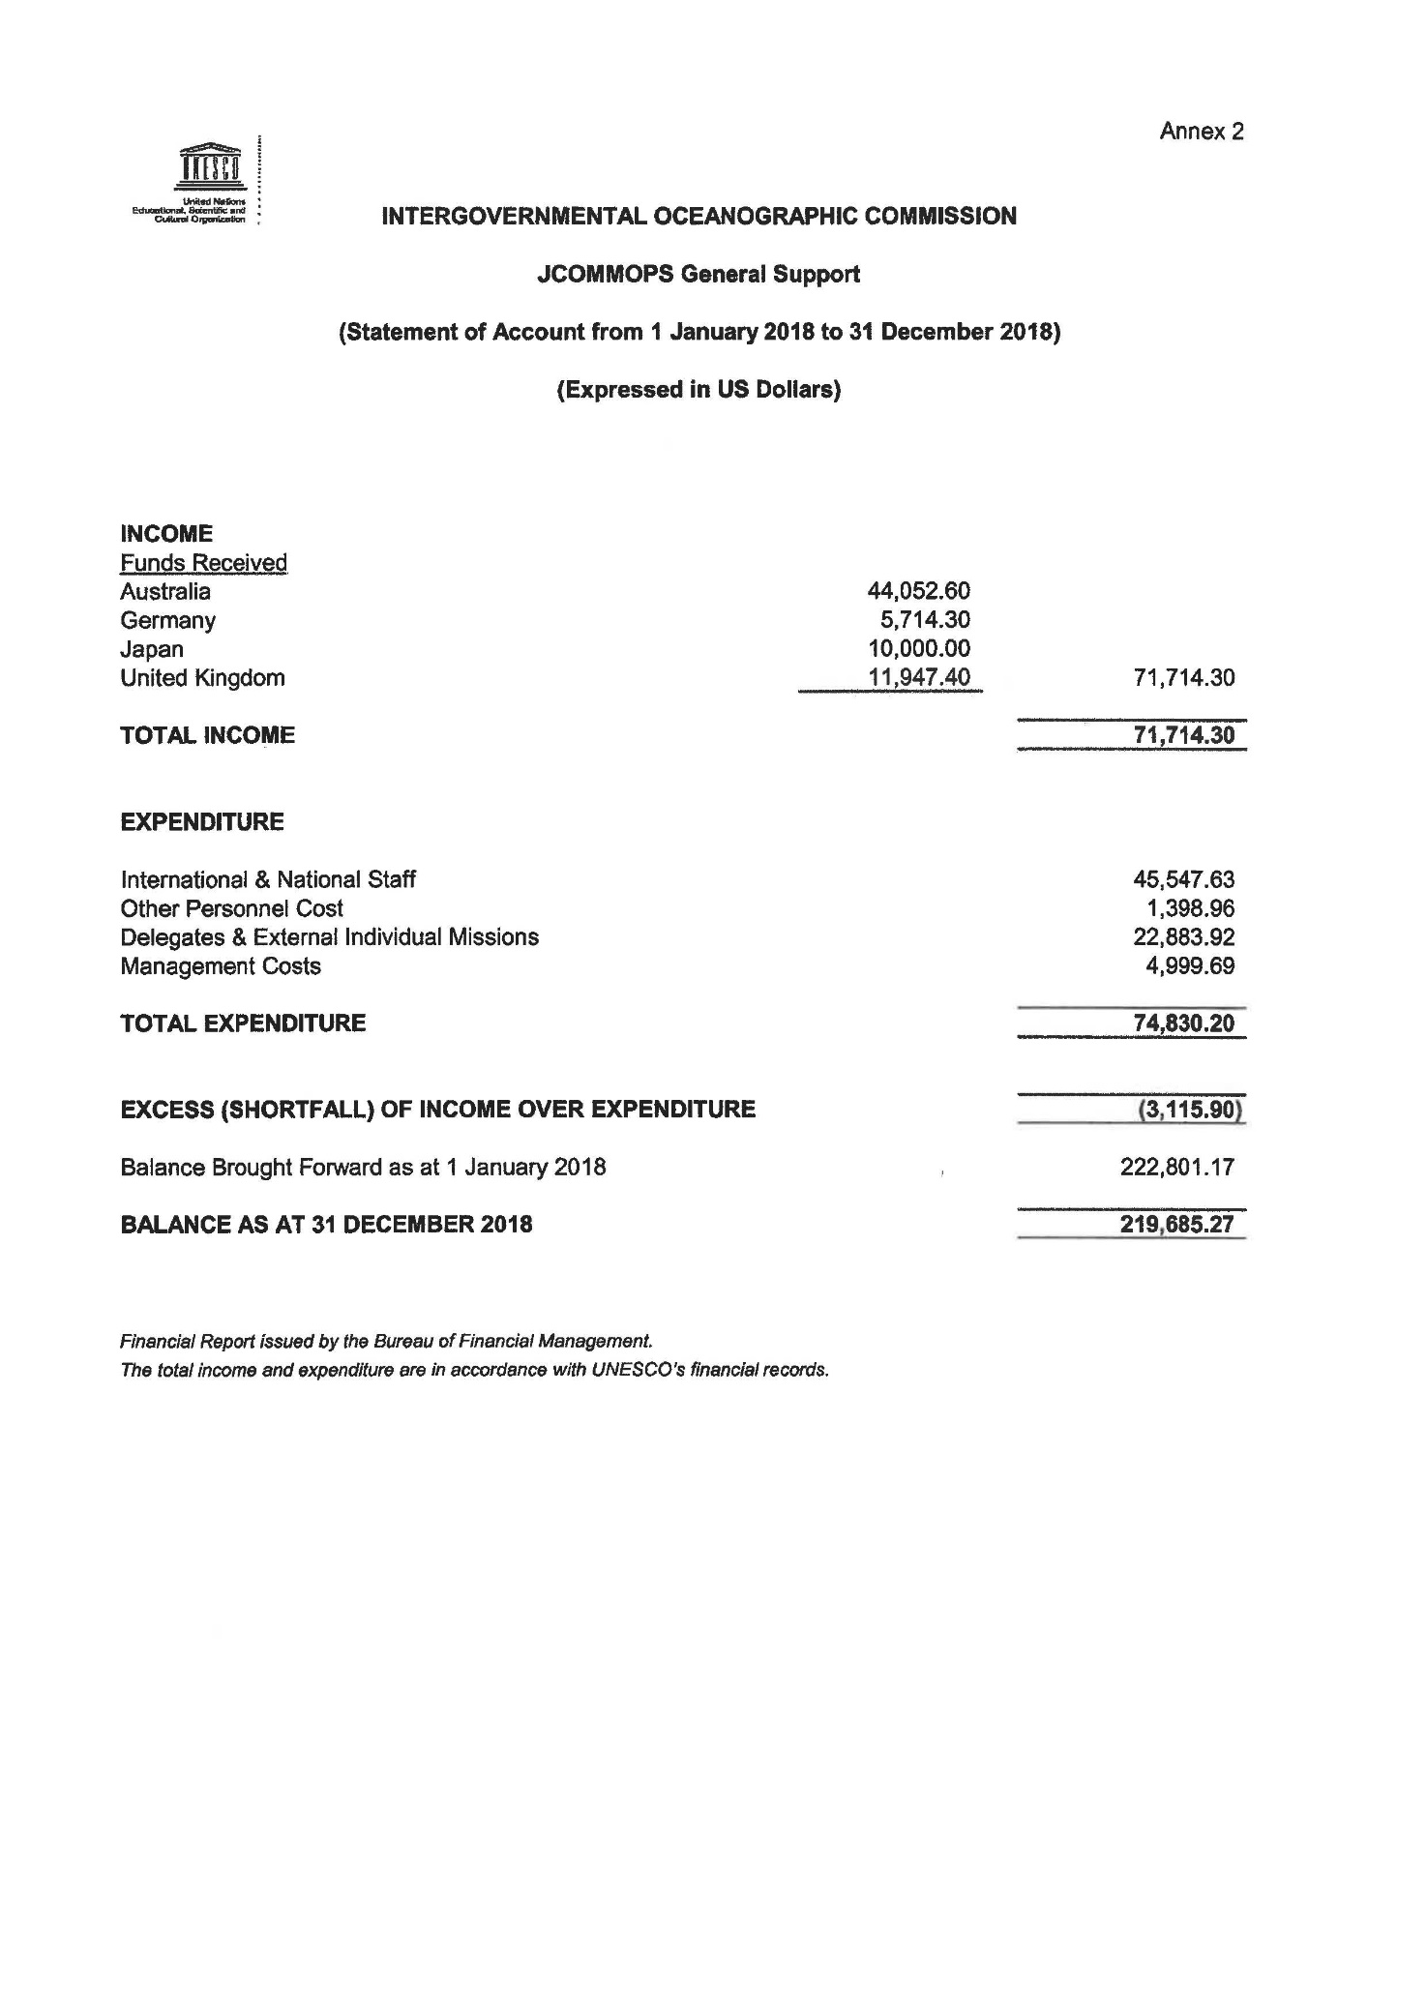

1. . All figures pertaining to budgetary implementation and financial reporting were reviewed by the Bureau of Financial Management (BFM), with the exception of Table 5 and charts with the overview of the staffing situation. Table 10 and Chart 5 (Evolution of voluntary contributions and gap by function) was reviewed by the Bureau for Strategic Planning (BSP) as compliant with [206 EX/5.II.B.INF](http://unesdoc.unesco.org/ulis/cgi-bin/ulis.pl?lin=1&catno=261859). All figures are expressed in US dollars.
2. Regular programme budget figure adjusted for additional appropriations and comparative transfers from Part V of UNESCO budget (ref. Documents [205 EX/4.II.INF Rev](https://unesdoc.unesco.org/ark:/48223/pf0000265667.locale=fr). and 206 EX/4.II.1.INF as at 31.12.2018). $ 60.8 of additional appropriations reduce the overall VC target within the IOC IBF.
3. The contributions are shown separately as they do not enter the UNESCO/IOC budgetary flow. Formal letters confirming the amounts reported were sent by the relevant partner institutions to the Executive Secretary for the purpose of inclusion in this report. The total of contributions of $2,788,733 was reported to the UNESCO Executive Board in Annex III-b of document [206 EX/4.II.A.INF](https://unesdoc.unesco.org/ark:/48223/pf0000367527.locale=fr).